Supplementary material
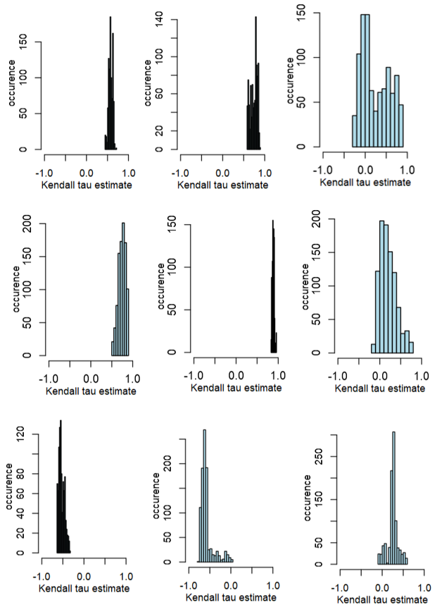
Figure S1. The frequency distribution of the trend statistic for sensitivity analysis. towards rolling window metrics for time series of remotely sensed indices. The first column represents the Normalized Difference Vegetation Index (NDVI), the second column represents the Modified Normalized Water Index (MNDWI), and the third column represents the Modified Vegetation Water Ratio (MVWR) from February 18, 2000, to July 31, 2021, in Qeshm Island (Panel A), and Gabrik (Panel B). In each panel, the first row refers to autocorrelation (acf(1)), the first row refers to standard deviation, and the third row refers to skewness.
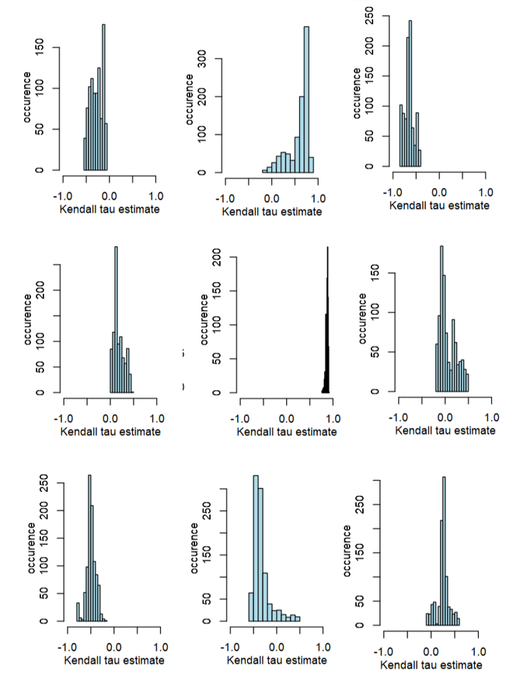
Figure S2. The frequency distribution of the trend statistic for sensitivity analysis. towards rolling window metrics for time series of remotely sensed indices. The first column represents the Normalized Difference Vegetation Index (NDVI), the second column represents the Modified Normalized Water Index (MNDWI), and the third column represents the Modified Vegetation Water Ratio (MVWR) from February 18, 2000, to July 31, 2021, in Qeshm Island (Panel A), and Gabrik (Panel B). In each panel, the first row refers to autocorrelation (acf(1)), the first row refers to standard deviation, and the third row refers to skewness.

