Supplementary Tables
Table S1. miRNA inhibitors or mimics
 | Manufacturer | Catalogue no. | Assay ID
Inhibitor control (Scr-2) | Ambion | AM17010 | CM00200
hsa-miR-31 inhibitor | Ambion | AM17000 | AM11465
Mimic control (Scr-1) | Ambion | AM17110
hsa-miR-21 mimic | Ambion | 4464066 | MC10206
hsa-miR-31 mimic | Ambion | 4464066 | MC11465
hsa-miR-146a mimic | Ambion | 4464066 | MC10722
hsa-miR-211 mimic | Ambion | 4464066 | MC10168

Table S2. TaqMan probes
 | Manufacturer | Catalogue no.
RNU6B | Thermo Fisher Scientific | 001903
hsa-miR-21 | Thermo Fisher Scientific | 000397
hsa-miR-31 | Thermo Fisher Scientific | 002279
hsa-miR-125b | Thermo Fisher Scientific | 000449
hsa-miR-134 | Thermo Fisher Scientific | 000459
hsa-miR-146a | Thermo Fisher Scientific | 000468
hsa-miR-187 | Thermo Fisher Scientific | 001193
hsa-miR-211 | Thermo Fisher Scientific | 000514

Table S3 Antibodies
Antibody | Manufacturer | Catalogue no. | Reactivity | Dilution
t-AKT (B-1) | Santa Cruz Biotech | sc-5298 | Mouse | 1:1000
pAKT (4051) | Cell signaling | 4051 | Mouse | 1:1000
t-ERK (K-23) | Santa Cruz Biotech | sc-94 | Rabbit | 1:1000
pERK | Cell signaling | 9101 | Rabbit | 1:1000
GAPDH | Santa Cruz Biotech | sc-32233 | Mouse | 1:10000

Supplementary figures

Fig. S1. H₂O₂ tretament and miRNA expression. (A) NOK, (B) FaDu, (C, D) SAS. Cells are tretaed with 12.5 µM H₂O₂ for 1 h. (A - C) Culture medium is change, and the miRNA expression is assayed 24 h later. (D) The miRNA expression in cell is assayed 24 h later without changing the culture medium.

Fig. S2. HE-stained skin tissue sections from control, and those receiving 2 min or 7 min CAP treatment. No injury is noted in epidermis, dermis and hypodermis tissues.

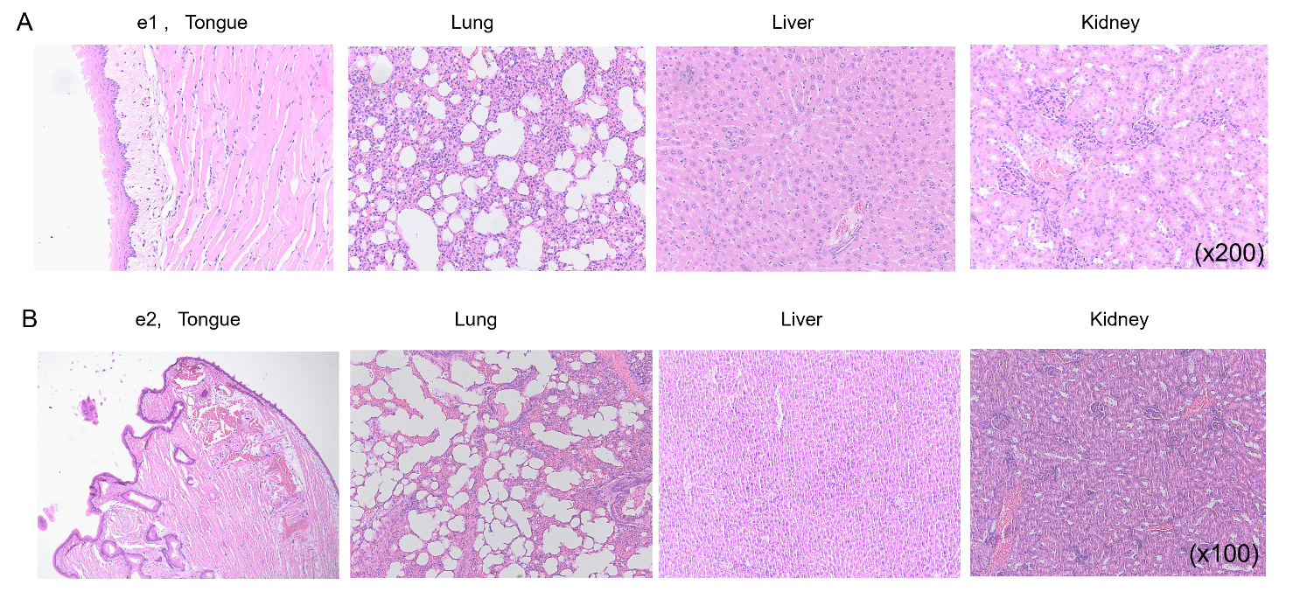

Fig. S3. HE-stained sections of tongue, lung, liver and kidney tissues harvested from mice receiving two-shot of 14 min CAP treatment. (A) e1 (B) e2. Number, magnification fold.

Fig. S4. miRNA expression in four control tumors (a1- a4), three tumors receiving 10 min CAP treatment (b1 – b3 in A – C) and one tumor receiving 14 min CAP treatment (c1 in D). The data are organized in Fig. 5F.

