Supplementary material
- Initialization algorithm and transmission and recovery algorithm
Explanation on the notations used:
- $i$: the anatomical site of infection, $i∈\left\{R,U,P\right\}$;
- ${wc}_{i}$: fraction of people initially infected in site $i$ with susceptible strain;
- ${qc}_{ij}$: fraction of people initially infected in sites $i$ and $j$ with susceptible strain;
- $l$: fraction of people initially infected with symptomatic infection in urethra;
- An infectious profile: $(i,s, r)$
  - $i$ is the anatomical site of infection, $i∈\{R,U,P\}$;
  - $r$ is the resistance profile that takes 0 for susceptible to ceftriaxone and 1 for resistant to ceftriaxone;
  - $s$ is the symptom status: 0 for asymptomatic and 1 for symptomatic;
- $β:$ yearly rate of sexual acts;
- $k_{i,j}$: the probability that a sexual act is between anatomical sites $i$ and $j$;
- $m_{i,j}$: the probability that a sexual act between anatomical sites $i$ and $j$ leads to the transmission of infection;
- $p_{j}$: the probability that an infection in anatomical site $j$ will become symptomatic (it was assumed that $p_{R}=p_{P}=0$);
- $f_{i}$: average time until natural recovery for asymptomatic infection at site $i$;
- $u$: average time between screening episodes;
- $z$: average time until seeking treatment for individuals with symptomatic urethral infection;
- $v$: average time until recovery after receiving treatment;
- $x$: probability of developing resistance while under treatment.

Initialization algorithm
1. A population of $n$ susceptible agents is created.
2. a. An agent is infected at pharynx with a drug-susceptible strain with the probability $w_{P}$;
b. An agent is infected at rectum with a drug-susceptible strain with the probability $w_{R}$;
c. An agent is infected at urethra with a drug-susceptible strain with the probability $w_{R}$; the infection becomes symptomatic with the probability $l$.
- An agent is infected at rectum and pharynx with a drug-susceptible strain with the probability $q_{RP}$; the infection becomes symptomatic in urethra with the probability $l$.
- An agent is infected at rectum and urethra with a drug-susceptible strain with the probability $q_{RU}$; the infection becomes symptomatic in urethra with the probability $l$.
- An agent is infected at pharynx and urethra with a drug-susceptible strain with the probability $q_{PU}$; the infection becomes symptomatic in urethra with the probability $l$.
Transmission and recovery algorithm
- Individuals with infectious profile $(i, r, s)$ with $i∈\{U,P\}$, $r∈\left\{0,1\right\}$and $s∈\left\{0,1\right\}$ send the following messages:
  - $(j, r, 1)$, with $j∈\{R,U,P\}$, $r∈\left\{0,1\right\}$ at the rate $βk_{i,j}m_{i,j}p_{j}$ and if those receiving the message will develop symptomatic infection at site $j$ with resistance status $r$;
  - $(j, r, 0)$, with $j∈\{R,U,P\}$, $r∈\left\{0,1\right\}$ at the rate $βk_{i,j}m_{i,j}(1-p_{j})$ and those receiving the message will develop asymptomatic infection at site $j$ with resistance status $r$.
- Individuals with infectious profile $(i, r, s)$ with $i∈\{R\}$, $r∈\left\{0,1\right\}$and $s∈\left\{0,1\right\}$ send the following messages:
  - $(j, r, 1)$, with $j∈\{U,P\}$, $r∈\left\{0,1\right\}$ at the rate $βk_{i,j}m_{i,j}p_{j}$ and those receiving the message will develop symptomatic infection at site $j$ with resistance status $r$;
  - $(j, r, 0)$, with $j∈\{U,P\}$, $r∈\left\{0,1\right\}$ at the rate $βk_{i,j}m_{i,j}(1-p_{j})$ and those receiving the message will develop asymptomatic infection at site $j$ with resistance status $r$.
- Individuals with infectious profile $(i, r, s)$ with $i∈\{R,U, P\}$, $r∈\{0,1\}$ and $s=0$ recover naturally$.$Time until natural recovery follows an exponential distribution with rate $f_{i}$.
- Individuals with infectious profile $(i, r, s)$ with $i∈\{R,U, P\}$, $r∈\{0,1\}$ and $s=0$ undergo screening. Time between screening episodes follows an exponential distribution with rate $u$.
Immediately after individuals receive the first-line treatment.
- Individuals with infectious profile $(i, r, s)$ with $i=U$, $r∈\{0,1\}$ and $s=1$ seek the first line treatment. Time until seeking treatment for individuals with symptomatic urethral infection follows an exponential distribution with rate $z$.
- a. Individuals with infectious profile $(i, r, s)$ with $i∈\{R,U,P\}$, $r=0$ and $s∈\{0,1\}$ receive the first-line treatment. Time until recovery after receiving the first-line treatment follows an exponential distribution with rate $v$ . During the treatment, the infection might develop resistance with the probability $x$, which results in changing the resistance status of infection to $r=1$. If resistance is not developed, the individual recovers in this site.
b. The first-line therapy is not successful on infectious profiles$(i, r, s)$ with $i∈\{R,U,P\}$, $r=1$, and $s∈\{0,1\}$, and does not change the infectious profile.
c. In case of individuals being infected in two sites with infectious profiles $(i, r, s)$ with $i∈\{R,U,P\}$, $r=0$ and $s∈\{0,1\}$, the infection might develop resistance with the probability $x$ in one site or it might develop resistance with the probability $x$ in another site, which results in changing the resistance status of infection to $r=1$ in that site. If resistance is not developed, the individual recovers in both sites.
- Individuals with infectious profile $(U, 1, 1)$ seek re-treatment with the second-line antibiotic (ertapenem). Time until seeking treatment with the second-line antibiotic for individuals with symptomatic urethral infection follows an exponential distribution with rate $z$.
- Individuals with infectious profile $(U, 1, 1)$ receive the second-line treatment. Time until recovery after receiving the second-line treatment follows an exponential distribution with rate $v$.
The values of the parameters are provided in Tables 1-3.

Parameter | Prior distribution | Source
Total population ($n$) | 10,000
Fraction of people initially infected at pharynx only with susceptible strain ($w_{P}$) | uniform(0.8*0.06, 1.2*0.06) | [12]
Fraction of people initially infected at rectum only with susceptible strain ($w_{R}$) | uniform(0.8*0.035, 1.2*0.035) | [12]
Fraction of people initially infected at urethra only with susceptible strain ($w_{U}$) | uniform(0.8*0.025, 1.2*0.025) | [12]
Fraction of people initially infected at rectum and pharynx with susceptible strain ($q_{RP}$) | uniform(0.8*0.02, 1.2*0.02) | [12]
Fraction of people initially infected at rectum and urethra with susceptible strain ($q_{RU}$) | uniform(0.8*0.0093, 1.2*0.0093) | [12]
Fraction of people initially infected at pharynx and urethra with susceptible strain ($q_{PU}$) | uniform(0.8*0.0087, 1.2*0.0087) | [12]
Fraction of people initially infected with symptomatic urethral infection ($l$) | uniform(0.01, 0.3) | Assumption
Table 1. Initialization parameters

Parameter | Prior distribution | Source
Probability that the infection will become symptomatic
$$p_{R}$$ | 0
$$p_{U}$$ | uniform (0.33, 0.94) | [9-11, 13]
$$p_{P}$$ | 0
Yearly rate of sexual acts ($β$) | uniform(0.8*80, 1.2*80) | [14]
Probability of a sexual act between two anatomical sites
$$k_{P,P}$$ | 0.83 | [15]
$$k_{P,U}$$ | 0.825 | [15]
$$k_{P,R}$$ | 0.6 | [15]
$$k_{U,R}$$ | 0.478 | [15]
$$k_{U,U}$$ | 0.03 | [15]
$$k_{R,U}$$ | 0.478 | [15]
$$k_{R,P}$$ | 0.6 | [15]
$$k_{U,P}$$ | 0.825 | [15]
Probability of transmission from one anatomical site to another |  | Assumption
$$m_{P,P}$$ | uniform (0.001, 0.1)
$$m_{P,U}$$ | uniform (0.001, 0.1)
$$m_{P,R}$$ | uniform (0.001, 0.1)
$$m_{U,R}$$ | uniform (0.001, 0.1)
$$m_{U,U}$$ | uniform (0.001, 0.1)
$$m_{R,U}$$ | uniform (0.001, 0.1)
$$m_{U,P}$$ | uniform (0.001, 0.1)
$$m_{R,P}$$ | uniform (0.001, 0.1)

Table 2. Transmission parameters

Parameter | Prior distribution | Source
Average time until natural recovery at different anatomical sites (years) |  | Assumption
$f_{R}$ | uniform(1/12, 5)
$f_{U}$ | uniform(1/12, 5)
$f_{P}$ | uniform(1/12, 5)
Average time until seeking treatment for individuals with symptomatic urethral infection (z) (years) | uniform(1/365, 14/365) | Assumption
Average time between screening episodes ($u$) (years) | uniform(1, 10) | Assumption
Average time until recovery after receiving treatment ($v$) (years) | uniform(1/365, 14/365) | Assumption based on [16]
Probability of developing resistant while under treatment ($x$) | uniform(0.001, 0.009) | Assumption

Table 3. Recovery parameters

- Histograms of the posterior distributions
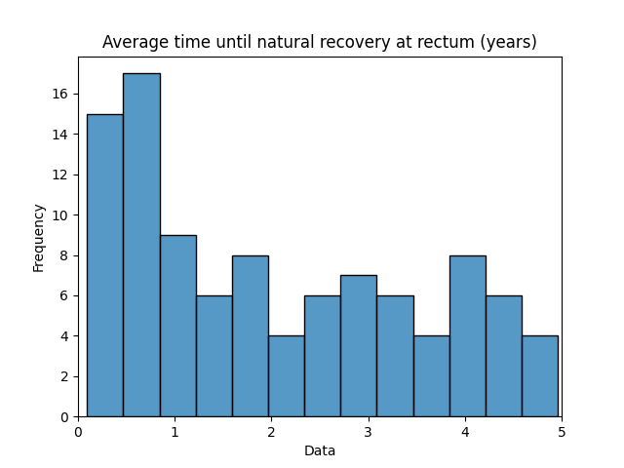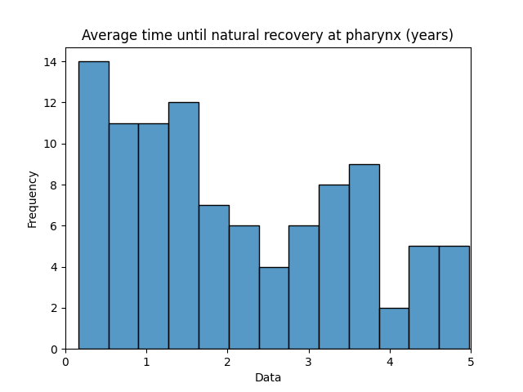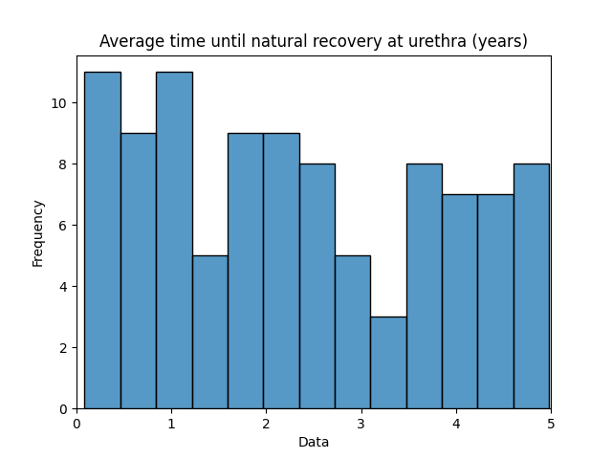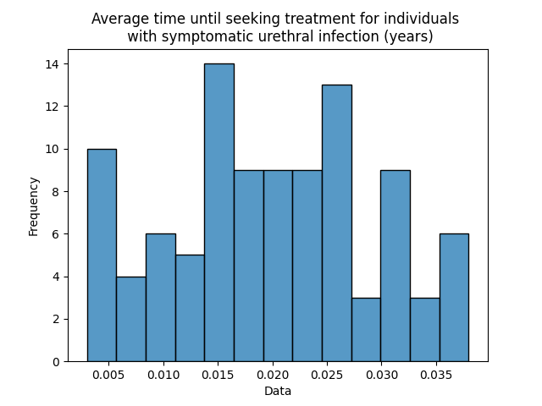
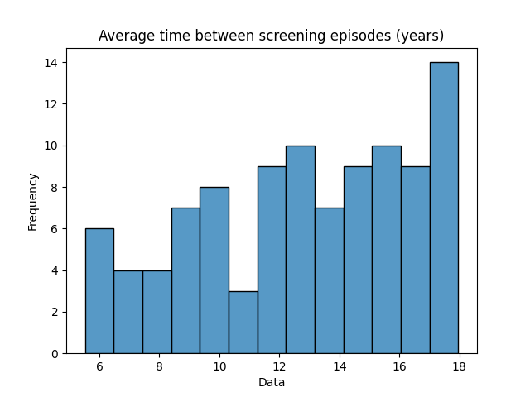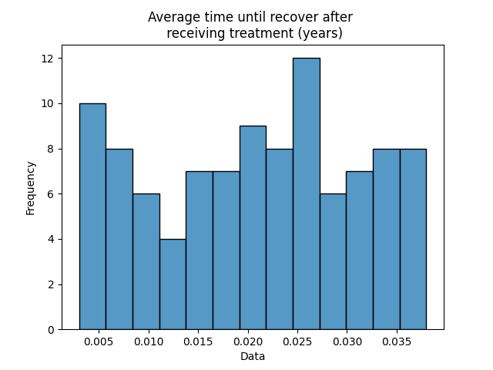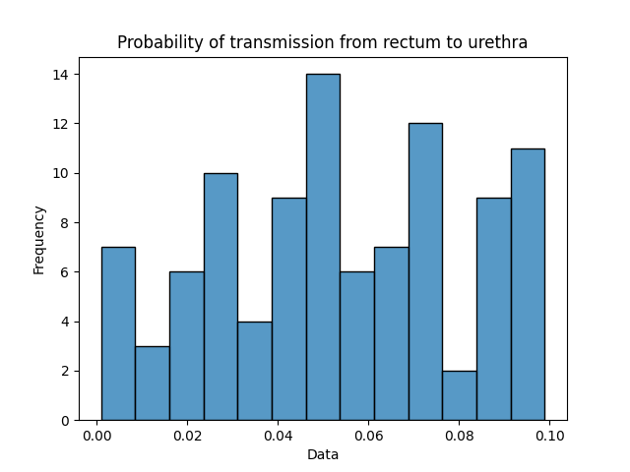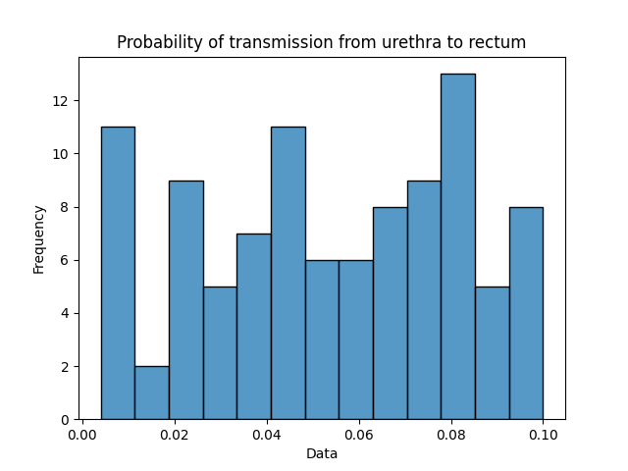
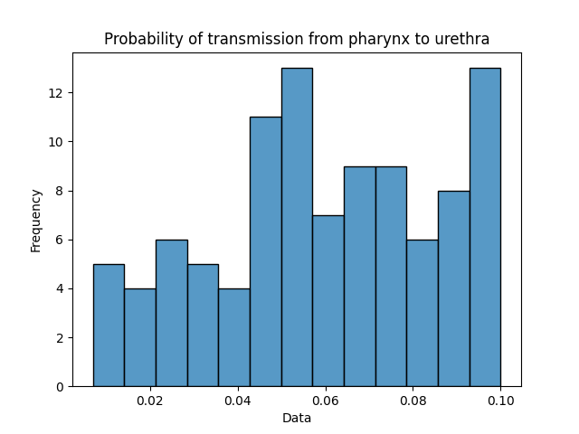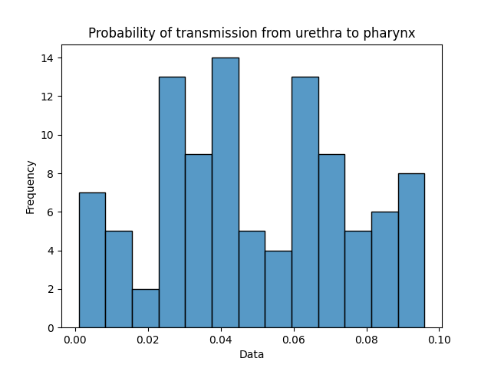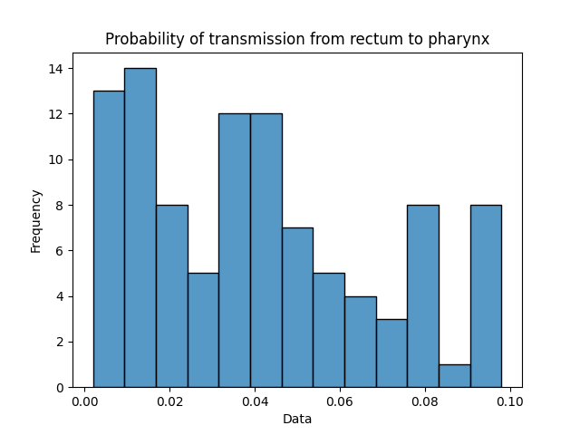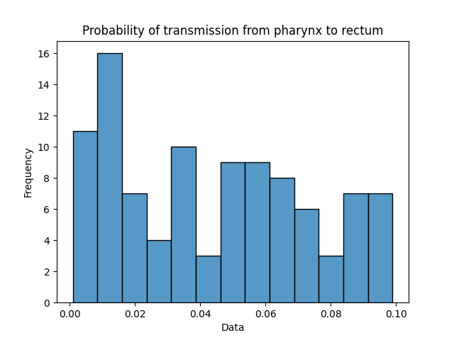
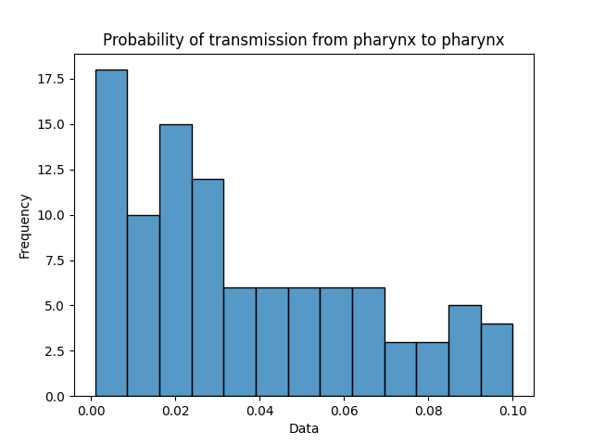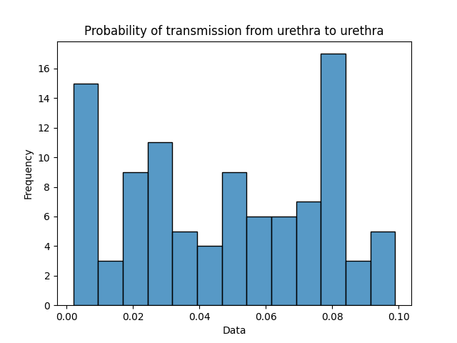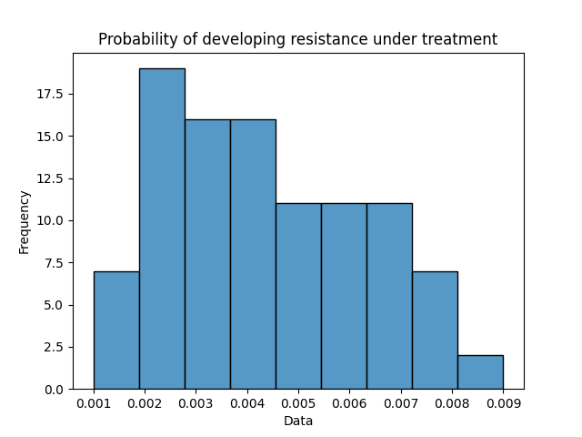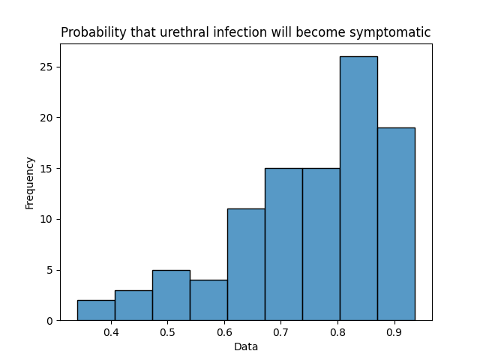
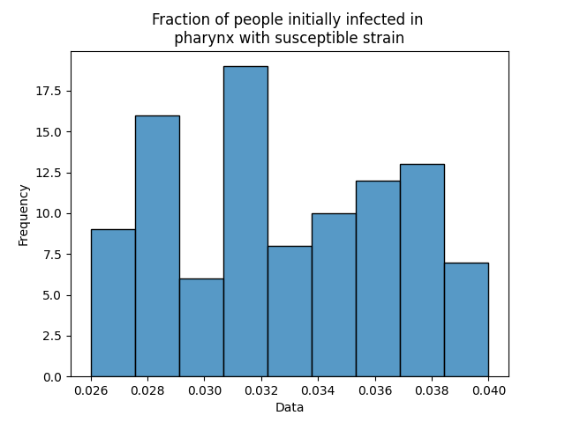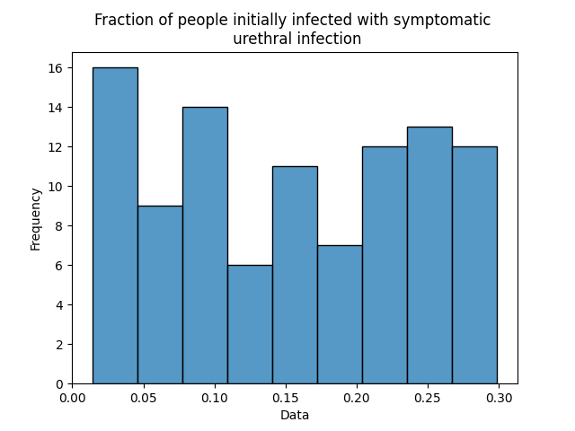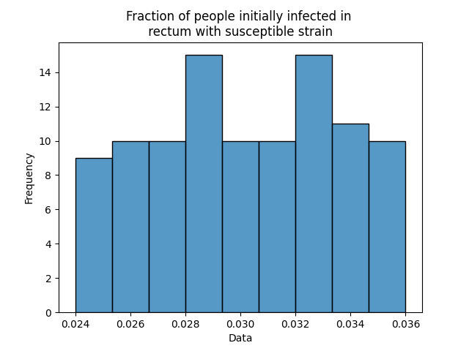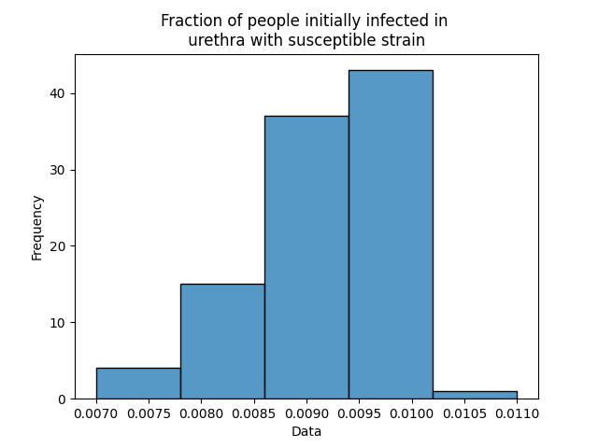
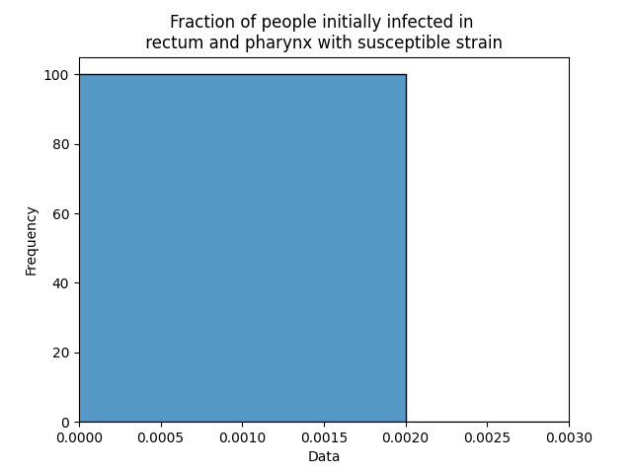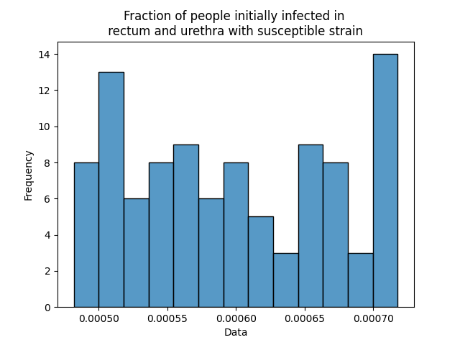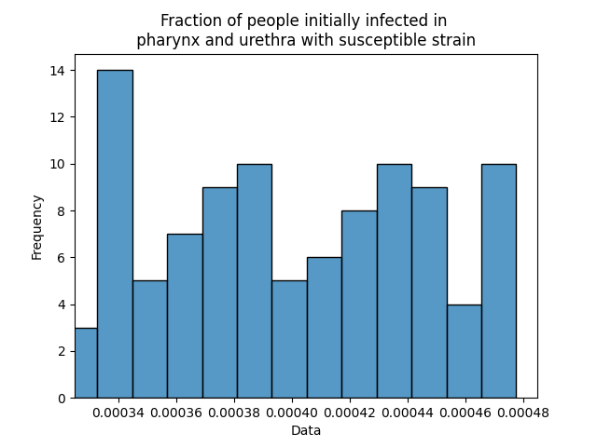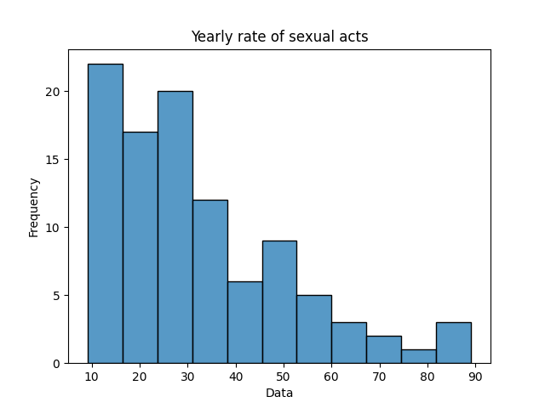
Figure 1. Histograms of the posterior distributions.

