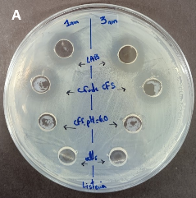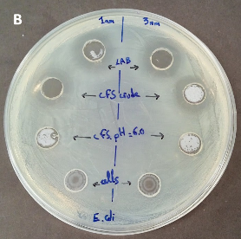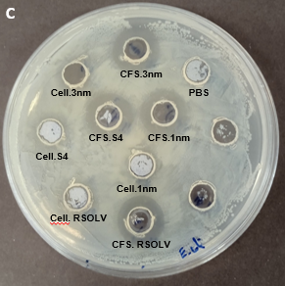
FigureS1. Antibacterial activity of some Lpb. plantarum strains and their CFSs (crude CFS, neutralized CFS pH=6.0, cells and heat treated cells) against L. monocytogenes (A) and E.coli (B and C).

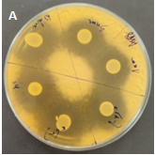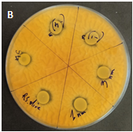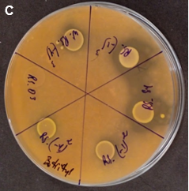

FigureS2. Antifungal activity of Lpb. plantarum strains against some indicator fungi species: Penicillium expansum (A), F. culmorum CECT 2148 (B) and Botrytis cinerea CECT 20973 (C)

Table S1. Pathogen antagonism by Lpb. plantarum on tomatoes. CFU counts of Lpb. plantarum inoculated in MRS as pure culture and inoculated as co-culture with pathogen (L. monocytogenes CECT 4031 or E.coli O157:H7) . Mean ± standard deviation from three independent CFU counts from three different experiments. Each experiment was done in duplicate. Log CFU per tomato compared to single inoculated pathogen used as control. Two-way ANOVA, Dunnett’s multiple comparisons test are used to compare strains at different time. § p<0.05 vs 5 days 3nm-Listeria, 1nm-Listeria, RSOLV-Listeria and pepp1-Listeria; & p<0.05 vs 5 days pepp2-Listeria.

 |  | Number of tomato-attached Lpb. plantarum (Log CFU/g in MRS)
 | Medium agar |  | 1 day | 3 days | 5 days
E.coli O157:H7-3nm | MRS |  | 1.83±1.26 | 1.78±1.53 | 1.85±1.31
E.coli O157:H7-1nm | MRS |  | 1.84±1.36 | 1.60±0.54 | 1.60±1.34
E.coli O157:H7-S4 | MRS |  | 1.86±1.28 | 1.54±0.51 | 1.73±1.26
E.coli O157:H7-RSOLV | MRS |  | 1.82±1.05 | 1.60±0.69 | 1.72±1.20
E.coli O157:H7-pepp1 | MRS |  | 1.93±1.36 | 1.52±0.98 | 1.65±0.39
E.coli O157:H7-pepp2 | MRS |  | 1.91±1.06 | 1.42±1.26 | 1.59±1.18
L. monocytogenes CECT 4031 -3nm | MRS |  | 1.86±1.16 | 1.75±1.18 | 1.90±0.94
L. monocytogenes CECT 4031 -1nm | MRS |  | 1.83±0.63 | 1.36±0.73 | 1.59±0.40
L. monocytogenes CECT 4031 –S4 | MRS |  | 1.72±0.55 | 1.75±0.67 | 1.04±0.15§
L. monocytogenes CECT 4031 -RSOLV | MRS |  | 1.70±0.80 | 1.74±1.29 | 1.85±0.43
L. monocytogenes CECT 4031 –pepp1 | MRS |  | 1.93±0.88 | 1.57±1.46 | 2.00±1.44&
L. monocytogenes CECT 4031 –pepp2 | MRS |  | 1.98±1.60 | 1.61±1.20 | 1.63±0.84
3nm (control) | MRS |  | 1.80±1.30 | 1.59±1.20 | 1.68±1.09
1nm (control) | MRS |  | 1.80±1.10 | 1.40±0.33 | 2.15±0.55
S4 (control) | MRS |  | 1.66±1.56 | 1.81±0.60 | 1.79±0.93
RSOLV (control) | MRS |  | 1.93±1.77 | 1.14±1.29 | 1.10±0.55
pepp1 (control) | MRS |  | 1.87±1.15 | 1.43±0.45 | 1.75±0.03
pepp2 (control) | MRS |  | 1.82±1.67 | 1.01±0.45 | 1.02±0.15

