Supplementary Information
Terramechanics and Experimental Setup
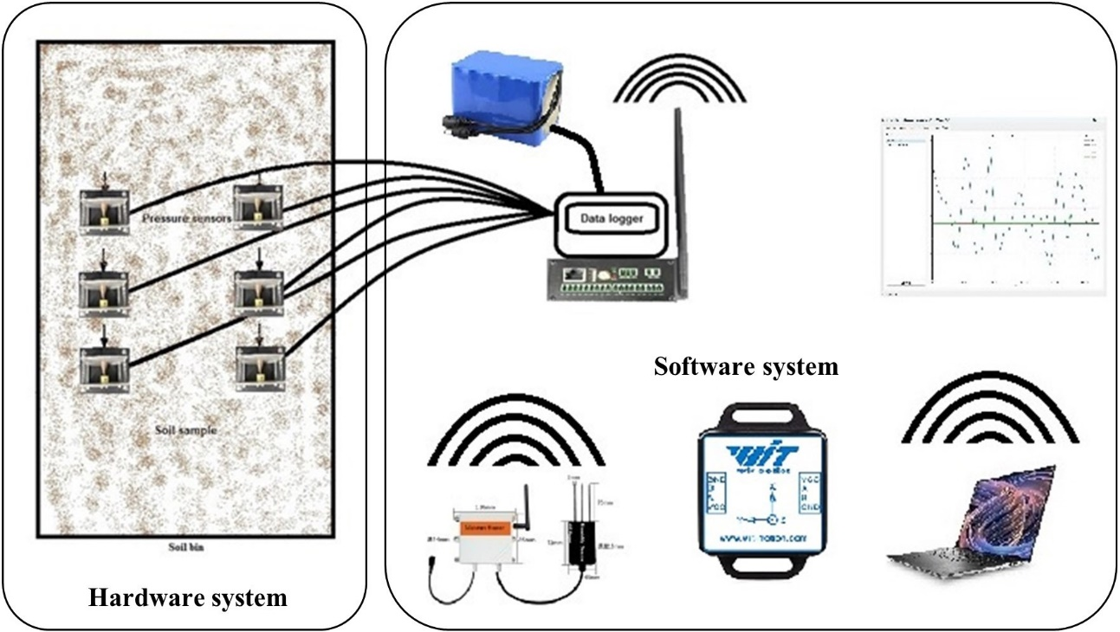

Supplementary Figure 1. Schematic drawing of the model experiment (soil bin, pressure sensors, wireless data logger equipment, signal amplifier, 12V/24V power supply, the 9-axis attitude sensor, communication module, and software).

Soil Sample and Preparation of soil bed
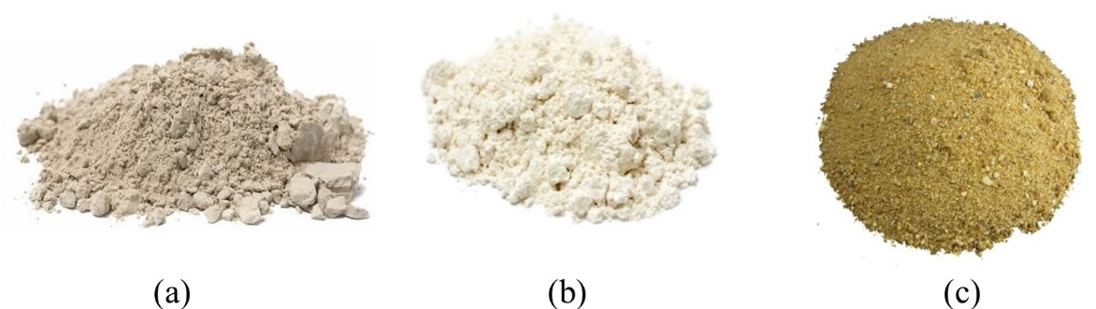

Supplementary Figure 2. (a) Bentonite clay (-0.063mm), (b) Diatom soils (>20μm), and (c) Sand (2mm~5mm) were used.

Pressure sensor
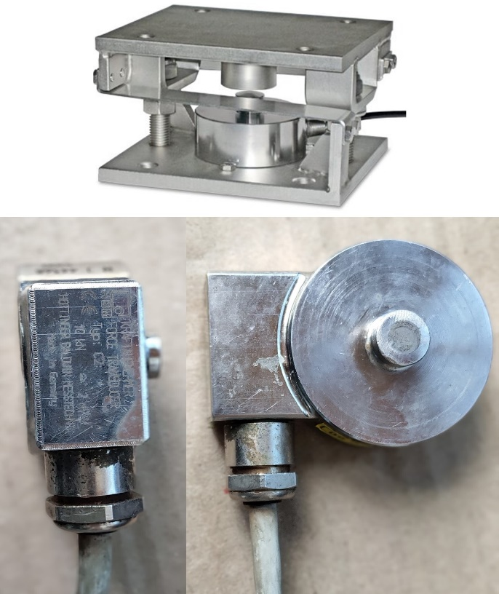

Supplementary Figure 3. Pressure sensor including sensor bracket.

Soil bin
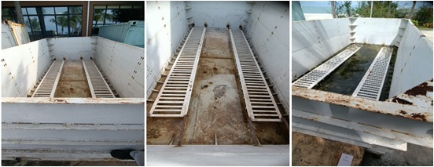

Supplementary Figure 4. Experimental setup for Soil Bin Test.

9-axis attitude sensor
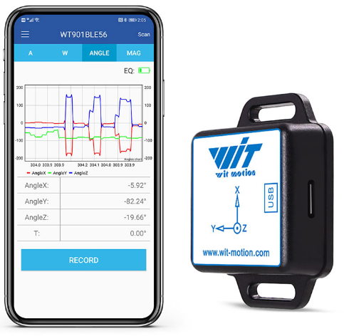

Supplementary Figure 5. Attitude sensor (WitMotion Bluetooth BLE 5.0 9 Axis Low-consumption Sensor WT901BLECL Angle + Acceleration + Gyro + Mag MPU9250 on PC/Android, China)

Soil moisture and measurement system
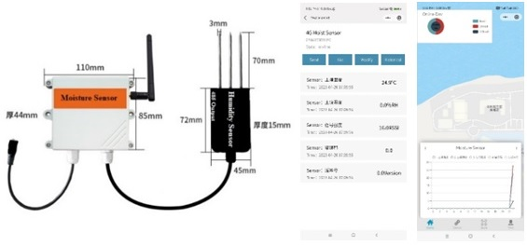

Supplementary Figure 6. Moisture sensor wireless interface and WeChat Mini app interface.

Supplementary Figure 7. Soil moisture 4G wireless web interface.

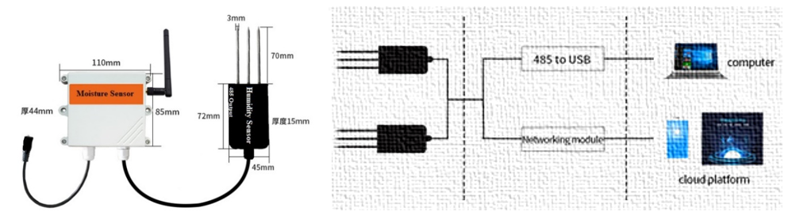

(a) (b)
Supplementary Figure 8. (a) 4G wireless soil temperature and moisture sensor (b) Wireless communication module.

Data acquisition FD0843 (6 Channel)
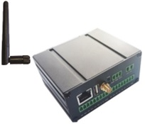
The FD0843 with its integrated Wireless Serial Communication Module serves as a data collection hub, adept at gathering and transmitting information from sensors through its 6 channels. When pressure sensors are connected to the FD0843, each sensor's data flows into one of these channels, simplifying data aggregation and transmission. Its wireless capability enhances the ease and versatility of data retrieval, facilitating both real-time monitoring and subsequent analysis on a computer. By analyzing this data, we can gain deeper insights into how different loads impact sinkage, enriching our knowledge of pressure sinkage behaviour. To ensure precision in data collection, it's essential to correctly install, set up, and calibrate both the FD0843 and the pressure sensors. For optimal setup and operation, always adhere to the manufacturer's instructions or seek advice from technical specialists.

Supplementary Figure 9. 6-channel wireless Data Acquisition System.

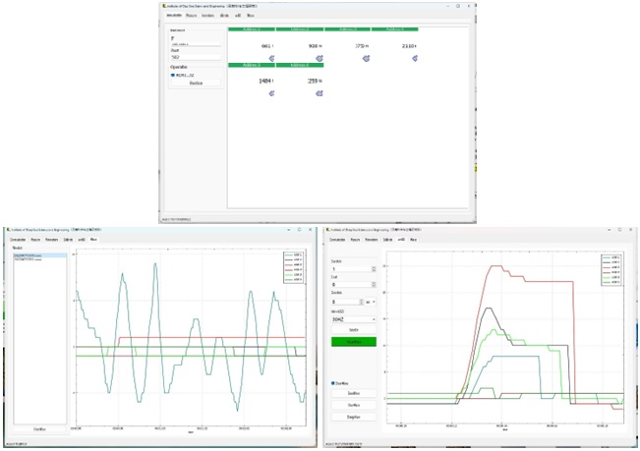

Supplementary Figure 10. 6-Channel Computer-Enabled Ground Pressure Measurement Software.

Supplementary Table 1. Loose soil properties for the tracked vehicle, soil bin experiment.
Parameter | Unit | Bentonite |  |  | Diatom
Condition | - | Loose | Loose | Loose | Loose | Loose | Loose
Moisture Content | % | 10 | 20 | 30 | 10 | 20 | 30
Normal Stiffness | kPa | 26 | 35 | 32 | 43 | 67.7 | 78
Terrain Stiffness (k∅) | kN/m | 18 | 17.1 | 20 | 27 | 32 | 37
Ground Pressure | PSI | 23 | 28 | 32 | 28 | 32 | 37
Sinkage | cm | 2.5 | 3.6 | 4.8 | 1.8 | 2.6 | 3.8
Sinkage Ratio (s/D) | - | 0.19 | 0.18 | 0.16 | 0.13 | 0.1 | 0.8
Shear Stiffness | kPa | 12 | 17 | 19 | 26 | 31 | 37
Cohesion | kPa | 6.5 | 8.7 | 10.5 | 4.2 | 5.5 | 6.3
Friction Angle | ° | 26 | 28.5 | 30 | 33 | 34.5 | 37
Hardening Ratio | - | 1.7 | 2.1 | 2.32 | 1.5 | 2.15 | 2.6
Dilation Angle | ° | 6 | 5.5 | 6.5 | 3.5 | 5 | 6.5
Fluid Content | % | 10 | 15 | 20 | 12 | 16 | 19
Ground Pressure | kPa | 23 | 29 | 34 | 36 | 42 | 46

Supplementary Table 2. Compact soil properties for the tracked vehicle, soil bin experiment.
Parameter | Unit | Bentonite |  |  | Diatom
Condition | - | Compact | Compact | Compact | Compact | Compact | Compact
Moisture Content | % | 10 | 20 | 30 | 10 | 20 | 30
Normal Stiffness | kPa | 37 | 46 | 61 | 58 | 84 | 91
Terrain Stiffness (k∅) | kN/m | 16.3 | 18.9 | 26 | 35 | 43 | 46
Ground Pressure | PSI | 26 | 31 | 37 | 33 | 37 | 42
Sinkage | cm | 1.1 | 2.3 | 3.1 | 0.8 | 1.3 | 2.1
Sinkage Ratio (s/D) | - | 0.11 | 0.09 | 0.06 | 0.12 | 0.07 | 0.06
Shear Stiffness | kPa | 16 | 19 | 26 | 37 | 41.6 | 48.5
Cohesion | kPa | 8.5 | 12.7 | 14.5 | 7.3 | 8.2 | 9.5
Friction Angle | ° | 28 | 31 | 35 | 35 | 37 | 41
Hardening Ratio | - | 2.3 | 2.5 | 2.7 | 2.6 | 3.3 | 3.8
Dilation Angle | ° | 7 | 7.9 | 8.8 | 6 | 7.5 | 8.7
Friction Coefficient | μ | 0.8 | 0.65 | 0.58 | 0.9 | 0.84 | 0.76
Ground Pressure | kPa | 31 | 38 | 45 | 33 | 46 | 52

Mechanics of track soil interaction
Supplementary Table 3. The physical properties of Bentonite and Diatom soil.
Parameter | Unit | Bentonite | Diatom | Sand Gravel mixture
Classification | - | Clay soil | Sedimentary deposit/rock | Silty gravel
Bulk density | g/cm³ | 1.4 (Loose)  1.5 (Compact) | 1.1 (Loose)  1.2 (Compact) | 1.6 (Loose)  1.7 (Compact)
Water Moisture content | % | 29 | 23 | 11
Internal friction angle | ° | 21 | 27 | 35
Cohesion | kPa | High | Low | Very low
Porosity | % | 54 | 62 | 31
Swelling Capacity | % | High | Low | Very low
Specific gravity | - | 2.4 | 2.2 | 2.6
Soil cone index (dry) | MPa | 1.7 | 1.0 | 3.4
Soil cone index (wet) | MPa | 1.1 | 0.6 | 1.9

Tracked vehicle
Supplementary Table 4. A tracked vehicle was used for the experiment's basic parameters.
Parameter name | Symbol | Parameter content
Track length × width × Height (cm) | L_{x}×L_{y}×L_{z} | 120 × 90 × 80
Contact length of rubber track | cm | 90
Width of single rubber track | cm | 20
Drive wheel diameter | cm | 26
Front idler diameter | cm | 32
Lugs | cm | 19
Weight of the tracked vehicle | W (kg) | 530
Weight of the vehicle in the water | W_{w} (kg) | -470
Contact Pressure | P (kPa) | 13.889
Contact Pressure in the water | P_{w} (kPa) | 12.5

Soil bin
Supplementary Table 5. Soil bin parameters.
Soil Bin Specifications | Values
Length | 610 cm
Width | 245 cm
Height | 180 cm
Thickness | 0.4 cm
Depth | 175 cm
Material | Steel
Capacity | Adequate for accommodating small to medium rubber-tracked vehicles
Drainage System | Installed to control surplus water and soil saturation efficiently.
Side Walls | Smooth and vertical to reduce vehicle motion interference
Floor Surface | Even and level for uniform testing
Lighting | Adequate lighting for assessing visibility
Safety Features | Guardrails or obstacles for operator safety
Data Collection | Integration of sensor and data acquisition equipment

Supplementary Table 6. Properties of Test Soils.
Parameter name | Unit | Value
Soil particle density  - Bentonite  - Diatom  - Sand gravel mixture | g/cm³ | 2.7  2.3  2.7
Natural moisture content  - Bentonite  - Diatom  - Sand gravel mixture | % | 21  8  9
Grain size distribution  - Bentonite  - Diatom  - Sand gravel mixture | mm | < 0.002  0.1  2 ~ 5
Maximum dry density  - Bentonite  - Diatom  - Sand gravel mixture | g/cm³ | 1.2  1.7  1.8
Optimum moisture content  - Bentonite  - Diatom  - Sand gravel mixture | % | 19  13  8

Supplementary Table 7. Rubber Tracked Vehicle Motion Test on Diatom and Bentonite Soil
Soil Type | Speed (m/sec) | Motion Observation
Bentonite | 0.1 | Smooth
 | 0.2 | Steady
 | 0.3 | Unstable
Diatom | 0.1 | Smooth
 | 0.2 | Stable
 | 0.3 | Unstable

Supplementary Table 8. Parameters for Soil bin used for pressure sinkage and bearing capacity.
Soil Bin Specifications | Values
Length | 610 cm
Width | 245 cm
Height | 180 cm
Thickness | 0.4 cm
Depth | 175 cm
Material | Steel
Capacity | Adequate for accommodating small to medium rubber-tracked vehicles
Drainage System | Installed to control surplus water and soil saturation efficiently.
Side Walls | Smooth and vertical to reduce vehicle motion interference
Floor Surface | Even and level for uniform testing
Lighting | Adequate lighting for assessing visibility
Safety Features | Guardrails or obstacles for operator safety
Data Collection | Integration of sensor and data acquisition equipment

Supplementary Table 9. Cone penetration resistance at different moistures.
Soil | Depth (cm) | Cone penetration resistance kPa @ Moisture (%)
 |  | 10 % | 20 % | 30 %
Bentonite | 0-5 | 10 kPa | 20 kPa | 40 kPa
 | 5-15 | 15 kPa | 30 kPa | 45 kPa
 | 15-30 | 20 kPa | 25 kPa | 50 kPa
Diatom | 0-5 | 15 kPa | 18 kPa | 20 kPa
 | 5-15 | 18 kPa | 20 kPa | 22 kPa
 | 15-30 | 20 kPa | 22 kPa | 25 kPa

Track Vehicle Sinkage Observations
Supplementary Table 10. Observations Table for Rubber Tracked Vehicle Pressure Sinkage Test
Soil | Moisture (%) | Speed (m/s) | Sinkage (cm) | Track-Soil Observations
Bentonite | 5 | 0.1 | 1.10 | Normal wear and tear on tracks
Bentonite | 10 | 0.1 | 1.50 | Rutting beginning tracks deforming
Bentonite | 15 | 0.1 | 2.40 | Deep rutting, tracks digging in
Bentonite | 20 | 0.1 | 2.70 | Severe rutting, tracks stuck
Bentonite | 25 | 0.1 | 3.20 | Severe track deformation and sinking
Bentonite | 30 | 0.1 | 3.80 | Increased track slippage
Diatom | 5 | 0.1 | 0.55 | Normal wear and tear on tracks
Diatom | 10 | 0.1 | 0.80 | Minor rutting
Diatom | 15 | 0.1 | 0.83 | Rutting
Diatom | 20 | 0.1 | 0.90 | Deep Rutting
Diatom | 25 | 0.1 | 1.21 | Soil very soft, tracks dug in
Diatom | 30 | 0.1 | 1.30 | Severe track deformation and sinking

Cone index measurement
Supplementary Table 11. Experimental Soil Properties and Cone Index Measurement for Bentonite and Diatom
Soil type | Moisture content % | Loose Density 3g/cm³ | Compacted Density g/cm³ | Compaction % | Depth cm | Cone Index kPa
Bentonite | 10 | 1.3 | 1.5 | 15.38 | 10 | 94.12
 |  |  |  |  | 20 | 215.25
 |  |  |  |  | 30 | 127.36
 |  |  |  |  | 40 | 179.48
Bentonite | 20 | 1.2 | 1.4 | 17.67 | 10 | 184.16
 |  |  |  |  | 20 | 94.28
 |  |  |  |  | 30 | 179.4
 |  |  |  |  | 40 | 127.52
Bentonite | 30 | 1.1 | 1.3 | 18.18 | 10 | 94.44
 |  |  |  |  | 20 | 162.36
 |  |  |  |  | 30 | 127.6
 |  |  |  |  | 40 | 215.72
Diatom | 10 | 0.9 | 1.1 | 22.29 | 10 | 269.14
 |  |  |  |  | 20 | 293.62
 |  |  |  |  | 30 | 318.11
 |  |  |  |  | 40 | 342.59
Diatom | 20 | 0.8 | 1.0 | 25.4 | 10 | 219.38
 |  |  |  |  | 20 | 238.12
 |  |  |  |  | 30 | 257.86
 |  |  |  |  | 40 | 278.59
Diatom | 30 | 0.7 | 0.9 | 28.57 | 10 | 175.21
 |  |  |  |  | 20 | 192.44
 |  |  |  |  | 30 | 212.67
 |  |  |  |  | 40 | 231.89

Rubber Tracked Vehicle Ground Pressure and Sinkage Test Results
Supplementary Table 12. Rubber-Tracked Vehicle Sinkage, Ground Pressure, Speed Test Results
Soil Type | Speed (m/s) | Moisture Content (%) | Ground Pressure (kPa) | Sinkage (cm)
Bentonite | 0.1 | 10 | 23 | 1.5
Bentonite | 0.1 | 20 | 25 | 2.7
Bentonite | 0.1 | 30 | 27 | 3.8
Bentonite | 0.2 | 10 | 21 | 2.6
Bentonite | 0.2 | 20 | 23 | 3.7
Bentonite | 0.2 | 30 | 25 | 4.3
Bentonite | 0.3 | 10 | 19 | 3.2
Bentonite | 0.3 | 20 | 21 | 4.4
Bentonite | 0.3 | 30 | 23 | 5.2
Diatom | 0.1 | 10 | 29 | 0.8
Diatom | 0.1 | 20 | 31 | 0.9
Diatom | 0.1 | 30 | 33 | 1.3
Diatom | 0.2 | 10 | 27 | 0.6
Diatom | 0.2 | 20 | 29 | 1.8
Diatom | 0.2 | 30 | 31 | 1.6
Diatom | 0.3 | 10 | 25 | 1.9
Diatom | 0.3 | 20 | 27 | 1.7
Diatom | 0.3 | 30 | 29 | 2.8

Supplementary Table 13. Moisture Content, Cohesive Modulus, and Sinkage Exponent of Bentonite and Diatom
Soil Type | Moisture Content (%) | Sinkage Exponent | Cohesive Modulus (kPa)
Bentonite | 5 | 0.3 | 150
Bentonite | 10 | 0.5 | 100
Bentonite | 15 | 0.7 | 75
Bentonite | 20 | 0.9 | 50
Bentonite | 25 | 1.1 | 25
Bentonite | 30 | 1.3 | 12.5
Diatom | 5 | 0.1 | 75
Diatom | 10 | 0.3 | 50
Diatom | 15 | 0.5 | 37.5
Diatom | 20 | 0.7 | 25
Diatom | 25 | 0.9 | 12.5
Diatom | 30 | 1.1 | 6.25

Supplementary Table 14 Data Logging Table Showing Pressure Sensor Readings Recorded During Vehicle Track Testing on Bentonite and Diatom Soil Bed with 2-5mm Sand-Gravel Mixture at 10%, 20%, and 30% Moisture Levels and Speed is Set to Be 0.1, 0.2 and 0.3m/sec.
Table 14 (a): Data Logging Table @ 0.1 m/sec velocity.
Soil Type | Moisture Level (%) | Speed (m/sec) | Sensor 1 (kPa) | Sensor 2 (kPa) | Sensor 3 (kPa) | Sensor 4 (kPa) | Sensor 5 (kPa) | Sensor 6 (kPa)
Bentonite | 10 | 0.1 | 35 | 38 | 36 | 39 | 37 | 34
Bentonite | 20 | 0.1 | 39 | 42 | 40 | 43 | 41 | 38
Bentonite | 30 | 0.1 | 43 | 46 | 44 | 47 | 45 | 42
Diatom | 10 | 0.1 | 36 | 39 | 37 | 40 | 38 | 35
Diatom | 20 | 0.1 | 39 | 42 | 40 | 43 | 41 | 38
Diatom | 30 | 0.1 | 43 | 46 | 44 | 47 | 45 | 42
Table 14 (b): Data Logging Table @ 0.2 m/sec velocity.
Soil Type | Moisture Level (%) | Speed (m/sec) | Sensor 1 (kPa) | Sensor 2 (kPa) | Sensor 3 (kPa) | Sensor 4 (kPa) | Sensor 5 (kPa) | Sensor 6 (kPa)
Bentonite | 10 | 0.2 | 41 | 44 | 42 | 45 | 43 | 40
Bentonite | 20 | 0.2 | 44 | 47 | 45 | 48 | 46 | 43
Bentonite | 30 | 0.2 | 48 | 51 | 49 | 52 | 50 | 47
Diatom | 10 | 0.2 | 42 | 45 | 43 | 46 | 44 | 41
Diatom | 20 | 0.2 | 44 | 47 | 45 | 48 | 46 | 43
Diatom | 30 | 0.2 | 48 | 51 | 49 | 52 | 50 | 47
Table 14 (c): Data Logging Table @ 0.3 m/sec velocity.
Soil Type | Moisture Level (%) | Speed (m/sec) | Sensor 1 (kPa) | Sensor 2 (kPa) | Sensor 3 (kPa) | Sensor 4 (kPa) | Sensor 5 (kPa) | Sensor 6 (kPa)
Bentonite | 10 | 0.3 | 47 | 50 | 48 | 51 | 49 | 46
Bentonite | 20 | 0.3 | 50 | 53 | 51 | 54 | 52 | 49
Bentonite | 30 | 0.3 | 54 | 57 | 55 | 58 | 56 | 53
Diatom | 10 | 0.3 | 48 | 51 | 49 | 52 | 50 | 47
Diatom | 20 | 0.3 | 50 | 53 | 51 | 54 | 52 | 49
Diatom | 30 | 0.3 | 54 | 57 | 55 | 58 | 56 | 53

