Supplementary file
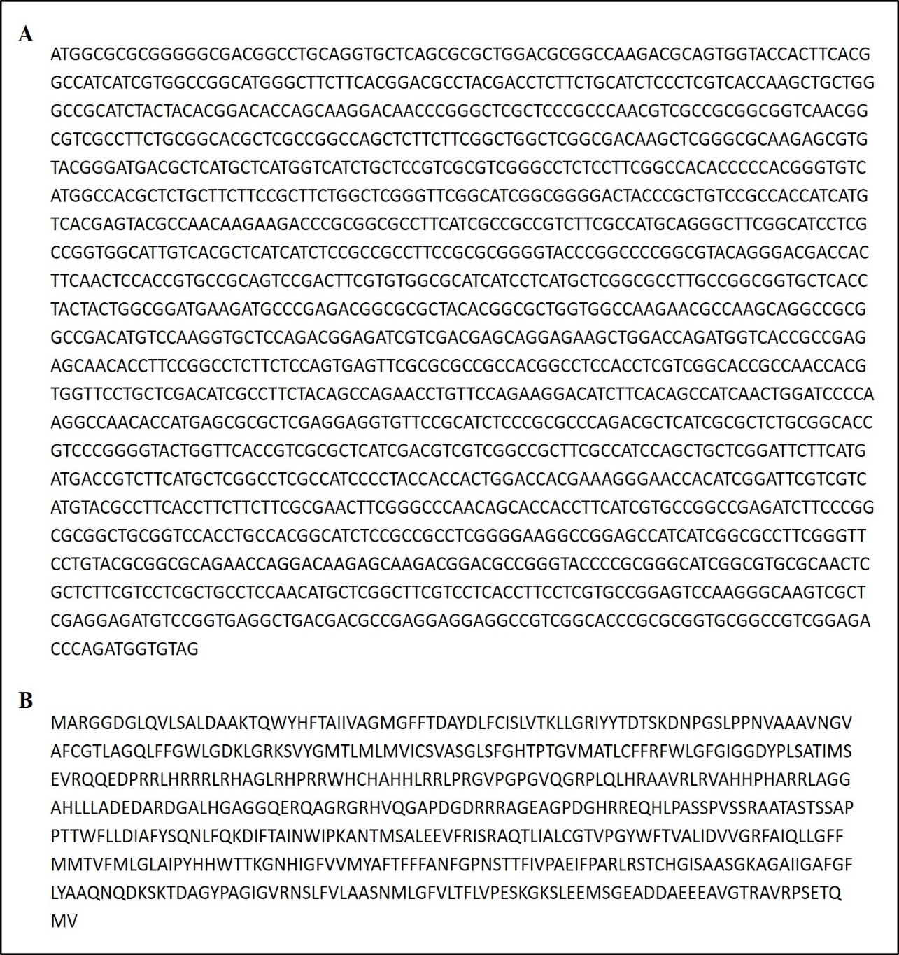

Figure S1. The nucleotide sequence of Erianthus arundinaceus Phosphate transporter 1;2 (EaPHT1;2). (A) The full-length CDS sequence of the EaPHT1;2 gene; (B) The ExPasy-translated protein sequence of the EaPHT1;2.

Figure S2: Physicochemical parameters of the selected protein: (A) Atomic composition of EaPHT1;2 protein, (B) Amino acid composition of EaPHT1;2 protein

Figure S3: Post-translation modification sites of EaPHT1. (A) Phosphorylation sites. (B) Glycosylation site. The amino acids are represented in different lines at their position in the sequence and the scores higher than the threshold value are considered for posttranslational modification.

Figure S4: Protein structure prediction and evaluation. (A) Secondary elements in the EaPHT1 protein predicted using the SOPMA tool. (B) Structural evaluation of EaPHT1;2 obtained through Phyre2 model; (B) EaPHT1;2 obtained through Swiss-Modelling.

Figure S5: Protein-protein Interaction analysis of EaPHT1;2 protein. (A) PPI of EaPHT1;2 with ZmPHT1 protein. (B) PPI of EaPHT1;2 with AtPHT protein. (C) PPI of EaPHT1;2 with SbPHT protein.

.
Figure S6: Subcellular Localization analysis (A) EaPHT1;2 protein localization using online tools DeepLoc analysis (B) QuickGo Term analysis of EaPHT1;2 protein

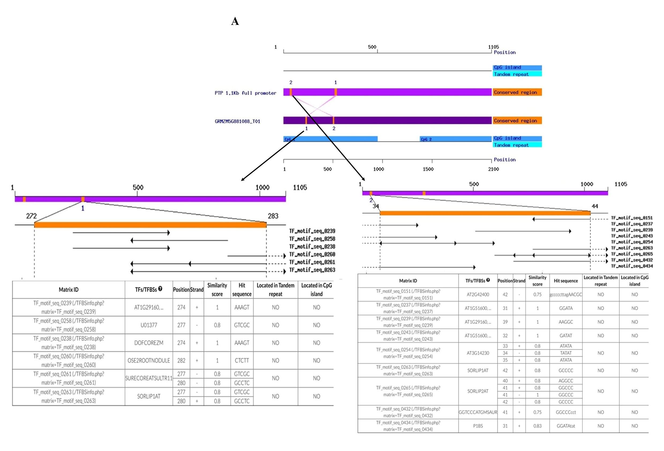
Figure S7: Comparative In-silico analysis of EaPHT1;2 promoter. (A) The EaPHT1;2 promoter conserved regions awith ZmPHT1 and (B) One conserved region was ShPHT1;2 promoter regions.

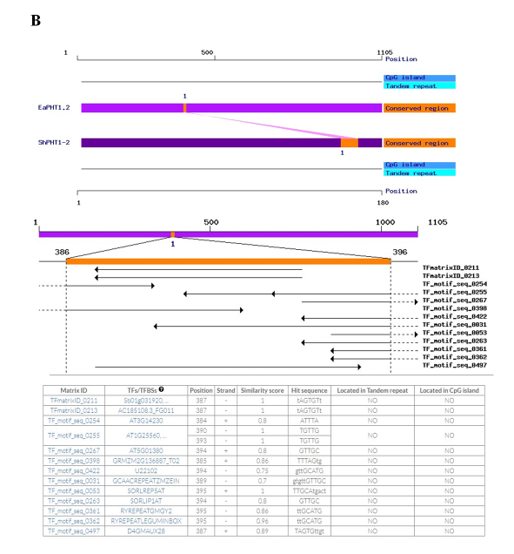
Figure S8: Comparative In-silico analysis of EaPHT1;2 promoter. (A) The EaPHT1;2 promoter conserved regions awith ZmPHT1 and (B) One conserved region was ShPHT1;2 promoter regions.
Table S1: List of primer sequences used in this study for EaPHT1-2 gene isolation, promoter isolation, promoter deletion constructs, and analysis.
Primers | Name | Primer sequence
Gene Isolation Primer | GPHT1F | ATGGCGCGCGGCGGGGACGGCCTGCA
Gene Isolation Primer | GPHT1R | CTACACCATCTGGGTCCCCGACGGC
Primary PCR Primer | ASP I | GGATCCTAATACGACTCACTATAGGGC
Primary PCR Primer | pPHT R1 | TAGTAGATGCGGCCGAGCAGC
Secondary PCR Primer | ASP II | AATAGGGCTCGAGCGGC
Secondary PCR Primer | pPHT R2 | CCCATGCCGGCGATGACGATG
Promoter-specific primers | pFL F | CGCAAGCTTAAGGCCCCCTTAGAACGCG
Promoter-specific primers | pFL R | TAAACCATGGGGTCGCTGCACC
GUS-specific Primers | GUS F | GGAATGGTGATTACCGACG
GUS-specific Primers | GUSR | ATACCTGTTCACCGACGACG
Deletion Primers  (For all deletion Reverse primer is the same) | EaPHT-pD1 F | CGCAAGCTTAGTGTTGTTGCATGACTG
 | EaPHT-pD2 F | CGCAAGCTTAGCATCTCCATCTAACCACCA
 | EaPHT-pD3 F | CGCAAGCTTAAGGCCCCCTTAGAACGCG
 | EaPHT-pD4 F | CGCAAGCTTAGTGTTGTTGCATGACTG
 | EaPHT-pD5 F | CGCAAGCTTAGCATCTCCATCTAACCACCA
 | pFL R | TAAACCATGGGGTCGCTGCACC

Table S2: Physicochemical characteristics of the EaPHT1;2 protein

Properties | Value
No. of amino acids | 542
Molecular weight | 58940.73
Theoretical pI | 9.8
No. of negatively charged residues (Asp + Glu) | 38
No. of positively charged residues (Arg + Lys) | 55
Total number of atoms | 8262
Extinction Coefficient (all pairs of Cys residues form cysteines) | 62255
Extinction Coefficient (all Cys residues are reduced) | 61880
Half-life (in vitro) (h) | 30
Instability index (II) | 43.1
Aliphatic index | 82.71
Grand average of hydropathicity | 0.019

Table S3: Subcellular localization of EaPHT1-2 gene in different locations
Localization | Likelihood
Cell membrane | 0.3897
Lysosome/Vacuole | 0.31
Endoplasmic reticulum | 0.2102
Golgi apparatus | 0.083
Mitochondrion | 0.0063
Peroxisome | 0.0005
Plastid | 0.0002
Nucleus | 0.0001
Extracellular | 0
Cytoplasm | 0

