This document is prepared to prove the process of the data gathering which three sample has studied with qualitative case study and the interview which has taken from these organization were in open ended question and there was a set predefined question that the data has been gathered through these questions.
In this document we are putting those questionnaire samples that are conducted and verified by the organization which the research has been conducted.
Data gathering in ANS ISP the first sample interview with IT expert Nasratullah Walizada.
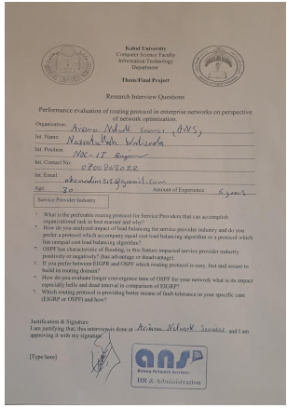
Data gathering in ANS ISP the first sample interview with IT expert Rohullah Habibzedah.
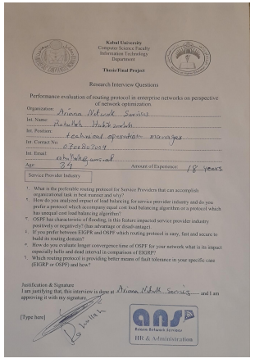

Data gathering in Miwand Bank the first sample interview with IT expert Shakib Kamal.
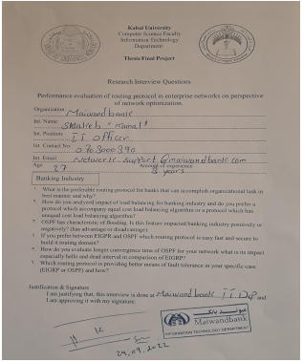

Data gathering in Miwand Bank the first sample interview with IT expert Nabiullah Amarkil.
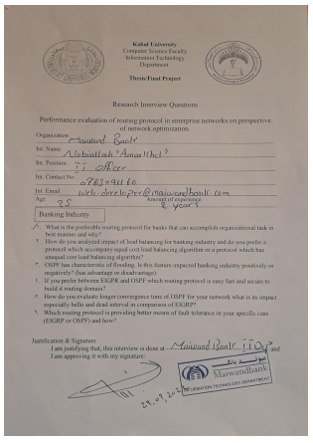
Data gathering in FMIC hospital the first sample interview with IT expert Abdul Jabar Amiri.
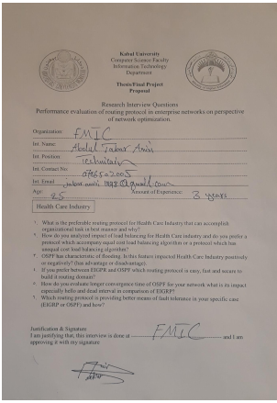

Data gathering in FMIC hospital the first sample interview with IT expert Ahwadullah Madadi.
