Figure 2. Significant Social Networks Map for the research participants.

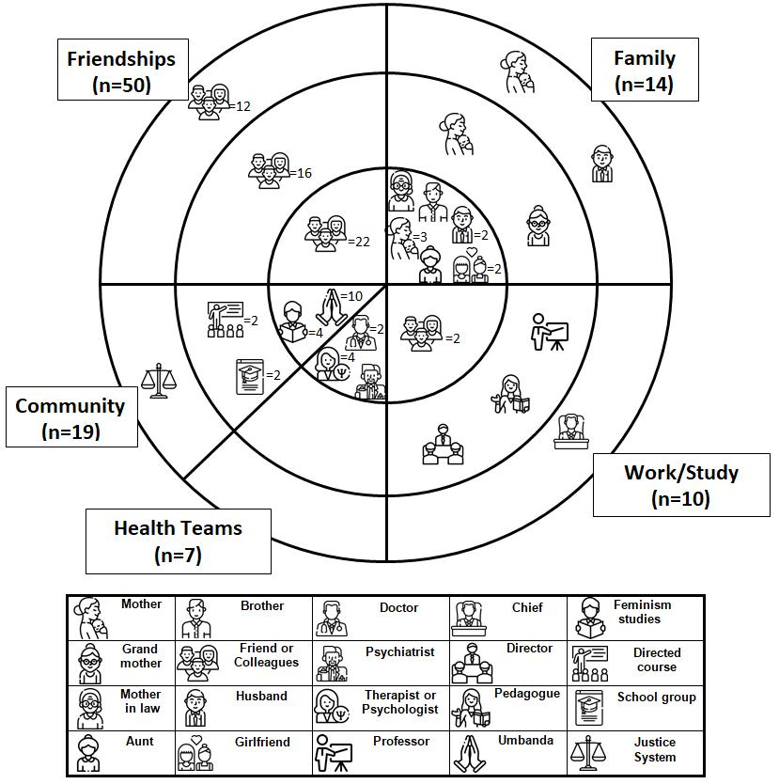

4.

