Improving the biogas production and methane yield in an UASB reactor with the addition of sulfate
D. Theodosi Palimeri¹, Konstantina Papadopoulou¹, A.G. Vlyssides¹ and A.A. Vlysidis^{1*}
Supplementary information document
- Number of publications investigating the effect of sulfur in anaerobic digestion over the years
The presence of sulfate in anaerobic digestion has gained significant interest over the last years. Using the Scopus database, we conducted a search with the keywords ("reactor") AND ("sulfur" OR "sulfate") AND ("anaerobic digestion"), resulting in 550 publications since 2000. Notably, there has been an upward trend in research on sulfur presence in anaerobic reactors, with 36% of the total publications emerging in the last 5 years. Figure S1 illustrates the number of publications investigating the effect of sulfur in anaerobic reactors over the last 23 years.
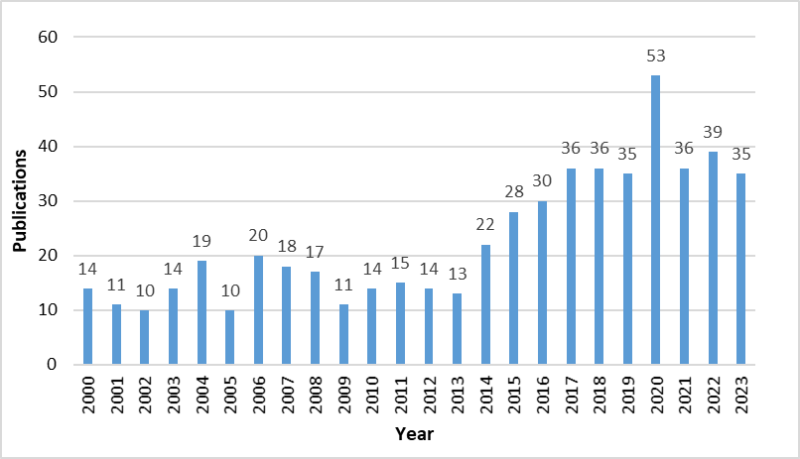
Figure S1. Number of publications investigating the effect of sulfur in anaerobic reactors over the last 23 years.
- Microbial community diversity in the UASB reactor.
The following figures (S1 A, S1 B, S2) represent the microbial community in the reactor. The figures are presented in the main article, but here they have been enlarged to show the labels indicating the microbial diversity more clearly.

Figure S1 A. Krona graph showing microbial community in the reactor. Graph A corresponds to the sample collected before the addition of sulfate to the substrate (day 85th).
A

Figure S1 B. Krona graph showing microbial community in the reactor Graph B corresponds to the sample collected after the addition of sulfate (day 170th).
B

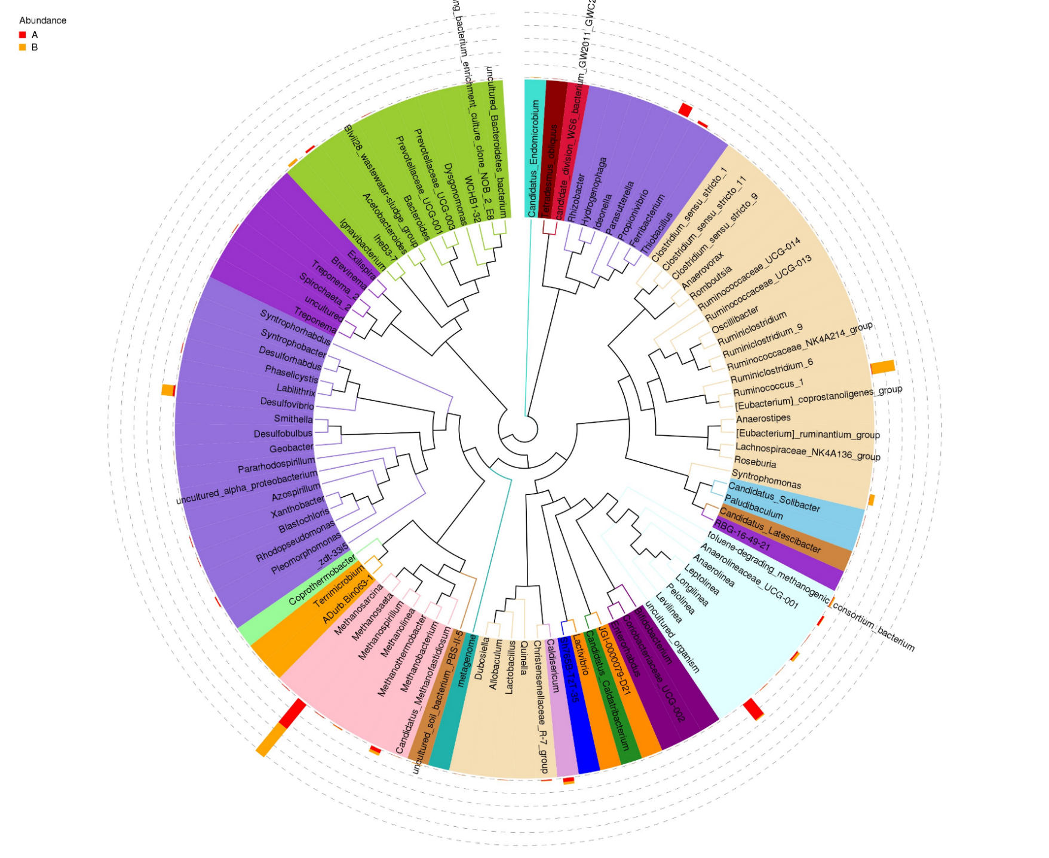
Figure S2. The distribution of the top 100 genera and the relative abundance for the 2 samples. Sample A (labeled with red color) was collected before the sulfate addition. Sample B (labeled with orange color) was collected after the sulfate addition.

