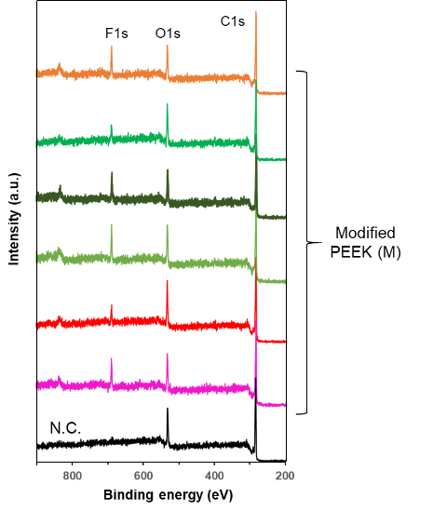
Figure S1. XPS spectral results of N.C. and all M group samples. Clear F1s signals are observed in all M group samples.
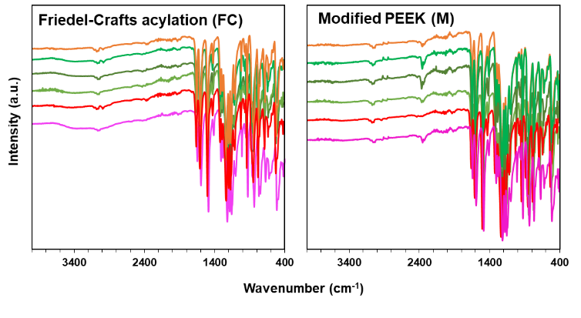
Figure S2. FT-IR results for all FC and M group samples. The same color indicates that the samples correspond between FC and M, respectively. The absorption bands appeared in the wavenumber region at approximately 3300–3500 cm⁻¹ , whtch are observed in the FC group, while they disappeared or weakened in all M group samples.

