Supplementary Materials:

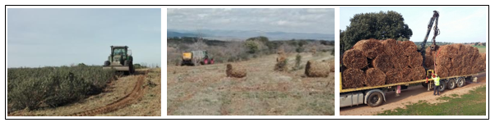
(a) (b) (c)
Figure S1: (a) Biomass collection with a harvester-baler in Soria, Spain; (b) Rockrose bales; (c) Logging truck loading bales

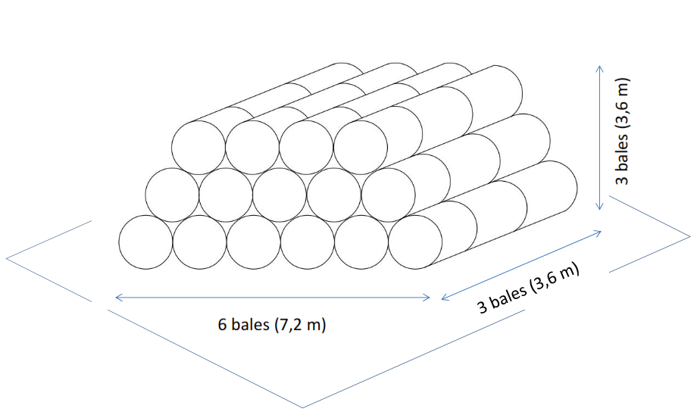
Figure S2: Stored rockrose bales for biomass dry matter variation study at CEDER-CIEMAT

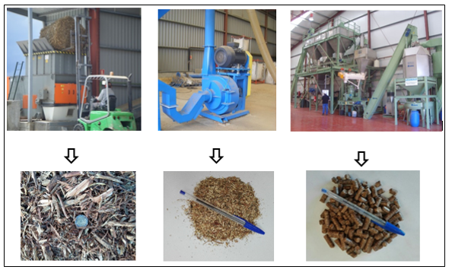
Figure S3: Pre-shredder (90 kW) and 30 mm milled rockrose (left); Post-grinder (75 kW) and 4 mm milled rockrose (center); Pelletisation pilot plant (30 kW) and Ø 8 mm rockrose pellets (right). Installations located at CEDER-CIEMAT (Soria)

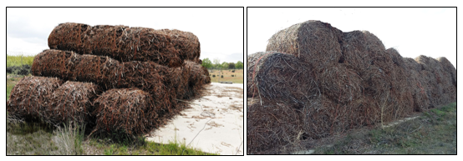
(a) | (b)
Figure S4: (a) Rockrose bale pile B at the time of stacking; (b) Rockrose bale pile B after the storage period (right)

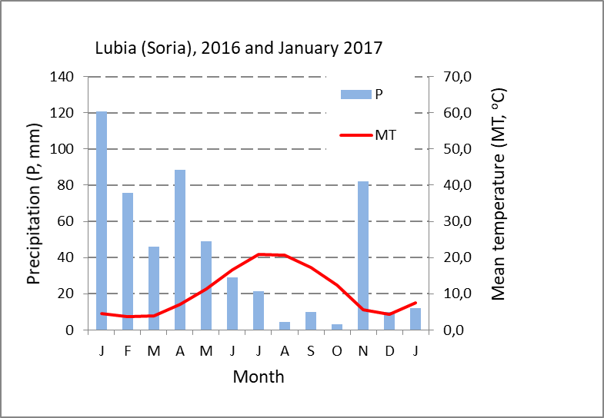
Figure S5. Bioclimatic diagram of CEDER (Lubia) during the storage period. Source: Lubia Weather Station data (Soria)

