Supplementary Materials
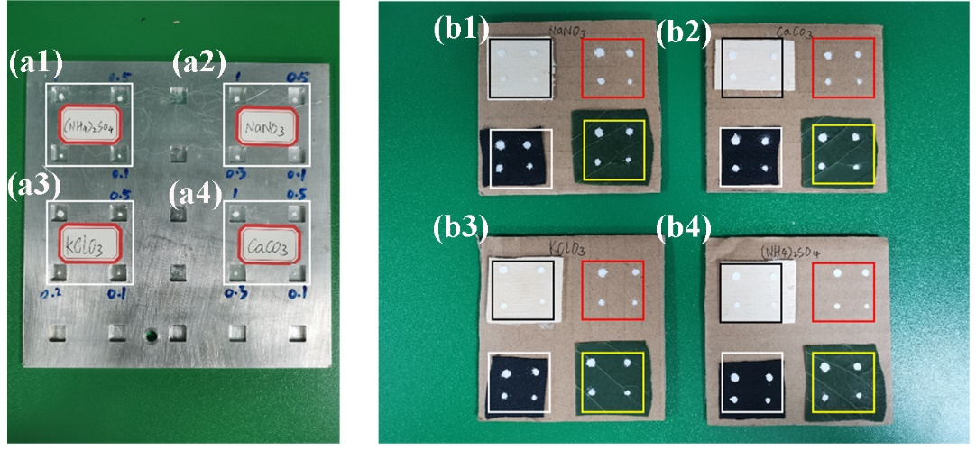
Figure S1. Photographs of the (a1) (NH₄)₂SO₄, (a2) NaNO₃, (a3) KClO₃, and (a4) CaCO₃ on aluminum plate substrate. Photographs of the (b1) NaNO₃, (b2) CaCO₃, (b3) KClO₃, and (b4) (NH₄)₂SO₄ on woodblock (black rectangle), paperboard (red rectangle), black cloth (white rectangle), and leaf (yellow rectangle) substrate.
Figure S2. Mean Raman spectra for (a) 0.3 mg, (b) 0.5 mg, and (c) 1 mg of KClO₃ on woodblock (black line), paperboard (red), cloth (green), leaves (blue), and aluminum plate (royal blue) substrate for a remote distance of 10 m.
Figure S3. Mean Raman spectra for (a) 0.3 mg, (b) 0.5 mg, and (c) 1 mg of NaNO₃ on woodblock (black line), paperboard (red), cloth (green), leaves (blue), and aluminum plate (royal blue) substrate for a remote distance of 10 m.
Figure S4. Mean Raman spectra for (a) 0.3 mg, (b) 0.5 mg, and (c) 1 mg of CaCO₃ on woodblock (black line), paperboard (red), cloth (green), leaves (blue) and aluminum plate (royal blue) substrate for a remote distance of 10 m.
Figure S5. Mean Raman spectra for (a) 0.3 mg, (b) 0.5 mg, and (c) 1 mg of (NH₄)₂SO₄ on woodblock (black line), paperboard (red), cloth (green), leaves (blue), and aluminum plate (royal blue) substrate for a remote distance of 10 m.

