Supporting Information
Four new diterpenoids from the South China Sea soft coral Sinularia nanolobata and DFT-based structure elucidation
Dan-Dan Yu ¹, Lin-Mao Ke ¹, Jiao Liu ², Song-Wei Li ³, Ming-Zhi Su ⁴, Li-Gong Yao ^{2,4}, H. Luo ^{1,}*, and Yue-Wei Guo ^{2,3,4,}*
¹ College of Pharmacy, Guangdong Medical University, Zhanjiang, Guangdong, 524023, China; ddyu@baridd.ac.cn (D.D.Y.), 1195104711@qq.com (L.M.K.), luohui@gdmu.edu.cn (H.L.)
² State Key Laboratory of Drug Research, Shanghai Institute of Materia Medica, Chinese Academy of Sciences, Shanghai 201203, China; 201728012342081@simm.ac.cn (J.L.), yaoligong@simm.ac.cn (L.G.Y.) ywguo@simm.ac.cn (Y.W.G.)
³ School of Medicine, Shanghai University, Baoshan District, Shanghai 200444, China; simmswli@163.com (S.W.L.)
⁴ Shandong Laboratory of Yantai Drug Discovery, Bohai Rim Advanced Research Institute for Drug Discovery, Yantai, Shandong 264117, China; smz0310@163.com (M.Z.S.)
* Correspondence: luohui@gdmu.edu.cn (H.L.); ywguo@simm.ac.cn (Y.W.G.)

Content
- Original spectra of 1 3
Figure S1a. ¹H NMR spectrum (600 MHz) of 1 in CDCl₃ 3
Figure S1b. DEPT135/¹³C NMR spectrum (150 MHz) of 1 in CDCl₃ 3
Figure S1c. HSQC spectrum (600 MHz) of 1 in CDCl₃ 4
Figure S1d. ¹H-¹H COSY spectrum of (600 MHz) 1 in CDCl₃ 4
Figure S1e. HMBC spectrum (600 MHz) of 1 in CDCl₃ 5
Figure S1f. NOESY spectrum (600 MHz) of 1 in CDCl₃ 5
Figure S1g. HR-EIMS of 1 6
Figure S1h. IR spectrum of 1 6
Figure S1i. ECD and UV spectra of 1 7
- Original spectra of 2 8
Figure S2a. ¹H NMR spectrum (600 MHz) of 2 in CDCl₃ 8
Figure S2b. DEPT135/¹³C NMR spectrum (150 MHz) of 2 in CDCl₃ 8
Figure S2c. HSQC spectrum (600 MHz) of 2 in CDCl₃ 9
Figure S2d. ¹H-¹H COSY spectrum (600 MHz) of 2 in CDCl₃ 9
Figure S2e. HMBC spectrum (600 MHz) of 2 in CDCl₃ 10
Figure S2f. NOESY spectrum (600 MHz) of 2 in CDCl₃ 10
Figure S2g. HR-EIMS of 2 11
Figure S2h. IR spectrum of 2 11
Figure S2i. ECD and UV spectra of 2 12
- Original spectra of 3 13
Figure S3a. ¹H NMR spectrum (600 MHz) of 3 in CDCl₃ 13
Figure S3b. DEPT135/¹³C NMR spectrum (150 MHz) of 3 in CDCl₃ 13
Figure S3c. HSQC spectrum (600 MHz) of 3 in CDCl₃ 14
Figure S3d. ¹H-¹H COSY spectrum (600 MHz) of 3 in CDCl₃ 14
Figure S3e. HMBC spectrum (600 MHz) of 3 in CDCl₃ 15
Figure S3f. NOESY spectrum (600 MHz) of 3 in CDCl₃ 15
Figure S3g. HR-EIMS of 3 16
Figure S3h. IR spectrum of 3 16
Figure S3i. ECD and UV spectra of 3 17
- Original spectra of 4 18
Figure S4a. ¹H NMR spectrum (600 MHz) of 4 in CDCl₃ 18
Figure S4b. DEPT135/¹³C NMR spectrum (150 MHz) of 4 in CDCl₃ 18
Figure S4c. HSQC spectrum (600 MHz) of 4 in CDCl₃ 19
Figure S4d. ¹H-¹H COSY spectrum (600 MHz) of 4 in CDCl₃ 19
Figure S4e. HMBC spectrum (600 MHz) of 4 in CDCl₃ 20
Figure S4f. NOESY spectrum (600 MHz) of 4 in CDCl₃ 20
Figure S4g. HR-EIMS of 4 21
Figure S4h. IR spectrum of 4 21
Figure S4i. ECD and UV spectra of 4 21
- QM-NMR calculation and DP4+ analysis of compound 3 22
Figure S5a. Structures of studied isomers for compound 3 22
Figure S5b. DP4+ results obtained using experimental data of 3 versus isomers 1 (3a) and 2 (3b) 22
- TDDFT-ECD calculations of compounds 1-4 23
Figure S6a. Experimental ECD curve of 1, and calculated ECD spectrum of (12S)-1 23
Figure S6b. Experimental ECD curve of 2, and calculated ECD spectrum of (11R,12R)-2 23
Figure S6c. Experimental ECD curve of 3, and calculated ECD spectrum of (4S,10R,12R)-3 24
Figure S6d. Experimental ECD curve of 4, and calculated ECD spectrum of (1S, 2R)-4 24
Figure S6e. Re-optimized conformers of (12S)-1 calculated at the B3LYP/6-311G(d,p) level with IEFPCM solvent model for acetonitrile. 27
Figure S6f. Re-optimized conformers of (11R, 12R)-2 calculated at the B3LYP/6-311G(d,p) level with IEFPCM solvent model for acetonitrile. 30
Figure S6g. Re-optimized conformers of (4S, 11R, 12R)-3 calculated at the B3LYP/6-311G(d,p) level with IEFPCM solvent model for acetonitrile. 33
Figure S6h. Re-optimized conformers of (1S, 2R)-4 calculated at the B3LYP/6-311G(d,p) level with IEFPCM solvent model for acetonitrile. 35

- Original spectra of 1
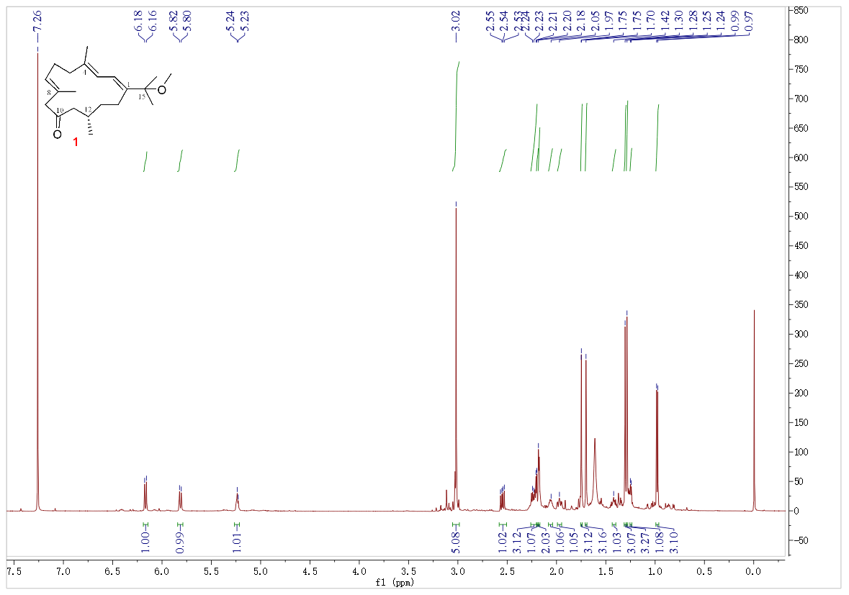
Figure S1a. ¹H NMR spectrum (600 MHz) of 1 in CDCl₃

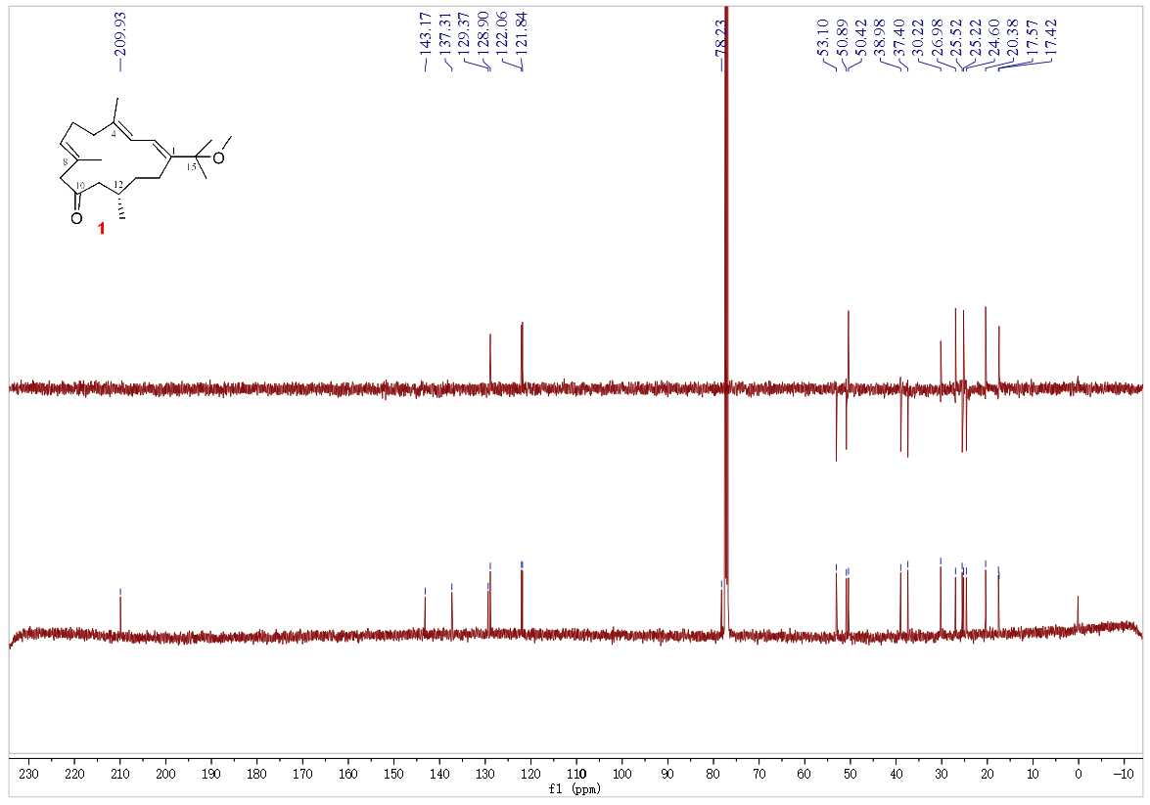
Figure S1b. DEPT135/¹³C NMR spectrum (150 MHz) of 1 in CDCl₃
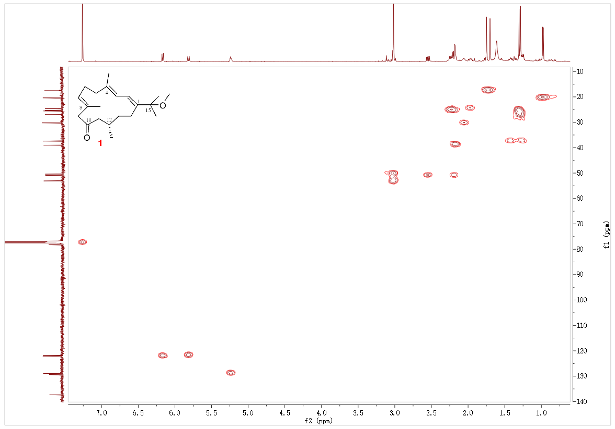
Figure S1c. HSQC spectrum (600 MHz) of 1 in CDCl₃

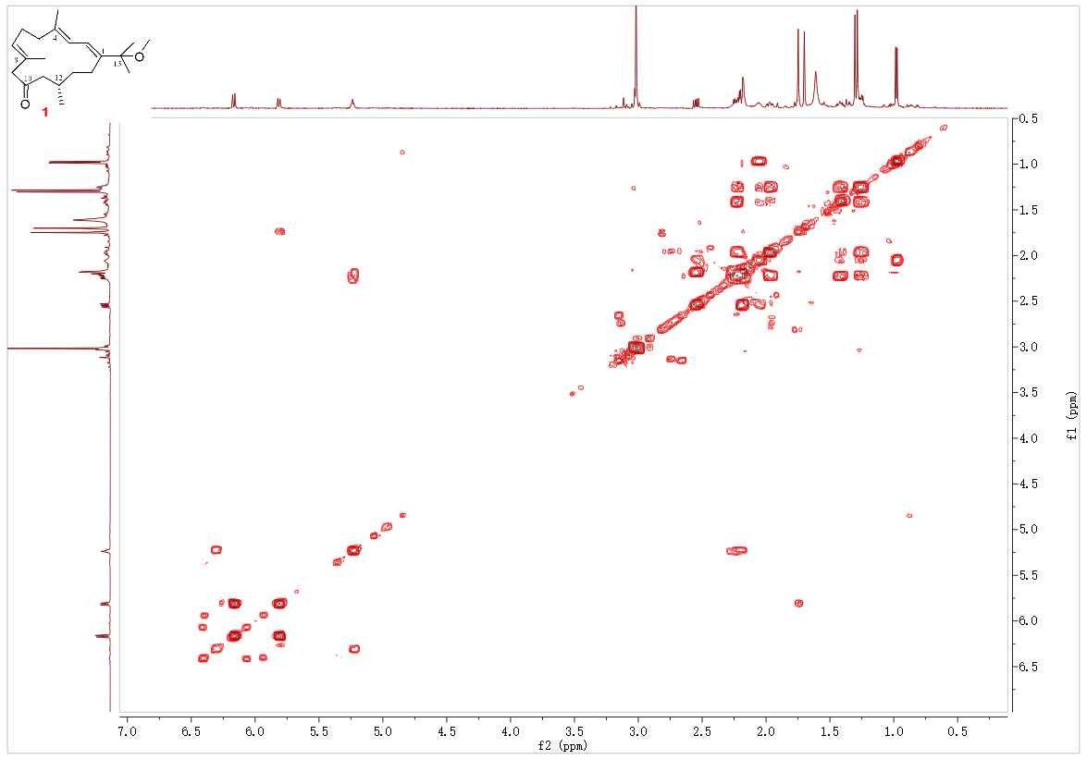
Figure S1d. ¹H-¹H COSY spectrum of (600 MHz) 1 in CDCl₃

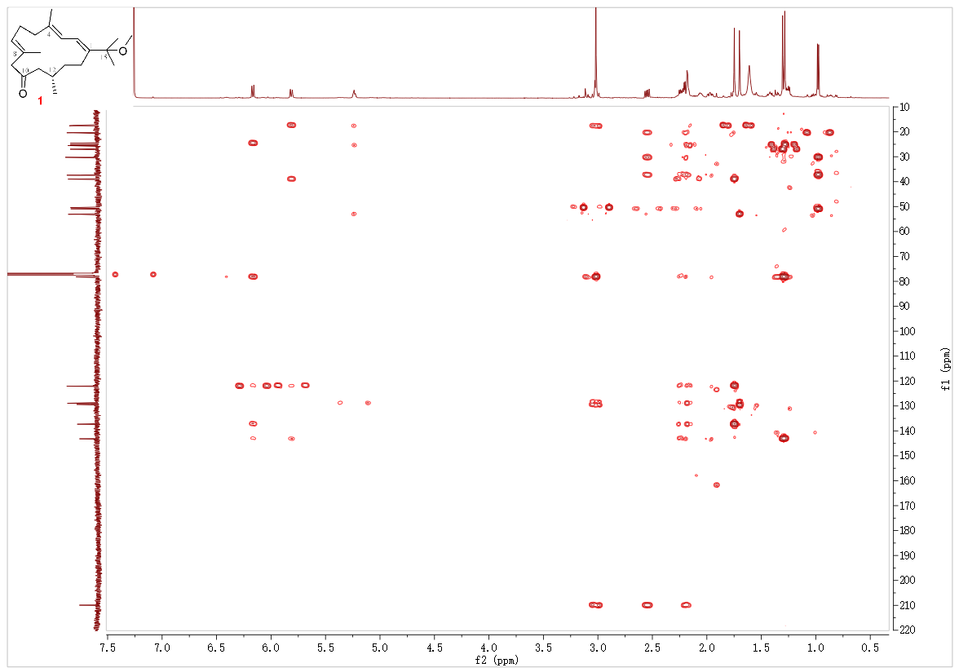
Figure S1e. HMBC spectrum (600 MHz) of 1 in CDCl₃

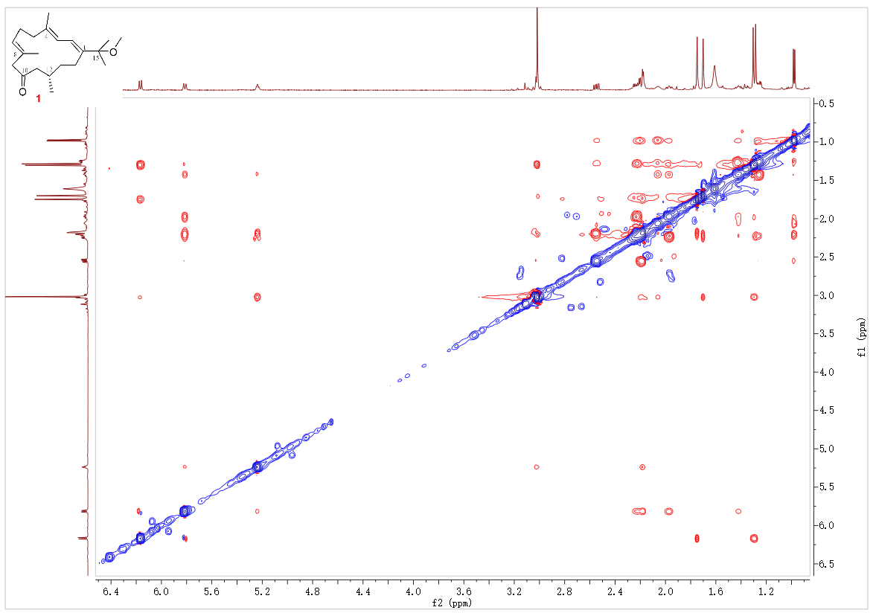
Figure S1f. NOESY spectrum (600 MHz) of 1 in CDCl₃

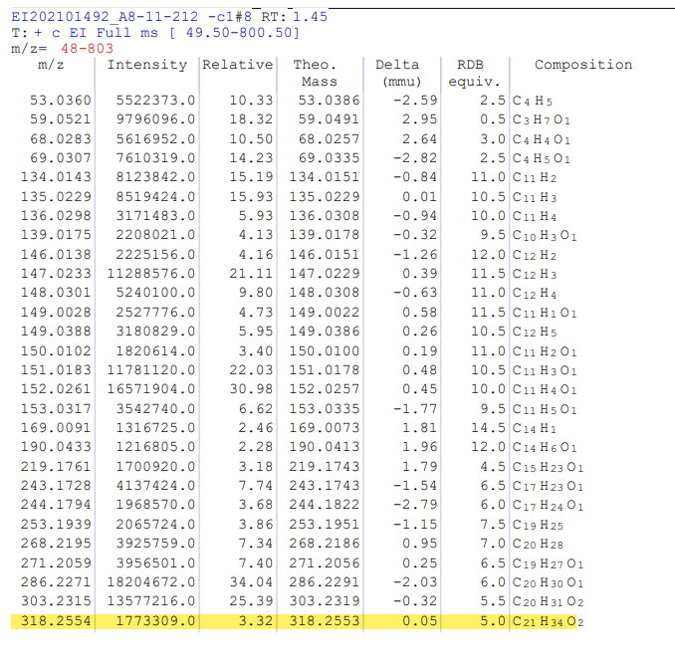
Figure S1g. HR-EIMS of 1

Figure S1h. IR spectrum of 1

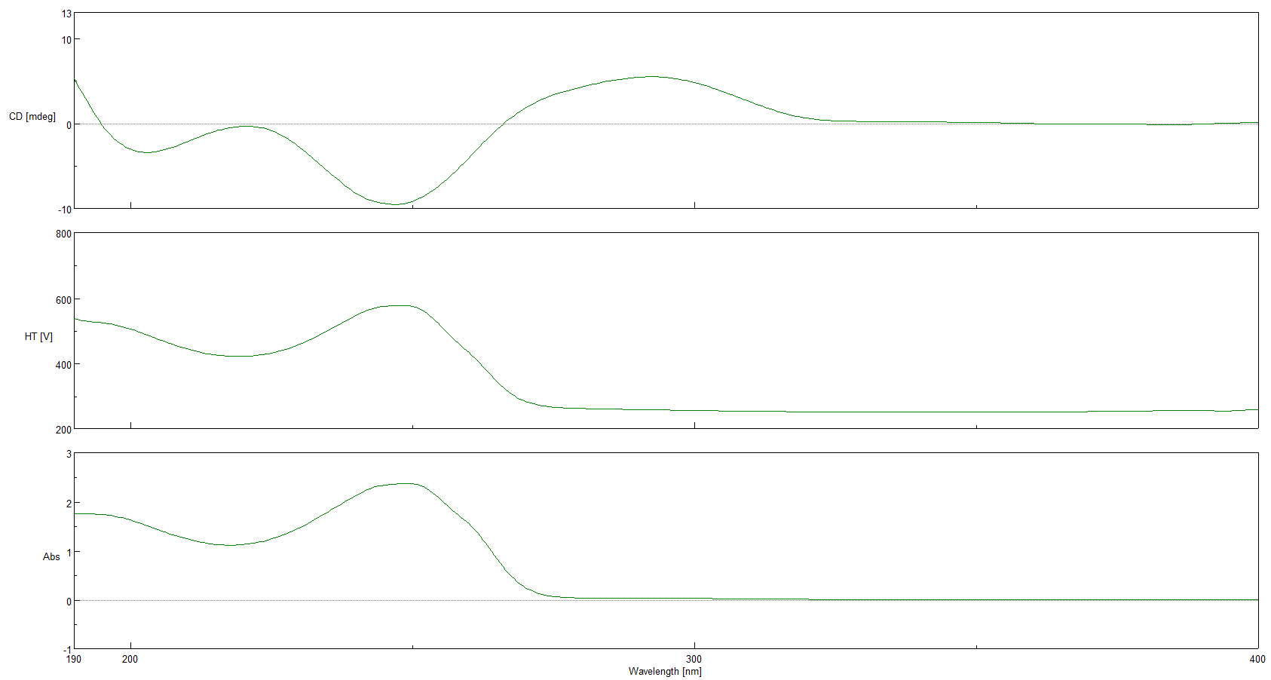
Figure S2i. ECD and UV spectra of 1

- Original spectra of 2
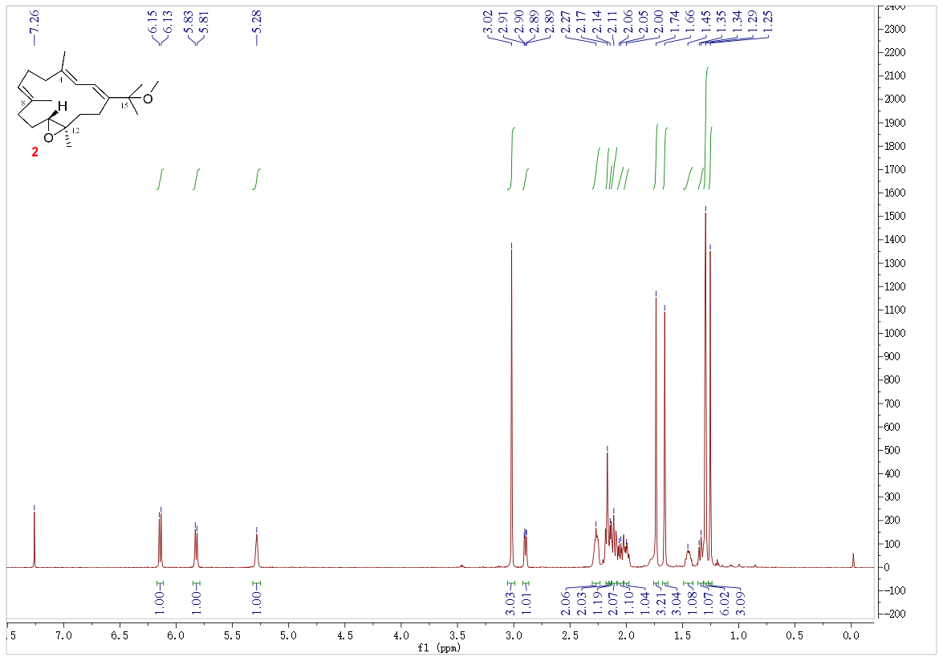
Figure S2a. ¹H NMR spectrum (600 MHz) of 2 in CDCl₃

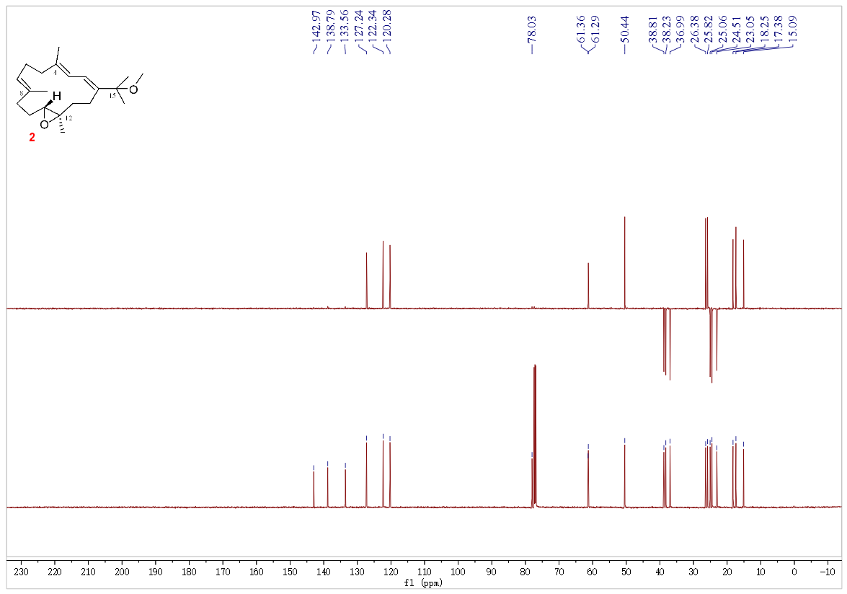
Figure S2b. DEPT135/¹³C NMR spectrum (150 MHz) of 2 in CDCl₃
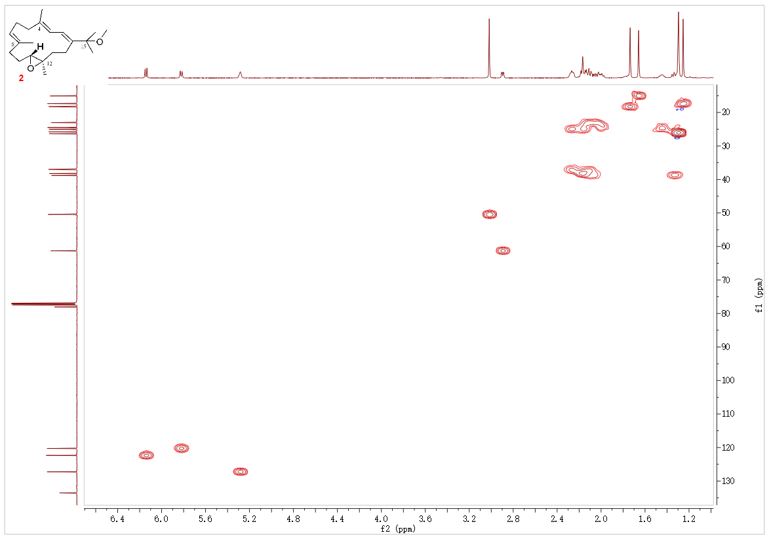
Figure S2c. HSQC spectrum (600 MHz) of 2 in CDCl₃

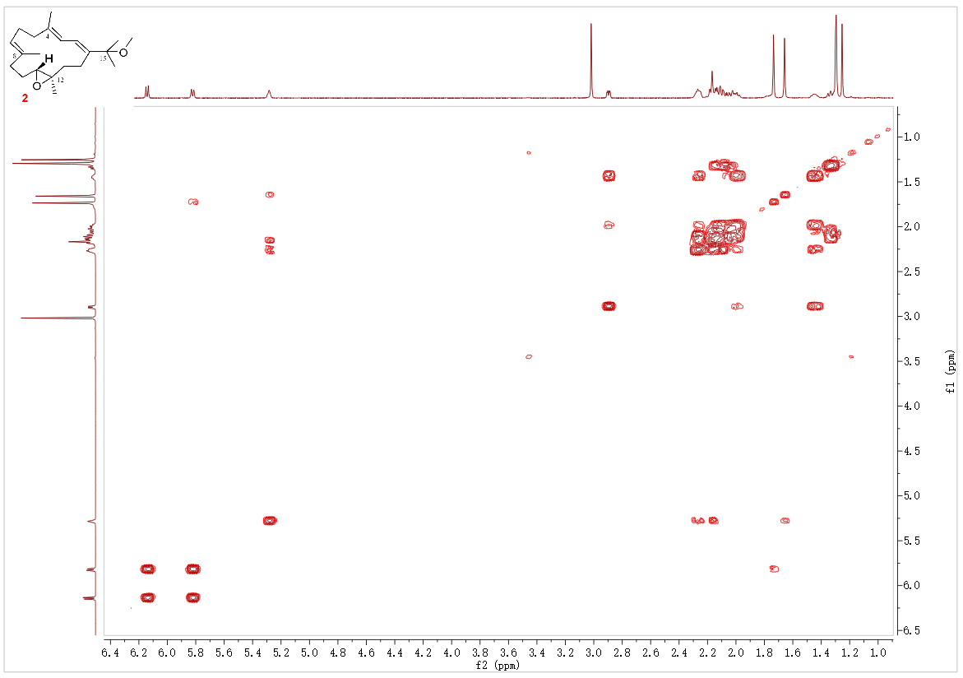
Figure S2d. ¹H-¹H COSY spectrum (600 MHz) of 2 in CDCl₃

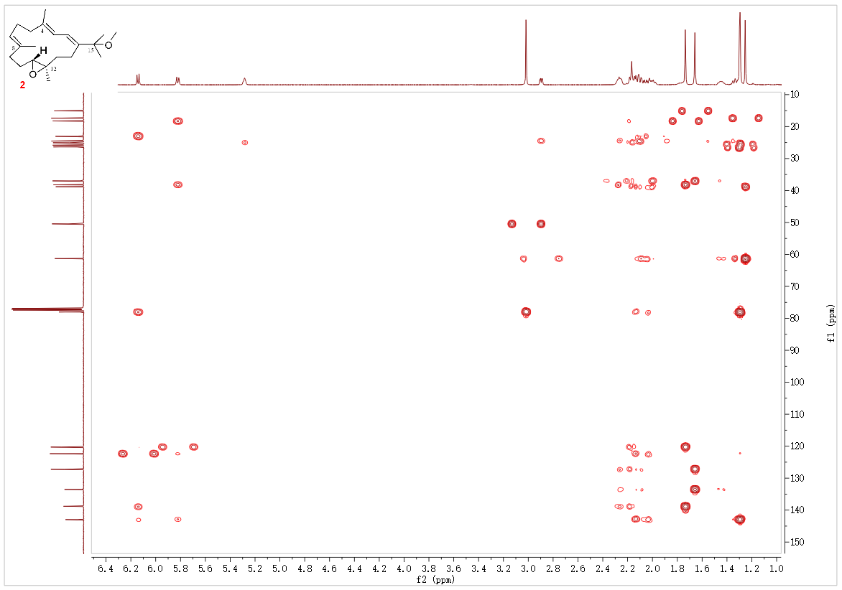
Figure S2e. HMBC spectrum (600 MHz) of 2 in CDCl₃

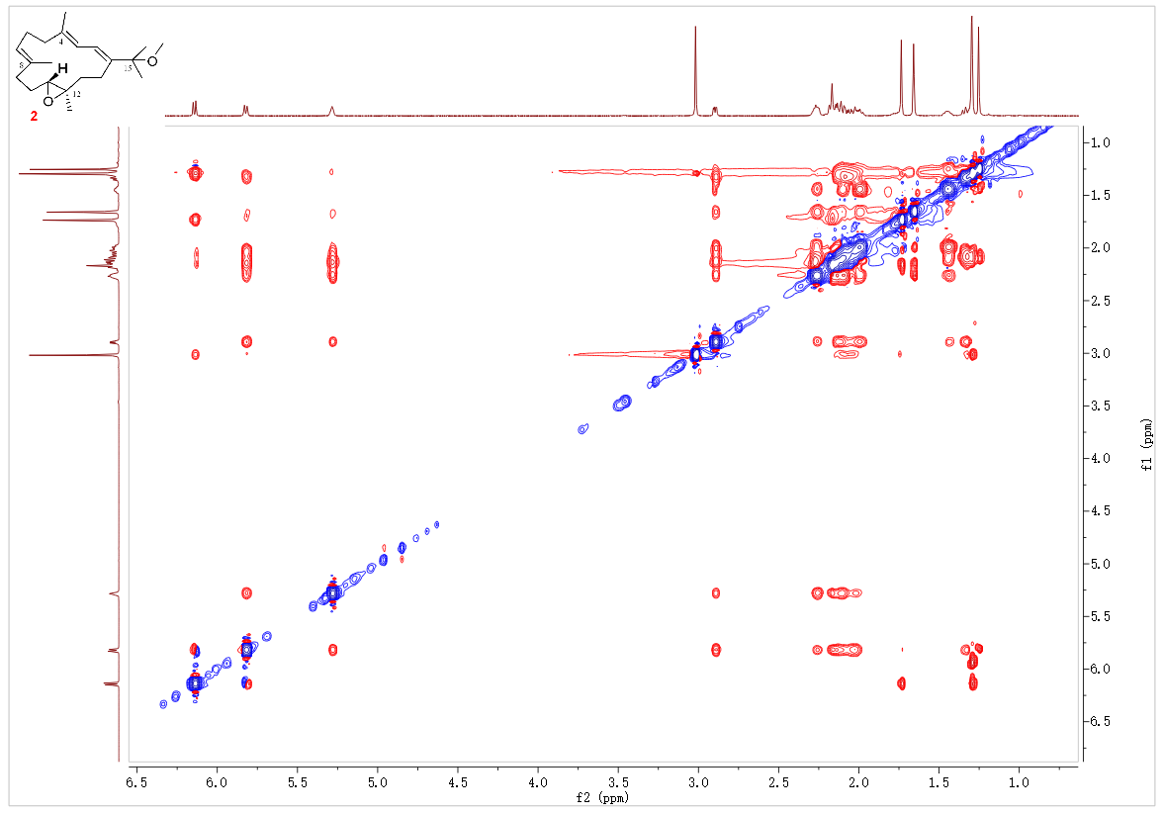
Figure S2f. NOESY spectrum (600 MHz) of 2 in CDCl₃

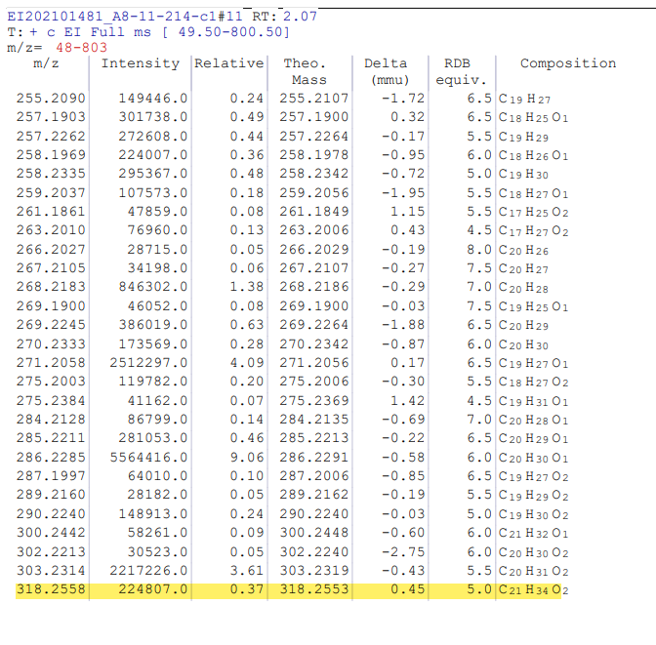
Figure S2g. HR-EIMS of 2

Figure S2h. IR spectrum of 2
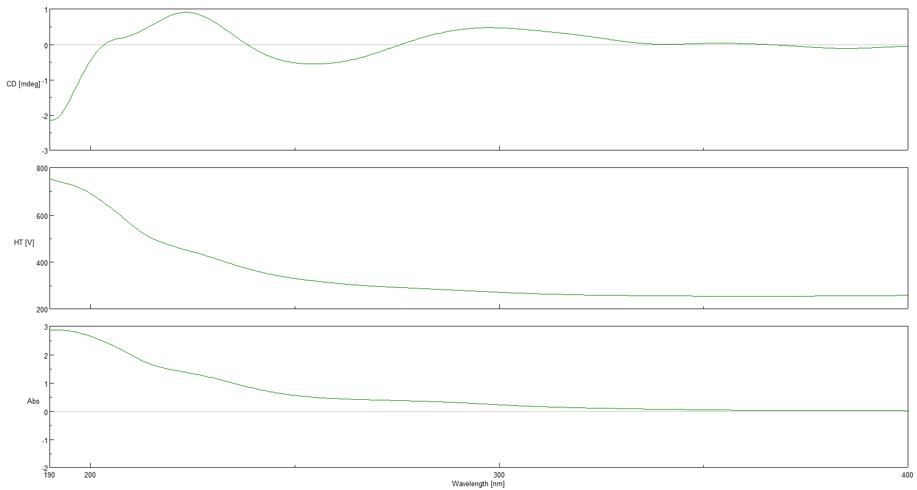
Figure S2i. ECD and UV spectra of 2

- Original spectra of 3
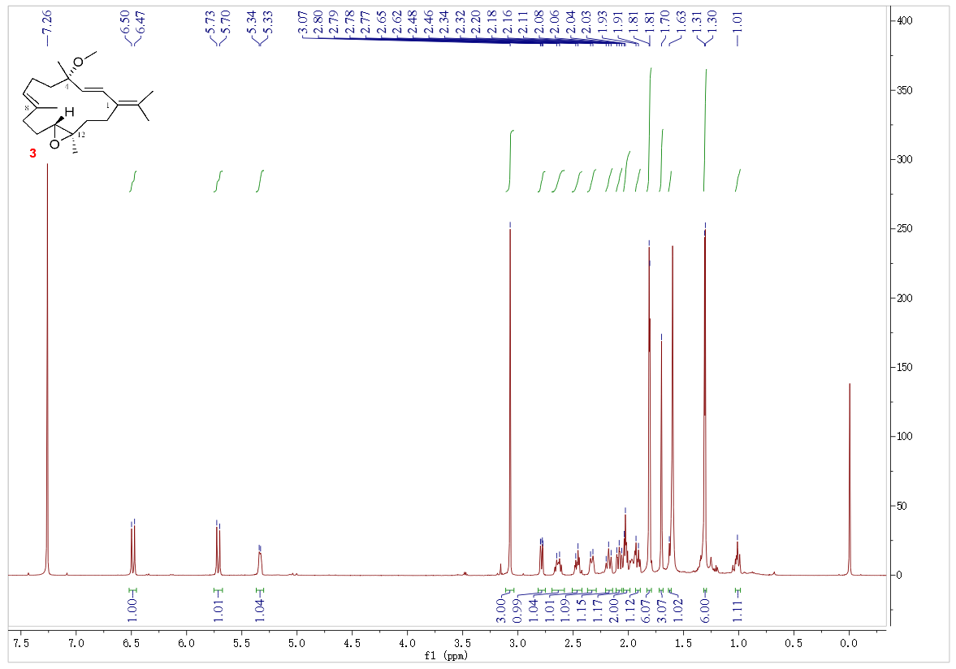
Figure S3a. ¹H NMR spectrum (600 MHz) of 3 in CDCl₃

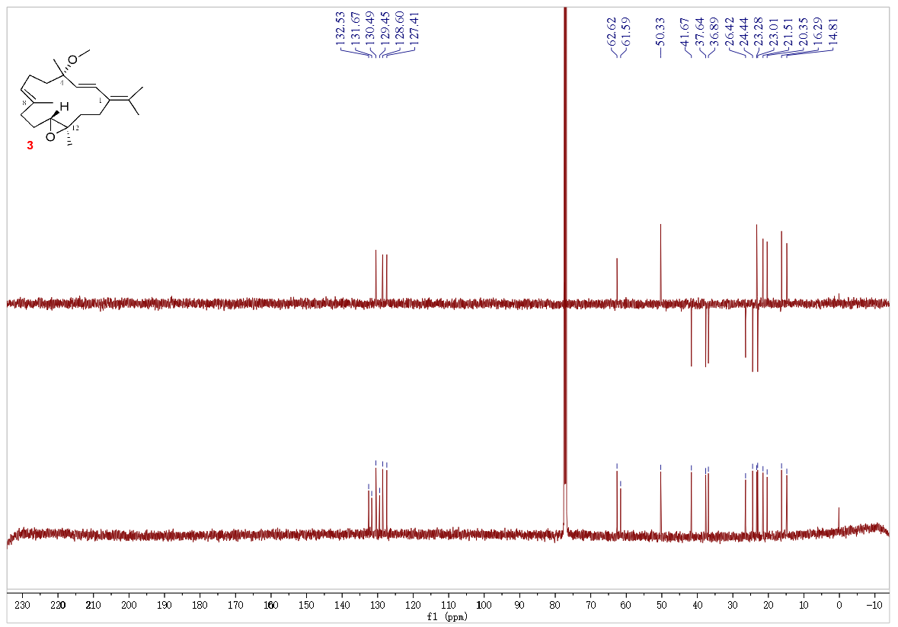
Figure S3b. DEPT135/¹³C NMR spectrum (150 MHz) of 3 in CDCl₃
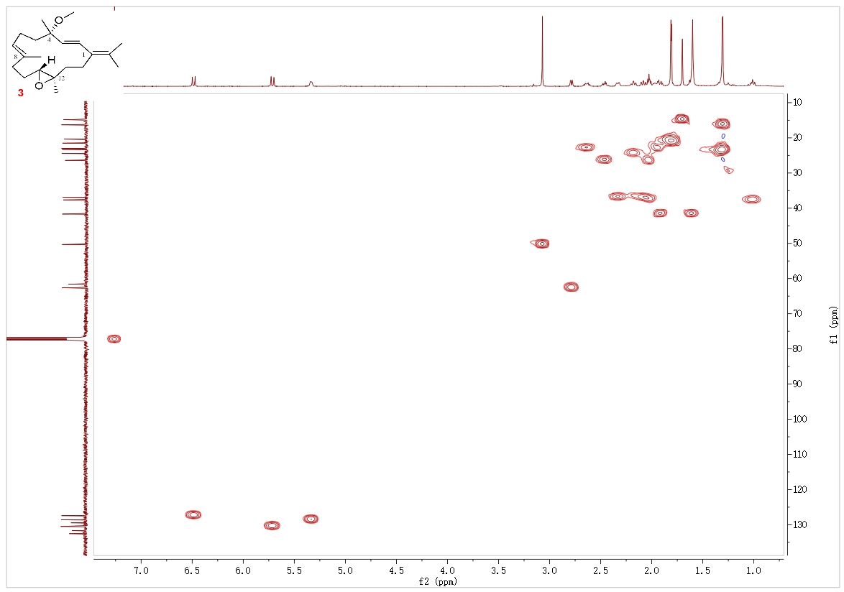
Figure S3c. HSQC spectrum (600 MHz) of 3 in CDCl₃

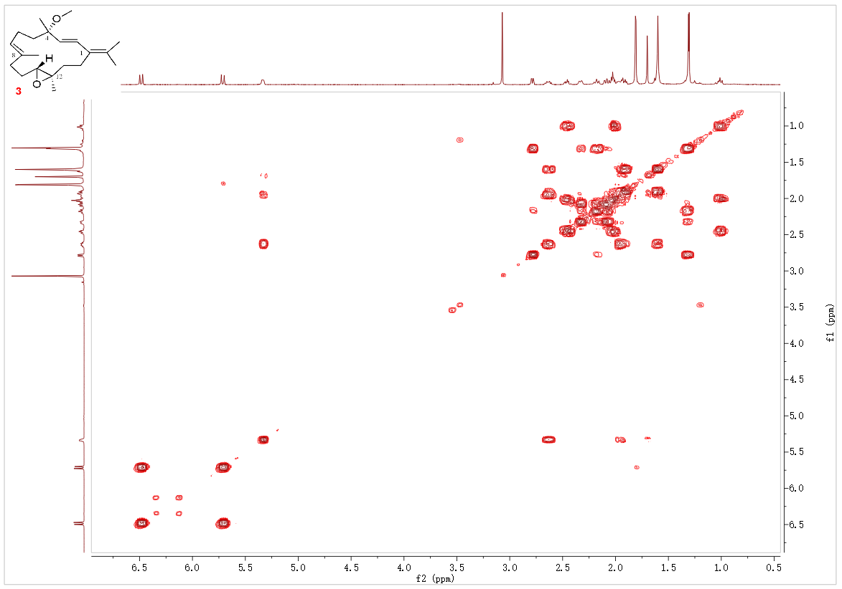
Figure S3d. ¹H-¹H COSY spectrum (600 MHz) of 3 in CDCl₃

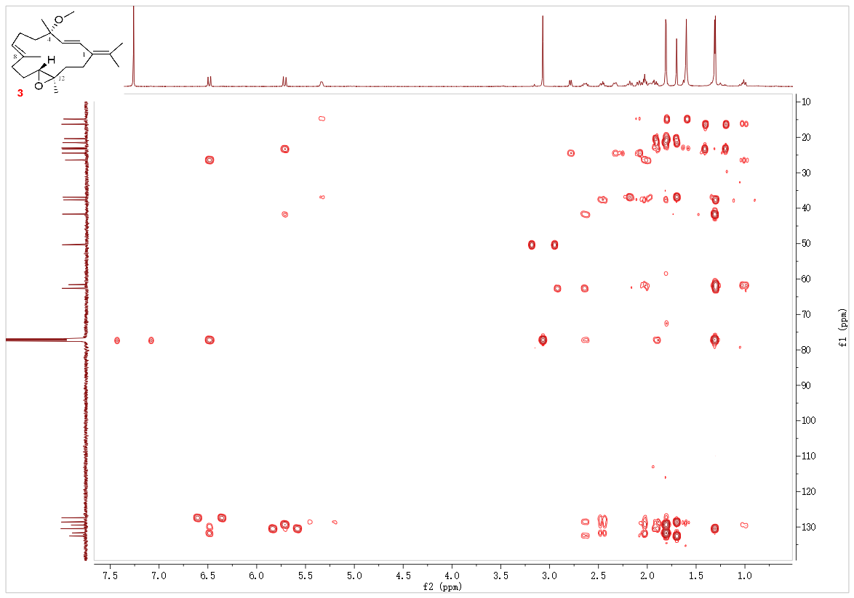
Figure S3e. HMBC spectrum (600 MHz) of 3 in CDCl₃

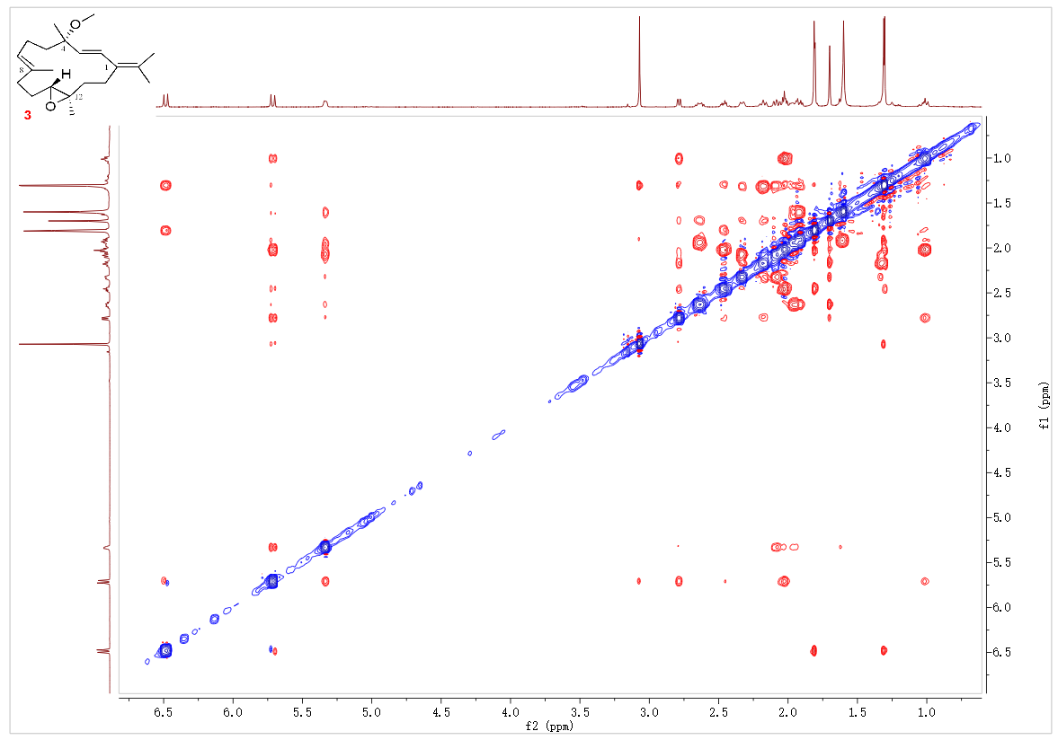
Figure S3f. NOESY spectrum (600 MHz) of 3 in CDCl₃

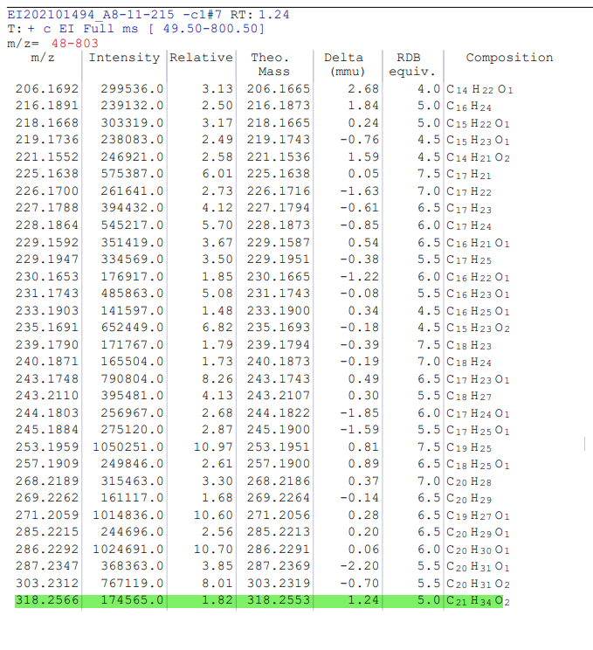
Figure S3g. HR-EIMS of 3

Figure S3h. IR spectrum of 3
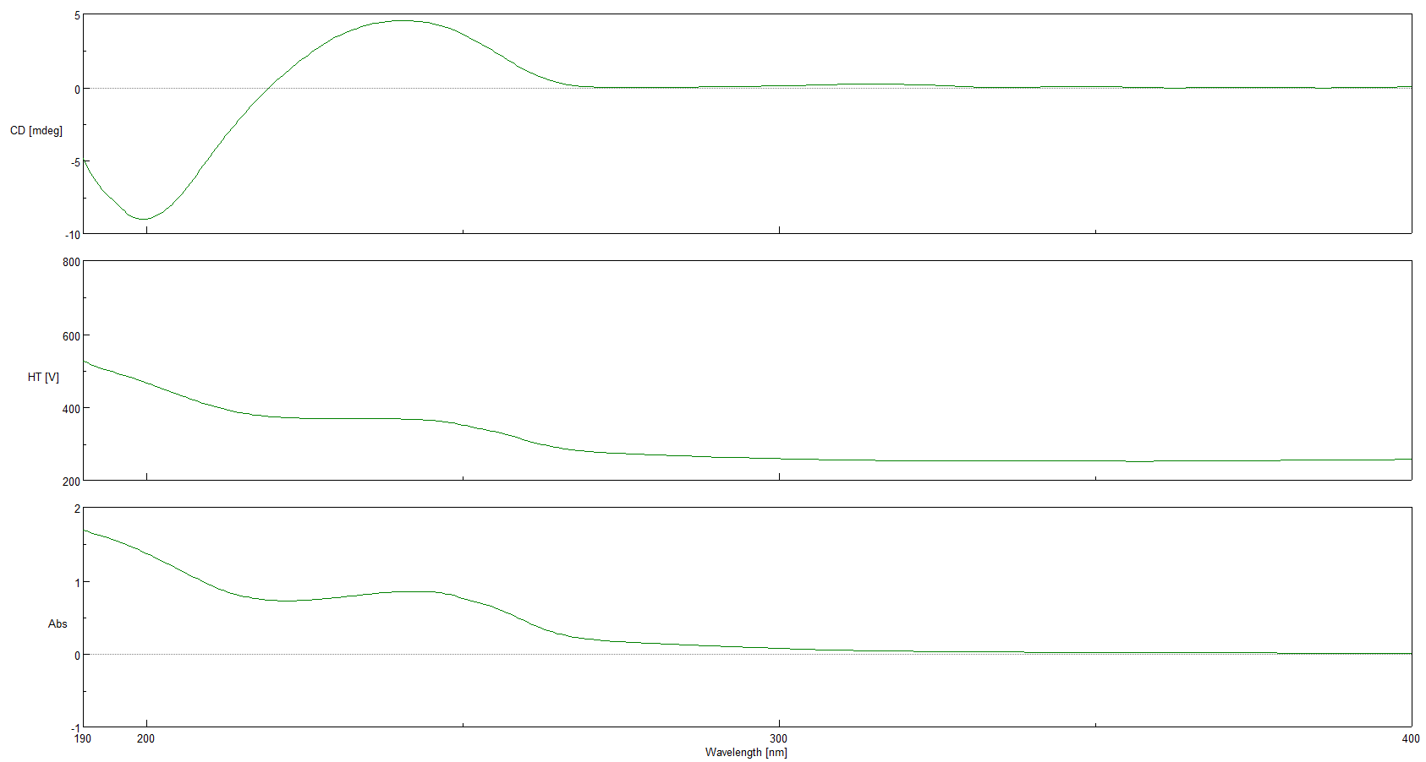
Figure S3i. ECD and UV spectra of 3

- Original spectra of 4
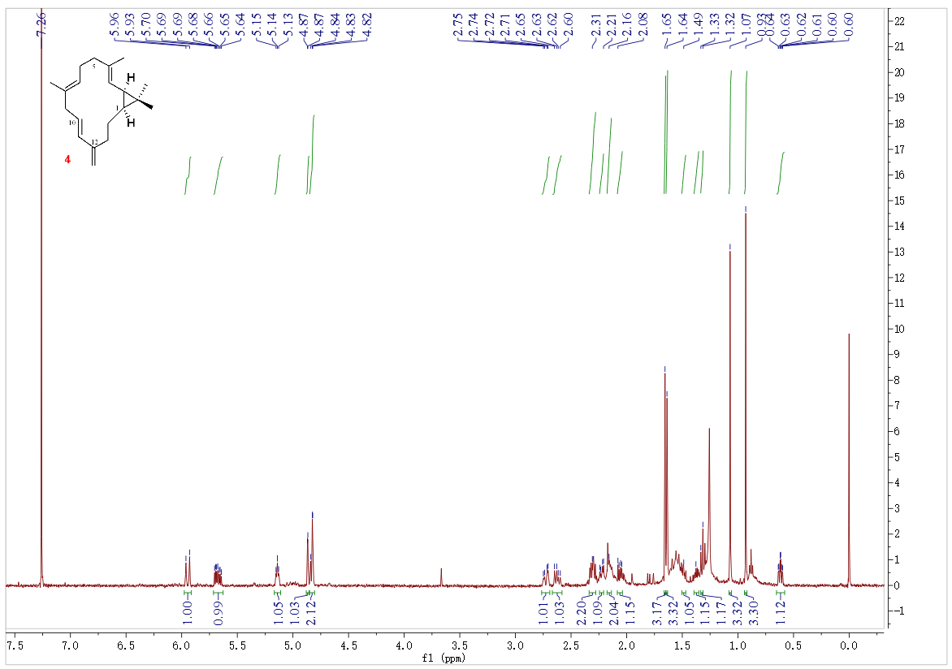
Figure S4a. ¹H NMR spectrum (600 MHz) of 4 in CDCl₃

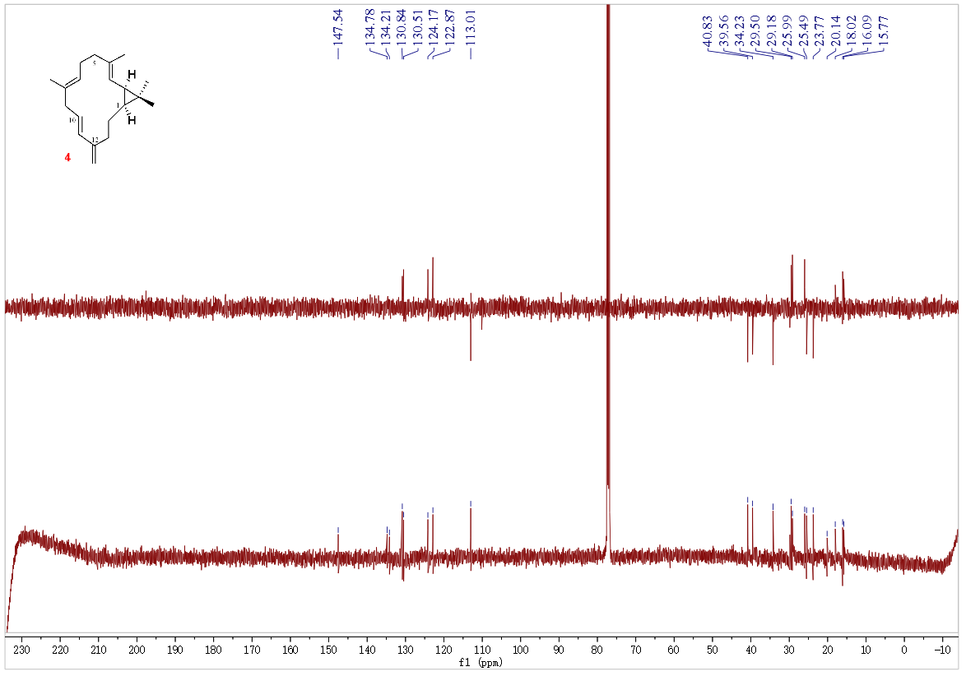
Figure S4b. DEPT135/¹³C NMR spectrum (150 MHz) of 4 in CDCl₃

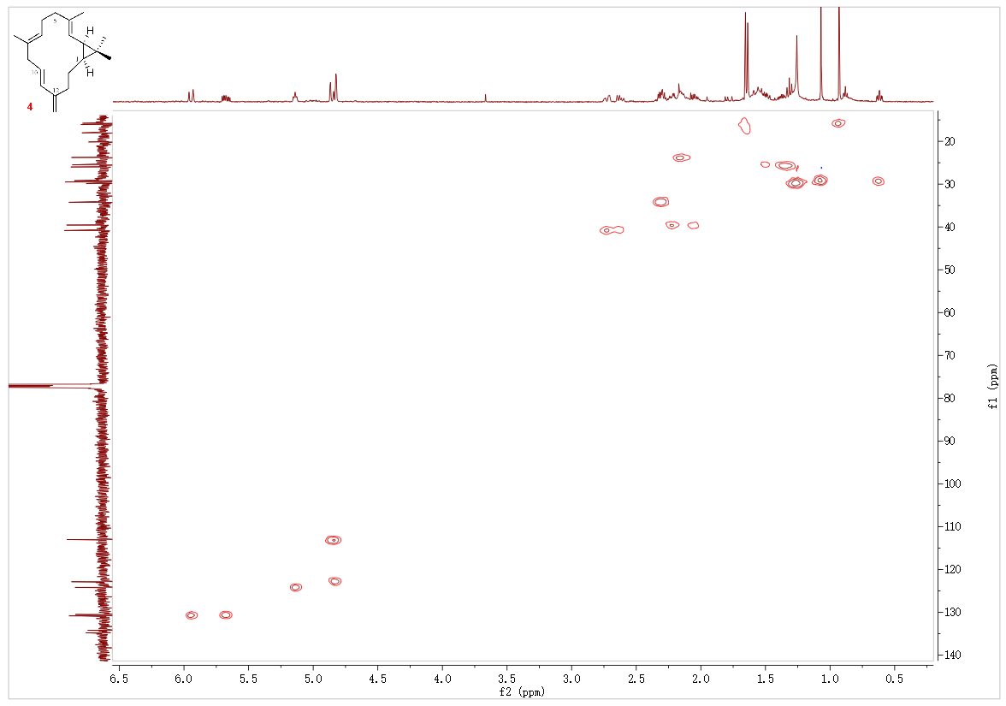
Figure S4c. HSQC spectrum (600 MHz) of 4 in CDCl₃

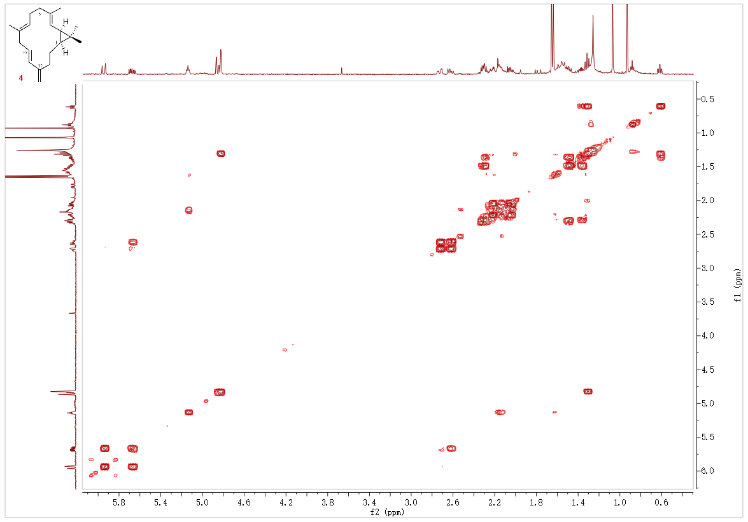
Figure S4d. ¹H-¹H COSY spectrum (600 MHz) of 4 in CDCl₃

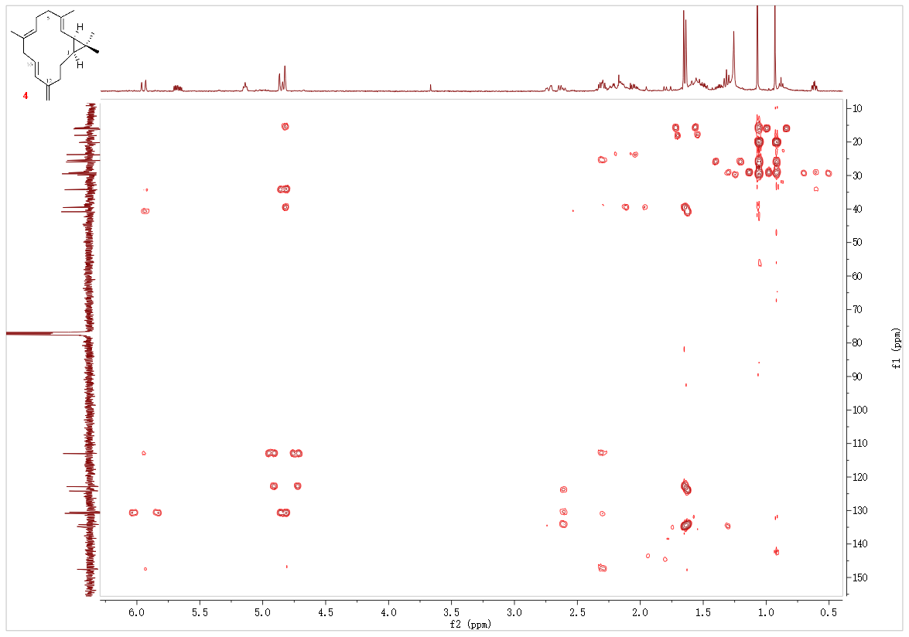
Figure S4e. HMBC spectrum (600 MHz) of 4 in CDCl₃

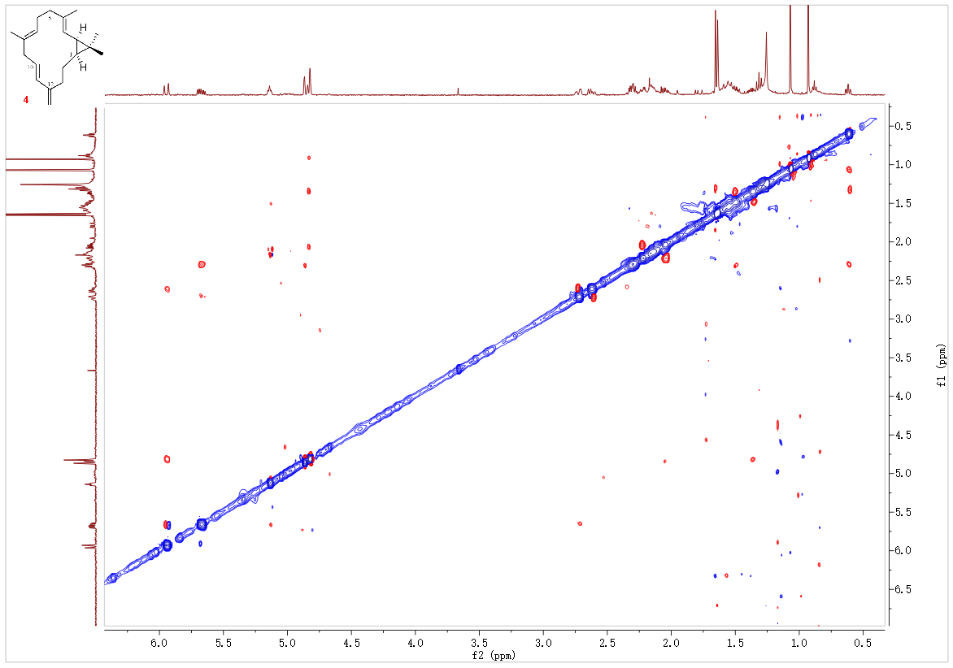
Figure S4f. NOESY spectrum (600 MHz) of 4 in CDCl₃

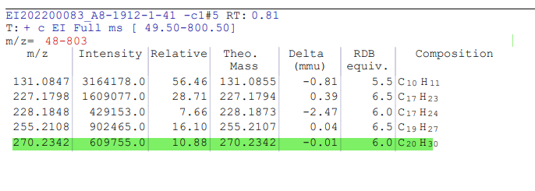
Figure S4g. HR-EIMS of 4

Figure S4h. IR spectrum of 4

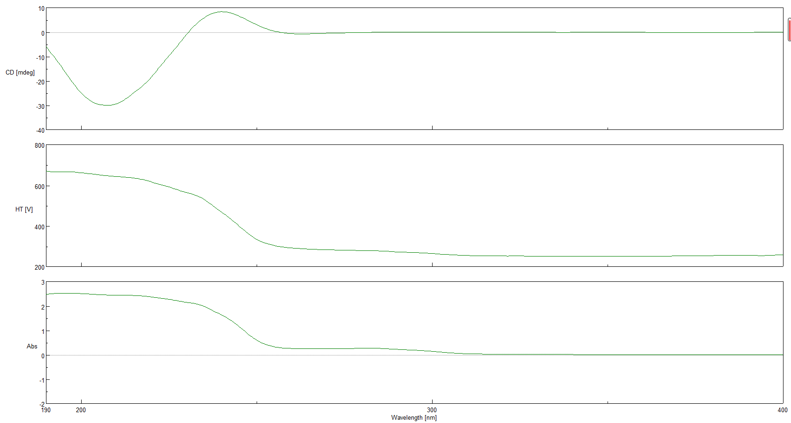
Figure S4i. ECD and UV spectra of 4

- QM-NMR calculation and DP4+ analysis of compound 3

Figure S5a. Structures of studied isomers for compound 3
Figure S5b. DP4+ results obtained using experimental data of 3 versus isomers 1 (3a) and 2 (3b).
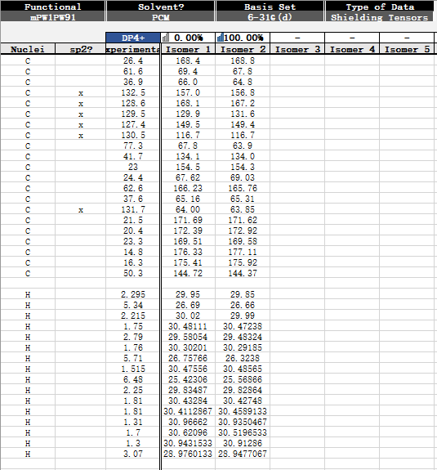
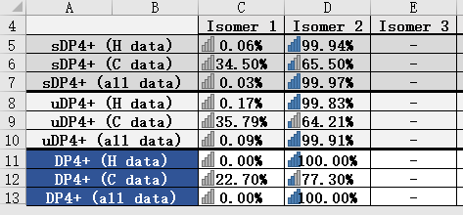

- TDDFT-EDC calculations of compounds 1-4
Torsional sampling (MCMM) conformational searches using MMFFs force field were carried out by means of the conformational search module in the Macromodel1 applying an energy window of 21 kJ/mol, which afforded 145, 171, 125, 126 conformers for (12S)-1, (11R, 12R)-2, (4S, 11R, 12R)-3, (1S, 2R)-4, respectively. The Boltzmann populations of the conformers were obtained based on the potential energy provided by the MMFFs force field, which afforded 5, 5, 5, 4 conformers for re-optimization. The re-optimization and the following TDDFT calculations of the re-optimized geometries were all performed with Gaussian 09 at the B3LYP/6-311G(d,p) level with IEFPCM solvent model for acetonitrile. Frequency analysis was performed as well to confirm that the re-optimized geometries were at the energy minima. Finally, the SpecDis 1.62 software was used to obtain the Boltzmann-averaged ECD spectra and visualize the results.
Figure S6a. Experimental ECD curve of 1, and calculated ECD spectrum of (12S)-1
Figure S6b. Experimental ECD curve of 2, and calculated ECD spectrum of (11R, 12R)-2
Figure S6c. Experimental ECD curve of 3, and calculated ECD spectrum of (4S, 11R, 12R)-3
Figure S6d. Experimental ECD curve of 4, and calculated ECD spectrum of (1S, 2R)-4

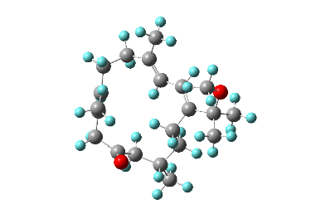 | 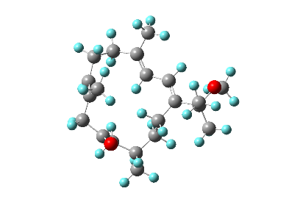 | 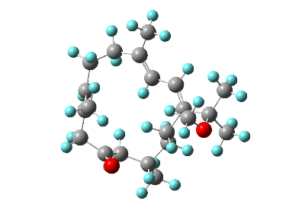
Conf. 1  3.16%  -971.22082194 a. u. | Conf. 2  9.43%  -971.22210426 a. u. | Conf. 3  16.36%  -971.22196749 a. u.
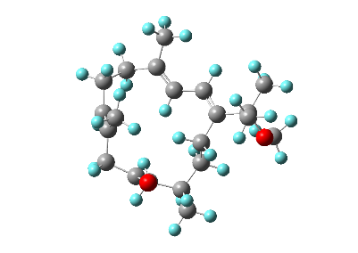 | 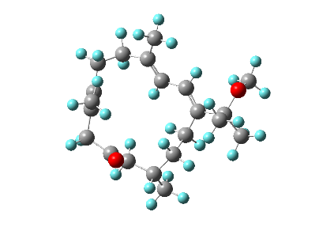
Conf. 4  5.73%  -971.22087028 a. u. | Conf. 5  65.32%  -971.22319110 a. u.

Conf. 1 | Coordinates (Angstroms)
atom | X | Y | Z
C | 2.93858 | -2.73139 | -0.37242
C | 3.25353 | -1.26776 | -0.22732
C | 3.14115 | -0.4776 | 0.84943
C | 3.57909 | 0.9813 | 0.76691
C | 2.38076 | 1.93369 | 0.76491
C | 1.9124 | 2.41783 | -0.59845
C | 1.8815 | -3.02857 | -1.47663
C | 0.44522 | -2.83282 | -1.02916
C | -0.08728 | -1.59638 | -0.9677
C | 0.53746 | 3.11018 | -0.66008
C | -0.6164 | 2.11737 | -0.91461
C | -1.44456 | -1.23358 | -0.56766
C | -0.80447 | 1.05656 | 0.188
C | -1.82645 | -0.02793 | -0.0984
C | -3.32664 | 0.24448 | 0.14523
C | -3.58568 | 1.30422 | 1.22865
C | -3.99279 | 0.68716 | -1.16861
O | -4.02832 | -0.9794 | 0.46707
C | -0.28146 | -4.08826 | -0.62352
C | 2.63491 | -0.91462 | 2.20027
C | 0.53523 | 4.20279 | -1.74009
O | 1.86503 | 2.29552 | 1.80501
C | -3.76931 | -1.55618 | 1.74101
H | 3.86512 | -3.24526 | -0.65875
H | 2.61891 | -3.17631 | 0.5725
H | 3.65134 | -0.81449 | -1.13526
H | 4.17466 | 1.13923 | -0.13417
H | 4.18944 | 1.23212 | 1.64034
H | 2.69785 | 3.11945 | -0.91531
H | 1.9787 | 1.58959 | -1.31344
H | 2.0145 | -4.06267 | -1.8082
H | 2.09824 | -2.39411 | -2.34217
H | 0.5649 | -0.77814 | -1.25737
H | 0.37077 | 3.58748 | 0.31183
H | -1.54122 | 2.69217 | -1.03118
H | -0.44509 | 1.61519 | -1.87539
H | -2.21447 | -1.99155 | -0.67038
H | 0.15154 | 0.56662 | 0.37319
H | -1.05408 | 1.56689 | 1.12175
H | -4.66074 | 1.36757 | 1.41372
H | -3.08638 | 1.0717 | 2.17129
H | -3.24208 | 2.28757 | 0.9024
H | -5.05367 | 0.89056 | -0.99778
H | -3.52393 | 1.58907 | -1.56597
H | -3.90268 | -0.10587 | -1.91342
H | 0.28083 | -4.61961 | 0.15379
H | -1.2829 | -3.89821 | -0.23846
H | -0.36192 | -4.77913 | -1.47108
H | 1.87562 | -0.22095 | 2.5722
H | 2.20696 | -1.91638 | 2.18631
H | 3.45079 | -0.90264 | 2.9329
H | -0.43122 | 4.71317 | -1.77921
H | 1.30471 | 4.95517 | -1.54432
H | 0.72766 | 3.77765 | -2.73114
H | -4.25307 | -2.5342 | 1.73892
H | -2.69728 | -1.69317 | 1.9203
H | -4.19416 | -0.96043 | 2.55637

Conf. 2 | Coordinates (Angstroms)
atom | X | Y | Z
C | 2.9733 | -2.70612 | -0.36256
C | 3.29655 | -1.2395 | -0.28175
C | 3.22462 | -0.4093 | 0.76798
C | 3.65123 | 1.04698 | 0.61315
C | 2.4441 | 1.98755 | 0.58686
C | 1.90068 | 2.3344 | -0.79
C | 1.84028 | -3.03053 | -1.38192
C | 0.43967 | -2.85282 | -0.82787
C | -0.11571 | -1.62662 | -0.75513
C | 0.50347 | 2.9805 | -0.85838
C | -0.62972 | 1.93583 | -0.94584
C | -1.43686 | -1.28379 | -0.23902
C | -0.80939 | 1.07204 | 0.31944
C | -1.80945 | -0.0659 | 0.20281
C | -3.23181 | 0.15494 | 0.74878
C | -3.21286 | 0.0131 | 2.28075
C | -3.8075 | 1.53181 | 0.36974
O | -4.12526 | -0.89792 | 0.327
C | -0.21926 | -4.11376 | -0.33234
C | 2.77051 | -0.79453 | 2.15276
C | 0.42187 | 3.94207 | -2.05422
O | 1.97973 | 2.4442 | 1.61372
C | -4.57754 | -0.87058 | -1.02238
H | 3.87795 | -3.22881 | -0.6979
H | 2.72069 | -3.12313 | 0.61485
H | 3.65752 | -0.82088 | -1.22118
H | 4.22735 | 1.16816 | -0.30633
H | 4.27519 | 1.34252 | 1.46214
H | 2.64986 | 3.02708 | -1.20087
H | 1.9626 | 1.44861 | -1.43204
H | 1.9636 | -4.06596 | -1.71326
H | 1.98054 | -2.40157 | -2.26693
H | 0.49093 | -0.80275 | -1.11737
H | 0.36603 | 3.56221 | 0.05989
H | -1.56627 | 2.45997 | -1.15779
H | -0.44302 | 1.28629 | -1.80979
H | -2.18197 | -2.07107 | -0.20666
H | 0.15422 | 0.64236 | 0.59753
H | -1.08567 | 1.72889 | 1.14945
H | -4.20806 | 0.21359 | 2.68652
H | -2.92059 | -1.0031 | 2.55228
H | -2.5062 | 0.71102 | 2.73446
H | -4.83651 | 1.60293 | 0.73163
H | -3.23301 | 2.3352 | 0.83316
H | -3.80812 | 1.69881 | -0.70839
H | 0.41954 | -4.61183 | 0.40699
H | -1.18977 | -3.93921 | 0.13121
H | -0.35278 | -4.82774 | -1.15371
H | 2.0174 | -0.09311 | 2.52358
H | 2.35131 | -1.7992 | 2.19485
H | 3.61126 | -0.74572 | 2.85501
H | -0.55499 | 4.43163 | -2.09783
H | 1.18614 | 4.72175 | -1.98804
H | 0.56965 | 3.40862 | -2.99953
H | -5.08602 | -1.82085 | -1.19264
H | -5.29086 | -0.05851 | -1.19941
H | -3.75082 | -0.78109 | -1.73493

Conf. 3 | Coordinates (Angstroms)
atom | X | Y | Z
C | 3.16654 | -2.43402 | -0.2557
C | 3.34404 | -0.95519 | -0.04902
C | 3.05602 | -0.20425 | 1.02276
C | 3.35611 | 1.29114 | 1.00201
C | 2.07962 | 2.11247 | 0.80254
C | 1.72752 | 2.45336 | -0.63633
C | 2.22153 | -2.77759 | -1.44618
C | 0.74857 | -2.76599 | -1.08611
C | 0.06811 | -1.60322 | -1.02918
C | 0.30441 | 2.97341 | -0.9159
C | -0.70134 | 1.83657 | -1.19686
C | -1.33784 | -1.42168 | -0.67965
C | -1.03617 | 0.95897 | 0.02831
C | -1.88915 | -0.27067 | -0.24156
C | -3.38149 | -0.15829 | 0.10455
C | -4.05213 | 0.95376 | -0.71656
C | -4.17702 | -1.45761 | -0.08374
O | -3.52424 | 0.31299 | 1.47369
C | 0.16146 | -4.1138 | -0.75732
C | 2.45358 | -0.71245 | 2.30759
C | 0.32502 | 3.95873 | -2.09525
O | 1.41677 | 2.48506 | 1.75128
C | -3.03095 | -0.53928 | 2.49875
H | 4.15153 | -2.86059 | -0.48293
H | 2.81453 | -2.93457 | 0.64891
H | 3.78987 | -0.44678 | -0.90386
H | 4.06285 | 1.51628 | 0.20065
H | 3.79506 | 1.59671 | 1.95626
H | 2.46415 | 3.22269 | -0.91103
H | 1.97122 | 1.59749 | -1.27547
H | 2.48838 | -3.77031 | -1.8207
H | 2.41863 | -2.07346 | -2.2607
H | 0.63188 | -0.70432 | -1.25454
H | -0.02796 | 3.51427 | -0.0229
H | -1.62408 | 2.28181 | -1.5798
H | -0.30912 | 1.21276 | -2.00908
H | -1.97325 | -2.29309 | -0.78542
H | -0.1062 | 0.62627 | 0.49248
H | -1.53816 | 1.57846 | 0.77529
H | -5.1061 | 1.02758 | -0.437
H | -3.58362 | 1.91923 | -0.52275
H | -3.98643 | 0.73879 | -1.78521
H | -5.20001 | -1.29532 | 0.26342
H | -4.21674 | -1.74155 | -1.13742
H | -3.75681 | -2.29485 | 0.47521
H | 0.7559 | -4.60694 | 0.02096
H | -0.8689 | -4.06473 | -0.40649
H | 0.19592 | -4.77256 | -1.63315
H | 1.58814 | -0.10826 | 2.59587
H | 2.13758 | -1.75311 | 2.24349
H | 3.17805 | -0.62592 | 3.12607
H | -0.67298 | 4.36328 | -2.28554
H | 0.99653 | 4.79944 | -1.89796
H | 0.66586 | 3.4676 | -3.01332
H | -3.62385 | -1.45583 | 2.59746
H | -1.98265 | -0.81539 | 2.33693
H | -3.10785 | 0.02436 | 3.42963

Conf. 4 | Coordinates (Angstroms)
atom | X | Y | Z
C | 3.47477 | -2.11049 | -0.46038
C | 3.49018 | -0.61412 | -0.31235
C | 3.26941 | 0.13486 | 0.77671
C | 3.36873 | 1.65422 | 0.68399
C | 1.98235 | 2.30398 | 0.67569
C | 1.38012 | 2.56673 | -0.69507
C | 2.42439 | -2.61109 | -1.49643
C | 1.02389 | -2.75527 | -0.93364
C | 0.21751 | -1.68099 | -0.82063
C | -0.11874 | 2.91784 | -0.75531
C | -1.02284 | 1.67284 | -0.87844
C | -1.14637 | -1.65426 | -0.29753
C | -1.0272 | 0.75375 | 0.35925
C | -1.7667 | -0.56763 | 0.20775
C | -3.2007 | -0.63171 | 0.75498
C | -3.93984 | -1.9392 | 0.43362
C | -3.20716 | -0.43442 | 2.2806
O | -3.95172 | 0.50955 | 0.25928
C | 0.65761 | -4.1443 | -0.47979
C | 2.93401 | -0.39619 | 2.14677
C | -0.39116 | 3.87626 | -1.92532
O | 1.4257 | 2.61002 | 1.71248
C | -4.35431 | 0.45809 | -1.10373
H | 4.46448 | -2.42263 | -0.81667
H | 3.31753 | -2.61418 | 0.49593
H | 3.73485 | -0.08725 | -1.23462
H | 3.90943 | 1.93623 | -0.22187
H | 3.90694 | 2.04611 | 1.55214
H | 1.97371 | 3.40571 | -1.08695
H | 1.62135 | 1.72676 | -1.3562
H | 2.75525 | -3.58097 | -1.87988
H | 2.4219 | -1.92325 | -2.34796
H | 0.62803 | -0.73243 | -1.15069
H | -0.37051 | 3.43609 | 0.17678
H | -2.04571 | 2.00959 | -1.06351
H | -0.71876 | 1.10487 | -1.76656
H | -1.68562 | -2.59401 | -0.32421
H | 0.00259 | 0.52933 | 0.64234
H | -1.45036 | 1.32104 | 1.19049
H | -4.98062 | -1.84457 | 0.75229
H | -3.92514 | -2.18027 | -0.63029
H | -3.49861 | -2.77708 | 0.97647
H | -4.23542 | -0.47362 | 2.64838
H | -2.62792 | -1.21985 | 2.77079
H | -2.78659 | 0.53265 | 2.55785
H | 1.40578 | -4.52148 | 0.22752
H | -0.31566 | -4.19799 | 0.00716
H | 0.65826 | -4.83965 | -1.3275
H | 2.05682 | 0.11424 | 2.55496
H | 2.73829 | -1.46785 | 2.14793
H | 3.7588 | -0.19929 | 2.84195
H | -1.44755 | 4.15615 | -1.96428
H | 0.19662 | 4.79409 | -1.83172
H | -0.13444 | 3.4114 | -2.88354
H | -4.70644 | 1.45836 | -1.36062
H | -3.52614 | 0.19422 | -1.77119
H | -5.17466 | -0.25051 | -1.26326

Conf. 5 | Coordinates (Angstroms)
atom | X | Y | Z
C | 3.17426 | -2.59145 | -0.55996
C | 3.37979 | -1.10309 | -0.60385
C | 3.51721 | -0.24099 | 0.41252
C | 3.75128 | 1.23755 | 0.12176
C | 2.50247 | 2.06716 | 0.42721
C | 1.63578 | 2.45057 | -0.76088
C | 1.88641 | -3.05027 | -1.30183
C | 0.60409 | -2.80354 | -0.53682
C | -0.11565 | -1.68351 | -0.75706
C | 0.29276 | 3.10836 | -0.40998
C | -0.7214 | 2.10725 | 0.19008
C | -1.37411 | -1.31105 | -0.1279
C | -1.34764 | 1.10683 | -0.81473
C | -1.98149 | -0.10555 | -0.16211
C | -3.33779 | 0.05266 | 0.56438
C | -3.11301 | 0.33616 | 2.05924
C | -4.21702 | 1.15955 | -0.04123
O | -4.06193 | -1.20073 | 0.58185
C | 0.24228 | -3.86746 | 0.4673
C | 3.48177 | -0.60469 | 1.87464
C | -0.27523 | 3.88038 | -1.60958
O | 2.236 | 2.40058 | 1.56643
C | -4.59188 | -1.66045 | -0.65558
H | 4.02689 | -3.06946 | -1.05919
H | 3.1674 | -2.97013 | 0.46417
H | 3.44099 | -0.6956 | -1.6128
H | 4.03952 | 1.37158 | -0.92239
H | 4.55628 | 1.61742 | 0.7593
H | 2.24881 | 3.13881 | -1.36021
H | 1.51351 | 1.56697 | -1.39735
H | 1.97831 | -4.12247 | -1.50803
H | 1.84794 | -2.54492 | -2.27202
H | 0.28437 | -0.99738 | -1.49778
H | 0.50459 | 3.83358 | 0.38272
H | -0.22503 | 1.55076 | 0.98921
H | -1.51868 | 2.68427 | 0.66999
H | -1.89878 | -2.09494 | 0.40839
H | -2.08367 | 1.6306 | -1.43012
H | -0.57279 | 0.7691 | -1.50466
H | -4.07708 | 0.44231 | 2.56432
H | -2.56815 | -0.49303 | 2.51464
H | -2.53776 | 1.25054 | 2.20838
H | -5.19782 | 1.13694 | 0.43999
H | -3.78025 | 2.14437 | 0.13168
H | -4.35782 | 1.04046 | -1.1172
H | 1.07748 | -4.05223 | 1.15257
H | -0.62875 | -3.61351 | 1.07022
H | 0.04343 | -4.82012 | -0.03828
H | 4.468 | -0.44714 | 2.32761
H | 2.78616 | 0.0425 | 2.41564
H | 3.19307 | -1.64102 | 2.04652
H | -1.2321 | 4.34665 | -1.35627
H | 0.41068 | 4.67331 | -1.9215
H | -0.44032 | 3.22884 | -2.47279
H | -4.96367 | -2.66983 | -0.47304
H | -5.42611 | -1.04058 | -1.00188
H | -3.82835 | -1.70216 | -1.43996

Figure S6e. Re-optimized conformers of (12S)-1 calculated at the B3LYP/6-311G(d,p) level with IEFPCM solvent model for acetonitrile.

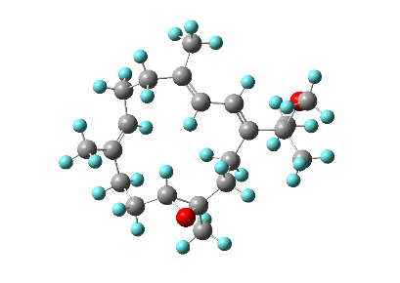 | 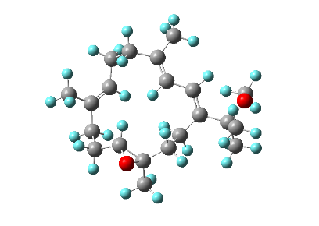 | 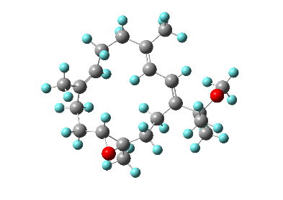
Conf. 1  20.79%  -971.16409466 a. u. | Conf. 2  4.59%  -971.16296862 a. u. | Conf. 3  1.77%  -971.15570297 a. u.
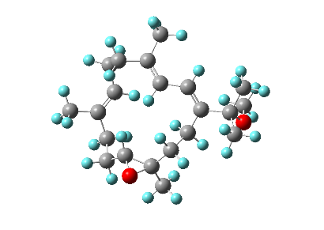 | 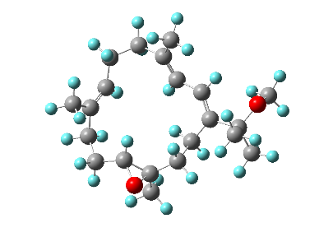
Conf. 4  70.48%  -971.16454601 a. u. | Conf. 5  2.38%  -971.15664626 a. u.

Conf. 1 | Coordinates (Angstroms)
atom | X | Y | Z
C | 2.66625 | 2.8229 | 0.48781
C | 2.75898 | 1.37958 | 0.91351
C | 3.6683 | 0.46786 | 0.53723
C | 3.58609 | -0.95919 | 1.05036
C | 3.33129 | -2.03874 | -0.03037
C | 1.99554 | -1.86952 | -0.71332
C | 1.6832 | 3.0661 | -0.6958
C | 0.21718 | 2.86385 | -0.35861
C | -0.31485 | 1.62531 | -0.37695
C | 0.75107 | -2.60014 | -0.39352
C | -0.56942 | -1.90152 | -0.68544
C | -1.69395 | 1.23563 | -0.10426
C | -1.07988 | -1.10023 | 0.5387
C | -2.09184 | -0.00491 | 0.24365
C | -3.58057 | -0.30575 | 0.48778
C | -3.99074 | -1.697 | -0.03027
C | -3.88335 | -0.20656 | 1.99256
O | -4.42033 | 0.71554 | -0.09108
C | -0.54261 | 4.10767 | 0.01976
C | 4.82469 | 0.7545 | -0.38989
C | 0.70001 | -3.69314 | 0.65091
O | 1.52523 | -2.93211 | -1.5752
C | -4.58758 | 0.69933 | -1.50497
H | 3.64636 | 3.20202 | 0.18754
H | 2.34791 | 3.43169 | 1.34166
H | 1.96953 | 1.04265 | 1.58143
H | 4.5312 | -1.2109 | 1.54774
H | 2.8023 | -1.02726 | 1.81069
H | 3.40291 | -3.02598 | 0.43023
H | 4.1161 | -1.99798 | -0.79359
H | 1.86078 | -0.88681 | -1.16359
H | 1.97244 | 2.40272 | -1.5162
H | 1.83016 | 4.09148 | -1.05143
H | 0.36625 | 0.82032 | -0.63211
H | -0.42002 | -1.23168 | -1.53556
H | -1.31324 | -2.64355 | -0.99372
H | -2.46224 | 1.99458 | -0.20508
H | -0.21529 | -0.64032 | 1.02577
H | -1.49242 | -1.79736 | 1.27212
H | -5.06983 | -1.82114 | 0.09144
H | -3.74259 | -1.83621 | -1.08373
H | -3.49783 | -2.48708 | 0.53799
H | -4.92825 | -0.46698 | 2.18087
H | -3.24823 | -0.88093 | 2.57054
H | -3.70827 | 0.81492 | 2.33585
H | -0.57058 | 4.81355 | -0.81884
H | -1.56679 | 3.90503 | 0.33239
H | -0.038 | 4.62775 | 0.84272
H | 5.76667 | 0.41489 | 0.0556
H | 4.71689 | 0.21455 | -1.33699
H | 4.92478 | 1.81303 | -0.62829
H | -0.04222 | -4.44325 | 0.36064
H | 1.66142 | -4.19439 | 0.75609
H | 0.40906 | -3.2946 | 1.6263
H | -5.22103 | -0.13186 | -1.83289
H | -5.08359 | 1.63593 | -1.76417
H | -3.6304 | 0.64947 | -2.03444

Conf. 2 | Coordinates (Angstroms)
atom | X | Y | Z
C | 2.52434 | 2.92305 | 0.44295
C | 2.63295 | 1.50382 | 0.9411
C | 3.58407 | 0.60271 | 0.65242
C | 3.52069 | -0.7983 | 1.23504
C | 3.3864 | -1.94384 | 0.20205
C | 2.10019 | -1.8708 | -0.58556
C | 1.62128 | 3.08146 | -0.81635
C | 0.14402 | 2.8296 | -0.57734
C | -0.33625 | 1.57043 | -0.59943
C | 0.86605 | -2.63782 | -0.31583
C | -0.45437 | -2.01082 | -0.73972
C | -1.7175 | 1.13055 | -0.42628
C | -1.05354 | -1.13008 | 0.38552
C | -2.09218 | -0.10819 | -0.04492
C | -3.58608 | -0.49323 | -0.06211
C | -3.9578 | -1.03797 | -1.45157
C | -3.96242 | -1.53223 | 1.00815
O | -4.42123 | 0.68 | 0.06606
C | -0.6897 | 4.04927 | -0.28752
C | 4.77582 | 0.88114 | -0.23147
C | 0.78185 | -3.6712 | 0.78537
O | 1.74009 | -2.99896 | -1.41676
C | -4.47148 | 1.29943 | 1.34578
H | 3.51089 | 3.32245 | 0.19388
H | 2.12815 | 3.55743 | 1.24387
H | 1.82147 | 1.17555 | 1.58663
H | 4.43859 | -0.98299 | 1.80735
H | 2.69006 | -0.85883 | 1.9447
H | 3.46119 | -2.90078 | 0.72232
H | 4.22375 | -1.9115 | -0.50365
H | 1.9595 | -0.92078 | -1.09995
H | 1.99466 | 2.40071 | -1.58682
H | 1.75373 | 4.09844 | -1.20077
H | 0.39283 | 0.78793 | -0.7836
H | -0.27412 | -1.40548 | -1.63156
H | -1.15687 | -2.80073 | -1.0278
H | -2.50466 | 1.84307 | -0.64958
H | -0.22989 | -0.59027 | 0.86007
H | -1.46502 | -1.77731 | 1.16138
H | -5.01004 | -1.3353 | -1.46653
H | -3.79963 | -0.26443 | -2.20542
H | -3.34701 | -1.90465 | -1.71174
H | -5.04874 | -1.64934 | 1.02171
H | -3.52477 | -2.50512 | 0.77809
H | -3.63268 | -1.24342 | 2.00812
H | -0.68422 | 4.73425 | -1.14369
H | -1.72501 | 3.81061 | -0.04452
H | -0.26732 | 4.60794 | 0.5561
H | 5.70296 | 0.57746 | 0.26772
H | 4.72233 | 0.30671 | -1.1629
H | 4.86559 | 1.93277 | -0.50258
H | 0.0808 | -4.46027 | 0.49631
H | 1.74945 | -4.13377 | 0.97599
H | 0.42101 | -3.22766 | 1.71703
H | -3.47189 | 1.51527 | 1.73842
H | -5.00666 | 2.24049 | 1.21006
H | -5.01744 | 0.69135 | 2.07533

Conf. 3 | Coordinates (Angstroms)
atom | X | Y | Z
C | -2.32811 | 2.91043 | 0.33956
C | -2.66468 | 1.68257 | -0.48236
C | -3.60816 | 0.77504 | -0.19737
C | -3.78586 | -0.46169 | -1.05609
C | -3.60103 | -1.79637 | -0.2927
C | -2.27775 | -1.88004 | 0.43015
C | -1.1136 | 3.71846 | -0.14388
C | 0.27165 | 3.10883 | -0.02445
C | 0.47974 | 1.79188 | 0.17428
C | -1.06849 | -2.6031 | -0.01355
C | 0.27346 | -2.08493 | 0.48321
C | 1.76983 | 1.11302 | 0.29006
C | 0.92159 | -1.09784 | -0.5174
C | 2.00353 | -0.1919 | 0.03966
C | 3.40392 | -0.77688 | 0.32713
C | 3.48456 | -1.22972 | 1.79479
C | 3.76787 | -1.95498 | -0.59185
O | 4.4193 | 0.24981 | 0.24669
C | 1.38256 | 4.1132 | -0.20282
C | -4.53472 | 0.89971 | 0.9885
C | -1.03717 | -3.42766 | -1.28078
O | -1.91308 | -3.14179 | 1.03648
C | 4.74132 | 0.73925 | -1.04968
H | -2.16891 | 2.62654 | 1.3867
H | -3.18682 | 3.59327 | 0.34857
H | -2.06116 | 1.52236 | -1.37344
H | -4.79473 | -0.4682 | -1.48795
H | -3.08213 | -0.42389 | -1.89296
H | -3.71555 | -2.62802 | -0.99069
H | -4.39699 | -1.90831 | 0.45228
H | -2.09343 | -1.0363 | 1.09413
H | -1.10372 | 4.66885 | 0.40432
H | -1.26703 | 4.00671 | -1.19486
H | -0.39723 | 1.1608 | 0.2546
H | 0.11019 | -1.58705 | 1.44277
H | 0.93613 | -2.93624 | 0.67429
H | 2.61898 | 1.70629 | 0.61265
H | 0.13025 | -0.47184 | -0.93415
H | 1.32394 | -1.66253 | -1.36305
H | 4.4722 | -1.65215 | 1.99954
H | 3.32485 | -0.374 | 2.45351
H | 2.72901 | -1.98434 | 2.01943
H | 4.80393 | -2.24622 | -0.40286
H | 3.13431 | -2.8198 | -0.38765
H | 3.66654 | -1.70808 | -1.65046
H | 1.34741 | 4.87184 | 0.58779
H | 2.37379 | 3.66187 | -0.20076
H | 1.26093 | 4.64985 | -1.15111
H | -4.2847 | 0.18116 | 1.77782
H | -4.50888 | 1.89533 | 1.4318
H | -5.56743 | 0.68727 | 0.69073
H | -0.34486 | -4.26647 | -1.15838
H | -2.02034 | -3.83368 | -1.5164
H | -0.69578 | -2.83252 | -2.13164
H | 5.28717 | -0.00115 | -1.64444
H | 3.85051 | 1.05504 | -1.60337
H | 5.38687 | 1.60579 | -0.89863

Conf. 4 | Coordinates (Angstroms)
atom | X | Y | Z
C | 2.71426 | 2.74152 | 0.50437
C | 2.68641 | 1.31639 | 0.99462
C | 3.57826 | 0.34549 | 0.7466
C | 3.36337 | -1.05446 | 1.29458
C | 3.17382 | -2.1575 | 0.22466
C | 1.95419 | -1.9228 | -0.63418
C | 1.8808 | 2.97252 | -0.79195
C | 0.37907 | 2.85996 | -0.60925
C | -0.21875 | 1.65283 | -0.66844
C | 0.63643 | -2.57518 | -0.48475
C | -0.5888 | -1.80733 | -0.95941
C | -1.64073 | 1.35406 | -0.53095
C | -1.24631 | -1.00804 | 0.19443
C | -2.15078 | 0.14849 | -0.20378
C | -3.66196 | -0.1126 | -0.13094
C | -4.53165 | 1.12725 | -0.37995
C | -4.06448 | -1.21203 | -1.12621
O | -3.99354 | -0.69555 | 1.1594
C | -0.3388 | 4.15334 | -0.32821
C | 4.83735 | 0.53673 | -0.06363
C | 0.38211 | -3.64934 | 0.54967
O | 1.54433 | -2.96665 | -1.54761
C | -3.76399 | 0.11613 | 2.3038
H | 3.73897 | 3.06216 | 0.3004
H | 2.33501 | 3.4033 | 1.29118
H | 1.81562 | 1.04712 | 1.58812
H | 4.23113 | -1.33514 | 1.90463
H | 2.49586 | -1.05348 | 1.96132
H | 3.11494 | -3.12838 | 0.72058
H | 4.05156 | -2.19876 | -0.4297
H | 1.93976 | -0.9393 | -1.10181
H | 2.21889 | 2.25435 | -1.54439
H | 2.12057 | 3.97043 | -1.17432
H | 0.43626 | 0.80513 | -0.83718
H | -0.28064 | -1.13508 | -1.76362
H | -1.30682 | -2.50998 | -1.39483
H | -2.32474 | 2.17231 | -0.72465
H | -0.44662 | -0.60915 | 0.82624
H | -1.81867 | -1.69076 | 0.82473
H | -5.57833 | 0.85874 | -0.21981
H | -4.28472 | 1.95413 | 0.28753
H | -4.42508 | 1.47972 | -1.40784
H | -5.13673 | -1.40658 | -1.043
H | -3.84115 | -0.90547 | -2.1502
H | -3.53531 | -2.14224 | -0.9155
H | -0.24271 | 4.84001 | -1.17749
H | -1.39876 | 4.02067 | -0.11244
H | 0.11586 | 4.66107 | 0.53061
H | 4.80001 | -0.03598 | -0.99685
H | 5.01606 | 1.57848 | -0.32838
H | 5.70935 | 0.17101 | 0.49048
H | -0.37232 | -4.34889 | 0.17632
H | 1.28684 | -4.21492 | 0.76915
H | 0.00726 | -3.21972 | 1.48216
H | -3.9501 | -0.51777 | 3.17189
H | -2.73222 | 0.48402 | 2.34796
H | -4.4444 | 0.97406 | 2.34777

Conf. 5 | Coordinates (Angstroms)
atom | X | Y | Z
C | -2.74365 | 2.89377 | -0.24394
C | -2.9617 | 1.47411 | -0.70675
C | -3.65815 | 0.49382 | -0.11673
C | -3.79944 | -0.85324 | -0.80413
C | -3.37848 | -2.0826 | 0.03078
C | -1.96733 | -2.00523 | 0.56033
C | -1.40857 | 3.49487 | -0.75368
C | -0.16368 | 2.96332 | -0.06947
C | 0.4542 | 1.85996 | -0.53543
C | -0.76171 | -2.64011 | -0.01546
C | 0.58461 | -2.02798 | 0.33954
C | 1.69175 | 1.26175 | -0.03973
C | 1.16222 | -1.08015 | -0.74601
C | 2.08777 | -0.01955 | -0.18419
C | 3.48928 | -0.42841 | 0.32405
C | 3.44845 | -0.7637 | 1.82439
C | 4.07555 | -1.61926 | -0.45346
O | 4.39928 | 0.69547 | 0.27288
C | 0.28243 | 3.72818 | 1.14927
C | -4.38929 | 0.64949 | 1.19422
C | -0.80357 | -3.49263 | -1.26266
O | -1.4236 | -3.21204 | 1.14307
C | 4.81602 | 1.136 | -1.01413
H | -2.79282 | 2.97221 | 0.84574
H | -3.55519 | 3.52596 | -0.63007
H | -2.51568 | 1.2447 | -1.67381
H | -4.851 | -0.99888 | -1.08466
H | -3.22671 | -0.83942 | -1.73621
H | -3.50988 | -2.98352 | -0.57197
H | -4.04698 | -2.19293 | 0.89232
H | -1.77713 | -1.12272 | 1.17093
H | -1.44894 | 4.58104 | -0.62035
H | -1.34371 | 3.31583 | -1.83192
H | 0. | 1.38053 | -1.39836
H | 0.45596 | -1.47578 | 1.27331
H | 1.28695 | -2.84227 | 0.54903
H | 2.38997 | 1.93029 | 0.45486
H | 0.32406 | -0.5869 | -1.24049
H | 1.66604 | -1.67226 | -1.51481
H | 4.45152 | -1.0303 | 2.16833
H | 3.10447 | 0.10521 | 2.3888
H | 2.77743 | -1.59829 | 2.02998
H | 5.10691 | -1.78187 | -0.1312
H | 3.51325 | -2.53252 | -0.25247
H | 4.07266 | -1.45499 | -1.53268
H | -0.53943 | 3.80927 | 1.87046
H | 1.12629 | 3.26458 | 1.65987
H | 0.56044 | 4.75482 | 0.88258
H | -4.00877 | -0.0414 | 1.95423
H | -4.31837 | 1.6595 | 1.59693
H | -5.45249 | 0.41384 | 1.06654
H | -0.05945 | -4.29186 | -1.18908
H | -1.78105 | -3.95286 | -1.40378
H | -0.57011 | -2.89858 | -2.15026
H | 5.36799 | 2.06365 | -0.85567
H | 5.48169 | 0.41443 | -1.50008
H | 3.96633 | 1.33955 | -1.6746

Figure S6f. Re-optimized conformers of (11R, 12R)-2 calculated at the B3LYP/6-311G(d,p) level with IEFPCM solvent model for acetonitrile.

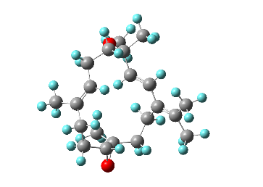 | 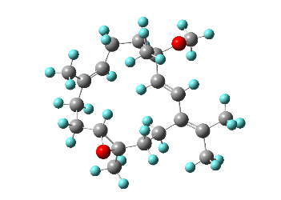 | 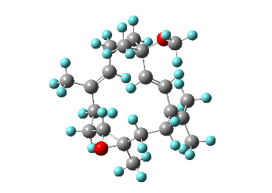
Conf. 1  0.02%  -971.15464835 a. u. | Conf. 2  74.32%  -971.15296407 a. u. | Conf. 3  0.00%  -971.14545343 a. u.
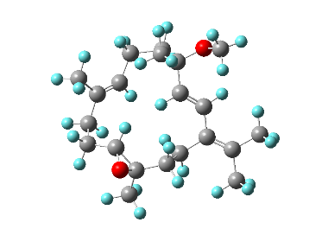 | 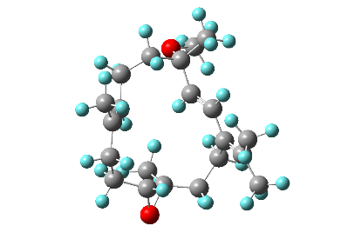
Conf. 4  25.66%  -971.15480698 a. u. | Conf. 5  0.01%  -971.15368466 a. u.

Conf. 1 | Coordinates (Angstroms)
atom | X | Y | Z
C | -2.26388 | 2.17362 | -0.8949
C | -0.82079 | 2.05678 | -1.32887
C | 0.2131 | 2.82783 | -0.95775
C | 1.56693 | 2.67386 | -1.62539
C | 2.76526 | 2.36661 | -0.70213
C | 2.91193 | 0.91849 | -0.27961
C | -3.09656 | 0.89481 | -1.08702
C | -2.98224 | -0.17854 | 0.02399
C | -1.54976 | -0.63551 | 0.25064
C | 2.5759 | 0.32229 | 1.03506
C | 2.46611 | -1.19503 | 1.16704
C | -0.97823 | -1.73547 | -0.26985
C | 1.06434 | -1.8439 | 1.29483
C | 0.36293 | -2.27754 | 0.00686
C | 0.88969 | -3.24783 | -0.78752
C | 2.1513 | -4.01043 | -0.45278
C | 0.28153 | -3.69845 | -2.09766
C | -3.93687 | -1.33503 | -0.32156
C | 0.09277 | 3.96307 | 0.03242
C | 1.94927 | 1.13654 | 2.14858
O | 3.93843 | 0.68426 | 0.70072
O | -3.43852 | 0.51303 | 1.20874
C | -3.53823 | -0.25286 | 2.39481
H | -2.74152 | 2.96365 | -1.4955
H | -2.35388 | 2.49543 | 0.14747
H | -0.62889 | 1.29273 | -2.08402
H | 1.50529 | 1.90434 | -2.4062
H | 1.79483 | 3.61653 | -2.14674
H | 2.75663 | 3.01536 | 0.1788
H | 3.68968 | 2.61579 | -1.24184
H | 2.94598 | 0.21981 | -1.12247
H | -2.84226 | 0.42538 | -2.04625
H | -4.15697 | 1.17123 | -1.13682
H | -0.98096 | 0.03102 | 0.8952
H | 3.01702 | -1.63806 | 0.33346
H | 3.03831 | -1.44614 | 2.07189
H | -1.58957 | -2.34067 | -0.9335
H | 0.40578 | -1.1855 | 1.86662
H | 1.17717 | -2.73608 | 1.92515
H | 2.00687 | -5.07794 | -0.66883
H | 2.99866 | -3.68584 | -1.07424
H | 2.45563 | -3.9216 | 0.59233
H | -0.15908 | -4.7024 | -2.00611
H | -0.48256 | -3.02479 | -2.48869
H | 1.0652 | -3.77798 | -2.86332
H | -3.86082 | -2.15699 | 0.3963
H | -4.96821 | -0.96719 | -0.32631
H | -3.71937 | -1.73998 | -1.31514
H | -0.91791 | 4.06422 | 0.43393
H | 0.77552 | 3.8394 | 0.88252
H | 0.35953 | 4.91822 | -0.44253
H | 2.22954 | 0.72293 | 3.12515
H | 2.28874 | 2.17381 | 2.11775
H | 0.8557 | 1.13181 | 2.07958
H | -2.61153 | -0.80135 | 2.61736
H | -3.73137 | 0.4568 | 3.20446
H | -4.36738 | -0.97416 | 2.35946

Conf. 2 | Coordinates (Angstroms)
atom | X | Y | Z
C | -1.59768 | 3.09968 | -0.51245
C | -2.1291 | 1.75253 | -0.93882
C | -3.15764 | 1.05795 | -0.42315
C | -3.57027 | -0.27027 | -1.03604
C | -3.58005 | -1.47059 | -0.06025
C | -2.24029 | -1.69934 | 0.60205
C | -0.06665 | 3.28432 | -0.62148
C | 0.85647 | 2.51831 | 0.37018
C | 0.97175 | 1.04282 | 0.01942
C | -1.23242 | -2.72017 | 0.23255
C | 0.22225 | -2.42095 | 0.56728
C | 2.107 | 0.32603 | 0.10759
C | 1.0296 | -1.85771 | -0.62668
C | 2.27985 | -1.10172 | -0.20016
C | 3.48676 | -1.71815 | -0.08253
C | 3.69951 | -3.19461 | -0.32909
C | 4.77426 | -1.03249 | 0.31718
C | 0.35629 | 2.66556 | 1.8171
C | -4.0036 | 1.52994 | 0.7369
C | -1.46581 | -3.73414 | -0.869
O | -2.07543 | -2.88778 | 1.39556
O | 2.1533 | 3.14985 | 0.40508
C | 2.80884 | 3.37423 | -0.83244
H | -1.92818 | 3.35423 | 0.49907
H | -2.03998 | 3.86635 | -1.16878
H | -1.62382 | 1.32388 | -1.80694
H | -4.58549 | -0.1735 | -1.45029
H | -2.90989 | -0.50012 | -1.88149
H | -3.9043 | -2.36817 | -0.59616
H | -4.32486 | -1.30532 | 0.7297
H | -1.84296 | -0.80601 | 1.0913
H | 0.14445 | 4.34971 | -0.46358
H | 0.2393 | 3.05323 | -1.65035
H | 0.03716 | 0.57842 | -0.2804
H | 0.24213 | -1.7049 | 1.39561
H | 0.70314 | -3.33661 | 0.93833
H | 2.98187 | 0.86682 | 0.45313
H | 0.3886 | -1.18027 | -1.20243
H | 1.28313 | -2.66689 | -1.31709
H | 4.3683 | -3.35378 | -1.18779
H | 4.20113 | -3.65221 | 0.53515
H | 2.78245 | -3.75699 | -0.50883
H | 5.11364 | -1.38799 | 1.30083
H | 5.57161 | -1.29199 | -0.39312
H | 4.71568 | 0.05522 | 0.35969
H | 0.18861 | 3.72112 | 2.06138
H | -0.57405 | 2.11186 | 1.97531
H | 1.11345 | 2.26649 | 2.49778
H | -5.06537 | 1.54276 | 0.45396
H | -3.92188 | 0.85733 | 1.6008
H | -3.7405 | 2.53463 | 1.07417
H | -0.95246 | -4.67231 | -0.62404
H | -2.52757 | -3.96 | -0.98958
H | -1.0729 | -3.37902 | -1.82874
H | 2.84277 | 2.47318 | -1.45893
H | 2.34684 | 4.18804 | -1.40852
H | 3.83264 | 3.66881 | -0.58318

Conf. 3 | Coordinates (Angstroms)
atom | X | Y | Z
C | -2.3879 | 2.03634 | 1.144
C | -0.90013 | 1.92135 | 1.36974
C | 0.06853 | 2.79233 | 1.04321
C | 1.51699 | 2.47233 | 1.37214
C | 2.46439 | 2.411 | 0.15085
C | 2.00669 | 1.43685 | -0.91348
C | -3.10493 | 0.69501 | 0.8945
C | -2.79688 | -0.08391 | -0.41364
C | -1.33511 | -0.51478 | -0.48226
C | 2.57096 | 0.09513 | -1.19659
C | 1.70786 | -0.92906 | -1.92954
C | -0.85454 | -1.60886 | 0.12617
C | 1.28494 | -2.2169 | -1.17797
C | 0.54188 | -2.12231 | 0.15169
C | 1.03424 | -2.63505 | 1.30909
C | 2.36396 | -3.33619 | 1.47604
C | 0.27489 | -2.57873 | 2.61841
C | -3.16305 | 0.75469 | -1.64974
C | -0.17516 | 4.12308 | 0.37
C | 3.7619 | -0.44763 | -0.435
O | 2.87421 | 1.23411 | -2.04053
O | -3.6688 | -1.22503 | -0.27904
C | -3.77474 | -2.09638 | -1.39121
H | -2.61502 | 2.74197 | 0.33697
H | -2.8521 | 2.46697 | 2.04567
H | -0.59412 | 1.01019 | 1.88354
H | 1.91365 | 3.23609 | 2.05849
H | 1.56169 | 1.51631 | 1.90759
H | 3.47549 | 2.16596 | 0.49114
H | 2.536 | 3.40204 | -0.31745
H | 0.96456 | 1.5848 | -1.20582
H | -4.18815 | 0.86879 | 0.90397
H | -2.89355 | 0.01101 | 1.72582
H | -0.67582 | 0.15937 | -1.01844
H | 0.83139 | -0.41708 | -2.3372
H | 2.28838 | -1.25697 | -2.8041
H | -1.58689 | -2.20601 | 0.66909
H | 2.17665 | -2.83435 | -1.05113
H | 0.64191 | -2.77201 | -1.87602
H | 3.00655 | -2.79167 | 2.1823
H | 2.20489 | -4.33061 | 1.91744
H | 2.92974 | -3.47448 | 0.55417
H | 0.91639 | -2.16618 | 3.40949
H | -0.6272 | -1.96701 | 2.5777
H | -0.00901 | -3.58812 | 2.95084
H | -4.22275 | 1.03127 | -1.62241
H | -2.56664 | 1.67219 | -1.68314
H | -2.97026 | 0.21062 | -2.58005
H | 0.24228 | 4.94029 | 0.97501
H | 0.31754 | 4.18237 | -0.60975
H | -1.23662 | 4.3342 | 0.22074
H | 4.33382 | -1.13573 | -1.07015
H | 4.43458 | 0.35805 | -0.13314
H | 3.44484 | -0.99524 | 0.45742
H | -4.33367 | -1.64494 | -2.22298
H | -2.79266 | -2.42265 | -1.75825
H | -4.32797 | -2.97194 | -1.03934

Conf. 4 | Coordinates (Angstroms)
atom | X | Y | Z
C | 1.46486 | -2.93532 | -1.18977
C | 1.99022 | -1.52422 | -1.29073
C | 3.05749 | -0.98121 | -0.67741
C | 3.48121 | 0.44645 | -0.98677
C | 3.51907 | 1.41569 | 0.22027
C | 2.16082 | 1.5887 | 0.86049
C | -0.06645 | -3.10074 | -1.06747
C | -0.77933 | -2.53115 | 0.19484
C | -0.92613 | -1.0231 | 0.08453
C | 1.19685 | 2.67618 | 0.57865
C | -0.28314 | 2.35704 | 0.741
C | -2.05938 | -0.37544 | -0.2376
C | -0.91732 | 1.8659 | -0.58435
C | -2.21005 | 1.07886 | -0.41934
C | -3.43067 | 1.67645 | -0.45299
C | -3.63236 | 3.16402 | -0.63004
C | -4.74787 | 0.95242 | -0.28828
C | -0.0069 | -2.90176 | 1.47399
C | 3.95209 | -1.7176 | 0.29392
C | 1.52339 | 3.82931 | -0.34978
O | 1.96576 | 2.65761 | 1.80356
O | -2.06351 | -3.18308 | 0.14402
C | -2.86539 | -3.14389 | 1.31195
H | 1.95497 | -3.4794 | -0.37667
H | 1.74978 | -3.46858 | -2.11075
H | 1.44543 | -0.89172 | -1.99452
H | 4.49175 | 0.42558 | -1.42262
H | 2.81999 | 0.86309 | -1.75666
H | 3.91182 | 2.3829 | -0.10851
H | 4.21991 | 1.04659 | 0.98064
H | 1.72398 | 0.64627 | 1.20113
H | -0.28601 | -4.17534 | -1.07711
H | -0.5617 | -2.67372 | -1.94766
H | -0.00441 | -0.47519 | 0.25656
H | -0.38819 | 1.59093 | 1.51614
H | -0.81884 | 3.24404 | 1.10582
H | -2.93906 | -0.99062 | -0.39502
H | -0.193 | 1.22355 | -1.09862
H | -1.07184 | 2.72046 | -1.24902
H | -4.25698 | 3.36704 | -1.51213
H | -4.17729 | 3.5787 | 0.22998
H | -2.70736 | 3.73261 | -0.73473
H | -5.27785 | 1.3262 | 0.59953
H | -5.40536 | 1.15656 | -1.14517
H | -4.66026 | -0.1291 | -0.18437
H | 0.11872 | -3.98839 | 1.54753
H | 0.98408 | -2.43888 | 1.46777
H | -0.52344 | -2.54946 | 2.37168
H | 4.9954 | -1.68981 | -0.05034
H | 3.94304 | -1.24995 | 1.28735
H | 3.67543 | -2.76619 | 0.42127
H | 1.00551 | 4.73467 | -0.00964
H | 2.59374 | 4.04557 | -0.36203
H | 1.19717 | 3.62397 | -1.37586
H | -2.48622 | -3.81165 | 2.09832
H | -2.96016 | -2.13105 | 1.72548
H | -3.8569 | -3.49539 | 1.01084

Conf. 5 | Coordinates (Angstroms)
atom | X | Y | Z
C | 2.48295 | 1.94953 | -0.15239
C | 1.00229 | 2.21438 | 0.0199
C | 0.41274 | 2.76993 | 1.08915
C | -1.07178 | 3.07335 | 1.17035
C | -1.95805 | 2.83417 | -0.06362
C | -2.49469 | 1.42259 | -0.23623
C | 3.04167 | 0.69635 | 0.559
C | 2.79376 | -0.67043 | -0.12614
C | 1.3146 | -0.96387 | -0.31934
C | -2.36655 | 0.53016 | -1.41673
C | -2.66268 | -0.95924 | -1.26242
C | 0.53035 | -1.66665 | 0.51592
C | -1.48272 | -1.93948 | -1.06551
C | -0.88286 | -2.03473 | 0.33693
C | -1.59785 | -2.55317 | 1.37207
C | -2.98888 | -3.12631 | 1.22515
C | -1.10006 | -2.63302 | 2.79919
C | 3.51843 | -1.75557 | 0.69132
C | 1.16561 | 3.18623 | 2.33248
C | -1.59397 | 0.92719 | -2.65778
O | -3.56377 | 1.31008 | -1.19227
O | 3.41055 | -0.52225 | -1.42392
C | 3.433 | -1.66929 | -2.25251
H | 3.05144 | 2.81135 | 0.21949
H | 2.72002 | 1.87108 | -1.21829
H | 0.37273 | 1.93603 | -0.8208
H | -1.5 | 2.53019 | 2.02932
H | -1.16699 | 4.13469 | 1.44686
H | -1.45707 | 3.18643 | -0.97089
H | -2.85079 | 3.46412 | 0.04601
H | -2.71082 | 0.92081 | 0.7128
H | 2.64362 | 0.64148 | 1.57868
H | 4.13139 | 0.80552 | 0.63836
H | 0.90576 | -0.52755 | -1.22773
H | -3.3789 | -1.0643 | -0.44255
H | -3.20142 | -1.25796 | -2.17378
H | 0.99694 | -2.05445 | 1.41684
H | -0.6946 | -1.71657 | -1.7898
H | -1.84536 | -2.93615 | -1.34912
H | -3.067 | -4.06192 | 1.79566
H | -3.74901 | -2.45023 | 1.64319
H | -3.27173 | -3.34265 | 0.19283
H | -1.8937 | -2.31349 | 3.48794
H | -0.85412 | -3.66908 | 3.07573
H | -0.22798 | -2.00994 | 3.00289
H | 4.59703 | -1.56805 | 0.67052
H | 3.19423 | -1.74127 | 1.73681
H | 3.32842 | -2.75866 | 0.29827
H | 0.98306 | 4.24484 | 2.56528
H | 0.82132 | 2.61505 | 3.20656
H | 2.24529 | 3.04241 | 2.24951
H | -2.11337 | 0.5535 | -3.54883
H | -1.51314 | 2.01231 | -2.75201
H | -0.58328 | 0.50425 | -2.66052
H | 4.13323 | -2.43542 | -1.88956
H | 2.43957 | -2.12979 | -2.35581
H | 3.76922 | -1.33191 | -3.2372

Figure S6g. Re-optimized conformers of (4S, 11R, 12R)-3 calculated at the B3LYP/6-311G(d,p) level with IEFPCM solvent model for acetonitrile.

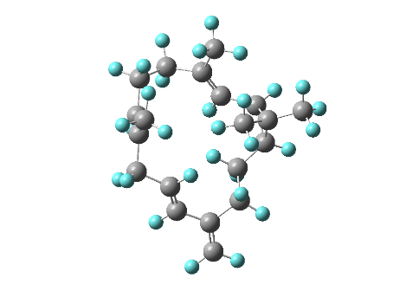 | 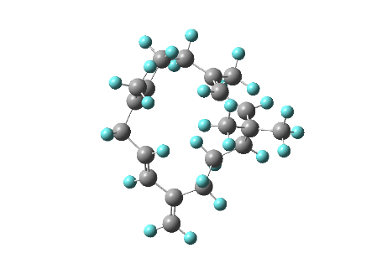
Conf. 1  4.29%  -780.12918558 a. u. | Conf. 2  2.00%  -780.13733449 a. u.
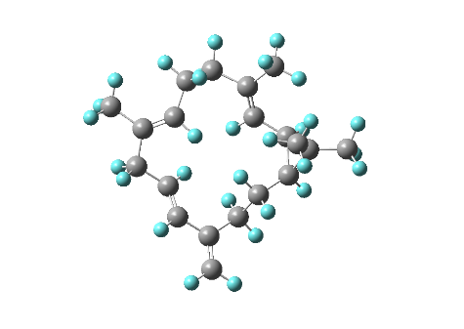 | 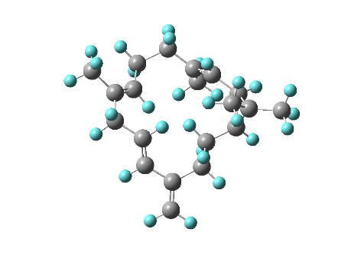
Conf. 3  14.36%  -780.13310085 a. u. | Conf. 4  79.34%  -780.13557317 a. u.

Conf. 1 | Coordinates (Angstroms)
atom | X | Y | Z
C | -2.89044 | -0.76114 | -1.61945
C | -2.72948 | -2.05723 | -0.77478
C | -2.46782 | 0.51826 | -0.92405
C | -1.35037 | 1.15542 | -1.30125
C | 0.82019 | -3.09002 | 0.60562
C | 1.67845 | -1.84995 | 0.59005
C | 2.74323 | -1.6453 | -0.19686
C | 3.4903 | -0.38038 | -0.3276
C | 2.81247 | 0.91378 | 0.08984
C | 1.59188 | 1.20534 | -0.8127
C | -0.74181 | 2.40198 | -0.73756
C | 0.76948 | 2.4381 | -0.48706
C | -0.19355 | 2.53781 | 0.68089
C | 4.7059 | -0.3745 | -0.89749
C | -0.32819 | 3.9098 | 1.32242
C | -0.32833 | 1.40512 | 1.6811
H | -1.15837 | 3.32375 | -1.14123
H | 1.2597 | 3.37461 | -0.74353
C | -3.38428 | 1.01018 | 0.167
C | -1.2978 | -2.46829 | -0.55169
C | -0.66397 | -2.71614 | 0.60193
C | -1.28489 | -2.61456 | 1.97185
H | -3.947 | -0.68365 | -1.90489
H | -2.32084 | -0.87786 | -2.54695
H | -3.23862 | -2.85935 | -1.32524
H | -3.26707 | -1.95347 | 0.16998
H | -0.80759 | 0.72074 | -2.13964
H | 1.03094 | -3.68442 | 1.50419
H | 1.06555 | -3.71772 | -0.25533
H | 1.34667 | -1.05202 | 1.24816
H | 3.08918 | -2.46278 | -0.82808
H | 2.48994 | 0.85494 | 1.13433
H | 3.5332 | 1.73433 | 0.03038
H | 1.94902 | 1.29536 | -1.84628
H | 0.94831 | 0.3267 | -0.80219
H | 5.17372 | -1.29081 | -1.24344
H | 5.26719 | 0.54408 | -1.02965
H | -1.30493 | 4.0225 | 1.8062
H | 0.44104 | 4.05914 | 2.08838
H | -0.2255 | 4.70997 | 0.58471
H | -1.26556 | 1.49806 | 2.23805
H | -0.32683 | 0.42625 | 1.20427
H | 0.48744 | 1.43807 | 2.41095
H | -3.0459 | 1.95477 | 0.59172
H | -4.39543 | 1.15683 | -0.23113
H | -3.47404 | 0.28307 | 0.9809
H | -0.71762 | -2.57997 | -1.46854
H | -2.30626 | -2.23574 | 1.9563
H | -1.29472 | -3.59734 | 2.45792
H | -0.69163 | -1.95771 | 2.61836

Conf. 2 | Coordinates (Angstroms)
atom | X | Y | Z
C | 2.79185 | 1.6769 | -1.17822
C | 2.13313 | 2.57388 | -0.11303
C | 2.56493 | 0.17615 | -1.12241
C | 1.89171 | -0.42553 | -0.13087
C | -1.76193 | 2.79115 | 0.48725
C | -2.23552 | 1.36574 | 0.36184
C | -2.96916 | 0.86465 | -0.64052
C | -3.25069 | -0.56579 | -0.86549
C | -2.32651 | -1.59511 | -0.23478
C | -0.88604 | -1.44628 | -0.77665
C | 1.59395 | -1.87953 | 0.00385
C | 0.16345 | -2.40682 | -0.24864
C | 0.74366 | -2.41142 | 1.15004
C | -4.23898 | -0.93602 | -1.69513
C | 1.14389 | -3.76819 | 1.70889
C | 0.22595 | -1.46989 | 2.22303
H | 2.38376 | -2.54755 | -0.32553
H | 0.1277 | -3.39122 | -0.70979
C | 3.16003 | -0.56522 | -2.29467
C | 0.62745 | 2.65539 | -0.2108
C | -0.25929 | 2.80551 | 0.78132
C | 0.09723 | 2.92458 | 2.24099
H | 3.87542 | 1.85703 | -1.156
H | 2.47378 | 2.02679 | -2.17083
H | 2.55265 | 3.57974 | -0.24961
H | 2.44684 | 2.25769 | 0.88557
H | 1.49115 | 0.21273 | 0.64788
H | -2.28951 | 3.3026 | 1.30205
H | -1.9866 | 3.33762 | -0.43281
H | -1.86895 | 0.69298 | 1.1327
H | -3.36524 | 1.54774 | -1.39062
H | -2.32048 | -1.48435 | 0.85467
H | -2.7095 | -2.59786 | -0.44474
H | -0.92134 | -1.56201 | -1.86694
H | -0.55794 | -0.42215 | -0.60828
H | -4.87053 | -0.20266 | -2.1866
H | -4.44505 | -1.98038 | -1.90271
H | 1.92298 | -3.66206 | 2.47199
H | 0.28734 | -4.26852 | 2.17421
H | 1.53075 | -4.4253 | 0.92566
H | -0.12285 | -0.51794 | 1.82485
H | -0.60936 | -1.93038 | 2.7601
H | 1.01038 | -1.25468 | 2.95697
H | 3.02196 | -1.64413 | -2.2268
H | 2.70539 | -0.22724 | -3.2335
H | 4.23421 | -0.36257 | -2.38028
H | 0.23417 | 2.58861 | -1.22554
H | 1.16326 | 2.80665 | 2.43416
H | -0.20665 | 3.90559 | 2.62537
H | -0.44224 | 2.18036 | 2.83844

Conf. 3 | Coordinates (Angstroms)
atom | X | Y | Z
C | 0.49333 | -3.06251 | -0.64017
C | 1.50303 | -2.77987 | 0.51375
C | -0.8605 | -2.38844 | -0.48416
C | -1.0733 | -1.1538 | -0.96411
C | 3.55114 | 0.5484 | 0.00252
C | 2.34564 | 1.38296 | -0.31972
C | 2.01921 | 2.55076 | 0.24812
C | 0.82749 | 3.35812 | -0.06179
C | -0.33969 | 2.7149 | -0.78791
C | -1.14887 | 1.79171 | 0.15127
C | -2.32893 | -0.34114 | -0.95769
C | -2.34307 | 1.11747 | -0.50037
C | -3.15372 | 0.08037 | 0.25469
C | 0.75498 | 4.62908 | 0.36582
C | -4.66258 | 0.1209 | 0.07436
C | -2.73644 | -0.28604 | 1.66979
H | -2.93751 | -0.51196 | -1.8457
H | -2.93089 | 1.78786 | -1.12426
C | -1.90853 | -3.21365 | 0.21786
C | 2.02041 | -1.37068 | 0.45241
C | 3.26298 | -0.93738 | 0.20214
C | 4.47752 | -1.82041 | 0.06339
H | 0.34403 | -4.14567 | -0.70352
H | 0.95964 | -2.75168 | -1.57973
H | 2.31478 | -3.50705 | 0.44365
H | 1.00278 | -2.95898 | 1.47382
H | -0.24457 | -0.68885 | -1.49706
H | 4.07906 | 0.95451 | 0.87466
H | 4.26533 | 0.627 | -0.83125
H | 1.70537 | 0.97485 | -1.09699
H | 2.68107 | 2.96564 | 1.00717
H | -0.99652 | 3.49965 | -1.17433
H | 0.00882 | 2.14571 | -1.65586
H | -0.47785 | 1.04255 | 0.57561
H | -1.49907 | 2.40071 | 0.99359
H | 1.56238 | 5.08337 | 0.93117
H | -0.11054 | 5.24938 | 0.16004
H | -5.11032 | -0.8597 | 0.27175
H | -5.1176 | 0.83807 | 0.76696
H | -4.93727 | 0.4175 | -0.94141
H | -3.27518 | -1.17368 | 2.01311
H | -1.66974 | -0.49322 | 1.75499
H | -2.97978 | 0.52925 | 2.36007
H | -2.86614 | -2.70068 | 0.28613
H | -2.0623 | -4.15628 | -0.32038
H | -1.58822 | -3.48445 | 1.23069
H | 1.24622 | -0.61612 | 0.55263
H | 4.27588 | -2.86528 | 0.29779
H | 4.88103 | -1.77128 | -0.95485
H | 5.2764 | -1.47565 | 0.73023

Conf. 4 | Coordinates (Angstroms)
atom | X | Y | Z
C | 1.3532 | -2.96762 | -0.27965
C | 2.55963 | -2.0787 | -0.7012
C | -0.00588 | -2.47155 | -0.73342
C | -0.91153 | -2.0594 | 0.16625
C | 2.8657 | 1.50737 | 0.94147
C | 1.45597 | 1.92076 | 0.63694
C | 1.08512 | 2.83225 | -0.27242
C | -0.2942 | 3.17429 | -0.65903
C | -1.44838 | 2.30137 | -0.19611
C | -1.35847 | 0.86434 | -0.75854
C | -2.285 | -1.52917 | -0.09851
C | -2.53168 | -0.05557 | -0.47342
C | -2.94292 | -0.57818 | 0.88911
C | -0.50938 | 4.22281 | -1.47089
C | -4.43356 | -0.75755 | 1.12857
C | -2.18892 | -0.16983 | 2.14275
H | -2.96138 | -2.23292 | -0.57872
H | -3.37097 | 0.09104 | -1.14933
C | -0.2597 | -2.46862 | -2.21934
C | 2.43044 | -0.64896 | -0.25253
C | 3.18846 | 0.04854 | 0.60393
C | 4.41504 | -0.48007 | 1.30357
H | 1.35524 | -3.05838 | 0.81058
H | 1.52741 | -3.97293 | -0.68518
H | 2.6451 | -2.09924 | -1.79483
H | 3.46957 | -2.54426 | -0.31638
H | -0.61727 | -2.1139 | 1.21261
H | 3.05732 | 1.64718 | 2.01461
H | 3.57786 | 2.16373 | 0.42497
H | 0.69318 | 1.38518 | 1.19523
H | 1.86377 | 3.37089 | -0.81131
H | -1.47153 | 2.26238 | 0.89782
H | -2.38729 | 2.76533 | -0.51168
H | -1.24443 | 0.9306 | -1.84707
H | -0.44453 | 0.39775 | -0.3988
H | 0.30971 | 4.83538 | -1.83403
H | -1.50804 | 4.49764 | -1.79205
H | -4.61748 | -1.51842 | 1.89539
H | -4.89243 | 0.17702 | 1.47001
H | -4.94924 | -1.0707 | 0.21698
H | -2.26967 | -0.94828 | 2.90984
H | -1.12752 | 0.00277 | 1.96286
H | -2.61154 | 0.74844 | 2.56235
H | -1.26323 | -2.1187 | -2.46226
H | 0.45663 | -1.82802 | -2.7456
H | -0.13651 | -3.47651 | -2.63306
H | 1.58648 | -0.12679 | -0.69235
H | 4.6788 | -1.49251 | 0.99844
H | 5.27758 | 0.16711 | 1.10559
H | 4.27073 | -0.47992 | 2.39018

Figure S6h. Re-optimized conformers of (1S, 2R)-4 calculated at the B3LYP/6-311G(d,p) level with IEFPCM solvent model for acetonitrile.

