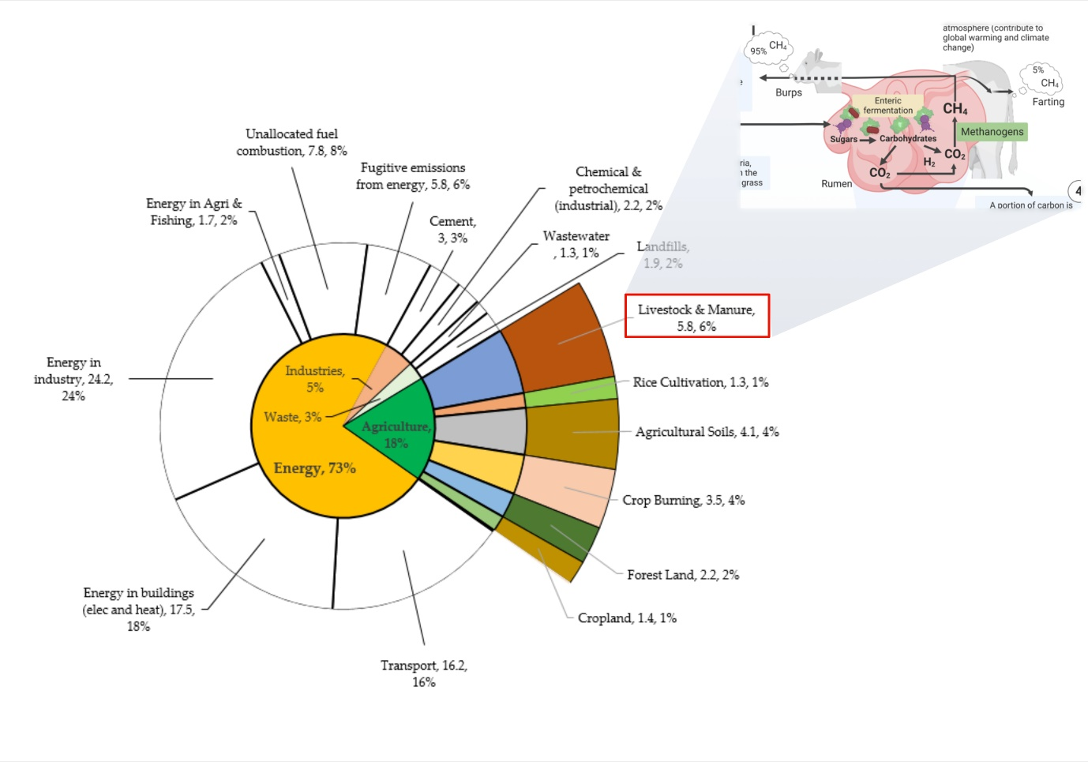
Figure S1. Distribution of global greenhouse gas emissions by sector.

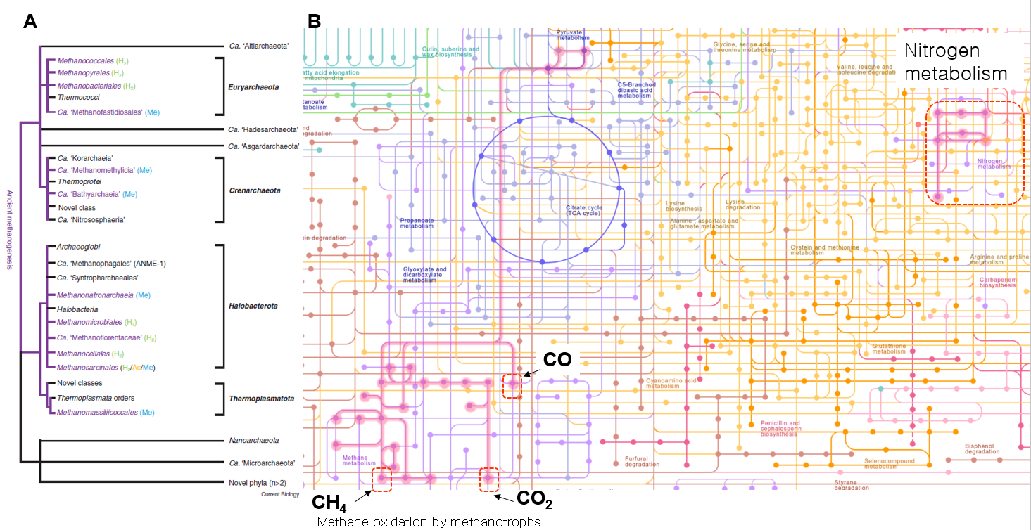
Figure S2. Methanogenesis and methanotrophy pathways versus nitrogen metabolism. (A) Cluster of methanogens species. (B) Metabolic pathways in biological systems, with a highlight on the methanogenesis, methanotrophy (thick lines on the left side of the panel B) and nitrogen metabolism (thick lines surrounded by a dash square at the upper right side of panel B). This pathways was obtained from the Kyoto Encyclopedia of Genes and Genomes (KEGG, https://www.genome.jp/pathway/map01100+M00052, accessed on December 9, 2022).

