Supplementary Materials
Scopus - Web of Science Bibliographic map based on Bibliographic Data type or Text Data type of VOSviewer software.
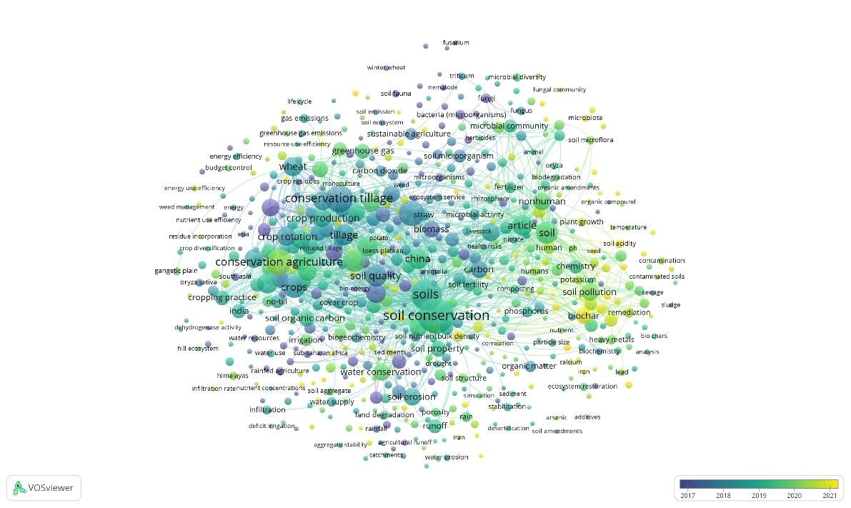
Figure S1a. Bibliographic map based on Bibliographic Data type of VOSviewer software. Results were obtained with the VOSviewer software based on bibliographic data for the “Conservation - Carbon” AND “Straw” query. Supported read data were from Scopus bibliographic database files.

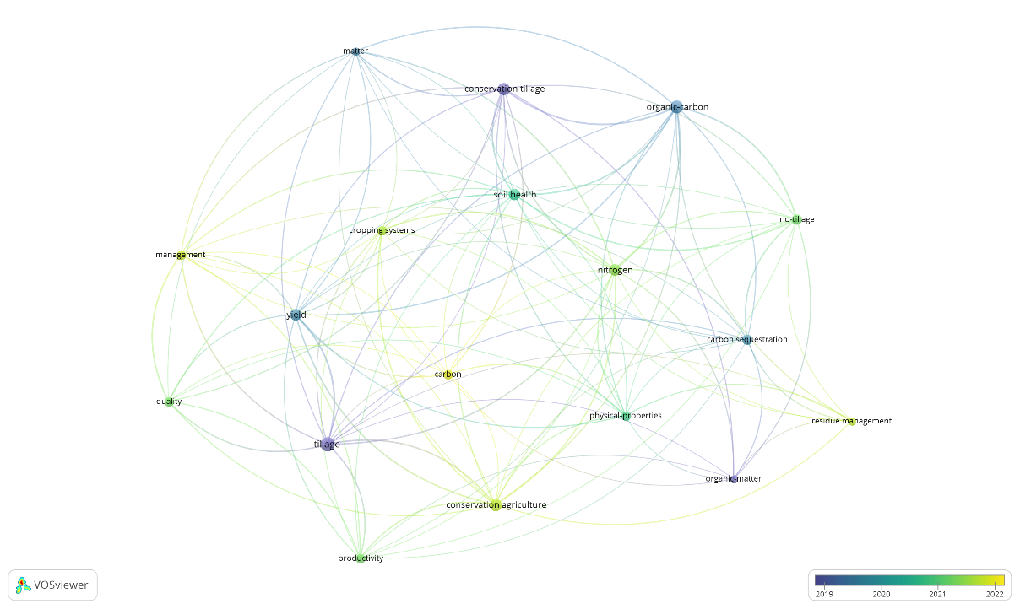
Figure S1b. Bibliographic map based on Bibliographic Data type of VOSviewer software. Results were obtained with the VOSviewer software based on bibliographic data for the “Conservation - Carbon” AND “Straw” query. Supported read data were from Web of Science bibliographic database files.

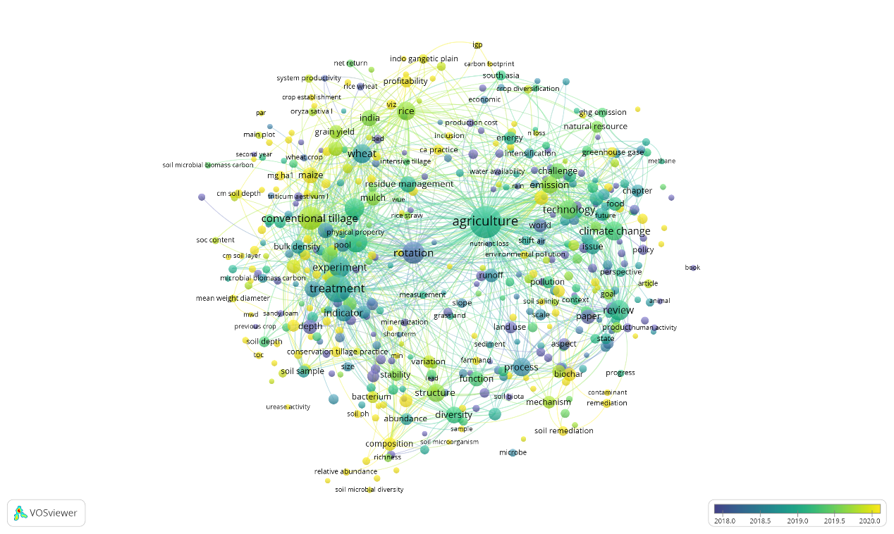
Figure S1c. Bibliographic map based on Text Data type of VOSviewer software. Results were obtained with the VOSviewer software based on bibliographic data for the “Conservation - Carbon” AND “Straw” query. Supported read data were from Scopus bibliographic database files.

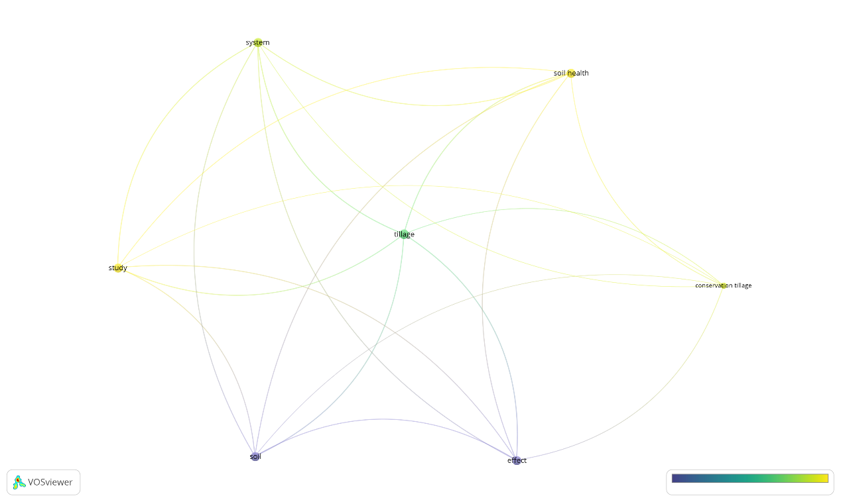
Figure S1d. Bibliographic map based on Text Data type of VOSviewer software. Results were obtained with the VOSviewer software based on bibliographic data for the “Conservation - Carbon” AND “Straw” query. Supported read data were from Web of Science bibliographic database files.
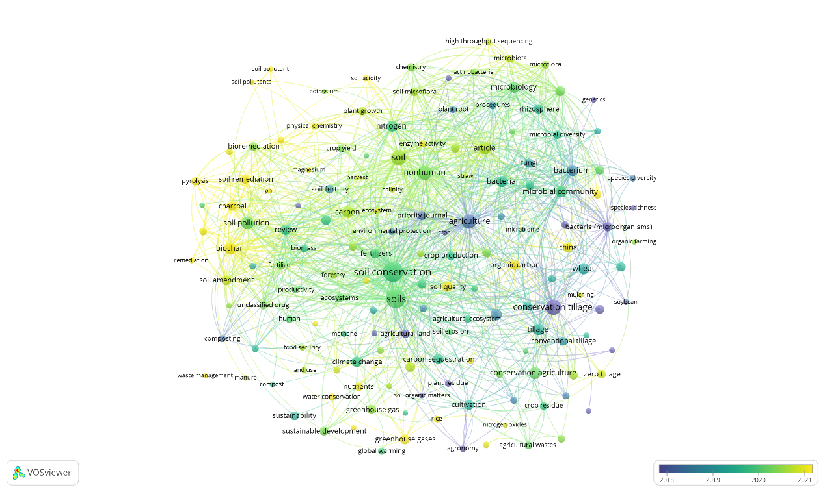
Figure S2a. Bibliographic map based on Bibliographic Data type of VOSviewer software. Results were obtained with the VOSviewer software based on bibliographic data for the “Conservation - Microbes” AND “Straw” query. Supported read data were from Scopus bibliographic database files.

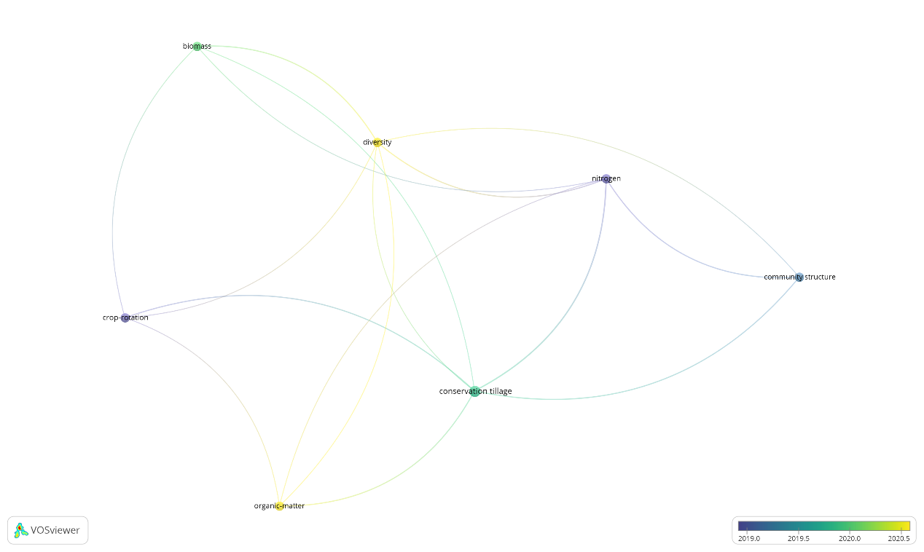
Figure S2b. Bibliographic map based on Bibliographic Data type of VOSviewer software. Results were obtained with the VOSviewer software based on bibliographic data for the “Conservation - Microbes” AND “Straw” query. Supported read data were from Web of Science bibliographic database files.

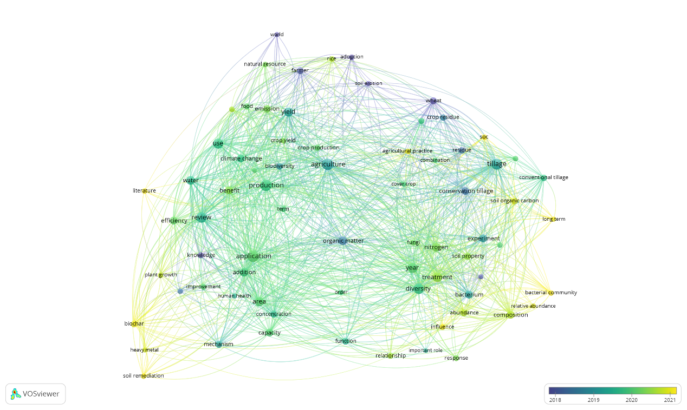

Figure S2c. Bibliographic map based on Text Data type of VOSviewer software. Results were obtained with the VOSviewer software based on bibliographic data for the “Conservation - Microbes” AND “Straw” query. Supported read data were from Scopus bibliographic database files.

Figure S2d. Bibliographic map based on Text Data type of VOSviewer software. Results were obtained with the VOSviewer software based on bibliographic data for the “Conservation - Microbes” AND “Straw” query. Supported read data were from Web of Science bibliographic database files.

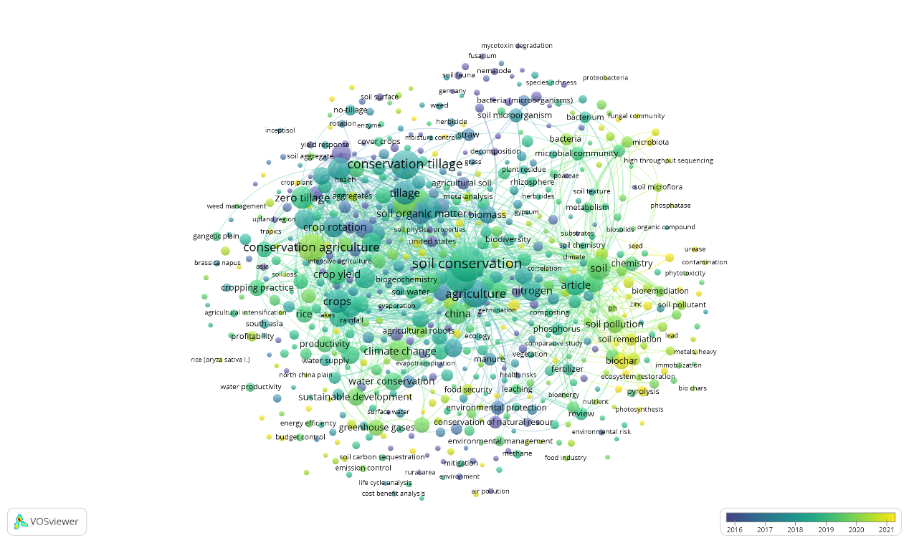
Figure S3a. Bibliographic map based on Bibliographic Data type of VOSviewer software. Results were obtained with the VOSviewer software based on bibliographic data for the “Conservation - Nitrogen” AND “Straw” query. Supported read data were from Scopus bibliographic database files.

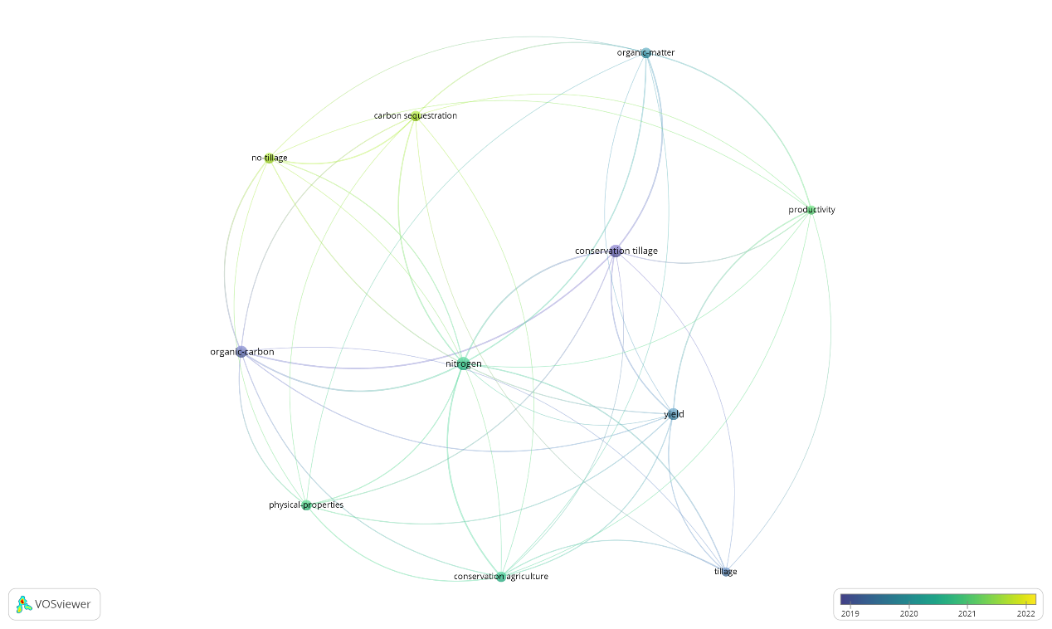
Figure S3b. Bibliographic map based on Bibliographic Data type of VOSviewer software. Results were obtained with the VOSviewer software based on bibliographic data for the “Conservation - Nitrogen” AND “Straw” query. Supported read data were from Web of Science bibliographic database files.

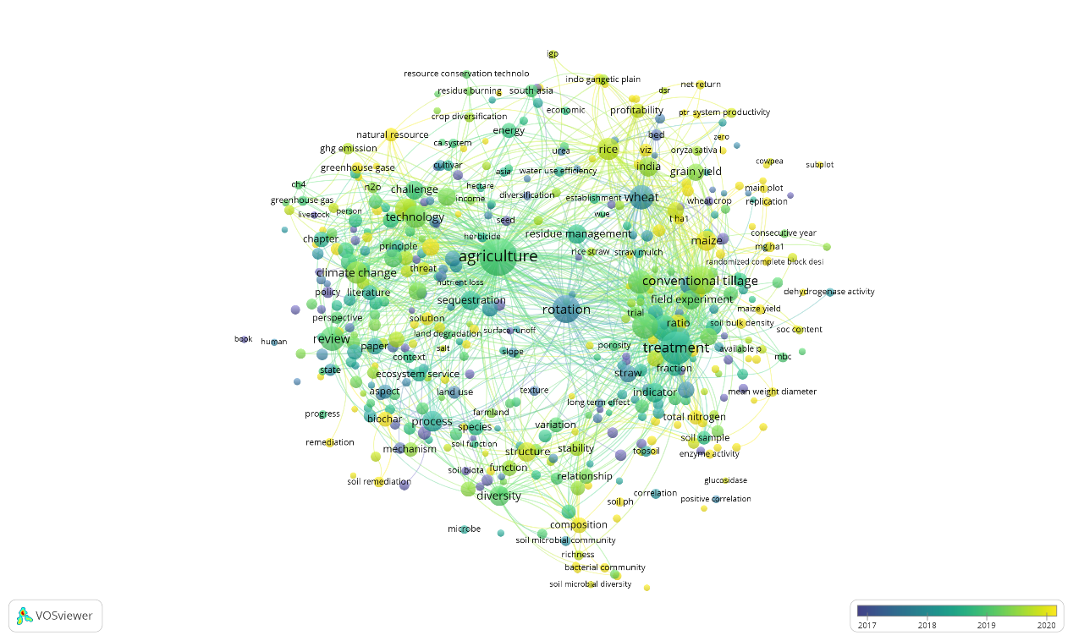

Figure S3c. Bibliographic map based on Text Data type of VOSviewer software. Results were obtained with the VOSviewer software based on bibliographic data for the “Conservation - Nitrogen” AND “Straw” query. Supported read data were from Scopus bibliographic database files.
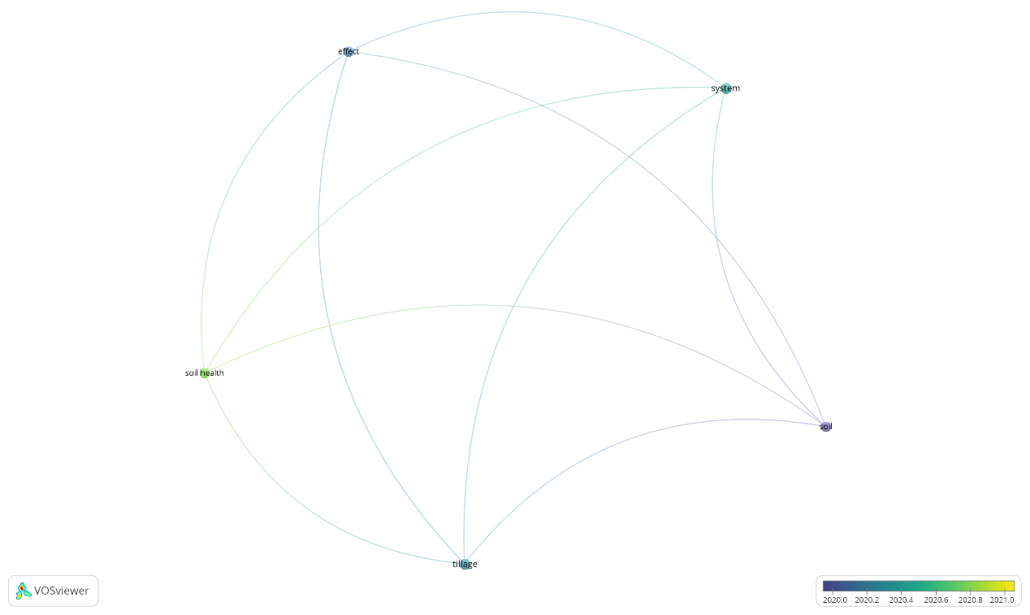
Figure S3d. Bibliographic map based on Text Data type of VOSviewer software. Results were obtained with the VOSviewer software based on bibliographic data for the “Conservation - Nitrogen” AND “Straw” query. Supported read data were from Web of Science bibliographic database files.

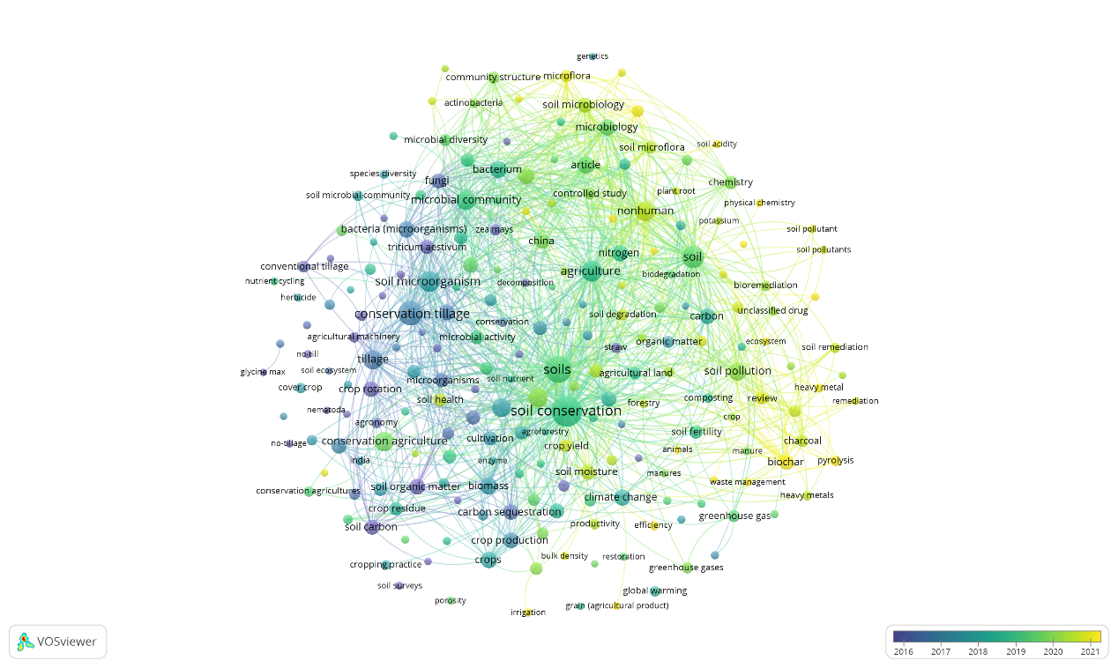
Figure S4a. Bibliographic map based on Bibliographic Data type of VOSviewer software. Results were obtained with the VOSviewer software based on bibliographic data for the “Conservation - Microorganisms” AND “Straw” query. Supported read data were from Scopus bibliographic database files.

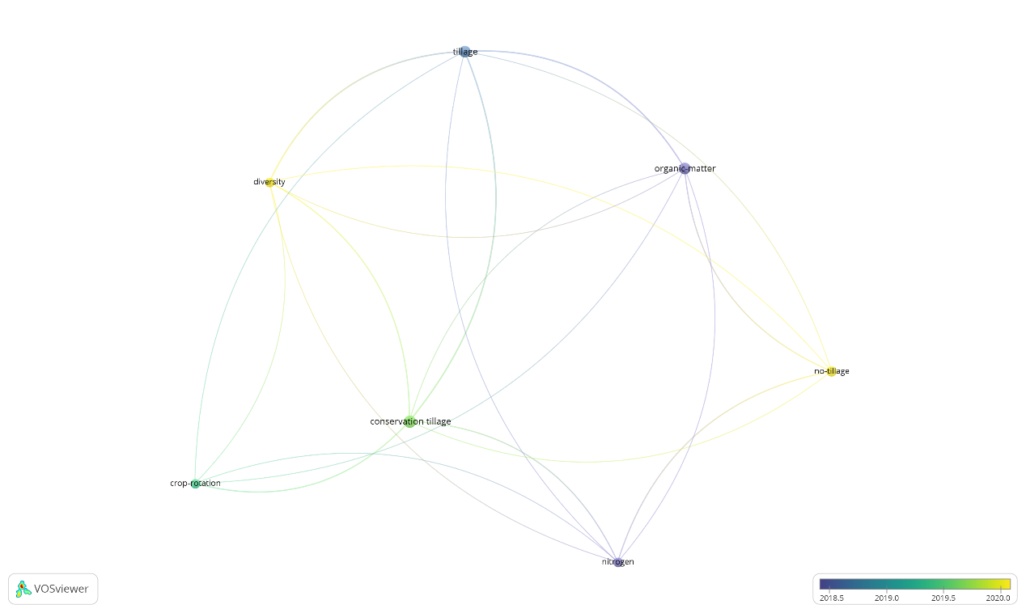
Figure S4b. Bibliographic map based on Bibliographic Data type of VOSviewer software. Results were obtained with the VOSviewer software based on bibliographic data for the “Conservation - Microorganisms” AND “Straw” query. Supported read data were from Web of Science bibliographic database files.

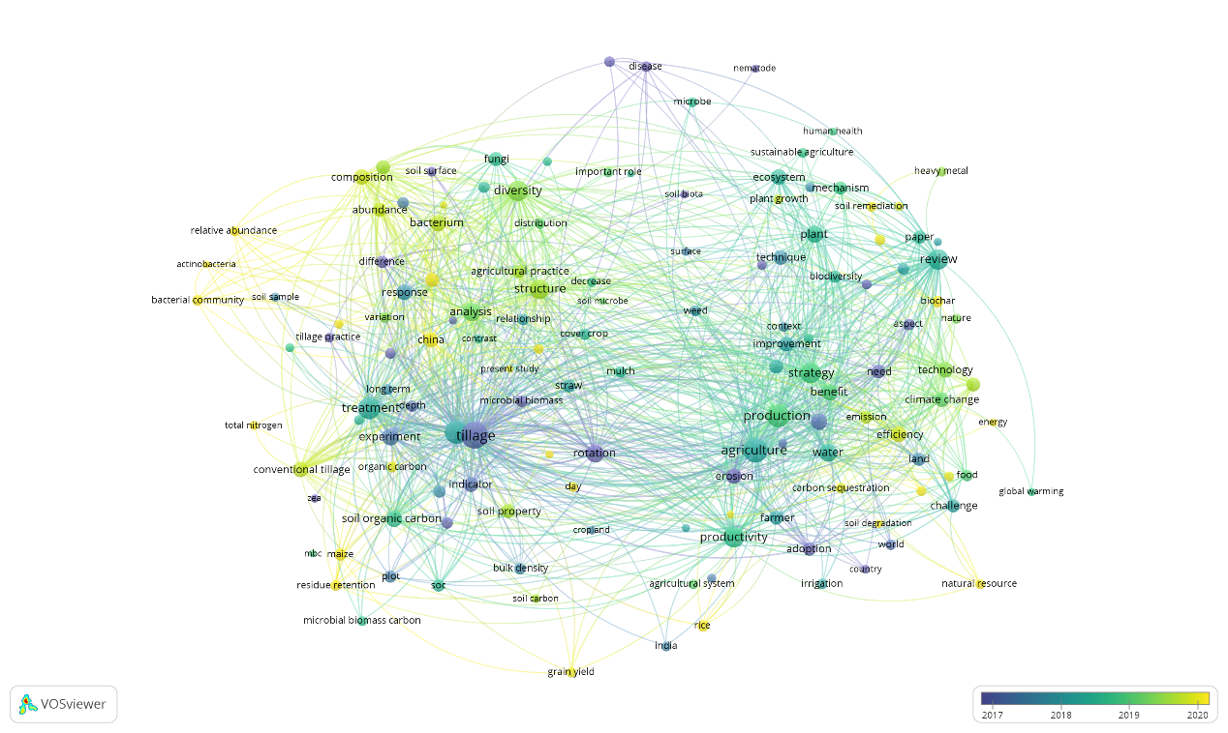
Figure S4c. Bibliographic map based on Text Data type of VOSviewer software. Results were obtained with the VOSviewer software based on bibliographic data for the “Conservation - Microorganisms” AND “Straw” query. Supported read data were from Scopus bibliographic database files.

Figure S4d. Bibliographic map based on Text Data type of VOSviewer software. Results were obtained with the VOSviewer software based on bibliographic data for the “Conservation - Microorganisms” AND “Straw” query. Supported read data were from Web of Science bibliographic database files.

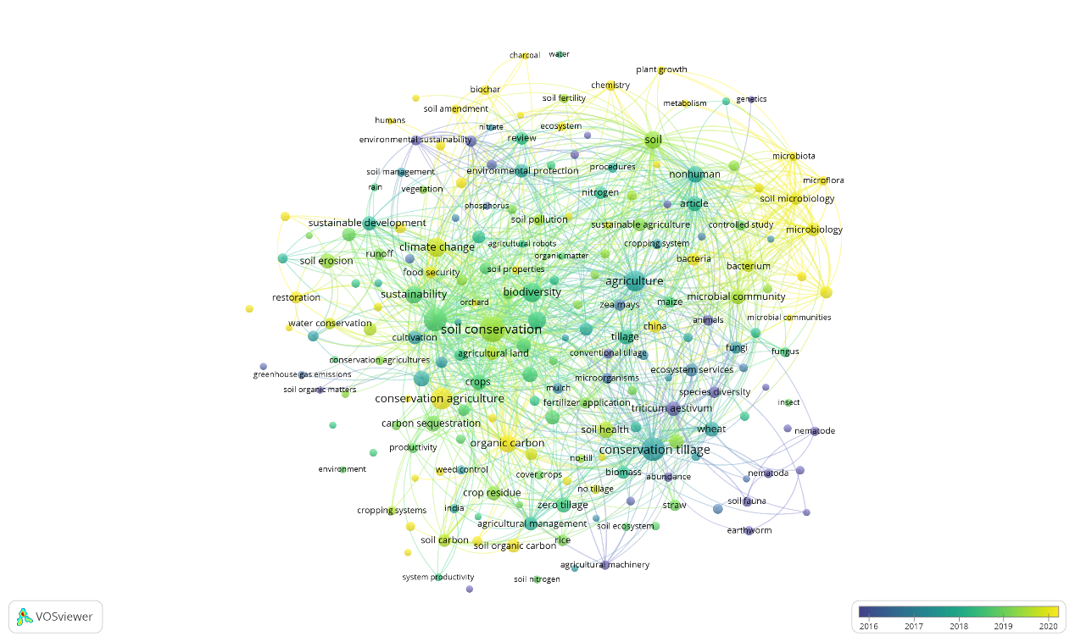
Figure S5a. Bibliographic map based on Bibliographic Data type of VOSviewer software. Results were obtained with the VOSviewer software based on bibliographic data for the “Conservation - Biodiversity” AND “Straw” query. Supported read data were from Scopus bibliographic database files.

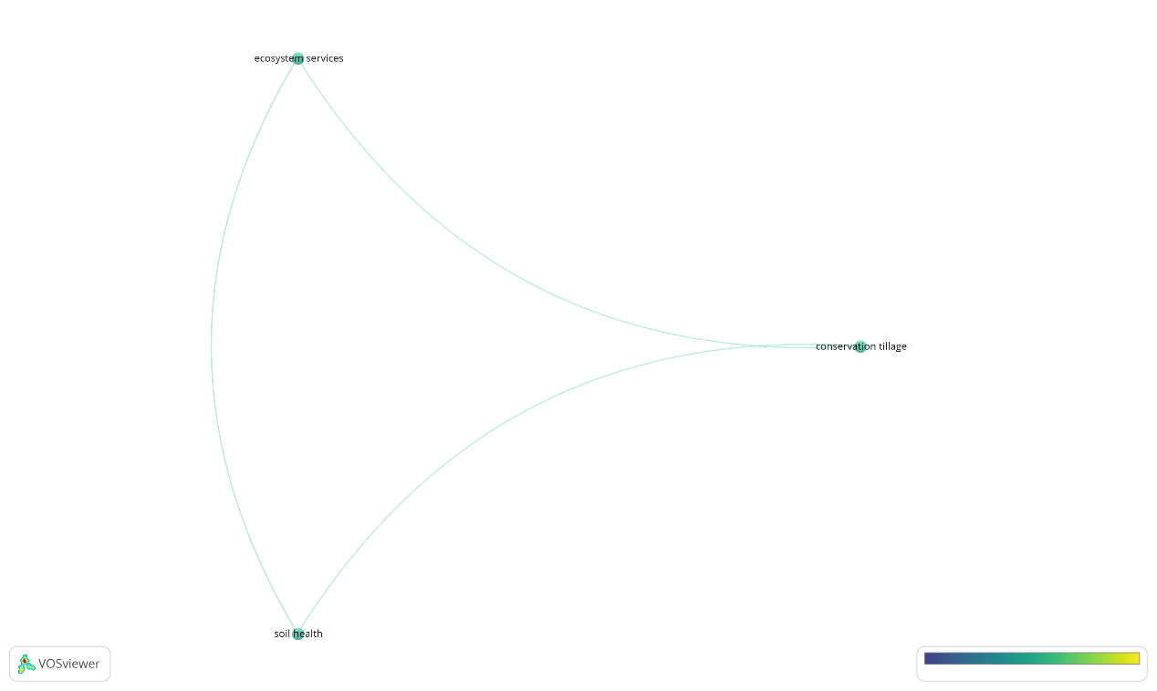
Figure S5b. Bibliographic map based on Bibliographic Data type of VOSviewer software. Results were obtained with the VOSviewer software based on bibliographic data for the “Conservation - Biodiversity” AND “Straw” query. Supported read data were from Web of Science bibliographic database files.

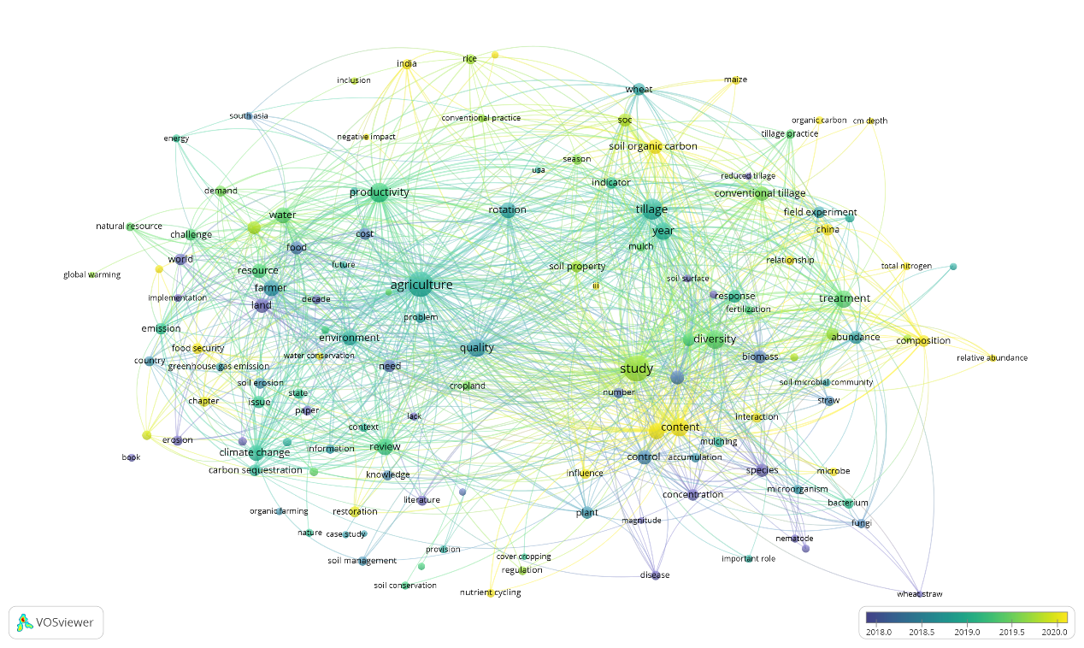
Figure S5c. Bibliographic map based on Text Data type of VOSviewer software. Results were obtained with the VOSviewer software based on bibliographic data for the “Conservation - Biodiversity” AND “Straw” query. Supported read data were from Scopus bibliographic database files.

Figure S5d. Bibliographic map based on Text Data type of VOSviewer software. Results were obtained with the VOSviewer software based on bibliographic data for the “Conservation - Biodiversity” AND “Straw” query. Supported read data were from Web of Science bibliographic database files.

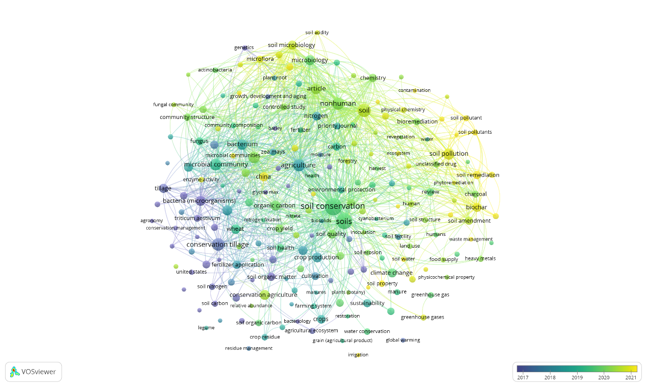
Figure S6a. Bibliographic map based on Bibliographic Data type of VOSviewer software. Results were obtained with the VOSviewer software based on bibliographic data for the “Conservation - Bacteria” AND “Straw” query. Supported read data were from Scopus bibliographic database files.

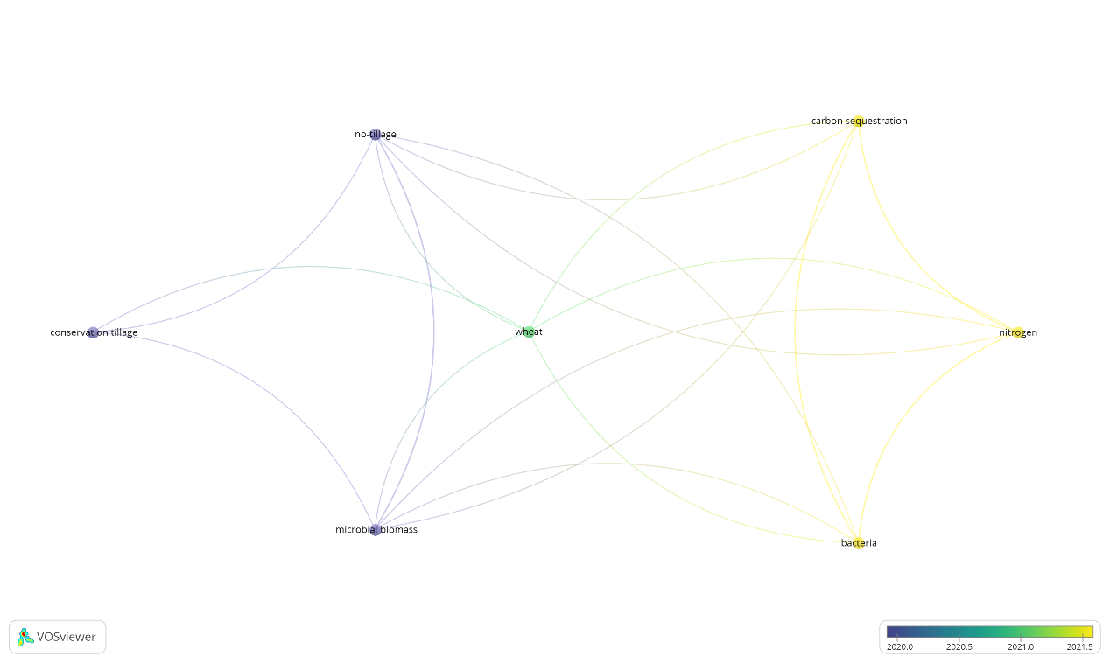
Figure S6b. Bibliographic map based on Bibliographic Data type of VOSviewer software. Results were obtained with the VOSviewer software based on bibliographic data for the “Conservation - Bacteria” AND “Straw” query. Supported read data were from Web of Science bibliographic database files.

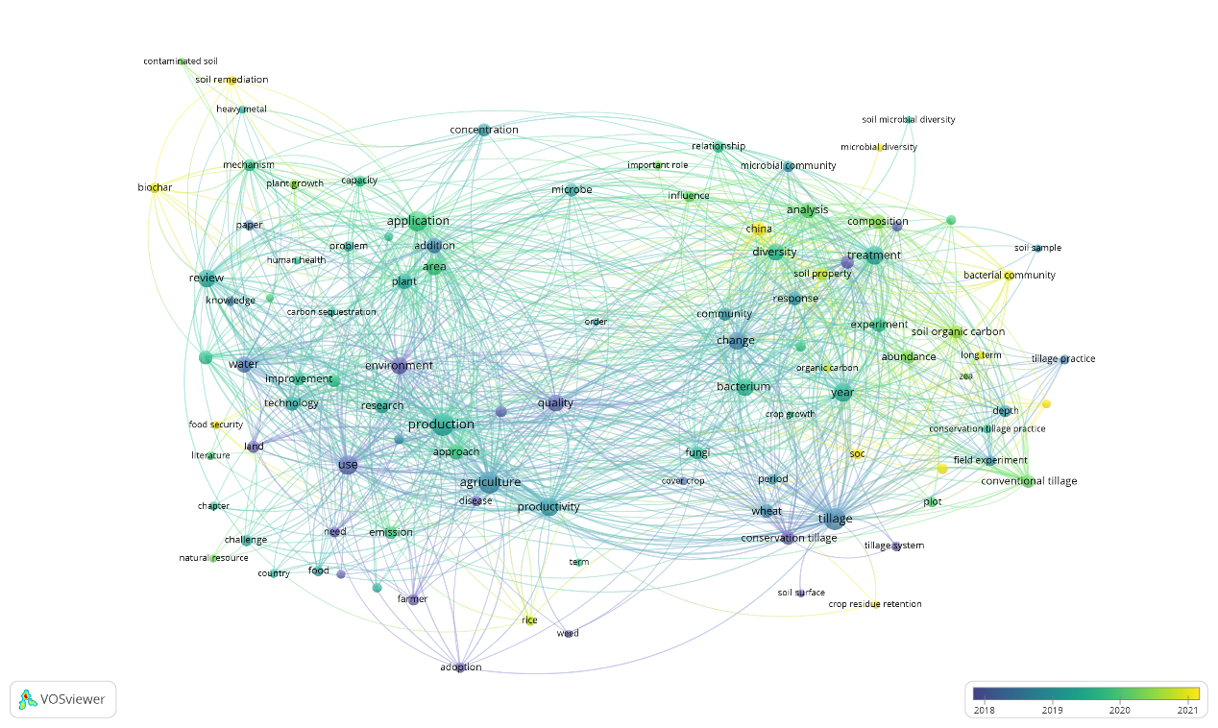
Figure S6c. Bibliographic map based on Text Data type of VOSviewer software. Results were obtained with the VOSviewer software based on bibliographic data for the “Conservation - Bacteria” AND “Straw” query. Supported read data were from Scopus bibliographic database files.

Figure S6d. Bibliographic map based on Text Data type of VOSviewer software. Results were obtained with the VOSviewer software based on bibliographic data for the “Conservation - Bacteria” AND “Straw” query. Supported read data were from Web of Science bibliographic database files.

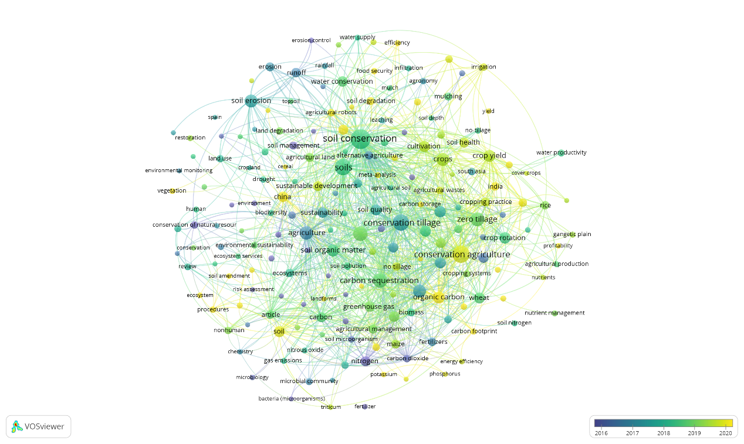
Figure S7a. Bibliographic map based on Bibliographic Data type of VOSviewer software. Results were obtained with the VOSviewer software based on bibliographic data for the “Conservation - Climatic” AND “Straw” query. Supported read data were from Scopus bibliographic database files.

Figure S7b. Bibliographic map based on Bibliographic Data type of VOSviewer software. Results were obtained with the VOSviewer software based on bibliographic data for the “Conservation - Climatic” AND “Straw” query. Supported read data were from Web of Science bibliographic database files.

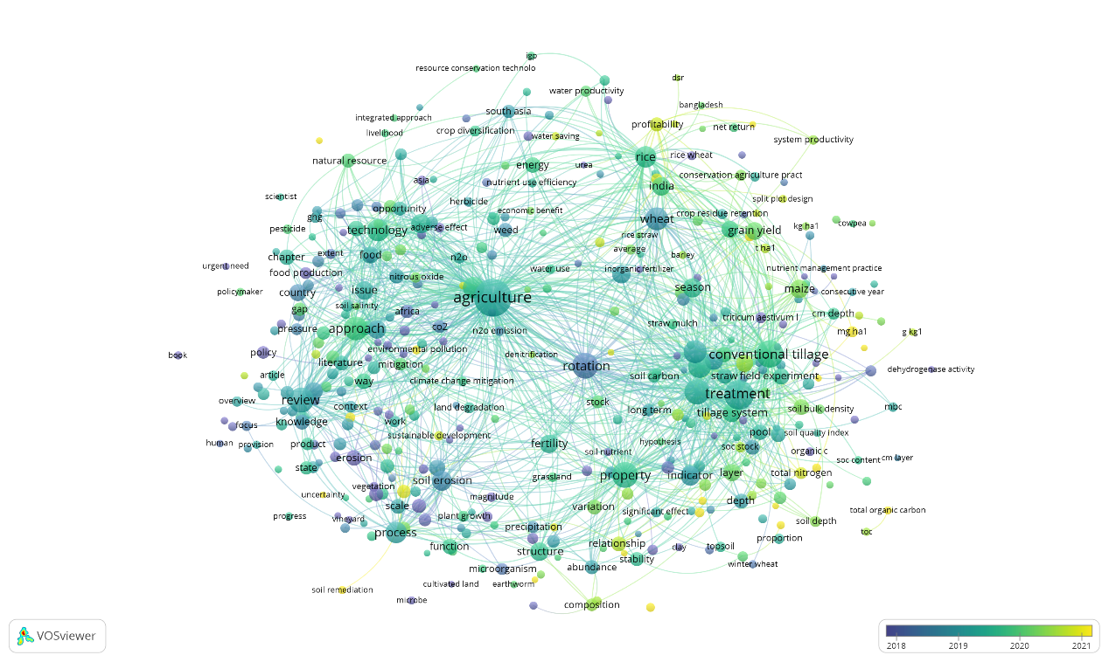
Figure S7c. Bibliographic map based on Text Data type of VOSviewer software. Results were obtained with the VOSviewer software based on bibliographic data for the “Conservation - Climatic” AND “Straw” query. Supported read data were from Scopus bibliographic database files.

Figure S7d. Bibliographic map based on Text Data type of VOSviewer software. Results were obtained with the VOSviewer software based on bibliographic data for the “Conservation - Climatic” AND “Straw” query. Supported read data were from Web of Science bibliographic database files.
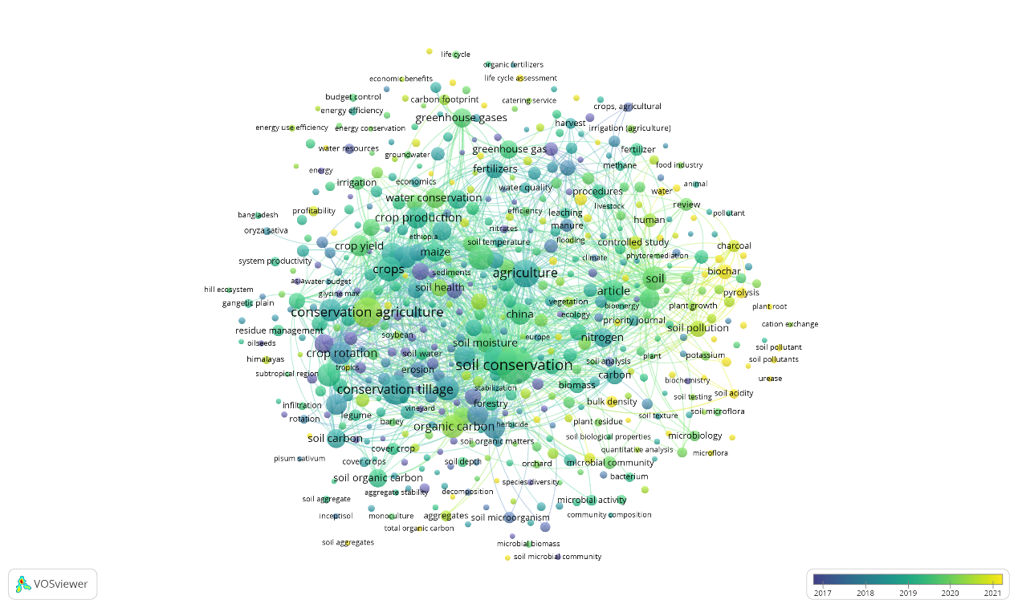
Figure S8a. Bibliographic map based on Bibliographic Data type of VOSviewer software. Results were obtained with the VOSviewer software based on bibliographic data for the “Conservation - Climate” AND “Straw” query. Supported read data were from Scopus bibliographic database files.

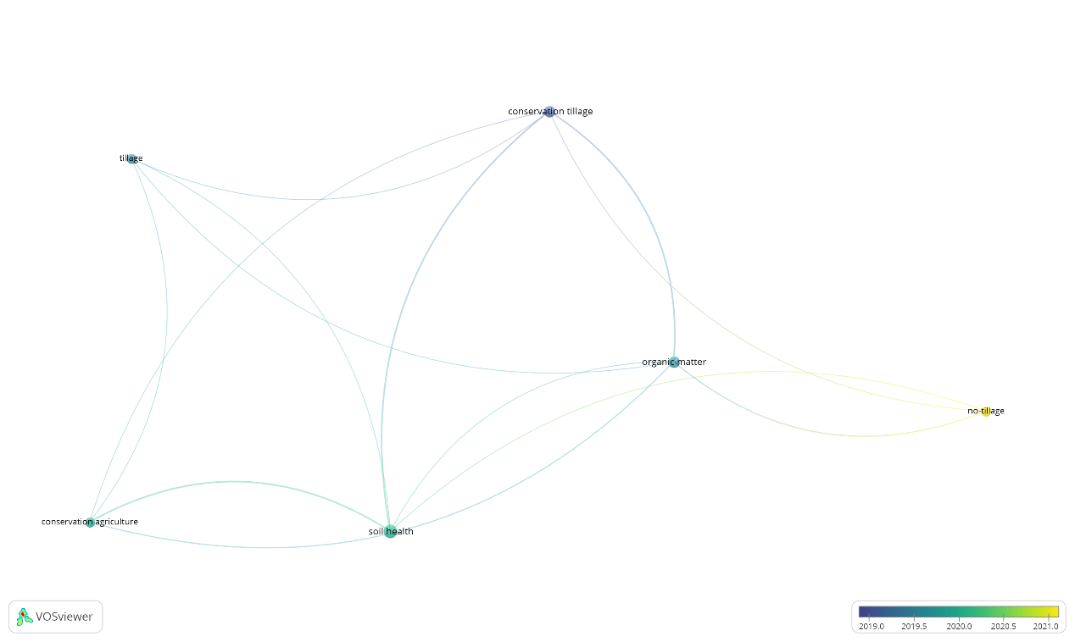

Figure S8b. Bibliographic map based on Bibliographic Data type of VOSviewer software. Results were obtained with the VOSviewer software based on bibliographic data for the “Conservation - Climate” AND “Straw” query. Supported read data were from Web of Science bibliographic database files.

Figure S8c. Bibliographic map based on Text Data type of VOSviewer software. Results were obtained with the VOSviewer software based on bibliographic data for the “Conservation - Climate” AND “Straw” query. Supported read data were from Scopus bibliographic database files.

Figure S8d. Bibliographic map based on Text Data type of VOSviewer software. Results were obtained with the VOSviewer software based on bibliographic data for the “Conservation - Climate” AND “Straw” query. Supported read data were from Web of Science bibliographic database files.
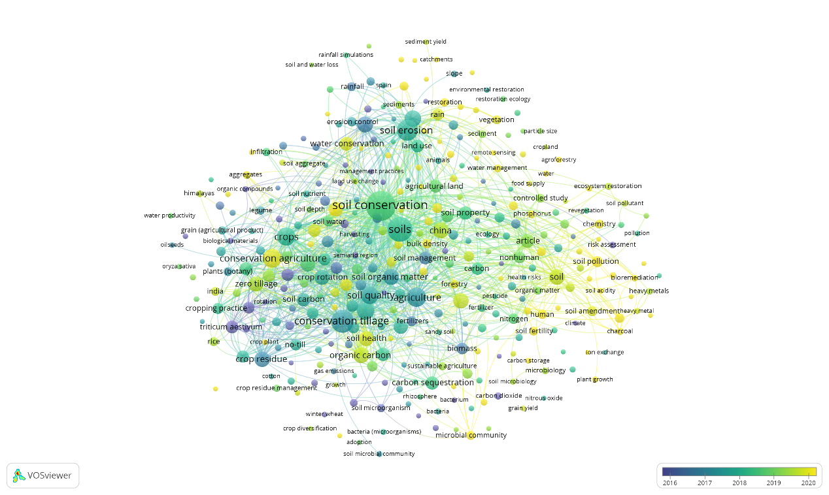
Figure S9a. Bibliographic map based on Bibliographic Data type of VOSviewer software. Results were obtained with the VOSviewer software based on bibliographic data for the “Conservation - Erosion” AND “Straw” query. Supported read data were from Scopus bibliographic database files.

Figure S9b. Bibliographic map based on Bibliographic Data type of VOSviewer software. Results were obtained with the VOSviewer software based on bibliographic data for the “Conservation - Erosion” AND “Straw” query. Supported read data were from Web of Science bibliographic database files.

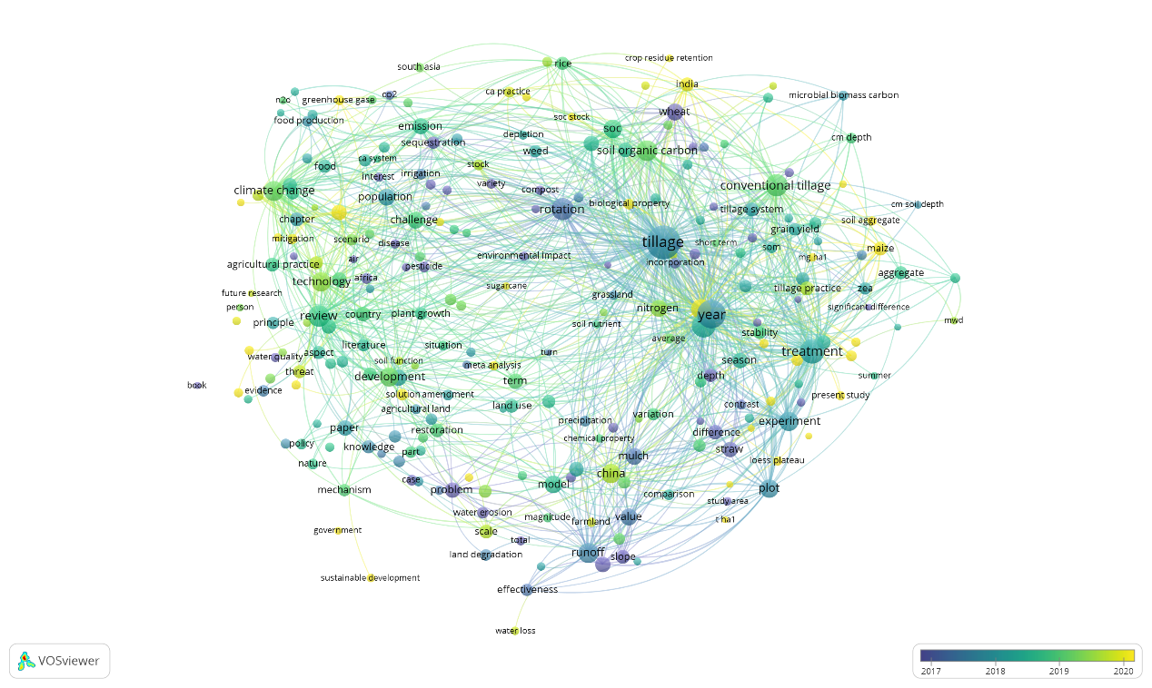
Figure S9c. Bibliographic map based on Text Data type of VOSviewer software. Results were obtained with the VOSviewer software based on bibliographic data for the “Conservation - Erosion” AND “Straw” query. Supported read data were from Scopus bibliographic database files.

Figure S9d. Bibliographic map based on Text Data type of VOSviewer software. Results were obtained with the VOSviewer software based on bibliographic data for the “Conservation - Erosion” AND “Straw” query. Supported read data were from Web of Science bibliographic database files.

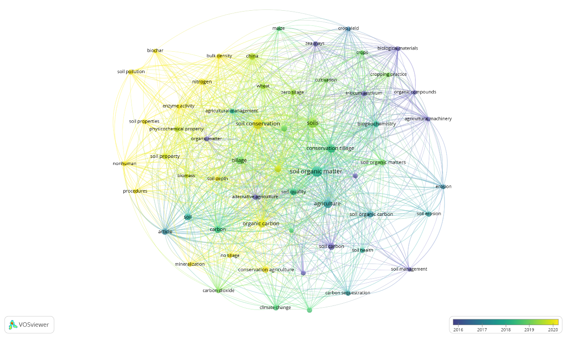
Figure S10a. Bibliographic map based on Bibliographic Data type of VOSviewer software. Results were obtained with the VOSviewer software based on bibliographic data for the “Conservation - SOM” AND “Straw” query. Supported read data were from Scopus bibliographic database files.

Figure S10b. Bibliographic map based on Bibliographic Data type of VOSviewer software. Results were obtained with the VOSviewer software based on bibliographic data for the “Conservation - SOM” AND “Straw” query. Supported read data were from Web of Science bibliographic database files.

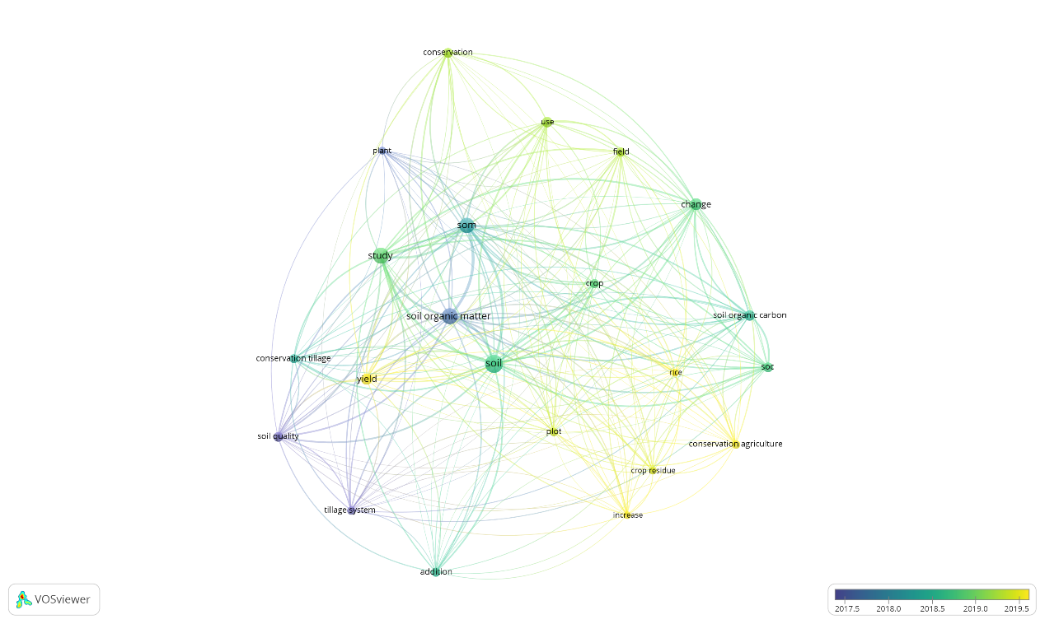
Figure S10c. Bibliographic map based on Text Data type of VOSviewer software. Results were obtained with the VOSviewer software based on bibliographic data for the “Conservation - SOM” AND “Straw” query. Supported read data were from Scopus bibliographic database files.

Figure S10d. Bibliographic map based on Text Data type of VOSviewer software. Results were obtained with the VOSviewer software based on bibliographic data for the “Conservation - SOM” AND “Straw” query. Supported read data were from Web of Science bibliographic database files.

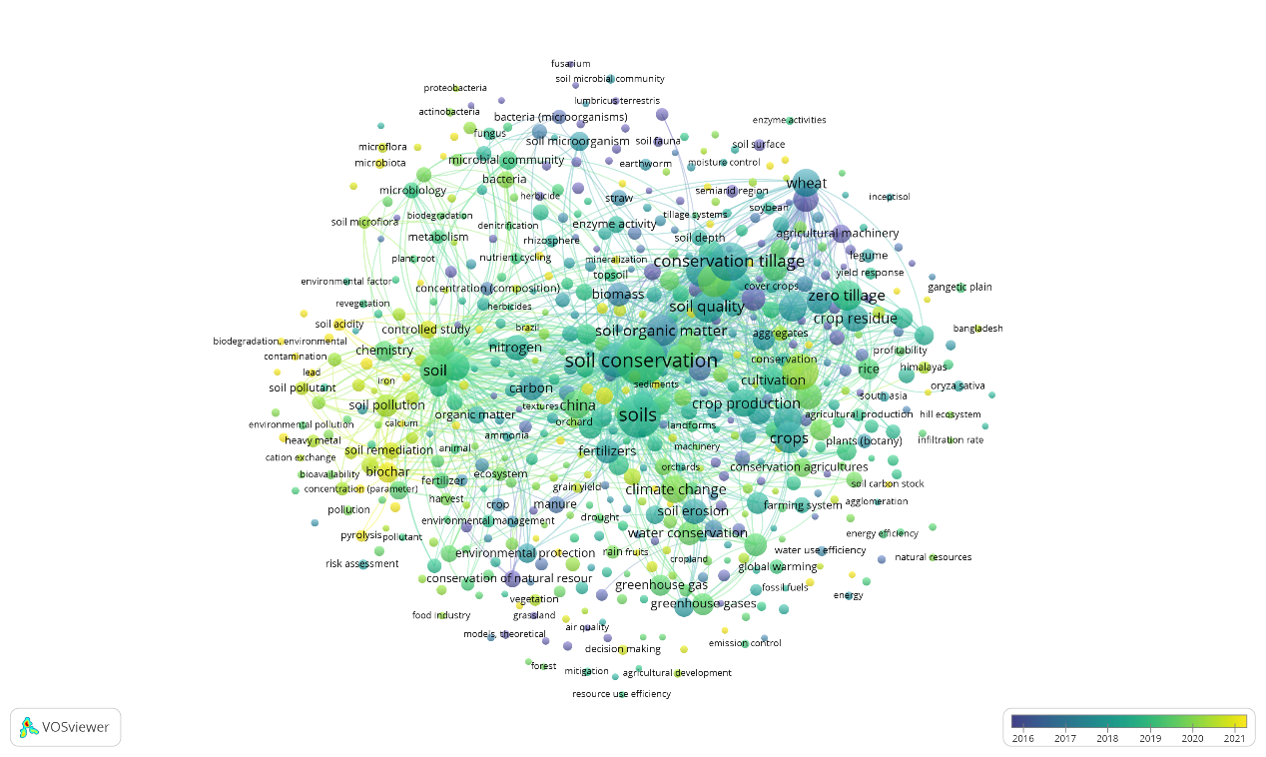
Figure S11a. Bibliographic map based on Bibliographic Data type of VOSviewer software. Results were obtained with the VOSviewer software based on bibliographic data for the “Conservation - Organic matter” AND “Straw” query. Supported read data were from Scopus bibliographic database files.

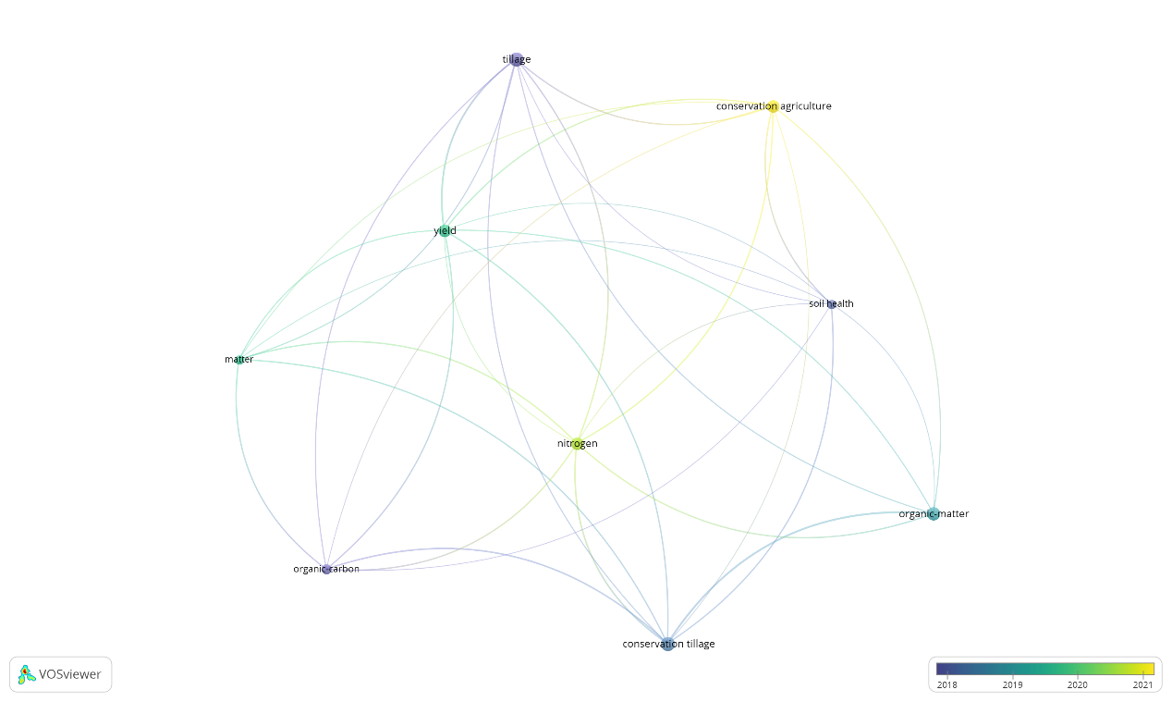
Figure S11b. Bibliographic map based on Bibliographic Data type of VOSviewer software. Results were obtained with the VOSviewer software based on bibliographic data for the “Conservation - Organic matter” AND “Straw” query. Supported read data were from Web of Science bibliographic database files.

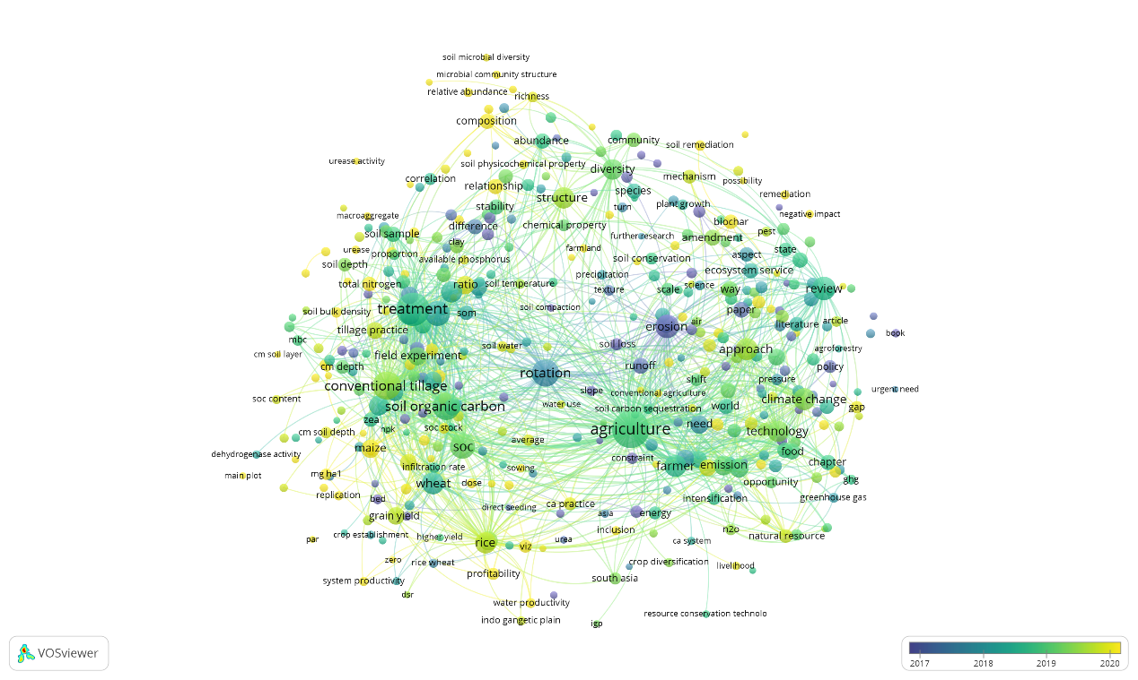
Figure S11c. Bibliographic map based on Text Data type of VOSviewer software. Results were obtained with the VOSviewer software based on bibliographic data for the “Conservation - Organic matter” AND “Straw” query. Supported read data were from Scopus bibliographic database files.

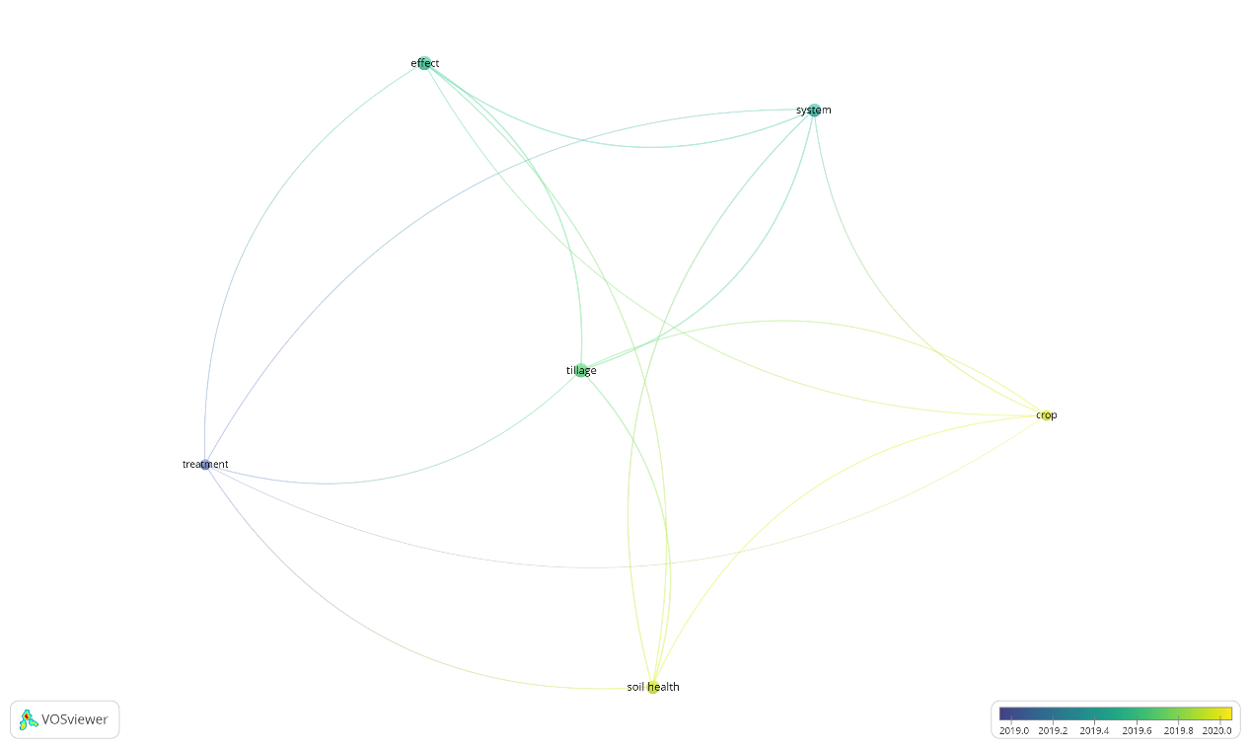
Figure S11d. ibliographic map based on Text Data type of VOSviewer software. Results were obtained with the VOSviewer software based on bibliographic data for the “Conservation - Organic matter” AND “Straw” query. Supported read data were from Web of Science bibliographic database files.
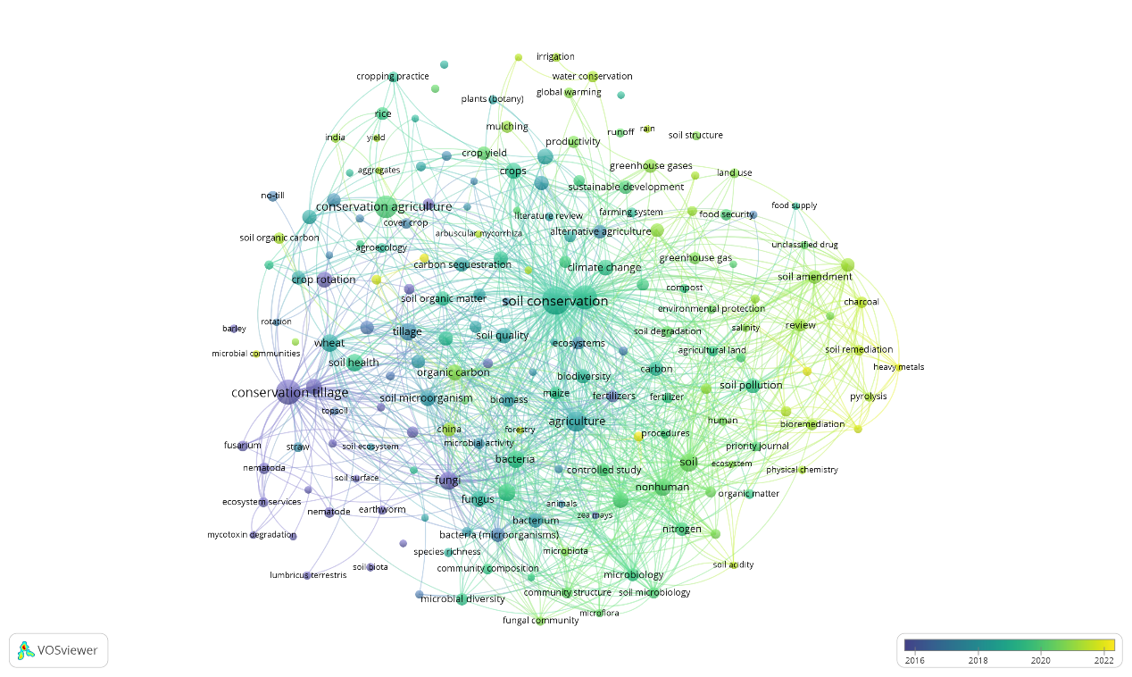
Figure S12a. Bibliographic map based on Bibliographic Data type of VOSviewer software. Results were obtained with the VOSviewer software based on bibliographic data for the “Conservation - Fungi” AND “Straw” query. Supported read data were from Scopus bibliographic database files.

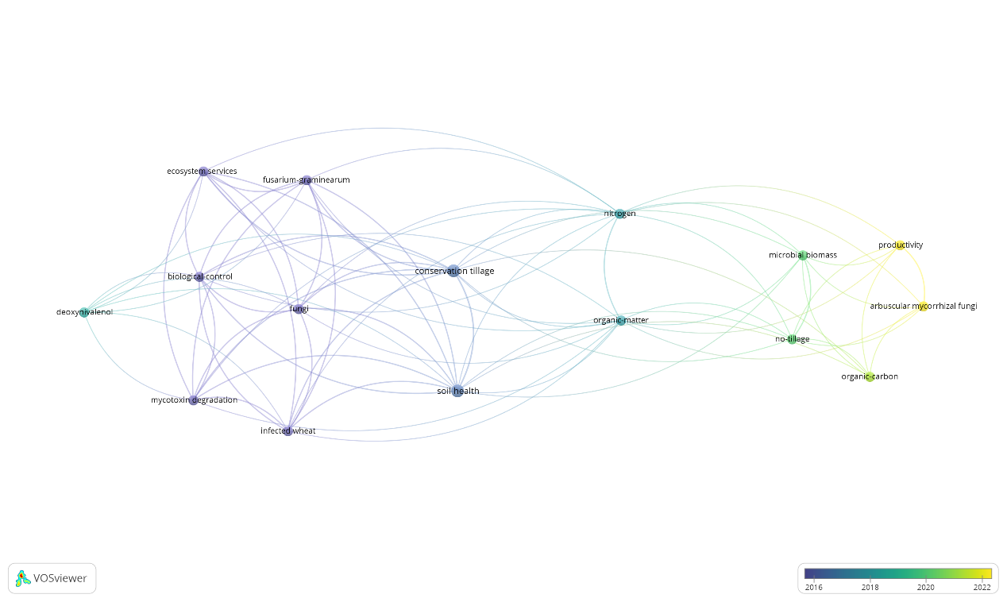
Figure S12b. Bibliographic map based on Bibliographic Data type of VOSviewer software. Results were obtained with the VOSviewer software based on bibliographic data for the “Conservation - Fungi” AND “Straw” query. Supported read data were from Web of Science bibliographic database files.

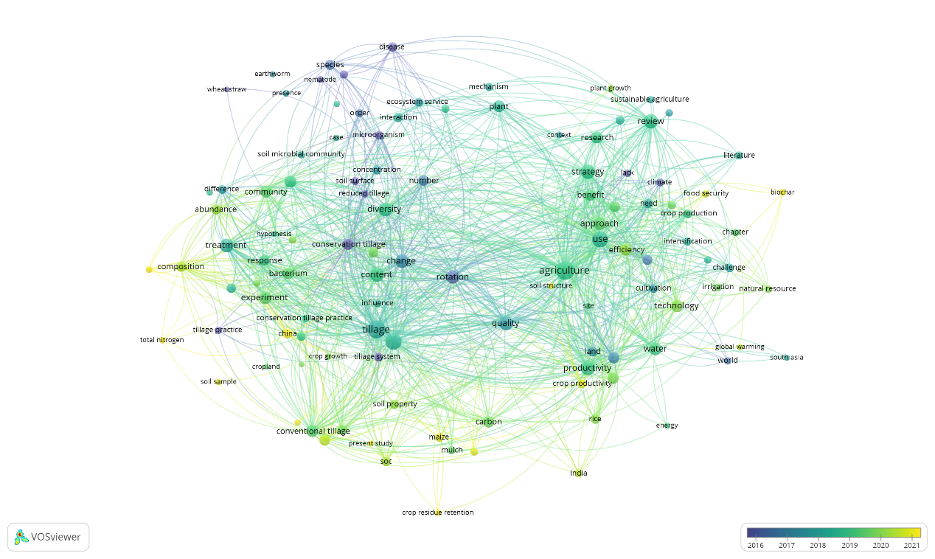
Figure S12c. Bibliographic map based on Text Data type of VOSviewer software. Results were obtained with the VOSviewer software based on bibliographic data for the “Conservation - Fungi” AND “Straw” query. Supported read data were from Scopus bibliographic database files.

Figure S12d. Bibliographic map based on Text Data type of VOSviewer software. Results were obtained with the VOSviewer software based on bibliographic data for the “Conservation - Fungi” AND “Straw” query. Supported read data were from Web of Science bibliographic database files.

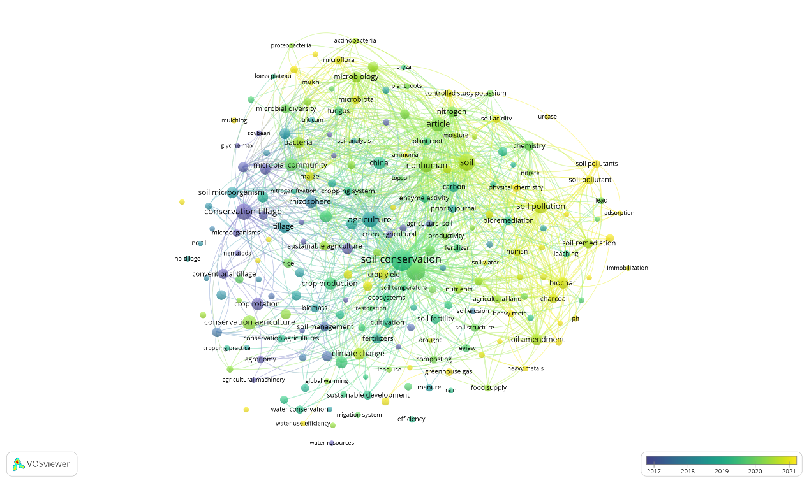
Figure S13a. Bibliographic map based on Bibliographic Data type of VOSviewer software. Results were obtained with the VOSviewer software based on bibliographic data for the “Conservation - Rhizosphere” AND “Straw” query. Supported read data were from Scopus bibliographic database files.

Figure S13b. Bibliographic map based on Bibliographic Data type of VOSviewer software. Results were obtained with the VOSviewer software based on bibliographic data for the “Conservation - Rhizosphere” AND “Straw” query. Supported read data were from Web of Science bibliographic database files.

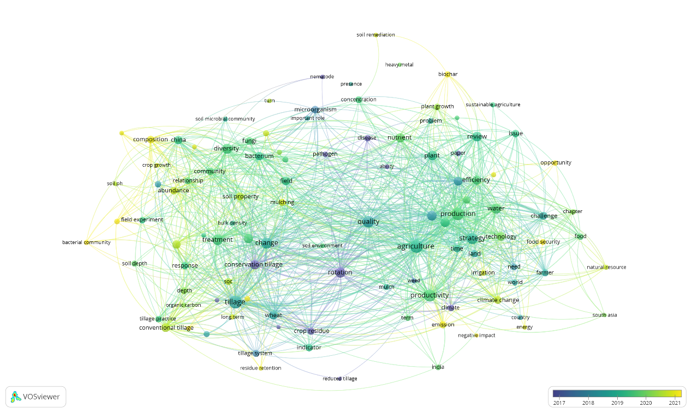
Figure S13c. Bibliographic map based on Text Data type of VOSviewer software. Results were obtained with the VOSviewer software based on bibliographic data for the “Conservation - Rhizosphere” AND “Straw” query. Supported read data were from Scopus bibliographic database files.

Figure S13d. Bibliographic map based on Text Data type of VOSviewer software. Results were obtained with the VOSviewer software based on bibliographic data for the “Conservation - Rhizosphere” AND “Straw” query. Supported read data were from Web of Science bibliographic database files.

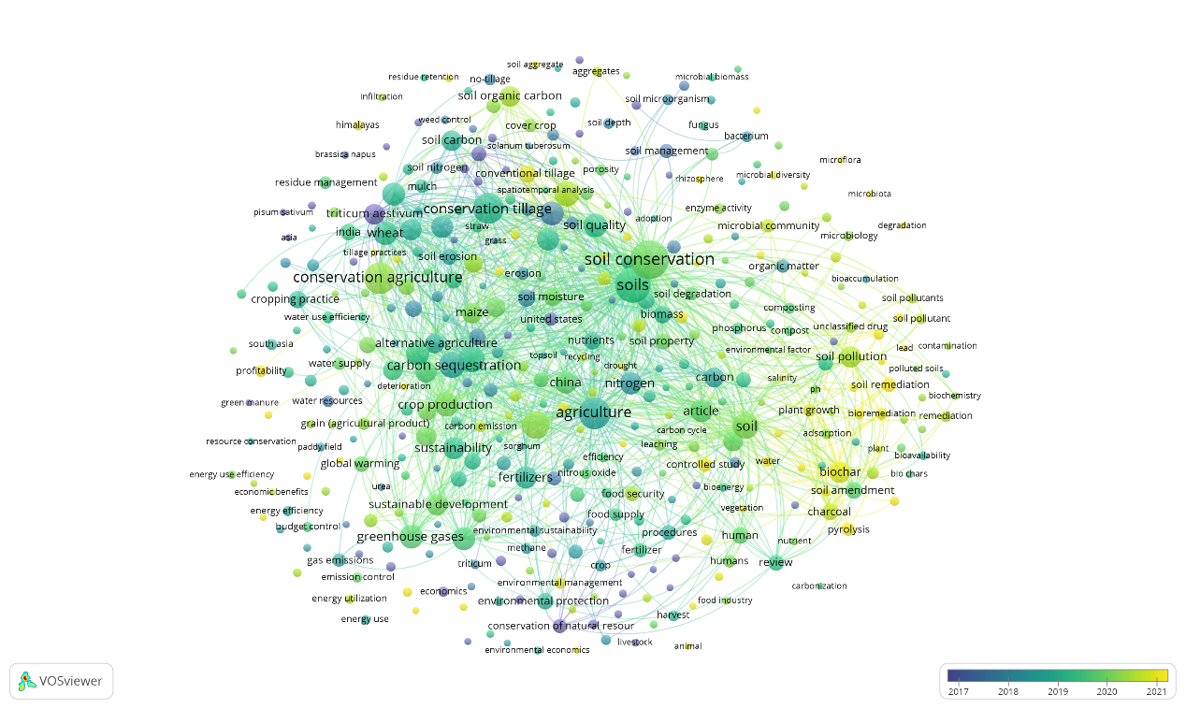
Figure S14a. Bibliographic map based on Bibliographic Data type of VOSviewer software. Results were obtained with the VOSviewer software based on bibliographic data for the “Conservation - Emission” AND “Straw” query. Supported read data were from Scopus bibliographic database files.

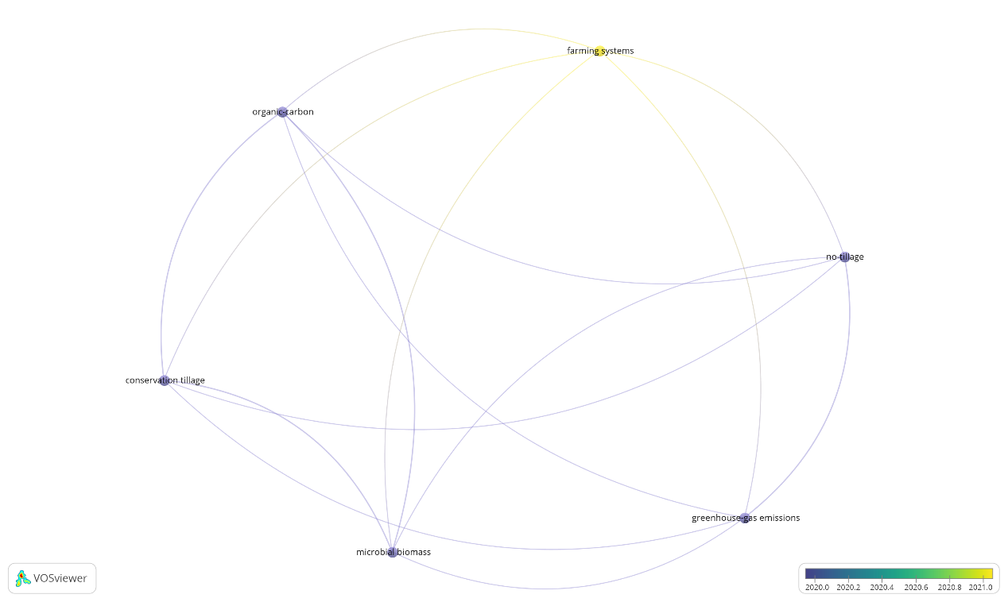
Figure S14b. Bibliographic map based on Bibliographic Data type of VOSviewer software. Results were obtained with the VOSviewer software based on bibliographic data for the “Conservation - Emission” AND “Straw” query. Supported read data were from Web of Science bibliographic database files.

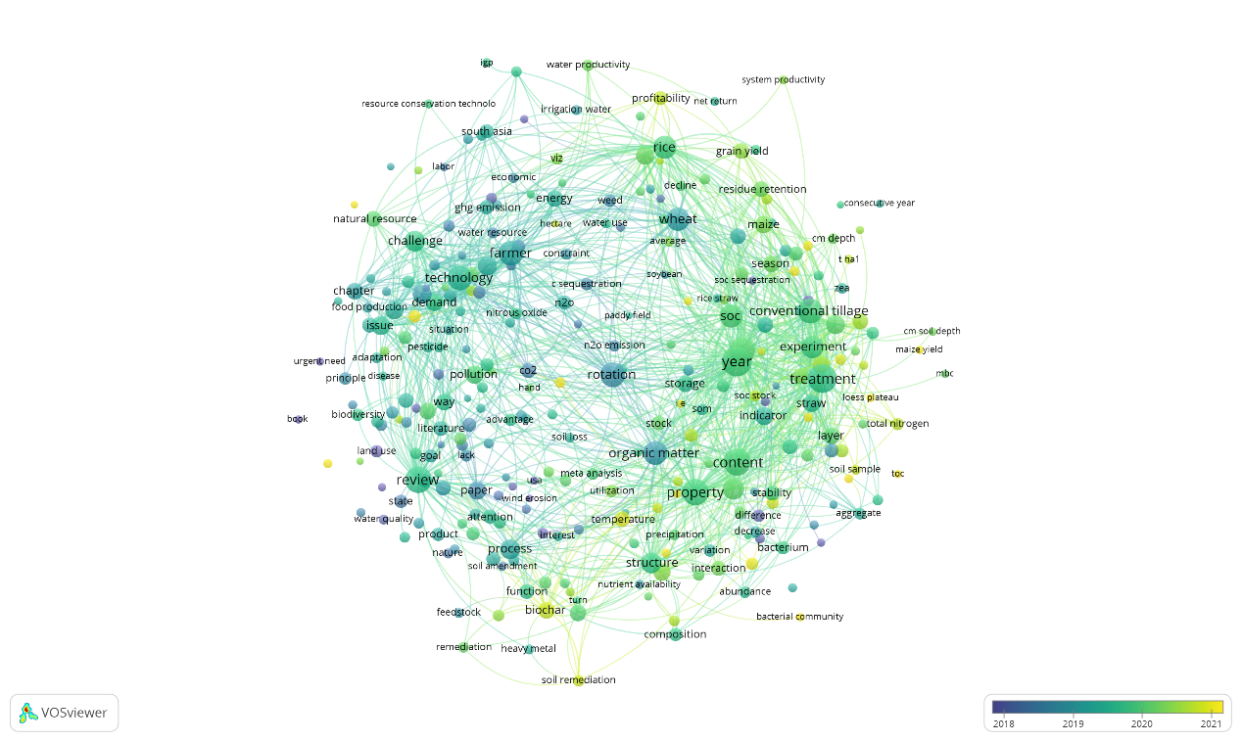
Figure S14c. Bibliographic map based on Text Data type of VOSviewer software. Results were obtained with the VOSviewer software based on bibliographic data for the “Conservation - Emission” AND “Straw” query. Supported read data were from Scopus bibliographic database files.

Figure S14d. Bibliographic map based on Text Data type of VOSviewer software. Results were obtained with the VOSviewer software based on bibliographic data for the “Conservation - Emission” AND “Straw” query. Supported read data were from Web of Science bibliographic database files.

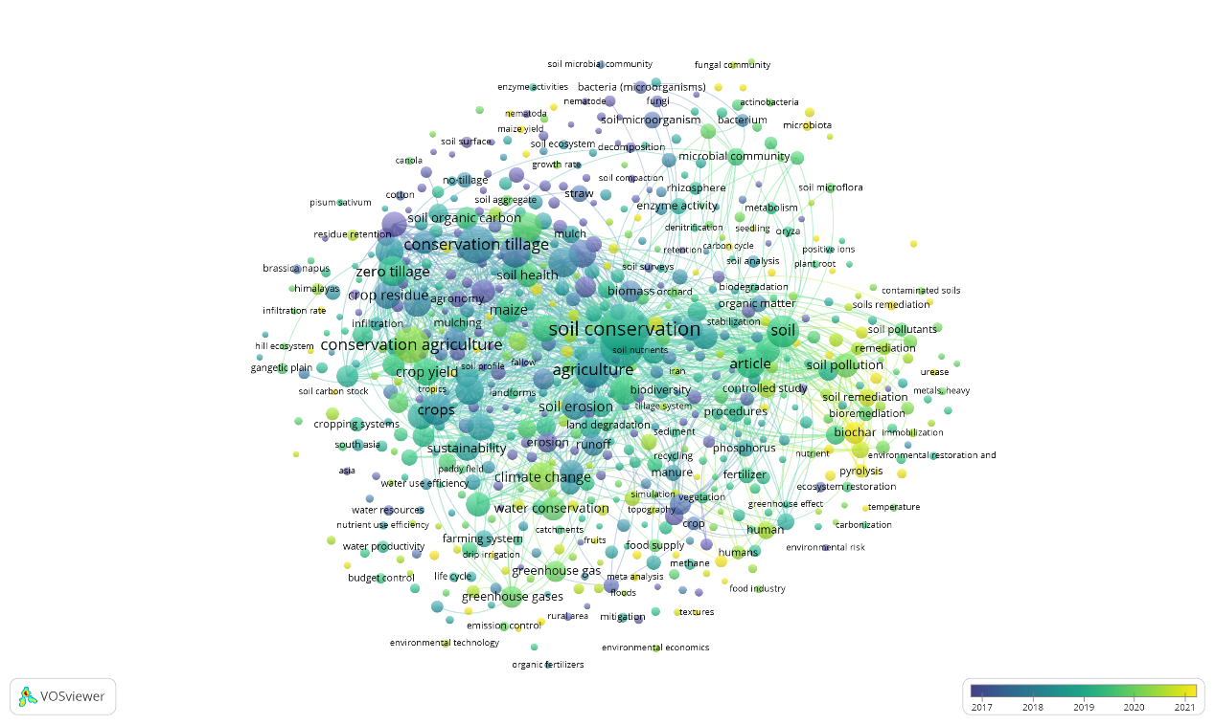
Figure S15a. Bibliographic map based on Bibliographic Data type of VOSviewer software. Results were obtained with the VOSviewer software based on bibliographic data for the “Conservation - Water” AND “Straw” query. Supported read data were from Scopus bibliographic database files.

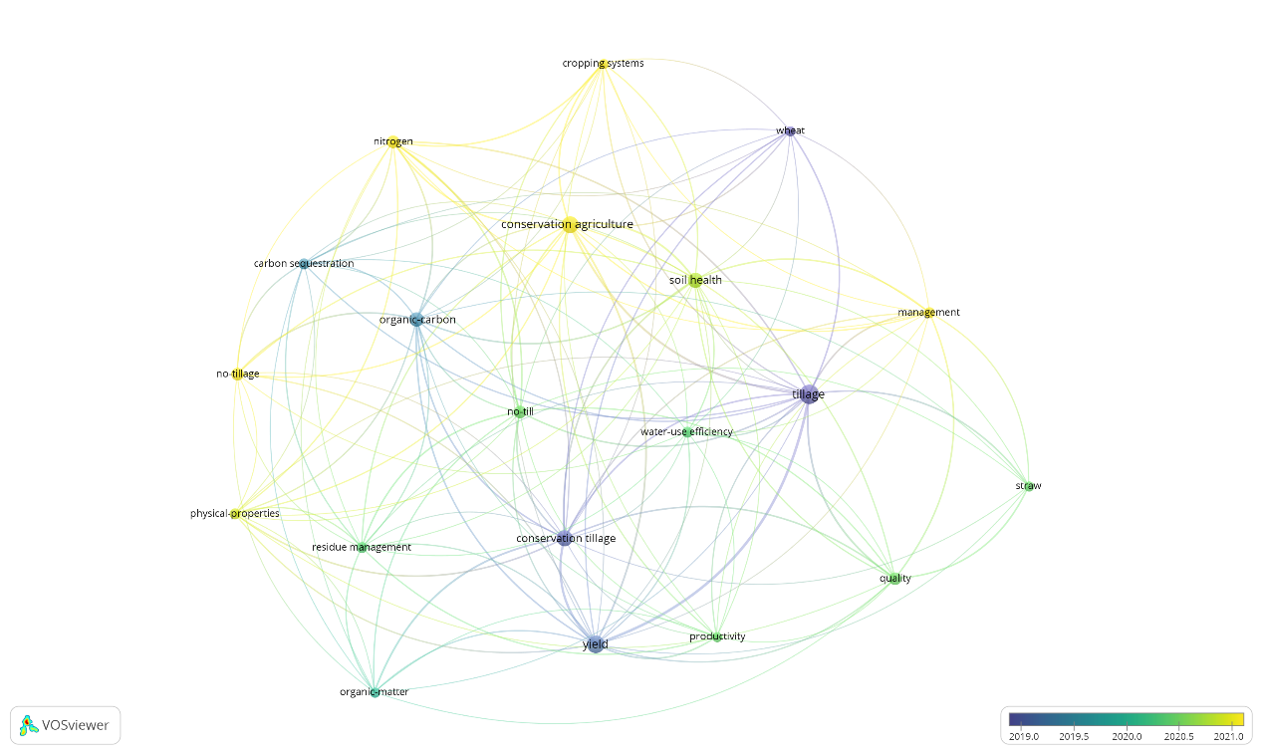
Figure S15b. Bibliographic map based on Bibliographic Data type of VOSviewer software. Results were obtained with the VOSviewer software based on bibliographic data for the “Conservation - Water” AND “Straw” query. Supported read data were from Web of Science bibliographic database files.

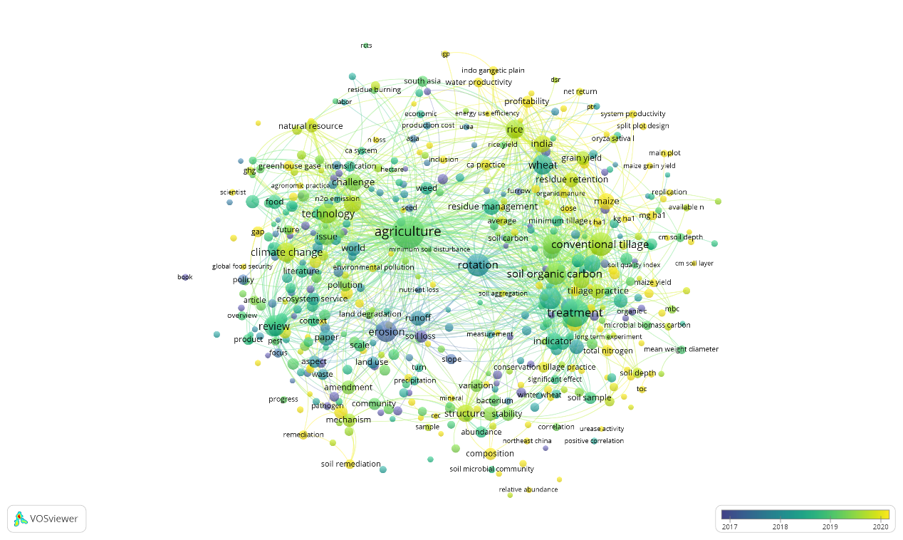
Figure S15c. Bibliographic map based on Text Data type of VOSviewer software. Results were obtained with the VOSviewer software based on bibliographic data for the “Conservation - Water” AND “Straw” query. Supported read data were from Scopus bibliographic database files.

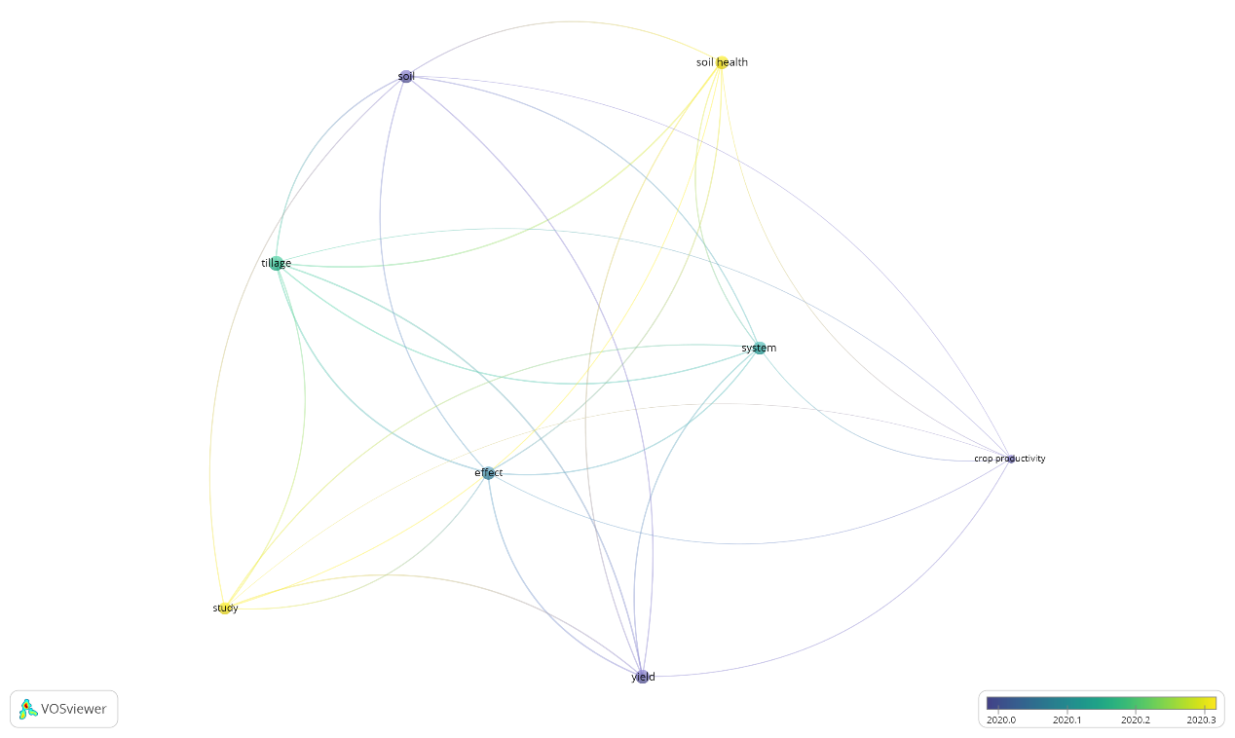
Figure S15d. Bibliographic map based on Text Data type of VOSviewer software. Results were obtained with the VOSviewer software based on bibliographic data for the “Conservation - Water” AND “Straw” query. Supported read data were from Web of Science bibliographic database files.

