Supporting information
Synthesis of a New Dinuclear Cu(I) Complex with Triazine Ligand and diphenylphosphine methane: X-ray Structure, Optical properties, DFT calculations and application in DSSC.

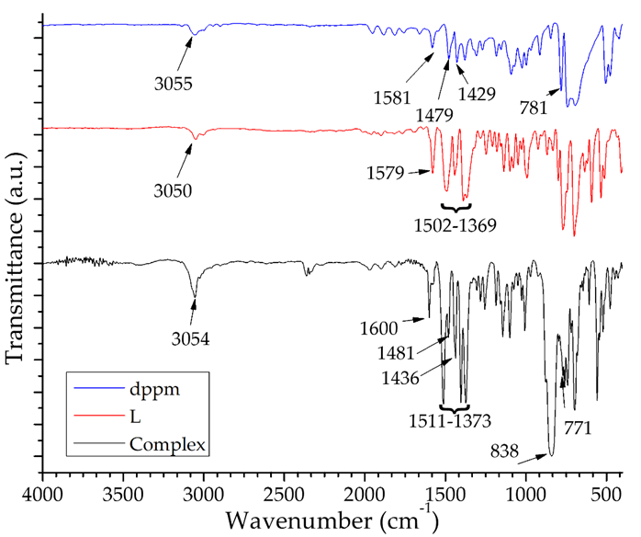
Figure S1. Infrared spectra of complex and the corresponding starting materials.

Figure S2. ¹H NMR spectrum of the complex in acetone-d₆.
Figure S3. ³¹P NMR spectrum of the complex in acetone-d₆.

Table S1. Geometries of intermolecular hydrogen bonds and π···π contacts in complex 1.
D-H···A | D-H (Å) | H···A (Å) | D···A (Å) | D-H···A (°) | Symmetry codes
C62-H62···N7 | 0.95 | 2.65 | 3.565(6) | 161 | -1/2+x,-1/2+y,-1/2+z
C1-H1A···F1 | 0.99 | 2.63 | 3.603(6) | 166 | x,y,x
C8-H8···F8 | 0.95 | 2.53 | 3.372(8) | 147 | -x+1,-y+1,-z+1
C8-H8···F9 | 0.95 | 2.49 | 3.065(7) | 119 | -x+1,-y+1,-z+1
C40-H40···F7 | 0.95 | 2.63 | 3.582(6) | 17 | -x,-y+1,-z+1
C40-H40···F10 | 0.95 | 2.47 | 3.214(4) | 135 | -x,-y+1,-z+1
C46-H46···F5 | 0.95 | 2.59 | 3.434(7) | 147 | x-1/2,-y+1/2,+z-1/2
C47-H47···F2 | 0.95 | 2.57 | 3.323(8) | 136 | x-1/2,-y+1/2,+z-1/2
C49-H49···F1 | 0.95 | 2.50 | 3.365(8) | 150 | x,y,x
C61-H61···F3 | 0.95 | 2.49 | 3.222(6) | 133 | x,y,x
C63-H63···F10 | 0.94 | 2.30 | 3.219(6) | 162 | -x+1/2,+y-1/2,-z+1.5
C9-H9···πª | 0.95 | 3.58 | 4.336 | 138 | -x+1,-y+1,-z+1
C17-H17···π^{b} | 0.95 | 3.46 | 3.943 | 114 | -x+1/2,+y-1/2,-z+1.5
C33-H33 ···π^{c} | 0.95 | 3.53 | 4.105 | 121 | -x+1/2,+y-1/2,-z+1/2
π···π^{d} |  |  | 3.756 |  | -x+1,-y+1,-z+1

ª Centroid: C25, C26, C27, C28, C29, C30
^{b} Centroid: C60, C61, C62, C63, C64, C65
^{c} Centroid: C42, C43, C44, C45, C46, C47
^{d} Centroids: N4, C5, C9, C6, C8, C7 and C5, C8, C9, C6, C7, N6

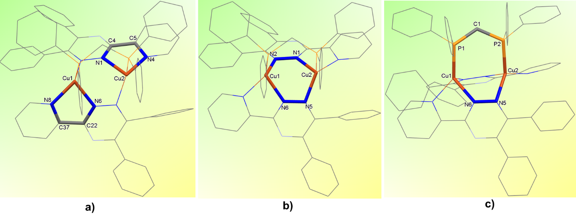
Figure S4. Perspective views of [Cu₂(L)₂dppm]⁺ in the crystal structure of 1, showing a) two five-membered Cu-N-C-C-N, b) one six-membered Cu-N-N-Cu-N-N and c) one seven-membered Cu-N-N-Cu-P-C-P chelate rings. Hydrogen atoms have been omitted for clarity.

Figure S5. Intramolecular π···π interactions in the crystal structure of 1. Hydrogen atoms have been omitted for clarity.

Figure S6. Intermolecular C-H··· π and π- stacking interactions between pair of [Cu₂(L)₂dppm]⁺ cations. Hydrogen atoms have been omitted for clarity.

Figure S7. Perspective view of the three-dimensional (3D) hydrogen-bonded network in the crystal structure of complex 1, formed through C-H···N, C-H···F, C-H···π and π···π interactions. Hydrogen atoms have been omitted for clarity.

Figure S8. Percentages of intermolecular interactions in the fingerprint plot for complex 1.
Figure S9. HOMO and LUMO frontier orbital plots of the title complex on TD-DFT calculations.

Figure S10. UV-Vis absorption spectra of complex, free ligand L and N719 recorded in 2x10⁻⁵ mol/L solution in ethanol.

Figure S11. Cyclic voltammogram of [Cu₂(L)₂dppm](PF₆)₂ (5x10⁻³ M) in acetonitrile at T = 298 K using NBu₄PF₆ (0.1 M) as supporting electrolyte (scan rate = 20 mVs⁻¹).

