Supplementary Materials:

Table S1: Recombinant RBD proteins evaluated in this project.
RBD lot# used for vaccination | Purification ID | Fermentation ID | RBD classification
S2RBD-150121JXL-1 | PDD011221 | PDF110220C | WT
S2RBD-140421JXL-1 | PDD041221 | PDF032221B | Beta
S2RBD-300721JXL-1 | PDD072721A | PDF071221A | Delta
S2RBD-141022JXL-1 | PDD101022 | PDF082922B | BA.4/5
Sc2RBD-140423JXL-1 | PDD041123 | PDF032023B1 | XBB.1.5

List of mutations included in the SARS-COV-2 spikeprotein of the lentiviral-based pseudoviruses
BA.2.75.2: T19I, del24-26, A27S, G142D, K147E, W152R, F157L, I210V, V213G, G257S, G339H, R346T, S371F, S373P, S375F, T376A, D405N, R408S, K417N, N440K, G446S, N460K, S477N, T478K, E484A, F486S, Q498R, N501Y, Y505H, D614G, H655Y, N679K, P681H, N764K, D796Y, Q954H, N969K, D1199N
BA.4: T19I, del24-26, A27S, del69-70, G142D, V213G, G339D, S371F, T376A, D405N, R408S, K417N, N440K, L452R, S477N, T478K, E484A, F486V, Q498R, N501Y, Y505H, D614G, H655Y, N679K, P681H, N764K, D796Y, Q954H, N969K

BQ.1.1: T19I, del24-26, A27S, del69-70, G142D, V213G, G339D, R346T, S371F, T376A, D405N, R408S, K417N, N440K, K444T, L452R, N460K, S477N, T478K, E484A, F486V, Q498R, N501Y, Y505H, D614G, H655Y, N679K, P681H, N764K, D796Y, Q954H, N969K

XBB.1.5: T19I, L24S, del25-27, V83A, G142D, del144, H146Q, Q183E, V213E, G252V, G339H, R346T, L368I, S371F, S373P, S375F, T376A, D405N, R408S, K417N, N440K, V445P, G446S, N460K, S477N, T478K, E484A, F486P, F490S, Q498R, N501Y, Y505H, D614G, H655Y, N679K, P681H, N764K, D796Y, Q954H, N969K

XBB.1.16: T19I, L24S, del25-27, V83A, G142D, del144, H146Q, E180V, Q183E, V213E, G252V, G339H, R346T, L368I, S371F, S373P, S375F, T376A, D405N, R408S, K417N, N440K, V445P, G446S, N460K, S477N, T478R, E484A, F486P, F490S, Q498R, N501Y, Y505H, D614G, H655Y, N679K, P681H, N764K, D796Y, Q954H, N969K

EG.5.1: T19I, L24S, del25-27, Q52H, V83A, G142D, del144, H146Q, Q183E, V213E, G252V, G339H, R346T, L368I, S371F, S373P, S375F, T376A, D405N, R408S, K417N, N440K, V445P, G446S, F456L, N460K, S477N, T478K, E484A, F486P, F490S, Q498R, N501Y, Y505H, D614G, H655Y, N679K, P681H, N764K, D796Y, Q954H, N969K

Fitted data plots of pseudovirus neutralization experiments

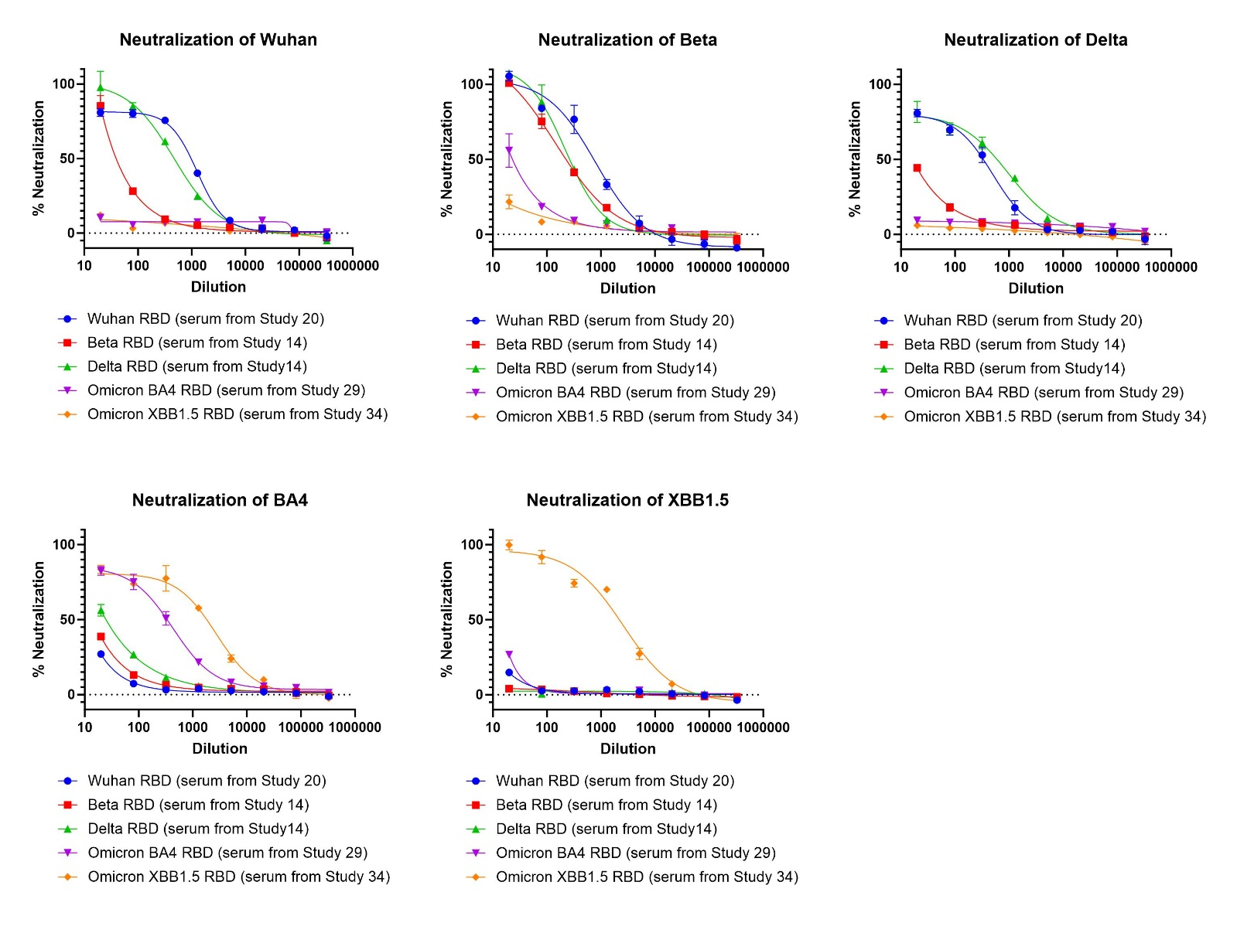
Figure S1. Neutralizing antibody titers of sera from mice immunized with five variant RBDs (WT, Beta, Delta, BA.4/5 and XBB.1.5) adjuvanted with Alum+CpG against a panel of five pseudovirus variants (WT, Beta, Delta, BA.4/5 and XBB.1.5). Cross-protection against pseudoviruses decreases progressively from WT RBD to XBB 1.5. (Varying levels of cross-protection among WT, Beta, and Delta, but almost none against Omicron BA 4/5 and XBB 1.5). On the other hand, XBB 1.5 antigen showed cross-protection against Omicron BA 4/5, while BA 4/5 RBD showed very low-level neutralization titers against XBB 1.5 pseudovirus.

