Supplementary material
Galleria mellonella antimicrobial peptides and stress manage-ment gene expression in response to deleterious events caused by Sporothrix brasiliensis
Nathália Faria Reis¹, Myrela Conceição Santos de Jesus¹, Lais Cavalcanti dos Santos Velasco de Souza¹, Lucas Martins Alcântara¹, Julia Andrade de Castro Rodrigues¹, Simone Cristina Pereira Brito¹, Patrícia de Azambuja Penna², Cecília Stahl Vieira², José Rodrigo Santos Silva³, Bruno de Araújo Penna⁴, Ricardo Luiz Dantas Machado¹, Hector M. Mora-Montes⁵, Andréa Regina de Souza Baptista^{1,6*}
¹ Center for Microorganisms' Investigation, Department of Microbiology and Parasitology, Biomedical Institute, Federal Fluminense University, Niterói, Rio de Janeiro, Brazil
² Laboratory of Insect Biology, Federal Fluminense University, Niterói, RJ, Brazil
³ Department of Statistics and Actuarial Sciences, Federal University of Sergipe, Brazil
⁴ Laboratory of Gram-Positive Cocos, Biomedical Institute, Fluminense Federal, University, Niterói, Rio de Janeiro, Brazil
⁵ Department of Biology, Division of Natural and Exact Sciences, Campus Guanajuato, University of Guanajuato, Guanajuato, Mexico
⁶ Rede Micologia RJ - Fundação de Amparo à Pesquisa do Estado do Rio de Janeiro (FAPERJ), Rio de Janeiro, Brasil.

* Correspondence: andrearegina@id.uff.br.

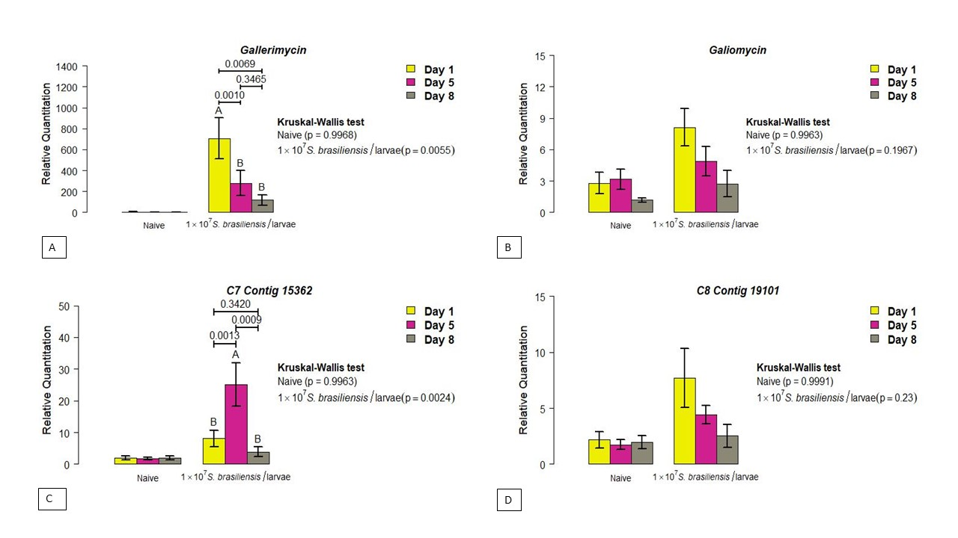
Figure S1: Investigation of the gene expression profile of the invertebrate host Galleria mellonella in infection by the pathogenic fungus Sporothix brasiliensis. Dynamics of gene expression observed according to day, for each experimental group. (A) Gallerimycin, (B) Galliomycin and the stress manager genes (C) C7 Contig 15362 and (D) C8 Contig 19101. The units on the Y axis were calculated based onthe 2^{-ΔΔCT} method, and are expressed as mean. Each gene was normalized and compared to the expression of control (naive) insects using the β-actin reference gene. The Mann-Whitney test was used to compare the relative quantification of genes and a p ≤0.05 value was considered significant.

