Sublemental information

Methods
Different variants of the equations allow further customization
A second variant of equation 3.1 can be used to fully standardise the values across experiments. Thereby, using $μ_{c}$, the mean value of the control, instead of $min⁡(\vec{x_{ct}})$, will result in values standardised to the control, where either the highest value is 1 or the lowest -1, respectively (which can only be achieved asymptotically in case equation 3.1 is used). This results in the following equation:
${rex}_{i,k}=\frac{x_{i}-μ_{c}}{max⁡(\vec{x_{ct}})-μ_{c}}$ (eqn 3.2)
with the same notation as in equation 3.1. In the R package, the different equations can be selected. However, it should be noted that using these results in equation 4.1 will lead to a weight of 1 for all traits in the next step (see below) and, therefore, will affect the InARes value. However, this weight exclusion might be aimed for, e.g., if one would like to use the InARes as an overall plasticity index (see package description for further details). With the unweighted sum (using the next step with positive values; see below), the value would reflect the summed traits’ differences from the control to the treatment under the respective environmental conditions, which is one possible definition of a plasticity index (Whitman & Agrawal, 2009).
Similar to the previous step, equation 4.1 comes with another variant that allows customisation and incorporation of additional knowledge of the investigated system, if available. For example, the maximum relative response of an organism to a certain treatment can be set for each trait separately if, e.g., literature data is available. Furthermore, the user can specify which trait is adaptive and which is maladaptive under the respective treatment. To realise those customisations, we have created the following equation:
$InARes=\frac{\sum_{k}^{n_{traits}}{\frac{{rex}_{i,k}}{{rexmax}_{k} ∙ a_{k}}}}{n_{traits}}$ (eqn 4.2)
with the same parameters as in equation 4.1 but with ${rexmax}_{k}$ as the absolute maximum response value of the $k$^{th} trait, derived from literature or previous experiments. This value is reported by the function in the R package and should also be reported in corresponding publications. The user might like to take values from literature or other experiments because of an even better comparison across studies or to recalculate values of another study for comparison with their results. Using this feature of the InARes framework improves comparability and transparency (i.e., on the organism response quality within experiments). The parameter $a_{k}$ can be either 1 or -1 and defines the k^{th} trait's adaptability (adaptive or maladaptive). If detailed knowledge about an organism and its adaptation against a stressor is already available, the user can enter that information. Therefore, the algorithm will respect that information and calculate the values accordingly.
Applying the Index for Adaptive Responses in a case study
We used an extensive experiment of a predator-prey system to evaluate the effectiveness of single adaptive traits of a prey, contributing to the inducible defence against its predator. In this study, the water flea Daphnia magna was exposed to an invertebrate predator, the tadpole shrimp Triops cancriformis. Details on this predator-prey system and the experiment can be found in the corresponding study by Diel et al. (2023, manuscript in preparation). Briefly, D. magna exhibits various defensive morphological changes induced in proximity to the predator. The authors took advantage of various defence strategies of different clones of this species. Thereby, they generated a wide variety of morphs, differing in their expression strength and combination of those defensive traits. Ten morphological traits of the prey were recorded on living individuals, which were exposed to the predator individually (body length, dorso-ventral body width, lateral body width, tail-spine length, distance between the fornices, length of the furca, length of the dorsal and ventral spinules as well as the length of the dorsal and ventral spinule bearing areas). Therefore, each prey's survival probability could be related to their morphological traits. These data were analysed with a comprehensive binomial generalised additive mixed model, including all traits and a set of interactions between those traits and, additionally, with the predator body length (19 fixed terms in total). They found that the tail-spine length and the length of the furca played a crucial role in the defence against this predator. Furthermore, in specific orientations, the lateral body width, and the length of the dorsal spinule bearing area also affected the survival probability positively.
Here, we tested our InARes with the data of this corresponding study and ran the same model (i.e., the interaction with the predators' body length and all random effects were the same) but with other predictors (the respective InARes or pc scores, see below) instead of the 19 terms of the original model. All models aimed to predict the survival probability of the prey after being caught. The corresponding study assessed this survival probability, which enabled us to compare those predictions with observational data. We estimated the (predictive) quality of the resulting models by comparing the deviation of these models.
First, we created a predictive model from the full model of the corresponding study by running a downward model selection. As the InARes is a trait selection, its (predictive) power should be compared with a predictive model rather than a full model as applied in the corresponding study. Second, we included all traits in the InARes without further information, as we would have no further information about the system. We calculated a second variant of this, excluding collinear terms from the calculation of the InARes. This was necessary for the regression models of the corresponding study to assess whether collinear terms have affected the application of the InARes framework. Third, we included only those traits estimated as adaptive by the algorithm and equations 5.1 and 5.2 indicated their effectiveness (as they would have been selected from simple control vs exposure data). Then we recalculated the InARes value with just those traits and applied it to the model.
Fourth, we included only the two terms found in the corresponding study to have a significant overall effect. This reflects the a priori knowledge about the system entered into the algorithm. As an additional test of the fit quality, we fitted a trait-based model with just those two traits included. In a second variant, we included the two terms of significant effect and the two terms that only had an effect in specific orientations in the InARes framework, being a more refined example of the former model.
Fifth, we applied a principal component analysis to those trait data, including all observations and all traits, and analysed the component scores with a similar model as the other data. We used all component scores contributing to at least 5 % of the variance, reflecting a common approach for such data. Again, as a second variant, we applied only the component scores of the first principal component in the model, reflecting a benchmark for the InARes, intending to have only one number reflecting the total defence.

Testing the transferability of the relation between the Index for Adaptive Responses value and the adaptation effectiveness
The InARes framework aims to allow a comparison of InARes values across studies and even across systems and/or species. To test this transferability of the relation between the InARes values and their effectiveness (e.g., increase in survival probability), we used data from another predator-prey study (Laforsch & Tollrian, 2004). In this study, D. cucullata was exposed to the kairomones of three different invertebrate predators (Chaboborus flavicans, Cyclops sp. and Leptodora kindtii). Three functional traits were recorded (helmet length, body length, and tail spine length). A subsequent predation trial with each predator was performed with different life stages of D. cucullata. In each trial, 10 animals of one size class of either typical or induced morphs were exposed to the predator. Different measures of effectivity were recorded for each predator. However, the morphology of the prey animals applied in the feeding trial was not recorded.
For our comparison, we just used those size classes that have been most susceptible to the predators since the here-used predators have a very narrow size preference compared to T. cancriformis. If we had used the other size classes as well, the survival probability would have been biased by the size preference of the predators and hence not comparable to our predation trial. Furthermore, at those size classes, the defences should be most effective, allowing for higher estimation accuracy. In this study (Laforsch & Tollrian, 2004), the most susceptible size class against Cyclops sp. and L. kindtii was the intermediate size class (2), but against C. flavicans, it was the biggest size class (3).
We applied the InARes framework to the data set of this study and estimated the defence effectiveness. The defence effectiveness cannot be defined as the pure survival probability in this study. Against C. flavicans, we used the attack efficiency (i.e., the proportion of ingested prey). Against Cyclops sp., we used the survival probability and the ratio of the completely eaten vs incompletely eaten prey, as the latter probably reflects the effectivity of the morphological traits more accurately (preventing Cyclops sp. from complete ingestion). In the case of L. kindtii, we used the survival probability. As the response to the defence (e.g., survival probability) can be on very different ranges, it would not have been meaningful to compare the absolute change in survival rate. (since this range was approximately found in all experiments). Instead, we calculated the relative increase of the survival rate, using an increase in the InARes from 0 to 0.4 (i.e., the survival rate at 0.4 divided by the survival rate at 0). This should provide a comparable measure of the effectiveness of the defence.
Testing the prediction accuracy of the algorithm on the adaptiveness of traits with simulations
We simulated data to analyse the effect of the transformation method on the data and variance structure and to estimate the prediction accuracy of the algorithm comprising equations 5.1 and 5.2. Therefore, we defined several parameters of the data that should be tested semi-permutated to analyse how they affect the quality of the outcome. During the simulation, we ran the complete framework in its default form and checked whether the outcome was similar to the input (i.e., whether the traits set as adaptive or maladaptive when creating the data are estimated as such, by the algorithm). Each permutation of the simulation (i.e., with each parameter combination) was repeated 100 times.
First, we simulated data to analyse how strongly the data and variance structure is affected by the rex-transformation. The number of traits to be included in the InARes was set to 3 for this test. We manipulated the number of replicates (5, 10, 20, 50), the number of adaptive traits (0-100 % of the included traits), the number of non-gaussian distributed traits (0-100 % of the included traits), and the difference in the traits between the control and the treatment (5, 10, 20, 30 %). The primary attention was set to non-gaussian distributed data, as this step is the most vulnerable for this issue. Non-gaussian distribution may bias the transformation towards one or the other direction (i.e., control or treatment). To see the effect on the relationship between control and treatment, we calculated the standardised Euclidean distance of each point to the control mean before and after transformation. We then calculated the change in distance between both values to estimate the amount of change in the data structure. To benchmark our transformation method, we compared it with a simple z-transformation performed similarly to the rex-transformation. We created a generalised additive model to analyse this change with the tested parameters.
Second, we tested different thresholds for the algorithm comprising equations 5.1 and 5.2 to estimate the most appropriate value. We tested 5, 10, 20, 30 and 50 % thresholds in change from control to treatment. The resulting most appropriate threshold was then set as default in the algorithm.
Third, we manipulated the attributes of the simulated data to analyse their effect on the prediction quality of the algorithm. We manipulated the trait number that is included in the InARes (2, 4 and 10 traits), the replicate number per treatment (5, 10, 20, 50), the number of adaptive and/or maladaptive traits (0-100 % of the included traits and combinations of both), and the difference between control and treatment values (5, 10, 20, 30 %). This resulted in 656 different cases or combinations of attribute values (65600 observations) covered by the simulated data set. After running this simulation, we used those data to create a binomial generalised additive model containing the manipulated parameters and their two-way interactions. This model was used to estimate the quality of the predictions under the tested circumstances.

Results

Additional results of the simulation approach
We tested different thresholds (i.e., 5, 10, 15, 20 %) of a change in contribution as a result of the algorithm comprising equations 5.1 and 5.2, in dependence of the difference between treatments (5, 10, 20, 30, 50 % mean difference between control and treatment). In all cases, the 5 % threshold resulted in the highest level of correct estimation of whether a trait is adaptive, maladaptive, or non-adaptive. A threshold of 10 % performed almost as good, but higher thresholds resulted in a substantial decrease in correct estimations. Therefore, we set the 5 % threshold as the default for our algorithm.
We evaluated the quality of our transformation method with simulations by calculating the change in the Euclidean distance of each point to the control mean before and after the transformation. To have a value for comparison, we further calculated the same distance with a common z-transformation. All manipulated data attributes (i.e., number of non-gaussian distributed traits, number of replicates, number of traits where treatment differs from control, the difference between control and treatment) and their interactions had a significant effect on the change of the distance (see SI for more detail). How these attributes affected the change in distance and their respective F- and p-values are shown in Figure SI1.
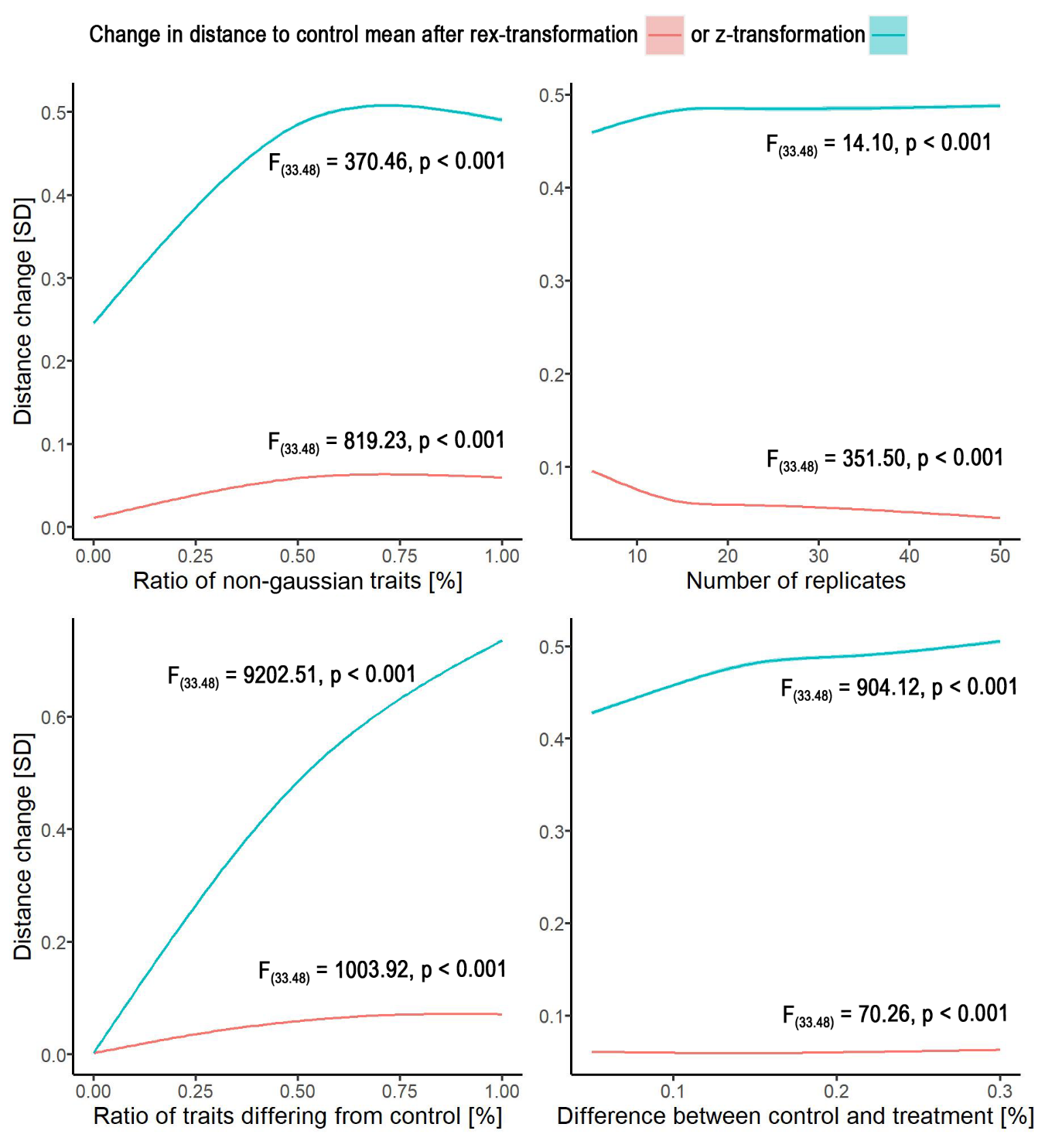
Figure SI1. The effect of data attributes on the rex-transformation (red). For comparison, also a z-transformation was performed (blue). Data were achieved with a generalised additive model used for prediction for each attribute, while the other attributes were set to the median value. The underlying trait data were achieved by simulations. Data are shown as the change in the Euclidean distance from each point to the control mean before and after transformation (in standard deviations). Solid lines indicate the mean value. Ribbons (very small) indicate the standard deviation.

How to apply the Index for Adaptive Responses framework practically
The InARes framework can be applied very simply by using the R package InARes. Here, we will show how the different steps can be applied in R and briefly explain the output of the functions. Please consider the R package help and readme files (https://github.com/Maki-science/InARes) for a more comprehensive explanation. Three functions can be applied stepwise to calculate the InARes and estimate each trait's contribution. First, the original trait values must be rex-transformed:
data <- mydata
trait <- mydata$currentTrait
mydata$currentTrait_d <- Trex(data = data,
treatCol = “treatment”,
ctrl = “control”,
trait = trait,
usemc = 0
)
This function applies equation 3.1. It returns a vector containing the transformed values in the same order as the input. This step should be performed with each trait that is supposed to be included in the InARes value. When usemc is set to 1, equation 3.2 will be applied with the reference set to control mean instead of the highest absolute value (i.e., no weighing in the next step).
The next step is the calculation of the InARes value:
traits.adapt <- c(“trait1_d”, “trait2_d”, “trait3_d”, …)
InAResresults <- InARes_index(data = data,
traits.adapt = traits.adapt,
traits.mal = FALSE,
treatCol = “treatment”,
ctrl = “control”,
as.defined = FALSE,
rexmax.adapt = FALSE,
rexmax.mal = FALSE,
na.action = “keep”,
as.PI = FALSE
)
mydata$InARes <- InAResresults$I
print(InAResresults $rexmax)
In its default version, this function applies equation 4.1. It will treat the input without a priori information and will estimate the adaptiveness from the data itself. It weights and sums all trait values accordingly into one number for each individual. If a priori knowledge is to be included, the user can define traits.mal, if traits are known to be maladaptive upon increase, or traits.adapt if traits are known to be adaptive (in contrast to "unknown"). In this case, the as.defined option should also be set as TRUE. Then all traits are applied as specified by the user. Similarly, the ${rxmax}_{k}$ values can be set for adaptive and maladaptive traits if they are available from the literature or preliminary experiments. In case of missing observations (also just in single traits), it can be specified how the algorithm should treat them. This can be done simply by setting na.action either to “keep”, “omit”, or “interpolate". In the case of "keep”, missing observations will be conserved. Therefore, also the InARes value will be missing. This is the default specification. When set to “omit”, the weighted sum of the traits will be calculated without the missing trait value. Therefore, the number of traits for this individual value will be reduced by the number of missing trait values. However, this may bias the InARes value and should be used cautiously. When set to "interpolate", the algorithm will use the median trait value of the respective treatment and calculate the InAResvalue as usual. This will allow using data sets where measuring all traits at each individual (e.g., in field data) is challenging. However, if too many trait values are missing, this might also bias the returned InARes value. This function returns a list object with the InARes values in a vector in order of the input data and a data frame with the calculated ${rexmax}_{k}$ values for each trait. If this step should calculate an overall plasticity index (in the former step usemc set to 0), then as.PI should be set to TRUE. In the next (optional) step, we can estimate the adaptiveness of each trait:
params <- c(“trait1_d”, “trait2_d”, “trait3_d”, …)
I <- “InARes”
InAResContribution(data = data,
params = params,
I = I,
treatCol = “treatment”,
ctrl = “control”,
th.change = 0.05,
th.sd = 0.5
)
The algorithm of this function applies equations 5.1 and 5.2. It returns a list object. This contains a clear-text summary for each trait, stating whether the respective trait is supposed to be adaptive, maladaptive, or not adaptive or unclear (in case of very high standard deviation). Furthermore, it provides a statement about potential interactions if there is a high standard deviation in the treatment. Additionally, a data frame is contained in the returned object as well. It contains the calculated contribution values and their standard deviations for the control and the treatment, as well as the corrected contribution change (as explained before). The latter is used for the estimation of the adaptiveness of the traits. These numbers cannot be considered quantitatively, but they can be used qualitatively and ordinarily ordered by their absolute value to get an idea of how important which trait is supposed to be.

Two application examples

Study on rotifers in a multi-predator context
We re-analysed parts of the data of a multi-predator study with rotifers facing an invertebrate and a vertebrate predator (Zhang et al., 2022). Briefly, in experiment II described in Zhang et al., 2022, the rotifer Brachionus calyciflorus was exposed to either no predator cues (control), cues from a predatory rotifer (Asplanchna brightwelii, A), cues from fish larvae (Carassius auratus, F), or cues from both predators (A+F). During the experiment, five morphological traits were recorded (i.e., body length, body width, posterolateral spine length, anterior spine length, probability of posterolateral spine development) and the final density at the end of the experiment (a proxy for reproductive output). Furthermore, feeding trials were performed with fish-induced morphs of B. calyciflorus fed to fish larvae and Asplanchna-induced morphs fed to A. brightwelii to assess the respective predation rate.
Analysis of rotifer data
We evaluated the morphological and reproduction data with the full and default framework (i.e., no customisation of the formulas). To estimate the defence against each of these predators, we calculated the InARes for each single predator treatment separately (i.e., A, F). We then used the weighing parameter ${rexmax}_{k}$, estimated with equation 4.1, from the single predator treatments. Then, we calculated the InARes against each of the predators for the rotifers of the A+F treatment, using the ${rexmax}_{k}$ of the respective single predator treatments. Therefore, we achieved the total defence of the rotifers against each of the predators (see SI for more detail). We evaluated significant differences between the treatments with linear regression with the InARes as a response, and the treatment as an explanatory parameter (i.e., one-way ANOVA). Residuals were checked for normal distribution and homogeneity of variance.
Results of rotifer data
We found a significant increase in the InARes value of B. calyciflorus against A. brightwelii (F_{(1,17)} = 87.662, p < 0.001, Fig. SI2). The ${rexmax}_{k}$ values can be seen in Table SI1. Following the estimation of the traits’ contribution to the InARes, all traits (i.e., body length, body width, posterolateral spine length, anterior spine length, posterolateral spine probability) but the final density were predicted to be adaptive against this predator. As a proxy for reproductive output, the final density had neither a positive nor negative effect on the InARes. However, due to its relatively high variance, it was suggested by the algorithm to exhibit interactions with other parameters or the environment. The most important trait is the probability of expressing posterolateral spines, followed by their length (Table SI1).
Against C. auratus, there was also a significant increase in the InARes value of B. calyciflorus (F_{(1,17)} = 143.790, p < 0.001, Fig. SI2). All morphological traits were predicted to be maladaptive upon increase, but an increase in the reproductive trait was recognised as adaptive. The algorithm suggested no interactions. The values for ${rexmax}_{k}$ and numerical output for the contribution estimation can be seen in Table SI1.
Table SI1. The ${rexmax}_{k}$ values and the estimated contribution to the InARes for each trait investigated in the corresponding study. The numbers also represent the numerical output of the algorithm and the estimation of the contribution. We separately calculated the InARes and the traits’ contribution against both predators (i.e., Asplanchna brightwelii and Carassius auratus). Note that the contribution change is corrected as explained in the methods section.
B. calyciflorus vs A. brightwelii
Trait | $${rexmax}_{k}$$ | Mean contribution (control) | Mean contribution (treatment) | Contribution change
Body length | 0.788 | 0.264 ± 0.465 | 0.171 ± 0.046 | 0.141
Body width | 0.731 | 0.209 ± 0.801 | 0.146 ± 0.040 | 0.122
Posterolateral spine length | 0.962 | -0.013 ± 0.552 | 0.218 ± 0.030 | 0.219
Anterior spine length | 0.926 | 0.068 ± 0.464 | 0.143 ± 0.032 | 0.135
Posterolateral spine probability | 0.658 | -0.136 ± 0.880 | 0.254 ± 0.033 | 0.269
Final density | -0.582 | -0.529 ± 0.719 | -0.071 ± 0.104 | -0.010

B. calyciflorus vs C. auratus
Trait | $${rexmax}_{k}$$ | Mean contribution (control) | Mean contribution (treatment) | Contribution change
Body length | -0.912 | -0.271 ± 0.700 | -0.188 ± 0.030 | -0.172
Body width | -0.883 | -0.205 ± 0.990 | -0.177 ± 0.028 | -0.166
Posterolateral spine length | -0.895 | 0.016 ± 0.862 | -0.160 ± 0.061 | -0.161
Anterior spine length | -0.837 | -0.089 ± 0.636 | -0.187 ± 0.038 | -0.182
Posterolateral spine probability | -0.763 | 0.129 ± 1.168 | -0.184 ± 0.049 | -0.191
Final density | 0.739 | 0.505 ± 1.017 | 0.117 ± 0.044 | 0.088

When the rotifers were exposed to both predator cues simultaneously, we used the values for ${rexmax}_{k}$ estimated before to calculate the InARes against each predator. However, B. calyciflorus was not significantly defended against A. brightwelii (F_{(1,17)} = 2.306, p < 0.147) nor against C. auratus (F_{(1,17)} = 0.017, p < 0.898, Fig. SI2).
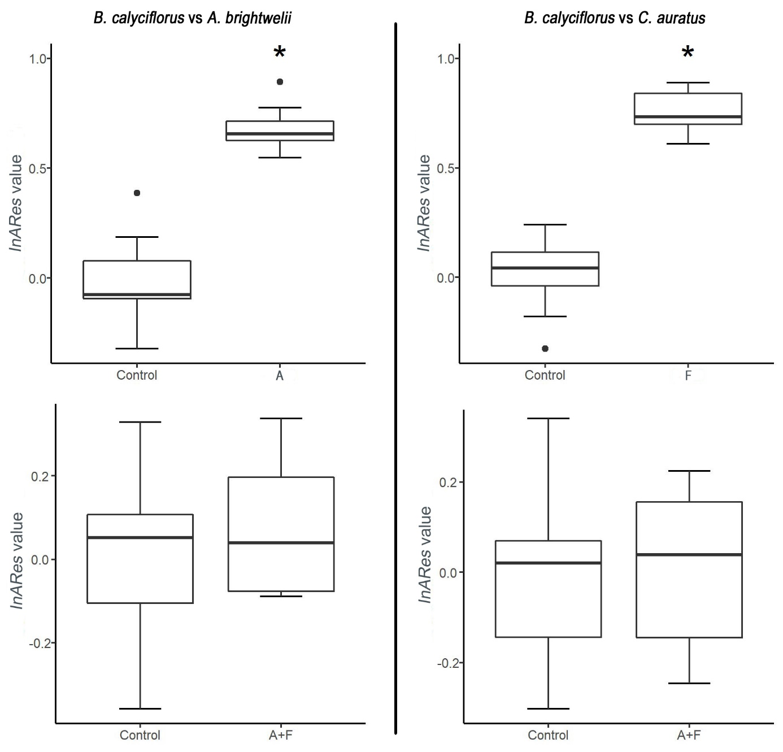
Figure SI2. The InARes values of B. calyciflorus after exposure to A. brightwelii cues (A), C. auratus larvae cues (F), or cues of both predators simultaneously (A+F), against either A. brightwelii (left) or C. auratus (right). The bold, horizontal lines indicate the median, the boxes indicate the 25 and 75 percentiles, and the whiskers indicate the 1.5-fold of those percentiles. Single dots indicate observations off the 1.5-fold of the percentiles. Asterisks indicate a significant difference between treatments, estimated with linear regression (i.e., one-way ANOVA).
Discussion of rotifer data
In the study of a multi-predator experiment (Zhang et al., 2022), the prey rotifers exhibited strong defences against the respective predator when exposed to their cues separately. These results are in line with prevailing theories of responses to invertebrate and vertebrate predators (e.g., Dodson, 1974). However, when the rotifers were exposed to both cues simultaneously, they were not defended against either predator. The authors performed predation trials in the corresponding study with the single-predator exposed rotifers. When exposed to the invertebrate predator A. brightwelii, the defended morphs had a strongly increased survival probability. This reflects the strong defence against this predator, indicated by the high InARes value. However, when exposed to the fish larvae of C. auratus, the defended morphs did not show a difference in survival compared to control animals (Zhang et al., 2022), even though they should be relatively well defended according to the InARes value. However, the result of this feeding trial might be artificial. It is generally assumed that a decrease in body size can provide a benefit against visual hunting fish. The visual hunting fish usually aim for larger prey items to maximise energy efficiency (Galarowicz & Wahl, 2005; Murray et al., 2016). A reduction in body size was observed in the corresponding study and found to be adaptive by our algorithm. Furthermore, the decrease in body size, in general, seems to be more important for protection (or avoidance) than reproduction. In the feeding trials of the corresponding study, there was no "competing" prey that would have rendered the decrease in body size beneficial. The fish larvae probably had enough time to search and feed all prey items and had no choice between large and small prey items. Therefore, the algorithm potentially, correctly estimated the adaptiveness of the investigated traits. Feeding trials with the multi-predator exposed animals were not conducted, i.e., no such data could be used to confirm the InARes estimations in this case.

Study on cocoa trees in a complex environment
In this study, the authors investigated the adaptation in functional root traits of cocoa trees (Theobroma cacao) and their differing resource acquisition strategies in different soils (Borden et al., 2020). The general question in this study was how these strategies are affected by different management, i.e., monoculture or agroforestry with another shade tree species (Terminalia ivorensis) nearby.
Briefly, they analysed the leaf-specific area and a set of absorptive root traits (specific root length, average diameter, specific root tip abundance, specific root area, tissue density, N content, C:N ratio), a set of transport root traits (specific root length, average diameter, tissue density), as well as the ratio of the biomass of the absorptive and the transport roots, the ratio of their respective length, and the biomass growth rate of the fine roots (divided by the basal area of the block, the tree occurs in; see the corresponding study for more details). Those traits were recorded from trees at four sites comprising different soil sand content (loamy and sandy) and soil moisture (wet and dry).
Analysis of cocoa tree data
With the InARes framework, we aimed to answer the following questions: (I) Is there a general adaptation to soil texture and soil moisture, and (II) which traits affect the adaptation? (III) Is this adaptation affected by shade trees (agroforestry), and (IV) is this effect different at varying soil texture and/or moisture?
To answer these questions, we calculated the InARes of cocoa trees against sandy soil conditions and the InARes of cocoa trees against dry soil conditions separately. We used the monoculture treatment as a baseline. We achieved the ${rexmax}_{k}$ values for each case, which were used to calculate the InARes under agroforestry. The authors recorded the proportion of sand and soil moisture as continuous parameters. Thus, we compared the results with generalised additive mixed models with soil sand content and soil moisture as continuous parameters for each observation. By doing so, we achieved a valid model without transforming values, which was necessary in the corresponding study. Additionally, this model fits the InARes values better than a model with stochastic parameters (i.e., with two-level factors being high or low for soil sand and soil moisture).
However, the complexity of the environment (i.e., various soil textures and moisture) raises several questions about how to apply the InARes framework (Fig. SI3). One could transform the data across all environmental levels (i.e., loamy/sandy or wet/dry, respectively) or separately for each level. When calculating the InARes value and estimating the traits' contribution, one could again calculate it across all environments or for each level separately and in combination with the previously mentioned transformation possibilities. This results in four ways to apply the InARes framework (Fig. SI3).
Generally, both ways of transformation are viable. However, when transforming the trait values across the different environments, one can calculate the general adaptation (i.e., regardless of the environment). This will result in a more conservative estimation of adaptive traits (i.e., only stronger effects of traits will be visible). Traits that have relatively minor impact within just one but not in the other environment will diminish and likely be covered by more effective traits or traits that are effective in both environments. Thus, the trait's contribution will be weighted between the environments to some extent. When transforming the data across the different environments, we cannot recommend calculating the InARes for each condition separately afterwards. Especially ${rexmax}_{k}$ will be biased by this approach and may end in misleading results (Fig. SI3).
When transforming the trait values for each environmental condition separately, one accounts for environmental differences. One trait can have another effect under different environmental conditions; therefore, each environment can, or should, be investigated separately (dependent on the initial question). However, after separating the transformation, it is not recommended to calculate the InARes across all conditions. This would lead to totally unweighted trait contribution between environments and neglect the previously mentioned differences in trait contribution under different conditions. In this case, we recommend performing a separate calculation for each condition. This further allows for more complex statistical analyses that can answer more complex hypotheses (Fig. SI3). Therefore, this way can be considered as most powerful. For our analysis of the cocoa tree data, we applied the latter variant, as the first variant is applied similarly to the previous data sets, we analysed in this study. However, we show how the estimation of the adaptivity of traits (i.e., the traits' contribution to the InARes) differs between both approaches.

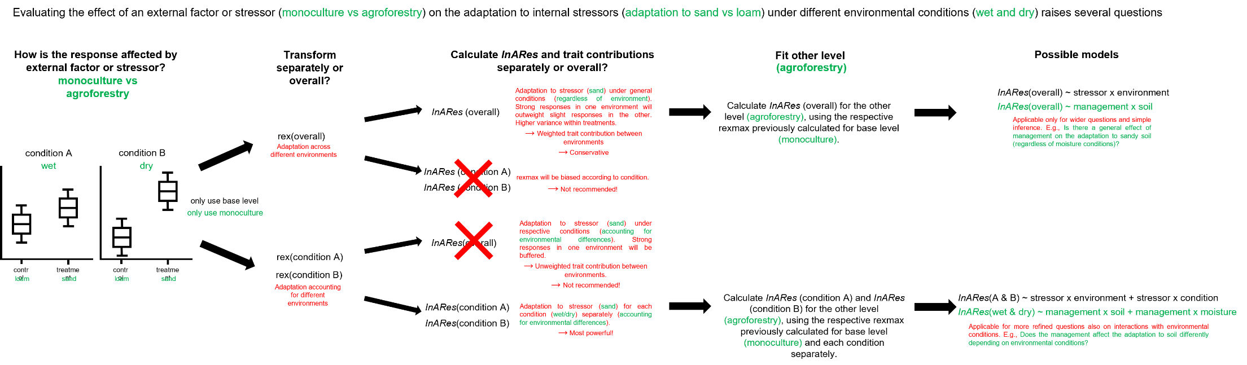
Figure SI3. Applying the InARes framework in complex environments with several conditions raises several questions about how to apply the framework. This scheme summarises the possible ways of applying the InARes framework with the example of the cocoa data set (green) and notes the meaning, background, and recommendations of the different ways (red).

Results of cocoa tree data
We estimated the contribution of the single traits to the adaptation to sand and drought under either wet or dry conditions or loamy or sandy conditions, respectively. Additionally, we estimated the contribution in an across-environment context (i.e., regardless of environmental condition) to highlight the differences between the two pathways described before (Fig. SI3). We forego showing the ${rexmax}_{k}$ and the estimated contribution values here, but the adaptiveness of each trait under the respective circumstances can be seen in Table SI2.
Table SI2. The adaptiveness of each recorded trait to sandy or dry soil under either wet or dry conditions or loamy or sandy conditions, respectively. Additionally, the overall estimation (regardless of the environmental conditions) is shown. No arrow indicates neither adaptive nor maladaptive effects. A red down-arrow indicates that an increase in this trait is maladaptive, while a green up-arrow indicates the trait to be adaptive upon increase.
 | Adaptation to sand |  |  | Adaptation to drought
Trait | wet | dry | overall | loamy | sandy | overall
Specific leaf area
Specific root length of absorptive roots |  | ↓ |  | ↑ |  | ↑
Average diameter of absorptive roots |  | ↑ | ↑ | ↓ | ↓ | ↓
Specific root tip abundance of absorptive roots |  | ↓ | ↓ |  |  | ↑
Specific root area of absorptive roots |  |  |  |  |  | ↑
Root tissue density of absorptive roots | ↓ | ↓ | ↓ |  |  | ↓
Root N content of absorptive roots | ↑ |  | ↑ | ↑ | ↑ | ↑
Root C:N of absorptive roots | ↓ | ↑ | ↓ | ↓ |  | ↓
Specific root length of transport roots | ↓ | ↑ | ↓ |  | ↑
Average diameter of transport roots |  | ↑ | ↑ | ↓ |  | ↓
Root tissue density of transport roots | ↑ | ↑ | ↑ |  |  | ↓
Absorptive:Transport root biomass |  | ↓ | ↓
Absorptive:Transport root length | ↑ | ↓ | ↓ | ↑ | ↓
Biomass growth of fine roots | ↑ | ↓ | ↓ | ↑ | ↓

The evaluation of the generalised additive models showed a significant effect of the management (i.e., monoculture vs agroforestry) in general (F_{(1, 118)} = 4.296, p = 0.041), which varied under varying proportions of sand and soil moisture (i.e., exhibiting interactions). However, the interactions could be investigated in more detail with a smooth-factor interaction analysis (e.g., Rose et al., 2012), but we forego these detailed analyses here, as this is just an example of how to use the InARes framework. The proportion of sand in the soil significantly affected the adaptation to sandy soil for monoculture (F_{(1, 120)} = 16.587, p < 0.001) and for agroforestry (F_{(1, 120)} = 7.428, p = 0.015). However, the adaptation was just slightly affected by the management regarding the soil sand content. The soil moisture, however, had a clear effect under agroforestry (F_{(1, 120)} = 3.674, p = 0.043) but not under monoculture (F_{(1, 120)} = 0.421, p = 0.518). This further indicates an interaction between the management and soil moisture (Fig. SI4).
We did not find a significant interaction of the management with soil sand or soil moisture in the adaptation to dry soil. However, the management had a generally significant effect (F_{(1, 118)} = 5.162, p = 0.025) on the adaptation to dry soil (Fig. SI4).

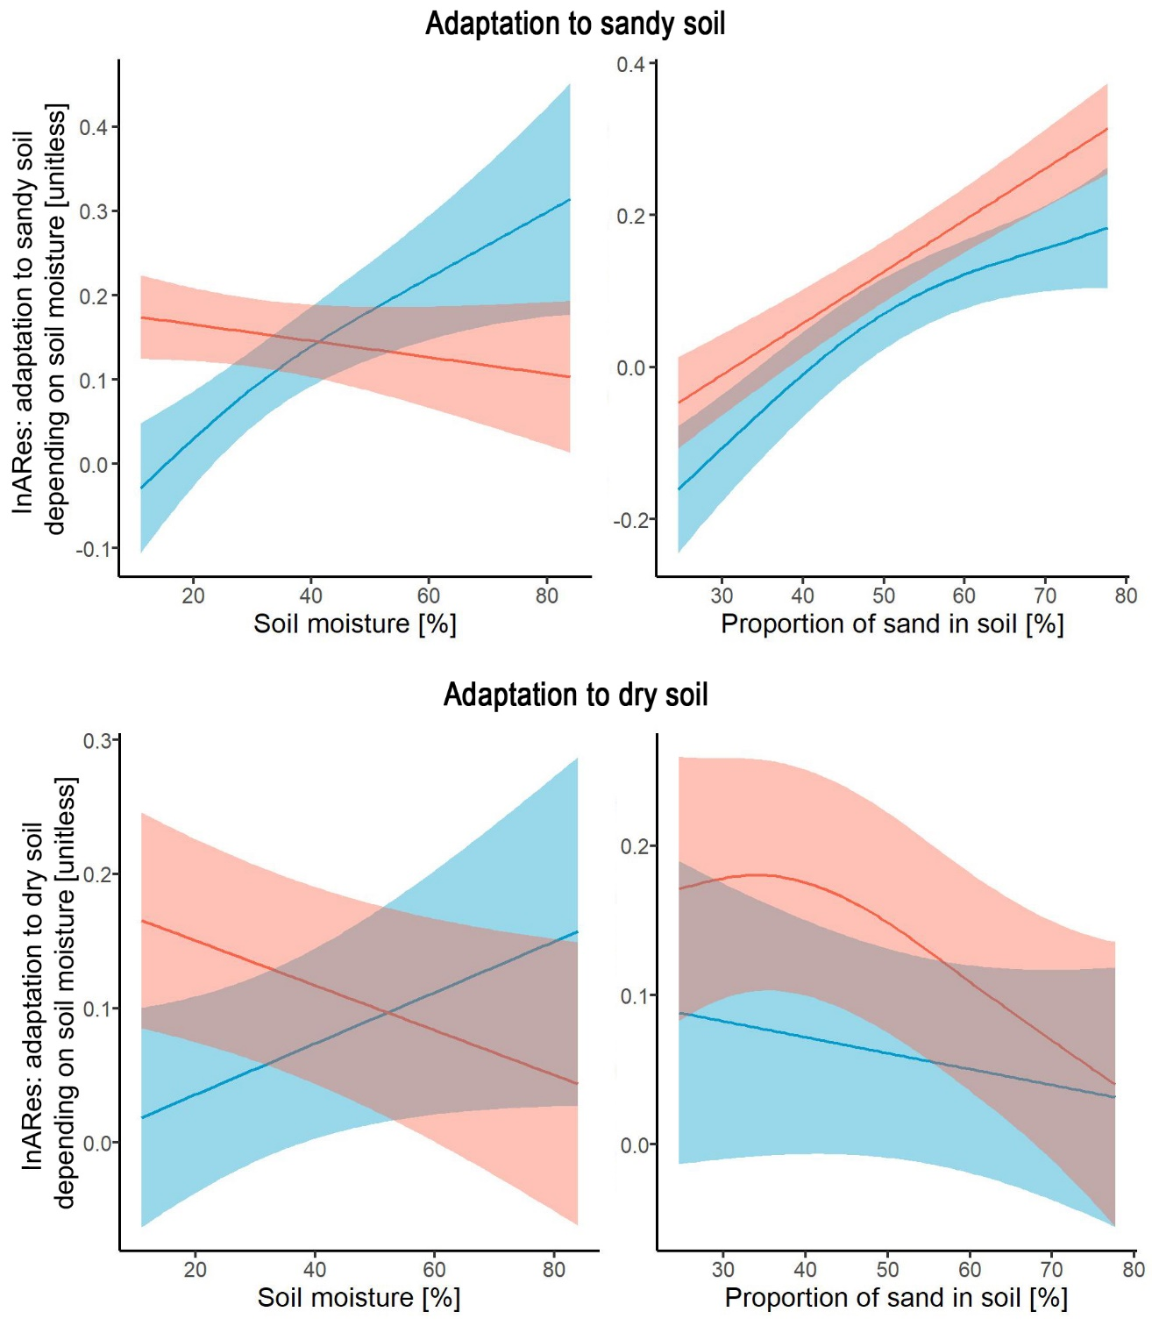
Figure SI4. Results of the generalised additive models, estimating the effects of monoculture (red) vs agroforestry (blue). Solid lines indicate mean values. Ribbons indicate the standard deviation of the model estimations. The effect of the respective condition (proportion of sand or soil moisture) is shown with the other condition set to the median value (e.g., the effect of soil moisture under the median proportion of sand).
Discussion of cocoa data
The traits estimated to be adaptive or maladaptive are generally in line with prevailing theories and the corresponding study (Table SI2, see the corresponding study for further reading). Under the different conditions, some traits are likewise adaptive, but some traits are adaptive under one condition but not or even maladaptive under the other condition. This, together with a few unexpected findings that the algorithm discovered, was also discussed by the authors of the corresponding study (Borden et al., 2020), which is why we forego the discussion. Generally speaking, under different conditions, the adaptation to sandy soil or dry soil seems to be differently affected by the recorded traits and is in line with the authors’ discussion.
The management (i.e., monoculture vs agroforestry) impacts the adaptation to sandy soil or dry soil, respectively. Surprisingly, trees from agroforestry are not generally superiorly adapted to harsh conditions. Furthermore, a similar pattern in the adaptation to sandy and dry soil can be found. Under drought, plants in monoculture seem to be better adapted to sandy and dry soil compared to trees grown in agroforestry. This is inverted under high soil sand or water content, respectively. These results can be interpreted in two ways: First, trees in monoculture can better adapt to sandy and dry soil. Or second, trees under drought are less affected by sandy soil when grown in agroforestry. Higher water availability and lower evaporation rates in agroforestry reduce the importance of adapting to sandy and dry soil. Sandy soil is generally worse at keeping water compared to loamy soil. Furthermore, a better adaptation to sandy and dry soil under wet conditions may imply a better performance to “sudden” drought events. We will leave this discussion to experts in this research field, as a complete discussion of this topic would be beyond the scope of this example.
In this section, we have shown how the InARes framework can be applied in a complex environmental setting and how it can be used as a powerful analysis and interpretation tool to answer complex questions. It should be noted that the models would benefit greatly from a higher resolution of the sand and moisture gradient and may be biased in this case. That is probably the reason why the authors of the corresponding study used a factorial design (besides the huge effort that would have been necessary to achieve such a gradient). Nevertheless, we chose this approach to show how data with continuous environmental parameters could be applied to our framework. Furthermore, the models fitted the InARes value superior when the continuous variable was used instead of the two-level factor (high vs low). This indicates the adequate estimation of the InARes. The trees are likely to adapt stronger to harsher environments, which was accurately reflected by this finding.

Discussion of the algorithms’ evaluation of the predation trial
To test the algorithm in a natural context, we estimated each trait's contribution in the corresponding predator-prey study (Diel et al., 2023, manuscript in preparation). The algorithm found the tail-spine and the length of the dorsal spinule bearing area (SBA) to be adaptive, which was similar to the original model estimation. Further, the algorithm found the length of the ventral SBA, the dorsal and ventral spinule length, and the distance between the fornices to be adaptive as well. For the length of the ventral SBA, this result is not surprising. In the corresponding study, the length of the ventral SBA was collinear with the dorsal SBA. Therefore, it has been excluded from the model, and following a model comparison, the ventral SBA was considered less important than the dorsal SBA (Diel et al., 2023, manuscript in preparation). On the other hand, these results could also mean that both SBAs provide very similar protection. This, however, cannot be distinguished with a regression model due to the collinearity. The distance between the fornices was also found to be a good predictor of the survival probability of the prey after creating a predictive (i.e., selected) model. Therefore, the estimation of the adaptiveness of the fornices is in line with the predictive model. Furthermore, the lateral body width of the prey may be a good proxy for the distance between the fornices, as both traits describe the same body axes. The corresponding study shows that the lateral body width provides a protective benefit in a specific orientation of the prey towards the predator (Diel et al., 2023, manuscript in preparation). Therefore, it might be that both traits are either interactive or exchangeable to a certain extent. The algorithm found the dorsal and ventral spinules to be adaptive, which was previously suggested in another study (Diel et al., 2021). However, the spinules were not found to protect this predator in the corresponding study. Thus, we cannot exclude it being an artefact caused by a general defensive response by the prey or not. The spinules might protect against other predators, and the responsiveness is coupled with other traits. But it is also possible that the corresponding study could not find a defensive benefit because of the relatively stronger effects of the other traits. Finally, the algorithm found an increase in the furca to be maladaptive. The furca is a claw at the abdomen of the prey animal. It can be used to hit the predator actively. In the corresponding study, there was a strong interaction of the furca length with the predator body length (Diel et al., 2023, manuscript in preparation). However, it was also found that a long furca resulted in a low survival probability against smaller predators and only provided protection against relatively large predators. Therefore, depending on the predators' size, an elongation of the furca is likely maladaptive. In the corresponding study, it was suggested that the furca length is a proxy for other traits, like the strength of the muscles responsible for the strikes with the furca (Diel et al., 2023, manuscript in preparation). So far, we cannot provide a definite statement about the adaptiveness of the furca. These results show that the algorithm cannot replace experiments, e.g., feeding experiments, for estimating the adaptiveness of a certain defensive trait when definite knowledge is aimed for or necessary. However, the InARes framework can help create new hypotheses and design experiments. This will improve the knowledge about the studied system and help to achieve this definite knowledge.
General
- In a publication, ${rexmax}_{k}$ should be reported to allow other researchers to use and compare these data.
- The term ‘Index for Adaptive Responses’, ‘Index for Adaptive Responses framework’, or InARes should be included in the keywords of a publication to simplify literature search for ${rexmax}_{k}$ values.
- When a special case is faced, or certain complications or complicated applications of the framework have to be performed, it would be appreciated if they are reported via the package website (as an issue or discussion). This may help to improve and standardise the application of the framework and this recommendation list.
Traits
- The InARes gain accuracy when including as many functional traits as possible.
- Particular caution has to be paid for when selecting traits. Only actual functional traits should be included, not responses (e.g., an increase in metabolic rate probably is not a functional trait but a response to increased stress levels).
- Do not include derivatives of traits containing the same information as the other traits (e.g., root volume is a derivative of root diameter and length). However, ratios of traits might contain additional information. This should be carefully considered.
- We could show that the InARes perform superior in our case, and the simulations showed high accuracy in estimating the adaptiveness of traits. However, we must admit that the InARes framework is an abstraction and simplification. If one is interested in a detailed (and quantitative) estimation of the effectivity and the definite contribution to the adaptiveness of each trait, we recommend an extensive exposure trial (like our corresponding study). However, this experiment would have to be repeated for every species under every environmental condition. Our algorithms provide a fast and simple method to get more insight into the traits' modalities.
Comparability
- The data should be set on a similar basis to compare data across studies or even across species. At best, all functional traits should be included, and a similar environmental condition (i.e., similar baseline) should be set up (e.g., adaptation against toxins under predation – both species should be exposed to the predator).
- For better comparability across studies of the same species and/or environment, ${rexmax}_{k}$ should be reported and/or used from literature when available.
Calculation
- The InARes should be calculated in a multi-environment experiment either on all individuals across environments or for each environment separately, depending on the targeted question (see Fig. 5). However, in some cases, it might be useful to perform the transformation across all environments and the InARes calculation for each environment separately. In such a case, we recommend carefully considering implications and potential bias (as stated in Fig. SI3).
- Missing observations of single traits can be interpolated by the algorithms. However, attention should be paid when there are too many missing values, as this might bias the estimation.
- Collinearity is not an issue for the InARes framework. In fact, collinear terms should be included in the calculation. The InARes is meant as a comprehensive adaptation, especially accounting for integrated trait interactions (i.e., collinearity).
- Single outliers are no issue for the algorithm. Therefore, they can be included in the calculation.
- The estimation of the adaptiveness (i.e., adaptiveness or maladaptiveness of a trait) works best with 10 or more replicates and more than 2 traits.
- If definite knowledge about the functional traits and their adaptiveness is available (i.e., which trait has an effect), this information should be included in the calculation (see package description for further information). As shown with the model comparison in table 1, this will provide the highest estimation accuracy.
- The InARes value might be biased in cases where an organism responds to a certain stressor in a maladaptive way without a biological reason. If this is the case at an individual level, the algorithm performance would not be affected, as it is robust to outliers. However, if a whole population responds that way, this will bias the InARes value. Therefore, we recommend always including available knowledge where possible.
Box SI1. Recommendations for and limitations of the Index for Adaptive Responses framework. Even though the Index for Adaptive Responses framework is meant to be as simple as possible, the complexity of 'whole organism' responses requires careful thought when using the framework. We will provide this list and future updates in the R package readme file and description. See the package description and the functions within for a description of how to apply these recommendations.

