Supplementary Materials:

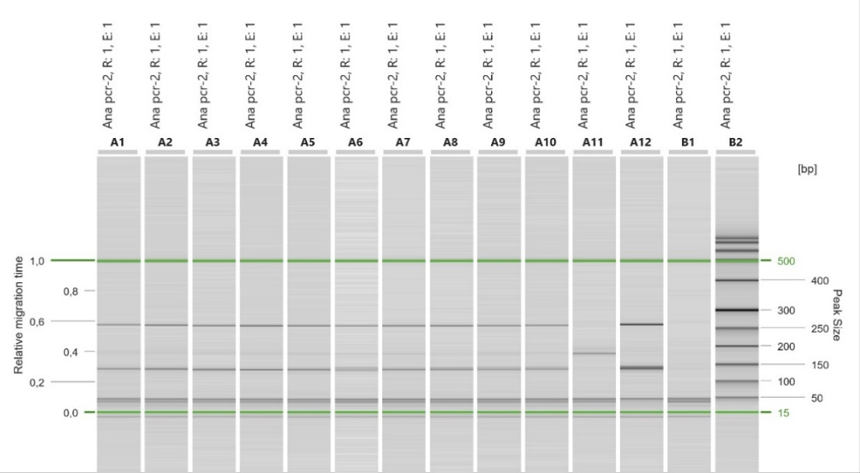

Figure S1. Capillary electrophoresis run of the multiplex PCR on Trichinella larvae collected from the pine marten. A1 to A10 larvae isolated from the pine marten; A11 T. spiralis positive control; A12 T. britovi positive control; B1 negative control; B2 size marker.

