Histological and Immunohistochemical Characterization of Osteoimmunological Processes in Scaffold-Guided Bone Regeneration in an Ovine Large Segmental Defect Model
Ronja Finze ^{1,2,‡}, Markus Laubach ^{1,3,4,‡}, Mairim Russo Serafini ⁵, Ulrich Kneser ², Flavia Medeiros Savi ^{1,3,6,*}

Supplementary Table 1
Details of experimental groups. mPCL-TCP = medical-grade polycaprolactone and tricalcium phosphate; mPCL-TCP-CaP = medical-grade polycaprolactone and tricalcium phosphate and calcium phosphate surface coating; PRP = Platelet-Rich-Plasma; ICGB = iliac crest bone graft; RIA system = Reamer-Irrigator-Aspirator system; rhBMP-7 = recombinant human bone morphogenic protein-7; CPF = cortico-periosteal flap; Allo-MSC = allogenic mesenchymal stem cells
Experimental Groups
Scaffold | Bone Graft Material / Substitute | Tibial Defect Sizes | Time Points
mPCL-TCP | RIA | 6 cm | 6 hours  12 months  14 months  15 months  21 months  27 months
mPCL-TCP | ICGB (6 ml) | 6 cm | 2 months  6 months
mPCL-TCP | rhBMP-7 (2 mg) carried in PRP | 6 cm | 12 months
mPCL-TCP-CaP | CPF | 3 cm  6 cm | 12 months  12 months  15 months
mPCL-TCP | Allo-MSC | 3 cm | 36 months

Supplementary Table 2
Verified primary antibody staining to detect inflammatory and blood vessel markers as well as bone ECM proteins in the preclinical critical-sized bone defect model. PK: Proteinase K. ab: abcam; SC: Santa Cruz;
Antibody | Positive control | Reactivity | Raised in | Clonality | Cat. no. | Antigen retrieval | Blocking | Dilution | Incubation | DAB
Inflammation/Osteoclastic activity markers
Nitric oxide synthase (iNOS) | Sheep spleen | Mouse | Rabbit | Polyclonal | ab15323 | PK 5 min | 2% BSA | 1:100 | 60 min | 3 min
Mannose receptor (MR) | Sheep liver | Human, Mouse, Rat | Rabbit | Polyclonal | ab64693 | PK 5 min | 2% BSA | 1:500 | 60 min | 45 sec
Arginase-1 (ARG-1) | Sheep spleen | Human, Mouse, Rat | Rabbit | Polyclonal | Proteintech  16001-1-AP | PK 5 min | 2% BSA | 1:100 | 60 min | 5 min
Cluster of differentiation 68 (CD68) | Sheep spleen | Mouse, Rat | Rabbit | Polyclonal | ab125212 | PK 5 min | 2% BSA | 1:300 | 60 min | 1:30 min
Interferon regulatory factor 5 (IRF5) | Sheep spleen | Human, Mouse, Rat,  Human, Mouse, Rat | Mouse  Rabbit | Monoclonal  Polyclonal | sc-56714  Proteintech 10547-1AP | PK 5 min  PK 5 min | 2% BSA  2% BSA | 1:100  1:100 | 60 min  60 min | 5 min  3 min
Cluster of differentiation (CD3) | Sheep spleen | Human | Mouse | Monoclonal | ab17143 | PK 5 min | 2% BSA | 1:100 | 60 min | 5 min
Cluster of differentiation 45 (CD45) | Sheep spleen | Human, Mouse, Rat | Rabbit | Polyclonal | ab10558 | PK 5 min | 2% BSA | 1:100 | 60 min | 5 min
Vascularization markers
Vascular endothelial growth factor (VEGF) | Sheep tibia | Human, Mouse, Rat | Rabbit | Polyclonal | SC152 | PK 5 min | 2% BSA | 1:500 | 60 min | 1:30 min
Cluster of differentiation 31 (CD31) (PECAM-1 (M-20)) | Sheep tibia | Human, Mouse, Rat | Goat | Polyclonal | SC1506-R | PK 5min | 2% BSA | 1:1000 | 60 min | 1 min
von Willebrand factor (vWF) | Sheep tibia | Human | Rabbit | Polyclonal | IR527 | PK 5min | 2% BSA | Ready to use | 60 min | 1:30 min
Alpha smooth muscle actin (α-SMA) | Heart | Human, Mouse, Pig, Rabbit, Rat, Sheep, | Mouse | Monoclonal | ab7817 | PK 5 min | 2% BSA | 1:500 | 60 min | 2 min
Angiopoietin-1 (ANG1) | Sheep tibia | Human, Mouse, Rat | Rabbit | Polyclonal | ab102015 | PK 5 min | 2% BSA | 1:100 | 60 min | 1 min
Noggin (NOG) | Sheep tibia | Human, Mouse, Rat | Rabbit | Polyclonal | SC25656 | PK 5 min | 2% BSA | 1:100 | 60 min | 5 min
NOTCH 1 | Sheep tibia | Human, Mouse, Rat | Rabbit | Polyclonal | SC6014-R | PK 5 min | 2% BSA | 1:100 | 60 min | 5 min
Extracellular matrix markers
Collagen type I (COL I) | Sheep tibia | Human  Human | Rabbit  Rabbit | Polyclonal Monoclonal | ab34710  ab138492 | PK 5min | 2% BSA | 1:1000  1:500 | 60 min | 2 min  30 sec
Collagen type II (COL II) | Sheep tibia | Avian, Bovine, broad species, Chicken, Fish, Goat, Human, Mouse, Ovine, Rabbit, Rat, Shark, Zebrafish, Xenopus | Mouse | Monoclonal | DSHB  II-II6B3 | PK 5min | 2% BSA | 1:100 | 60 min | 40 sec
Bone morphogenetic protein 2 (BMP2) | Sheep tibia | Human, Mouse, Rat, | Mouse | Monoclonal | SC137087 | PK 5 min | 2% BSA | 1:50 | 60 min | overnight
Osteoprotegerin (OPG) | Sheep tibia | Human | Rabbit | Polyclonal | ab73400 | PK 5 min | 2% BSA | 1:100 | 60 min | 30 sec
Alkaline Phosphatase (ALP) | Sheep tibia | Human, Mouse, Rat, | Mouse | Monoclonal | sc166261 | PK 5 min | 2% BSA | 1:500 | 60 min | 5 min
Sclerostin (SCL) | Sheep tibia | Human, Mouse, Rat, Sheep, | Rabbit | Polyclonal | ab63097 | PK 5 min | 2% BSA | 1:100 | 60 min | 1 min
Osteomodulin (OMD) | Sheep tibia | Human, Mouse | Rabbit | Polyclonal | ab154249 | PK 5 min | 2% BSA | 1:500 | 60 min | 1 min
Osteonectin (ON) | Sheep tibia | Bovine, Cow, Dog, Human, Monkey, Pig, Rabbit, Rat | Mouse | Monoclonal | DSHB - AON-1 | PK 5 min | 2% BSA | 1:100 | 60 min | 2 min
Osteopontin (OPN) | Sheep tibia | Dog, Human, Mouse, Pig, Rat, | Rabbit | Polyclonal | ab8448 | PK 5 min | 2% BSA | 1:100 | 60 min | 40 sec
Osteocalcin (OC) | Sheep tibia | Cow, Dog, Goat, Human, Pig, Rat, Rabbit, Sheep | Mouse | Monoclonal | ab13418 | PK 5 min | 2% BSA | 1:500 | 60 min | 30 sec

Supplementary figure 1. Schematic overview of the histologic sectioning methodology used in our model of the ovine segmental tibial defect.
Supplementary figure 1. (A-D) Longitudinal and radial view, and dimensions of the mPCL-TCP scaffold. (F-G) Standardized transverse sectioning planes for the immunohistological specimens are proximal host bone and defect site interface, middle: defect site only; distal host bone and defect site interface. Reproduced and modified from Henkel et al. [20] and Medeiros Savi et al. [27]. Scale bar: 5 mm.

Supplementary figure 2. Immunohistochemical analysis of protein expression in SGBR throughout the entire bone regeneration period, negative controls.
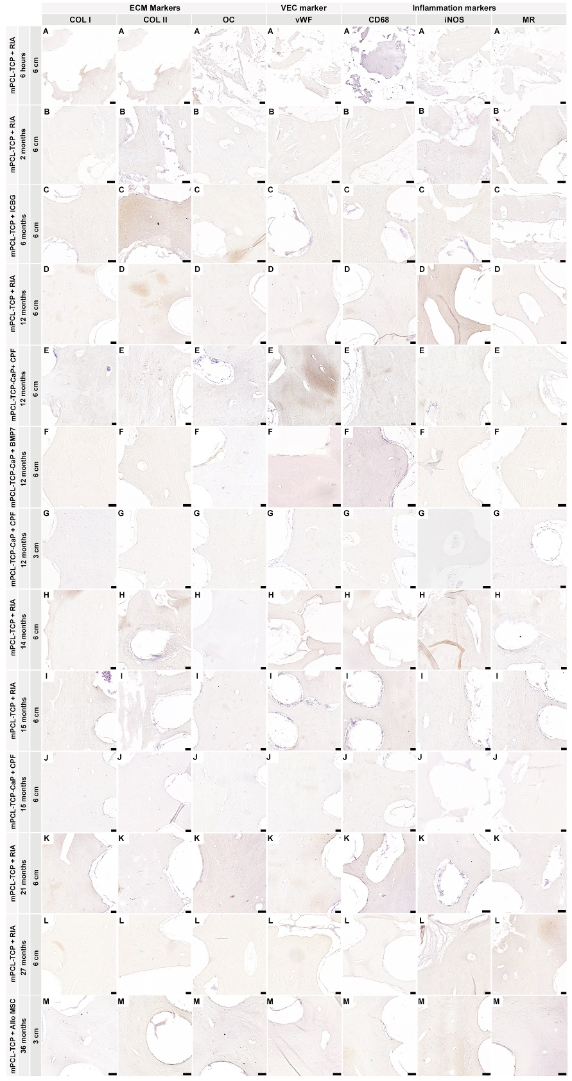
Supplementary figure 2. Immunohistochemical analysis of protein expression in SGBR throughout the entire bone regeneration period. Negative controls for Collagen type I (Col I), Collagen type II (Coll II); Osteocalcin (OC); von Willebrand Factor (vWF); cluster of differentiation 68 (CD68); inducible nitric oxidase synthesis (iNOS); Mannose receptor (MR). Scale bars: 50µm

Supplementary figure 3. Inflammation markers negative controls.
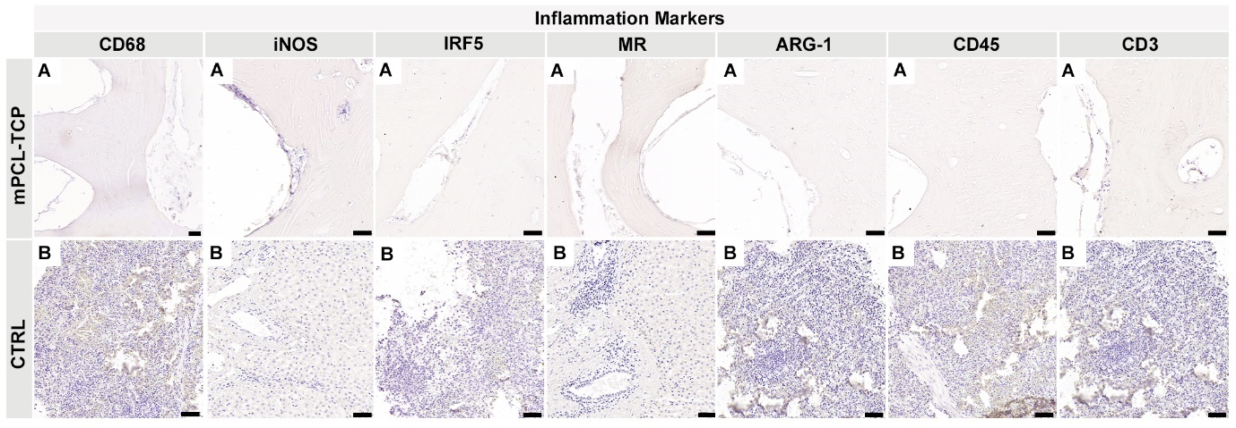
Supplementary figure 3. Inflammation markers negative controls for Cluster of differentiation 68 (CD68), Nitric oxide synthase (iNOS), interferon regulatory factor 5 (IRF5), mannose receptor (MR), Arginase-1 (ARG-1), cluster of differentiation 45 (CD45) and cluster of differentiation 3 (CD3). Scale bars: 50µm

Supplementary Figure 4. Vascular endothelial cellular markers negative controls.
Supplementary figure 4. Vascular endothelial cellular markers negative controls for Vascular Endothelial Factor (VEGF); Angiopoietin (ANG1); Cluster of differentiation 31 (CD31); von Willebrand Factor (vWF); Anti smooth Muscle Actin (α-SMA); Noggin (NOG). Scale bars: 50µm
            - Supplementary figure 5. Extracellular matrix markers negative controls.
Supplementary figure 5. Extracellular matrix markers negative controls for: Collagen type I (Col I), Collagen type II (Coll II); Bone Morphogenic Growth Factor 2 (BMP2); Alkaline Phosphatase (ALP); Osteomodulin (OMD); Osteonectin (ON); Osteopontin (OPN); Osteocalcin (OC); Sclerostin (SCL) and Osteoprotegerin (OPG); Isotypes controls for NOG and NOTCH were used from another tissue sample, however done at the same time. Scale bars: 50µm

