Supplementary Materials
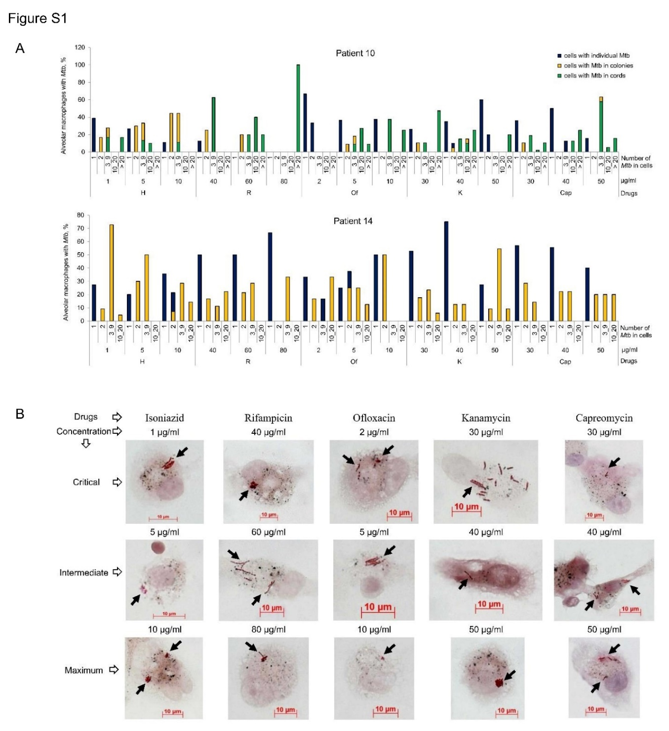

Figure S1. M. tuberculosis (Mtb) are able to survive exposure to different concentrations of anti-TB drugs in the ex vivo cultures of alveolar macrophages obtained from the distant lung tissues of patient 10 with XDR-TB and patient 14 with isoniazid-resistant TB. (a) The number of alveolar macrophages with a particular number of acid-fast Mtb in them expressed as the percentage of the total number of infected alveolar macrophages does not change significantly between the ex vivo cell cultures exposed to different concentrations of anti-TB drugs during three days. Drugs: H, isoniazid; R, rifampicin; Of, ofloxacin; K, kanamycin; Cap, capreomycin. (b) The colonies of acid-fast Mtb stained by the ZN method and indicated by black arrows are demonstrated on representative images of viable alveolar macrophages without apoptotic or necrotic morphology exposed to different concentrations of anti-TB drugs in ex vivo culture during three days for patient 14. The scale bars are 10 μm each.
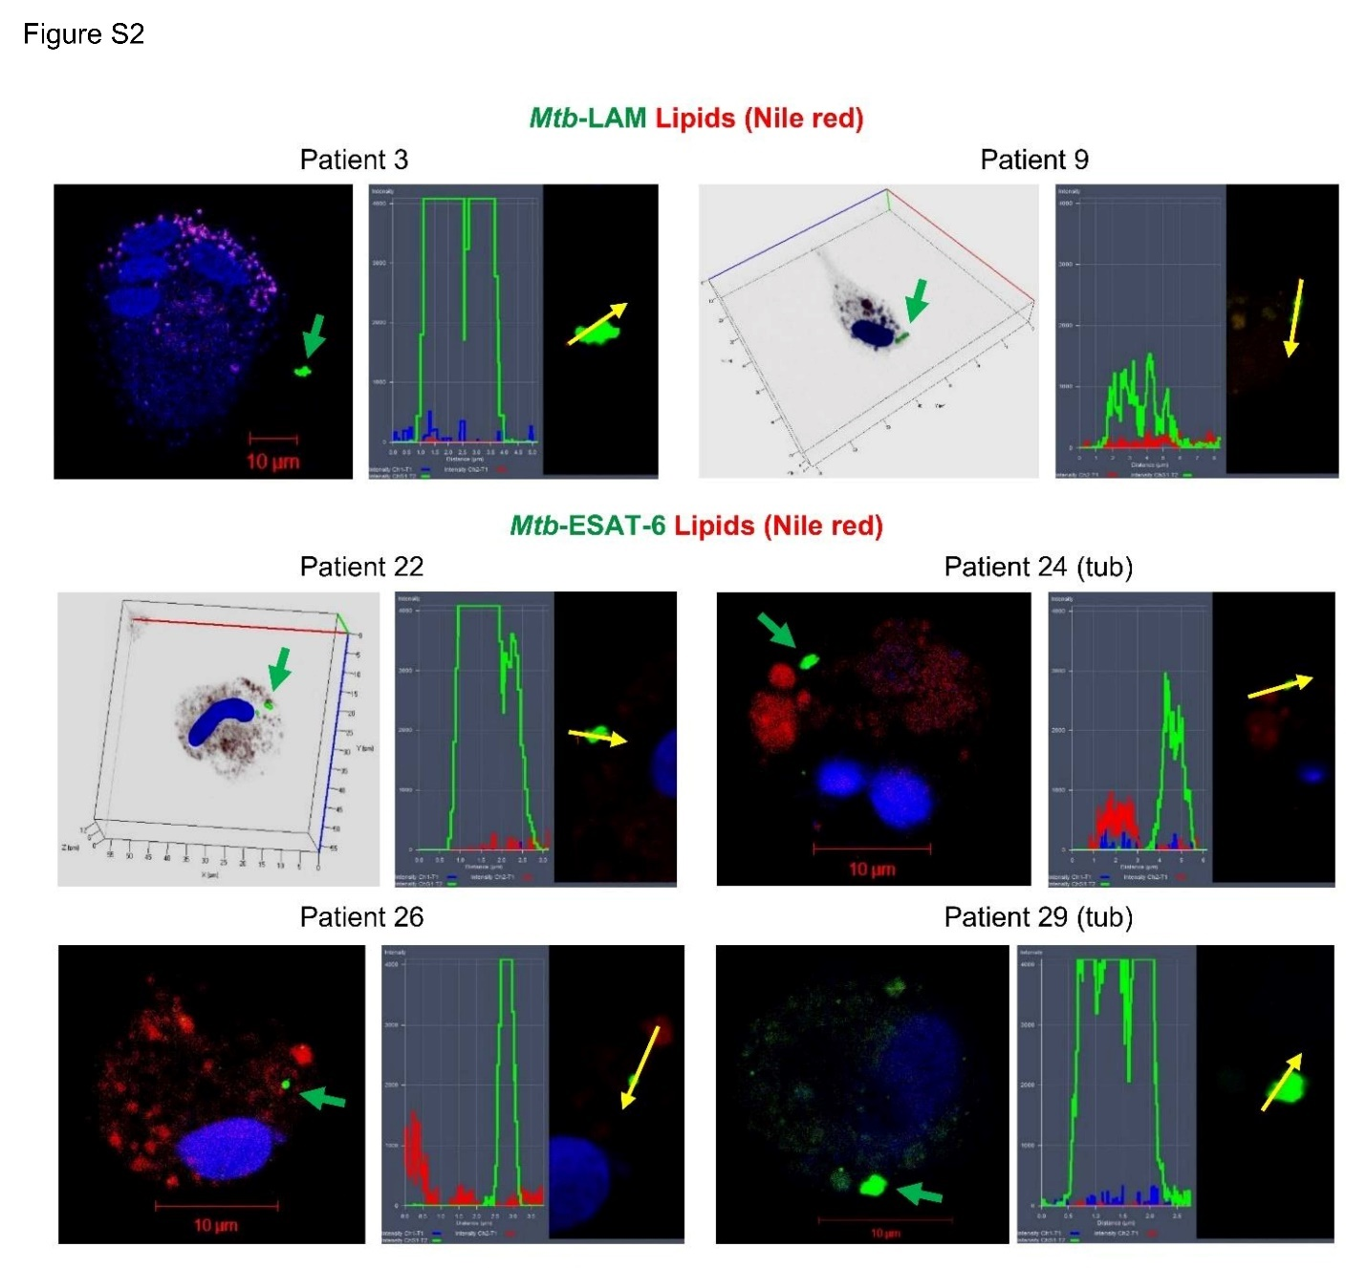
Figure S2. Intracellular lipophilic inclusions are not found in the Mtb located both within and outside the alveolar macrophages obtained from the tuberculoma walls (tub) and the tissues distant from the macro-TB lesions of the patients’ resected lung parts on representative confocal 3D or single immunofluorescent images stained by the Mtb LAM- or ESAT-6-specific antibodies (green signal) and Nile red dye (red signal) after ex vivo culture for 16-18 hours. Nuclei are stained by DAPI (blue signal). Green arrows point to Mtb (solitary or as colonies). To the right of these images: the profile images of the arrow-marked Mtb shown. Yellow arrows point to the areas for constructing profile graphs. The scale bars are 10 μm each.
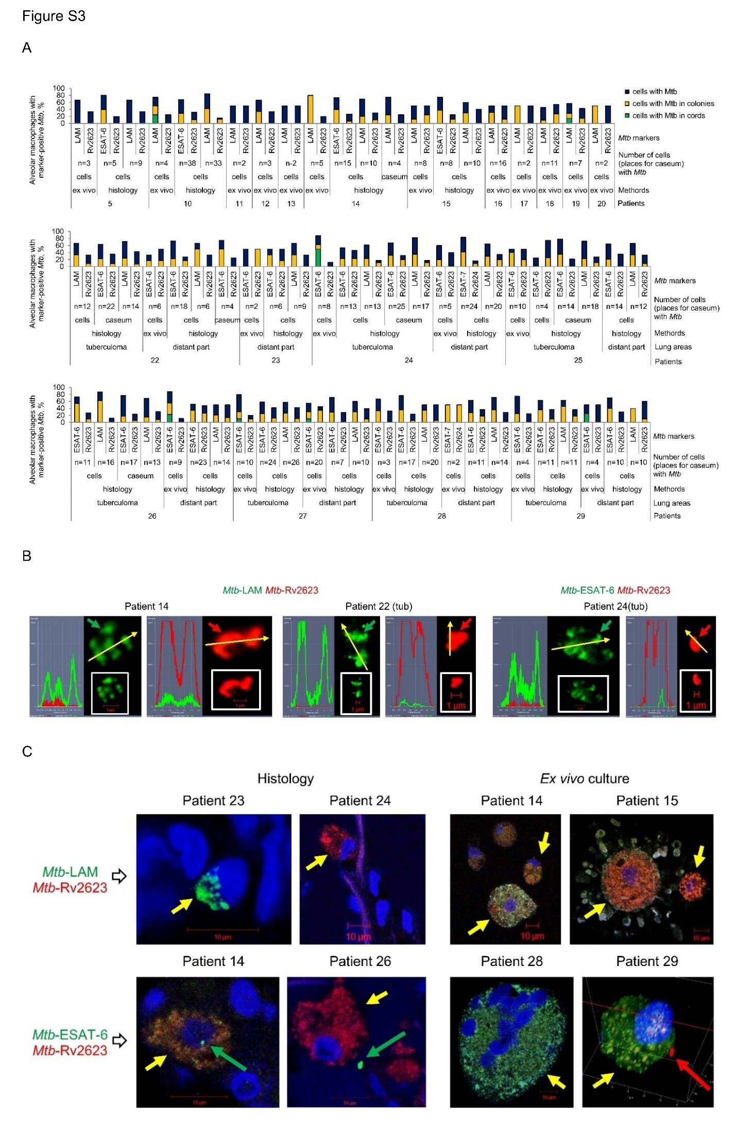
Figure S3. Rv2623-positive Mtb present in alveolar macrophages and necrotic caseum in various lung TB lesions of all the patients studied. (a) The number of alveolar macrophages or caseous regions with LAM- or ESAT-6- and Rv2623-positive Mtb (solitary or as colonies) and with Mtb colonies (including those with cording morphology) is expressed as the percentage of the total number of host cells or caseous regions with LAM- or ESAT-6- and Rv2623-positive Mtb analyzed simultaneously in them on the histological sections and after ex vivo culture for 16-18 hours; (b) Representative profile images demonstrate LAM- or ESAT-6-positive Mtb (green signal) not expressing Rv2623 protein and, conversely, Rv2623-positive Mtb (red signal) not expressing the virulence factors LAM and ESAT-6 in the caseous center of a small granuloma (only for patient 14) and tuberculomas (for other patients) on the histological sections. Yellow arrows point to the areas for constructing profile graphs. Close-ups of the images with the arrow-marked Mtb and the scale bar are shown in the lower right part of profile images. The scale bars are 1 μm each; (c) The Mtb markers stained with antibodies reacting with Mtb LAM or ESAT-6 (green signal) and Mtb Rv2623 (red signal) often colocalize in the same intracellular vesicles of alveolar macrophages along with or without marker-positive Mtb in them on the histological sections and after ex vivo cell culture for 16-18 hours. Representative confocal immunofluorescent images are shown. Short yellow arrows point to the alveolar macrophages with intracellular vesicles in them. Long green and red arrows point to ESAT-6- and Rv2623-positive Mtb, respectively. The scale bars are 10 μm each.

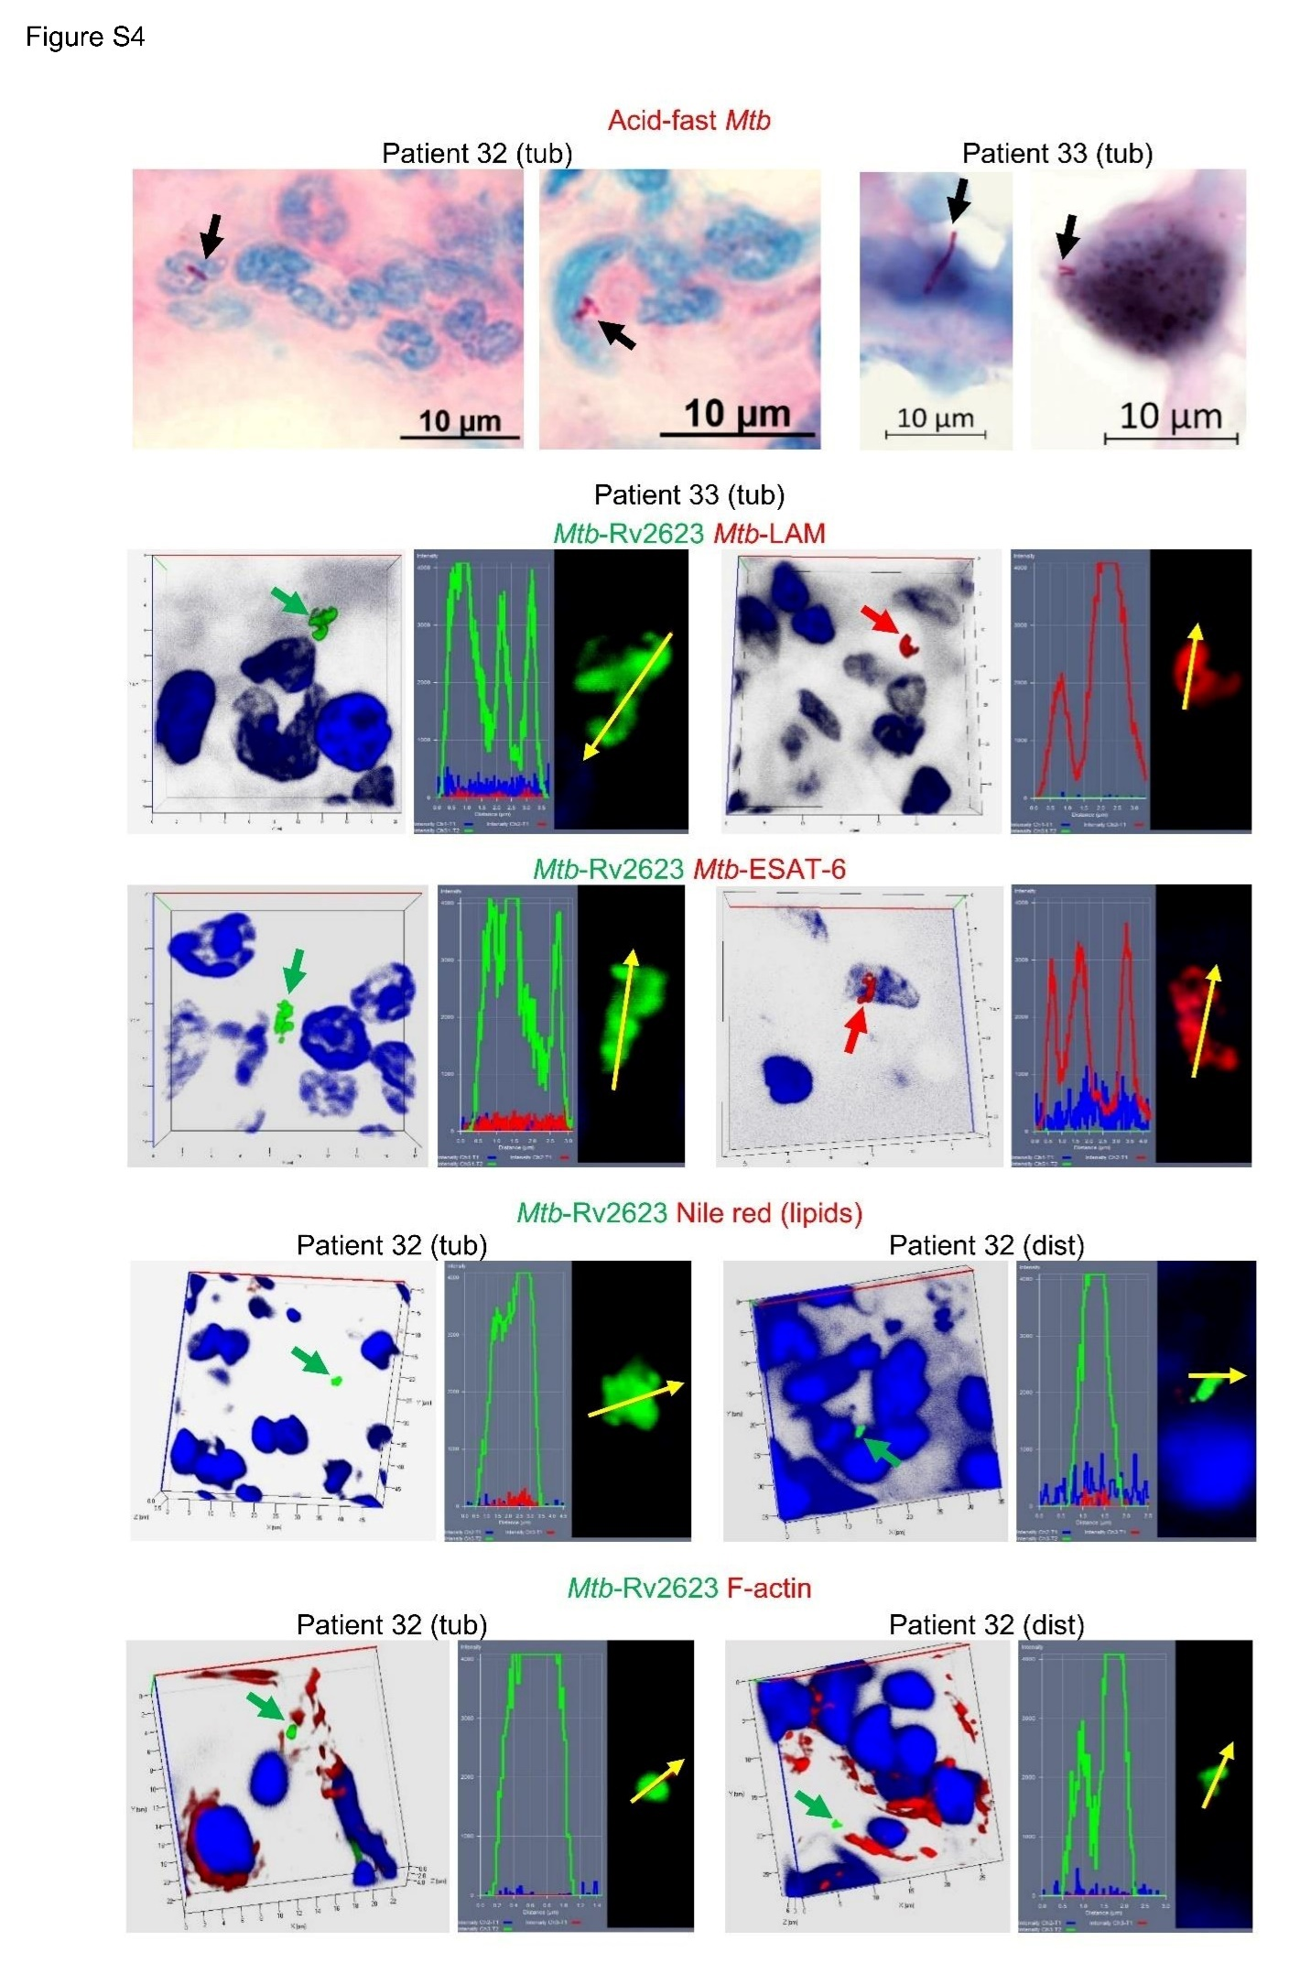
Figure S4. Rv2623-positive Mtb identified in alveolar macrophages in tuberculoma (tub) walls and tissues distant (dist) from the macro-TB lesions of patients 32 and 33 without any anti-TB treatment before surgery. Representative images of acid-fast Mtb after ZN staining are shown in the patients’ alveolar macrophages on the histological sections. Representative confocal 3D immunofluorescent images simultaneously stained with appropriate specific antibodies and dyes demonstrate Rv2623-positive Mtb (green signal) not expressing the virulence factors LAM and ESAT-6 and, vice versa, LAM- or ESAT-6-positive Mtb (red signal) not expressing Rv2623 protein, the absence of intracellular lipophilic inclusions stained by the Nile red dye (red signal), and a lack of colocalization with filamentous actin stained by the Phalloidin dye (red signal) in Rv2623-positive Mtb (green signal) in alveolar macrophages on the histological sections. Nuclei are stained by DAPI (blue signal). Green, red, and black arrows point to Rv2623-, LAM- or ESAT-6-positive Mtb, and acid-fast Mtb, respectively. To the right of the 3D immunofluorescent images: profile images of the arrow-marked Mtb. Yellow arrows point to the areas for constructing profile graphs. The scale bars are 10 μm each.

Table S1. Subpopulations (SP) of Mtb in alveolar macrophages of patients with pulmonary TB
SP¹ | TB patients²
 | 1, 11,  12, 21 | 2 | 3 | 4, 23 | 5 | 6 (cav), 10 | 7, 8 | 9 | 13 | 14 | 15
1  2  3  4  5  6  7  8  9  10 | +  -  -  -  -  -  -  ns  +  - | +  +  -  -  -  -  -  ns  +  - | +  +  +  -  +  -  -  ns  +  + | +  +  +  +  -  -  +  ns  +  + | +  -  +  -  -  -  -  ns  +  - | +  +  +  +  -  +  +  ns  +  + | +  +  +  +  -  +  +  ns  ns  ns | +  +  +  +  -  -  +  ns  ns  ns | +  -  -  -  -  -  +  ns  +  - | +  -  +  -  -  -  +  +  +  + | +  -  +  -  -  -  -  +  +  +

SP¹ | TB patients²
 | 16 | 17 | 18 | 19 | 20 | 22 | 26 | 24, 27 |  | 25, 28, 29
 |  |  |  |  |  |  |  | tub | dist | tub | dist
1  2  3  4  5  6  7  8  9  10 | +  -  +  +  -  -  -  +  +  + | +  +  +  +  -  -  -  ns  +  - | +  +  +  +  -  +  +  +  +  + | +  -  +  -  +  -  -  ns  +  + | +  +  -  -  -  -  +  ns  +  - | +  +  +  +  +  -  ns  ns  +  + | +  -  +  -  +  -  -  ns  +  + | +  + -  +  + -  - +  + -  + -  + -  +  + |  | +  -  +  -  -  -  -  - ns  +  +
(+), is present; (-), is absent; ns, not studied.
¹ Description in Table 2.
² Alveolar macrophages were studied in the ex vivo cell cultures obtained from the cavity (cav) and tuberculoma (tub) walls and the tissues distant (dist or without labeling) from the macro-TB lesions of the patients’ resected lung parts.

