Supplementary Materials

Table S1. Results of the Multifactorial ANOVA and Tukey's HD test regarding grammage and thickness. Results are reported as F-values and lowercase letters (“c” > “b” > “a”), respectively. Different letters identify significantly different samples.
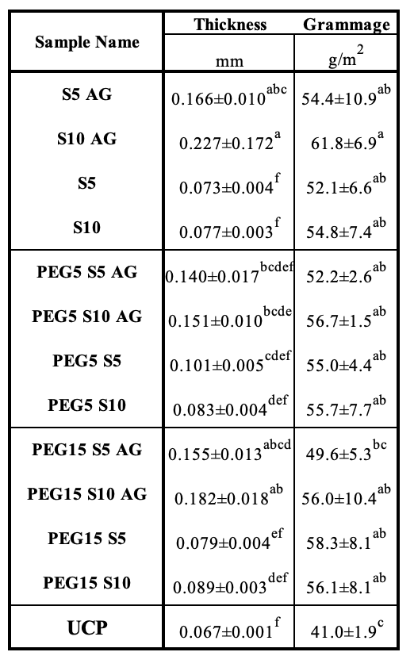
Table S2. Results of the Multifactorial ANOVA and Tukey's HD test regarding CA Oil. Results are reported as F-values and lowercase letters (“c” > “b” > “a”), respectively. Different letters identify significantly different samples.
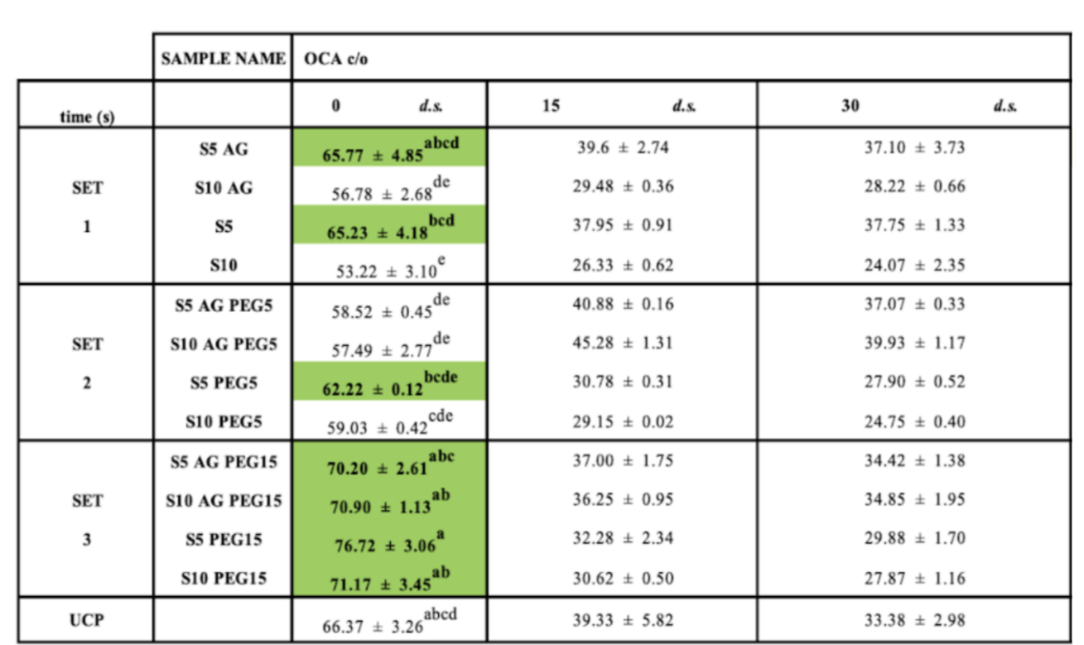

Table S3. Results of the Multifactorial ANOVA and Tukey's HD test regarding KIT12. Results are reported as F-values and lowercase letters (“c” > “b” > “a”), respectively. Different letters identify significantly different samples.
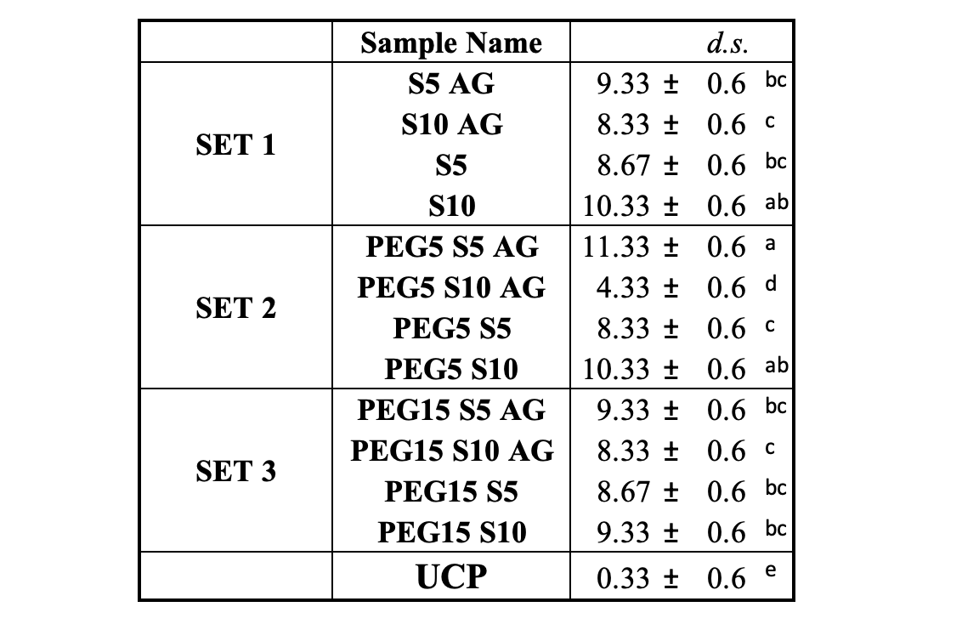
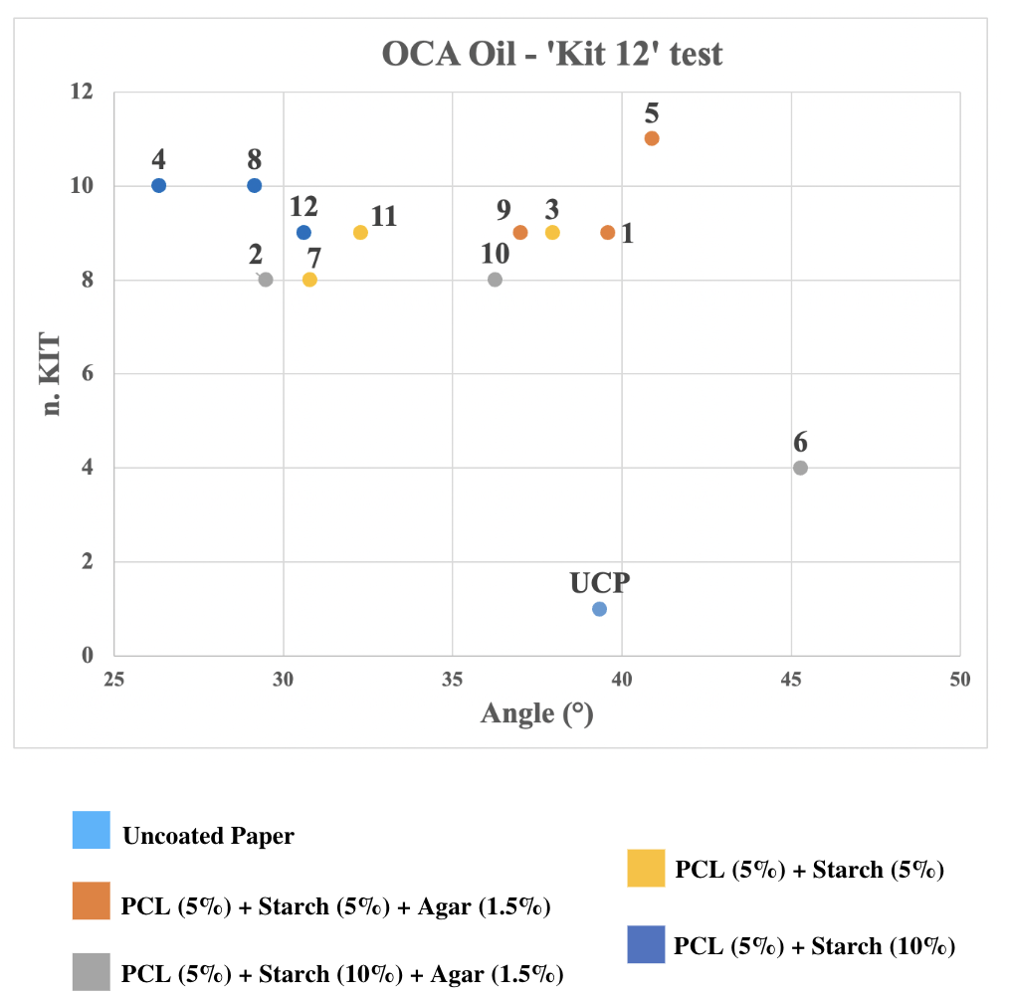
Figure S1. Numerical results of the KIT 12 test

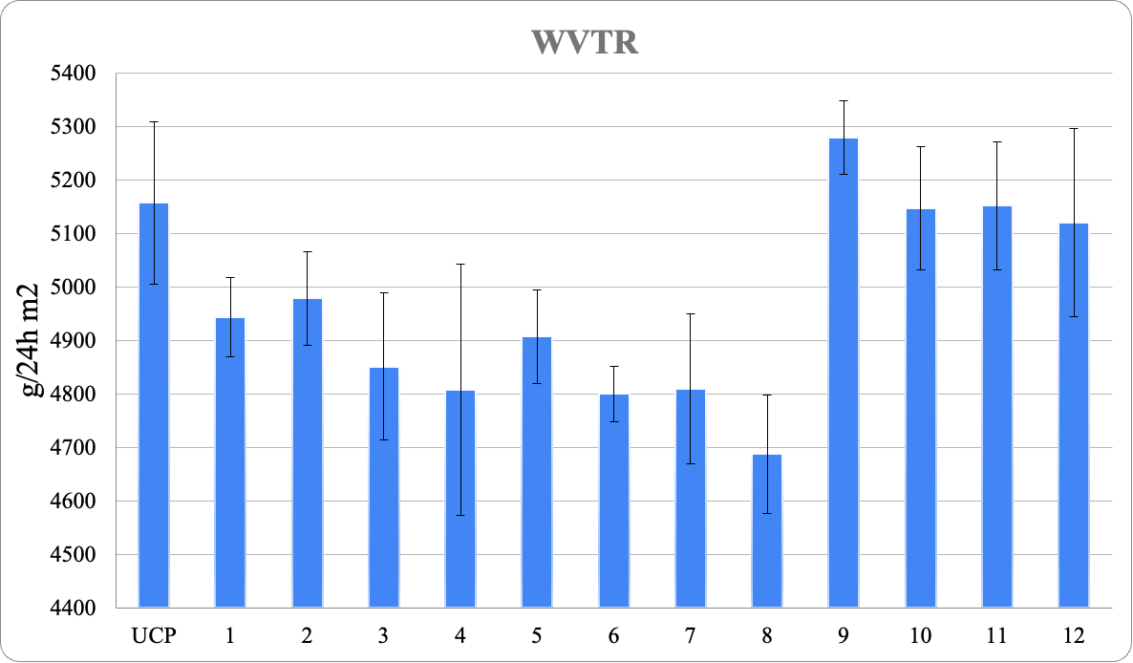
Figure S2. Numerical results of the WVTR

Table S4. Results of the Multifactorial ANOVA and Tukey's HD test regarding WVTR. Results are reported as F-values and lowercase letters (“c” > “b” > “a”), respectively. Different letters identify significantly different samples.
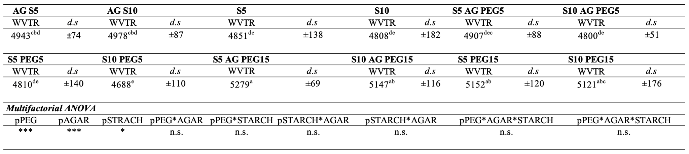

Table S5. Results of the Multifactorial ANOVA and Tukey's HD test regarding CA Water. Results are reported as F-values and lowercase letters (“c” > “b” > “a”), respectively. Different letters identify significantly different samples.
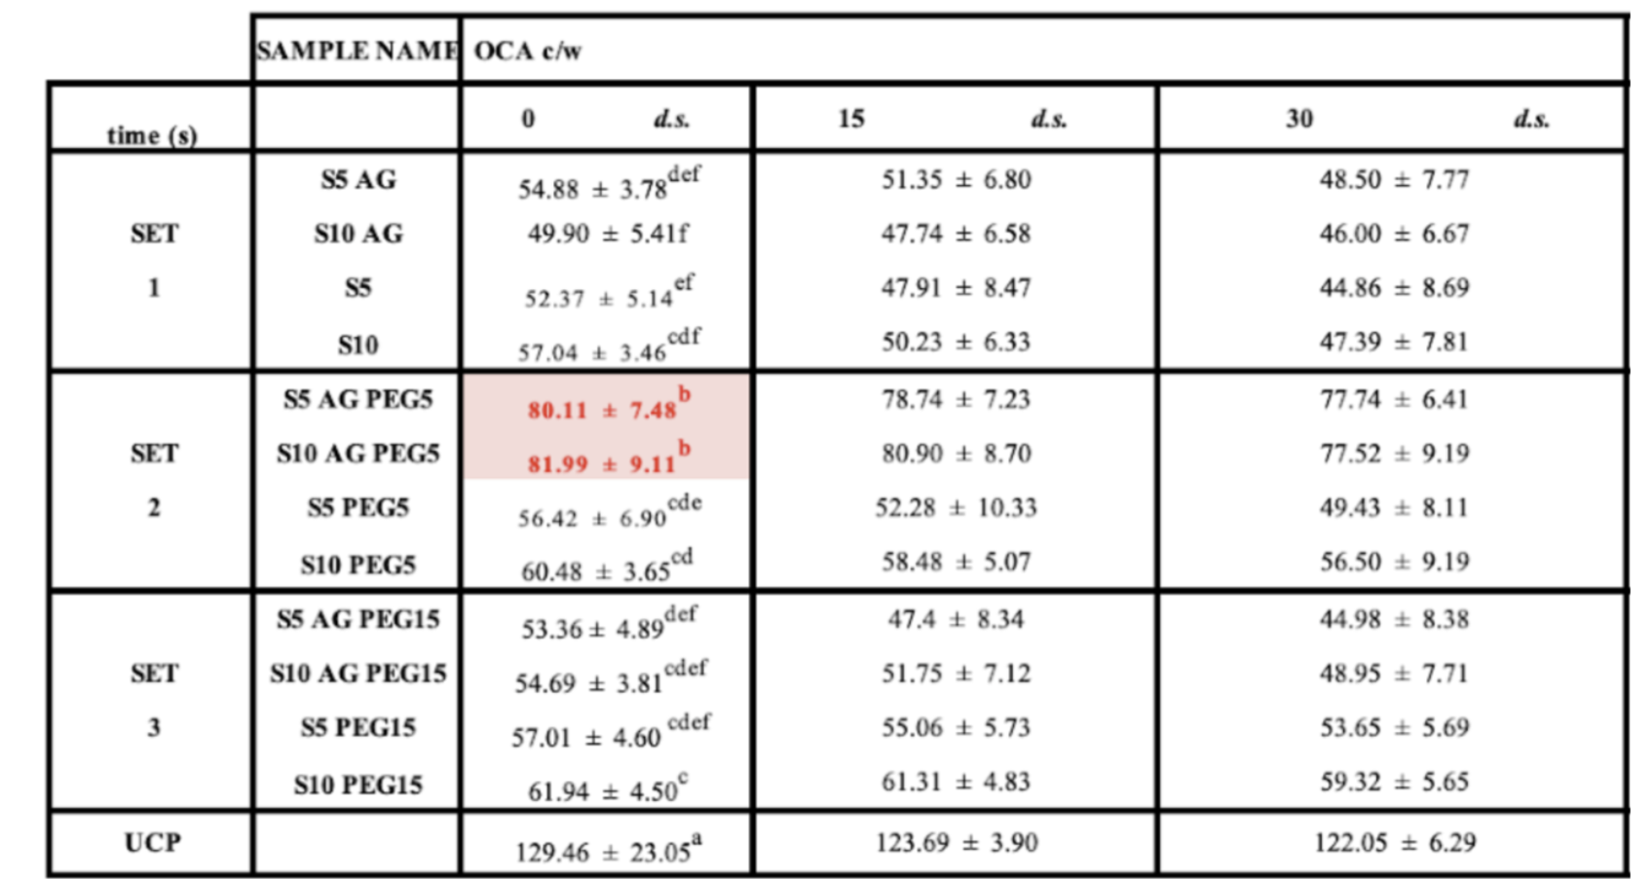

Table S6. Results of the Multifactorial ANOVA and Tukey's HD test regarding Mechanical properties. Results are reported as F-values and lowercase letters (“c” > “b” > “a”), respectively. Different letters identify significantly different samples.
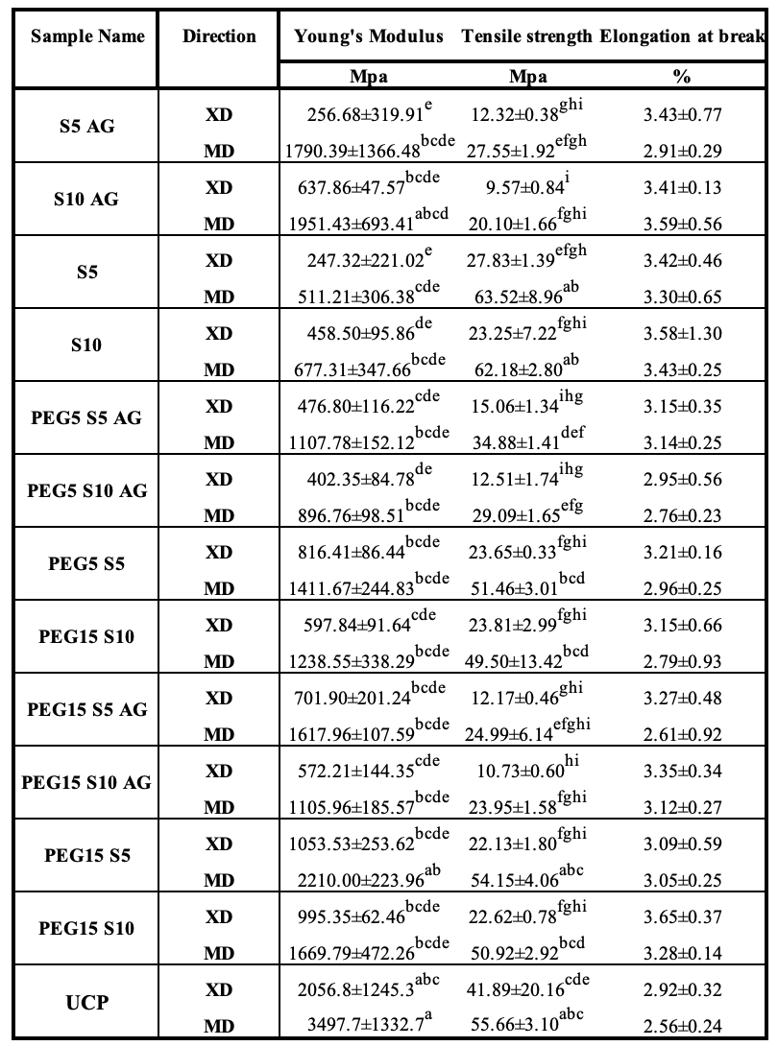

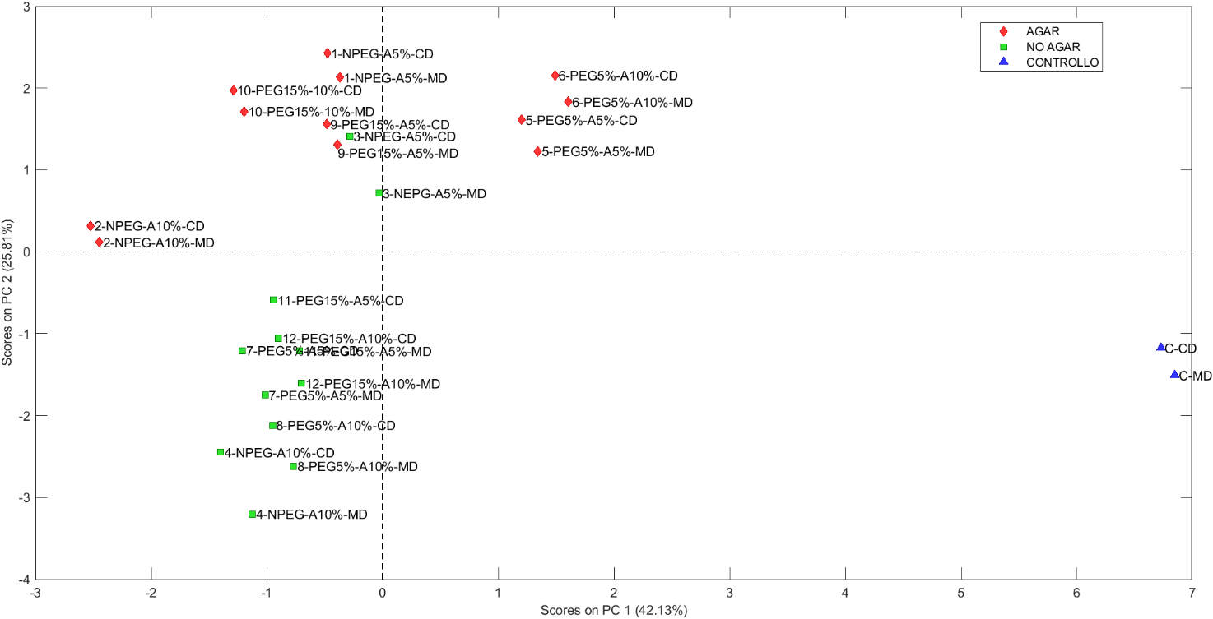
Figure S3. Scores of the PCA analysis

