Table S1. Analysed center of pressure (CoP) parameters
Parameter | Definition | Formula
Length of the CoP trajectory along the frontal axis | Length of the frontal component of the CoP signal | 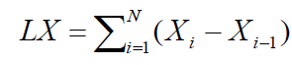
Length of the CoP trajectory along the sagittal axis | Length of the sagittal component of the CoP signal | 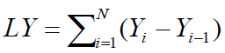
RMSD along the frontal axis | Root mean square deviation of the CoP position along the frontal axis | 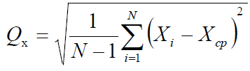
RMSD along the sagittal axis | Root mean square deviation of the CoP position along the sagittal axis | 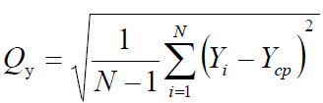
Confidence ellipse area | The main part of the area occupied by the CoP without so-called loops and accidental outliers | 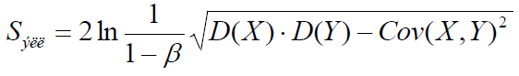
X_{i}. Y_{i} – CoP coordinates in time
N – number of counts
β –probability that the point of the statokinesiogram hits into the ellipse (β = 0.9).
D(X), D(Y) – corresponding component dispersion

Table S2. Length of the CoP trajectory along the frontal axis based on participant’s cognitive type and tES condition (mm).
participants | Control | left tES | midline tES | right tES
FD (N=16) | 155 [107; 196] | 165 [114; 195] | 164 [142; 205]# | 119 [96; 185]
FI (N=16) | 126 [85; 142] | 116 [98; 139] | 121 [87; 153] | 119 [100; 158]
All (N=32) | 135 [98; 166] | 129 [105; 186] | 146 [99; 182]* | 119 [97; 169]
*p < 0.05; #p=0.06 compared to control condition.

Table S3. Ellipse area based on participant’s cognitive type and tES condition (mm²)
participants | Control | left tES | midline tES | right tES
FD (N=16) | 151 [86; 231] | 153 [81; 367]* | 142 [113; 192]* | 122 [77; 169]
FI (N=16) | 56 [46; 102] | 73 [44; 101] | 66 [45; 98] | 76 [45; 92]
All (N=32) | 93 [50; 148] | 90 [65; 176]* | 101 [66; 174]* | 85 [67; 147]
*p < 0.05 compared to control condition.

Table S4. RMSD along the frontal axis based on participant’s cognitive type and tES condition (mm).
participants | Control | left tES | midline tES | right tES
FD (N=16) | 3.1 [2.0 ;3.7] | 3.2 [1.9; 4.8]* | 3.1 [2.5; 3.9] | 2.4 [2.2; 3.2]
FI (N=16) | 1.6 [1.6; 2.6] | 1.8 [1.5; 2.2] | 1.7 [1.4; 2.3] | 1.9 [1.4; 2.3]
All (N=32) | 2.2 [1.6; 3.2] | 2.1 [1.7; 3.5] | 2.4 [1,6; 3.6] | 2.2 [1.7; 3.0]
*p < 0.05 compared to control condition.

Table S5. RMSD along the sagittal axis based on participant’s cognitive type and tES condition (mm).
participants | control | left tES | midline tES | right tES
FD (N=16) | 3.1 [2.3; 4.0] | 3.4 [2.8 ;5.5] | 3.3 [3.1; 4.2]* | 3.2 [2.7; 4.0]
FI (N=16) | 2.4 [2.1; 2.7] | 2.9 [2.1; 3.3] | 2.8 [2.1; 3.3] | 2.6 [2.3; 3.0]
All (N=32) | 2.6 [2.1; 3.3] | 3.1 [2.5; 3.9] | 3.2 [2.5; 3.6]* | 2.8 [2.5; 3.6]
*p < 0.05 compared to control condition.

