Supporting Information
Industrial Scale Direct Liquefaction of Eucalyptus Biomass
Irina Fernandes², José Condeço², Duarte M. Cecilio ^{1,2}, Maria Joana Neiva Correia ², João Bordado^{2,3}, Margarida Mateus ^{1,2}*
¹ Secil S.A., Fábrica Secil – Outão, Setúbal, Portugal.
² CERENA, Centro de Recursos Naturais e Ambiente, Departamento de Engenharia Química, Instituto Superior Técnico, Universidade de Lisboa, Lisboa, Portugal* Correspondence: e-mail@e-mail.com; Tel.: (optional; include country code; if there are multiple corresponding a
600
1100
1600
2100
2600
3100
3600
Absorvância
Número de Onda (cm
-
1
)
Xylitol
Xylose
Trehalose
Sorbose
Ribose
Rhamnose
Mannose
HMF
Glucose
Galactose
Furfural
Fructose
Cellobiose
Arabinose
Acid
Succinic
Acid
Lactic
Acid
Levullinic
S1: FTIR Spectrum of Sugars Standards.

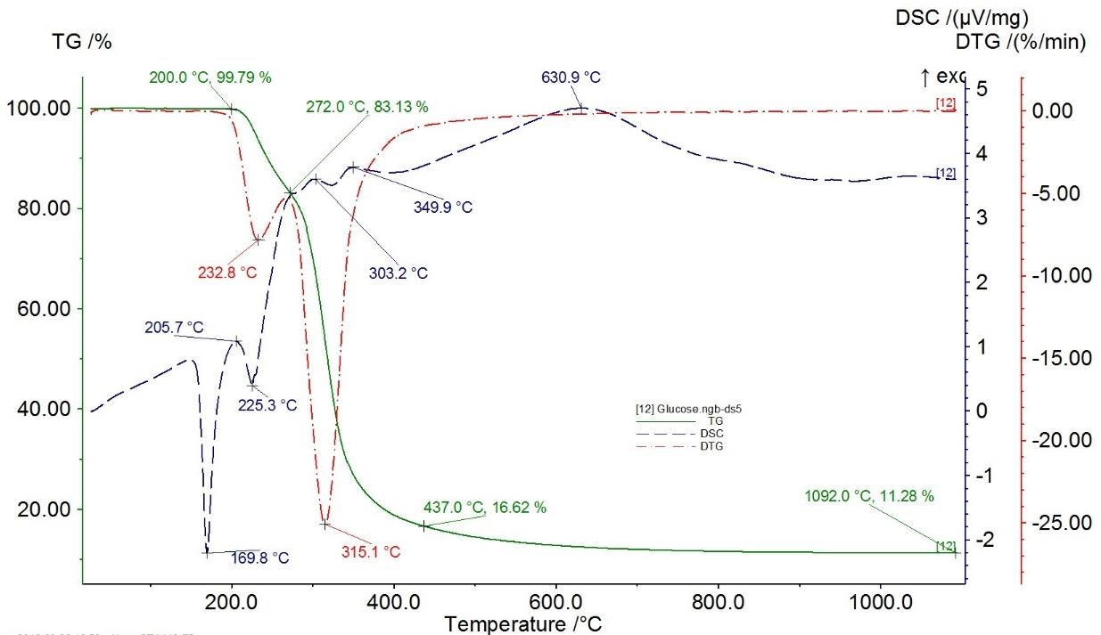
S2: TG/DTG/DSC of glucose.
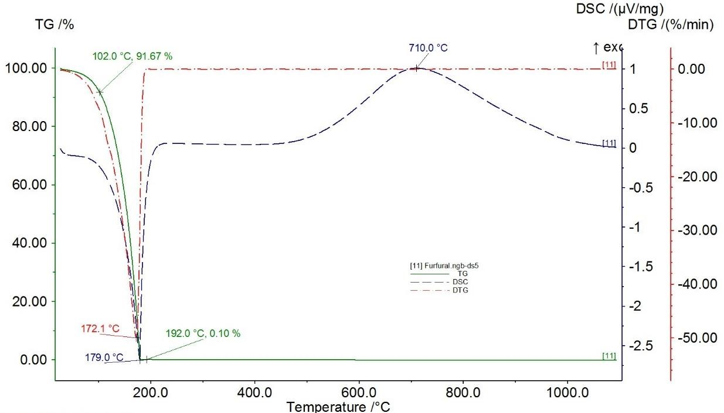
S3: Curva de TG/DTG/DSC of furfural.

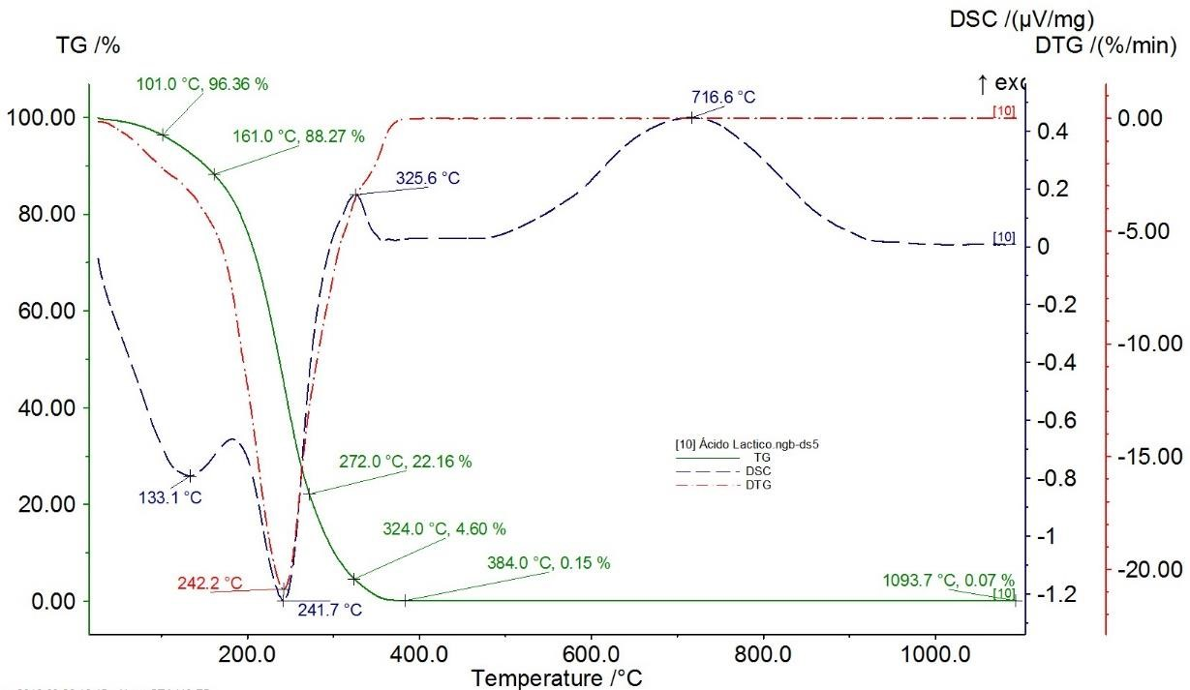
S4: TG/DTG/DSC of lactic acid.

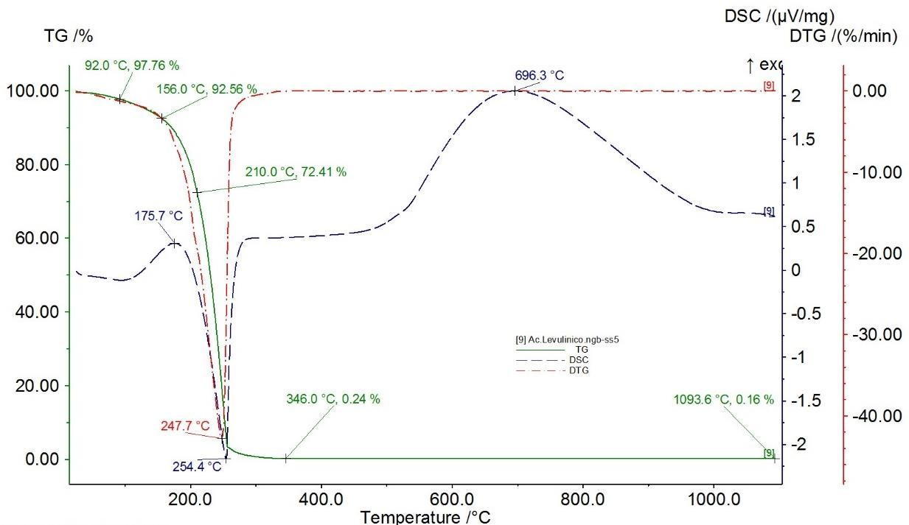
S5: TG/DTG/DSC of Levullinic acid.

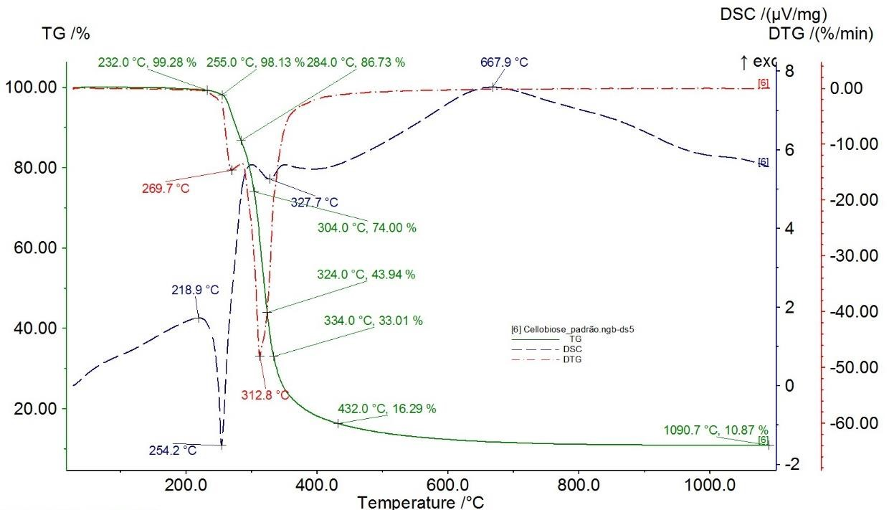

S6: TG/DTG/DSC of cellobiose.

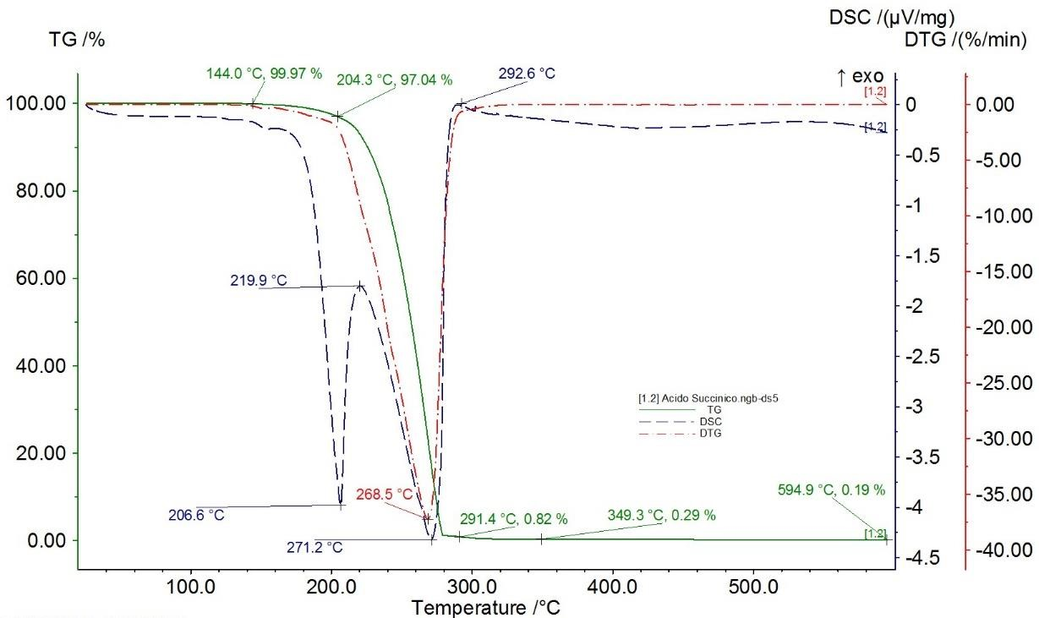
S7: TG/DTG/DSC of Succinic Acid.

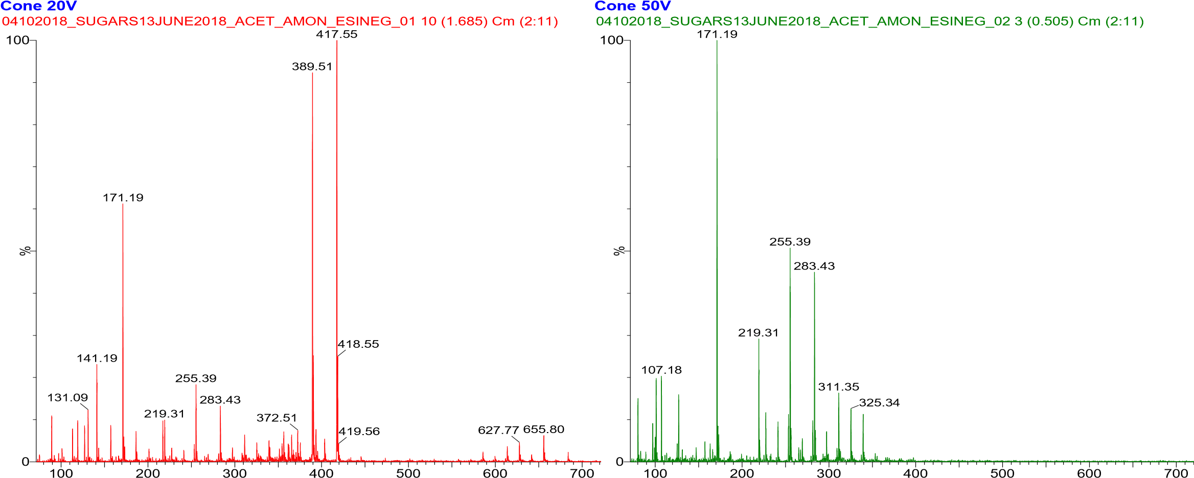

S8: Mass spectrum of the sugar solution from the third reaction by direct infusion: cone 20V (left) and 50V (right).
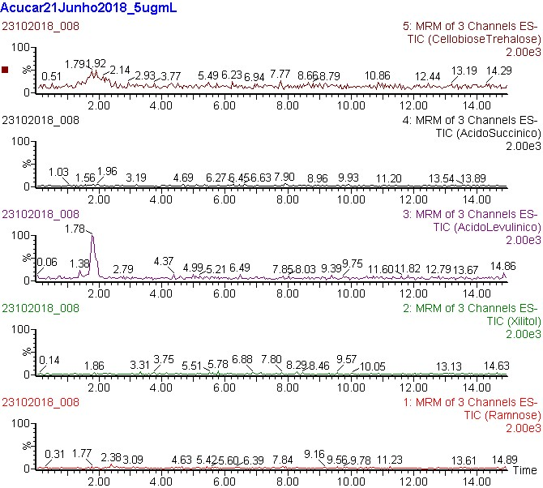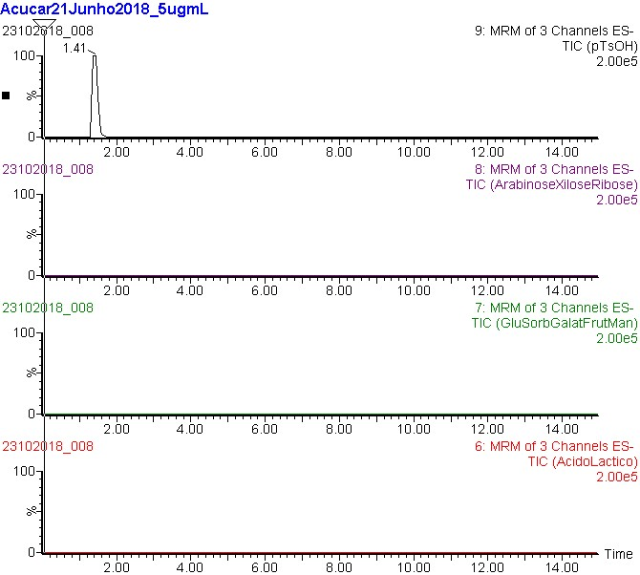

S9: HPLC Chromatogram for all standards sugars (TIC - Total Ion Count).

