Supporting Information
Impact of Polylactic Acid Microplastics on Performance and Microbial Dynamics in Activated Sludge System
Mengbo Huang^{1,2,3}, Dongqi Wang^{1,2,3,*}, Shengwei Zhang³, Yuzhu Weng^{3,4,} Kailong Li³,Renjie Huang³, Yuan Guo³, Chunbo Jiang^{2,3}, Zhe Wang^{2,3}, Hui Wang³, Haiyu Meng³, Yishan Lin⁵, Mingliang Fang^{6,*}, Jiake Li^{1,2,3}
¹ National Demonstration Center for Experimental Water Resources and Hydro-electric Engineering Education, Xi’an University of Technology, Xi'an, Shaanxi 710048, China
² State Key Laboratory of Eco-hydraulics in Northwest Arid Region, Xi’an University of Technology, Xi'an, Shaanxi 710048, China
³ Department of Municipal and Environmental Engineering, Xi’an University of Technology, Xi'an, Shaanxi 710048, China; 2210421298@stu.xaut.edu.cn (M.H.); 2190421301@stu.xaut.edu.cn (S.Z.); wengyuzhu@hhu.edu.cn (Y.W.); 2200421171@stu.xaut.edu.cn (K.L.); 3210673022@stu.xaut.edu.cn (R.H.); hmeng@xaut.edu.cn (H.M.); wangzhewater@xaut.edu.cn (Z.W.); wanghui306@xaut.edu.cn(H.W.); chunbo@xaut.edu.cn (C.J.); guoyuan@xaut.edu.cn (Y.G.); sys@xaut.edu.cn (J.L.)
⁴ College of Environment, Hohai University, Nanjing, Jiangsu 210098 China
⁵ Shaanxi Key Laboratory of Earth Surface System and Environmental Carrying Capacity, College of Urban and Environmental Sciences, Northwest University, Xi'an, Shaanxi 710127, China; yshanlisa@hotmail.com (Y.L.)
⁶ Department of Environmental Science and Engineering, Fudan University, 220 Handan Rd., Shanghai 200433, China; mlfang@ntu.edu.sg (M.F.)
* Correspondence: wangdq@xaut.edu.cn (D.W.); mlfang@fudan.edu.cn (M.F.)

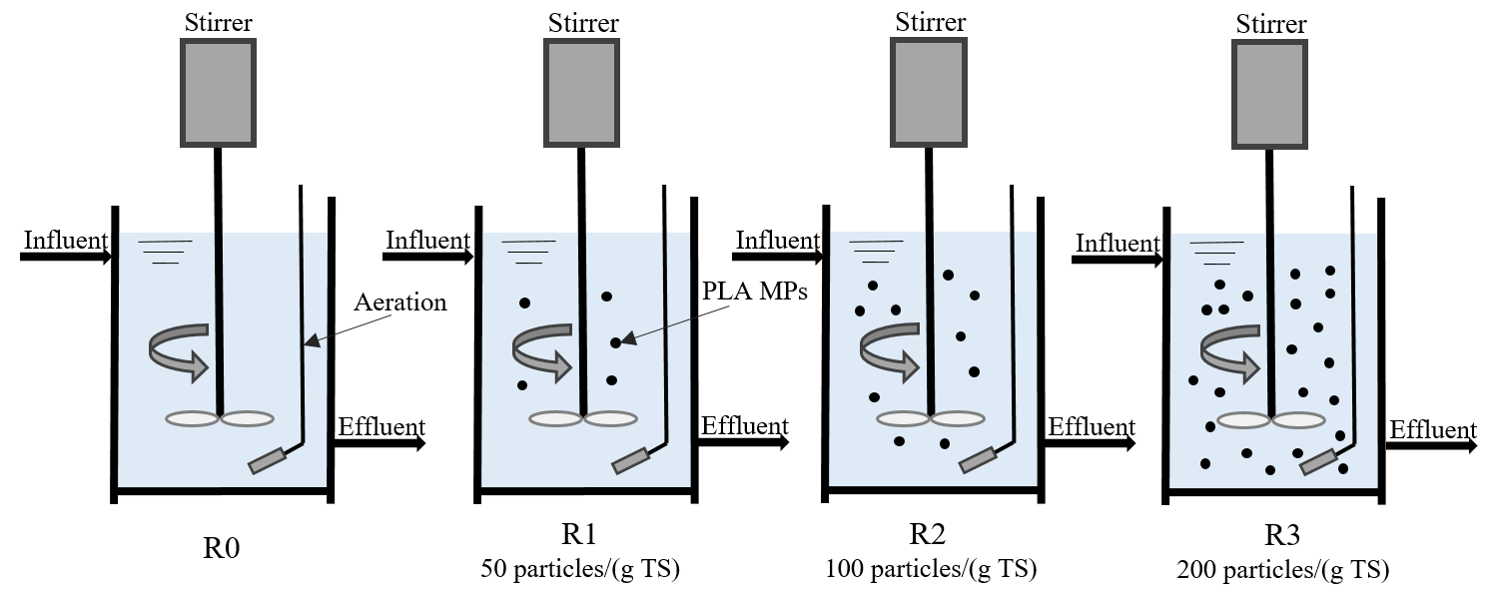
Figure S1 SBRs used in this study.

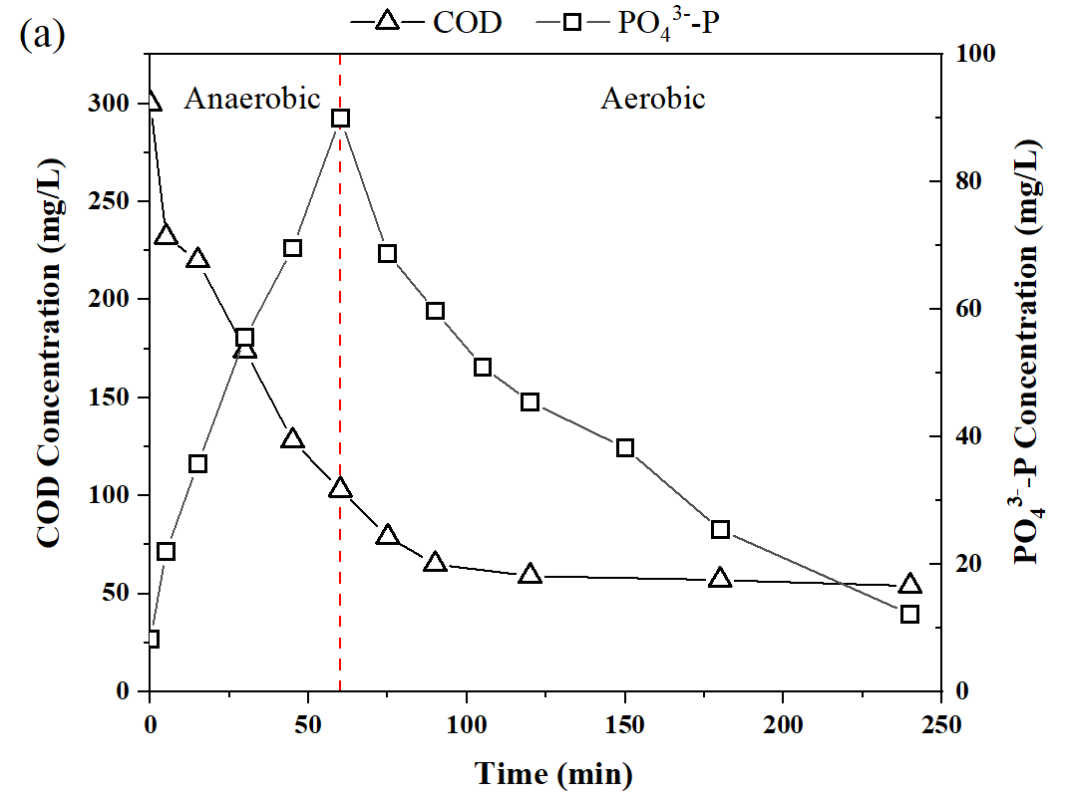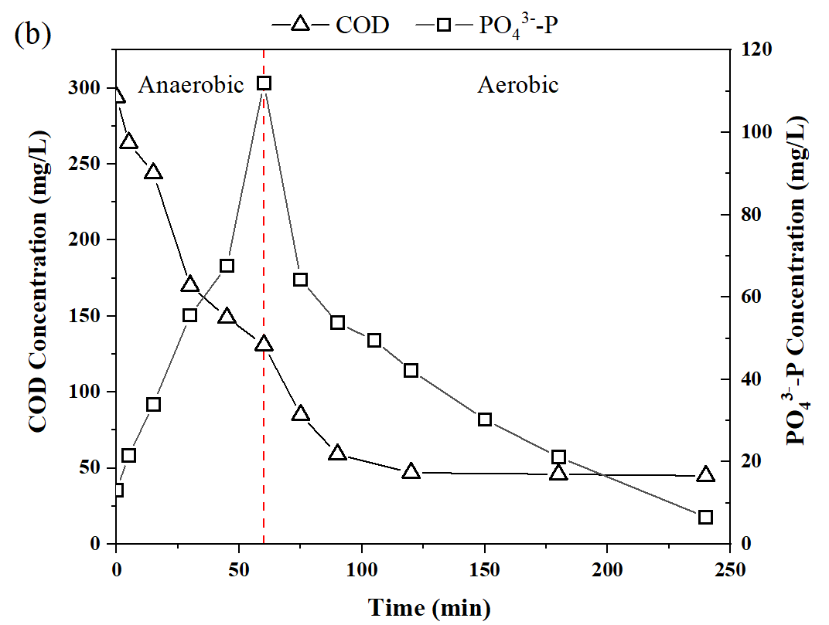
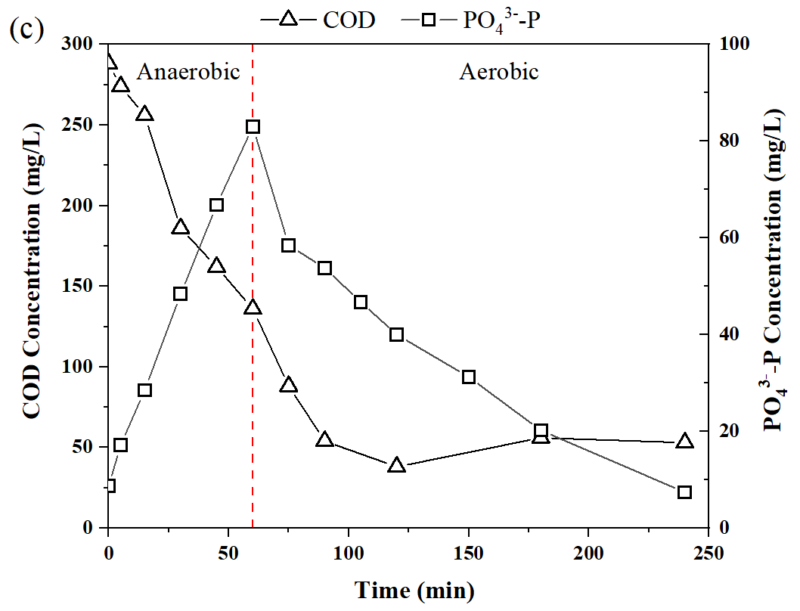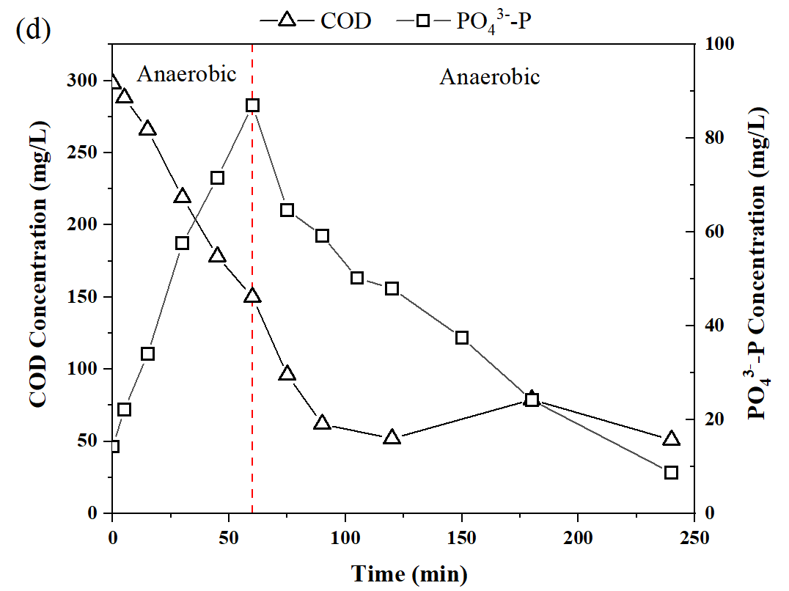
Figure S2 Profiles of PO₄³⁻-P and COD during EBPR activity batch tests with the sludge collected from (a) R0, (b) R1, (c) R2, and (d) R3.

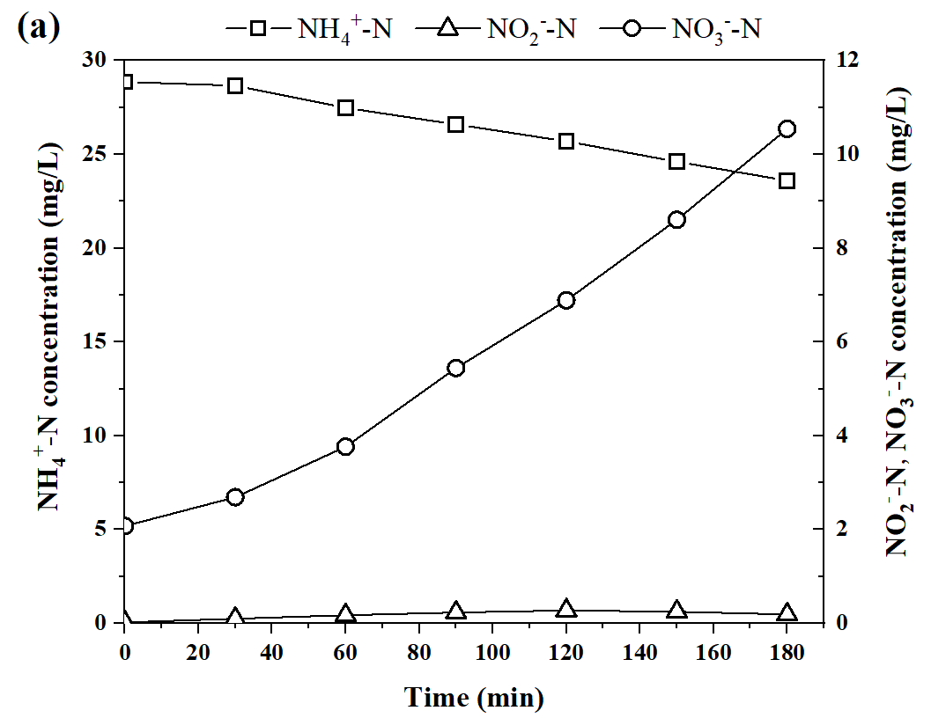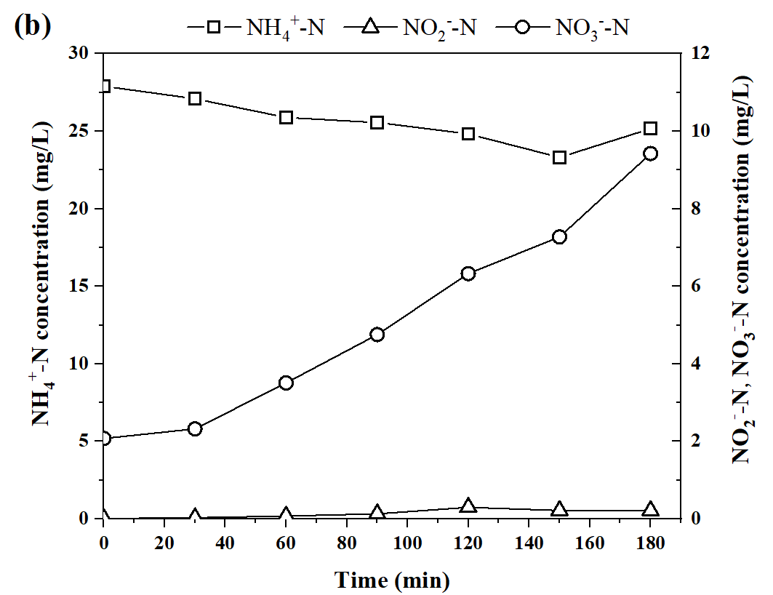
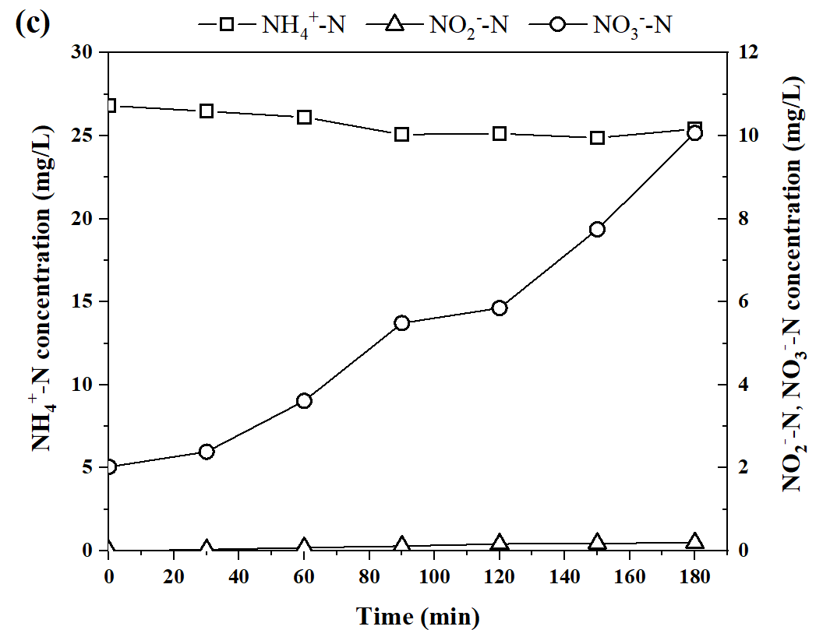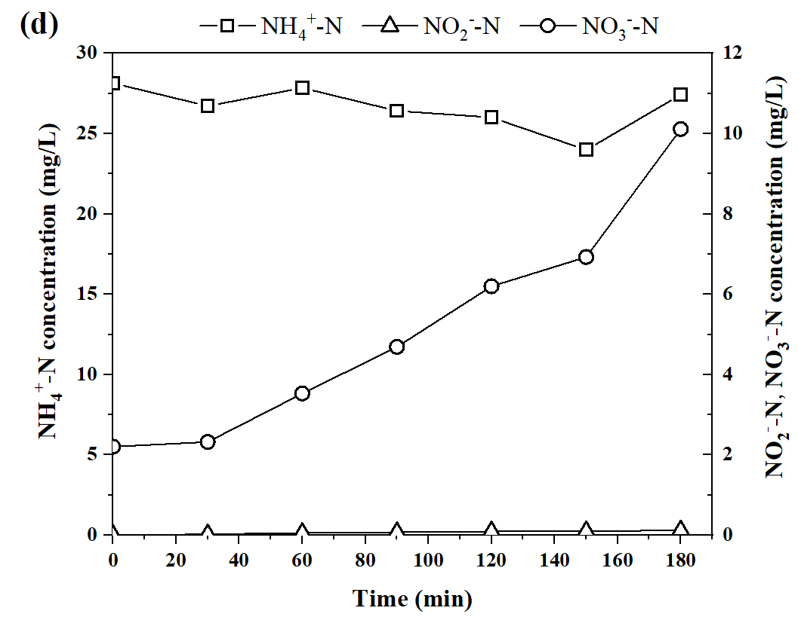
Figure S3 Profiles of NH₄⁺-N, NO₂⁻-N and NO₃⁻-N during nitrification activity batch tests with the sludge collected from (a) R0, (b) R1, (c) R2, and (d) R3.

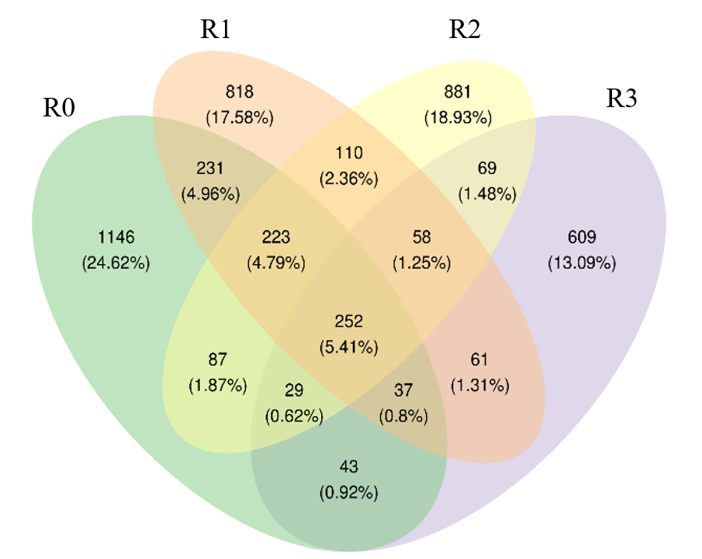
Figure S4 Common and unique ASVs in different samples.

Table S1 Composition and concentration of trace elements in synthetic wastewater.
Composition | Concentration (mg/L)
Yeast extract | 8
MgCl₂·6H₂O | 219
MgSO₄·7H₂O | 14
KCl | 98
CaCl₂ | 46
H₃BO₃ | 0.061
Na₂MoO₄·2H₂O | 0.031
KI | 0.015
CuSO₄·5H₂O | 0.061
Co(NO₃)₂·6H₂O | 0.075
ZnSO₄·7H₂O | 0.3
MnSO₄·H₂O | 0.34
FeSO₄·7H₂O | 0.3

Table S2 Alpha diversity indices.
Sample | ASVs | Observed species | Good's coverage | Shannon | Gini-Simpson | Chao1
R0 | 1158 | 1155 | 0.997 | 3.908 | 0.860 | 1259
R1 | 1709 | 1715 | 0.995 | 5.275 | 0.858 | 1868
R2 | 1790 | 1779 | 0.995 | 5.914 | 0.935 | 1949
R3 | 2048 | 2053 | 0.997 | 6.648 | 0.961 | 2097

