Article

Assessment of Narrow Band Imaging Algorithm for Video Capsule Endoscopy Based on Decorrelated Color Space for Esophageal Images: Supplement Material

Arvind Mukundan 1, Riya Karmakar 1, Yu-Ming Tsao 1, and Hsiang-Chen Wang 1, *

|  |
| --- |
| **Citation:** To be added by editorial staff during production.  Received: date  Revised: date  Accepted: date  Published: date    **Copyright:** © 2023 by the authors. Submitted for possible open access publication under the terms and conditions of the Creative Commons Attribution (CC BY) license (https://creativecommons.org/licenses/by/4.0/). |

1 Department of Mechanical Engineering, Advanced Institute of Manufacturing with High Tech Innovations (AIM-HI) and Center for Innovative Research on Aging Society (CIRAS), National Chung Cheng University, 168, University Rd., Min Hsiung, Chia Yi 62102, Taiwan; [d09420003@ccu.edu.tw](mailto:d09420003@ccu.edu.tw) (A.M), [d09420002@ccu.edu.tw](mailto:d09420002@ccu.edu.tw) (Y.-M.T.).

2

**\*** Correspondence: [hcwang@ccu.edu.tw](mailto:hcwang@ccu.edu.tw) (H.-C. W)

**Abstract:** This paper includes the supplementary materials to the article “Assessment of Narrow Band Imaging Algorithm for Video Capsule Endoscopy Based on Decorrelated Color Space for Esophageal Images”. Section 1 describes the equation used for image comparison, including structural similarity index measure (SSIM), entropy, and PSRN. Section 2 provides the results of the three comparison parameters in 20 randomly chosen images. The last section shows few image examples of NBI conversion algorithm.

**Keywords:** Narrow Band Imaging, Hyperspectral Imaging, Decorrelated Color Space, Video Capsule Endoscopy, Peak Signal to Noise Ration, Structural Similarity Index Metric, Entropy

1. Equations for Image Comparisons

The entropy of an image is defined as follows:

[entropy](https://i.stack.imgur.com/EkmZI.gif),

where *n* is the number of gray levels (256 for 8-bit images), *pi* is the probability of a pixel having gray level *i*, and *b* is the base of the logarithm function. The entropy of an image is rather different from the entropy feature extracted from the gray-level co-occurrence matrix of an image.

Structural similarity index measure (SSIM) is a method for predicting the perceived quality of digital television and cinematic pictures, as well as other kinds of digital images and videos. It is used for measuring the similarity between two images. It can be represented by the following equation:

,

where µx is the pixel sample mean of x, µy is the pixel sample mean of y, C1 and C2 are variables to stabilize the division with weak denominator, K1 = 0.01 and K2 = 0.03, σxy refers to the covariance of x and y, L denotes the dynamic range of pixel values $, σ_{x}^{2}$ is the covariance of x, and $σ_{y}^{2}$ is the covariance of y.

PSNR is most easily defined via the [mean squared error](https://en.wikipedia.org/wiki/Mean_squared_error) (*MSE*). Given a noise-free *m*×*n* monochrome image *I* and its noisy approximation *K*, *MSE* is defined as follows:  


PSNR (in [dB](https://en.wikipedia.org/wiki/Decibel)) is defined as follows:

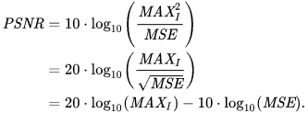

Here, *MAXI* is the maximum possible pixel value of the image. When the pixels are represented using 8 bits per sample, the *MAXI* is 255. In general, when samples are represented using linear [PCM](https://en.wikipedia.org/wiki/Pulse-code_modulation) with *B* bits per sample, the *MAXI* is 2*B* − 1.

1. Results of Image Comparison

Table S1. Results of PSNR comparison of each image in Olympus and VCE



Table S2. Results of Entropy comparison of each image in Olympus and VCE



Table S3. Results of SSIM comparison of each image in Olympus and VCE



S3. Image examples of NBI conversion algorithm

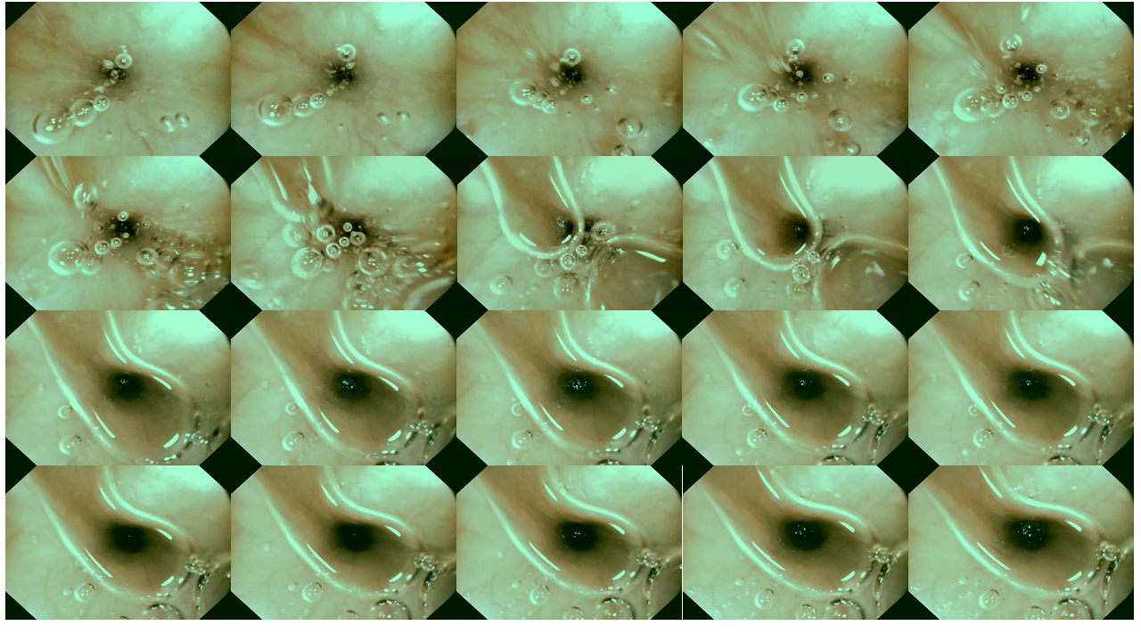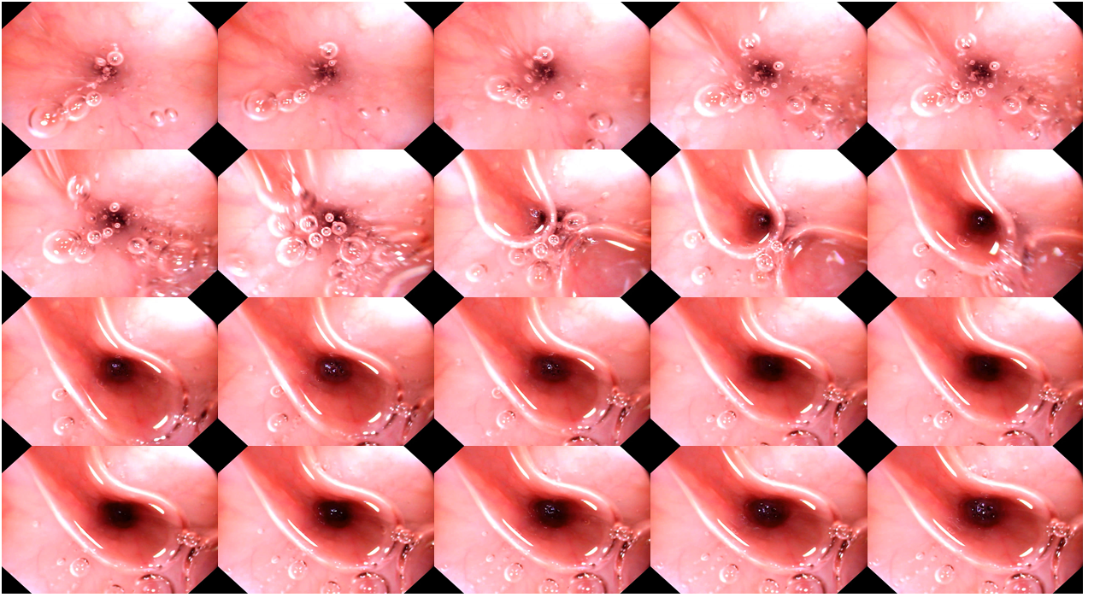Figure S1. 20 Randomly chosen images of WLI in VCE

Figure S2. Twenty randomly chosen images of NBI in VCE

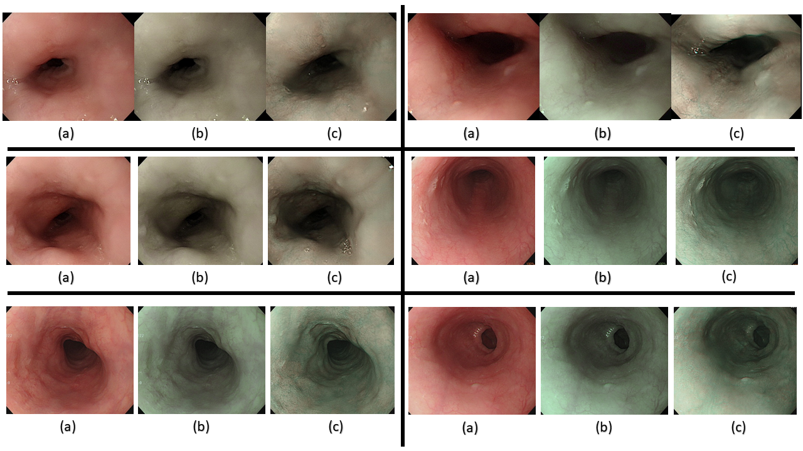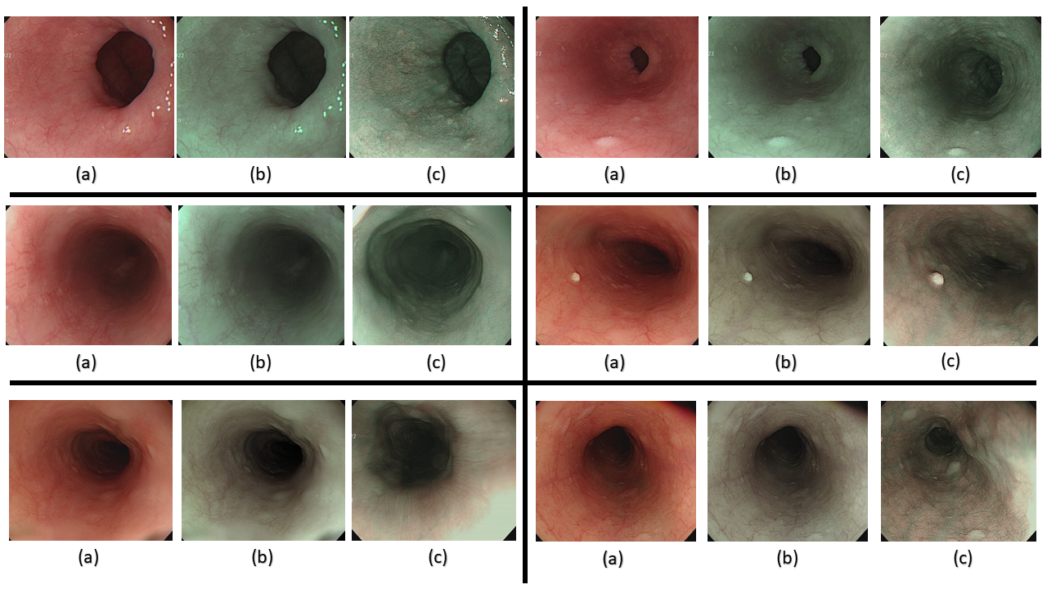Figure S3. Six randomly chosen (a) WLI images, simulated NBI images, and a similar original NBI from Olympus endoscope

Figure S4. Six randomly chosen (a) WLI images, (b) simulated NBI images, and (c) similar original NBI images from Olympus endoscope

**Author Contributions:** Conceptualization, K.-Y.Y, H.-C.W and A.M.; data curation, K.-Y.Y, Y.-M.T and A.M.; formal analysis, K.-Y.Y, R.K and A.M.; funding acquisition, C.-W.H, Y.-J.F and H.-C.W.; investigation, R.K, Y.-M.T and A.M.; methodology, Y.-J.F, H.-C.W and A.M.; project administration, Y.-M.T, A.M. and H.-C.W.; resources, C.-W.H, H.-C.W and A.M.; software, Y.-M.T and A.M.; supervision, C.-W.H, Y.-M.T and H.-C.W.; validation, Y.-J.F, Y.-M.T and A.M.; writing—original draft, R.K and A.M.; writing—review and editing, R.K, A.M. and H.-C.W. All authors have read and agreed to the published version of the manuscript.

**Funding:** This research was supported by the National Science and Technology Council, The Republic of China, under the grants NSTC 111-2221-E-194-007. This work was financially/partially supported by the Advanced Institute of Manufacturing with High-tech Innovations (AIM-HI) and the Center for Innovative Research on Aging Society (CIRAS) from The Featured Areas Research Center Program within the framework of the Higher Education Sprout Project by the Ministry of Education (MOE) in Taiwan.

**Institutional Review Board Statement:** The study was conducted in accordance with the Declaration of Helsinki and approved by the Institutional Review Board.

**Informed Consent Statement:** Not applicable.

**Data Availability Statement:** Not Applicable.

**Conflicts of Interest:** The authors declare no conflict of interest.

**Disclaimer/Publisher’s Note:** The statements, opinions and data contained in all publications are solely those of the individual author(s) and contributor(s) and not of MDPI and/or the editor(s). MDPI and/or the editor(s) disclaim responsibility for any injury to people or property resulting from any ideas, methods, instructions or products referred to in the content.