Supplementary information

Table S1. BET surface area of RH-BC and WD-BC

|  |  |
| --- | --- |
| Biochar | BET surface area (m2/g) |
| WD-BC | 211.14 |
| RH-BC | 205.60 |

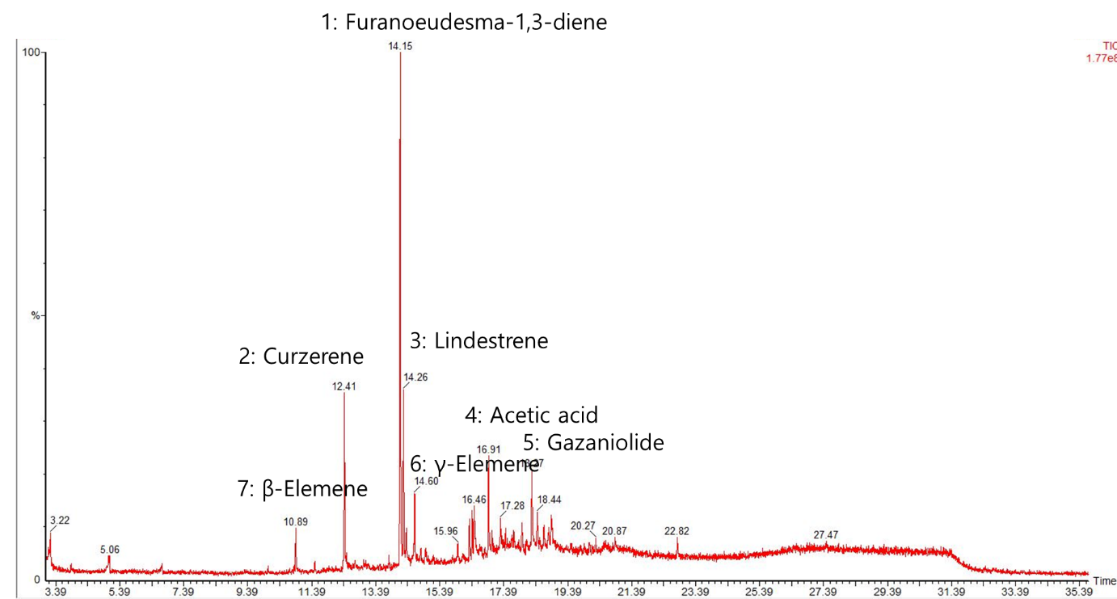

Fig. S1. GC-MS spectra of myrrh resin extracts for terpenes analysis.



Fig. S2. FTIR spectra of RH-BC and WD-BC before myrrh resin extracts adsorption.