Supplementary Figure

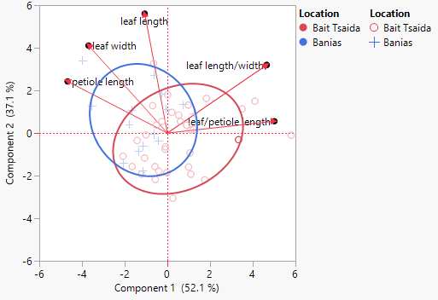

Supplementary Figure 1: PCA (Principal component analysis) biplot analysis performed on 46 Sylvestris accessions, using the leaves and petioles measured data. Red marks Bait Tsaida's accessions, and blue marks Bania's accessions. Ellipses density distribution is 0.8.

