**Figure S1**

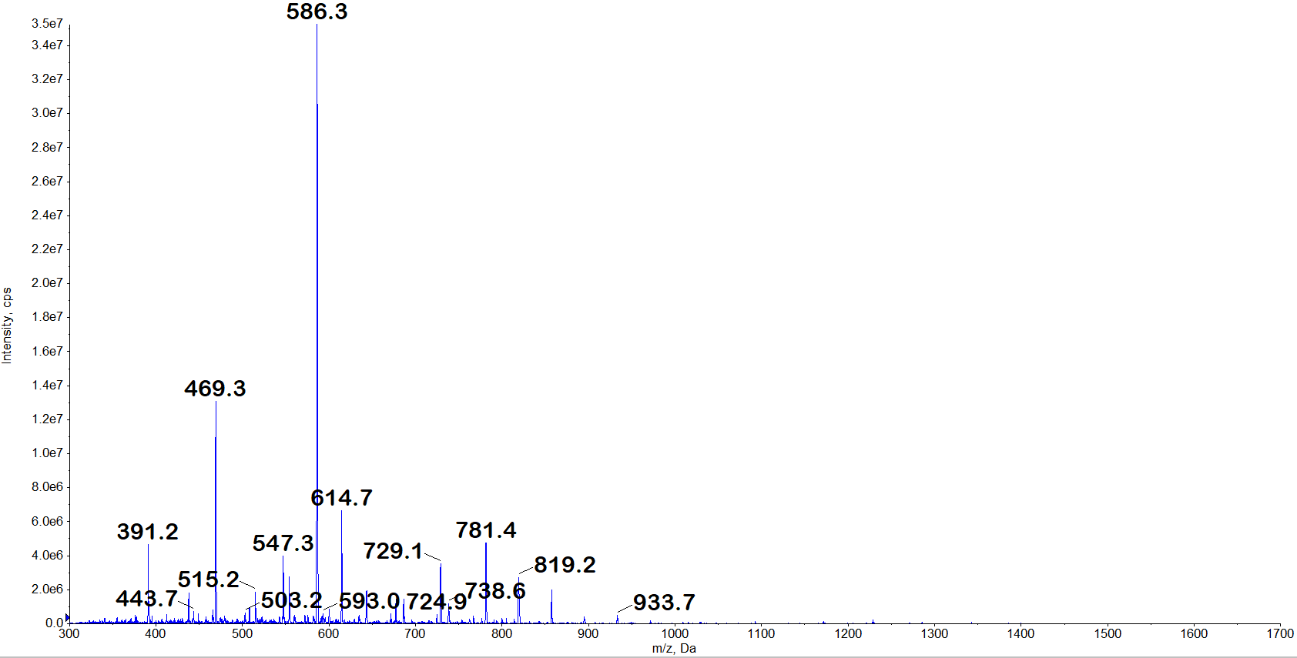

○

M

a

s

s

r

a

n

g

e

:

3

0

0

-

1

7

0

0

m

/

z

○

M

o

d

e

:

p

o

s

i

t

i

v

e

○

S

a

m

p

l

e

P

r

e

p

a

r

a

t

i

o

n

:

**B**

**M**

**A**

**P**

**-**

**1**

**8**

**p**

**e**

**p**

**t**

**i**

**d**

**e**

w

a

s

d

i

s

s

o

l

v

e

d

i

n

5

0

0

?

L

o

f

3

0

%

A

C

N

(

0

.

0

5

%

T

F

A

)

**[**

**M**

**W**

**]**

**[**

**M**

**+**

**H**

**]**

**+**

**=**

**2**

**3**

**4**

**2**

**.**

**9**

**2**

**[**

**M**

**+**

**2**

**H**

**]**

**2**

**+**

**=**

**1**

**1**

**7**

**1**

**.**

**9**

**6**

**[**

**M**

**+**

**3**

**H**

**]**

**3**

**+**

**=**

**7**

**8**

**1**

**.**

**6**

**5**

**[**

**M**

**+**

**4**

**H**

**]**

**4**

**+**

**=**

**5**

**8**

**6**

**.**

**4**

**5**

**[**

**M**

**+**

**5**

**H**

**]**

**5**

**+**

**=**

**4**

**6**

**9**

**.**

**3**

**8**

**[**

**B**

**M**

**A**

**P**

**-**

**1**

**8**

**]**

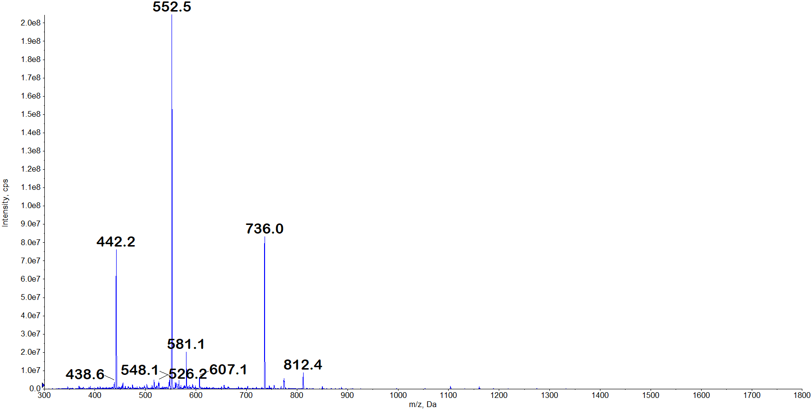

**[**

**M**

**W**

**]**

**[**

**M**

**+**

**H**

**]**

**+**

**=**

**2**

**2**

**0**

**6**

**.**

**8**

**5**

**[**

**M**

**+**

**2**

**H**

**]**

**2**

**+**

**=**

**1**

**1**

**0**

**3**

**.**

**9**

**3**

**[**

**M**

**+**

**3**

**H**

**]**

**3**

**+**

**=**

**7**

**3**

**6**

**.**

**2**

**8**

**[**

**M**

**+**

**4**

**H**

**]**

**4**

**+**

**=**

**5**

**5**

**2**

**.**

**4**

**[**

**M**

**+**

**5**

**H**

**]**

**5**

**+**

**=**

**4**

**4**

**2**

**.**

**1**

**7**

**[**

**B**

**M**

**A**

**P**

**-**

**1**

**8**

**-**

**F**

**L**

**]**

○

M

a

s

s

r

a

n

g

e

:

3

0

0

-

1

8

0

0

m

/

z

○

M

o

d

e

:

p

o

s

i

t

i

v

e

○

S

a

m

p

l

e

P

r

e

p

a

r

a

t

i

o

n

:

**B**

**M**

**A**

**P**

**-**

**1**

**8**

**-**

**F**

**L**

**p**

**e**

**p**

**t**

**i**

**d**

**e**

w

a

s

d

i

s

s

o

l

v

e

d

i

n

5

0

0

?

L

o

f

3

0

%

A

C

N

(

0

.

0

5

%

T

F

A

)

Figure S1. ESI-MS spectra of peptides. The molecular masses of BMAP-18 and BMAP-18-FL were analyzed using Electrospray Ionization-Mass Spectrometry (ESI-MS).

**Figure S2.**



Figure S2. SYTOX green uptake caused by peptides. The SYTOX Green uptake assay was conducted on *S. aureus* with peptides administered at 1 MIC. SYTOX Green, a fluorescent nucleic acid stain, enters the bacterial cells through compromised membranes, leading to a detctable fluorescence signal. Mellitin and buforin-2 were used as positive and negative controls, respectively. In comparison to melittin, both BMAP-18 and BMAP-18-FL showed no significant induction of SYTOX Green entry.