Type of the Paper (Article, Review, Communication, etc.)
SUPPLEMENTARY MATERIALS: ASSESSING THE POLARISATION OF CLIMATE PHENOMENA BASED ON LONG-TERM PRECIPITATION AND TEMPERATURE SEQUENCES

Bernard Twaróg
Cracow University of Technology; btwarog@pk.edu.pl

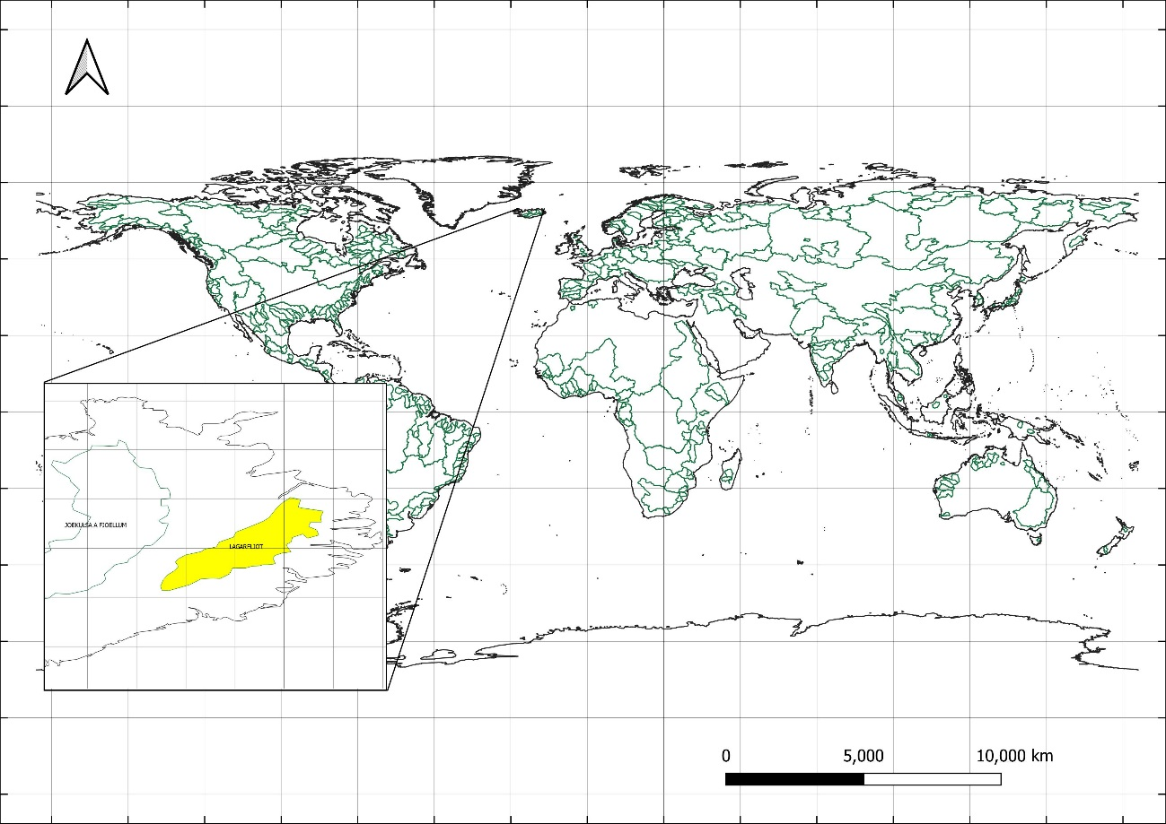
Figure 1. The location of the LAGARFLJOD basin in Iceland in which the trends of the P2 polarisation measure, the point of trend change and the new trend post are confirmed. A grid with a spatial resolution of 0.5°x 0.5° longitude and latitude is marked.

Table 1. Characteristics calculated based on monthly precipitation sums in analyzed watersheds in terms of precipitation polarisation.
 |  |  |  |  |  |  | Statistics: minimum value, maximum value, standard deviation
No | GRDC code | WMO - Region code | RIVER name | Continent | Country | Catchment area | MIN | MAX | MEAN | STD
 |  |  |  |  |  | [km²] | [mm]
1 | 1104150 | 1 | CHELIF | Africa | ALGERIA | 43750 | 0.2 | 209.6 | 33.7 | 30.54
2 | 1147010 | 1 | CONGO | Africa | CONGO, THE DE | 3475000 | 45.2 | 227.2 | 125.2 | 36.04
3 | 1159100 | 1 | ORANGE | Africa | SOUTH AFRICA | 850530 | 0.2 | 166.1 | 30.0 | 27.57
4 | 1160580 | 1 | GROOT-VIS | Africa | SOUTH AFRICA | 29745 | 0.5 | 226.6 | 37.8 | 30.28
5 | 1160880 | 1 | TUGELA | Africa | SOUTH AFRICA | 28920 | 0.2 | 351.2 | 71.9 | 60.10
6 | 1286900 | 1 | RUFIJI | Africa | TANZANIA, UNI | 158200 | 0.1 | 380.9 | 80.9 | 84.20
7 | 1289200 | 1 | PANGANI | Africa | TANZANIA, UNI | 25110 | 1.2 | 436.6 | 72.6 | 69.59
8 | 1289450 | 1 | RUVU | Africa | TANZANIA, UNI | 15190 | 0.0 | 695.0 | 94.4 | 83.42
9 | 1309700 | 1 | SEBOU | Africa | MOROCCO | 17250 | 0.1 | 287.0 | 52.4 | 51.53
10 | 1336500 | 1 | CROSS | Africa | CAMEROON | 6810 | 0.0 | 1085.2 | 216.5 | 164.78
11 | 1338050 | 1 | SANAGA | Africa | CAMEROON | 131520 | 0.0 | 478.2 | 141.5 | 101.62
12 | 1339100 | 1 | NYONG | Africa | CAMEROON | 26400 | 0.0 | 1064.1 | 145.4 | 100.71
13 | 1340500 | 1 | NTEM | Africa | CAMEROON | 18100 | 0.0 | 1067.8 | 135.0 | 95.45
14 | 1362100 | 1 | NILE | Africa | EGYPT | 2900000 | 3.3 | 167.5 | 54.2 | 38.6
15 | 1389090 | 1 | MANGOKY | Africa | MADAGASCAR | 53225 | 0.0 | 562.4 | 74.4 | 92.63
16 | 1389230 | 1 | TSIRIBIHINA | Africa | MADAGASCAR | 45000 | 0.0 | 613.7 | 95.5 | 110.17
17 | 1425500 | 1 | CAVALLY | Africa | COTE D'IVOIRE | 28800 | 1.2 | 672.2 | 165.0 | 102.46
18 | 1426380 | 1 | BANDAMA | Africa | COTE D'IVOIRE | 95500 | 0.0 | 434.6 | 100.1 | 71.48
19 | 1427500 | 1 | SASSANDRA | Africa | COTE D'IVOIRE | 62000 | 0.0 | 624.8 | 124.9 | 90.50
20 | 1427600 | 1 | DAVO | Africa | COTE D'IVOIRE | 6600 | 0.0 | 597.4 | 117.2 | 77.62
21 | 1428500 | 1 | COMOE | Africa | COTE D'IVOIRE | 69900 | 0.0 | 388.7 | 95.6 | 73.07
22 | 1445100 | 1 | KOUILOU | Africa | CONGO | 55010 | 0.0 | 467.0 | 119.3 | 98.86
23 | 1526300 | 1 | PRA | Africa | GHANA | 22714 | 0.0 | 428.0 | 117.2 | 74.41
24 | 1530100 | 1 | TANO | Africa | GHANA | 15800 | 0.0 | 568.5 | 120.8 | 86.63
25 | 1531700 | 1 | VOLTA | Africa | GHANA | 394100 | 0.0 | 333.8 | 84.2 | 74.34
26 | 1643100 | 1 | OGOOUE | Africa | GABON | 205000 | 0.4 | 770.6 | 144.1 | 90.22
27 | 1644100 | 1 | NYANGA | Africa | GABON | 20000 | 0.0 | 562.6 | 124.2 | 110.57
28 | 1732100 | 1 | MONO | Africa | BENIN | 21575 | 0.1 | 370.9 | 102.9 | 77.29
29 | 1733600 | 1 | OUEME | Africa | BENIN | 46990 | 0.0 | 404.4 | 95.8 | 80.01
30 | 1789300 | 1 | TANA | Africa | KENYA | 42220 | 2.5 | 527.0 | 65.6 | 73.02
31 | 1812100 | 1 | SENEGAL | Africa | SENEGAL | 268000 | 0.0 | 310.4 | 46.9 | 62.73
32 | 1813200 | 1 | GAMBIA | Africa | SENEGAL | 42000 | 0.0 | 482.6 | 93.9 | 117.80
33 | 1814070 | 1 | GEBA | Africa | SENEGAL | 7340 | 0.0 | 653.1 | 94.9 | 128.2
34 | 1815020 | 1 | CORUBAL | Africa | SENEGAL | 23840 | 0.0 | 796.7 | 135.6 | 160.32
35 | 1834101 | 1 | NIGER | Africa | NIGERIA | 575500 | 0.1 | 236.1 | 54.7 | 57.78
36 | 1878100 | 1 | SHEBELLE | Africa | SOMALIA | 278000 | 0.2 | 268.1 | 50.4 | 39.91
37 | 1880100 | 1 | JUBA | Africa | SOMALIA | 179520 | 0.2 | 396.8 | 56.3 | 49.87
38 | 1891500 | 1 | ZAMBEZI | Africa | MOZAMBIQUE | 940000 | 0.1 | 390.0 | 75.6 | 84.92
39 | 1894200 | 1 | BUZI | Africa | MOZAMBIQUE | 26314 | 0.6 | 769.3 | 94.4 | 107.3
40 | 1895500 | 1 | SAVE | Africa | MOZAMBIQUE | 100885 | 0.2 | 589.7 | 59.4 | 75.1
41 | 1896500 | 1 | LIMPOPO | Africa | MOZAMBIQUE | 342000 | 0.1 | 344.5 | 44.2 | 48.27
42 | 1897500 | 1 | INCOMATI | Africa | MOZAMBIQUE | 37600 | 0.0 | 504.0 | 66.1 | 64.89
43 | 1899100 | 1 | MAPUTO | Africa | MOZAMBIQUE | 28500 | 0.1 | 462.8 | 67.1 | 62.04
44 | 1992900 | 1 | SHIRE | Africa | MALAWI | 149500 | 1.0 | 390.7 | 95.5 | 97.09
45 | 2178300 | 2 | YONGDING HE | Asia | CHINA | 42500 | 0.1 | 249.5 | 33.6 | 42.12
46 | 2178400 | 2 | DALINGHE | Asia | CHINA | 17687 | 0.0 | 474.1 | 42.2 | 58.50
47 | 2178500 | 2 | LUAN HE | Asia | CHINA | 44100 | 0.0 | 315.9 | 39.3 | 51.49
48 | 2179100 | 2 | LIAO HE | Asia | CHINA | 120764 | 0.0 | 315.0 | 36.5 | 47.52
49 | 2180800 | 2 | HUANG HE (YELLOW R | Asia | CHINA | 730036 | 0.0 | 209.2 | 34.0 | 34.22
50 | 2181900 | 2 | YANGTZE RIVER (CHA | Asia | CHINA | 1705383 | 3.0 | 310.0 | 87.9 | 58.10
51 | 2181950 | 2 | HUAI HE | Asia | CHINA | 121330 | 0.0 | 523.6 | 72.3 | 68.36
52 | 2186800 | 2 | XI JIANG | Asia | CHINA | 329705 | 2.9 | 393.4 | 113.5 | 90.27
53 | 2186901 | 2 | BEI JIANG | Asia | CHINA | 38363 | 0.3 | 582.7 | 138.3 | 105.60
54 | 2186950 | 2 | DONG JIANG | Asia | CHINA | 25325 | 0.1 | 749.8 | 146.8 | 126.69
55 | 2260100 | 2 | CHINDWIN RIVER | Asia | MYANMAR | 27420 | 0.0 | 1284.9 | 273.8 | 289.55
56 | 2260500 | 2 | IRRAWADDY | Asia | MYANMAR | 117900 | 0.3 | 624.1 | 156.4 | 145.75
57 | 2261500 | 2 | SITTANG RIVER | Asia | MYANMAR | 14660 | 0.0 | 451.6 | 107.4 | 106.79
58 | 2335950 | 2 | INDUS | Asia | PAKISTAN | 832418 | 0.6 | 184.2 | 37.6 | 31.84
61 | 2423450 | 2 | KARKHEH | Asia | VIET NAM | 45882 | 0.0 | 265.6 | 38.8 | 39.95
62 | 2423500 | 2 | KARUN | Asia | VIET NAM | 60769 | 0.0 | 302.8 | 47.5 | 51.62
63 | 2569005 | 2 | MEKONG | Asia | IRAN, ISLAMIC | 635000 | 1.2 | 445.9 | 126.8 | 108.40
64 | 2587100 | 2 | ISHIKARI | Asia | IRAN, ISLAMIC | 12697 | 13.7 | 535.8 | 95.3 | 46.34
65 | 2588200 | 2 | YODO | Asia | CAMBODIA | 7281 | 20.5 | 574.2 | 144.6 | 78.17
66 | 2588301 | 2 | KISO | Asia | JAPAN | 4684 | 17.4 | 560.6 | 137.1 | 81.42
67 | 2588320 | 2 | TENRYU | Asia | JAPAN | 4880 | 3.5 | 538.5 | 130.4 | 82.86
68 | 2588551 | 2 | TONE | Asia | JAPAN | 12458 | 9.7 | 576.8 | 129.4 | 86.95
69 | 2588700 | 2 | KITAKAMI | Asia | JAPAN | 7869 | 11.9 | 453.3 | 116.7 | 60.45
70 | 2589200 | 2 | GONO (GO) | Asia | JAPAN | 3807 | 8.5 | 537.0 | 128.6 | 80.46
71 | 2589500 | 2 | SHINANO, CHIKUMA | Asia | JAPAN | 9719 | 19.8 | 403.3 | 128.9 | 54.78
72 | 2589700 | 2 | MOGAMI | Asia | JAPAN | 6271 | 16.5 | 461.0 | 126.6 | 53.82
73 | 2595400 | 2 | EUPHRATES | Asia | JAPAN | 274100 | 0.0 | 147.1 | 29.4 | 24.81
74 | 2595700 | 2 | TIGRIS | Asia | JAPAN | 134000 | 0.1 | 232.3 | 46.1 | 40.99
75 | 2651100 | 2 | BRAHMAPUTRA | Asia | IRAQ | 636130 | 1.3 | 651.4 | 127.7 | 120.00
76 | 2677100 | 2 | HAN-GANG (HAN RIVE | Asia | IRAQ | 25046 | 0.5 | 757.3 | 104.3 | 113.63
77 | 2694510 | 2 | NAKTONG | Asia | BANGLADESH | 22916 | 0.2 | 627.2 | 96.1 | 96.62
78 | 2846800 | 2 | GANGES | Asia | KOREA, REPUBL | 835000 | 0.4 | 441.1 | 93.2 | 115.61
79 | 2853150 | 2 | MAHI RIVER | Asia | KOREA, REPUBL | 33670 | 0.0 | 678.1 | 69.0 | 118.18
80 | 2853200 | 2 | NARMADA | Asia | INDIA | 89345 | 0.0 | 626.0 | 95.7 | 138.52
81 | 2853300 | 2 | TAPTI RIVER | Asia | INDIA | 61575 | 0.0 | 461.8 | 71.6 | 97.95
82 | 2854050 | 2 | DAMODAR RIVER | Asia | INDIA | 19220 | 0.0 | 652.8 | 107.0 | 132.09
84 | 2854300 | 2 | KRISHNA | Asia | INDIA | 251355 | 0.0 | 324.1 | 69.3 | 74.57
85 | 2854500 | 2 | PENNER RIVER | Asia | INDIA | 53290 | 0.0 | 324.5 | 55.3 | 59.23
86 | 2854800 | 2 | CAUVERY RIVER | Asia | INDIA | 74004 | 0.0 | 390.3 | 84.5 | 69.53
87 | 2855800 | 2 | MAHANADI RIVER (MA | Asia | INDIA | 132090 | 0.0 | 626.7 | 115.9 | 152.84
88 | 2856900 | 2 | GODAVARI | Asia | INDIA | 299320 | 0.0 | 487.2 | 95.5 | 119.05
89 | 2901202 | 2 | ANADYR | Asia | INDIA | 156000 | 0.0 | 200.2 | 24.3 | 20.78
90 | 2902850 | 2 | KAMCHATKA | Asia | INDIA | 51600 | 0.0 | 263.9 | 45.6 | 30.77
91 | 2903420 | 2 | LENA | Asia | INDIA | 2430000 | 1.8 | 96.2 | 28.3 | 20.66
92 | 2906900 | 2 | AMUR | Asia | RUSSIAN FEDER | 1730000 | 0.6 | 188.5 | 41.8 | 41.71
93 | 2909150 | 2 | YENISEI | Asia | RUSSIAN FEDER | 2440000 | 3.5 | 95.8 | 33.9 | 21.73
94 | 2912600 | 2 | OB | Asia | RUSSIAN FEDER | 2949998 | 4.5 | 99.5 | 37.9 | 19.01
96 | 2917100 | 2 | AMU DARYA | Asia | RUSSIAN FEDER | 450000 | 0.2 | 103.8 | 24.5 | 20.30
97 | 2919200 | 2 | URAL | Asia | RUSSIAN FEDER | 190000 | 0.7 | 107.7 | 28.3 | 17.40
99 | 2964998 | 2 | MAE KLONG | Asia | RUSSIAN FEDER | 26449 | 0.0 | 653.6 | 148.9 | 135.25
100 | 2998110 | 2 | YANA | Asia | KAZAKHSTAN | 224000 | 0.0 | 99.7 | 18.1 | 17.00
101 | 2998150 | 2 | OMOLOY | Asia | UZBEKISTAN | 10800 | 0.0 | 102.8 | 14.7 | 14.95
102 | 2998400 | 2 | INDIGIRKA | Asia | KAZAKHSTAN | 305000 | 0.0 | 107.1 | 19.3 | 17.39
103 | 2998450 | 2 | ALAZEYA | Asia | THAILAND | 29000 | 0.0 | 113.1 | 18.3 | 15.44
104 | 2998510 | 2 | KOLYMA | Asia | THAILAND | 526000 | 0.0 | 106.5 | 22.9 | 18.12
105 | 2998702 | 2 | ANYUY (TRIB. KOLYM | Asia | RUSSIAN FEDER | 30000 | 0.0 | 212.2 | 17.1 | 17.64
106 | 2998720 | 2 | BOL. ANYUY (TRIB. | Asia | RUSSIAN FEDER | 49600 | 0.0 | 175.0 | 17.8 | 16.77
107 | 2998800 | 2 | PALYAVAAM | Asia | RUSSIAN FEDER | 6810 | 0.0 | 207.4 | 19.9 | 18.69
108 | 2999150 | 2 | ANABAR | Asia | RUSSIAN FEDER | 78800 | 0.0 | 160.5 | 19.7 | 17.54
109 | 2999200 | 2 | NADYM | Asia | RUSSIAN FEDER | 48000 | 0.5 | 172.1 | 39.6 | 25.50
110 | 2999250 | 2 | TAZ | Asia | RUSSIAN FEDER | 100000 | 1.1 | 144.1 | 41.1 | 23.93
111 | 2999500 | 2 | PUR | Asia | RUSSIAN FEDER | 95100 | 2.6 | 148.6 | 40.2 | 24.71
112 | 2999850 | 2 | KHATANGA | Asia | RUSSIAN FEDER | 275000 | 0.0 | 129.4 | 22.0 | 18.74
113 | 2999910 | 2 | OLENEK | Asia | RUSSIAN FEDER | 198000 | 0.9 | 114.7 | 22.4 | 16.82
114 | 3102500 | 3 | ATRATO | S. America | RUSSIAN FEDER | 9432 | 48.5 | 1065.2 | 477.4 | 118.18
115 | 3103300 | 3 | MAGDALENA | S. America | RUSSIAN FEDER | 257438 | 22.0 | 400.0 | 170.6 | 69.09
118 | 3178800 | 3 | LIMARI | S. America | RUSSIAN FEDER | 11343 | 0.0 | 275.6 | 14.6 | 27.87
119 | 3178900 | 3 | HUASCO | S. America | RUSSIAN FEDER | 7187 | 0.0 | 202.2 | 7.0 | 17.27
120 | 3179250 | 3 | RAPEL | S. America | RUSSIAN FEDER | 13186 | 0.0 | 473.6 | 62.0 | 77.45
121 | 3179500 | 3 | BIOBIO | S. America | COLOMBIA | 24029 | 0.1 | 611.1 | 104.8 | 98.00
122 | 3181500 | 3 | BAKER | S. America | COLOMBIA | 23736 | 0.0 | 333.4 | 52.1 | 41.99
123 | 3206720 | 3 | ORINOCO | S. America | COLOMBIA | 836000 | 9.8 | 501.6 | 189.6 | 112.18
124 | 3258200 | 3 | SALADO | S. America | CHILE | 29000 | 0.1 | 256.3 | 63.9 | 47.61
125 | 3265601 | 3 | PARANA | S. America | CHILE | 2346000 | 3.1 | 264.1 | 99.0 | 57.62
126 | 3275750 | 3 | COLORADO (ARGENTIN | S. America | CHILE | 223000 | 1.4 | 101.7 | 25.0 | 15.31
127 | 3275990 | 3 | NEGRO (ARGENTINIA) | S. America | CHILE | 95000 | 0.7 | 299.0 | 46.9 | 39.77
128 | 3276200 | 3 | CHUBUT | S. America | CHILE | 16400 | 0.4 | 224.1 | 42.3 | 34.18
129 | 3276800 | 3 | SANTA CRUZ | S. America | CHILE | 15550 | 0.0 | 176.4 | 30.4 | 26.02
130 | 3308400 | 3 | CUYUNI | S. America | VENEZUELA | 53400 | 6.4 | 471.4 | 151.3 | 79.96
131 | 3308600 | 3 | ESSEQUIBO | S. America | ARGENTINA | 66600 | 2.2 | 624.3 | 168.2 | 124.29
132 | 3410500 | 3 | CORANTIJN | S. America | ARGENTINA | 51600 | 0.0 | 567.5 | 171.9 | 118.72
133 | 3411300 | 3 | COPPENAME | S. America | ARGENTINA | 12300 | 0.1 | 631.5 | 197.8 | 121.59
134 | 3412800 | 3 | MARONI | S. America | ARGENTINA | 63700 | 0.3 | 1246.6 | 195.4 | 132.88
135 | 3469050 | 3 | URUGUAY | S. America | ARGENTINA | 244000 | 19.0 | 439.2 | 131.2 | 58.78
136 | 3469100 | 3 | NEGRO (URUGUAY) | S. America | ARGENTINA | 63000 | 1.6 | 623.3 | 100.1 | 59.64
137 | 3514800 | 3 | OYAPOCK | S. America | GUYANA | 25120 | 0.0 | 1870.9 | 219.6 | 166.35
138 | 3629000 | 3 | AMAZONAS | S. America | GUYANA | 4640300 | 69.5 | 333.9 | 184.5 | 53.88
139 | 3629150 | 3 | RIO TAPAJOS | S. America | SURINAME | 358657 | 0.0 | 540.7 | 172.9 | 133.97
140 | 3629204 | 3 | RIO JAMANXIM | S. America | SURINAME | 40400 | 0.0 | 629.1 | 192.9 | 146.18
141 | 3630050 | 3 | XINGU | S. America | SURINAME | 446570 | 0.0 | 483.5 | 162.3 | 119.37
142 | 3630300 | 3 | RIO MAICURU | S. America | URUGUAY | 17072 | 0.0 | 1051.9 | 163.6 | 113.08
143 | 3631050 | 3 | RIO ARAGUARI | S. America | URUGUAY | 23373 | 0.0 | 1972.8 | 211.7 | 169.92
144 | 3631100 | 3 | RIO JARI | S. America | FRENCH GUIANA | 51343 | 0.0 | 1758.9 | 185.4 | 140.04
145 | 3631210 | 3 | RIO PARU DE ESTE | S. America | BRAZIL | 30945 | 0.0 | 1444.9 | 172.4 | 129.07
146 | 3649950 | 3 | TOCANTINS | S. America | BRAZIL | 742300 | 0.0 | 528.5 | 137.5 | 116.47
147 | 3650150 | 3 | RIO CAPIM | S. America | BRAZIL | 38178 | 0.0 | 907.2 | 159.1 | 149.44
148 | 3650202 | 3 | RIO GURUPI | S. America | BRAZIL | 31850 | 0.5 | 682.5 | 146.4 | 130.83
149 | 3650285 | 3 | RIO PINDARE | S. America | BRAZIL | 34300 | 0.0 | 709.3 | 124.0 | 121.43
150 | 3650335 | 3 | RIO MEARIM | S. America | BRAZIL | 25500 | 0.0 | 566.7 | 101.1 | 98.89
151 | 3650359 | 3 | RIO ITAPECURU | S. America | BRAZIL | 50800 | 0.0 | 538.8 | 108.8 | 104.80
152 | 3650481 | 3 | RIO PARNAIBA | S. America | BRAZIL | 322823 | 0.0 | 435.8 | 81.7 | 78.86
153 | 3650525 | 3 | RIO ACARAU | S. America | BRAZIL | 11160 | 0.0 | 504.5 | 64.5 | 89.02
154 | 3650649 | 3 | RIO JAGUARIBE | S. America | BRAZIL | 48200 | 0.1 | 450.4 | 63.8 | 77.52
155 | 3650885 | 3 | RIO PARAIBA | S. America | BRAZIL | 19244 | 0.0 | 362.8 | 47.3 | 51.21
156 | 3651900 | 3 | SAO FRANCISCO | S. America | BRAZIL | 622600 | 0.0 | 430.0 | 78.9 | 76.93
157 | 3652039 | 3 | RIO ITAPICURU | S. America | BRAZIL | 35150 | 0.0 | 331.8 | 50.7 | 44.64
158 | 3652050 | 3 | RIO VAZA-BARRIS | S. America | BRAZIL | 15740 | 0.0 | 314.5 | 49.0 | 41.96
159 | 3652135 | 3 | RIO PARAGUACU | S. America | BRAZIL | 53866 | 0.0 | 435.8 | 59.2 | 55.48
160 | 3652220 | 3 | RIO DE CONTAS | S. America | BRAZIL | 42245 | 0.0 | 445.2 | 58.0 | 66.71
161 | 3652320 | 3 | RIO PRADO | S. America | BRAZIL | 30360 | 0.5 | 461.8 | 70.7 | 68.93
162 | 3652455 | 3 | JEQUITINHONHA | S. America | BRAZIL | 67769 | 0.0 | 519.1 | 79.0 | 83.82
163 | 3652500 | 3 | MUCURI | S. America | BRAZIL | 14174 | 0.0 | 542.7 | 86.0 | 80.73
164 | 3652600 | 3 | RIO DOCE | S. America | BRAZIL | 78456 | 0.0 | 565.9 | 102.9 | 101.32
165 | 3652890 | 3 | PARAIBA DO SUL | S. America | BRAZIL | 55083 | 0.1 | 449.3 | 116.2 | 93.15
166 | 3653120 | 3 | RIO RIBEIRA DO IGU | S. America | BRAZIL | 12450 | 0.2 | 429.6 | 119.2 | 67.57
167 | 3653400 | 3 | RIO JACUI | S. America | BRAZIL | 71454 | 4.0 | 381.8 | 135.2 | 60.48
168 | 3843100 | 3 | MIRA | S. America | BRAZIL | 4960 | 13.3 | 330.4 | 101.1 | 50.87
169 | 3844100 | 3 | ESMERALDAS | S. America | BRAZIL | 18800 | 8.0 | 555.1 | 156.2 | 105.90
170 | 3844400 | 3 | DAULE | S. America | BRAZIL | 8690 | 0.2 | 677.7 | 133.5 | 140.59
171 | 3844450 | 3 | VINCES | S. America | BRAZIL | 4400 | 1.3 | 777.4 | 176.5 | 166.87
174 | 3948800 | 3 | CANETE | S. America | BRAZIL | 4900 | 0.0 | 229.4 | 40.5 | 40.69
176 | 4101500 | 4 | COLVILLE RIVER | N.America | BRAZIL | 53535 | 0.0 | 112.9 | 15.0 | 15.59
177 | 4101800 | 4 | NOATAK RIVER | N.America | BRAZIL | 31080 | 0.2 | 158.6 | 26.8 | 22.28
178 | 4101900 | 4 | KOBUK RIVER | N.America | ECUADOR | 24657 | 0.2 | 184.7 | 26.9 | 23.10
179 | 4102100 | 4 | KUSKOKWIM RIVER | N.America | ECUADOR | 80549 | 0.5 | 195.3 | 40.9 | 30.65
180 | 4102710 | 4 | COPPER RIVER | N.America | ECUADOR | 62678 | 2.5 | 553.6 | 60.7 | 43.12
181 | 4102740 | 4 | NUSHAGAK RIVER | N.America | ECUADOR | 25512 | 0.0 | 318.6 | 50.5 | 36.89
182 | 4102800 | 4 | SUSITNA RIVER | N.America | PERU | 50246 | 2.8 | 222.9 | 53.4 | 35.55
183 | 4103200 | 4 | YUKON RIVER | N.America | PERU | 831390 | 2.9 | 98.8 | 27.9 | 16.67
184 | 4115201 | 4 | COLUMBIA RIVER | N.America | PERU | 665371 | 3.7 | 165.5 | 46.9 | 24.62
185 | 4126700 | 4 | OUACHITA RIVER | N.America | PERU | 39622 | 3.1 | 416.2 | 110.3 | 59.04
186 | 4126800 | 4 | RED RIVER | N.America | UNITED STATES | 174825 | 3.9 | 219.4 | 73.9 | 39.91
187 | 4127800 | 4 | MISSISSIPPI RIVER | N.America | UNITED STATES | 2964255 | 10.6 | 148.7 | 60.6 | 24.95
188 | 4145081 | 4 | SKAGIT RIVER | N.America | UNITED STATES | 7089 | 1.0 | 609.5 | 134.2 | 102.81
189 | 4145900 | 4 | ROGUE RIVER | N.America | UNITED STATES | 10202 | 0.1 | 517.3 | 80.5 | 73.94
190 | 4146110 | 4 | KLAMATH RIVER | N.America | UNITED STATES | 31339 | 0.0 | 425.3 | 64.2 | 64.29
191 | 4146180 | 4 | EEL RIVER (CALIF.) | N.America | UNITED STATES | 8063 | 0.0 | 841.9 | 115.1 | 135.02
192 | 4146280 | 4 | SACRAMENTO RIVER | N.America | UNITED STATES | 60886 | 0.0 | 564.3 | 71.4 | 81.19
193 | 4146360 | 4 | SAN JOAQUIN RIVER | N.America | UNITED STATES | 35058 | 0.0 | 354.1 | 43.0 | 53.95
194 | 4146400 | 4 | SALINAS RIVER | N.America | UNITED STATES | 10764 | 0.0 | 304.7 | 32.3 | 46.22
195 | 4147011 | 4 | PENOBSCOT RIVER | N.America | UNITED STATES | 19464 | 12.6 | 267.7 | 88.5 | 36.70
196 | 4147060 | 4 | ST. CROIX RIVER | N.America | UNITED STATES | 3559 | 9.3 | 279.7 | 90.6 | 39.23
197 | 4147380 | 4 | MERRIMACK RIVER | N.America | UNITED STATES | 12005 | 6.3 | 355.5 | 91.3 | 40.96
198 | 4147460 | 4 | CONNECTICUT RIVER | N.America | UNITED STATES | 25019 | 10.5 | 296.2 | 89.3 | 35.85
199 | 4147500 | 4 | HUDSON RIVER | N.America | UNITED STATES | 20953 | 8.6 | 224.7 | 89.2 | 35.14
200 | 4147600 | 4 | DELAWARE RIVER | N.America | UNITED STATES | 17560 | 8.2 | 361.8 | 96.0 | 42.11
201 | 4147703 | 4 | SUSQUEHANNA RIVER | N.America | UNITED STATES | 70189 | 6.3 | 304.1 | 85.4 | 35.44
202 | 4147900 | 4 | POTOMAC RIVER | N.America | UNITED STATES | 29940 | 4.0 | 260.3 | 83.1 | 38.87
203 | 4148050 | 4 | JAMES RIVER | N.America | UNITED STATES | 17503 | 3.5 | 287.8 | 88.9 | 42.61
204 | 4148090 | 4 | ROANOKE RIVER | N.America | UNITED STATES | 21715 | 1.1 | 296.1 | 92.7 | 45.14
205 | 4148232 | 4 | CAPE FEAR RIVER | N.America | UNITED STATES | 13611 | 1.5 | 414.8 | 98.9 | 49.17
206 | 4148300 | 4 | PEE DEE RIVER | N.America | UNITED STATES | 22870 | 0.2 | 334.5 | 98.6 | 47.06
207 | 4148550 | 4 | SANTEE RIVER | N.America | UNITED STATES | 38073 | 0.3 | 361.6 | 102.1 | 49.80
208 | 4148650 | 4 | SAVANNAH RIVER | N.America | UNITED STATES | 25512 | 2.3 | 329.0 | 105.8 | 51.50
209 | 4148720 | 4 | ALTAMAHA RIVER | N.America | UNITED STATES | 35224 | 1.4 | 348.9 | 101.2 | 50.97
210 | 4148851 | 4 | ST. JOHNS RIVER | N.America | UNITED STATES | 22922 | 2.9 | 415.9 | 108.6 | 70.66
211 | 4149120 | 4 | PEARL RIVER | N.America | UNITED STATES | 17024 | 0.5 | 373.6 | 118.3 | 61.59
212 | 4149400 | 4 | ALABAMA RIVER | N.America | UNITED STATES | 56895 | 1.0 | 428.2 | 113.8 | 56.31
213 | 4149413 | 4 | TOMBIGBEE RIVER | N.America | UNITED STATES | 47700 | 0.9 | 416.5 | 115.4 | 57.70
214 | 4149632 | 4 | APALACHICOLA RIVER | N.America | UNITED STATES | 49728 | 1.4 | 424.8 | 110.4 | 53.88
215 | 4149781 | 4 | SUWANNEE RIVER | N.America | UNITED STATES | 24320 | 2.4 | 425.7 | 107.2 | 61.43
216 | 4150283 | 4 | NUECES RIVER | N.America | UNITED STATES | 43823 | 0.1 | 292.5 | 51.8 | 43.22
217 | 4150330 | 4 | SAN ANTONIO RIVER | N.America | UNITED STATES | 10155 | 0.6 | 351.5 | 65.4 | 51.21
218 | 4150450 | 4 | COLORADO RIVER (CA | N.America | UNITED STATES | 108788 | 0.4 | 256.0 | 47.5 | 35.52
219 | 4150500 | 4 | BRAZOS RIVER | N.America | UNITED STATES | 116827 | 0.9 | 220.1 | 58.3 | 37.49
220 | 4150600 | 4 | TRINITY RIVER (TEX | N.America | UNITED STATES | 44512 | 3.2 | 319.2 | 79.9 | 48.67
221 | 4150700 | 4 | SABINE RIVER | N.America | UNITED STATES | 24162 | 5.1 | 377.8 | 101.8 | 55.10
222 | 4152050 | 4 | COLORADO RIVER (PA | N.America | UNITED STATES | 618715 | 0.9 | 106.5 | 25.2 | 15.52
223 | 4202100 | 4 | ALSEK RIVER | N.America | UNITED STATES | 16200 | 0.0 | 268.5 | 39.1 | 31.82
224 | 4202601 | 4 | TAKU RIVER | N.America | UNITED STATES | 17700 | 3.1 | 392.0 | 83.7 | 54.50
225 | 4204900 | 4 | STIKINE RIVER | N.America | UNITED STATES | 51593 | 0.2 | 437.8 | 56.7 | 46.36
226 | 4206100 | 4 | NASS RIVER | N.America | UNITED STATES | 19200 | 3.0 | 681.1 | 115.8 | 79.49
227 | 4206250 | 4 | SKEENA RIVER | N.America | UNITED STATES | 42200 | 0.8 | 409.9 | 63.1 | 37.34
228 | 4207900 | 4 | FRASER RIVER | N.America | UNITED STATES | 217000 | 6.5 | 130.1 | 49.4 | 20.05
229 | 4208025 | 4 | MACKENZIE RIVER | N.America | UNITED STATES | 1660000 | 6.4 | 89.8 | 31.7 | 16.35
230 | 4208040 | 4 | PEEL RIVER (TRIB. | N.America | UNITED STATES | 70600 | 3.4 | 107.6 | 32.2 | 18.48
231 | 4209150 | 4 | ANDERSON RIVER | N.America | UNITED STATES | 56300 | 0.0 | 138.1 | 20.0 | 14.62
232 | 4209402 | 4 | COPPERMINE RIVER | N.America | UNITED STATES | 50700 | 0.0 | 182.3 | 21.8 | 17.97
233 | 4209600 | 4 | ELLICE RIVER | N.America | CANADA | 16900 | 0.0 | 154.8 | 15.7 | 15.25
234 | 4209800 | 4 | BACK RIVER | N.America | CANADA | 98200 | 0.0 | 141.9 | 20.2 | 16.80
235 | 4209850 | 4 | HAYES RIVER (TRIB. | N.America | UNITED STATES | 18100 | 0.0 | 118.2 | 18.8 | 16.72
236 | 4213711 | 4 | NELSON RIVER | N.America | CANADA | 1060000 | 4.0 | 147.2 | 40.2 | 24.76
237 | 4214025 | 4 | HAYES RIVER (TRIB. | N.America | CANADA | 103000 | 0.0 | 159.8 | 40.5 | 27.91
238 | 4214035 | 4 | AUX MELEZES | N.America | CANADA | 42700 | 0.0 | 233.1 | 46.2 | 27.37
239 | 4214040 | 4 | CANIAPISCAU | N.America | CANADA | 86800 | 0.0 | 315.8 | 60.1 | 33.32
240 | 4214051 | 4 | THELON RIVER | N.America | CANADA | 152000 | 0.0 | 164.7 | 22.5 | 18.20
241 | 4214070 | 4 | THLEWIAZA RIVER | N.America | CANADA | 27000 | 0.1 | 156.3 | 27.4 | 22.37
242 | 4214075 | 4 | FERGUSON RIVER | N.America | CANADA | 12400 | 0.0 | 114.7 | 22.0 | 19.91
243 | 4214080 | 4 | ATTAWAPISKAT RIVER | N.America | CANADA | 36000 | 0.0 | 245.3 | 52.0 | 35.36
244 | 4214090 | 4 | KAZAN RIVER | N.America | CANADA | 72300 | 0.0 | 155.9 | 21.9 | 19.61
245 | 4214100 | 4 | QUOICH RIVER | N.America | CANADA | 30100 | 0.0 | 145.8 | 21.1 | 19.54
246 | 4214105 | 4 | SEAL RIVER | N.America | CANADA | 48100 | 0.2 | 226.7 | 35.0 | 26.20
247 | 4214270 | 4 | CHURCHILL RIVER | N.America | CANADA | 287000 | 2.9 | 149.1 | 39.0 | 25.63
248 | 4214440 | 4 | SEVERN RIVER (TRIB | N.America | CANADA | 94300 | 1.0 | 183.7 | 47.8 | 31.36
249 | 4214450 | 4 | WINISK RIVER | N.America | CANADA | 50000 | 3.1 | 195.6 | 54.0 | 32.90
250 | 4214520 | 4 | ALBANY RIVER | N.America | CANADA | 118000 | 6.3 | 189.3 | 60.8 | 28.34
251 | 4214551 | 4 | MOOSE RIVER (TRIB. | N.America | CANADA | 60100 | 5.1 | 173.4 | 65.2 | 27.61
252 | 4214650 | 4 | NOTTAWAY | N.America | CANADA | 57500 | 11.6 | 202.4 | 76.8 | 33.79
253 | 4214680 | 4 | RUPERT RIVER | N.America | CANADA | 40900 | 1.6 | 234.7 | 70.9 | 33.99
254 | 4214700 | 4 | EASTMAIN | N.America | CANADA | 44300 | 0.3 | 213.0 | 63.4 | 34.85
255 | 4214770 | 4 | GRANDE RIVIERE | N.America | CANADA | 96300 | 0.0 | 218.4 | 61.1 | 36.00
256 | 4214800 | 4 | GRANDE RIVIERE DE | N.America | CANADA | 42200 | 0.0 | 189.3 | 56.0 | 35.02
257 | 4214900 | 4 | BALEINE, GRANDE RI | N.America | CANADA | 29800 | 0.0 | 285.4 | 44.5 | 30.85
258 | 4214930 | 4 | ARNAUD | N.America | CANADA | 26900 | 0.0 | 152.1 | 30.6 | 22.36
259 | 4214940 | 4 | FEUILLES (RIVIERE | N.America | CANADA | 41700 | 0.0 | 140.1 | 38.9 | 24.58
260 | 4214950 | 4 | GEORGE RIVER | N.America | CANADA | 35200 | 0.0 | 284.9 | 48.8 | 33.07
261 | 4231630 | 4 | SAINT JOHN RIVER | N.America | CANADA | 39900 | 10.4 | 242.3 | 84.1 | 31.69
263 | 4243300 | 4 | ST. MAURICE (RIVIE | N.America | CANADA | 42000 | 6.9 | 220.9 | 76.3 | 31.58
264 | 4243400 | 4 | SAGUENAY (RIVIERE) | N.America | CANADA | 73000 | 3.3 | 199.8 | 74.9 | 34.81
265 | 4243610 | 4 | MANICOUAGAN (RIVIE | N.America | CANADA | 45800 | 2.5 | 329.2 | 79.1 | 37.35
266 | 4244500 | 4 | CHURCHILL, FLEUVE | N.America | CANADA | 92500 | 0.0 | 284.1 | 68.5 | 32.55
267 | 4244635 | 4 | NATASHQUAN (RIVIER | N.America | CANADA | 15600 | 0.1 | 254.6 | 73.9 | 35.23
268 | 4244660 | 4 | LITTLE MECATINA RI | N.America | CANADA | 19100 | 0.0 | 241.1 | 79.7 | 34.00
269 | 4351900 | 4 | BRAVO | N.America | CANADA | 450902 | 0.9 | 148.2 | 32.0 | 24.79
270 | 4353300 | 4 | YAQUI | N.America | CANADA | 57908 | 0.2 | 258.9 | 43.2 | 46.84
271 | 4355300 | 4 | FUERTE | N.America | CANADA | 34247 | 0.1 | 313.0 | 61.4 | 66.52
272 | 4356080 | 4 | SAN PEDRO | N.America | CANADA | 25800 | 0.0 | 643.5 | 49.1 | 62.52
273 | 4356100 | 4 | SANTIAGO | N.America | CANADA | 128943 | 0.2 | 348.4 | 58.8 | 67.46
274 | 4356280 | 4 | ARMERIA | N.America | CANADA | 9744 | 0.0 | 420.9 | 67.9 | 76.15
275 | 4356700 | 4 | VERDE | N.America | CANADA | 17617 | 0.0 | 522.1 | 104.1 | 108.63
276 | 4358300 | 4 | PANUCO | N.America | CANADA | 58115 | 0.4 | 592.5 | 80.8 | 73.16
277 | 4359220 | 4 | PAPALOAPAN | N.America | CANADA | 21419 | 2.4 | 1003.3 | 174.6 | 153.14
278 | 4362201 | 4 | GRISALVA | N.America | CANADA | 37702 | 0.0 | 556.6 | 115.9 | 112.02
279 | 4362600 | 4 | USUMACINTA | N.America | CANADA | 50743 | 6.1 | 621.9 | 208.0 | 134.59
280 | 4664800 | 4 | LEMPA | N.America | MEXICO | 18176 | 0.0 | 568.1 | 121.3 | 117.29
281 | 4772300 | 4 | GRANDE DE MATAGALP | N.America | MEXICO | 14646 | 0.0 | 714.0 | 172.6 | 129.74
282 | 4773800 | 4 | SAN JUAN | N.America | MEXICO | 28600 | 0.2 | 728.7 | 151.9 | 119.67
283 | 5101201 | 5 | BURDEKIN | Australia and Oceania | MEXICO | 129760 | 0.1 | 597.5 | 54.2 | 66.25
284 | 5101301 | 5 | FITZROY | Australia and Oceania | MEXICO | 135757 | 0.2 | 531.4 | 55.2 | 54.76
285 | 5109170 | 5 | GILBERT RIVER | Australia and Oceania | MEXICO | 11800 | 0.0 | 907.4 | 63.1 | 91.86
286 | 5109200 | 5 | MITCHELL RIVER (N. | Australia and Oceania | MEXICO | 45872 | 0.1 | 639.7 | 78.2 | 105.72
287 | 5141100 | 5 | BRANTAS | Australia and Oceania | MEXICO | 8650 | 0.0 | 684.7 | 195.0 | 137.15
288 | 5141200 | 5 | SOLO (BENGAWAN SOL | Australia and Oceania | MEXICO | 12804 | 0.0 | 578.7 | 174.8 | 128.36
289 | 5223100 | 5 | KELANTAN | Australia and Oceania | MEXICO | 11900 | 4.0 | 875.8 | 220.5 | 119.37
290 | 5224500 | 5 | PAHANG | Australia and Oceania | MEXICO | 19000 | 18.4 | 876.1 | 206.8 | 93.08
291 | 5230300 | 5 | RAJANG | Australia and Oceania | EL SALVADOR | 34053 | 51.1 | 957.2 | 311.6 | 119.93
292 | 5231700 | 5 | KINABATANGAN | Australia and Oceania | NICARAGUA | 10800 | 7.2 | 1035.7 | 219.4 | 84.96
294 | 5550500 | 5 | SEPIK | Australia and Oceania | NICARAGUA | 40922 | 16.4 | 841.7 | 300.9 | 108.33
295 | 5553100 | 5 | PURARI | Australia and Oceania | AUSTRALIA | 11100 | 0.0 | 984.9 | 248.3 | 110.02
296 | 5606100 | 5 | BLACKWOOD RIVER | Australia and Oceania | AUSTRALIA | 20500 | 0.1 | 244.3 | 44.6 | 38.03
297 | 5607100 | 5 | MURCHISON RIVER | Australia and Oceania | AUSTRALIA | 82300 | 0.1 | 192.5 | 18.9 | 23.28
298 | 5607200 | 5 | GASCOYNE RIVER | Australia and Oceania | AUSTRALIA | 73400 | 0.1 | 255.4 | 19.0 | 27.32
299 | 5607400 | 5 | ASHBURTON RIVER | Australia and Oceania | INDONESIA | 70200 | 0.0 | 240.5 | 22.7 | 33.21
300 | 5607450 | 5 | FORTESCUE RIVER | Australia and Oceania | INDONESIA | 48900 | 0.0 | 277.1 | 26.6 | 40.25
301 | 5607500 | 5 | DE GREY RIVER | Australia and Oceania | MALAYSIA | 49600 | 0.0 | 331.6 | 25.1 | 41.87
302 | 5608024 | 5 | FITZROY RIVER | Australia and Oceania | MALAYSIA | 45300 | 0.0 | 488.1 | 50.9 | 74.18
303 | 5608090 | 5 | ORD | Australia and Oceania | MALAYSIA | 46100 | 0.0 | 475.2 | 52.1 | 75.50
304 | 5608400 | 5 | DURACK RIVER | Australia and Oceania | MALAYSIA | 4150 | 0.0 | 537.1 | 63.8 | 87.66
305 | 5608500 | 5 | DRYSDALE | Australia and Oceania | AUSTRALIA | 14000 | 0.0 | 673.3 | 80.1 | 104.96
306 | 5708110 | 5 | VICTORIA RIVER | Australia and Oceania | PAPUA NEW GUI | 44900 | 0.0 | 482.8 | 52.8 | 77.09
307 | 5708145 | 5 | DALY | Australia and Oceania | PAPUA NEW GUI | 47000 | 0.0 | 583.0 | 85.2 | 111.58
308 | 5709100 | 5 | ROPER RIVER | Australia and Oceania | AUSTRALIA | 47400 | 0.0 | 563.6 | 67.7 | 93.81
309 | 5709110 | 5 | MACARTHUR RIVER | Australia and Oceania | AUSTRALIA | 10400 | 0.0 | 615.0 | 56.2 | 87.07
310 | 5803180 | 5 | SOUTH ESK RIVER | Australia and Oceania | AUSTRALIA | 3278 | 1.1 | 218.0 | 61.3 | 34.09
311 | 5865300 | 5 | WAIKATO RIVER | Australia and Oceania | AUSTRALIA | 11395 | 6.2 | 405.0 | 126.8 | 55.64
312 | 5868100 | 5 | CLUTHA | Australia and Oceania | AUSTRALIA | 20306 | 5.1 | 271.8 | 82.3 | 40.61
313 | 6112090 | 6 | DOURO | Europe | AUSTRALIA | 91491 | 0.4 | 216.5 | 53.2 | 38.97
314 | 6113050 | 6 | TEJO | Europe | AUSTRALIA | 67490 | 0.2 | 275.9 | 57.2 | 46.61
315 | 6116200 | 6 | GUADIANA | Europe | AUSTRALIA | 60883 | 0.1 | 247.3 | 45.5 | 39.80
316 | 6122100 | 6 | SEINE | Europe | AUSTRALIA | 65000 | 1.7 | 180.5 | 61.1 | 29.14
317 | 6123100 | 6 | LOIRE | Europe | AUSTRALIA | 110000 | 3.0 | 188.9 | 65.4 | 29.90
318 | 6125100 | 6 | GARONNE | Europe | AUSTRALIA | 52000 | 1.4 | 236.2 | 74.7 | 36.17
319 | 6139100 | 6 | RHONE | Europe | AUSTRALIA | 95590 | 6.5 | 278.0 | 85.8 | 39.95
320 | 6217100 | 6 | GUADALQUIVIR | Europe | AUSTRALIA | 46995 | 0.1 | 270.0 | 47.9 | 44.12
321 | 6226800 | 6 | EBRO | Europe | AUSTRALIA | 84230 | 2.3 | 192.9 | 53.6 | 27.88
322 | 6229500 | 6 | VAENERN-GOETA (GOE | Europe | AUSTRALIA | 46886 | 3.6 | 180.0 | 57.3 | 30.02
323 | 6233650 | 6 | ANGERMANAELVEN | Europe | NEW ZEALAND | 30638 | 3.9 | 187.3 | 54.0 | 27.76
324 | 6233750 | 6 | LULEAELVEN | Europe | NEW ZEALAND | 24924 | 2.5 | 155.8 | 49.0 | 24.79
325 | 6233850 | 6 | KALIXAELVEN | Europe | PORTUGAL | 23103 | 2.5 | 168.1 | 42.7 | 24.95
326 | 6233900 | 6 | MUONIO | Europe | PORTUGAL | 14409 | 1.8 | 155.7 | 36.9 | 23.44
327 | 6335020 | 6 | RHINE RIVER | Europe | PORTUGAL | 159300 | 7.4 | 202.3 | 77.5 | 33.15
328 | 6337200 | 6 | WESER | Europe | FRANCE | 37720 | 2.3 | 186.6 | 62.0 | 28.94
329 | 6340110 | 6 | ELBE RIVER | Europe | FRANCE | 131950 | 2.1 | 183.9 | 53.5 | 25.72
330 | 6348800 | 6 | PO | Europe | FRANCE | 70091 | 1.7 | 311.3 | 83.5 | 47.78
331 | 6401090 | 6 | OELFUSA | Europe | FRANCE | 5678 | 3.9 | 345.2 | 86.3 | 45.50
332 | 6401120 | 6 | THJORSA | Europe | SPAIN | 7380 | 4.4 | 312.8 | 93.5 | 42.93
333 | 6401601 | 6 | SVARTA, SKAGAFIROI | Europe | SPAIN | 393 | 0.0 | 170.0 | 40.0 | 21.62
334 | 6401701 | 6 | JOEKULSA A FJOELLU | Europe | SWEDEN | 7074 | 0.1 | 200.0 | 49.0 | 26.39
335 | 6401800 | 6 | LAGARFLJOT | Europe | SWEDEN | 2782 | 0.0 | 439.4 | 75.0 | 51.17
336 | 6421100 | 6 | MAAS | Europe | SWEDEN | 29000 | 1.6 | 212.9 | 72.0 | 33.23
337 | 6457010 | 6 | ODER RIVER | Europe | SWEDEN | 109729 | 4.1 | 214.6 | 51.9 | 26.18
338 | 6458010 | 6 | WISLA | Europe | SWEDEN | 194376 | 2.2 | 178.0 | 52.0 | 27.49
339 | 6604650 | 6 | SPEY | Europe | GERMANY | 2861 | 11.8 | 223.9 | 71.3 | 32.25
340 | 6604750 | 6 | TWEED | Europe | GERMANY | 4390 | 3.6 | 218.0 | 75.2 | 34.53
341 | 6605600 | 6 | TRENT | Europe | GERMANY | 7486 | 3.9 | 175.3 | 65.8 | 31.03
342 | 6607650 | 6 | THAMES | Europe | ITALY | 9948 | 0.9 | 184.5 | 58.5 | 31.36
343 | 6688150 | 6 | SAKARYA | Europe | ICELAND | 55322 | 0.8 | 172.4 | 39.8 | 24.31
344 | 6688600 | 6 | KIZILIRMAK | Europe | ICELAND | 75121 | 0.3 | 230.1 | 38.7 | 26.44
345 | 6730500 | 6 | TANA (NO, FI) | Europe | ICELAND | 14165 | 3.3 | 149.3 | 33.1 | 19.86
346 | 6731310 | 6 | DRAMSELV | Europe | ICELAND | 16020 | 2.6 | 257.2 | 59.2 | 34.96
347 | 6731400 | 6 | GLOMA | Europe | ICELAND | 40243 | 3.0 | 172.6 | 53.2 | 26.92
348 | 6742900 | 6 | DANUBE | Europe | NETHERLANDS | 807000 | 5.5 | 156.7 | 64.1 | 25.79
349 | 6854100 | 6 | KOKEMAENJOKI | Europe | POLAND | 26025 | 1.2 | 164.3 | 50.7 | 27.40
350 | 6854500 | 6 | OULUJOKI | Europe | POLAND | 22841 | 5.9 | 155.0 | 50.9 | 26.50
351 | 6854600 | 6 | IIJOKI | Europe | UNITED KINGDO | 14191 | 5.6 | 143.9 | 50.1 | 25.29
352 | 6854700 | 6 | KEMIJOKI | Europe | UNITED KINGDO | 50686 | 3.5 | 137.1 | 43.4 | 23.61
353 | 6855200 | 6 | KYMIJOKI | Europe | UNITED KINGDO | 36275 | 0.8 | 183.7 | 51.5 | 27.99
354 | 6855400 | 6 | VUOKSI | Europe | UNITED KINGDO | 61061 | 4.6 | 152.7 | 52.4 | 26.03
355 | 6934100 | 6 | SKJERN A | Europe | TURKEY | 1040 | 0.0 | 255.5 | 67.3 | 35.14
356 | 6934250 | 6 | GUDENA | Europe | TURKEY | 1290 | 0.6 | 196.8 | 59.5 | 30.81
357 | 6970100 | 6 | ONEGA | Europe | NORWAY | 55770 | 3.0 | 175.2 | 48.2 | 24.28
358 | 6970250 | 6 | NORTHERN DVINA(SEV | Europe | NORWAY | 348000 | 3.6 | 132.2 | 48.6 | 21.95
359 | 6970500 | 6 | MEZEN | Europe | NORWAY | 56400 | 3.8 | 150.6 | 45.8 | 23.54
360 | 6970700 | 6 | PECHORA | Europe | ROMANIA | 312000 | 5.8 | 131.9 | 44.6 | 20.32
361 | 6971130 | 6 | TULOMA | Europe | FINLAND | 17500 | 6.3 | 148.8 | 40.5 | 22.57
362 | 6971450 | 6 | PONOY | Europe | FINLAND | 15200 | 1.8 | 193.8 | 38.4 | 22.01
363 | 6971600 | 6 | VARZUGA | Europe | FINLAND | 7940 | 2.3 | 139.2 | 39.9 | 22.93
364 | 6972130 | 6 | NIZHNY VYG (SOROKA | Europe | FINLAND | 27000 | 4.9 | 162.8 | 46.7 | 25.87
365 | 6972350 | 6 | NARVA | Europe | FINLAND | 56000 | 3.8 | 167.7 | 52.8 | 28.59
366 | 6972430 | 6 | NEVA | Europe | FINLAND | 281000 | 5.1 | 162.2 | 52.9 | 25.00
367 | 6972800 | 6 | KEM | Europe | DENMARK | 27900 | 3.8 | 149.6 | 45.3 | 24.19
368 | 6972860 | 6 | KOVDA | Europe | DENMARK | 25900 | 0.4 | 149.9 | 43.0 | 24.35
369 | 6973300 | 6 | WESTERN DVINA (DAU | Europe | RUSSIAN FEDER | 64500 | 0.5 | 228.3 | 54.9 | 29.97
370 | 6974150 | 6 | NEMAN | Europe | RUSSIAN FEDER | 81200 | 1.4 | 178.0 | 53.6 | 28.24
371 | 6977100 | 6 | VOLGA | Europe | RUSSIAN FEDER | 1360000 | 2.4 | 113.7 | 46.1 | 20.54
372 | 6978250 | 6 | DON | Europe | RUSSIAN FEDER | 378000 | 2.1 | 111.4 | 40.4 | 19.74
373 | 6980300 | 6 | SOUTHERN BUG | Europe | RUSSIAN FEDER | 46200 | 0.5 | 174.7 | 47.2 | 29.07
374 | 6980800 | 6 | DNIEPR | Europe | RUSSIAN FEDER | 463000 | 3.0 | 142.5 | 50.2 | 24.20
375 | 6981800 | 6 | DNIESTR | Europe | RUSSIAN FEDER | 66100 | 3.6 | 195.4 | 54.0 | 30.97
376 | 6983350 | 6 | KUBAN | Europe | RUSSIAN FEDER | 48100 | 3.1 | 203.9 | 76.3 | 33.93
377 | 6990700 | 6 | KURA | Europe | ESTONIA | 178000 | 3.1 | 141.6 | 43.2 | 22.09

Table 2. Watersheds in which trends in factors related to precipitation polarisation have been identified at a significance level of 5%.
 |  |  |  |  |  | Slope estimator by Sen at 5% significance level |  |  | Change point in a time series (year) of |  | Probability of significance for the change point |  | Probability of significance for the change point |  | New Slope estimator by Sen
No | GRDC code | WMO – Region code | RIVER name | COUNTRY | P₁ | Trend(STD) | Trend(RANGE) | P₂ | Trend(STD) | Trend(RANGE) | Trend(STD) | Trend(RANGE) | newTrend(STD) | newTrend(RANGE) | newTrend(STD) | newTrend(RANGE) | newP₂
 |  |  |  |  |  | [mm/year] |  | [] | [year of change] |  | [] |  | [] |  | [mm/year] |  | []
7 | 1289200 | 1 | PANGANI | TZ | 6.26 | -0.187 | -0.712 | 3.81 | 1964 | 1964 | 0.01 | 0.00 | 0.37 | 0.23 | -0.164 | -0.762 | 4.64
14 | 1362100 | 1 | NILE | EG | 4.26 | -0.041 | -0.093 | 2.28 | 1964 | 1967 | 0.00 | 0.00 | 0.57 | 0.94 | -0.029 | -0.021 | 0.73
15 | 1389090 | 1 | MANGOKY | MG | 6.07 | -0.206 | -0.776 | 3.77 | 1939 | 1939 | 0.01 | 0.01 | 0.46 | 0.48 | 0.083 | 0.305 | 3.66
17 | 1425500 | 1 | CAVALLY | CI | 6.55 | -0.213 | -0.618 | 2.90 | 1963 | 1971 | 0.00 | 0.02 | 0.51 | 0.79 | -0.104 | -0.210 | 2.02
18 | 1426380 | 1 | BANDAMA | CI | 6.08 | -0.170 | -0.578 | 3.40 | 1929 | 1974 | 0.00 | 0.00 | 0.07 | 0.99 | -0.089 | -0.037 | 0.42
19 | 1427500 | 1 | SASSANDRA | CI | 6.90 | -0.195 | -0.523 | 2.68 | 1967 | 1960 | 0.01 | 0.06 | 0.91 | 0.70 | 0.027 | -0.163 | -6.05
20 | 1427600 | 1 | DAVO | CI | 7.70 | -0.140 | -0.464 | 3.31 | 1964 | 1964 | 0.00 | 0.01 | 0.12 | 0.49 | 0.170 | 0.314 | 1.85
21 | 1428500 | 1 | COMOE | CI | 5.32 | -0.167 | -0.576 | 3.44 | 1938 | 1938 | 0.00 | 0.00 | 0.19 | 0.11 | -0.077 | -0.323 | 4.20
24 | 1530100 | 1 | TANO | GH | 6.56 | -0.166 | -0.804 | 4.83 | 1968 | 1968 | 0.00 | 0.00 | 0.12 | 0.11 | -0.180 | -0.797 | 4.44
31 | 1812100 | 1 | SENEGAL | SN | 4.95 | -0.151 | -0.453 | 3.00 | 1967 | 1967 | 0.00 | 0.00 | 0.54 | 0.37 | 0.070 | 0.441 | 6.29
32 | 1813200 | 1 | GAMBIA | SN | 4.10 | -0.187 | -0.486 | 2.60 | 1965 | 1965 | 0.00 | 0.00 | 0.40 | 0.54 | 0.176 | 0.467 | 2.65
33 | 1814070 | 1 | GEBA | SN | 5.09 | -0.217 | -0.745 | 3.44 | 1965 | 1965 | 0.00 | 0.00 | 0.29 | 0.43 | 0.240 | 0.616 | 2.57
34 | 1815020 | 1 | CORUBAL | SN | 4.97 | -0.374 | -1.251 | 3.35 | 1967 | 1965 | 0.00 | 0.00 | 0.23 | 0.60 | 0.240 | 0.363 | 1.51
45 | 2178300 | 2 | YONGDING HE | CN | 5.92 | -0.085 | -0.391 | 4.57 | 1979 | 1967 | 0.09 | 0.03 | 0.24 | 0.09 | -0.198 | -0.619 | 3.12
47 | 2178500 | 2 | LUAN HE | CN | 6.13 | -0.089 | -0.378 | 4.25 | 1979 | 1978 | 0.07 | 0.06 | 0.51 | 0.13 | -0.147 | -1.077 | 7.31
49 | 2180800 | 2 | HUANG HE (YELLOW R | CN | 6.11 | -0.050 | -0.201 | 4.02 | 1968 | 1968 | 0.14 | 0.04 | 0.87 | 0.43 | -0.010 | -0.154 | 15.31
50 | 2181900 | 2 | YANGTZE RIVER (CHA | CN | 5.28 | -0.083 | -0.388 | 4.69 | 1932 | 1939 | 0.00 | 0.00 | 0.81 | 0.94 | -0.007 | 0.010 | -1.38
55 | 2260100 | 2 | CHINDWIN RIVER | MM | 4.44 | 0.239 | 1.046 | 4.37 | 1962 | 1963 | 0.02 | 0.02 | 0.52 | 0.39 | -0.188 | -1.537 | 8.17
62 | 2423500 | 2 | KARUN | IR | 5.87 | 0.058 | 0.274 | 4.70 | 1973 | 1973 | 0.00 | 0.00 | 0.33 | 0.24 | -0.205 | -0.842 | 4.10
73 | 2595400 | 2 | EUPHRATES | IQ | 5.93 | -0.037 | -0.139 | 3.81 | 1976 | 1977 | 0.16 | 0.12 | 0.09 | 0.22 | -0.113 | -0.322 | 2.85
74 | 2595700 | 2 | TIGRIS | IQ | 5.67 | 0.077 | 0.306 | 3.96 | 1937 | 1937 | 0.00 | 0.00 | 0.61 | 0.76 | -0.024 | 0.048 | -2.03
75 | 2651100 | 2 | BRAHMAPUTRA | BD | 5.42 | -0.215 | -1.109 | 5.17 | 1955 | 1955 | 0.00 | 0.00 | 0.29 | 0.11 | -0.142 | -0.677 | 4.76
76 | 2677100 | 2 | HAN-GANG (HAN RIVE | KR | 6.66 | 0.385 | 1.329 | 3.46 | 1962 | 1953 | 0.00 | 0.00 | 0.50 | 0.13 | 0.208 | 1.268 | 6.09
77 | 2694510 | 2 | NAKTONG | KR | 6.49 | 0.234 | 0.759 | 3.24 | 1952 | 1973 | 0.07 | 0.08 | 0.05 | 0.05 | 0.384 | 2.653 | 6.91
78 | 2846800 | 2 | GANGES | IN | 3.81 | -0.077 | -0.247 | 3.20 | 1978 | 1982 | 0.13 | 0.22 | 0.25 | 0.14 | -0.305 | -1.259 | 4.12
81 | 2853300 | 2 | TAPTI RIVER | IN | 4.71 | 0.128 | 0.426 | 3.32 | 1929 | 1929 | 0.01 | 0.00 | 0.62 | 0.53 | -0.036 | -0.159 | 4.37
89 | 2901202 | 2 | ANADYR | RU | 9.64 | -0.047 | -0.138 | 2.95 | 1950 | 1950 | 0.01 | 0.04 | 0.29 | 0.58 | -0.036 | -0.058 | 1.59
90 | 2902850 | 2 | KAMCHATKA | RU | 8.57 | -0.131 | -0.351 | 2.69 | 1956 | 1956 | 0.00 | 0.00 | 0.14 | 0.09 | -0.075 | -0.264 | 3.52
93 | 2909150 | 2 | YENISEI | RU | 4.25 | -0.020 | -0.074 | 3.66 | 1975 | 1954 | 0.01 | 0.01 | 0.09 | 0.54 | 0.081 | -0.051 | -0.62
96 | 2917100 | 2 | AMU DARYA | UZ | 5.10 | 0.027 | 0.089 | 3.31 | 1947 | 1951 | 0.00 | 0.01 | 0.11 | 0.07 | -0.052 | -0.230 | 4.42
103 | 2998450 | 2 | ALAZEYA | RU | 7.33 | 0.030 | 0.101 | 3.34 | 1995 | 1995 | 0.09 | 0.10 | 0.56 | 0.34 | 0.282 | 1.207 | 4.29
105 | 2998702 | 2 | ANYUY (TRIB. KOLYM | RU | 12.03 | -0.060 | -0.189 | 3.16 | 1986 | 1990 | 0.00 | 0.00 | 0.56 | 0.49 | -0.066 | 0.160 | -2.41
106 | 2998720 | 2 | BOL. ANYUY (TRIB. | RU | 10.43 | -0.031 | -0.105 | 3.41 | 1990 | 1990 | 0.03 | 0.07 | 0.00 | 0.06 | 0.215 | 0.635 | 2.96
107 | 2998800 | 2 | PALYAVAAM | RU | 11.10 | -0.056 | -0.155 | 2.75 | 1930 | 1930 | 0.00 | 0.01 | 0.48 | 0.91 | -0.014 | -0.011 | 0.78
114 | 3102500 | 3 | ATRATO | CO | 8.60 | 0.350 | 1.084 | 3.10 | 1941 | 1941 | 0.00 | 0.00 | 0.68 | 0.61 | 0.086 | 0.300 | 3.49
119 | 3178900 | 3 | HUASCO | CL | 11.71 | -0.080 | -0.259 | 3.25 | 1944 | 1944 | 0.00 | 0.00 | 0.72 | 0.54 | 0.013 | 0.092 | 6.96
124 | 3258200 | 3 | SALADO | AR | 5.38 | 0.134 | 0.379 | 2.82 | 1965 | 1965 | 0.00 | 0.00 | 0.22 | 0.88 | 0.153 | 0.121 | 0.79
129 | 3276800 | 3 | SANTA CRUZ | AR | 6.78 | -0.174 | -0.552 | 3.18 | 1941 | 1940 | 0.00 | 0.00 | 1.00 | 0.90 | 0.000 | 0.020 | -71.56
132 | 3410500 | 3 | CORANTIJN | SR | 4.78 | -0.193 | -0.444 | 2.30 | 1938 | 1938 | 0.00 | 0.03 | 0.97 | 0.82 | -0.004 | 0.073 | -16.82
133 | 3411300 | 3 | COPPENAME | SR | 5.19 | -0.256 | -0.697 | 2.72 | 1955 | 1955 | 0.00 | 0.01 | 0.56 | 0.50 | -0.097 | -0.322 | 3.31
134 | 3412800 | 3 | MARONI | SR | 9.38 | -0.375 | -1.247 | 3.33 | 1949 | 1950 | 0.00 | 0.00 | 0.81 | 0.73 | -0.040 | -0.168 | 4.23
135 | 3469050 | 3 | URUGUAY | UY | 7.15 | 0.174 | 0.618 | 3.55 | 1945 | 1940 | 0.00 | 0.01 | 0.13 | 0.07 | 0.155 | 0.558 | 3.59
136 | 3469100 | 3 | NEGRO (URUGUAY) | UY | 10.43 | 0.191 | 0.586 | 3.07 | 1933 | 1933 | 0.00 | 0.01 | 0.27 | 0.28 | 0.087 | 0.324 | 3.71
137 | 3514800 | 3 | OYAPOCK | GF | 11.25 | -0.203 | -0.653 | 3.22 | 1958 | 1949 | 0.12 | 0.05 | 0.08 | 0.31 | 0.463 | 0.709 | 1.53
144 | 3631100 | 3 | RIO JARI | BR | 12.56 | -0.219 | -0.825 | 3.78 | 1958 | 1969 | 0.06 | 0.01 | 0.85 | 0.68 | -0.029 | -0.460 | 15.65
145 | 3631210 | 3 | RIO PARU DE ESTE | BR | 11.19 | -0.204 | -0.771 | 3.78 | 1940 | 1945 | 0.04 | 0.04 | 0.94 | 0.90 | -0.013 | 0.084 | -6.52
155 | 3650885 | 3 | RIO PARAIBA | BR | 7.08 | 0.177 | 0.624 | 3.53 | 1959 | 1959 | 0.04 | 0.05 | 0.33 | 0.22 | 0.124 | 0.659 | 5.30
166 | 3653120 | 3 | RIO RIBEIRA DO IGU | BR | 6.36 | 0.112 | 0.390 | 3.47 | 1981 | 1979 | 0.00 | 0.00 | 0.12 | 0.09 | 0.400 | 1.198 | 3.00
167 | 3653400 | 3 | RIO JACUI | BR | 6.25 | 0.126 | 0.494 | 3.91 | 1945 | 1962 | 0.03 | 0.03 | 0.56 | 0.53 | 0.059 | 0.434 | 7.38
168 | 3843100 | 3 | MIRA | EC | 6.23 | -0.110 | -0.382 | 3.46 | 1930 | 1929 | 0.00 | 0.00 | 0.30 | 0.99 | 0.047 | -0.001 | -0.02
171 | 3844450 | 3 | VINCES | EC | 4.65 | 0.160 | 0.796 | 4.99 | 1920 | 1946 | 0.14 | 0.01 | 0.89 | 0.95 | 0.017 | 0.041 | 2.45
176 | 4101500 | 4 | COLVILLE RIVER | US | 7.24 | -0.041 | -0.146 | 3.59 | 1967 | 1965 | 0.04 | 0.02 | 0.86 | 0.85 | 0.010 | 0.029 | 2.98
179 | 4102100 | 4 | KUSKOKWIM RIVER | US | 6.36 | -0.068 | -0.275 | 4.06 | 1955 | 1963 | 0.00 | 0.00 | 0.38 | 0.44 | -0.054 | -0.204 | 3.79
180 | 4102710 | 4 | COPPER RIVER | US | 12.78 | -0.174 | -0.532 | 3.06 | 1961 | 1961 | 0.00 | 0.00 | 0.46 | 0.58 | 0.047 | 0.157 | 3.36
181 | 4102740 | 4 | NUSHAGAK RIVER | US | 8.64 | -0.091 | -0.216 | 2.38 | 1951 | 1967 | 0.00 | 0.08 | 0.61 | 0.65 | -0.031 | 0.192 | -6.22
196 | 4147060 | 4 | ST. CROIX RIVER | US | 6.89 | 0.076 | 0.262 | 3.44 | 1956 | 1956 | 0.03 | 0.05 | 0.91 | 0.81 | 0.009 | -0.081 | -9.44
197 | 4147380 | 4 | MERRIMACK RIVER | US | 8.52 | 0.088 | 0.307 | 3.50 | 1976 | 1977 | 0.00 | 0.01 | 0.48 | 0.70 | 0.149 | 0.323 | 2.17
198 | 4147460 | 4 | CONNECTICUT RIVER | US | 7.97 | 0.056 | 0.191 | 3.42 | 1971 | 1971 | 0.01 | 0.03 | 0.81 | 0.95 | 0.050 | 0.034 | 0.68
200 | 4147600 | 4 | DELAWARE RIVER | US | 8.40 | 0.081 | 0.298 | 3.70 | 1970 | 1967 | 0.02 | 0.02 | 0.74 | 0.93 | 0.045 | 0.089 | 1.98
208 | 4148650 | 4 | SAVANNAH RIVER | US | 6.34 | -0.073 | -0.364 | 5.00 | 1945 | 1953 | 0.07 | 0.01 | 0.72 | 0.99 | -0.022 | -0.004 | 0.18
217 | 4150330 | 4 | SAN ANTONIO RIVER | US | 6.85 | 0.142 | 0.493 | 3.48 | 1964 | 1966 | 0.00 | 0.00 | 0.38 | 0.87 | 0.169 | 0.113 | 0.67
223 | 4202100 | 4 | ALSEK RIVER | CA | 8.44 | -0.087 | -0.320 | 3.68 | 1943 | 1943 | 0.00 | 0.00 | 0.13 | 0.25 | 0.053 | 0.134 | 2.54
224 | 4202601 | 4 | TAKU RIVER | CA | 7.14 | -0.165 | -0.524 | 3.18 | 1948 | 1948 | 0.00 | 0.00 | 0.64 | 0.96 | 0.050 | 0.006 | 0.12
225 | 4204900 | 4 | STIKINE RIVER | US | 9.44 | -0.276 | -0.903 | 3.27 | 1941 | 1942 | 0.00 | 0.00 | 0.84 | 0.75 | 0.011 | 0.048 | 4.31
226 | 4206100 | 4 | NASS RIVER | CA | 8.53 | -0.204 | -0.694 | 3.41 | 1967 | 1966 | 0.00 | 0.00 | 0.50 | 0.78 | 0.147 | 0.146 | 0.99
227 | 4206250 | 4 | SKEENA RIVER | CA | 10.96 | -0.122 | -0.423 | 3.46 | 1926 | 1936 | 0.00 | 0.00 | 0.30 | 0.52 | -0.032 | -0.100 | 3.08
230 | 4208040 | 4 | PEEL RIVER (TRIB. | CA | 5.64 | 0.038 | 0.153 | 4.01 | 1935 | 1935 | 0.01 | 0.00 | 0.49 | 0.24 | 0.014 | 0.080 | 5.73
233 | 4209600 | 4 | ELLICE RIVER | CA | 10.15 | -0.043 | -0.148 | 3.41 | 1939 | 1939 | 0.00 | 0.00 | 0.61 | 0.54 | -0.013 | -0.048 | 3.62
235 | 4209850 | 4 | HAYES RIVER (TRIB. | CA | 7.07 | -0.037 | -0.140 | 3.75 | 1937 | 1937 | 0.00 | 0.00 | 0.16 | 0.26 | 0.033 | 0.104 | 3.19
243 | 4214080 | 4 | ATTAWAPISKAT RIVER | CA | 6.94 | 0.078 | 0.250 | 3.20 | 1965 | 1965 | 0.00 | 0.00 | 0.60 | 0.53 | -0.060 | -0.315 | 5.22
248 | 4214440 | 4 | SEVERN RIVER (TRIB | CA | 5.83 | 0.045 | 0.160 | 3.58 | 1967 | 1937 | 0.08 | 0.06 | 0.26 | 0.68 | 0.097 | 0.084 | 0.86
261 | 4231630 | 4 | SAINT JOHN RIVER | CA | 7.32 | 0.054 | 0.254 | 4.68 | 1975 | 1975 | 0.12 | 0.02 | 0.71 | 0.56 | 0.044 | 0.255 | 5.84
263 | 4243300 | 4 | ST. MAURICE (RIVIE | CA | 6.78 | 0.076 | 0.265 | 3.47 | 1956 | 1956 | 0.00 | 0.00 | 0.76 | 0.95 | 0.020 | 0.026 | 1.30
267 | 4244635 | 4 | NATASHQUAN (RIVIER | CA | 7.22 | -0.049 | -0.199 | 4.03 | 1940 | 1944 | 0.00 | 0.01 | 0.55 | 0.70 | 0.017 | 0.057 | 3.40
277 | 4359220 | 4 | PAPALOAPAN | MX | 6.54 | 0.160 | 0.591 | 3.71 | 1950 | 1950 | 0.05 | 0.01 | 0.46 | 0.14 | -0.203 | -1.280 | 6.30
292 | 5231700 | 5 | KINABATANGAN | MY | 12.11 | -0.130 | -0.560 | 4.32 | 1947 | 1947 | 0.00 | 0.00 | 0.03 | 0.05 | 0.247 | 0.864 | 3.50
295 | 5553100 | 5 | PURARI | PG | 8.95 | -0.365 | -1.331 | 3.64 | 1950 | 1950 | 0.00 | 0.00 | 0.11 | 0.17 | 0.238 | 0.814 | 3.43
296 | 5606100 | 5 | BLACKWOOD RIVER | AU | 6.42 | -0.068 | -0.202 | 2.95 | 1968 | 1970 | 0.00 | 0.01 | 0.85 | 0.85 | 0.011 | -0.067 | -6.31
300 | 5607450 | 5 | FORTESCUE RIVER | AU | 6.88 | 0.111 | 0.399 | 3.60 | 1959 | 1959 | 0.03 | 0.02 | 0.31 | 0.50 | 0.181 | 0.445 | 2.46
301 | 5607500 | 5 | DE GREY RIVER | AU | 7.92 | 0.144 | 0.536 | 3.72 | 1972 | 1965 | 0.04 | 0.01 | 0.29 | 0.26 | 0.414 | 0.981 | 2.37
306 | 5708110 | 5 | VICTORIA RIVER | AU | 6.26 | 0.221 | 0.664 | 3.01 | 1971 | 1964 | 0.02 | 0.05 | 0.05 | 0.11 | 0.541 | 1.304 | 2.41
307 | 5708145 | 5 | DALY | AU | 5.22 | 0.209 | 0.717 | 3.43 | 1973 | 1972 | 0.03 | 0.03 | 0.13 | 0.06 | 0.618 | 2.309 | 3.74
308 | 5709100 | 5 | ROPER RIVER | AU | 6.01 | 0.238 | 0.680 | 2.86 | 1973 | 1973 | 0.02 | 0.05 | 0.15 | 0.13 | 0.556 | 1.940 | 3.49
334 | 6401701 | 6 | JOEKULSA A FJOELLU | IS | 7.58 | -0.116 | -0.401 | 3.45 | 1937 | 1937 | 0.00 | 0.00 | 0.71 | 0.34 | -0.013 | -0.095 | 7.47
335 | 6401800 | 6 | LAGARFLJOT | IS | 8.59 | -0.136 | -0.533 | 3.92 | 1953 | 1953 | 0.00 | 0.00 | 0.00 | 0.00 | 0.310 | 0.889 | 2.86
339 | 6604650 | 6 | SPEY | GB | 6.58 | 0.126 | 0.433 | 3.44 | 1973 | 1973 | 0.00 | 0.00 | 0.69 | 0.98 | -0.048 | 0.014 | -0.29
344 | 6688600 | 6 | KIZILIRMAK | TR | 8.69 | -0.062 | -0.260 | 4.16 | 1925 | 1925 | 0.00 | 0.00 | 0.40 | 0.94 | 0.015 | 0.004 | 0.24
345 | 6730500 | 6 | TANA (NO, FI) | NO | 7.35 | 0.040 | 0.113 | 2.80 | 1963 | 1950 | 0.04 | 0.07 | 0.95 | 0.79 | -0.002 | 0.031 | -14.31
349 | 6854100 | 6 | KOKEMAENJOKI | FI | 5.95 | 0.037 | 0.186 | 5.03 | 1976 | 1968 | 0.18 | 0.05 | 0.80 | 0.45 | -0.024 | 0.186 | -7.89
355 | 6934100 | 6 | SKJERN A | DK | 7.27 | 0.096 | 0.309 | 3.21 | 1958 | 1930 | 0.00 | 0.02 | 0.58 | 0.17 | 0.051 | 0.202 | 3.96
356 | 6934250 | 6 | GUDENA | DK | 6.37 | 0.070 | 0.207 | 2.97 | 1931 | 1931 | 0.03 | 0.08 | 0.34 | 0.63 | 0.035 | 0.067 | 1.94
367 | 6972800 | 6 | KEM | RU | 6.03 | -0.037 | -0.127 | 3.45 | 1941 | 1941 | 0.11 | 0.11 | 0.66 | 0.44 | -0.012 | -0.062 | 4.99
376 | 6983350 | 6 | KUBAN | RU | 5.92 | 0.058 | 0.241 | 4.13 | 1959 | 1960 | 0.03 | 0.03 | 0.22 | 0.72 | 0.075 | 0.110 | 1.46

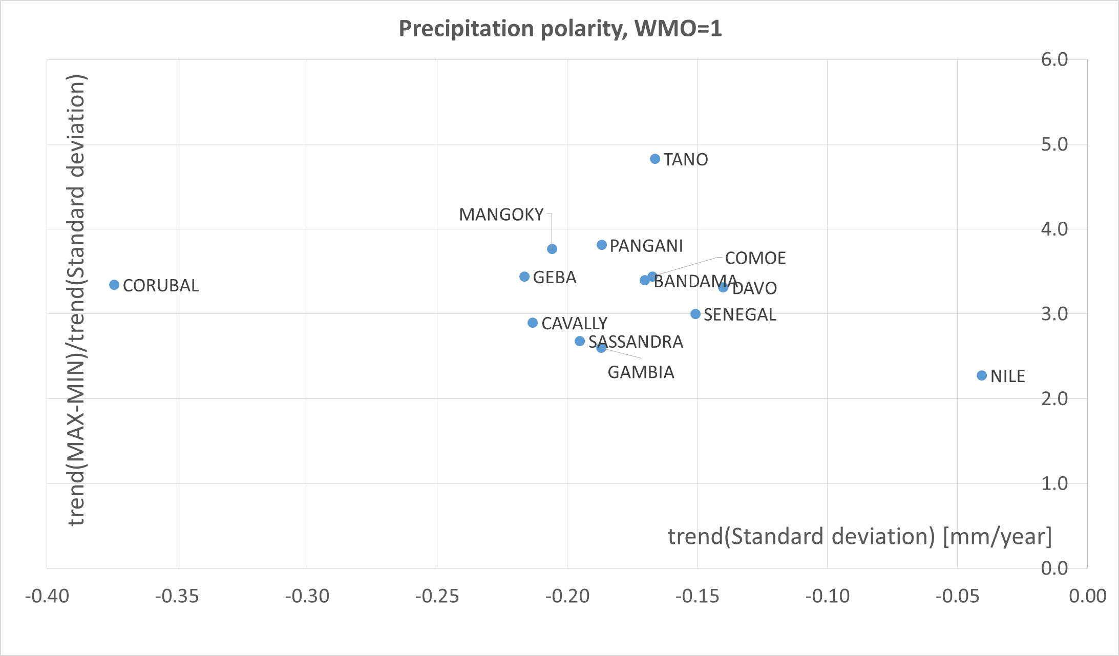
Figure 2. Watersheds in the region for which WMO_REG=1 (Africa), in which significant polarisation trends were identified for monthly precipitation sums during the period from 1901 to 2010 at a significance level of 5%. Quadrant II gathers catchments in which both trends are negative.

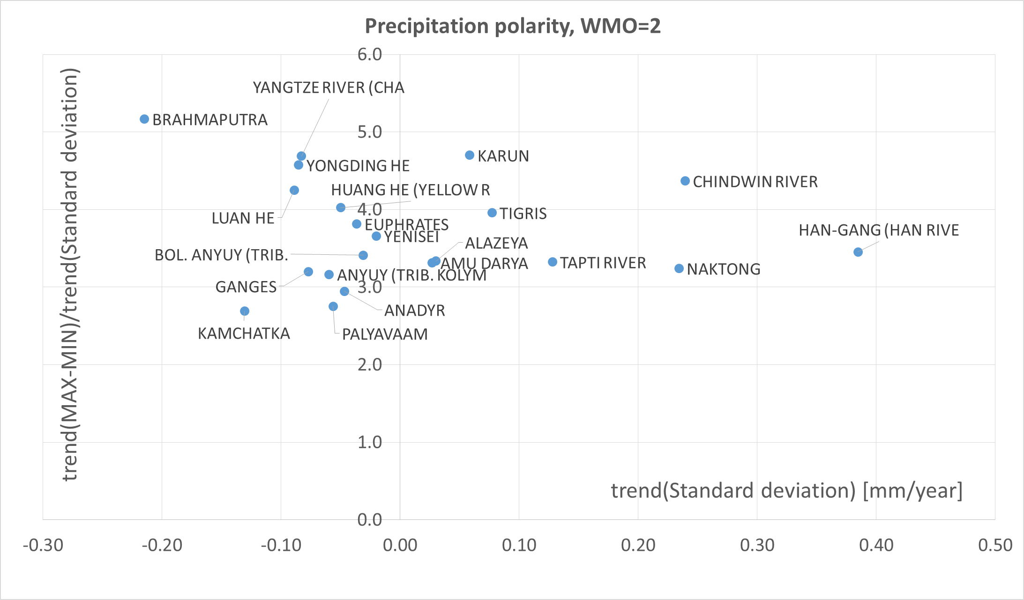
Figure 3. Watersheds in the region for which WMO_REG=2 (Asia), in which significant polarisation trends were identified for monthly precipitation sums during the period from 1901 to 2010 at a significance level of 5%. Quadrant I is the area indicating an increase in the trend in amplitude and the trend in standard deviation (variability). Quadrant II gathers catchments in which both trends are negative.
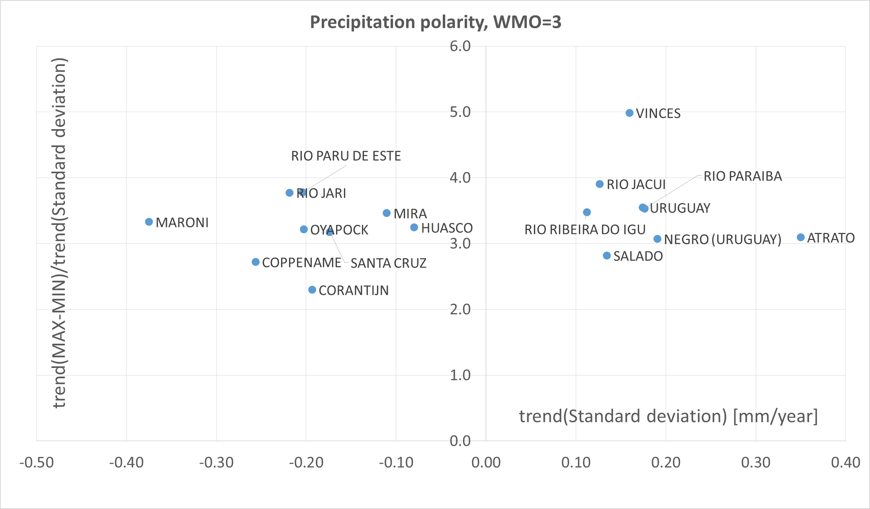
Figure 4. Watersheds in the region for which WMO_REG=3 (South America), in which significant polarisation trends were identified for monthly precipitation sums during the period from 1901 to 2010 at a significance level of 5%. Quadrant I is the area indicating an increase in the trend in amplitude and the trend in standard deviation (variability). Quadrant II gathers catchments in which both trends are negative.

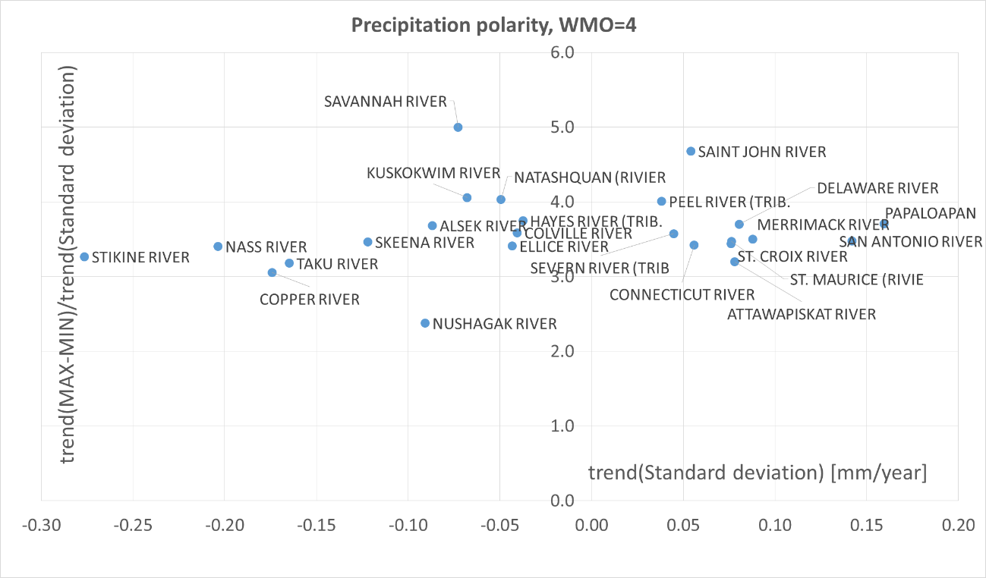
Figure 5. Watersheds in the region for which WMO_REG=4 (North America), in which significant polarisation trends were identified for monthly precipitation sums during the period from 1901 to 2010 at a significance level of 5%. Quadrant I is the area indicating an increase in the trend in amplitude and the trend in standard deviation (variability). Quadrant II gathers catchments in which both trends are negative.
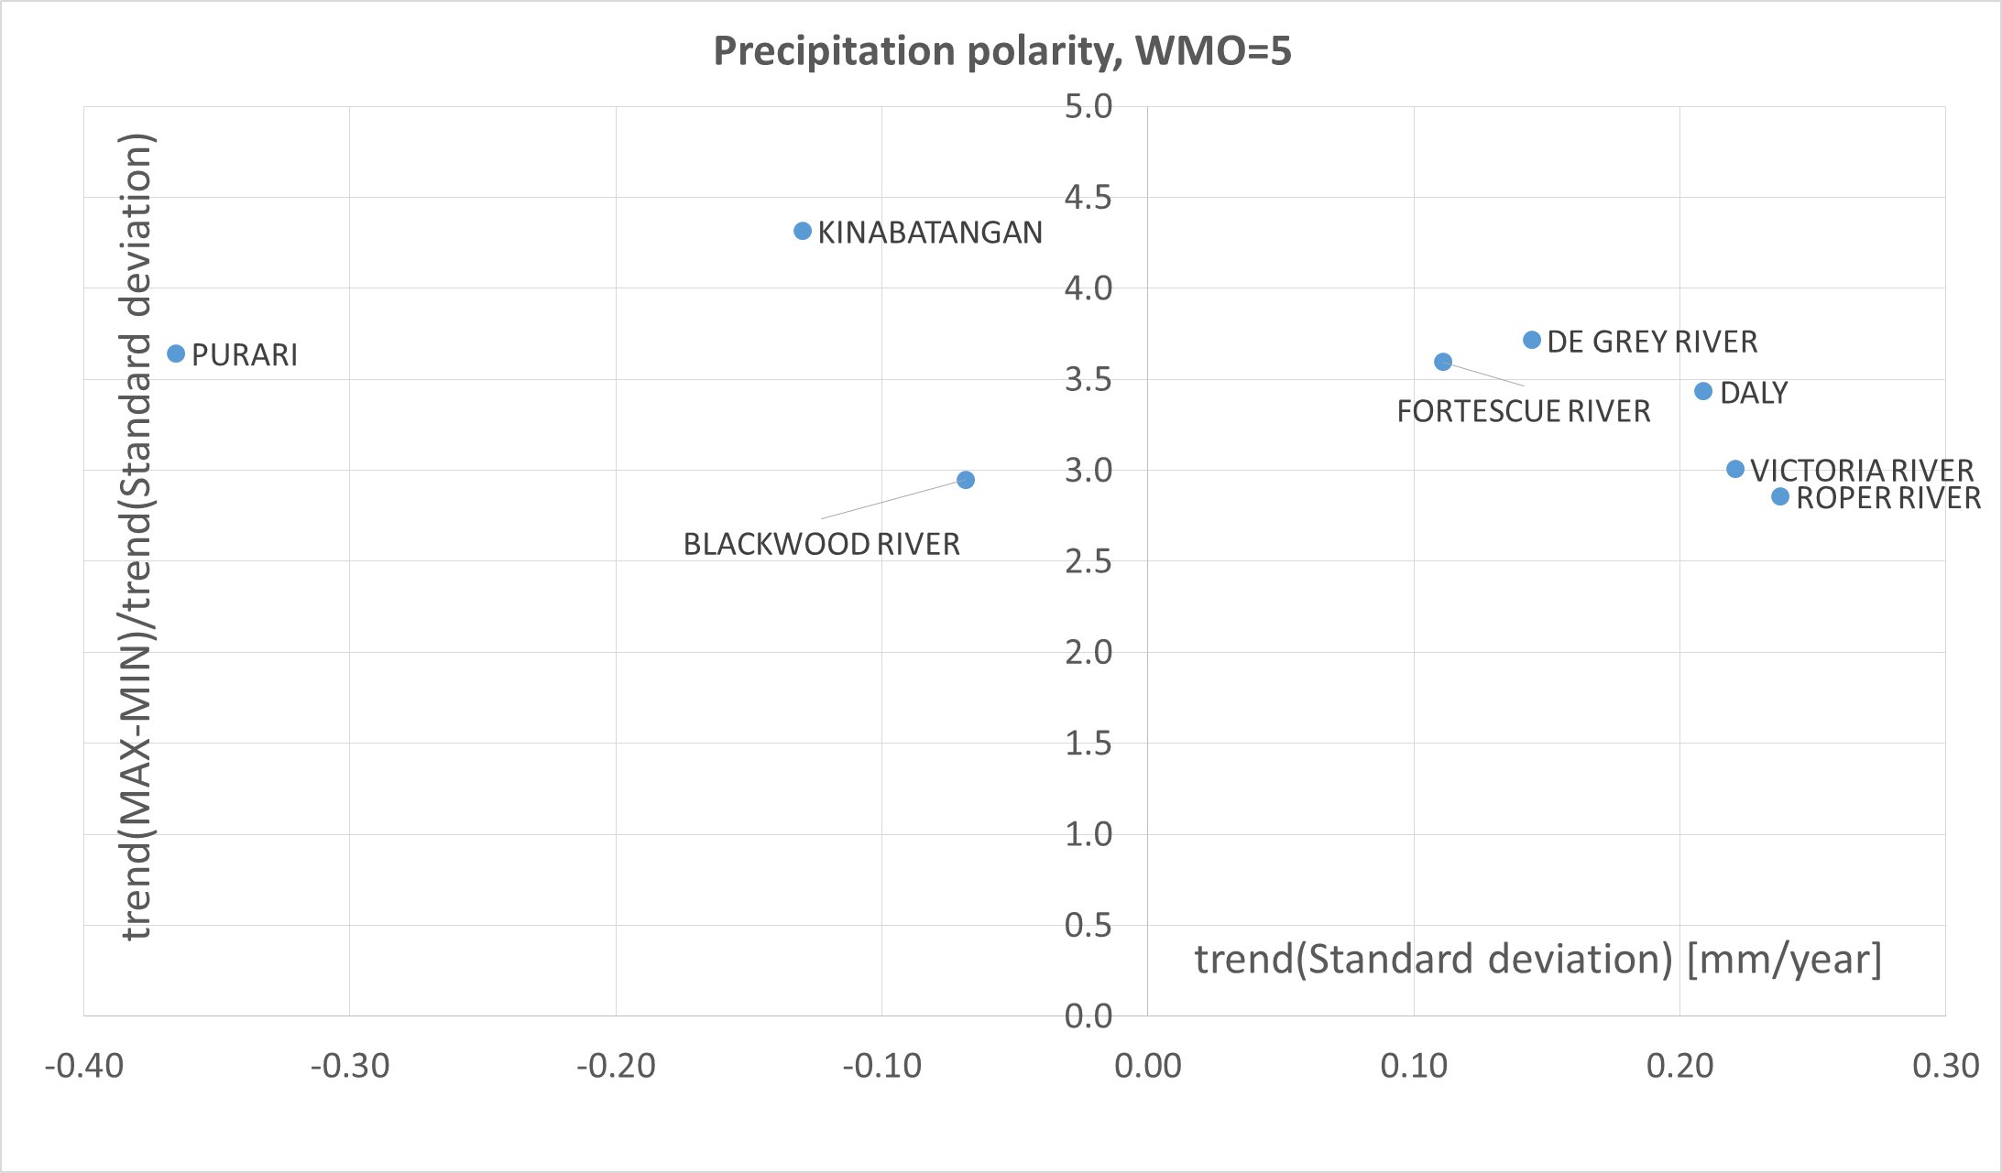
Figure 6. Watersheds in the region for which WMO_REG=5 (Australia and Oceania), in which significant polarisation trends were identified for monthly precipitation sums during the period from 1901 to 2010 at a significance level of 5%. Quadrant I is the area indicating an increase in the trend in amplitude and the trend in standard deviation (variability). Quadrant II gathers catchments in which both trends are negative.

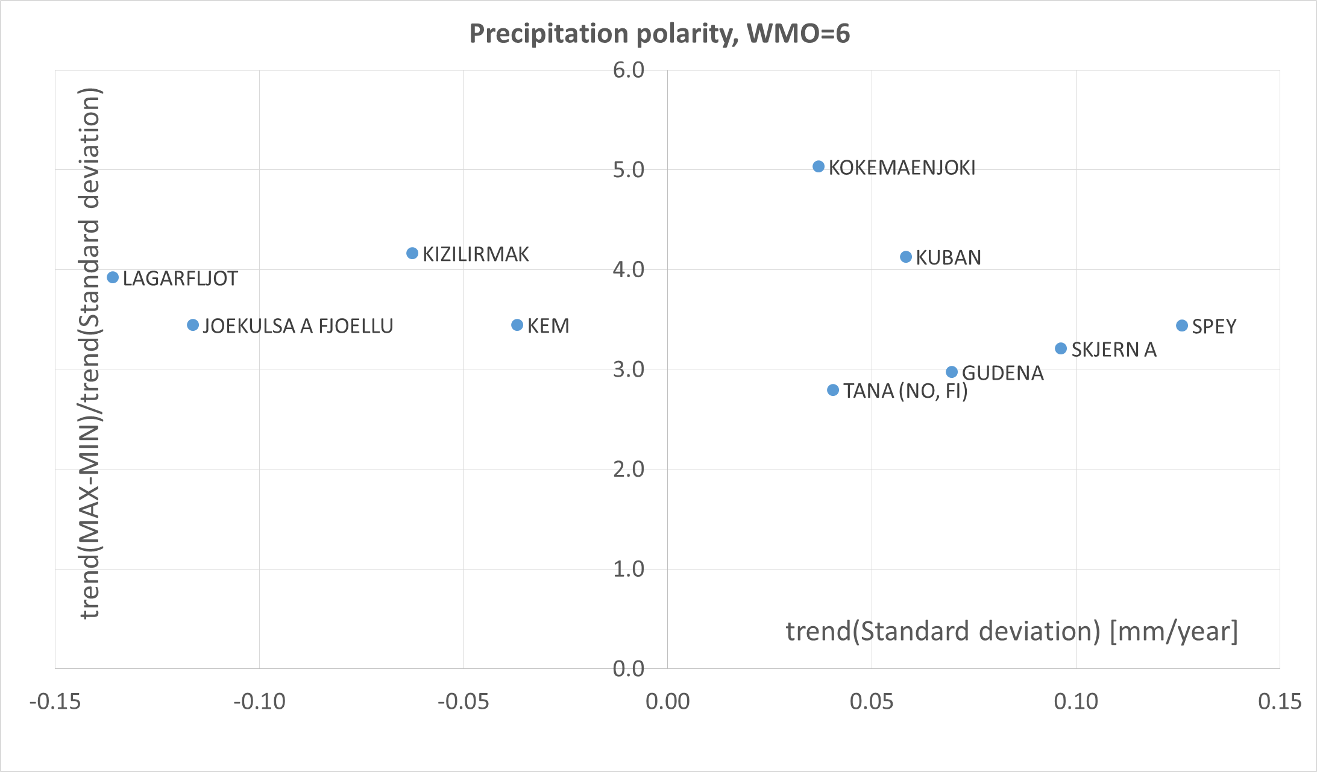
Figure 7. Watersheds in the region for which WMO_REG=6 (Europe), in which significant polarisation trends were identified for monthly precipitation sums during the period from 1901 to 2010 at a significance level of 5%. Quadrant I is the area indicating an increase in the trend in amplitude and the trend in standard deviation (variability). Quadrant II gathers catchments in which both trends are negative.

Table 3. Characteristics calculated based on monthly mean temperatures in analyzed watersheds in terms of temperature polarisation.
 |  |  |  |  |  |  | Statistics: minimum value, maximum value, standard deviation
No | GRDC code | WMO - Region code | RIVER name | Continent | Country code | Catchment area | MIN | MAX | MEAN | STD
 |  |  |  |  |  | [km²] | [°C]
2 | 1147010 | 1 | CONGO | Africa | CONGO, THE DE | 3475000 | 21.5 | 26.0 | 23.69 | 0.67
3 | 1159100 | 1 | ORANGE | Africa | SOUTH AFRICA | 850530 | 7.8 | 26.3 | 18.01 | 4.97
4 | 1160580 | 1 | GROOT-VIS | Africa | SOUTH AFRICA | 29745 | 7.5 | 22.6 | 15.56 | 4.02
5 | 1160880 | 1 | TUGELA | Africa | SOUTH AFRICA | 28920 | 7.6 | 22.6 | 16.34 | 3.73
6 | 1286900 | 1 | RUFIJI | Africa | TANZANIA, UNI | 158200 | 17.6 | 26.2 | 21.78 | 1.66
7 | 1289200 | 1 | PANGANI | Africa | TANZANIA, UNI | 25110 | 16.1 | 24.9 | 20.83 | 1.77
8 | 1289450 | 1 | RUVU | Africa | TANZANIA, UNI | 15190 | 20.7 | 28.5 | 24.99 | 1.75
9 | 1309700 | 1 | SEBOU | Africa | MOROCCO | 17250 | 4.2 | 27.0 | 14.81 | 6.08
10 | 1336500 | 1 | CROSS | Africa | CAMEROON | 6810 | 18.7 | 25.5 | 22.27 | 1.16
11 | 1338050 | 1 | SANAGA | Africa | CAMEROON | 131520 | 20.9 | 26.3 | 23.40 | 1.02
12 | 1339100 | 1 | NYONG | Africa | CAMEROON | 26400 | 21.1 | 26.2 | 23.70 | 0.87
13 | 1340500 | 1 | NTEM | Africa | CAMEROON | 18100 | 20.9 | 26.4 | 23.58 | 0.86
14 | 1362100 | 1 | NILE | Africa | EGYPT | 2900000 | 19.4 | 29.5 | 25.32 | 2.08
15 | 1389090 | 1 | MANGOKY | Africa | MADAGASCAR | 53225 | 16.7 | 27.0 | 22.65 | 2.83
16 | 1389230 | 1 | TSIRIBIHINA | Africa | MADAGASCAR | 45000 | 15.8 | 24.9 | 21.07 | 2.37
18 | 1426380 | 1 | BANDAMA | Africa | COTE D'IVOIRE | 95500 | 23.6 | 30.5 | 26.55 | 1.29
19 | 1427500 | 1 | SASSANDRA | Africa | COTE D'IVOIRE | 62000 | 22.7 | 28.5 | 25.40 | 1.10
20 | 1427600 | 1 | DAVO | Africa | COTE D'IVOIRE | 6600 | 23.4 | 28.7 | 25.96 | 1.02
21 | 1428500 | 1 | COMOE | Africa | COTE D'IVOIRE | 69900 | 23.8 | 31.0 | 27.01 | 1.44
22 | 1445100 | 1 | KOUILOU | Africa | CONGO | 55010 | 19.8 | 27.4 | 24.11 | 1.42
23 | 1526300 | 1 | PRA | Africa | GHANA | 22714 | 22.3 | 29.4 | 26.11 | 1.13
24 | 1530100 | 1 | TANO | Africa | GHANA | 15800 | 22.1 | 29.4 | 25.85 | 1.18
25 | 1531700 | 1 | VOLTA | Africa | GHANA | 394100 | 24.1 | 32.2 | 27.70 | 1.75
26 | 1643100 | 1 | OGOOUE | Africa | GABON | 205000 | 20.6 | 26.5 | 23.80 | 1.03
27 | 1644100 | 1 | NYANGA | Africa | GABON | 20000 | 19.9 | 27.4 | 24.12 | 1.47
28 | 1732100 | 1 | MONO | Africa | BENIN | 21575 | 23.2 | 29.9 | 26.22 | 1.35
29 | 1733600 | 1 | OUEME | Africa | BENIN | 46990 | 23.6 | 30.5 | 26.78 | 1.53
30 | 1789300 | 1 | TANA | Africa | KENYA | 42220 | 19.8 | 26.0 | 22.72 | 1.12
31 | 1812100 | 1 | SENEGAL | Africa | SENEGAL | 268000 | 20.3 | 35.5 | 28.67 | 3.13
32 | 1813200 | 1 | GAMBIA | Africa | SENEGAL | 42000 | 21.5 | 33.5 | 27.73 | 2.35
33 | 1814070 | 1 | GEBA | Africa | SENEGAL | 7340 | 20.0 | 32.6 | 27.09 | 2.36
34 | 1815020 | 1 | CORUBAL | Africa | SENEGAL | 23840 | 20.7 | 30.9 | 26.18 | 1.79
37 | 1880100 | 1 | JUBA | Africa | SOMALIA | 179520 | 19.9 | 28.2 | 24.05 | 1.09
38 | 1891500 | 1 | ZAMBEZI | Africa | MOZAMBIQUE | 940000 | 14.5 | 26.7 | 21.35 | 2.77
39 | 1894200 | 1 | BUZI | Africa | MOZAMBIQUE | 26314 | 15.5 | 27.3 | 22.57 | 2.63
40 | 1895500 | 1 | SAVE | Africa | MOZAMBIQUE | 100885 | 14.8 | 26.9 | 21.37 | 2.98
41 | 1896500 | 1 | LIMPOPO | Africa | MOZAMBIQUE | 342000 | 11.6 | 27.2 | 20.21 | 3.89
42 | 1897500 | 1 | INCOMATI | Africa | MOZAMBIQUE | 37600 | 11.9 | 25.4 | 19.34 | 3.14
43 | 1899100 | 1 | MAPUTO | Africa | MOZAMBIQUE | 28500 | 10.3 | 23.7 | 18.06 | 3.12
44 | 1992900 | 1 | SHIRE | Africa | MALAWI | 149500 | 15.4 | 26.9 | 21.55 | 2.38
45 | 2178300 | 2 | YONGDING HE | Asia | CHINA | 42500 | -16.1 | 24.8 | 5.79 | 11.68
46 | 2178400 | 2 | DALINGHE | Asia | CHINA | 17687 | -16.2 | 26.9 | 7.48 | 12.58
47 | 2178500 | 2 | LUAN HE | Asia | CHINA | 44100 | -17.8 | 24.5 | 4.87 | 12.31
48 | 2179100 | 2 | LIAO HE | Asia | CHINA | 120764 | -20.3 | 25.7 | 5.15 | 13.24
49 | 2180800 | 2 | HUANG HE (YELLOW R | Asia | CHINA | 730036 | -14.4 | 21.4 | 6.07 | 10.04
50 | 2181900 | 2 | YANGTZE RIVER (CHA | Asia | CHINA | 1705383 | -2.4 | 23.0 | 11.34 | 7.40
51 | 2181950 | 2 | HUAI HE | Asia | CHINA | 121330 | -3.0 | 31.0 | 15.05 | 9.25
52 | 2186800 | 2 | XI JIANG | Asia | CHINA | 329705 | 5.9 | 26.6 | 18.56 | 5.66
53 | 2186901 | 2 | BEI JIANG | Asia | CHINA | 38363 | 4.8 | 29.6 | 19.19 | 6.66
55 | 2260100 | 2 | CHINDWIN RIVER | Asia | MYANMAR | 27420 | 10.9 | 25.8 | 19.76 | 4.38
56 | 2260500 | 2 | IRRAWADDY | Asia | MYANMAR | 117900 | 9.3 | 23.4 | 17.79 | 4.19
57 | 2261500 | 2 | SITTANG RIVER | Asia | MYANMAR | 14660 | 18.0 | 31.9 | 24.93 | 2.69
58 | 2335950 | 2 | INDUS | Asia | PAKISTAN | 832418 | 1.7 | 27.3 | 16.46 | 7.65
61 | 2423450 | 2 | KARKHEH | Asia | IRAN, ISLAMIC | 45882 | -3.6 | 30.2 | 15.86 | 8.74
62 | 2423500 | 2 | KARUN | Asia | IRAN, ISLAMIC | 60769 | -3.1 | 30.5 | 15.69 | 8.95
63 | 2569005 | 2 | MEKONG | Asia | CAMBODIA | 635000 | 12.5 | 24.8 | 20.33 | 3.09
65 | 2588200 | 2 | YODO | Asia | JAPAN | 7281 | -0.5 | 28.1 | 13.43 | 8.29
66 | 2588301 | 2 | KISO | Asia | JAPAN | 4683.8 | -4.7 | 25.2 | 10.65 | 8.73
67 | 2588320 | 2 | TENRYU | Asia | JAPAN | 4880 | -6.3 | 23.2 | 8.86 | 8.40
68 | 2588551 | 2 | TONE | Asia | JAPAN | 12458 | -2.8 | 26.6 | 11.98 | 8.38
69 | 2588700 | 2 | KITAKAMI | Asia | JAPAN | 7869.4 | -7.3 | 25.7 | 9.23 | 9.21
72 | 2589700 | 2 | MOGAMI | Asia | JAPAN | 6270.9 | -5.9 | 27.0 | 10.45 | 9.16
73 | 2595400 | 2 | EUPHRATES | Asia | IRAQ | 274100 | -1.6 | 32.0 | 16.33 | 9.12
74 | 2595700 | 2 | TIGRIS | Asia | IRAQ | 134000 | -2.6 | 32.1 | 16.17 | 9.54
75 | 2651100 | 2 | BRAHMAPUTRA | Asia | BANGLADESH | 636130 | -1.7 | 16.5 | 8.60 | 5.38
78 | 2846800 | 2 | GANGES | Asia | INDIA | 835000 | 10.3 | 30.8 | 21.56 | 5.47
79 | 2853150 | 2 | MAHI RIVER | Asia | INDIA | 33670 | 16.7 | 35.7 | 26.18 | 4.37
80 | 2853200 | 2 | NARMADA | Asia | INDIA | 89345 | 16.3 | 34.8 | 25.31 | 4.63
81 | 2853300 | 2 | TAPTI RIVER | Asia | INDIA | 61575 | 18.7 | 34.8 | 26.24 | 3.97
82 | 2854050 | 2 | DAMODAR RIVER | Asia | INDIA | 19220 | 14.8 | 34.2 | 25.18 | 4.84
84 | 2854300 | 2 | KRISHNA | Asia | INDIA | 251355 | 20.5 | 31.9 | 25.99 | 2.58
85 | 2854500 | 2 | PENNER RIVER | Asia | INDIA | 53290 | 21.5 | 33.2 | 27.24 | 2.78
86 | 2854800 | 2 | CAUVERY RIVER | Asia | INDIA | 74004 | 20.7 | 28.9 | 24.63 | 1.78
87 | 2855800 | 2 | MAHANADI RIVER (MA | Asia | INDIA | 132090 | 16.8 | 36.7 | 26.07 | 4.53
88 | 2856900 | 2 | GODAVARI | Asia | INDIA | 299320 | 18.6 | 35.3 | 26.16 | 3.89
89 | 2901202 | 2 | ANADYR | Asia | RUSSIAN FEDER | 156000 | -38.6 | 13.0 | -9.92 | 13.84
90 | 2902850 | 2 | KAMCHATKA | Asia | RUSSIAN FEDER | 51600 | -27.6 | 14.9 | -3.77 | 11.19
91 | 2903420 | 2 | LENA | Asia | RUSSIAN FEDER | 2430000 | -44.5 | 18.1 | -9.93 | 18.48
92 | 2906900 | 2 | AMUR | Asia | RUSSIAN FEDER | 1730000 | -32.2 | 21.4 | -1.56 | 15.67
93 | 2909150 | 2 | YENISEI | Asia | RUSSIAN FEDER | 2440000 | -36.2 | 18.8 | -5.75 | 15.32
94 | 2912600 | 2 | OB | Asia | RUSSIAN FEDER | 2949998 | -30.1 | 20.7 | -0.59 | 13.30
96 | 2917100 | 2 | AMU DARYA | Asia | UZBEKISTAN | 450000 | -13.5 | 24.2 | 8.17 | 9.72
97 | 2919200 | 2 | URAL | Asia | KAZAKHSTAN | 190000 | -25.7 | 25.8 | 3.44 | 13.30
99 | 2964998 | 2 | MAE KLONG | Asia | THAILAND | 26449 | 19.1 | 29.5 | 24.72 | 1.77
100 | 2998110 | 2 | YANA | Asia | RUSSIAN FEDER | 224000 | -51.5 | 17.0 | -16.34 | 20.91
101 | 2998150 | 2 | OMOLOY | Asia | RUSSIAN FEDER | 10800 | -54.7 | 17.2 | -17.61 | 21.63
102 | 2998400 | 2 | INDIGIRKA | Asia | RUSSIAN FEDER | 305000 | -50.1 | 17.3 | -16.00 | 20.71
103 | 2998450 | 2 | ALAZEYA | Asia | RUSSIAN FEDER | 29000 | -44.4 | 18.9 | -12.92 | 18.75
104 | 2998510 | 2 | KOLYMA | Asia | RUSSIAN FEDER | 526000 | -44.4 | 17.9 | -12.77 | 18.61
105 | 2998702 | 2 | ANYUY (TRIB. KOLYM | Asia | RUSSIAN FEDER | 30000 | -47.1 | 15.1 | -14.09 | 17.16
106 | 2998720 | 2 | BOL. ANYUY (TRIB. | Asia | RUSSIAN FEDER | 49600 | -47.0 | 16.0 | -13.39 | 17.49
107 | 2998800 | 2 | PALYAVAAM | Asia | RUSSIAN FEDER | 6810 | -34.8 | 8.7 | -11.79 | 11.77
108 | 2999150 | 2 | ANABAR | Asia | RUSSIAN FEDER | 78800 | -47.9 | 17.8 | -14.19 | 18.49
109 | 2999200 | 2 | NADYM | Asia | RUSSIAN FEDER | 48000 | -34.2 | 20.4 | -5.33 | 14.03
110 | 2999250 | 2 | TAZ | Asia | RUSSIAN FEDER | 100000 | -39.5 | 20.1 | -6.46 | 15.08
111 | 2999500 | 2 | PUR | Asia | RUSSIAN FEDER | 95100 | -37.1 | 20.1 | -5.87 | 14.53
112 | 2999850 | 2 | KHATANGA | Asia | RUSSIAN FEDER | 275000 | -46.1 | 16.3 | -13.90 | 17.18
113 | 2999910 | 2 | OLENEK | Asia | RUSSIAN FEDER | 198000 | -48.7 | 17.7 | -13.64 | 18.77
114 | 3102500 | 3 | ATRATO | S. America | COLOMBIA | 9432 | 22.6 | 27.3 | 24.67 | 0.72
115 | 3103300 | 3 | MAGDALENA | S. America | COLOMBIA | 257438 | 20.6 | 24.9 | 22.79 | 0.69
119 | 3178900 | 3 | HUASCO | S. America | CHILE | 7187 | -7.5 | 5.4 | -1.27 | 2.94
122 | 3181500 | 3 | BAKER | S. America | CHILE | 23736 | -1.4 | 17.6 | 8.36 | 3.60
123 | 3206720 | 3 | ORINOCO | S. America | VENEZUELA | 836000 | 22.1 | 27.7 | 24.75 | 0.92
124 | 3258200 | 3 | SALADO | S. America | ARGENTINA | 29000 | 4.7 | 26.0 | 16.08 | 5.47
125 | 3265601 | 3 | PARANA | S. America | ARGENTINA | 2346000 | 13.1 | 26.4 | 21.43 | 3.10
126 | 3275750 | 3 | COLORADO (ARGENTIN | S. America | ARGENTINA | 223000 | 1.3 | 21.5 | 12.03 | 5.61
127 | 3275990 | 3 | NEGRO (ARGENTINIA) | S. America | ARGENTINA | 95000 | 0.1 | 20.4 | 10.30 | 5.38
128 | 3276200 | 3 | CHUBUT | S. America | ARGENTINA | 16400 | -4.5 | 17.8 | 7.90 | 4.91
129 | 3276800 | 3 | SANTA CRUZ | S. America | ARGENTINA | 15550 | -6.1 | 11.5 | 3.46 | 4.25
130 | 3308400 | 3 | CUYUNI | S. America | GUYANA | 53400 | 22.6 | 27.9 | 25.08 | 0.83
131 | 3308600 | 3 | ESSEQUIBO | S. America | GUYANA | 66600 | 24.1 | 28.8 | 26.10 | 0.77
132 | 3410500 | 3 | CORANTIJN | S. America | SURINAME | 51600 | 24.6 | 29.3 | 26.52 | 0.86
133 | 3411300 | 3 | COPPENAME | S. America | SURINAME | 12300 | 23.9 | 28.8 | 26.02 | 0.86
134 | 3412800 | 3 | MARONI | S. America | SURINAME | 63700 | 23.6 | 28.6 | 25.72 | 0.78
135 | 3469050 | 3 | URUGUAY | S. America | URUGUAY | 244000 | 9.6 | 25.6 | 18.35 | 4.07
136 | 3469100 | 3 | NEGRO (URUGUAY) | S. America | URUGUAY | 63000 | 7.2 | 26.0 | 17.20 | 4.66
137 | 3514800 | 3 | OYAPOCK | S. America | FRENCH GUIANA | 25120 | 23.0 | 29.0 | 25.07 | 0.80
138 | 3629000 | 3 | AMAZONAS | S. America | BRAZIL | 4640300 | 22.4 | 26.9 | 24.84 | 0.76
139 | 3629150 | 3 | RIO TAPAJOS | S. America | BRAZIL | 358657 | 21.7 | 28.0 | 24.89 | 0.87
140 | 3629204 | 3 | RIO JAMANXIM | S. America | BRAZIL | 40400 | 24.3 | 29.5 | 26.14 | 0.75
141 | 3630050 | 3 | XINGU | S. America | BRAZIL | 446570 | 22.0 | 27.6 | 24.63 | 0.76
142 | 3630300 | 3 | RIO MAICURU | S. America | BRAZIL | 17072 | 22.8 | 28.2 | 24.98 | 0.86
143 | 3631050 | 3 | RIO ARAGUARI | S. America | BRAZIL | 23373 | 23.2 | 28.9 | 25.58 | 0.94
144 | 3631100 | 3 | RIO JARI | S. America | BRAZIL | 51343 | 23.6 | 28.7 | 25.81 | 0.84
145 | 3631210 | 3 | RIO PARU DE ESTE | S. America | BRAZIL | 30945 | 23.7 | 28.7 | 25.77 | 0.86
146 | 3649950 | 3 | TOCANTINS | S. America | BRAZIL | 742300 | 21.0 | 28.3 | 24.43 | 1.00
147 | 3650150 | 3 | RIO CAPIM | S. America | BRAZIL | 38178 | 24.1 | 28.8 | 26.36 | 0.71
148 | 3650202 | 3 | RIO GURUPI | S. America | BRAZIL | 31850 | 23.6 | 27.8 | 25.58 | 0.70
149 | 3650285 | 3 | RIO PINDARE | S. America | BRAZIL | 34300 | 23.7 | 28.7 | 25.76 | 0.85
150 | 3650335 | 3 | RIO MEARIM | S. America | BRAZIL | 25500 | 22.9 | 29.0 | 25.55 | 1.07
151 | 3650359 | 3 | RIO ITAPECURU | S. America | BRAZIL | 50800 | 22.6 | 29.2 | 25.71 | 1.06
152 | 3650481 | 3 | RIO PARNAIBA | S. America | BRAZIL | 322823 | 23.2 | 29.2 | 25.71 | 1.06
153 | 3650525 | 3 | RIO ACARAU | S. America | BRAZIL | 11160 | 22.8 | 27.6 | 25.31 | 1.00
154 | 3650649 | 3 | RIO JAGUARIBE | S. America | BRAZIL | 48200 | 22.2 | 28.7 | 25.75 | 1.31
155 | 3650885 | 3 | RIO PARAIBA | S. America | BRAZIL | 19244 | 19.8 | 26.6 | 23.50 | 1.44
156 | 3651900 | 3 | SAO FRANCISCO | S. America | BRAZIL | 622600 | 19.2 | 27.1 | 23.35 | 1.52
157 | 3652039 | 3 | RIO ITAPICURU | S. America | BRAZIL | 35150 | 19.5 | 27.2 | 23.63 | 1.83
158 | 3652050 | 3 | RIO VAZA-BARRIS | S. America | BRAZIL | 15740 | 19.9 | 28.0 | 24.07 | 1.80
160 | 3652220 | 3 | RIO DE CONTAS | S. America | BRAZIL | 42245 | 18.8 | 27.8 | 22.99 | 1.56
161 | 3652320 | 3 | RIO PRADO | S. America | BRAZIL | 30360 | 17.7 | 26.8 | 22.02 | 1.74
162 | 3652455 | 3 | JEQUITINHONHA | S. America | BRAZIL | 67769 | 17.0 | 25.7 | 21.67 | 1.93
163 | 3652500 | 3 | MUCURI | S. America | BRAZIL | 14174 | 17.5 | 26.6 | 22.48 | 2.11
164 | 3652600 | 3 | RIO DOCE | S. America | BRAZIL | 78456 | 15.4 | 25.3 | 20.77 | 2.26
166 | 3653120 | 3 | RIO RIBEIRA DO IGU | S. America | BRAZIL | 12450 | 10.6 | 24.2 | 18.23 | 2.91
168 | 3843100 | 3 | MIRA | S. America | ECUADOR | 4960 | 14.1 | 23.9 | 16.99 | 1.73
169 | 3844100 | 3 | ESMERALDAS | S. America | ECUADOR | 18800 | 15.1 | 20.3 | 18.11 | 0.75
170 | 3844400 | 3 | DAULE | S. America | ECUADOR | 8690 | 20.7 | 27.5 | 24.62 | 1.02
171 | 3844450 | 3 | VINCES | S. America | ECUADOR | 4400 | 20.0 | 25.8 | 23.06 | 0.93
174 | 3948800 | 3 | CANETE | S. America | PERU | 4900 | 2.7 | 12.3 | 6.99 | 1.64
176 | 4101500 | 4 | COLVILLE RIVER | N.America | UNITED STATES | 53535.3 | -40.0 | 13.5 | -11.15 | 14.66
177 | 4101800 | 4 | NOATAK RIVER | N.America | UNITED STATES | 31080 | -38.7 | 14.7 | -8.89 | 13.71
178 | 4101900 | 4 | KOBUK RIVER | N.America | UNITED STATES | 24656.8 | -37.7 | 14.9 | -7.44 | 14.02
179 | 4102100 | 4 | KUSKOKWIM RIVER | N.America | UNITED STATES | 80549 | -29.8 | 15.3 | -3.16 | 11.84
180 | 4102710 | 4 | COPPER RIVER | N.America | UNITED STATES | 62678 | -33.9 | 12.9 | -5.91 | 11.19
181 | 4102740 | 4 | NUSHAGAK RIVER | N.America | UNITED STATES | 25511.5 | -23.3 | 14.8 | -0.81 | 9.44
182 | 4102800 | 4 | SUSITNA RIVER | N.America | UNITED STATES | 50246 | -28.3 | 14.3 | -3.57 | 10.44
183 | 4103200 | 4 | YUKON RIVER | N.America | UNITED STATES | 831390 | -37.4 | 14.9 | -6.02 | 13.80
184 | 4115201 | 4 | COLUMBIA RIVER | N.America | UNITED STATES | 665371 | -13.8 | 20.5 | 5.68 | 7.90
185 | 4126700 | 4 | OUACHITA RIVER | N.America | UNITED STATES | 39621.8 | 0.2 | 30.2 | 17.17 | 7.74
186 | 4126800 | 4 | RED RIVER | N.America | UNITED STATES | 174825 | -1.0 | 30.7 | 16.72 | 8.24
187 | 4127800 | 4 | MISSISSIPPI RIVER | N.America | UNITED STATES | 2964255 | -11.0 | 26.5 | 9.64 | 9.67
188 | 4145081 | 4 | SKAGIT RIVER | N.America | UNITED STATES | 7088.8 | -12.5 | 17.0 | 4.38 | 6.27
189 | 4145900 | 4 | ROGUE RIVER | N.America | UNITED STATES | 10202 | -3.5 | 21.5 | 9.55 | 5.95
191 | 4146180 | 4 | EEL RIVER (CALIF.) | N.America | UNITED STATES | 8062.7 | 1.1 | 22.7 | 12.16 | 5.55
192 | 4146280 | 4 | SACRAMENTO RIVER | N.America | UNITED STATES | 60885.7 | -3.1 | 24.1 | 11.49 | 6.60
193 | 4146360 | 4 | SAN JOAQUIN RIVER | N.America | UNITED STATES | 35058.2 | 0.7 | 26.9 | 13.96 | 6.39
194 | 4146400 | 4 | SALINAS RIVER | N.America | UNITED STATES | 10764 | 3.6 | 23.9 | 14.35 | 4.83
195 | 4147011 | 4 | PENOBSCOT RIVER | N.America | UNITED STATES | 19463.9 | -16.9 | 21.7 | 4.56 | 10.50
196 | 4147060 | 4 | ST. CROIX RIVER | N.America | UNITED STATES | 3558.7 | -15.4 | 22.3 | 5.24 | 10.03
197 | 4147380 | 4 | MERRIMACK RIVER | N.America | UNITED STATES | 12004.7 | -11.8 | 22.9 | 7.31 | 9.55
198 | 4147460 | 4 | CONNECTICUT RIVER | N.America | UNITED STATES | 25019.4 | -14.4 | 21.7 | 5.88 | 9.90
199 | 4147500 | 4 | HUDSON RIVER | N.America | UNITED STATES | 20953 | -13.7 | 22.8 | 6.71 | 9.86
200 | 4147600 | 4 | DELAWARE RIVER | N.America | UNITED STATES | 17560.2 | -10.5 | 23.7 | 8.40 | 9.16
201 | 4147703 | 4 | SUSQUEHANNA RIVER | N.America | UNITED STATES | 70189 | -10.3 | 23.8 | 8.79 | 9.13
202 | 4147900 | 4 | POTOMAC RIVER | N.America | UNITED STATES | 29940.4 | -7.6 | 24.9 | 11.00 | 8.50
203 | 4148050 | 4 | JAMES RIVER | N.America | UNITED STATES | 17503.2 | -5.6 | 25.4 | 12.10 | 8.11
204 | 4148090 | 4 | ROANOKE RIVER | N.America | UNITED STATES | 21714.6 | -3.4 | 26.8 | 13.96 | 7.94
205 | 4148232 | 4 | CAPE FEAR RIVER | N.America | UNITED STATES | 13610.5 | -1.0 | 28.1 | 15.86 | 7.58
206 | 4148300 | 4 | PEE DEE RIVER | N.America | UNITED STATES | 22869.7 | -1.5 | 28.0 | 15.42 | 7.60
207 | 4148550 | 4 | SANTEE RIVER | N.America | UNITED STATES | 38073 | -0.4 | 28.4 | 15.86 | 7.45
208 | 4148650 | 4 | SAVANNAH RIVER | N.America | UNITED STATES | 25511.5 | 0.3 | 28.8 | 16.66 | 7.30
209 | 4148720 | 4 | ALTAMAHA RIVER | N.America | UNITED STATES | 35224 | 1.8 | 29.3 | 17.86 | 7.03
211 | 4149120 | 4 | PEARL RIVER | N.America | UNITED STATES | 17024.1 | 0.7 | 28.8 | 18.06 | 6.98
212 | 4149400 | 4 | ALABAMA RIVER | N.America | UNITED STATES | 56894.5 | -0.4 | 28.7 | 16.76 | 7.30
213 | 4149413 | 4 | TOMBIGBEE RIVER | N.America | UNITED STATES | 47700 | -1.0 | 29.5 | 17.03 | 7.51
215 | 4149781 | 4 | SUWANNEE RIVER | N.America | UNITED STATES | 24320.1 | 5.6 | 28.8 | 19.76 | 6.03
216 | 4150283 | 4 | NUECES RIVER | N.America | UNITED STATES | 43822.8 | 6.9 | 31.3 | 21.01 | 6.66
217 | 4150330 | 4 | SAN ANTONIO RIVER | N.America | UNITED STATES | 10155.4 | 5.9 | 30.4 | 20.17 | 6.57
218 | 4150450 | 4 | COLORADO RIVER (CA | N.America | UNITED STATES | 108788 | 2.1 | 29.8 | 17.70 | 7.51
219 | 4150500 | 4 | BRAZOS RIVER | N.America | UNITED STATES | 116827.1 | 0.9 | 30.3 | 17.65 | 7.77
220 | 4150600 | 4 | TRINITY RIVER (TEX | N.America | UNITED STATES | 44511.7 | 2.0 | 31.8 | 18.73 | 7.67
221 | 4150700 | 4 | SABINE RIVER | N.America | UNITED STATES | 24162.1 | 2.0 | 30.9 | 18.53 | 7.24
222 | 4152050 | 4 | COLORADO RIVER (PA | N.America | UNITED STATES | 618715 | -6.8 | 25.8 | 11.33 | 8.28
223 | 4202100 | 4 | ALSEK RIVER | N.America | CANADA | 16200 | -35.0 | 12.4 | -5.75 | 11.50
224 | 4202601 | 4 | TAKU RIVER | N.America | CANADA | 17700 | -26.3 | 12.8 | -1.70 | 9.16
225 | 4204900 | 4 | STIKINE RIVER | N.America | UNITED STATES | 51592.8 | -27.6 | 12.3 | -2.51 | 9.35
226 | 4206100 | 4 | NASS RIVER | N.America | CANADA | 19200 | -20.6 | 13.4 | 0.79 | 7.45
227 | 4206250 | 4 | SKEENA RIVER | N.America | CANADA | 42200 | -27.6 | 14.2 | -0.05 | 8.40
228 | 4207900 | 4 | FRASER RIVER | N.America | CANADA | 217000 | -27.3 | 16.4 | 1.63 | 8.63
229 | 4208025 | 4 | MACKENZIE RIVER | N.America | CANADA | 1660000 | -33.9 | 16.4 | -4.35 | 13.77
230 | 4208040 | 4 | PEEL RIVER (TRIB. | N.America | CANADA | 70600 | -41.5 | 14.4 | -8.31 | 14.50
231 | 4209150 | 4 | ANDERSON RIVER | N.America | CANADA | 56300 | -37.5 | 16.8 | -8.84 | 15.33
232 | 4209402 | 4 | COPPERMINE RIVER | N.America | CANADA | 50700 | -36.9 | 13.9 | -10.52 | 14.72
233 | 4209600 | 4 | ELLICE RIVER | N.America | CANADA | 16900 | -38.3 | 15.7 | -7.72 | 13.57
234 | 4209800 | 4 | BACK RIVER | N.America | CANADA | 98200 | -38.1 | 15.0 | -10.46 | 15.21
235 | 4209850 | 4 | HAYES RIVER (TRIB. | N.America | CANADA | 18100 | -44.3 | 11.6 | -15.47 | 15.17
236 | 4213711 | 4 | NELSON RIVER | N.America | CANADA | 1060000 | -28.0 | 21.3 | 1.58 | 12.45
237 | 4214025 | 4 | HAYES RIVER (TRIB. | N.America | CANADA | 103000 | -32.9 | 19.6 | -2.96 | 14.43
238 | 4214035 | 4 | AUX MELEZES | N.America | CANADA | 42700 | -32.7 | 14.8 | -5.84 | 12.68
239 | 4214040 | 4 | CANIAPISCAU | N.America | CANADA | 86800 | -30.9 | 14.7 | -4.79 | 12.91
240 | 4214051 | 4 | THELON RIVER | N.America | CANADA | 152000 | -39.2 | 16.1 | -9.86 | 15.51
241 | 4214070 | 4 | THLEWIAZA RIVER | N.America | CANADA | 27000 | -37.0 | 16.8 | -7.14 | 15.03
242 | 4214075 | 4 | FERGUSON RIVER | N.America | CANADA | 12400 | -41.0 | 13.9 | -11.57 | 15.26
243 | 4214080 | 4 | ATTAWAPISKAT RIVER | N.America | CANADA | 36000 | -29.9 | 20.2 | -1.66 | 13.73
244 | 4214090 | 4 | KAZAN RIVER | N.America | CANADA | 72300 | -39.6 | 15.4 | -10.58 | 15.46
245 | 4214100 | 4 | QUOICH RIVER | N.America | CANADA | 30100 | -43.5 | 13.3 | -13.46 | 15.31
246 | 4214105 | 4 | SEAL RIVER | N.America | CANADA | 48100 | -32.5 | 18.3 | -3.31 | 14.11
247 | 4214270 | 4 | CHURCHILL RIVER | N.America | CANADA | 287000 | -33.6 | 18.4 | -1.93 | 13.72
248 | 4214440 | 4 | SEVERN RIVER (TRIB | N.America | CANADA | 94300 | -30.9 | 20.0 | -1.52 | 13.78
249 | 4214450 | 4 | WINISK RIVER | N.America | CANADA | 50000 | -29.6 | 20.4 | -1.28 | 13.59
250 | 4214520 | 4 | ALBANY RIVER | N.America | CANADA | 118000 | -27.9 | 20.3 | -0.34 | 12.96
251 | 4214551 | 4 | MOOSE RIVER (TRIB. | N.America | CANADA | 60100 | -25.8 | 20.6 | 0.70 | 12.44
252 | 4214650 | 4 | NOTTAWAY | N.America | CANADA | 57500 | -26.5 | 20.2 | 0.32 | 12.28
253 | 4214680 | 4 | RUPERT RIVER | N.America | CANADA | 40900 | -27.8 | 19.4 | -0.52 | 12.61
254 | 4214700 | 4 | EASTMAIN | N.America | CANADA | 44300 | -28.6 | 18.1 | -2.01 | 12.73
255 | 4214770 | 4 | GRANDE RIVIERE | N.America | CANADA | 96300 | -30.5 | 16.8 | -3.63 | 13.05
257 | 4214900 | 4 | BALEINE, GRANDE RI | N.America | CANADA | 29800 | -31.6 | 14.1 | -5.62 | 12.64
258 | 4214930 | 4 | ARNAUD | N.America | CANADA | 26900 | -33.4 | 12.8 | -6.42 | 11.12
259 | 4214940 | 4 | FEUILLES (RIVIERE | N.America | CANADA | 41700 | -31.7 | 13.4 | -5.91 | 11.40
260 | 4214950 | 4 | GEORGE RIVER | N.America | CANADA | 35200 | -30.8 | 13.3 | -5.67 | 12.13
263 | 4243300 | 4 | ST. MAURICE (RIVIE | N.America | CANADA | 42000 | -23.7 | 20.1 | 1.18 | 11.80
264 | 4243400 | 4 | SAGUENAY (RIVIERE) | N.America | CANADA | 73000 | -26.3 | 19.1 | -0.39 | 12.36
265 | 4243610 | 4 | MANICOUAGAN (RIVIE | N.America | CANADA | 45800 | -26.7 | 16.4 | -2.13 | 12.17
267 | 4244635 | 4 | NATASHQUAN (RIVIER | N.America | CANADA | 15600 | -25.3 | 18.2 | -1.43 | 11.50
268 | 4244660 | 4 | LITTLE MECATINA RI | N.America | CANADA | 19100 | -24.7 | 15.4 | -1.66 | 10.79
269 | 4351900 | 4 | BRAVO | N.America | MEXICO | 450902 | 3.7 | 27.1 | 16.21 | 6.82
270 | 4353300 | 4 | YAQUI | N.America | MEXICO | 57908 | 5.5 | 26.9 | 17.00 | 6.07
272 | 4356080 | 4 | SAN PEDRO | N.America | MEXICO | 25800 | 7.4 | 23.8 | 16.55 | 3.80
273 | 4356100 | 4 | SANTIAGO | N.America | MEXICO | 128943 | 10.4 | 23.3 | 17.68 | 2.77
275 | 4356700 | 4 | VERDE | N.America | MEXICO | 17617 | 13.9 | 23.1 | 18.66 | 1.71
276 | 4358300 | 4 | PANUCO | N.America | MEXICO | 58115 | 10.6 | 22.3 | 16.92 | 2.45
277 | 4359220 | 4 | PAPALOAPAN | N.America | MEXICO | 21419 | 14.3 | 24.6 | 19.67 | 2.03
278 | 4362201 | 4 | GRISALVA | N.America | MEXICO | 37702 | 17.6 | 26.5 | 22.04 | 1.74
279 | 4362600 | 4 | USUMACINTA | N.America | MEXICO | 50743 | 18.1 | 27.1 | 22.75 | 1.78
280 | 4664800 | 4 | LEMPA | N.America | EL SALVADOR | 18176 | 18.3 | 26.6 | 22.50 | 1.35
281 | 4772300 | 4 | GRANDE DE MATAGALP | N.America | NICARAGUA | 14646 | 20.3 | 28.5 | 24.91 | 1.14
283 | 5101201 | 5 | BURDEKIN | Australia and Oceania | AUSTRALIA | 129760 | 14.0 | 29.5 | 22.47 | 4.06
285 | 5109170 | 5 | GILBERT RIVER | Australia and Oceania | AUSTRALIA | 11800 | 15.7 | 30.2 | 24.01 | 3.51
287 | 5141100 | 5 | BRANTAS | Australia and Oceania | INDONESIA | 8650 | 21.7 | 26.6 | 24.30 | 0.72
289 | 5223100 | 5 | KELANTAN | Australia and Oceania | MALAYSIA | 11900 | 22.5 | 28.0 | 25.64 | 0.71
290 | 5224500 | 5 | PAHANG | Australia and Oceania | MALAYSIA | 19000 | 21.7 | 27.2 | 24.65 | 0.68
291 | 5230300 | 5 | RAJANG | Australia and Oceania | MALAYSIA | 34053 | 22.3 | 26.6 | 24.52 | 0.56
292 | 5231700 | 5 | KINABATANGAN | Australia and Oceania | MALAYSIA | 10800 | 22.2 | 27.2 | 24.38 | 0.60
294 | 5550500 | 5 | SEPIK | Australia and Oceania | PAPUA NEW GUI | 40922 | 15.3 | 25.8 | 24.04 | 1.01
295 | 5553100 | 5 | PURARI | Australia and Oceania | PAPUA NEW GUI | 11100 | 17.2 | 22.5 | 20.22 | 0.84
296 | 5606100 | 5 | BLACKWOOD RIVER | Australia and Oceania | AUSTRALIA | 20500 | 8.5 | 24.9 | 15.74 | 4.31
297 | 5607100 | 5 | MURCHISON RIVER | Australia and Oceania | AUSTRALIA | 82300 | 10.8 | 32.7 | 21.73 | 6.12
299 | 5607400 | 5 | ASHBURTON RIVER | Australia and Oceania | AUSTRALIA | 70200 | 14.4 | 34.7 | 25.05 | 5.70
300 | 5607450 | 5 | FORTESCUE RIVER | Australia and Oceania | AUSTRALIA | 48900 | 13.6 | 34.1 | 24.67 | 5.70
301 | 5607500 | 5 | DE GREY RIVER | Australia and Oceania | AUSTRALIA | 49600 | 15.0 | 34.9 | 25.98 | 5.42
302 | 5608024 | 5 | FITZROY RIVER | Australia and Oceania | AUSTRALIA | 45300 | 16.8 | 33.6 | 26.58 | 4.30
303 | 5608090 | 5 | ORD | Australia and Oceania | AUSTRALIA | 46100 | 17.5 | 33.7 | 26.96 | 4.08
304 | 5608400 | 5 | DURACK RIVER | Australia and Oceania | AUSTRALIA | 4150 | 17.5 | 32.6 | 26.33 | 3.79
306 | 5708110 | 5 | VICTORIA RIVER | Australia and Oceania | AUSTRALIA | 44900 | 17.1 | 33.1 | 26.63 | 4.10
307 | 5708145 | 5 | DALY | Australia and Oceania | AUSTRALIA | 47000 | 18.8 | 32.3 | 27.11 | 3.03
308 | 5709100 | 5 | ROPER RIVER | Australia and Oceania | AUSTRALIA | 47400 | 18.5 | 33.1 | 26.97 | 3.51
309 | 5709110 | 5 | MACARTHUR RIVER | Australia and Oceania | AUSTRALIA | 10400 | 17.4 | 32.9 | 26.30 | 3.83
310 | 5803180 | 5 | SOUTH ESK RIVER | Australia and Oceania | AUSTRALIA | 3278 | 4.4 | 18.2 | 10.97 | 3.53
311 | 5865300 | 5 | WAIKATO RIVER | Australia and Oceania | NEW ZEALAND | 11395 | 4.8 | 19.5 | 11.55 | 3.64
312 | 5868100 | 5 | CLUTHA | Australia and Oceania | NEW ZEALAND | 20306 | -2.6 | 15.4 | 7.03 | 4.26
313 | 6112090 | 6 | DOURO | Europe | PORTUGAL | 91491 | -0.8 | 23.1 | 10.97 | 6.11
314 | 6113050 | 6 | TEJO | Europe | PORTUGAL | 67490 | 2.0 | 25.9 | 13.65 | 6.44
315 | 6116200 | 6 | GUADIANA | Europe | PORTUGAL | 60883 | 3.4 | 27.9 | 15.15 | 6.65
316 | 6122100 | 6 | SEINE | Europe | FRANCE | 65000 | -5.8 | 22.6 | 10.05 | 5.93
317 | 6123100 | 6 | LOIRE | Europe | FRANCE | 110000 | -5.3 | 23.3 | 10.38 | 5.82
318 | 6125100 | 6 | GARONNE | Europe | FRANCE | 52000 | -4.8 | 23.7 | 10.72 | 5.86
319 | 6139100 | 6 | RHONE | Europe | FRANCE | 95590 | -7.8 | 22.2 | 8.59 | 6.46
320 | 6217100 | 6 | GUADALQUIVIR | Europe | SPAIN | 46995 | 3.9 | 27.8 | 15.51 | 6.53
321 | 6226800 | 6 | EBRO | Europe | SPAIN | 84230 | -1.8 | 24.0 | 11.46 | 6.10
322 | 6229500 | 6 | VAENERN-GOETA (GOE | Europe | SWEDEN | 46886 | -14.6 | 19.5 | 4.31 | 7.70
323 | 6233650 | 6 | ANGERMANAELVEN | Europe | SWEDEN | 30638 | -19.7 | 16.3 | 0.71 | 8.55
324 | 6233750 | 6 | LULEAELVEN | Europe | SWEDEN | 24924 | -22.7 | 15.1 | -1.66 | 9.06
326 | 6233900 | 6 | MUONIO | Europe | SWEDEN | 14408.5 | -24.1 | 16.1 | -1.95 | 9.73
327 | 6335020 | 6 | RHINE RIVER | Europe | GERMANY | 159300 | -9.6 | 21.6 | 8.21 | 6.43
328 | 6337200 | 6 | WESER | Europe | GERMANY | 37720 | -9.9 | 21.2 | 8.12 | 6.42
329 | 6340110 | 6 | ELBE RIVER | Europe | GERMANY | 131950 | -11.4 | 21.7 | 7.87 | 6.95
332 | 6401120 | 6 | THJORSA | Europe | ICELAND | 7380 | -12.8 | 9.6 | 0.24 | 4.74
333 | 6401601 | 6 | SVARTA, SKAGAFIROI | Europe | ICELAND | 393 | -15.8 | 10.1 | -0.24 | 5.00
334 | 6401701 | 6 | JOEKULSA A FJOELLU | Europe | ICELAND | 7074 | -15.0 | 10.5 | 0.10 | 5.01
336 | 6421100 | 6 | MAAS | Europe | NETHERLANDS | 29000 | -7.9 | 22.4 | 8.96 | 5.89
337 | 6457010 | 6 | ODER RIVER | Europe | POLAND | 109729 | -12.9 | 22.5 | 8.01 | 7.48
338 | 6458010 | 6 | WISLA | Europe | POLAND | 194376 | -14.3 | 21.5 | 7.45 | 8.15
341 | 6605600 | 6 | TRENT | Europe | UNITED KINGDO | 7486 | -2.2 | 19.4 | 9.16 | 4.67
342 | 6607650 | 6 | THAMES | Europe | UNITED KINGDO | 9948 | -2.7 | 20.6 | 9.83 | 4.77
345 | 6730500 | 6 | TANA (NO, FI) | Europe | NORWAY | 14165 | -24.8 | 15.8 | -2.54 | 9.75
346 | 6731310 | 6 | DRAMSELV | Europe | NORWAY | 16020 | -16.7 | 16.4 | 1.20 | 7.85
347 | 6731400 | 6 | GLOMA | Europe | NORWAY | 40243 | -17.8 | 16.9 | 0.97 | 8.05
349 | 6854100 | 6 | KOKEMAENJOKI | Europe | FINLAND | 26025 | -19.7 | 20.5 | 3.58 | 8.68
350 | 6854500 | 6 | OULUJOKI | Europe | FINLAND | 22841 | -23.1 | 18.9 | 1.14 | 9.61
354 | 6855400 | 6 | VUOKSI | Europe | FINLAND | 61061 | -21.7 | 20.8 | 2.36 | 9.60
355 | 6934100 | 6 | SKJERN A | Europe | DENMARK | 1040 | -7.3 | 19.6 | 7.47 | 6.07
357 | 6970100 | 6 | ONEGA | Europe | RUSSIAN FEDER | 55770 | -22.8 | 21.9 | 1.55 | 10.33
358 | 6970250 | 6 | NORTHERN DVINA(SEV | Europe | RUSSIAN FEDER | 348000 | -24.6 | 20.8 | 0.79 | 11.12
359 | 6970500 | 6 | MEZEN | Europe | RUSSIAN FEDER | 56400 | -27.5 | 20.0 | -0.94 | 11.24
360 | 6970700 | 6 | PECHORA | Europe | RUSSIAN FEDER | 312000 | -29.7 | 18.9 | -3.32 | 11.66
361 | 6971130 | 6 | TULOMA | Europe | RUSSIAN FEDER | 17500 | -22.6 | 18.1 | -0.82 | 9.39
364 | 6972130 | 6 | NIZHNY VYG (SOROKA | Europe | RUSSIAN FEDER | 27000 | -22.6 | 20.3 | 1.20 | 9.83
365 | 6972350 | 6 | NARVA | Europe | ESTONIA | 56000 | -17.6 | 22.2 | 4.69 | 9.08
366 | 6972430 | 6 | NEVA | Europe | RUSSIAN FEDER | 281000 | -21.3 | 22.2 | 3.31 | 9.56
367 | 6972800 | 6 | KEM | Europe | RUSSIAN FEDER | 27900 | -24.5 | 18.6 | 0.40 | 9.77
369 | 6973300 | 6 | WESTERN DVINA (DAU | Europe | LATVIA | 64500 | -18.2 | 22.7 | 4.75 | 9.39
370 | 6974150 | 6 | NEMAN | Europe | LITHUANIA | 81200 | -16.1 | 21.6 | 6.13 | 8.58
371 | 6977100 | 6 | VOLGA | Europe | RUSSIAN FEDER | 1360000 | -22.0 | 23.4 | 3.02 | 11.28
372 | 6978250 | 6 | DON | Europe | RUSSIAN FEDER | 378000 | -19.1 | 26.4 | 6.50 | 10.97
373 | 6980300 | 6 | SOUTHERN BUG | Europe | UKRAINE | 46200 | -15.5 | 24.3 | 7.67 | 9.18
374 | 6980800 | 6 | DNIEPR | Europe | UKRAINE | 463000 | -16.3 | 23.5 | 6.69 | 9.39
375 | 6981800 | 6 | DNIESTR | Europe | MOLDOVA, REPU | 66100 | -13.9 | 22.8 | 7.64 | 8.59
377 | 6990700 | 6 | KURA | Europe | AZERBAIJAN | 178000 | -9.3 | 23.7 | 8.67 | 8.62

Table 4. Watersheds in which trends in factors related to temperature polarisation have been identified
at a significance level of 5%.
 |  |  |  |  |  | Slope estimator by Sen at 5% significance level |  |  | Change point in a time series (year) of |  | Probability of significance for the change point |  | Probability of significance for the change point |  | New Slope estimator by Sen
No | GRDC_NO | WMO | RIVER | COUNTRY | P₁ | Trend(STD) | Trend(RANGE) | P₂ | Trend(STD) | Trend(RANGE) | Trend(STD) | Trend(RANGE) | newTrend(STD) | newTrend(RANGE) | newTrend(STD) | newTrend(RANGE) | newP2
 |  |  |  |  |  | [°C/year] |  | [] | [year of change] |  | [] |  | [] |  | [°C/year] |  | []
15 | 1389090 | 1 | MANGOKY | MADAGASCAR | 3.64 | -0.00182 | -0.00609 | 3.35 | 1947 | 1942 | 0.003 | 0.001 | 0.520 | 0.365 | -0.00067 | 0.00288 | -4.282
22 | 1445100 | 1 | KOUILOU | CONGO | 5.36 | -0.00147 | -0.00377 | 2.56 | 1983 | 1983 | 0.002 | 0.009 | 0.260 | 0.066 | -0.00479 | -0.01666 | 3.481
23 | 1526300 | 1 | PRA | GHANA | 6.35 | 0.00110 | 0.00282 | 2.57 | 1968 | 1971 | 0.054 | 0.204 | 0.900 | 0.898 | -0.00020 | -0.00152 | 7.721
25 | 1531700 | 1 | VOLTA | GHANA | 4.67 | 0.00217 | 0.00457 | 2.11 | 1968 | 1978 | 0.000 | 0.008 | 0.090 | 0.840 | 0.00413 | -0.00260 | -0.628
45 | 2178300 | 2 | YONGDING HE | CHINA | 3.51 | -0.00502 | -0.01150 | 2.29 | 1972 | 1972 | 0.008 | 0.005 | 0.981 | 0.200 | 0.00064 | 0.02979 | 46.785
46 | 2178400 | 2 | DALINGHE | CHINA | 3.42 | -0.00639 | -0.01860 | 2.91 | 1971 | 1970 | 0.000 | 0.003 | 0.522 | 0.745 | -0.00509 | -0.01123 | 2.207
47 | 2178500 | 2 | LUAN HE | CHINA | 3.44 | -0.00508 | -0.01284 | 2.53 | 1972 | 1969 | 0.002 | 0.004 | 0.753 | 0.965 | -0.00311 | -0.00066 | 0.211
48 | 2179100 | 2 | LIAO HE | CHINA | 3.47 | -0.00728 | -0.02015 | 2.77 | 1957 | 1970 | 0.000 | 0.001 | 0.107 | 0.991 | -0.00856 | -0.00164 | 0.192
56 | 2260500 | 2 | IRRAWADDY | MYANMAR | 3.37 | -0.00151 | -0.00117 | 0.78 | 1983 | 1983 | 0.009 | 0.298 | 0.119 | 0.061 | -0.00827 | -0.02844 | 3.439
58 | 2335950 | 2 | INDUS | PAKISTAN | 3.34 | -0.00278 | -0.00842 | 3.03 | 1950 | 1973 | 0.007 | 0.045 | 0.076 | 0.227 | -0.00378 | -0.01879 | 4.970
69 | 2588700 | 2 | KITAKAMI | JAPAN | 3.58 | -0.00354 | -0.00999 | 2.82 | 1952 | 1955 | 0.009 | 0.044 | 0.440 | 0.416 | -0.00268 | -0.01211 | 4.525
72 | 2589700 | 2 | MOGAMI | JAPAN | 3.59 | -0.00401 | -0.01224 | 3.05 | 1952 | 1952 | 0.004 | 0.020 | 0.472 | 0.333 | -0.00263 | -0.01563 | 5.947
75 | 2651100 | 2 | BRAHMAPUTRA | BANGLADESH | 3.39 | -0.00167 | -0.00216 | 1.30 | 1983 | 1985 | 0.027 | 0.240 | 0.138 | 0.134 | -0.01091 | -0.02456 | 2.252
78 | 2846800 | 2 | GANGES | INDIA | 3.74 | -0.00282 | -0.00605 | 2.14 | 1962 | 1965 | 0.007 | 0.142 | 0.485 | 0.955 | -0.00178 | 0.00090 | -0.507
80 | 2853200 | 2 | NARMADA | INDIA | 4.00 | -0.00224 | -0.00510 | 2.28 | 1954 | 1962 | 0.056 | 0.101 | 0.496 | 0.924 | -0.00182 | 0.00107 | -0.592
81 | 2853300 | 2 | TAPTI RIVER | INDIA | 4.05 | -0.00237 | -0.00536 | 2.26 | 1975 | 1955 | 0.062 | 0.112 | 0.470 | 0.949 | -0.00379 | -0.00123 | 0.323
82 | 2854050 | 2 | DAMODAR RIVER | INDIA | 4.01 | -0.00359 | -0.00643 | 1.79 | 1962 | 1962 | 0.008 | 0.185 | 0.883 | 0.737 | -0.00078 | 0.00390 | -5.015
87 | 2855800 | 2 | MAHANADI RIVER (MA | INDIA | 4.38 | -0.00502 | -0.01388 | 2.76 | 1961 | 1955 | 0.000 | 0.000 | 0.150 | 0.109 | -0.00447 | -0.01622 | 3.629
88 | 2856900 | 2 | GODAVARI | INDIA | 4.29 | -0.00261 | -0.00681 | 2.61 | 1955 | 1955 | 0.015 | 0.040 | 0.425 | 0.772 | -0.00198 | -0.00316 | 1.600
92 | 2906900 | 2 | AMUR | RUSSIAN FEDER | 3.42 | -0.00732 | -0.02556 | 3.49 | 1956 | 1954 | 0.000 | 0.000 | 0.425 | 0.250 | -0.00359 | -0.01835 | 5.117
97 | 2919200 | 2 | URAL | KAZAKHSTAN | 3.87 | -0.00675 | -0.01437 | 2.13 | 1957 | 1977 | 0.011 | 0.312 | 0.474 | 0.700 | -0.00676 | 0.01863 | -2.754
114 | 3102500 | 3 | ATRATO | COLOMBIA | 6.56 | 0.00144 | 0.00459 | 3.19 | 1939 | 1939 | 0.002 | 0.000 | 0.942 | 0.973 | -0.00009 | -0.00008 | 0.894
123 | 3206720 | 3 | ORINOCO | VENEZUELA | 6.10 | 0.00167 | 0.00582 | 3.48 | 1957 | 1957 | 0.001 | 0.001 | 0.720 | 0.788 | -0.00051 | -0.00153 | 3.025
130 | 3308400 | 3 | CUYUNI | GUYANA | 6.30 | 0.00139 | 0.00589 | 4.25 | 1983 | 1971 | 0.000 | 0.000 | 0.567 | 0.096 | 0.00272 | 0.01479 | 5.440
131 | 3308600 | 3 | ESSEQUIBO | GUYANA | 6.04 | 0.00102 | 0.00337 | 3.30 | 1971 | 1971 | 0.043 | 0.011 | 0.173 | 0.159 | 0.00322 | 0.00913 | 2.837
150 | 3650335 | 3 | RIO MEARIM | BRAZIL | 5.66 | 0.00104 | 0.00398 | 3.83 | 1958 | 1958 | 0.048 | 0.004 | 0.777 | 0.112 | -0.00045 | -0.01061 | 23.601
152 | 3650481 | 3 | RIO PARNAIBA | BRAZIL | 5.65 | 0.00135 | 0.00529 | 3.92 | 1958 | 1958 | 0.010 | 0.001 | 0.730 | 0.921 | 0.00056 | -0.00078 | -1.389
156 | 3651900 | 3 | SAO FRANCISCO | BRAZIL | 5.24 | 0.00172 | 0.00636 | 3.69 | 1932 | 1932 | 0.033 | 0.011 | 0.383 | 0.097 | 0.00088 | 0.00511 | 5.782
157 | 3652039 | 3 | RIO ITAPICURU | BRAZIL | 4.22 | 0.00140 | 0.00456 | 3.27 | 1932 | 1933 | 0.031 | 0.043 | 0.629 | 0.296 | 0.00037 | 0.00216 | 5.855
158 | 3652050 | 3 | RIO VAZA-BARRIS | BRAZIL | 4.47 | 0.00129 | 0.00353 | 2.73 | 1933 | 1933 | 0.035 | 0.161 | 0.938 | 0.599 | 0.00008 | 0.00157 | 18.577
160 | 3652220 | 3 | RIO DE CONTAS | BRAZIL | 5.76 | 0.00218 | 0.00834 | 3.83 | 1930 | 1930 | 0.008 | 0.002 | 0.451 | 0.235 | 0.00086 | 0.00414 | 4.834
161 | 3652320 | 3 | RIO PRADO | BRAZIL | 5.23 | 0.00148 | 0.00478 | 3.22 | 1930 | 1930 | 0.068 | 0.035 | 0.582 | 0.880 | 0.00044 | 0.00055 | 1.247
162 | 3652455 | 3 | JEQUITINHONHA | BRAZIL | 4.52 | 0.00142 | 0.00533 | 3.74 | 1980 | 1937 | 0.078 | 0.054 | 0.395 | 0.385 | 0.00358 | 0.00300 | 0.839
168 | 3843100 | 3 | MIRA | ECUADOR | 5.65 | -0.00206 | -0.00601 | 2.92 | 1977 | 1977 | 0.000 | 0.000 | 0.066 | 0.116 | -0.00499 | -0.01346 | 2.699
169 | 3844100 | 3 | ESMERALDAS | ECUADOR | 6.97 | -0.00121 | -0.00409 | 3.37 | 1970 | 1970 | 0.002 | 0.007 | 0.694 | 0.465 | -0.00057 | -0.00407 | 7.160
171 | 3844450 | 3 | VINCES | ECUADOR | 6.24 | -0.00107 | -0.00468 | 4.36 | 1962 | 1955 | 0.014 | 0.000 | 0.750 | 0.362 | 0.00065 | -0.00279 | -4.298
232 | 4209402 | 4 | COPPERMINE RIVER | CANADA | 3.45 | -0.00750 | -0.02014 | 2.69 | 1976 | 1976 | 0.016 | 0.087 | 0.495 | 0.650 | -0.01386 | -0.02472 | 1.784
233 | 4209600 | 4 | ELLICE RIVER | CANADA | 3.99 | -0.00765 | -0.02281 | 2.98 | 1976 | 1966 | 0.005 | 0.015 | 0.182 | 0.080 | -0.01694 | -0.05337 | 3.150
237 | 4214025 | 4 | HAYES RIVER (TRIB. | CANADA | 3.64 | -0.00725 | -0.01971 | 2.72 | 1976 | 1984 | 0.011 | 0.044 | 0.074 | 0.453 | -0.03471 | -0.05878 | 1.693
263 | 4243300 | 4 | ST. MAURICE (RIVIE | CANADA | 3.72 | -0.00524 | -0.00957 | 1.83 | 1924 | 1925 | 0.062 | 0.452 | 0.714 | 0.952 | -0.00100 | -0.00094 | 0.940
264 | 4243400 | 4 | SAGUENAY (RIVIERE) | CANADA | 3.67 | -0.00438 | -0.01094 | 2.50 | 1949 | 1935 | 0.155 | 0.447 | 0.817 | 0.644 | 0.00170 | -0.00713 | -4.183
272 | 4356080 | 4 | SAN PEDRO | MEXICO | 4.32 | 0.00195 | 0.00451 | 2.32 | 1927 | 1979 | 0.170 | 0.879 | 0.529 | 0.661 | 0.00093 | 0.01016 | 10.943
295 | 5553100 | 5 | PURARI | PAPUA NEW GUI | 6.38 | -0.00328 | -0.01081 | 3.30 | 1946 | 1946 | 0.000 | 0.000 | 0.180 | 0.412 | 0.00100 | 0.00191 | 1.905
301 | 5607500 | 5 | DE GREY RIVER | AUSTRALIA | 3.66 | -0.00260 | -0.00480 | 1.85 | 1939 | 1939 | 0.064 | 0.342 | 0.576 | 0.865 | -0.00095 | 0.00070 | -0.737
311 | 5865300 | 5 | WAIKATO RIVER | NEW ZEALAND | 4.05 | 0.00216 | 0.00933 | 4.32 | 1953 | 1953 | 0.044 | 0.004 | 0.737 | 0.851 | -0.00090 | -0.00160 | 1.781
333 | 6401601 | 6 | SVARTA, SKAGAFIROI | ICELAND | 5.17 | -0.00347 | -0.01143 | 3.30 | 1920 | 1920 | 0.016 | 0.081 | 0.907 | 0.430 | 0.00019 | -0.00539 | -28.674

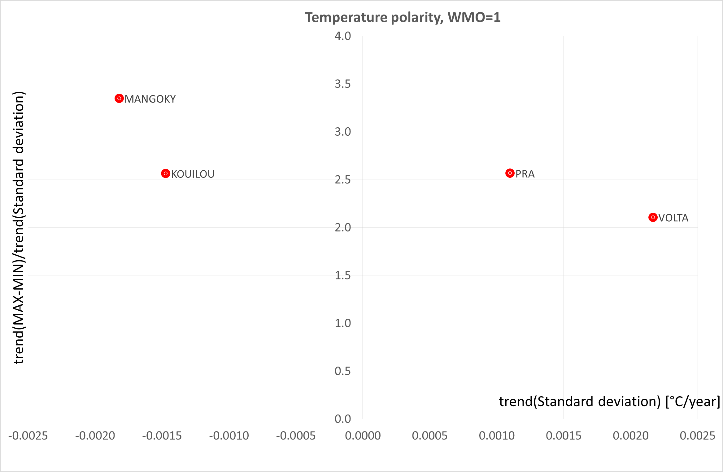
Figure 8. Watersheds in the region for which WMO_REG=1, in which significant polarisation trends were identified for monthly mean temperatures during the period from 1901 to 2010 at a significance level of 5%. Quadrant I is the area indicating an increase in the trend in amplitude and the trend in standard deviation (variability). Quadrant II gathers catchments in which both trends are negative.

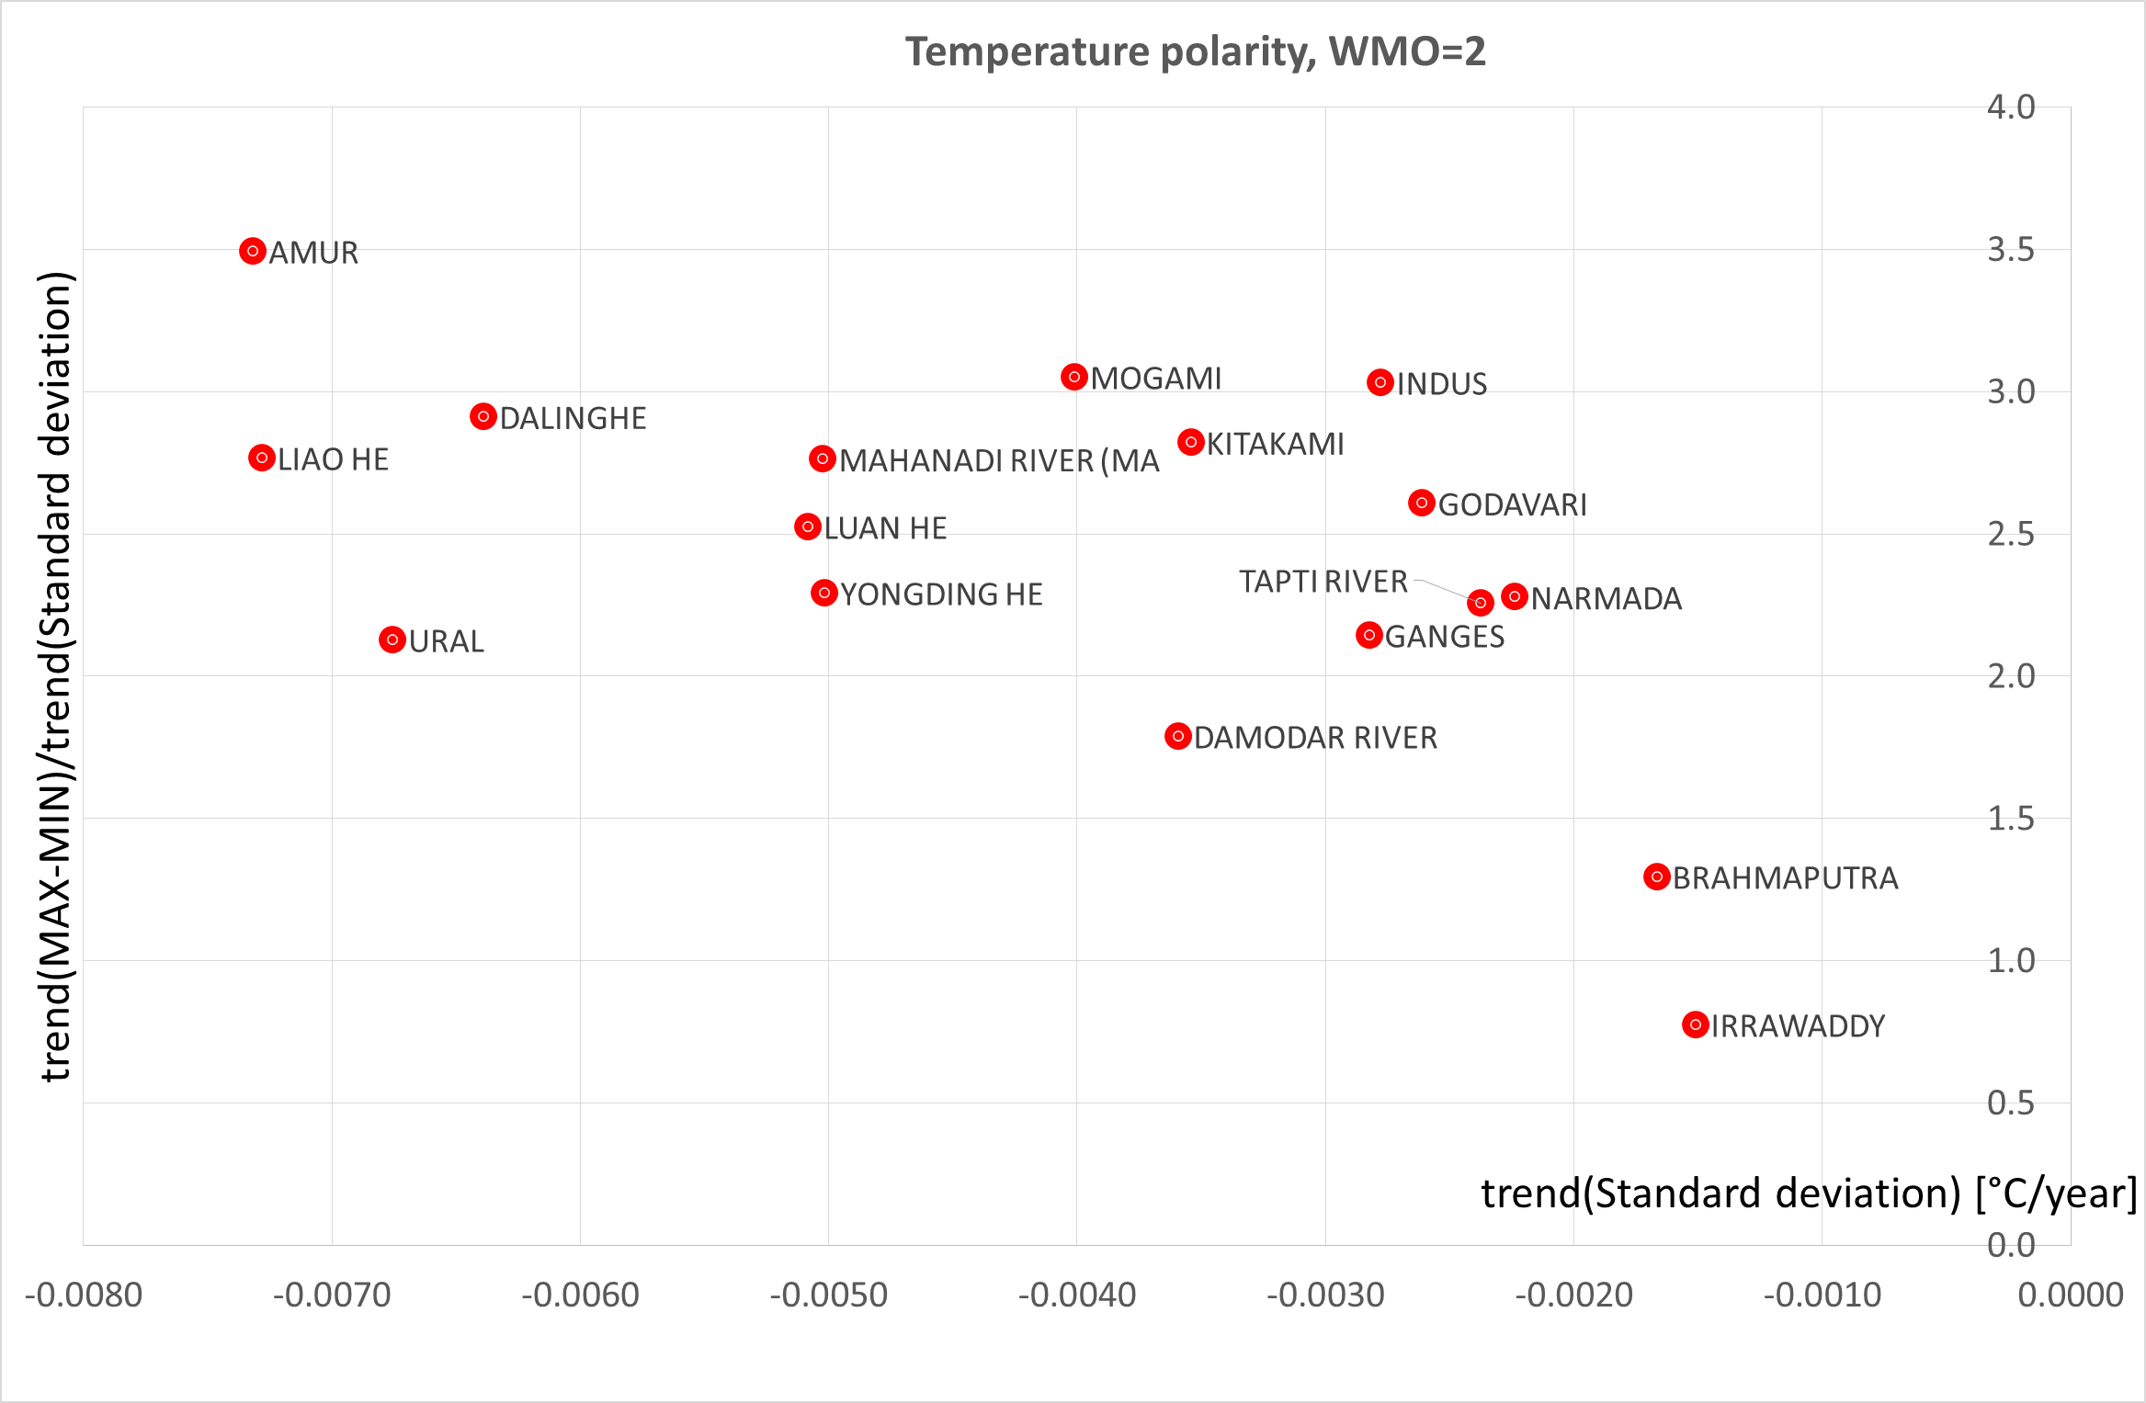
Figure 9. Watersheds in the region for which WMO_REG=2, in which significant polarisation trends were identified for monthly mean temperatures during the period from 1901 to 2010 at a significance level of 5%. Quadrant II gathers catchments in which both trends are negative.
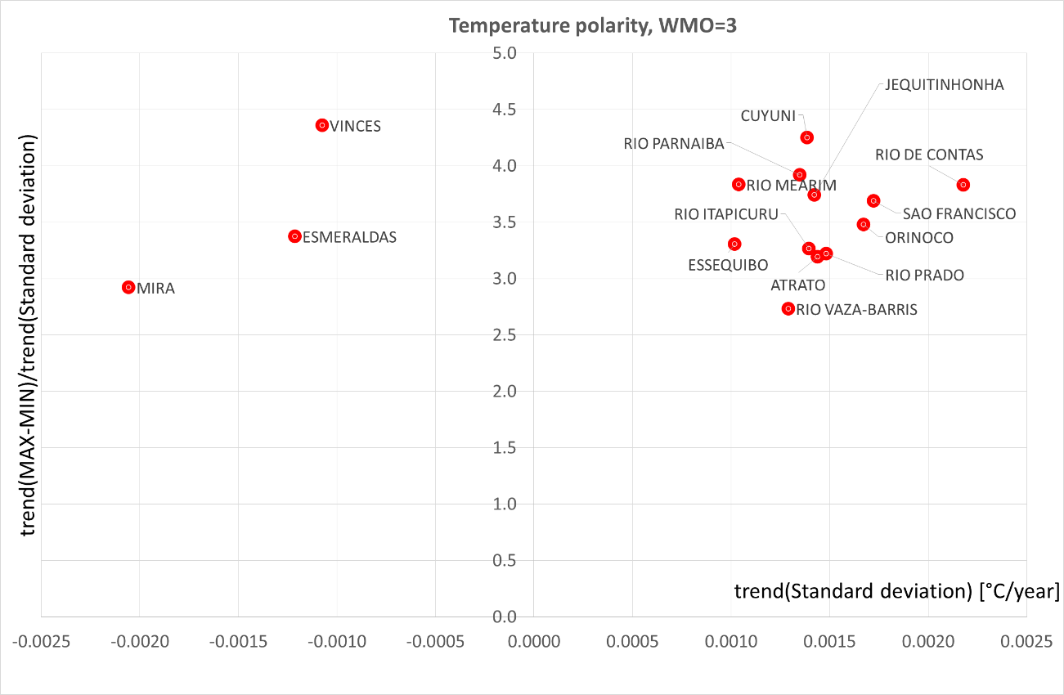
Figure 10. Watersheds in the region for which WMO_REG=3, in which significant polarisation trends were identified for monthly mean temperatures during the period from 1901 to 2010 at a significance level of 5%. Quadrant I is the area indicating an increase in the trend in amplitude and the trend in standard deviation (variability). Quadrant II gathers catchments in which both trends are negative.

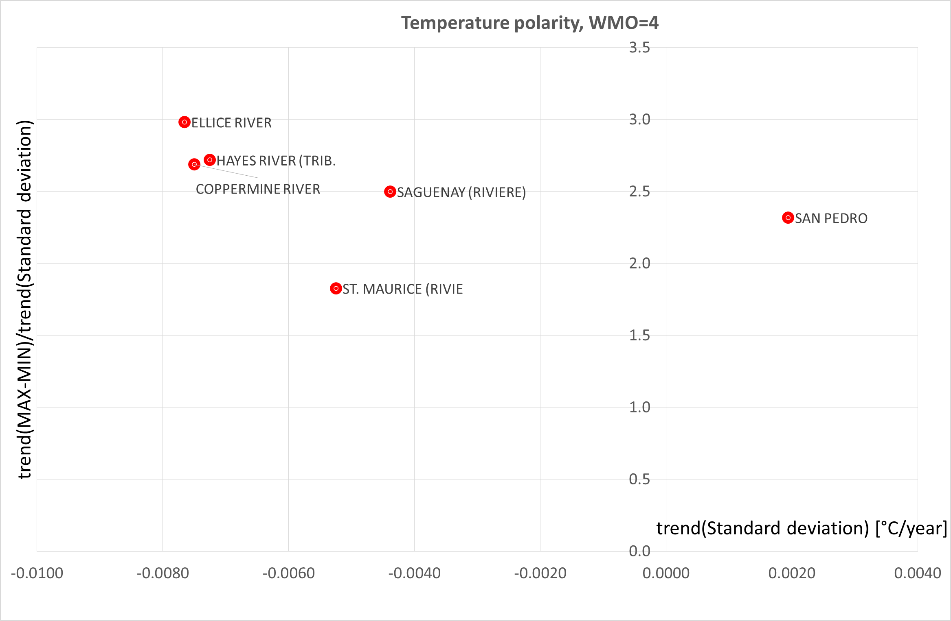
Figure 11. Watersheds in the region for which WMO_REG=4, in which significant polarisation trends were identified for monthly mean temperatures during the period from 1901 to 2010 at a significance level of 5%. Quadrant I is the area indicating an increase in the trend in amplitude and the trend in standard deviation (variability). Quadrant II gathers catchments in which both trends are negative.
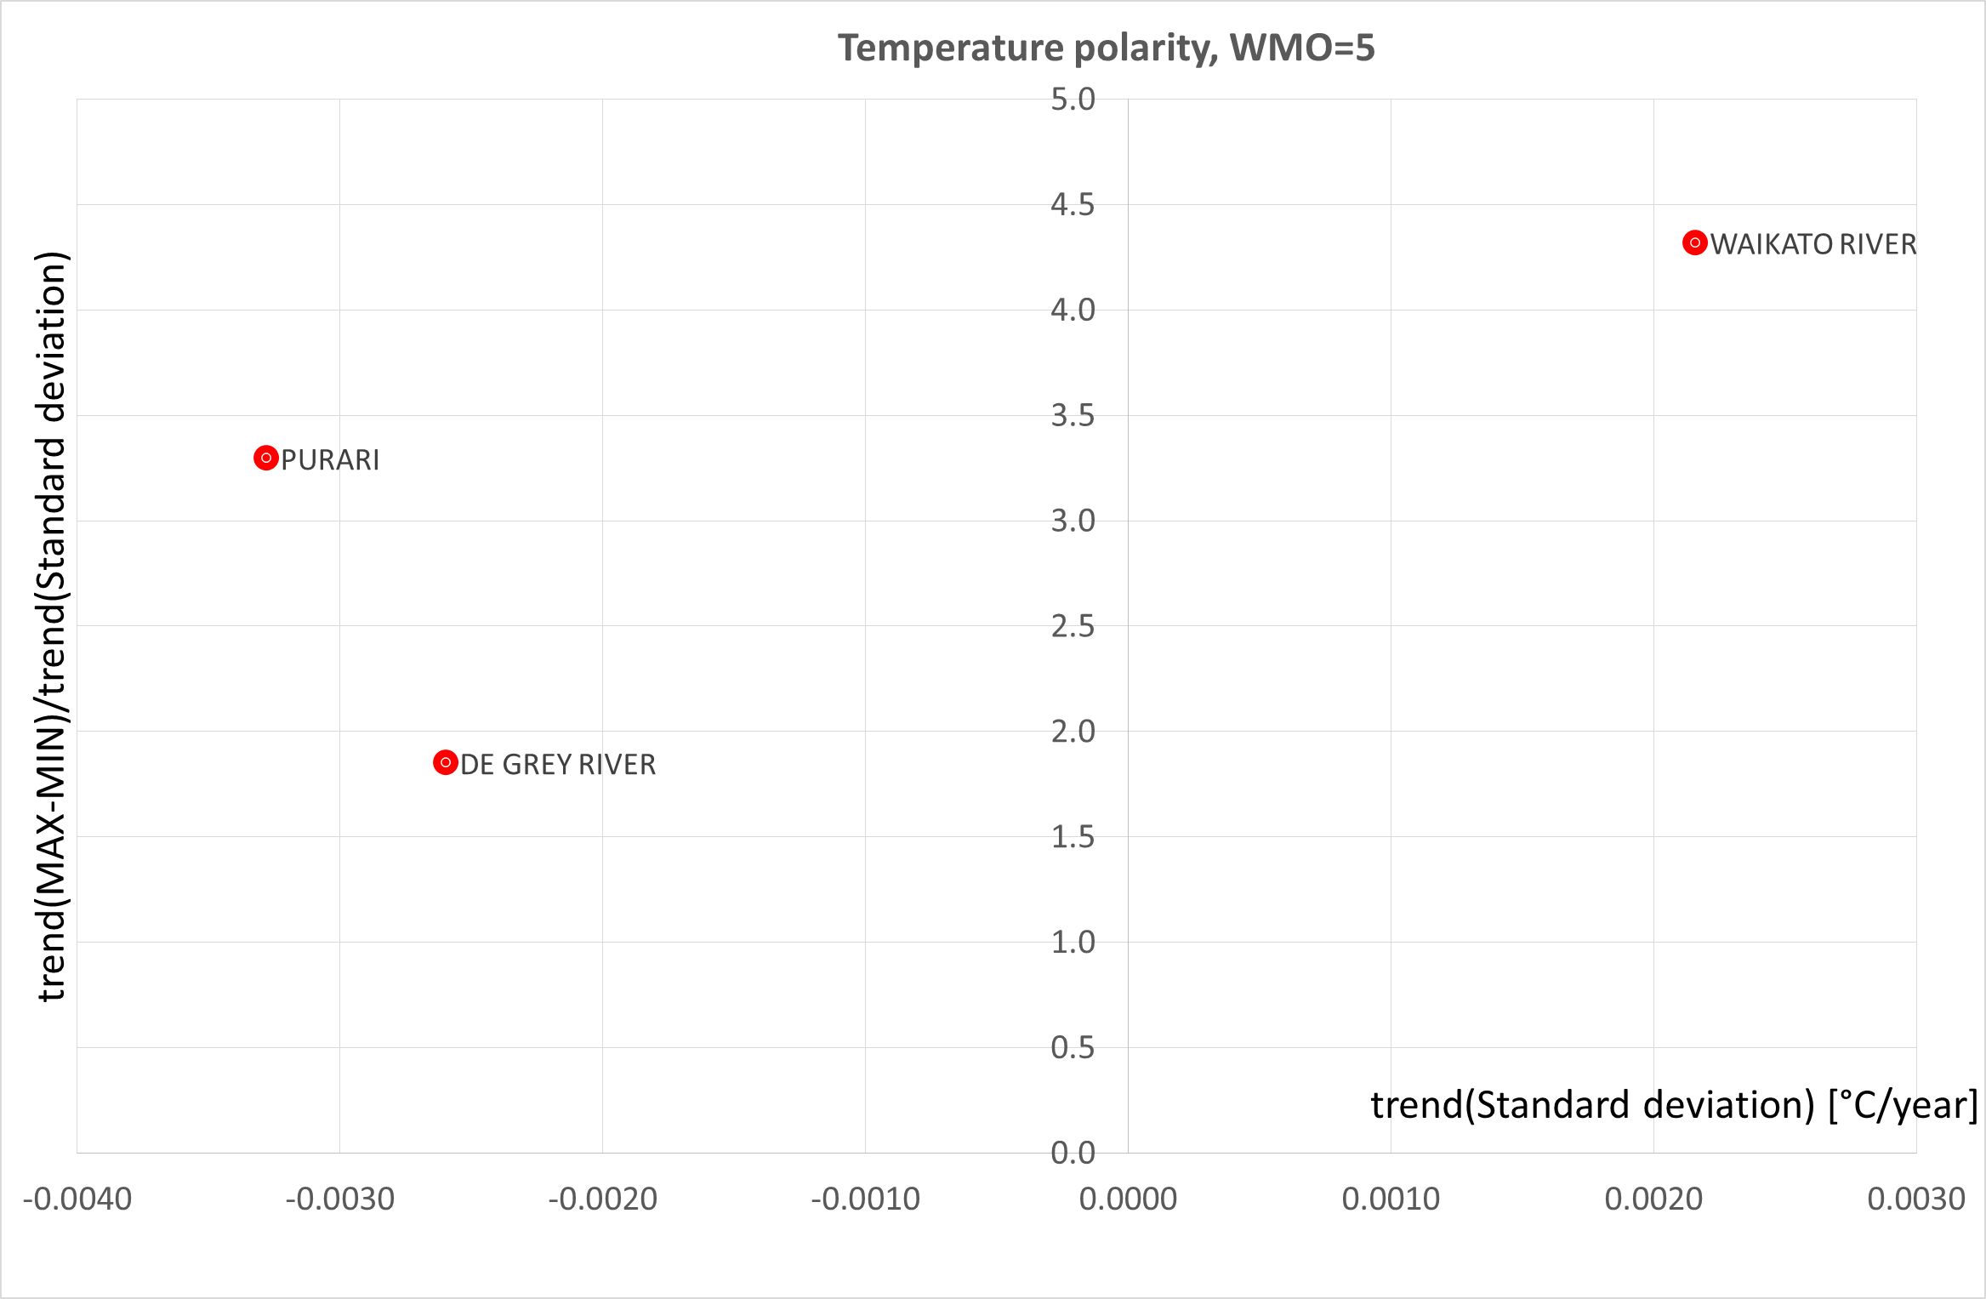
Figure 12. Watersheds in the region for which WMO_REG=5, in which significant polarisation trends were identified for monthly mean temperatures during the period from 1901 to 2010 at a significance level of 5%. Quadrant I is the area indicating an increase in the trend in amplitude and the trend in standard deviation (variability). Quadrant II gathers catchments in which both trends are negative.
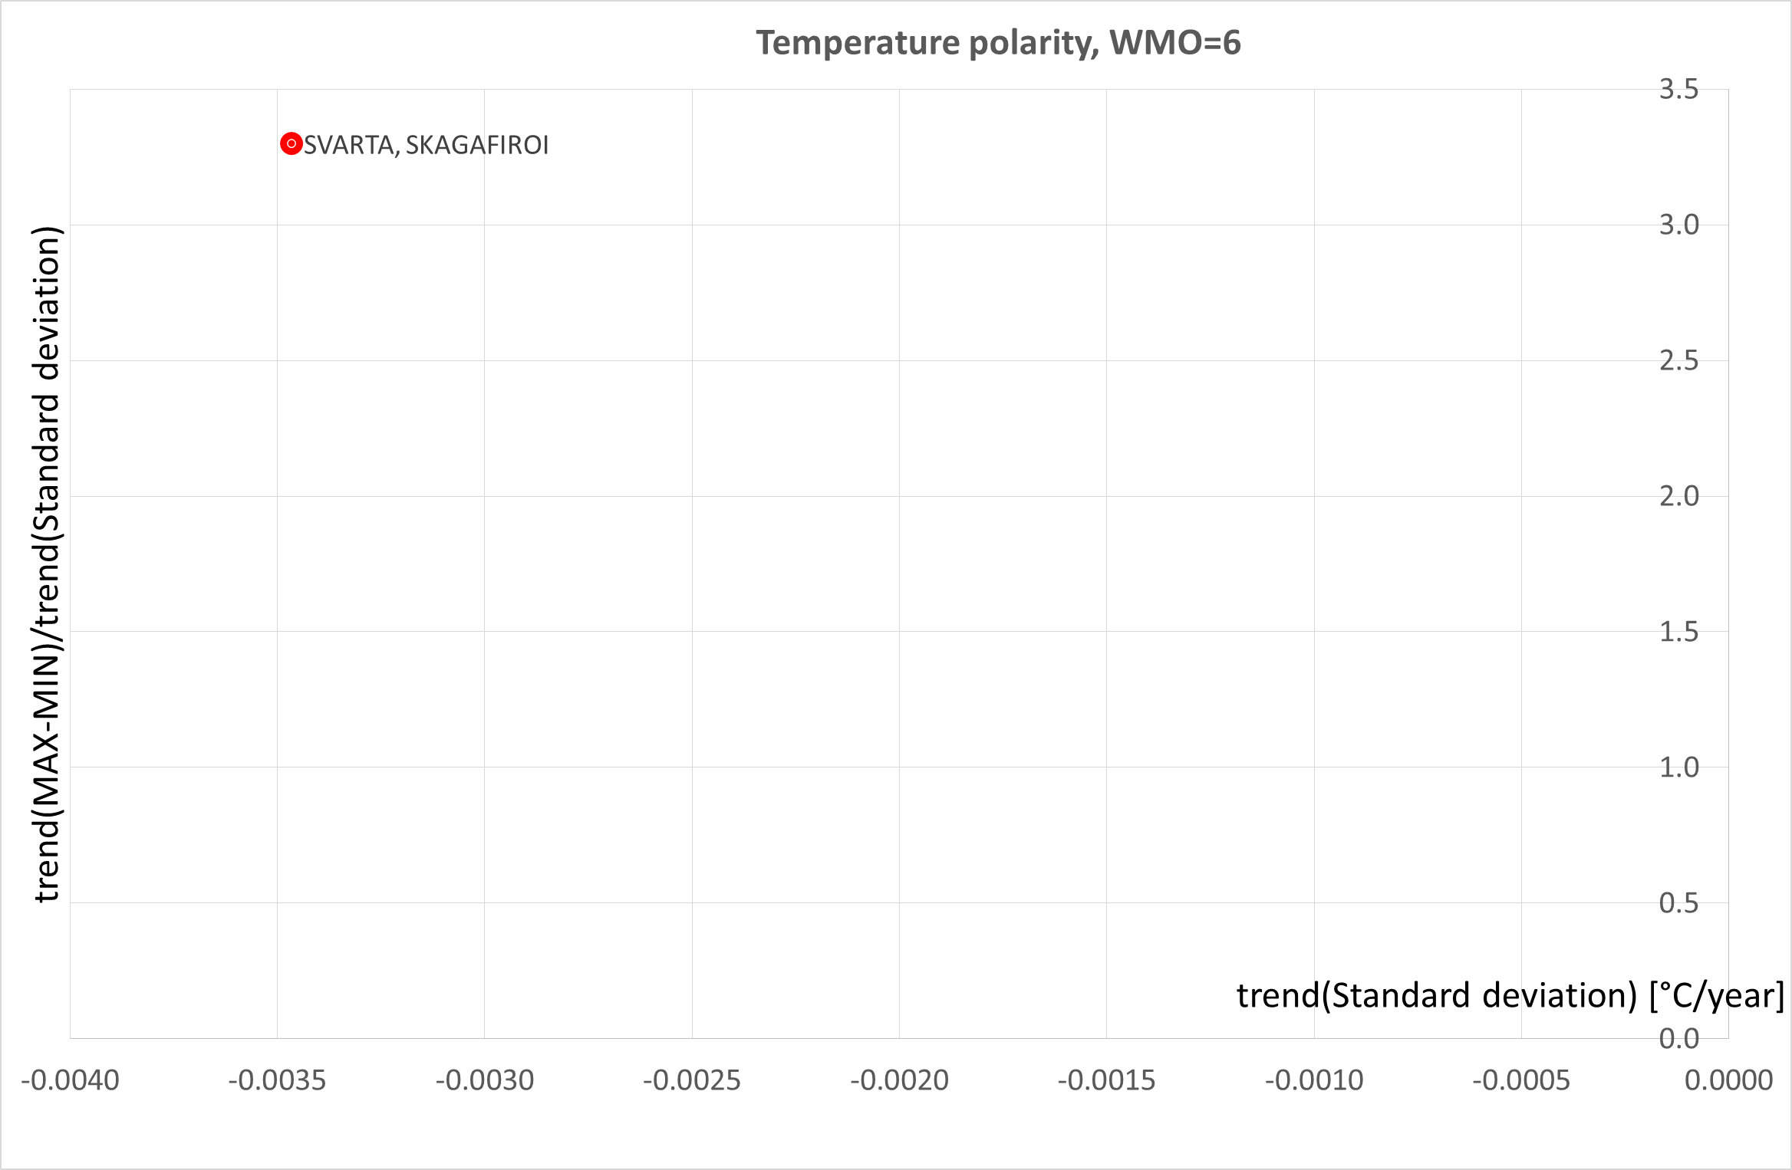
Figure 13. Watersheds in the region for which WMO_REG=6, in which significant polarisation trends were identified for monthly mean temperatures during the period from 1901 to 2010 at a significance level of 5%. Quadrant II gathers catchments in which both trends are negative.
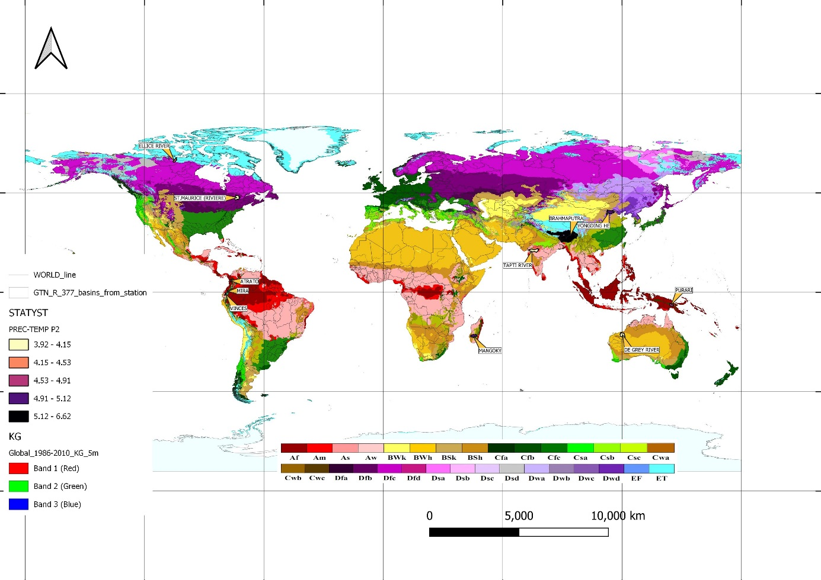
Figure 14. Image of polarisation of phenomena in the area of precipitation and temperatures against the Köppen-Geiger classification.

Table 5. River catchments with recognized strong polarity in areas of precipitation and temperature.
 |  |  |  |  | Precipitation |  |  |  | Temperature
No | RIVER | COUNTRY_TEMP | WMO_REG | Area | Precipitation slope estimator by Sen at 5% significance level |  |  | Modified sign | Temperature slope estimator by Sen at 5% significance level |  |  | Modified sign | Köppen-Geiger classification
 |  |  |  | [km²] | Trend(STD) | Trend(RANGE) | P₂ | P₂ | Trend(STD) | Trend(RANGE) | P₂ | P₂
15 | MANGOKY | MADAGASCAR | 1 | 53225 | -0.206 | -0.776 | 3.767 | -3.767 | -0.002 | -0.006 | 3.348 | -3.348 | Bsh (arid, summer dry, hot arid)  Aw (equatorial, winter dry)
45 | YONGDING HE | CHINA | 2 | 42500 | -0.085 | -0.391 | 4.574 | -4.574 | -0.005 | -0.012 | 2.293 | -2.293 | Bsk (arid, summer dry)  Dwb (snow, winter dry i warm summer)
75 | BRAHMAPUTRA | BANGLADESH | 2 | 636130 | -0.215 | -1.109 | 5.168 | -5.168 | -0.002 | -0.002 | 1.296 | -1.296 | ET (polar, polar tundra)  Cwa (warm temperature, winter dry, hot summer)
81 | TAPTI RIVER | INDIA | 2 | 61575 | 0.128 | 0.426 | 3.323 | 3.323 | -0.002 | -0.005 | 2.258 | -2.258 | Aw (equatorial, monsoonal)  As (equatorial, summer dry)
114 | ATRATO | COLOMBIA | 3 | 9432 | 0.350 | 1.084 | 3.096 | 3.096 | 0.001 | 0.005 | 3.192 | 3.192 | Af (equatorial, fully humid)
168 | MIRA | ECUADOR | 3 | 4960 | -0.110 | -0.382 | 3.463 | -3.463 | -0.002 | -0.006 | 2.921 | -2.921 | ET (polar, polar tundra )  Cfb (warm temperature, fully humid, warm summer)
171 | VINCES | ECUADOR | 3 | 4400 | 0.160 | 0.796 | 4.988 | 4.988 | -0.001 | -0.005 | 4.359 | -4.359 | As (equatorial, summer dry),  Am (equatorial, monsoonal)  Cfc (warm temperature, fully humid i cool summer).
233 | ELLICE RIVER | CANADA | 4 | 16900 | -0.043 | -0.148 | 3.411 | -3.411 | -0.008 | -0.023 | 2.982 | -2.982 | ET (polar, polar tundra),  Dfc (snow, fully humid, cool summer)
263 | ST. MAURICE | CANADA | 4 | 42000 | 0.076 | 0.265 | 3.472 | 3.472 | -0.005 | -0.010 | 1.826 | -1.826 | Dfb (snow, fully humid, cool summer)  Dfc (snow, fully humid, warm summer)
295 | PURARI | PAPUA NEW GUI | 5 | 11100 | -0.365 | -1.331 | 3.643 | -3.643 | -0.003 | -0.011 | 3.295 | -3.295 | Af (equatorial, fully humid)
301 | DE GREY RIVER | AUSTRALIA | 5 | 49600 | 0.144 | 0.536 | 3.715 | 3.715 | -0.003 | -0.005 | 1.850 | -1.850 | Bwh (arid, winter dry, hot arid)

