Crocus sativus, Olea europea and Salvia spp: role in neuroprotection against H₂O₂ and Aβ-peptide induced cell toxicity

Kofinas A¹, Pavlidis N¹, Andriopoulou CE¹, Epeslidou E¹, Leondaritis G^{1,2}, Angelis A³, Antoniadi L³, Skaltsounis LA³, and Konstandi M^{1,*}
¹Department of Pharmacology, Faculty of Medicine, University of Ioannina, Ioannina, Greece
² Institute of Biosciences (I.BS.), University Research Center of Ioannina (U.R.C.I.), Ioannina
³Department of Pharmacy, Division of Pharmacognosy and Natural Products Chemistry, National and Kapodistrian University of Athens, Athens, Greece

Corresponding author: Maria Konstandi; mkonstan@uoi.gr

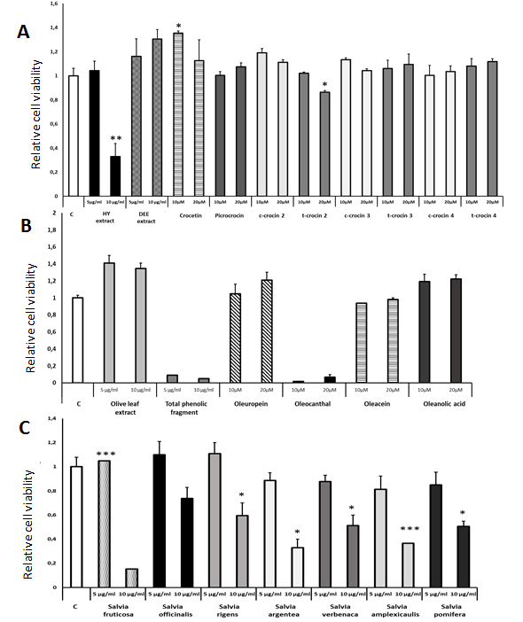

Supplementary Figure 1. Cytotoxicity of medicinal plant extracts and individual compounds.
The potential cytotoxicity of the medicinal plant extracts and reactive compounds was evaluated using differentiated human SH-SY5Y neuroblastoma cells, which were treated with the extracts or compounds for 48h. DMSO (0,2% v/v) was used as control and cell viability was assessed using the MTS assay. (A) Differentiated human SH-SY5Y neuroblastoma cells treated with different extracts of Crocus sativus and compounds. (B) Differentiated human SH-SY5Y neuroblastoma cells treated with different Olea europea leaf extracts and compounds. (C) Differentiated human SH-SY5Y neuroblastoma cells treated with Salvia spp leaf extracts. Treatment group differences were calculated using one-way ANOVA, followed by Bonferroni’s and Tuckey’s post-hoc tests; *P < 0.05, **P<0.01 and ***P< 0.001.

Supplementary Methods
Chromatographic isolation of secondary metabolites
Crocetin, Picrocrocin, cis- and trans- crocin 2, cis- and trans- crocin 3 and cis- and trans- crocin 4 are the main secondary metabolites of saffron hydroalcoholic extract. The separation protocol was previously described by Karkoula and co-workers (14) and includes the fractionation of saffron extract by Centrifugal Partition Chromatography (CPC) and the direct recovery of the target compounds in pure form. In more details, the analysis was performed on a preparative Fast Centrifugal Partition Chromatograph FCPC1000® (Rousselet-Robatel Kromaton, Anonay, France) equipped with a rotor of 1L and connected with a Prep36 LabAlliance (State College, PA, USA), a Büchi B−684 fraction collector (Flawil, Switzerland) and a SPECTRASYSTEM UV 2000 UV detector (Thermo Scientific, Illkirch, France). The experiment was carried out in step-gradient elution extrusion mode by using a series of five biphasic solvent systems consisting of n-Hept/EtOAc/BuOH/EtOH/H₂O in ratios: 4/10/0/4/10 (S1), 1/13/0/4 /10 (S2), 1/12/1/4/10 (S3), 1/10/3/4/10 (S4), 1/7/6/4/10 (S5). The lower phase of S1 was used as stationary phase while the upper phases of the five biphasic system were the mobile phases during the elution step and the lower phase of S5 was the mobile phase during the extrusion step. After equilibrating the two phases into the column, 10 g of the saffron extract were injected via a 30 mL injection loop (diluted in a ratio 7/3 lower phase/ upper phase of S1). The rotation speed was set at 850 rpm while the flow rate at 20 mL/min during the whole experiment.
Oleuropein is the most important compound of olive leaves and the main metabolite of the defatted acetone extract (approximately 40% of the extract). The separation process was based on the treatment of the extract using Centrifugal Partition Chromatography.
Oleocanthal, Oleacein and Oleanolic acid were obtained from the treatment of TPF using a well-established isolation protocol, which includes the initial fractionation o TPF by Centrifugal Partition Chromatography (CPC) (Angelis et al., 2017) and subsequently the further chromatographic purification of selected CPC fractions. The fractionation of TPF was performed on a Fast-Centrifugal Partition Chromatography FCPC1000 (Rousselet-Robatel Kromaton, Anonay, France) equipped with a 1 L preparative column. A step gradient elution extrusion method was applied in ascending mode using a series of the four biphasic systems composed of n-Нept: EtOAc: EtOH: H₂O in solvent ratios 4 :1 :3: 2 (S1), 3: 2: 3: 2 (S2), 2: 3: 3 :2 (S3) and 1 :4: 3:2 (S4), v/v/v/v. The flow rate was set at 15 mL/ min via a LabAlliance preparative pump, and the rotation speed at 900 rpm, respectively. 10 g of sample was injected into the column through a 30 mL loop (dissolved in 15 mL of upper S1 phase and 15 mL of lower S1 phase) after the equilibration of the two phases. Then, 1L of each upper phase (S1u, S2u, S3u, S4u) was pumped into the column (gradient elution step) and finally, the procedure was accomplished by extrusion the column content by pumping the lower stationary phase. 220 fractions of 20 mL were collected using a Büchi B‑684 fraction collector (Büchi Labortechnik AG, Flawil, Switzerland). All fractions were analyzed by TLC, and were combined based on their chemical similarity. The enriched in oleocanthal and oleacein fractions were further subjected to Prep-HPLC analysis in order to increase the purity of the target compounds (16).The experiments were run in a HPLC system equipped with two Prep Lab Alliance pumps, a SUPERCOSIL LC-18 (5 μm; SUPELCO) column (i. d. 21.2 × 250 mm), and a FLASH 06S DAD 600 detector (ECOM). The separations were achieved by using as mobile phase mixtures of AcN and H₂O in different proportions. For the oleocanthal purification the gradient method was as follow: 0 min - 80% H₂O, 20 min- 70% H₂O, 25 min– 10% H₂O and 30 – 80% H₂O. The purification of oleacein was achieved with the following gradient method: 0 min – 80% H₂O, 20 min- 70% H₂O, 25 min– 70% H₂O, 30 min– 10% H₂O and 35 – 80% H2O. Each injection was contacted to 100 mg of sample dissolved in 1 mL AcN. The flow rate was set at 15 mL/ min and the corresponding peaks were collected manually using UV chromatographs (at 280 nm). After evaporation of the collected samples the purity of the isolated compounds was calculated by HPLC-HRMS and NMR techniques and found higher than 95% for both compounds. Oleanolic acid was obtained from the corresponding enriched CPC fraction by using low pressure column chromatography. Normal phase Silica gel 60H® (0.04–0.06 mm) was used as stationary phase while mixtures of DCM, EtOAc and MeOH in increasing polarity mode were used as mobile phase. The fractions containing oleanolic acid were evaporated to dryness and the high purity of the isolated compound was checked by NMR.

