26th July 2023

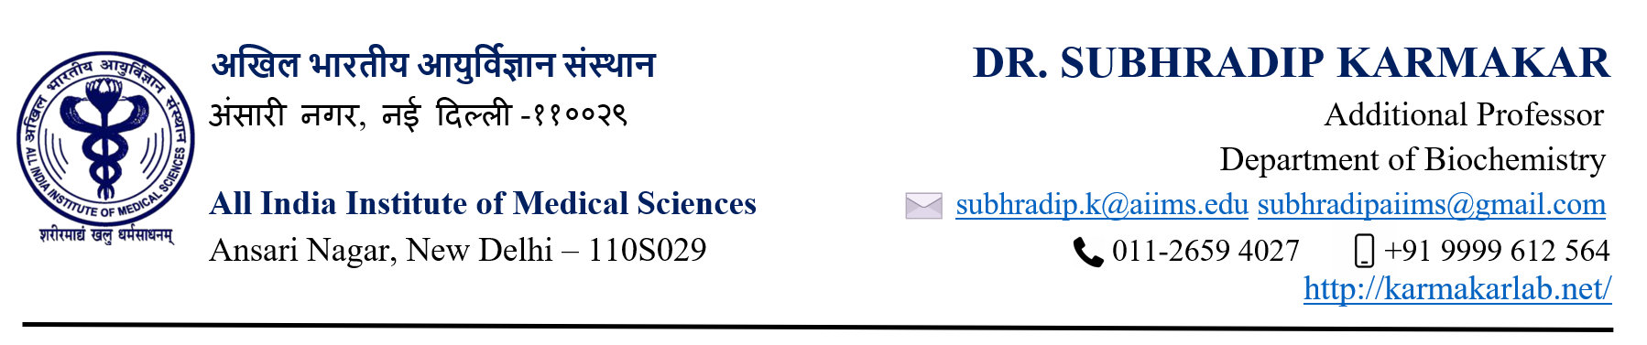
Dear Editor
We are glad to submit our review article titled :”The Paradigm of Immune dysregulation in COVID-19 infection”. In this manuscript, we investigated and summarized the effect of COVID-19 infection on human host and the sequel of inflammatory response that is initiated by the host to eliminate the virus. These events often get dysregulated resulting in immune mediated host injury. Vast majority of COVID related mortality is due to an elevated and dysregulated immune system. In this short review we investigated details into this process with clarity for a better understanding of viral infection process and its associated consequences.
We think our article will be of interest for wide range of audience. We confirm that this article is not communicated elsewhere.

Sincerely

Subhradip Karmakar( corresponding author)

