Supplementary Materials
Evaluation of synergistic effect of heteroaryl-ethylene molecules in combination with antibiotics: a preliminary study on control strains.
Carmelo Bonomo ^{1, †}, Paolo Giuseppe Bonacci ^{1, †}, Dalida Angela Bivona¹, Alessia Mirabile¹, Dafne Bongiorno ^{1, *}, Emanuele Nicitra¹, Andrea Marino², Carmela Bonaccorso^{3,*}, Giuseppe Consiglio³, Cosimo Gianluca Fortuna³, Stefania Stefani¹ and Nicolò Musso¹.
¹ Department of Biomedical and Biotechnological Sciences (BIOMETEC), Università degli Studi di Catania, Via S. Sofia, 89, 95123 Catania, Italy. carmelo.bonomo@phd.unict.it (C.B.); paolo.bonacci@phd.unict.it (P.G.B.); dalida.bivona@phd.unict.it (D.A.B.); alessiamirabile93@gmail.com (A.M.); dbongio@unict.it (D.B.); emanuelenicitra@gmail.com (E.N.); stefanis@unict.it (S.S.); nmusso@unict.it (N.M.).
² Unit of Infectious Diseases, Department of Clinical and Experimental Medicine, ARNAS Garibaldi Hospital, Università degli Studi di Catania, Via Palermo, 95122 Catania, Italy. andreamarino9103@gmail.com (A. Ma.).
³ Department of Chemical Sciences, Università degli Studi di Catania, Viale Andrea Doria 6, 95125 Catania, Italy. carmela.bonaccorso@unict.it (C. Bona.); giuseppe.consiglio@unict.it (G.C.); cg.fortuna@unict.it (C.G.F.).
* Correspondence: dbongio@unict.it (Microbiology Section), +393921210540; carmela.bonaccorso@unict.it (Chemistry Section), +393284723158-
† These authors contributed equally

Table of contents
Table S1. Structures of the 13 compounds added to the QSAR model for antimicrobial activity against S. aureus ATCC29213 | S2
Figure S1. Score plot of Principal Component Analysis (PCA) at the third component (PC1 vs PC2 vs PC3) for the 49 Heteroaromatic compounds tested for antimicrobial activity against S. aureus ATCC29213. | S4
Figure S2. Plot of the coefficient of determination R² and cross-validated coefficient of determination (leave-one-out, LOO) Q² vs. the number of LVs of the PLS models for antimicrobial activity against S. aureus ATCC29213. | S4
Figure S3. Plot of the Variable Influence on Projection VIP of the PLS models for antimicrobial activity against S. aureus ATCC29213. | S4
Figure S4. Plot of the Weights for VS+ descriptors at the third latent variable (LV1 vs LV2 vs LV3) of the PLS models for antimicrobial activity against S. aureus ATCC29213. | S5
Table S2. Structures of the 38 heteroaryl ethylene compounds of the QSAR model for cytotoxic activity towards CaCo2 colon-rectal cancer cell line | S6
Figure S5. Score plot of Principal Component Analysis (PCA) at the third component (PC1 vs PC2 vs PC3) for the 38 Heteroaromatic compounds tested for cytotoxic activity towards CaCo2 colon-rectal cancer cell line. | S11
Figure S6. Plot of the coefficient of determination R² and cross-validated coefficient of determination (leave-one-out, LOO) Q² vs. the number of LVs of the PLS models for cytotoxic activity towards CaCo2 colon-rectal cancer cell line. | S11
Figure S7. Plot of the Variable Influence on Projection VIP of the PLS models for cytotoxic activity towards CaCo2 colon-rectal cancer cell line. | S11
Figure S8. Plot of the Weights for VS+ descriptors at the third latent variable (LV1 vs LV2 vs LV3) of the PLS models for cytotoxic activity towards CaCo2 colon-rectal cancer cell line. | S12
Table S3. Dunnett’s multiple comparisons test performed for all combinations. | S13

Table S1. Structures of the 13 compounds added to the QSAR model for antimicrobial activity against S. aureus ATCC29213 [1]
Molecules & Smiles string | ID VS+ | MIC (µg/mL) | [Ref]
CN(C)c1ccc(\C=C\c2ccc3ccccc3[n+]2C)cc1 | PB1 | 4
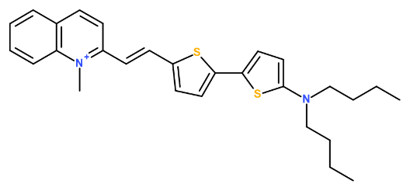  CCCCN(CCCC)c1ccc(s1)c2ccc(\C=C\c3ccc4ccccc4[n+]3C)s2 | PB2 | 4
C[n+]1c(\C=C\c2ccc(s2)c3ccccc3)ccc4ccccc14 | PB3 | 4
CN(C)c1ccc(\C=C\c2cccc(\C=C\c3ccc(cc3)N(C)C)[n+]2C)cc1 | PB4 | 0.25
Clc1ccc(Cl)c(c1)c2oc(\C=C\c3cc[n+](cc3)c4ncccn4)cc2 | PB5 | 1
C[n+]1ccc(\C=C\c2oc(cc2)c3cc(Cl)ccc3Cl)cc1 | PB6 | 4
CC[n+]1ccc2\C(=C\c3oc(cc3)c4ccc(Cl)cc4)\CCCc2c1 | PB7 | 4
CCCCN(CCCC)c1ccc(s1)c2ccc(\C=C\3/CCCc4c[n+](CC)ccc34)s2 | PB8 | 2 | [1]

Table S1. Continue
CC[n+]1ccc2\C(=C\c3ccccc3O)\CCCc2c1 | BCNAc1 | >128 | [1]
CC[n+]1ccc2\C(=C\c3ccc(cc3)N(C)C)\CCCc2c1 | BCM3 | 64 | [1]
C[n+]1c(\C=C\c2cc(Cl)ccc2O)cccc1\C=C\c3cc(Cl)ccc3O | BCM12 | >128 | [1]
CC[n+]1c(\C=C\c2cn(CC)c3ccccc23)ccc4ccccc14 | SQL | 4 | [2]
CC[n+]1c(\C=C\c2cn(CC)c3ccccc23)sc4ccccc14 | SBT | 1 | [2]
*Unpublished results

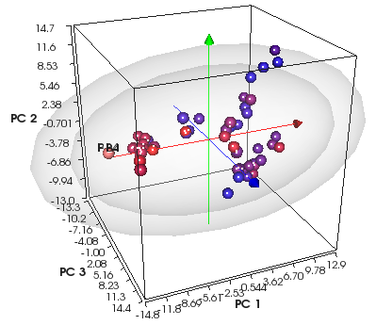
Figure S1. Score plot of Principal Component Analysis (PCA) at the third component (PC1 vs PC2 vs PC3) for the 49 Heteroaromatic compounds tested for antimicrobial activity against S. aureus ATCC29213. Compounds are color-coded by their activity values, using a scale from red (actives) to blue (inactives), according to the experimental MIC values.

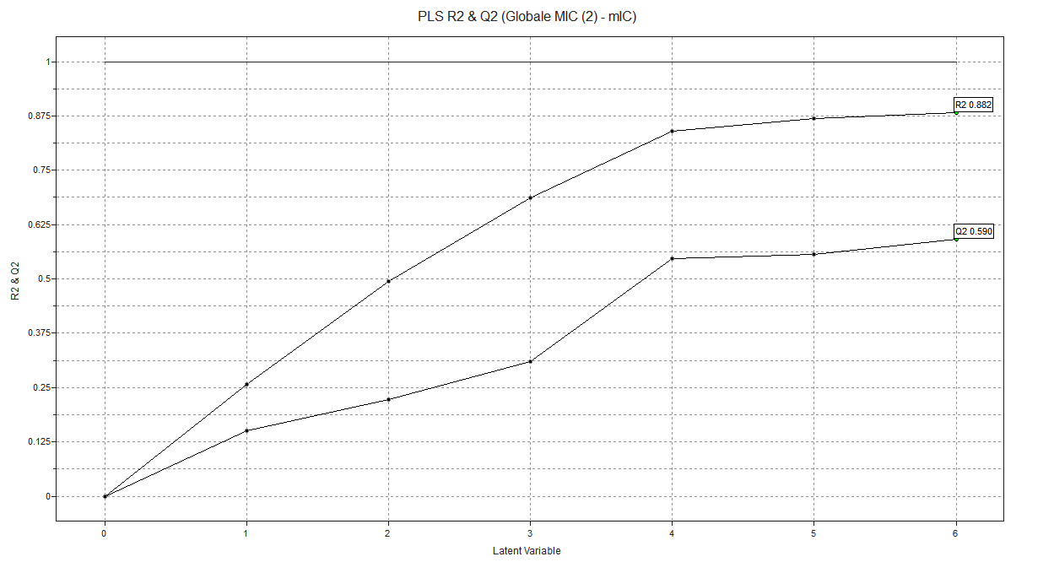
Figure S2. Plot of the coefficient of determination R² and cross-validated coefficient of determination (leave-one-out, LOO) Q² vs. the number of LVs of the PLS models for antimicrobial activity against S. aureus ATCC29213.

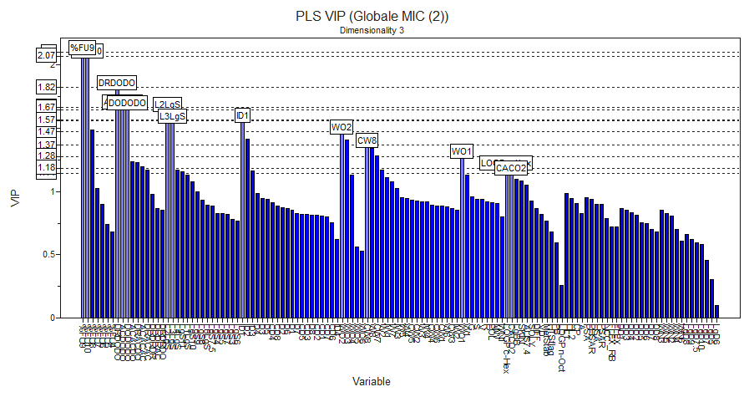
Figure S3. Plot of the Variable Influence on Projection VIP of the PLS models for antimicrobial activity against S. aureus ATCC29213.

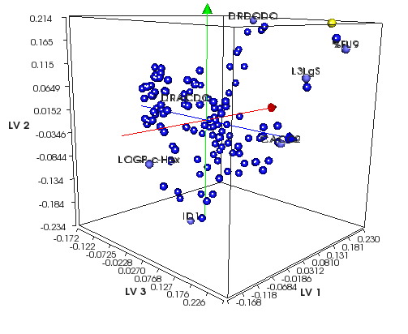
Figure S4. Plot of the Weights for VS+ descriptors at the third latent variable (LV1 vs LV2 vs LV3) of the PLS models for antimicrobial activity against S. aureus ATCC29213. The yellow circle represents the dependent variable (MIC).

Table S2. Structures of the 38 heteroaryl ethylene compounds of the QSAR model for cytotoxic activity towards CaCo2 colon-rectal cancer cell line
Molecules & Smiles string | ID VS+ | IC₅₀ 48h | Log(IC₅₀) 48h
C[n+]1c(\C=C\c2ccc(s2)c3ccc(s3)N4CCCCC4)ccc5ccccc15 | BC1 | 20 | 1.30
N#CC(=Cc1ccc(s1)c2ccc(s2)N3CCCCC3)C#N | BC2 | 100 | 2
CCOC(=O)\C(=C\c1ccc(s1)c2ccc(s2)N3CCCCC3)\C#N | BC3 | 250 | 2.40
OC(=O)\C(=C\c1ccc(s1)c2ccc(s2)N3CCCCC3)\C#N | BC4 | 250 | 2.40
C[n+]1ccccc1\C=C\c2ccc(cc2)c3cncnc3 | BC5 | 100 | 2
C[n+]1c(\C=C\c2ccc(cc2)c3cncnc3)ccc4ccccc14 | BC6 | 25 | 1.5
CCCCN(CCCC)c1ccc(s1)c2ccc(\C=C\c3ccc(c[n+]3C)C(=O)O)s2 | BCG3 | 8 | 0.90
CC[n+]1ccc2\C(=C\c3ccc(cc3)N(C)C)\CCCc2c1 | BCM3 | 1.35 | 0.13
COc1ccc(\C=C\c2cccc(\C=C\c3ccc(OC)cc3)[n+]2C)cc1 | BCM6 | 12.34 | 1.09

Table S2. Continue
C[n+]1c(\C=C\c2cc(Cl)ccc2O)cccc1\C=C\c3cc(Cl)ccc3O | BCM12 | 250 | 2.40
COc1cc(\C=C\c2cccc[n+]2C)cc(OC)c1OC | GC VI 2 | 250 | 2.40
C[n+]1ccccc1\C=C\c2ccc3ccc4CC=CC5C=Cc2c3c45 | GC VI 3 | 0.9 | -0.0458
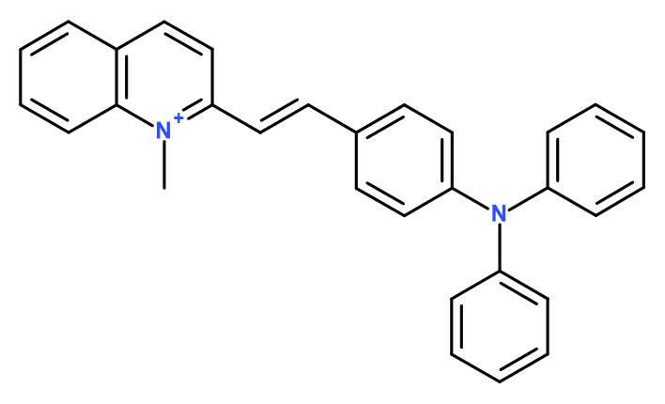  C[n+]1c(\C=C\c2ccc(cc2)N(c3ccccc3)c4ccccc4)ccc5ccccc15 | GC VI 14 | 4 | 0.602
CN(C)c1ccc(\C=C\c2cc[n+](C)cc2)cc1 | GC VI 17 | 8 | 0.903
CN(C)c1ccc(\C=C(/C#N)\c2cccc[n+]2C)cc1 | GC VI 26 | 100 | 2
CN(C)c1ccc(\C=C\C=C\c2cc[n+](C)cc2)cc1 | GC VI 45 | 16 | 1.20
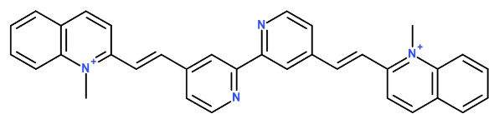  C[n+]1c(\C=C\c2ccnc(c2)c3cc(\C=C\c4ccc5ccccc5[n+]4C)ccn3)ccc6ccccc16 | GC VI 71 | 51.2 | 1.71
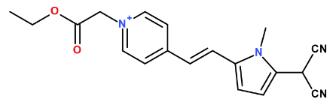  CCOC(=O)C[n+]1ccc(\C=C\c2ccc(C(C#N)C#N)n2C)cc1 | GC VII 13 | 100 | 2

Table S2. Continue
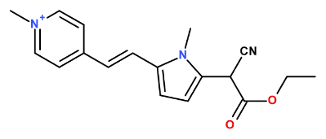  CCOC(=O)C(C#N)c1ccc(\C=C\c2cc[n+](C)cc2)n1C | GC VII 16 | 70 | 1.85
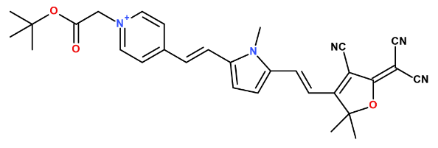  Cn1c(\C=C\C2=C(C#N)C(=C(C#N)C#N)OC2(C)C)ccc1\C=C\c3cc[n+]  (CC(=O)OC(C)(C)C)cc3 | GC VII 41 | 100 | 2
C[n+]1ccccc1\C=C\c2ccc3ccccc3c2 | GC VII 46 | 5.5 | 0.740
C[n+]1ccccc1\C=C\c2ccc(cc2)N(c3ccccc3)c4ccccc4 | GC VII 47 | 1 | 0
Cn1c(\C=C\C2=CC=C3C=CC=CC3=[N]2C)ccc1\C=C\c4ccncc4 | GF I 10 | 20 | 1.30
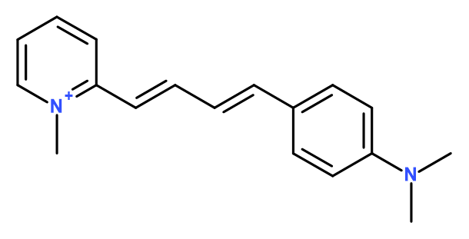  CN(C)c1ccc(\C=C\C=C\c2cccc[n+]2C)cc1 | GF I 25 | 10 | 1
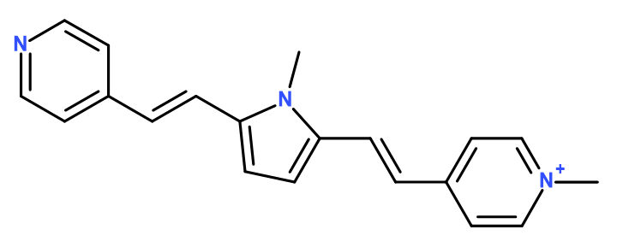  C[n+]1ccc(\C=C\c2ccc(\C=C\c3ccncc3)n2C)cc1 | GF I 30 | 50 | 1.70
C[n+]1ccc(\C=C\c2ccc(C=C(C#N)C#N)n2C)cc1 | GF I 31 | 100 | 2
C[n+]1ccc(\C=C\c2ccc(\C=C\C3=C(C#N)C(=C(C#N)C#N)OC3(C)C)n2C)cc1 | GF I 32 | 32 | 1.51

Table S2. Continue
CN(C)c1ccc(\C=C\c2ccc3ccccc3[n+]2C)cc1 | PB1 | 0.35 | -0.456
CCCCN(CCCC)c1ccc(s1)c2ccc(\C=C\c3ccc4ccccc4[n+]3C)s2 | PB2 | 0.18 | -0.745
C[n+]1c(\C=C\c2ccc(s2)c3ccccc3)ccc4ccccc14 | PB3 | 1.3 | 0.114
CN(C)c1ccc(\C=C\c2cccc(\C=C\c3ccc(cc3)N(C)C)[n+]2C)cc1 | PB4 | 0.33 | -0.481
Clc1ccc(Cl)c(c1)c2oc(\C=C\c3cc[n+](cc3)c4ncccn4)cc2 | PB5 | 0.95 | 0.246
C[n+]1ccc(\C=C\c2oc(cc2)c3cc(Cl)ccc3Cl)cc1 | PB6 | 3.22 | 0.508
CC[n+]1ccc2\C(=C\c3oc(cc3)c4ccc(Cl)cc4)\CCCc2c1 | PB7 | 1.36 | 0.134
CCCCN(CCCC)c1ccc(s1)c2ccc(\C=C\3/CCCc4c[n+](CC)ccc34)s2 | PB8 | 5.04 | 0.702
COc1ccc(\C=C\c2ccc3ccc4ccc(\C=C\c5ccc(OC)cc5)nc4c3n2)cc1 | PB9 | 250 | 2.40

Table S2. Continue
CN(C)c1ccc(\C=C\c2ccc3ccc4ccc(\C=C\c5ccc(cc5)N(C)C)nc4c3n2)cc1 | PB10 | 10.6 | 1.03
C(=C\c1ccc2ccc3ccc(\C=C\c4ccc(cc4)N(c5ccccc5)c6ccccc6)nc3c2n1)/c7ccc(cc7)N  (c8ccccc8)c9ccccc9 | PB11 | 11.5 | 1.06

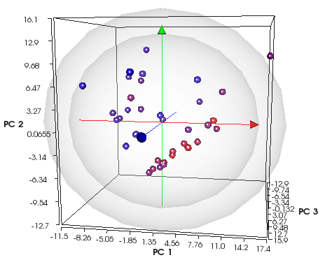
Figure S5. Score plot of Principal Component Analysis (PCA) at the third component (PC1 vs PC2 vs PC3) for the 38 Heteroaromatic compounds tested for cytotoxic activity towards CaCo2 colon-rectal cancer cell line. Compounds are color-coded by their activity values, using a scale from red (actives) to blue (inactives), according to the experimental MIC values.

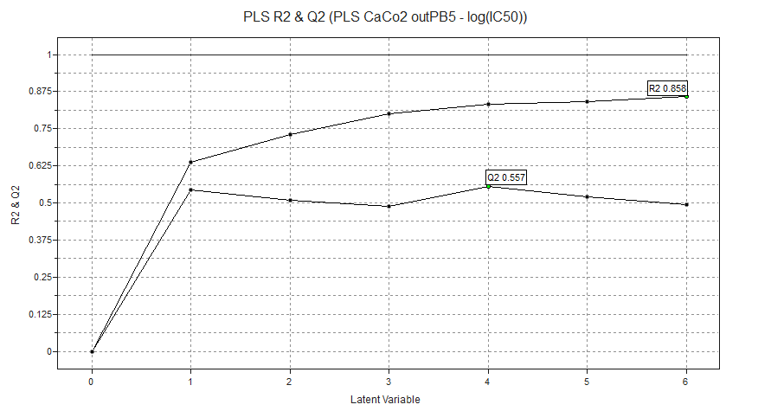
Figure S6. Plot of the coefficient of determination R² and cross-validated coefficient of determination (leave-one-out, LOO) Q² vs. the number of LVs of the PLS models for cytotoxic activity towards CaCo2 colon-rectal cancer cell line.

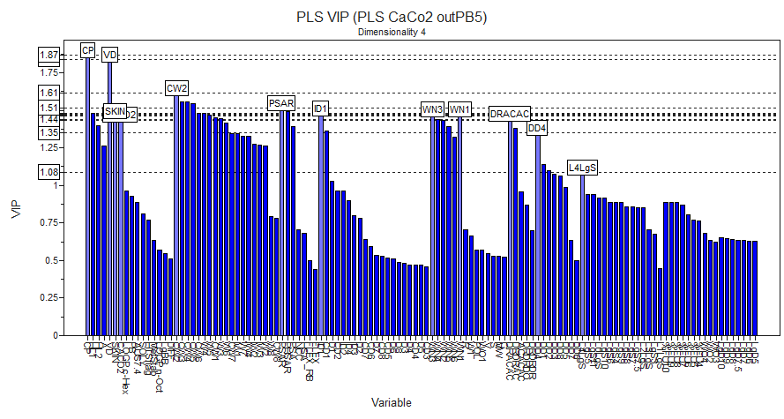
Figure S7. Plot of the Variable Influence on Projection VIP of the PLS models for cytotoxic activity towards CaCo2 colon-rectal cancer cell line.

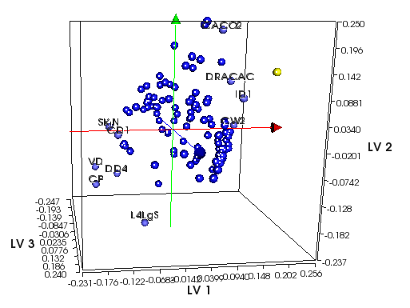
Figure S8. Plot of the Weights for VS+ descriptors at the third latent variable (LV1 vs LV2 vs LV3) of the PLS models for cytotoxic activity towards CaCo2 colon-rectal cancer cell line. The yellow circle represents the dependent variable the logarithm of the IC₅₀.

Table S3. Dunnett’s multiple comparisons test performed for all combinations.
Dunnett's multiple comparisons test | Mean Diff | 95% CI of diff | Below threshold? | Summary | Adjusted P Value
ANTIBIOTICS 24h
Untreated vs. T0 | 48,44 | 29,50 to 67,39 | Yes | **** | <0,0001
Untreated vs. Linezolid MIC | -3,090 | -36,67 to 30,49 | No | ns | 0,9997
Untreated vs. Linezolid subMIC | 7,008 | -26,57 to 40,59 | No | ns | 0,9993
Untreated vs. Gentamicin MIC | -7,797 | -41,38 to 25,78 | No | ns | 0,9992
Untreated vs. Gentamicin subMIC | 18,12 | -15,46 to 51,70 | No | ns | 0,7346
Untreated vs. Ampicillin MIC | 2,723 | -30,86 to 36,30 | No | ns | 0,9998
Untreated vs. Ampicillin subMIC | -5,167 | -38,75 to 28,41 | No | ns | 0,9996
Untreated vs. Erythromycin MIC | 2,213 | -31,37 to 35,79 | No | ns | 0,9998
Untreated vs. Erythromycin subMIC | -9,070 | -42,65 to 24,51 | No | ns | 0,9963
Untreated vs. Rifampicin MIC | 16,68 | -16,90 to 50,26 | No | ns | 0,8188
Untreated vs. Rifampicin subMIC | 3,783 | -29,80 to 37,36 | No | ns | 0,9997
ANTIBIOTICS + PB4 0,2 µM 24h
Untreated vs. T0 | 52,99 | 37,65 to 68,32 | Yes | **** | <0,0001
Untreated vs. Linezolid MIC | 10,99 | -16,19 to 38,17 | No | ns | 0,9435
Untreated vs. Linezolid subMIC | 22,91 | -4,265 to 50,09 | No | ns | 0,1618
Untreated vs. Gentamicin MIC | 29,40 | 2,225 to 56,58 | Yes | * | 0,0252
Untreated vs. Gentamicin subMIC | 22,53 | -4,648 to 49,71 | No | ns | 0,1778
Untreated vs. Ampicillin MIC | 21,13 | -6,045 to 48,31 | No | ns | 0,2471
Untreated vs. Ampicillin subMIC | 19,39 | -7,785 to 46,57 | No | ns | 0,3570
Untreated vs. Erythromycin MIC | 21,39 | -5,793 to 48,56 | No | ns | 0,2332
Untreated vs. Erythromycin subMIC | 30,08 | 2,905 to 57,26 | Yes | * | 0,0202
Untreated vs. Rifampicin MIC | 28,09 | 0,9099 to 55,27 | Yes | * | 0,0380
Untreated vs. Rifampicin subMIC | 24,31 | -2,865 to 51,49 | No | ns | 0,1126
ANTIBIOTICS 48h
Untreated vs. T0 | 136,6 | 104,1 to 169,1 | Yes | **** | <0,0001
Untreated vs. Linezolid MIC | -14,37 | -71,94 to 43,20 | No | ns | 0,9968
Untreated vs. Linezolid subMIC | -9,069 | -66,64 to 48,50 | No | ns | 0,9995
Untreated vs. Gentamicin MIC | -8,939 | -66,51 to 48,63 | No | ns | 0,9995
Untreated vs. Gentamicin subMIC | -33,12 | -90,69 to 24,45 | No | ns | 0,6570
Untreated vs. Ampicillin MIC | -82,54 | -140,1 to -24,97 | Yes | *** | 0,0008
Untreated vs. Ampicillin subMIC | -8,984 | -66,55 to 48,58 | No | ns | 0,9995
Untreated vs. Erythromycin MIC | -30,40 | -87,97 to 27,16 | No | ns | 0,7585
Untreated vs. Erythromycin subMIC | -42,07 | -99,64 to 15,50 | No | ns | 0,3247
Untreated vs. Rifampicin MIC | -44,02 | -101,6 to 13,54 | No | ns | 0,2669
Untreated vs. Rifampicin subMIC | -27,05 | -84,62 to 30,51 | No | ns | 0,8635
ANTIBIOTICS + PB4 0,2 µM 48h
Untreated vs. T0 | 84,25 | 63,16 to 105,3 | Yes | **** | <0,0001
Untreated vs. Linezolid MIC | 40,56 | 3,180 to 77,95 | Yes | * | 0,0245
Untreated vs. Linezolid subMIC | 55,66 | 18,28 to 93,05 | Yes | *** | 0,0005
Untreated vs. Gentamicin MIC | 41,74 | 4,358 to 79,13 | Yes | * | 0,0186
Untreated vs. Gentamicin subMIC | 86,73 | 49,35 to 124,1 | Yes | **** | <0,0001
Untreated vs. Ampicillin MIC | 58,50 | 21,12 to 95,89 | Yes | *** | 0,0002
Untreated vs. Ampicillin subMIC | 49,22 | 11,83 to 86,60 | Yes | ** | 0,0028
Untreated vs. Erythromycin MIC | 70,36 | 32,97 to 107,7 | Yes | **** | <0,0001
Untreated vs. Erythromycin subMIC | 30,43 | -6,955 to 67,81 | No | ns | 0,1963
Untreated vs. Rifampicin MIC | 27,48 | -9,900 to 64,87 | No | ns | 0,3169
Untreated vs. Rifampicin subMIC | 22,49 | -14,89 to 59,88 | No | ns | 0,5974

