Supplementary materials

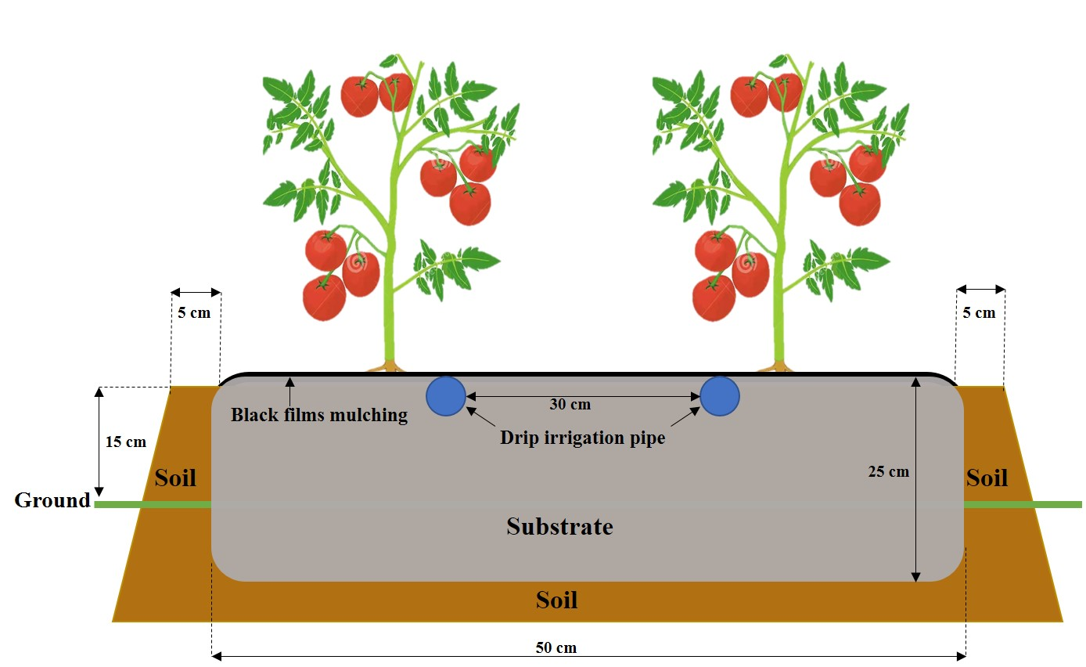
Fig.S1 Schematic of SMC substrate cultivation of greenhouse tomatoes.
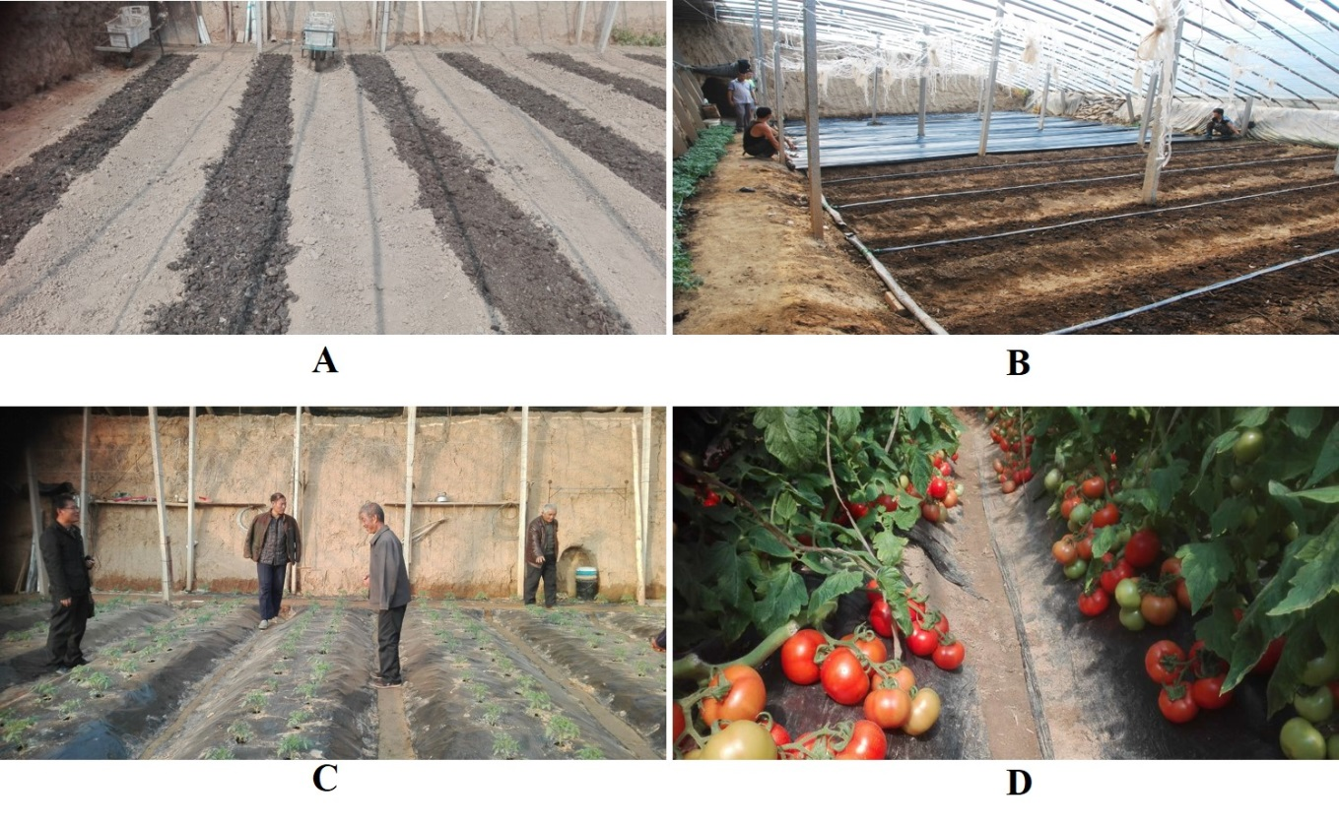
Fig.S2 Photographs of main SMC substrate cultivation processes in greenhouse.
(A) Soil preparation and substrate stuffing, (B) Laying of drip irrigation pipe and black film mulching, (C) Seedling stage, (D) Harvesting period.
Fig.S3 Bacterial (a) and fungal (b) community composition at the phyla level. See table S1 for the abbreviations of different cultivation duration of the substrate and the surrounding soil.

Table S1 The treatments and abbreviations of different cultivation duration of the substrate and the surrounding soil
Abbr. | Treatments
Sub CK | Substrate after fermented and composted but no planting in the testing greenhouse
Sub 1yr | Substrate after planting 1year in the testing greenhouse
Sub 3yr | Substrate after planting 3 years in the testing greenhouse
Sub 7yr | Substrate after planting 7 years in the testing greenhouse
Soil CK | continuous mono-cropping soil in the testing greenhouse
Soil 1yr | Surrounding soil of 1-yr substrate in the testing greenhouse
Soil 3yr | Surrounding soil of 3-yr substrate in the testing greenhouse
Soil 7yr | Surrounding soil of 7-yr substrate in the testing greenhouse

