Supplement
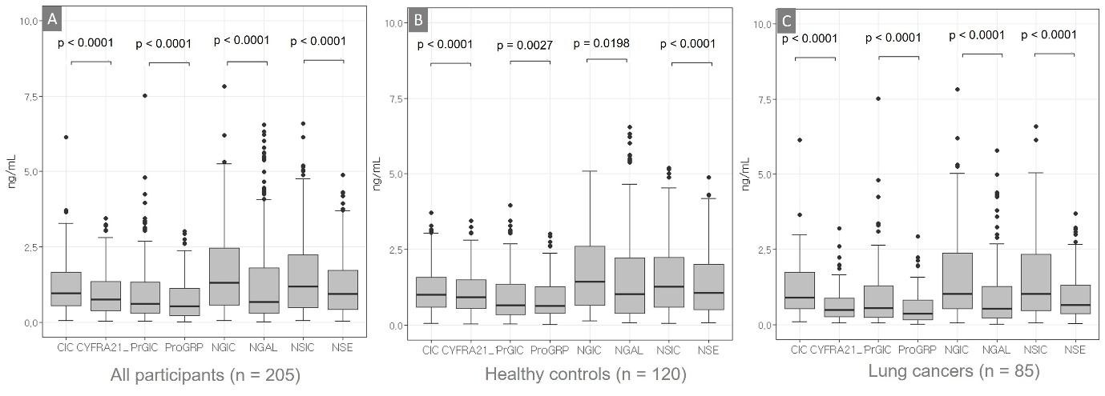
Figure S1. The levels of AICs and their antigens for CYFRA21-1, ProGRP, NGAL, and NSE in all participants (A), in healthy controls (B), and in patients with lung cancers (C).
Abbreviation: CIC, CYFRA 21-1-Anti-CYFRA 21-1 autoantibody immune complex; PrGIC, ProGRP-Anti-ProGRP autoantibody immune complex; NGIC, NGAL-Anti-NGAL autoantibody immune complex; NSIC, NSE-Anti-NSE autoantibody immune complex.

Supplement
Table S1. The levels of antigen-autoantibody immune complex, and free antigen, their ratios, and combinations from two to four ratios for four proteins
markers | NSCLC  (n = 86) | Healthy Control  (n = 120) | p-Value  (NSCLC vs. Healthy control)
CIC  (median (IQR), ng/mL) | 0.91 (0.54, 1.75) | 1.00 (0.58, 1.57) | 0.7031
CYFRA 21-1  (median (IQR), ng/mL) | 0.49 (0.26, 0.88) | 0.92 (0.56, 1.5) | <0.0001
PrGIC  (median (IQR), ng/mL) | 0.55 (0.24, 1.30) | 0.66 (0.34, 1.36) | 0.3007
ProGRP, ng/mL  (median (IQR), ng/mL) | 0.37 (0.16, 0.81) | 0.64 (0.39, 1.27) | 0.0002
NGIC  (median (IQR), ng/mL) | 1.02 (0.53, 2.38) | 1.43 (0.66, 2.61) | 0.2680
NGAL  (median (IQR), ng/mL) | 0.54 (0.22, 1.27) | 1.04 (0.38, 2.21) | 0.0015
NSIC  (median (IQR), ng/mL) | 1.03 (0.47, 2.34) | 1.28 (0.59, 2.23) | 0.4056
NSE  (median (IQR), ng/mL) | 0.65 (0.37, 1.31) | 1.07 (0.52, 2.02) | 0.0105
CIC/ CYFRA 21-1 ratio (median (IQR)) | 1.83 (1.40, 2.50) | 1.08 (0.92, 1.3) | <0.0001
PrGIC/ ProGRP ratio  (median (IQR)) | 1.69 (1.17, 2.06) | 1.06 (0.81, 1.32) | <0.0001
NGIC/NGAL ratio  (median (IQR)) | 2.05 (1.39, 2.45) | 1.27 (1, 1.65) | <0.0001
NSIC/NSE ratio  (median (IQR)) | 1.49 (1.02, 1.82) | 1.12 (0.99, 1.39) | 0.0001
C2-1  (median (IQR)) | 3.13 (2.19, 4.25) | 1.16 (0.81, 1.61) | <0.0001
C2-2  (median (IQR)) | 3.25 (2.29, 5.83) | 1.39 (1.06, 1.95) | <0.0001
C2-3  (median (IQR)) | 2.69 (1.85, 4.04) | 1.29 (0.95, 1.75) | <0.0001
C3-1  (median (IQR)) | 5.96 (3.48, 9.59) | 1.37 (1.01, 2.02) | <0.0001
C3-2  (median (IQR)) | 4.63 (3.22, 8.41) | 1.59 (1.2, 2.31) | <0.0001
C3-3  (median (IQR)) | 3.96 (2.28, 7.35) | 1.34 (0.86, 2.17) | <0.0001
C4-1  (median (IQR)) | 8.10 (4.38, 14.07) | 1.61 (1.08, 2.64) | <0.0001
Abbreviation: CIC, CYFRA 21-1-Anti-CYFRA 21-1 autoantibody immune complex; PrGIC, ProGRP-Anti-ProGRP autoantibody immune complex; NGIC, NGAL-Anti-NGAL autoantibody immune complex; NSIC, NSE-Anti-NSE autoantibody immune complex; NSCLC, non-small cell lung cancer; IQR, interquartile ranges.

Supplement
Table S2. The area under the curve (AUC)
Variable | AUC | 95 % CI | P-value
CIC | 0.484 | 0.403 to 0.565 | 0.7022
CYFRA21-1 | 0.311 | 0.236 to 0.385 | < 0.0001
PrGIC | 0.458 | 0.376 to 0.539 | 0.3002
ProGRP | 0.347 | 0.580 to 0.729 | 0.0002
NGIC | 0.455 | 0.373 to 0.536 | 0.2675
NGAL | 0.630 | 0.565 to 0.7000 | 0.0015
NSIC | 0.534 | 0.444 to 0.616 | 0.4049
NSE | 0.605 | 0.520 to 0.688 | 0.0104
CIC/CYFRA21-1 | 0.829 | 0.769 to 0.889 | < 0.0001
PrGIC/ProGRP | 0.768 | 0.703 to 0.833 | < 0.0001
NGIC/NGAL | 0.774 | 0.709 to 0.838 | < 0.0001
NSIC/NSE | 0.656 | 0.574 to 0.738 | 0.0001
C2-1 | 0.880 | 0.831 to 0.929 | < 0.0001
C2-2 | 0.879 | 0.832 to 0.927 | < 0.0001
C2-3 | 0.816 | 0.752 to 0.879 | < 0.0001
C3-1 | 0.917 | 0.878 to 0.956 | < 0.0001
C3-2 | 0.882 | 0.832 to 0.931 | < 0.0001
C3-3 | 0.855 | 0.804 to 0.910 | < 0.0001
C4-1 | 0.907 | 0.863 to 0.951 | < 0.0001
Abbreviation: CIC, CYFRA 21-1-Anti-CYFRA 21-1 autoantibody immune complex; PrGIC, ProGRP-Anti-ProGRP autoantibody immune complex; NGIC, NGAL-Anti-NGAL autoantibody immune complex; NSIC, NSE-Anti-NSE autoantibody immune complex; CI, confidence interval.

