Supplementary material
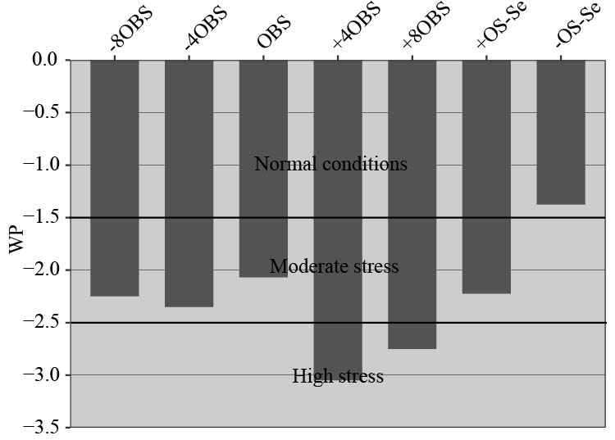
Supplementary figure 1: Water potential of coffee leaves as a result of Se application in C. arabica cv. Catuai seedlings under osmotic stress induced by PEG-6000. The values displayed are the distribution of four replicates. Treatments: -8BOS - Application of Se 8 days before stress (Stressed plants); -4BOS - Application of Se 4 days before stress (Stressed plants); 0OS - Application of Se in stress (Stressed plants); +4AOS - Application of Se 4 days after stress (Stressed plants); +8AOS Application of Se 8 days after stress (Stressed plants); +OS-Se - Without Se (Stressed plants); -OS-Se - Without Se (Non-stressed plants).

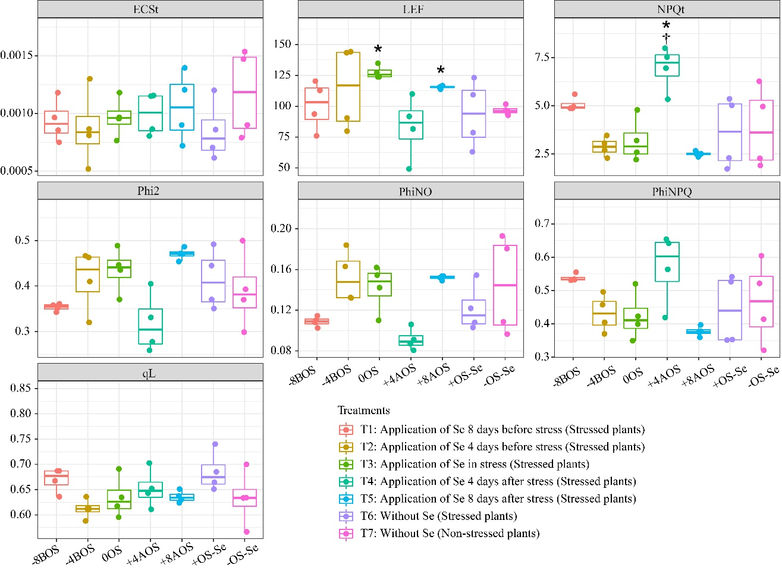
Supplementary figure 2: Total electrochromic shift (ECSt), total flow of electrons (LEF), total flow of electrons (NPQt), quantum yield of PSII (Phi2), quantum yield of non-regulated energy loss in PSII (PhiNO), quantum yield of regulated non-photochemical energy loss in PSII (PhiNPQ), and fraction of PSII centers which are in the open state (qL) as a result of Se application in C. arabica cv. Catuai seedlings under osmotic stress induced by PEG-6000. The values displayed are the distribution of four replicates. Asterisks refer to the significant difference when comparing all treatments with non-stressed plants without Se supply (-OS-Se) (p < 0.05). Dagger refers to the significant difference when comparing all treatments with stressed plants without Se supply (+OS-Se) (p < 0.05). Treatments: -8BOS - Application of Se 8 days before stress (Stressed plants); -4BOS - Application of Se 4 days before stress (Stressed plants); 0OS - Application of Se in stress (Stressed plants); +4AOS - Application of Se 4 days after stress (Stressed plants); +8AOS - Application of Se 8 days after stress (Stressed plants); +OS-Se - Without Se (Stressed plants); -OS-Se - Without Se (Non-stressed plants).
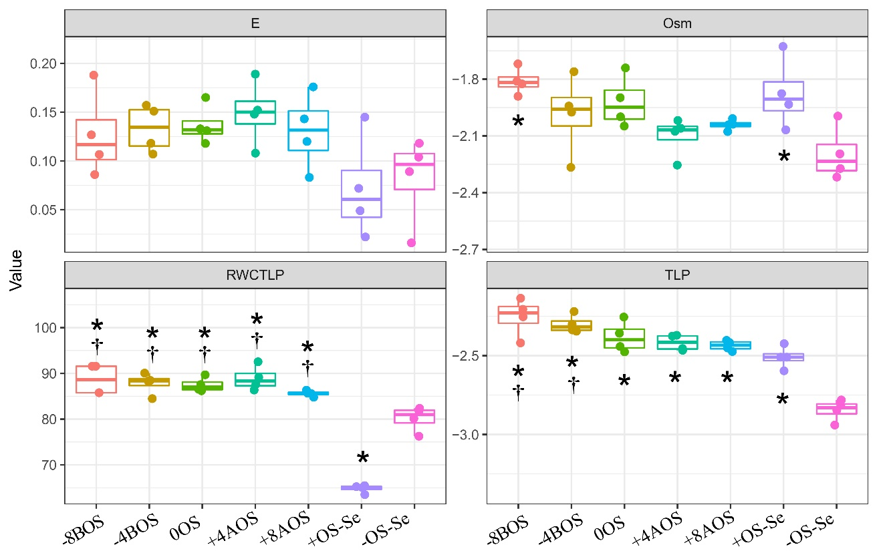
Supplementary figure 3: Elasticity (E), Osmotic potential (Osm), Relative water content at turgor loss point (RWCTLP), and turgor loss point (TLP) of coffee leaves as a result of Se application in C. arabica cv. Catuai seedlings under osmotic stress induced by PEG-6000. The values displayed are the distribution of four replicates. Treatments: -8BOS - Application of Se 8 days before stress (Stressed plants); -4BOS - Application of Se 4 days before stress (Stressed plants); 0OS - Application of Se in stress (Stressed plants); +4AOS - Application of Se 4 days after stress (Stressed plants); +8AOS Application of Se 8 days after stress (Stressed plants); +OS-Se - Without Se (Stressed plants); -OS-Se - Without Se (Non-stressed plants).
Variables | i) Contributions of all variables |  |  |  |  | Variables | ii) Contributions of reduced number of variables
 | PC1 | PC2 | PC3 | PC4 |  |  | PC1 | PC2 | PC3 | PC4
PL | 7.335 | 0.739 | 10.392 | 7.945 |  | PL | 7.064 | 30.181 | 4.701 | 3.123
PH | 9.152 | 0.327 | 1.796 | 1.335 |  | PH | - | - | - | -
APX | 8.232 | 5.634 | 3.123 | 4.584 |  | APX | 17.959 | 0.142 | 0.501 | 4.211
CAT | 3.630 | 2.789 | 18.581 | 0.003 |  | CAT | 10.394 | 19.244 | 0.948 | 23.059
GR | 3.028 | 7.442 | 8.588 | 4.391 |  | GR | 12.638 | 15.202 | 0.529 | 0.233
SOD | 3.646 | 14.082 | 0.767 | 0.082 |  | SOD | 16.491 | 0.950 | 7.555 | 22.579
RS | 2.700 | 0.267 | 0.016 | 21.803 |  | RS | - | - | - | -
AA | 1.567 | 0.003 | 10.418 | 5.192 |  | AA | - | - | - | -
Pro | 11.854 | 0.405 | 8.790 | 0.526 |  | Pro | 5.343 | 20.702 | 22.985 | 6.861
TSS | 3.719 | 0.001 | 9.315 | 13.493 |  | TSS | - | - | - | -
Starch | 9.582 | 1.860 | 1.278 | 2.334 |  | Starch | 14.069 | 0.245 | 2.407 | 20.424
Prt | 0.432 | 0.007 | 3.170 | 10.096 |  | Prt | 0.505 | 12.252 | 48.321 | 13.277
Sac | 0.092 | 0.051 | 6.206 | 18.417 |  | Sac | - | - | - | -
Se | 11.420 | 1.475 | 0.534 | 0.403 |  | Se | 15.536 | 1.081 | 12.053 | 6.231
ECSt | 0.132 | 0.196 | 0.536 | 1.079 |  | ECSt | - | - | - | -
LEF | 3.474 | 4.826 | 3.183 | 4.346 |  | LEF | - | - | - | -
NPQt | 3.443 | 13.771 | 4.769 | 0.419 |  | NPQt | - | - | - | -
Phi2 | 1.225 | 15.843 | 1.842 | 0.002 |  | Phi2 | - | - | - | -
PhiNO | 5.915 | 10.830 | 3.444 | 0.195 |  | PhiNO | - | - | - | -
PhiNPQ | 1.193 | 16.279 | 3.247 | 0.246 |  | PhiNPQ | - | - | - | -
qL | 8.229 | 3.174 | 0.003 | 3.108 |  | qL | - | - | - | -
Supplementary table 1: Contributions on the first two PC axes of i) all variables and ii) reduced number of variables.

