Article
Sour beer as bioreservoir of novel craft ale yeast cultures
Chiara Nasuti ¹, Jennifer Ruffini ¹, Laura Sola ², Mario Di Bacco ³, Stefano Raimondi ², Francesco Candeliere ², Lisa Solieri ^{1,4,*}
- Department of Life Sciences, University of Modena and Reggio Emilia, Via Amendola, 2-Pad. Besta, 42124 Reggio Emilia, Italy; chiara.nasuti@unimre.it; 227818@studenti.unimore.it; lisa.solieri@unimore.it
- Department of Life Sciences, University of Modena and Reggio Emilia, Via Campi 51, 41125, Modena, Italy; laura.sola@unimore.it; stefano.raimondi@unimore.it; francesco.candeliere@unimore.it;
- Ca’ Del Brado Brewery, Via Andrea Costa, 146/2, 40065 Rastignano (BO), Italy; quark@cadelbrado.it
- National Biodiversity Future Center (NBFC), 90133 Palermo, Italy; lisa.solieri@unimore.it
* Correspondence: L.S.: lisa.solieri@unimore.it; Tel.: +39 0522522026

Supplementary Data

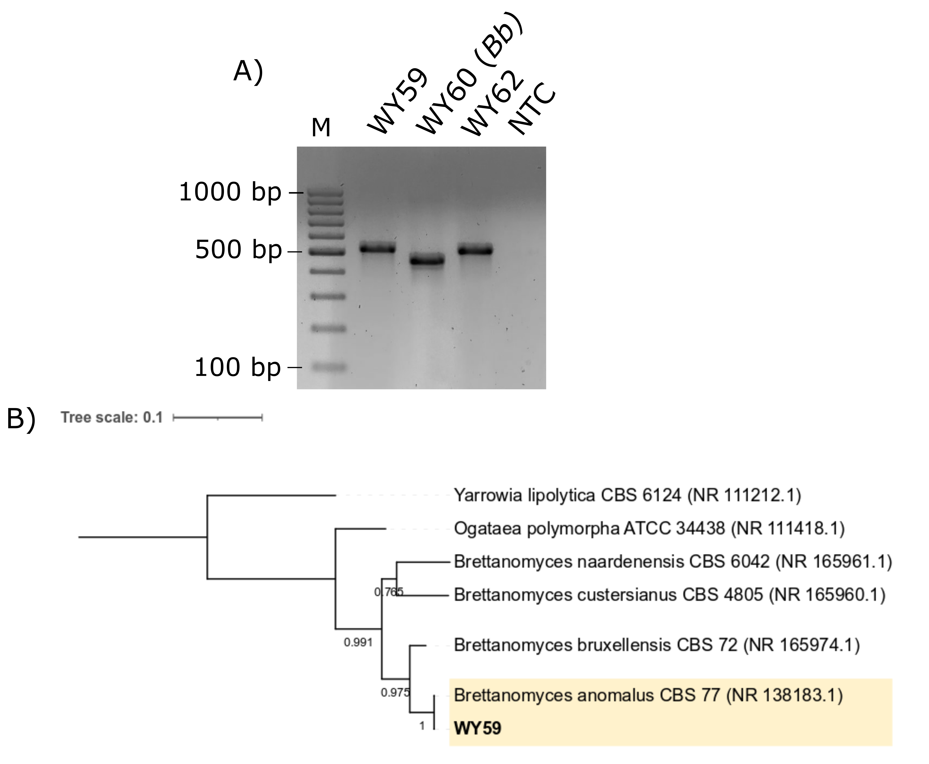
Supplementary Figure S1. Analysis of ITS region in D. anomala isolates. (A) Electrophoretic gel of ITS amplicons. D. bruxellensis strain WY60 was used as reference strain. (B) Phylogenetic tree obtained by neighbor joining (NJ) method [1] applied to a dataset of 7 rDNA sequences. The evolutionary distances were calculated by the Tamura 3-parameter method [2] considering the number of nucleotide substitutions per site. The gamma distribution was used to model the rate of change between sites. All positions containing gaps and missing data were eliminated (complete deletion option). The percentage of replicate trees in which the associated taxa clustered together in the bootstrap test [3] (1000 replicates) are shown next to the branches. The strain collected in this study is shown in bold. The lengths of the branches are proportional to the number of nucleotide substitutions, and they have been measured using the divergence scale shown at the top left. The tree was rooted using Yarrowia lypolitica as outgroup. The tree data (Newick) were generated with MegaX [4] and exported and visualized using ITOL [5]. Abbreviation: M: molecular size marker; Bb: Brettanomyces bruxellensis.

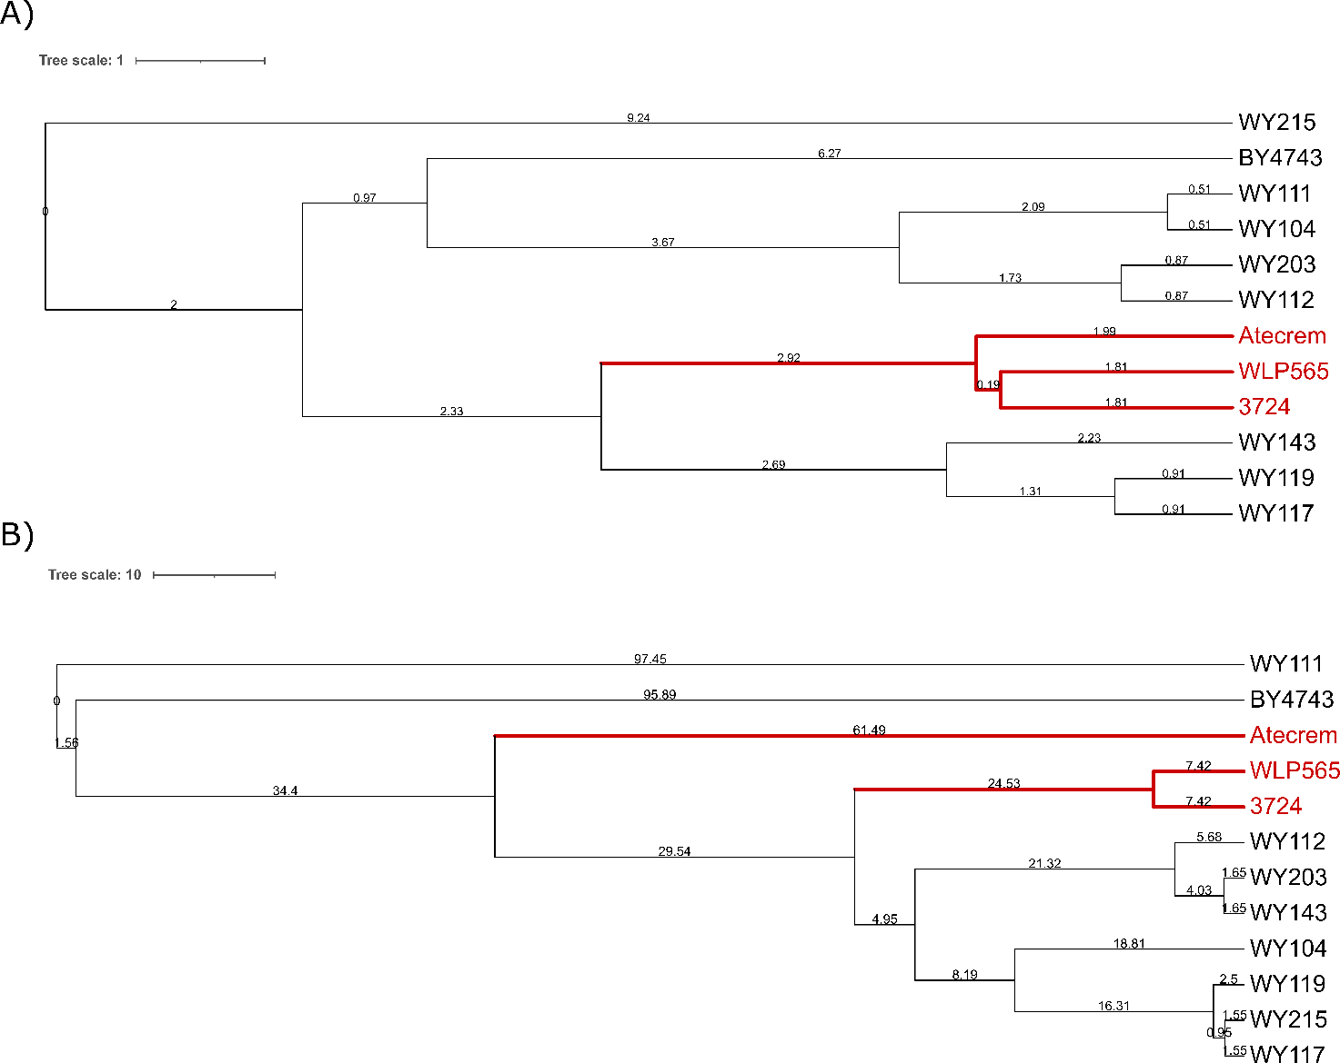
Supplementary Figure S2. Dendrograms generated using inter-delta PCR (A) and R3-RAPD PCR (B) fingerprints of 11 S. cerevisiae strains (7 indigenous wild strains isolated in this study from sour beer, 3 commercial starter cultures commonly used in the brewery plant, and BY4743 as reference strain). Commercial starters (in red) were detailed in Table 1. Similarity percentages were calculated using Pearson correlation coefficient, while hierarchical clustering analysis was carried out using the UPGMA (unweighted pair-group method with arithmetic mean) method with Bionumerics software. Numbers near the branches represent branch lengths. The tree data (Newick) were generated with MegaX [4] and exported and visualized using ITOL [5].

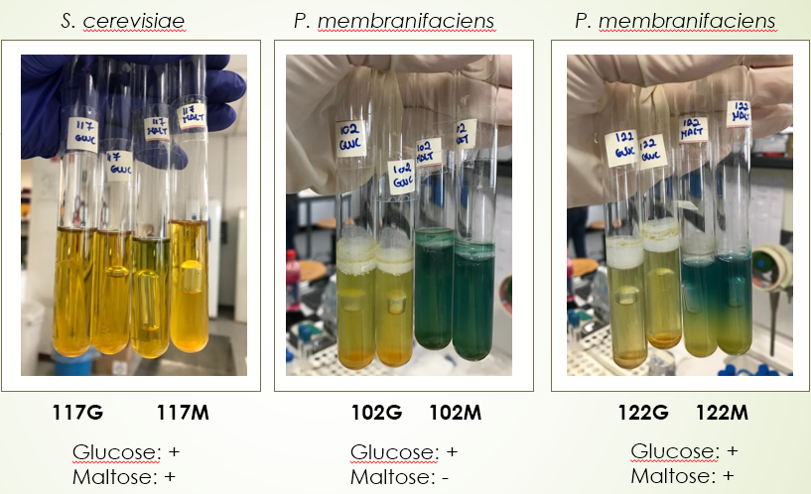
Supplementary Figure S3. Glucose and maltose fermentation test. Tubes containing Durham inverted tubes were photographed after 3 days of incubation at 27°C. Tests were carried out according to Kurtzamn et al. [6]. Abbreviations: G, glucose; M, maltose.

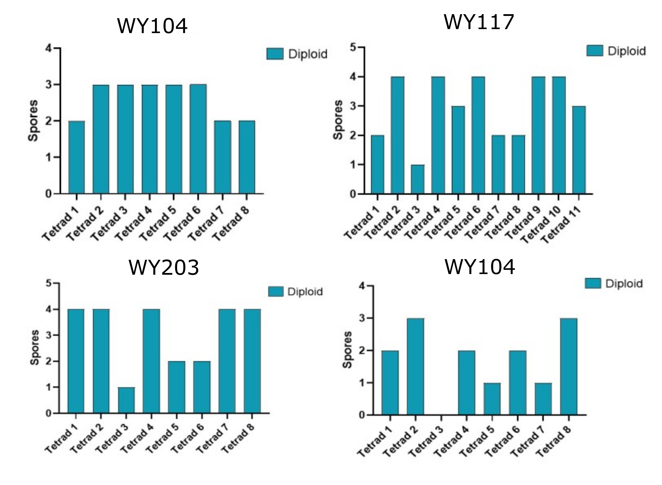
Supplementary Figure S4. Mating type genotyping of four S. cerevisiae sour beer wild strains and their monosporic derivatives. For each strain at least 8 meiotic events (asci) were dissected.

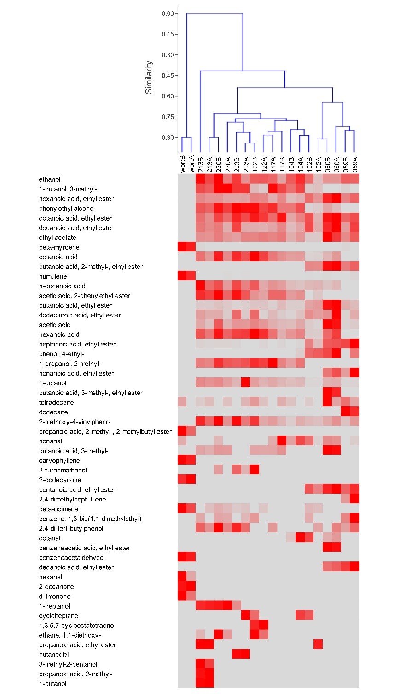
Supplementary Figure S5. Distribution of the 53 volatile organic compounds (VOCs) identified in the headspace of the fermented wort samples. The area of each VOC was mean centered and normalized by the standard deviation. Values are reported as colors ranging from the lowest (grey) to the highest (deepest red).

Supplementary Table S1. Primers, compound concentrations, and thermal conditions used this study.
Goal | Gene Target | Primer name | Sequence (5’->3’) | Cycling conditions |  | Reaction mixture | Reference
 |  |  |  |  | Vf (µL) | Compounds
Yeast identification | ITS region | ITS1  ITS4 | TCCGTAGGTGAACCTGCGG TCCTCCGCTTATTGATATGC | 95 °C for 5 min; (95 °C for 1 min, 55 °C for 2 min, 72 °C for 2 min)₃₅; 72 °C for 10 min |  | 1X Dream Taq Green Buffer, 2.0 mM MgCl₂, 200 μM of each dNTP, 0.3 μM of each primer, 1 U of Dream Taq DNA polymerase, 100 ng DNA template | [7]
 | 26S LSU | NL1  NL4 | GCATATCAATAAGCGGAGGAAAAG  GGTCCGTGTTTCAAGACGG- | 94 °C for 5 min; 36 cycles of 94 °C for 1 min, 52 °C for 45 s, 72 °C for 2 min; final extension at 72 °C for 10 min | 40 | 1X TaKaRa ExTaq Buffer*, 2.0 µM MgCl₂, 200 µM of each dNTP, 0.3 µM of each primer, 1 U of TaKaRa ExTaq DNA polymerase, and 100 ng of template DNA | [8]
 | DBP6 | Sbay_F1  Sbay_R1 | GCTGACTGCTGCTGCTGCCCCCG TGTTATGAGTACTTGGTTTGTCG | 95°C for 3 min, (95°C for 30 sec, 58°C for 30 sec, 72°C for 1 min)35; 72°C for 7 min | 20 | 1X Dream Taq Green Buffer, 2 mM MgCl₂, 200 μM of each dNTP, 0.4 μM of Sbay_F1, 0.8 μM Sbay_R1, 0.5U Dream Taq DNA polymerase, 50 ng DNA template | [9]
 | MEX67 | Scer_F2  Scer_R2 | GCGCTTTACATTCAGATCCCGAG TAAGTTGGTTGTCAGCAAGATTG | 95°C for 3 min, (95°C for 30 sec, 58°C for 30 sec, 72°C for 1 min)₃₅; 72°C for 7 min | 20 | 1X Dream Taq Green Buffer, 2 mM MgCl₂, 200 μM of each dNTP, 0.4 μM of each primer, 0.5U Dream Taq DNA polymerase, 50 ng DNA template | [9]
 | FSY1 | Seub_F3  Seub_R3 | GTCCCTGTACCAATTTAATATTGCGC  TTTCACATCTCTTAGTCTTTTCCAGACG | 95°C for 3 min, (95°C for 30 sec, 60°C for 30 sec, 72°C for 1 min)₃₅; 72°C for 7 min | 20 | 1X Dream Taq Green Buffer, 2 mM MgCl₂, 200 μM of each dNTP, 0.4 μM of each primer, 0.5U Dream Taq DNA polymerase, 50 ng DNA template | [9]
Yeast genotyping | Microsatellite (GTG)₅ | (GTG)₅ | GTGGTGGTGGTGGTG | 94 °C for 5 min; (94 °C for 15 s, 55 °C for 45 s, 72 °C for 1.30 min)₄₀; 72 °C for 4 min | 20 | 1X Dream Taq Green Buffer, 3 mM MgCl₂, 200 μM of each dNTP, 0.6 μM of primer, 200 mM BSA, 0.5U Dream Taq DNA polymerase, 50 ng DNA template | [10]
 | Random DNA | R3 | ATGCAGCCAC | 94°C for 4 min; (94°C for 25 sec, 42 C for 30 sec, 72 °C for 90 sec); 72°C for 5 min | 20 | 1X Dream Taq Green Buffer, 3.0 mM MgCl₂, 200 μM of each dNTP, 1 μM of primer, 0.5 U/μL of Dream Taq DNA polymerase, 50 ng DNA template | [11]
 | Transposable elements Ty2 | d12  d21 | TCAACAATGGAATCCCAAC  CATCTTAACACCGTATATGA | 95°C for 5 min; (95°C for 30 s min, 46°C for 30 s, 72°C for 90 s)₃₅; 72°C for 10 min | 25 | 1X Dream Taq Green Buffer, 2.5 mM MgCl₂, 200 μM of each dNTP, 1 μM of primer, 0.625U Dream Taq DNA polymerase, 50 ng DNA template | [12]
STA1 | STA1 | SD-5A  SD-6B | CAACTACGACTTCTGTCATA  GATGGTGACGCAATCACGA | 95°C for 3 min; (95°C for 30 sec, 60°C for 30 sec, 72°C for 1 min)₃₅; 72°C for 7 min | 20 | 1X Dream Taq Green Buffer, 2 mM MgCl₂, 200 μM of each dNTP, 0.4 μM of primer, 0.5U Dream Taq DNA polymerase, 50 ng DNA template | [13]
 | STA1 UAS2 promoter | STA1_UAS_Fw STA1_UAS_Rv | CCTGGCTCAAATTAAACTTTCG ACCACCAATAGGCAATAGAAA | 95°C for 3 min; (95°C for 30 sec, 56°C for 30 sec, 72°C for 1 min)₃₅; 72°C for 7 min | 20 | 1X Dream Taq Green Buffer, 2 mM MgCl₂, 200 μM of each dNTP, 0.4 μM of primer, 0.5U Dream Taq DNA polymerase, 50 ng DNA template | [14]
LAB identification | 16S rRNA | 27f  1490r | TCCATTTACTCGAGAGTTTGATCCTGGCTCAG  GGTTCCCCTAAGCTTACCTTGTTACGACTTC | 95 °C for 5 min; (95 °C for 1 min, 58 °C for 2.5 min, 72 °C for 2 min)₃₀; 72 °C for 5 min | 40 | 1X TaKaRa ExTaq Buffer*, 2.0 µM MgCl₂, 200 µM of each dNTP, 0.2 µM of each primer, 1 U of TaKaRa ExTaq DNA polymerase, and 100 ng of template DNA | [15]
LAB genotyping | Microsatellite (GTG)₅ | (GTG)₅ | GTGGTGGTGGTGGTG | 94 °C for 5 min; (94 °C for 15 s, 55 °C for 45 s, 72 °C for 1.30 min)₄₀; 72 °C for 4 min | 20 | 1X Dream Taq Green Buffer, 3 mM MgCl₂, 200 μM of each dNTP, 0.6 μM of primer, 200 mM BSA, 0.5U Dream Taq DNA polymerase, 50 ng DNA template | [16]

Supplementary Table S2. In silico 16S-ARDRA profiles of the main beer LAB species.
Species | Accession number | Tru1I ¹ | HhaI | HinfI
Levilactobacillus brevis | HM058775.1 | 467, 259, 252, 194, 134, 104, 86, 47,26 | 367, 500, 571 | 274, 891, 85, 58
Fructilactobacillus lindneri | CP014907.1 | 109, 150, 44, 86, 48, 86, 252, 534 | 289, 528, 492 | 55, 976, 278
Lentilactobacillus buchneri | M58811 | 421, 252, 200, 194, 134, 123, 111, 86 | 400, 500, 580 | 785-540-135
Lactiactobacillus casei | D16551 | 464, 252, 239, 194, 134, 86, 81, 46, 26 | 580, 450, 400, 380, 210 | 1000, 145
Loigolactobacillus coryniformis | MF114100.1 | 465, 255, 206, 194, 156, 134, 86, 26 | 496, 528, 287 | 976, 277, 58
Secundilactobacillus malefermentans | NR_113822.1 | 505, 278, 86, 134, 44, 150, 111 | 1021, 287 | 493, 398, 274, 85, 58
Latilactobacillus curvatus | CP017124.1 | 593, 278, 161, 134, 86 | 528, 495, 287 | 976, 251, 58, 25
Pediococcus damnsosus | D87678 | 423, 254, 206, 200, 137, 134, 86, 44, 13 | 528, 507, 287 | 976, 263, 58, 25
Pediococcus acidilactici | M58833 | 278, 243, 205, 194, 134, 120, 104, 86, 79, 47, 36 | 500, 400, 320, 260 | 710, 380, 190
Pediococcus pentosaceus | AB362986.1 | 278, 269, 243, 137, 134, 120, 104, 86, 80, 47, 44, 36, 13 | 528, 507, 287 | 1000, 145
Pediococcus inopitalus | AJ271383 | 395, 252, 247, 137, 134, 121, 96, 86, 44, 26, 13 | 507, 528, 287 | 976, 263, 58, 25
Pediococcus parvulus | D88528 | 395, 252, 182, 178, 150, 134, 86, 44, 26 | 568, 526, 345 | 976, 263, 58, 25
¹ Fragments were in bp.
Supplementary Table S3. ITS RFLP-PCR analysis of yeast isolates from natural sour beer.
Isolation condition | Strain | Amplicon  size¹ | Restriction profile |  | Yeast-ID best matching (%) |  |  | Pattern
 |  |  | HaeIII | HinfI
YPDA 28 °C | WY201, WY202, WY203, WY204, WY206, WY207, WY208, WY209, WY210, WY211, WY212, WY214, WY215, WY216, WY217, WY218, WY219, WY220 | 850 | 125, 170, 230, 325 | 110, 365, 375 |  | Saccharomyces cerevisiae (100%)/Saccharomyces coriocanus (100%)/Saccharomyces paradoxus (100%) | A
 | WY205, WY213 | 850 | 125, 230, 495 | 150, 365, 375 |  | Saccharomyces bayanus (89%)/Saccharomyces kudriavzevii (89%)/Saccharomyces pastorianus (89%)/Saccharomyces mikatae (89%) | C
WL 28 °C | WY101, WY104, WY106, WY107, WY108, WY109, WY111, WY112, WY113, WY114, WY116, WY117, WY118, WY119, WY120, WY143, WY151 | 850 | 125, 170, 230, 325 | 110, 365, 375 |  | Saccharomyces cerevisiae (100%)/Saccharomyces coriocanus (100%)/Saccharomyces paradoxus (100%) | A
 | WY115 | 850 | 125, 230, 495 | 150, 365, 375 |  | Saccharomyces bayanus (89%)/Saccharomyces kudriavzevii (89%)/Saccharomyces pastorianus (89%)/Saccharomyces mikatae (89%) | C
 | WY102, WY103, WY105, WY110, WY121, WY122, WY141, WY152 | 485 | 48, 84, 336 | 203, 282 |  | Pichia membranifaciens (73%) | B
 | WY59, WY62 | 550 | 110, 400 | 95, 230 |  | Kluyveromyces blattae (67%) | D
 | WY60, WY61 | 490 | 100, 350 | 210, 280 |  | Dekkera bruxellensis (83%) | E
¹ Amplicons and restriction fragments were in bp.

References
- Saitou, N; Nei M. The neighbor-joining method: A new method for reconstructing phylogenetic trees. Mol. Biol. Evol., 1987, 4, 406-425.
- Tamura, K. Estimation of the number of nucleotide substitutions when there are strong transition-transversion and G + C-content biases. Mol. Biol. Evol. 1992, 9, 678-687.
- Felsenstein, J. Confidence limits on phylogenies: An approach using the bootstrap. Evolution, 1985, 39, 783-791.
- Kumar, S.; Stecher, G.; Li, M.; Knyaz, C.; Tamura, K. MEGA X: Molecular evolutionary genetics analysis across computing platforms. Mol. Biol. Evol. 2018, 35, 1547-1549
- Letunic, I.; Bork, P. Interactive Tree of Life (iTOL) v4: Recent updates and new developments. Nucleic Acids Res. 2019, 2, 256–259.
- Kurtzman, C.P., Fell, J.W., Boekhout, T.; Robert, V. Methods for isolation, phenotypic characterization and maintenance of yeasts. In The yeasts, 5st ed; Kurtzman, C.P.; Fell, J.W.; Boekhout, T., Eds.; Elsevier, Amsterdam, 2011, pp. 87-110.
- White, T.J.; Bruns, T.; Lee, S.; Taylor, J. Amplification and direct sequencing of fungal ribosomal RNA genes for phylogenetics. In PCR Protocols: A Guide to Methods and Applications; Innis, M.A., Gelfand, D.H., Sninsky, J.J., White, T.J., Eds.; Academic Press: San Diego, CA, USA, 1990; pp. 315–322.
- Kurtzman, C.P.; Robnett, C.J. Identification and phylogeny of ascomycetous yeasts from analysis of nuclear large subunit (26S) ribosomal DNA partial sequences. Antonie Leeuwenhoek, 1998, 73, 331–371.
- Pengelly, R.J.; Wheals, A.E. Rapid identification of Saccharomyces eubayanus and its hybrids. FEMS Yeast Res., 2013, 13, 156-161.
- Dakal, T.C.; Solieri, L.; Giudici, P. Evaluation of fingerprinting techniques to assess genotype variation among Zygosaccharomyces strains. Food Microbiol. 2018, 72, 135-145.
- Corte, L.; Lattanzi, M.; Buzzini, P.; Bolano, A.; Fatichenti, F.; Cardinali, G. Use of RAPD and killer toxin sensitivity in Saccharomyces cerevisiae strain typing. J. Appl. Microbiol. 2005, 99, 609-617.
- Legras, J.-L.; Karst, F. Optimisation of interdelta analysis for Saccharomyces cerevisiae strain characterisation. FEMS Microbiol. Lett. 2003, 221, 2249-2255.
- Yamauchi, H.; Yamamoto, H.; Shibano, Y.; Amaya, N.; Saeki, T. Rapid methods for detecting Saccharomyces diastaticus, a beer spoilage yeast, using the polymerase chain reaction. J. Am. Soc. Brew. Chem. 1998, 56, 58–63.
- Krogerus, K.; Magalhães, F.; Kuivanen, J. et al. A deletion in the STA1 promoter determines maltotriose and starch utilization in STA1+ Saccharomyces cerevisiae strains. Appl Microbiol Biotechnol. 2019, 103, 7597–7615.
- Lane, D. J. 16S/23S rRNA sequencing. In Nucleic Acid Techniques in Bacterial Systematics; Stackebrandt, E.; Goodfellow, M., Eds; John Wiley & Sons: New York, NY, USA, 1991; pp. 115–175.
- Solieri, L.; Bianchi, A.; Giudici, P. Inventory of non-starter lactic acid bacteria from ripened Parmigiano-Reggiano cheese as assessed by a culture dependent multiphasic approach. Syst. Appl. Microbiol. 2012, 35, 270–277.

