**Supplementary Information**

**Mesophilic and thermophilic fermentation of waste activated sludge for volatile fatty acids production: focusing on anaerobic degradation of carbohydrate and protein**

Huilei Xionga,c, Lanhua Liu b,*, Baodong Songa, Haitao Liuc, Hanchang Shi a,d

a Beijing Institute of Collaborative Innovation, Beijing, China, 100094

b School of Ecology and Environment, Zhengzhou University, Zhengzhou, China, 450001

c School of Public Health, Xiangnan University, Chenzhou, China, 423099

d School of Environment, Tsinghua University, Beijing, China, 100084

Corresponding author: *lhliu@zzu.edu.cn

1. **The COD conversion factors of Humic acid (HA)**

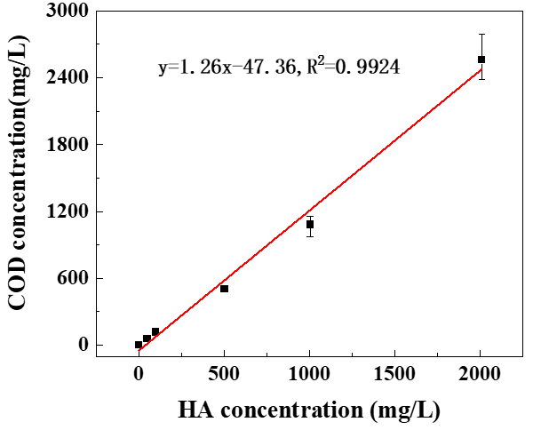

Figure S1 Calibration curves of HA

1. **Operation conditions of flasks**

Table S1 Summary of different operation conditions of flasks

|  |  |  |  |
| --- | --- | --- | --- |
| Series | Temperature(℃) | SRT(h) | Sludge type |
| 1# | 35±1 | 48 | Sludge A |
| 2# | 50±1 | 48 |

1. **Stable isotopic labeling test**

Table S2 Stable isotopic labeling test conditions

|  |  |  |  |  |  |
| --- | --- | --- | --- | --- | --- |
| Series | Inoculums  (ml) | Feed  (ml) | Total volume  (ml) | | Note |
| 3# | 8 | 72 | 80 | Feed is thickened sludge | |
| 4# | 8 | 72 | 80 | Feed is just glucose (2.00 g) | |
| 5# | 8 | 72 | 80 | Feed contains D-Glucose-13C6 (0.20 g), BSA(0.84 g) and VO(0.15 g). | |

1. **Formulars of organic matter decomposition during anaerobic hydrolysis and acidification**

**Table S3** Formulars of organic matter decomposition during anaerobic hydrolysis and acidification

|  |  |  |
| --- | --- | --- |
| No. | Formulars | Unit |
| 1 | P-P = T-P – S-P | mgCOD/L |
| 2 | P-C = T-C – S-C | mgCOD/L |
| 3 | Consumed TCOD = TCOD0 – TCODt | mgCOD/L |
| 4 | Consumed P-P = P-P 0 –P-P t | mgCOD/L |
| 5 | Consumed P-C = P-C 0 –P-C t | mgCOD/L |
| 6 | The consumed rate of P-P = Consumed P-P / TCOD0×100% | % |
| 7 | The consumed rate of P-C = Consumed P-C / TCOD0×100% | % |

Note: a) TCOD0, P-P 0 and P-C 0 were the initial concentration of TCOD, P-P and P-C;

b) TCODt, P-P t and P-C t were the concentration of TCOD, P-P and P-C at a given anaerobic digestion time.

1. **Composition of SCOD**

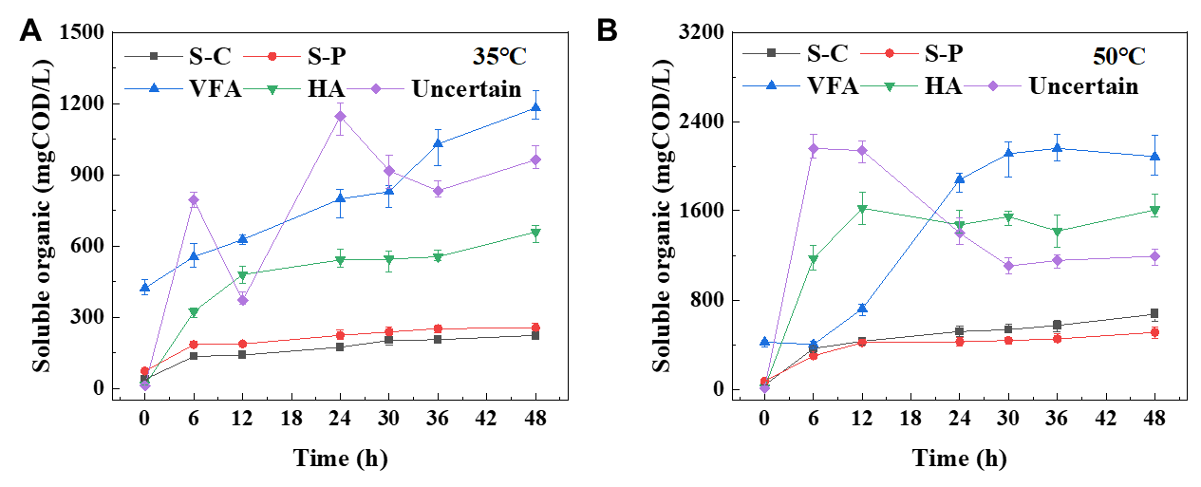

Figure S2 Composition of SCOD. (A) mesophilic digestion and (B) thermophilic digestion.

1. **The concentrations of six VFAs (HAc, HPr, i-HBu, n-HBu, i-HVa, n-HVa) produced by using sludge B (series 3#) during thermophilic digestion**

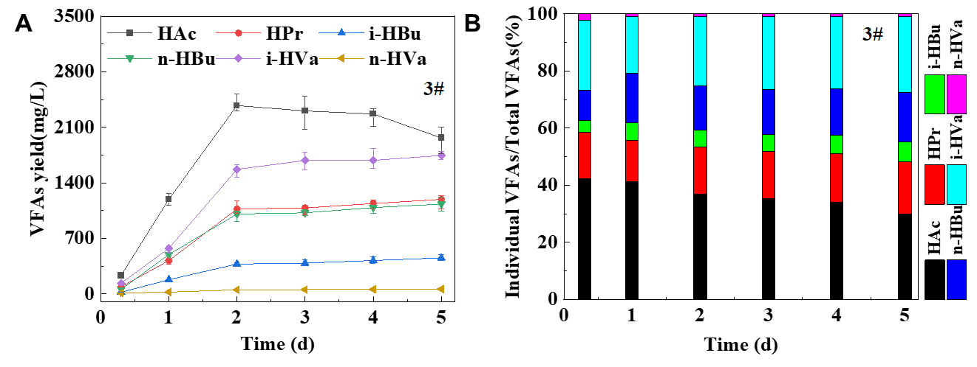

Figure S3 VFAs production in thermophilic digestion

1. **The existing forms of VFAs**

**Table S4** The existing forms of VFAs with 12C and 13C

|  |  |
| --- | --- |
| VFAs | The existing forms |
| HAc | C2H3O2-H，C[13]CH3O2-H，[13]C2H3O2-H； |
| HPr | C3H5O2-H，C2[13]CH5O2-H，C[13]C2H5O2-H，[13]C3H5O2-H； |
| HBu | C4H7O2-H，C3[13]CH7O2-H，C2[13]C2H7O2-H，C[13]C3H7O2-H，[13]C4H7O2-H； |
| HVa | C5H9O2-H，C4[13]CH9O2-H，C3[13]C2H9O2-H，C2[13]C3H9O2-H，C[13]C4H9O2-H，[13]C5H9O2-H； |

1. **The proportional distribution of VFAs yield**



**Figure S4.** The proportional distribution of VFAs yield from the degradation of carbohydrate and protein

1. **The metabolic pathway of carbohydrate and protein during anaerobic digestion proposed by Zehnder.**



Fig. S5 The pathway of carbohydrate and protein during anaerobic digestion (Zehnder 1988)

**Reference**

Zehnder, A J (1988). Biology of anaerobic microorganisms. John Wiley and Sons Inc