Longitudinal Transcranial Photobiomodulation with Light Emitting Diodes Improve Reaction Time and EEG Networks of the Human Brain
Akhil Chaudhari, Xinlong Wang, Anqi Wu, Hanli Liu*
Supplementary Materials
- Identification of human EEG networks and their alterations by longitudinal tPBM
A newly developed algorithm has been published that enables the identification of human EEG networks, as represented in 2-dimentional (2D) topographies and 3-dimensional (3D) cortical source locations for each network¹. The essence of this algorithm is the combination of group singular value decomposition (gSVD) with exact low-resolution brain electromagnetic tomography (eLORETA). The overall processing steps are shown in Fig. S1 below.
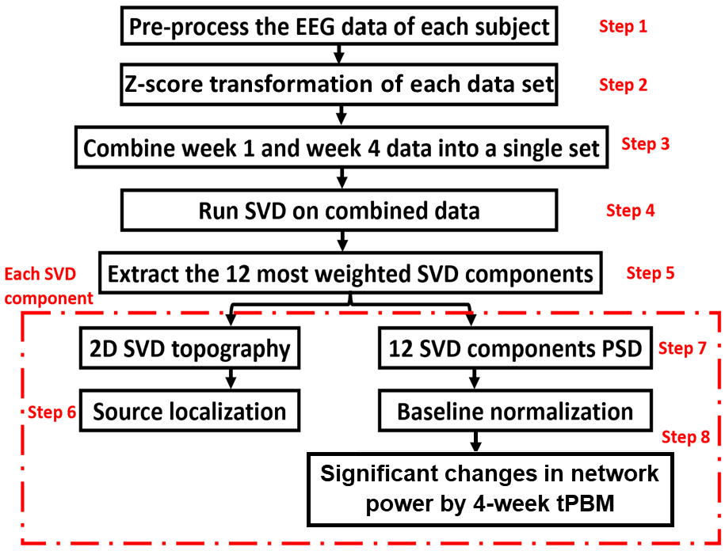
Fig. S1 An EEG data processing flow chart showing eight steps to obtain 2D and 3D brain EEG networks and the respective alterations induced by 4-week LED-tPBM. All steps were performed using MATLAB, except for step six, which was performed using eLORETA software. See the text for the details of each processing step.

Step 1: Pre-processing of raw EEG data
We followed the same procedures described in the sub-section of “EEG data preprocessing” of the main paper.
Steps 2: Z-score transformation
Group SVD can be considered similar to spatial group independent component analysis (ICA) which has been widely used in the field of fMRI²⁻⁴. The pre-processed EEG data were initially standardized by performing z-score transformation to minimize inter-subject variation. Specifically, we had each preprocessed EEG time series in a selected time period subtract its own temporal mean and then divide by its temporal standard deviation. This standardization step was necessary for an unbiased operation in gSVD.
Step 3: Forming the group for gSVD calculations
The standardized EEG time series from all 32 samples of EEG measurements (n = 7 and 9 participants for the tPBM and sham groups in S1 of week 1; n = 8 and 8 for both groups in S8 of week 4, respectively) were concatenated into a single 2D matrix, M_{gSVD}. One dimension of this 2D matrix was the concatenated time covering TP1 and TP2 in both S1 and S8 for the sham and LED groups. The other dimension was 64 channels with standardized EEG readings. There are interconnections between slow and fast EEG rhythms in mediating the brain networks⁵. Hence, the five frequency bands of EEG ( delta, theta, alpha, beta, and gamma) were considered together, rather than separating them into individual frequency bands while performing gSVD.
Steps 4 and 5: Computations of gSVD across EEG measures in S1 and S8 from both groups
gSVD was performed on the concatenated matrix, M_{gSVD,} to identify the common Principal Components (PC) across four weeks and two groups using the native MATLAB function ‘svd’. Specifically, gSVD was performed using the ‘economy-size decomposition’ style to remove extra rows and columns of zeros in the time dynamics vector (U) and singular value vector (S). The mathematical equation of ‘svd’ function can be expressed in Eq. 1:
$C=U×S×V^{T}$ (1)
where C is the transposed matrix of M_{gSVD} (i.e., C = M_{gSVD}^{T}), S is a diagonal matrix containing 64 singular values of C with a decreasing magnitude marking the weight of each component in C; U is an orthogonal matrix and represents time dynamics vectors for all 64 singular components without a unit; and V is an orthogonal matrix with a dimension of 64 × 64 (64 channels 64 singular components). Matrix V facilitated 2D topographies for all 64 singular components without a unit (owing to the z-score transformation of the EEG data). As a result, we obtained 64 gSVD-derived PCs with their respective weights (from matrix S) over the original signal, their corresponding 1D time series for each of the key components (from matrix U), and the corresponding topography for each respective component (from matrix V). Consequently, we selected all components that had less than 90% reduction of the most-weighted component and extracted 12 gSVD components to form a 2D topography and for 3D source localization analysis. These 12 components were used to define 12 EEG brain networks which may change their electrophysiological powers using longitudinal LED-tPBM during PVT performance.
Step 6: Source localization using eLORETA
3D cortical source localizations were projected using eLORETA for the 12 identified gSVD components. eLORETA is a free-access software package (http://www.uzh.ch/keyinst/loreta.htm) that converts the 2D scalp distribution of the electrical potential into a 3D distribution of the current density in the human brain. To localize electrical activity in the human cortex, eLORETA uses a total of 6239 voxels at a 5-mm spatial resolution. eLORETA offers a weighted least-squares based solution with a localization error⁶. In this study, eLORETA was utilized to localize the 3D cortical sources (cortical space) of the 2D electric potential distribution (sensor space) of the 12 SVD components. The Montreal Neurological Institute (MNI) coordinate system of the 64-electrode international 10-10 system was employed, and a default value of 1 was utilized as a regularization parameter for the generation of the transformation matrix. This procedure produced 3D cortical maps; 2D (sagittal, coronal, and axial) views were also generated for each SVD component.
To specifically examine power changes in EEG brain networks induced by longitudinal LED-tPBM during PVT performance, we divided the 1D time series (matrix U) into separate temporal segments for TP1 and TP2 and for S1 of weeks 1 and S8 of week 4 in the data process. This process was repeated for each participant and each group (LED and Sham). Accordingly, the power spectral density calculations for all 12 components/networks were performed on the segmented EEG brain networks for each participant, as described in Step 7.
Step 7: Calculations of PSD of 12 SVD components
Quantification of PSDs for each of the 12 SVD components (i.e., brain EEG networks) during TP1 and TP2 in S1 of week 1 and S2 of week 4 for both groups was achieved based on respective time courses using the native MATLAB function “pwelch” (with a 20-sec window and 50% overlap). This operation resulted in one PSD curve with a resolution of 0.125 Hz, ranging from 0 to 128 Hz for each SVD component, each subject, each week, and for each TP (TP1 and TP2).
Step 8: Computation of power changes of EEG networks induced by 4-week LED-tPBM
To compute the absolute power change of 12 EEG networks induced by the 4-week LED-tPBM stimulation, we obtained the spectrally averaged SPD power by multiplying the averaged PSD value over the corresponding spectral band with the respective frequency bandwidth for each subject for each of the 5-f bands (Delta: 0.5-4 Hz, Theta: 4-7 Hz, Alpha: 7-13 Hz, Beta: 13-30 Hz, and Gamma: 30-70 Hz) during TP1 and TP2 in sessions S1 and S8. Next, each frequency-specific power at each of the 5-f bands was baseline normalized with respect to its own frequency-specific baseline power for all 12 SVD components, for all subjects in both the tPBM and sham groups, and for TP1 and TP2 in both S1 and S8. Group-averaged nPSD values were obtained in each sham and tPBM group for all 12 components or networks. Furthermore, we computed differences in normalized network powers between S8 in week 4 and S1 in week 1 (i.e., Δnp = np_S8 – np_S1) for each of the sham and tPBM groups in all 5-f bands during TP1 and TP2, respectively. Finally, significant differences of ΔnP between the tPBM versus sham groups were determined by performing two-sample, non-parametric tests^{7,8} during TP1 and TP2 for each component in each frequency band at the significance level of p < 0.05 (marked by “*”) and p < 0.01 (marked by “&”). A MATLAB function of “ranksum” was used as non-parametric permutation comparisons between the LED and sham groups in the 5 frequency bands and the 12 brain EEG networks.

- Topographies of longitudinal effects induced by 4-week LED-tPBM
The longitudinal effects were obtained by taking the differences between sham-subtracted $\overline{nPSD(f)}$ topographies in week 1 and respective ones in week 4 for all 5-f bands during TP1 and TP2. Consequent results are shown in Figure S2. Specifically, during TP1, a 60% increase in cortical activation was observed in the left and right temporal regions in gamma band after 4 weeks of LED stimulation. During TP2, an 80% increase was observed globally in theta, beta, and gamma bands, while delta band showed a significant increase in the right temporal and medial lobes. An 80% increase was also observed in right temporal and left occipital regions for alpha band.

Fig. S2 Topographic maps of nPSD depicting changes in EEG power after 4-week tPBM during TP1 and TP2. The columns represent delta, theta, alpha, beta, and gamma frequency bands, respectively. The first and second rows correspond to 4-week, tPBM-induced nPSD changes during TP1 and TP2 in Session 8, respectively. Color bars indicate percent changes in nPSD with respect to those in Session 1 of Week 1. The “*” marks corrected p value < 0.05 after performing the cluster-based permutation test for multiple comparisons.

References:
1 Wang, X., Wanniarachchi, H., Wu, A. & Liu, H. Combination of Group Singular Value Decomposition and eLORETA Identifies Human EEG Networks and Responses to Transcranial Photobiomodulation. Frontiers in human neuroscience 16, doi:10.3389/fnhum.2022.853909 (2022).
2 Li, S. et al. Analysis of group ICA-based connectivity measures from fMRI: application to Alzheimer's disease. PloS one 7,11, doi:10.1371/journal.pone.0049340 (2012).
3 Calhoun, V. D., Liu J Fau - Adali, T. & Adali, T. A review of group ICA for fMRI data and ICA for joint inference of imaging, genetic, and ERP data. NeuroImage 45,1, doi:10.1016/j.neuroimage.2008.10.057 (2009).
4 Liu, C., JaJa, J. & Pessoa, L. LEICA: Laplacian eigenmaps for group ICA decomposition of fMRI data. NeuroImage 169, 363-373, doi:10.1016/j.neuroimage.2017.12.018 (2018).
5 Mantini, D., Perrucci Mg Fau - Del Gratta, C., Del Gratta C Fau - Romani, G. L., Romani Gl Fau - Corbetta, M. & Corbetta, M. Electrophysiological signatures of resting state networks in the human brain. Proceedings of the National Academy of Sciences of the United States of America 104,32, doi:10.1073/pnas.0700668104 (2007).
6 Pascual-Marqui, R. D. et al. Assessing interactions in the brain with exact low-resolution electromagnetic tomography. Philosophical transactions. Series A, Mathematical, physical, and engineering sciences 369,1952, 3768-3784, doi:10.1098/rsta.2011.0081 (2011).
7 Clements, G. M. et al. Spontaneous Alpha and Theta Oscillations Are Related to Complementary Aspects of Cognitive Control in Younger and Older Adults. Frontiers in human neuroscience 15 621620, doi:10.3389/fnhum.2021.621620 (2021).
8 MathWorks. Permutation Test, <https://www.mathworks.com/matlabcentral/fileexchange/63276-permutation-test> (2021).

