Supplementary Material

Supplementary Figures
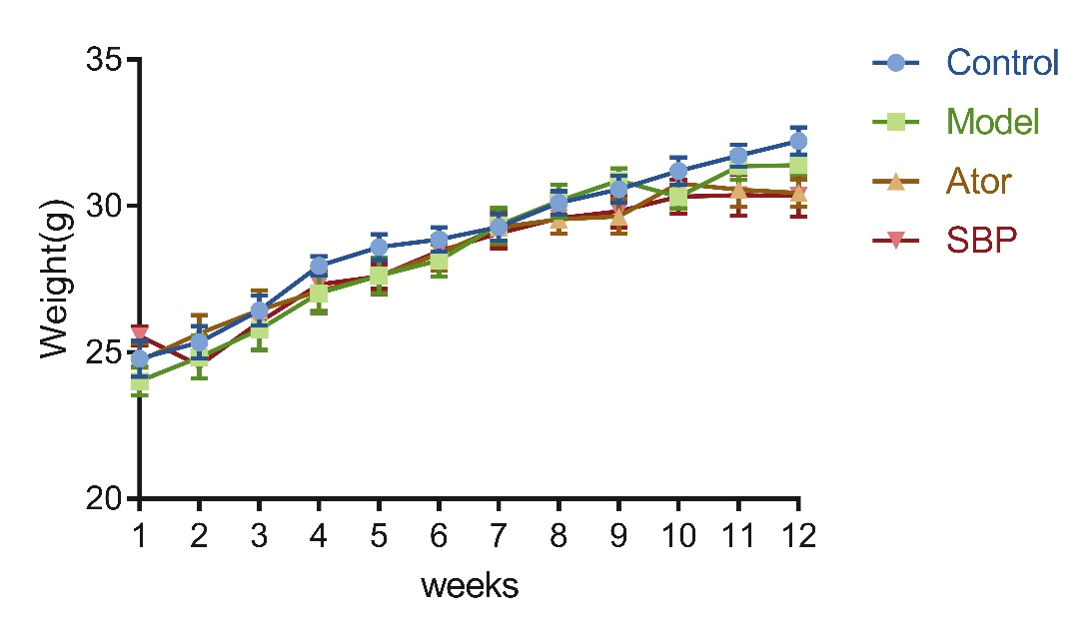

Supplementary Figure S1. Body weight of mice in per group.

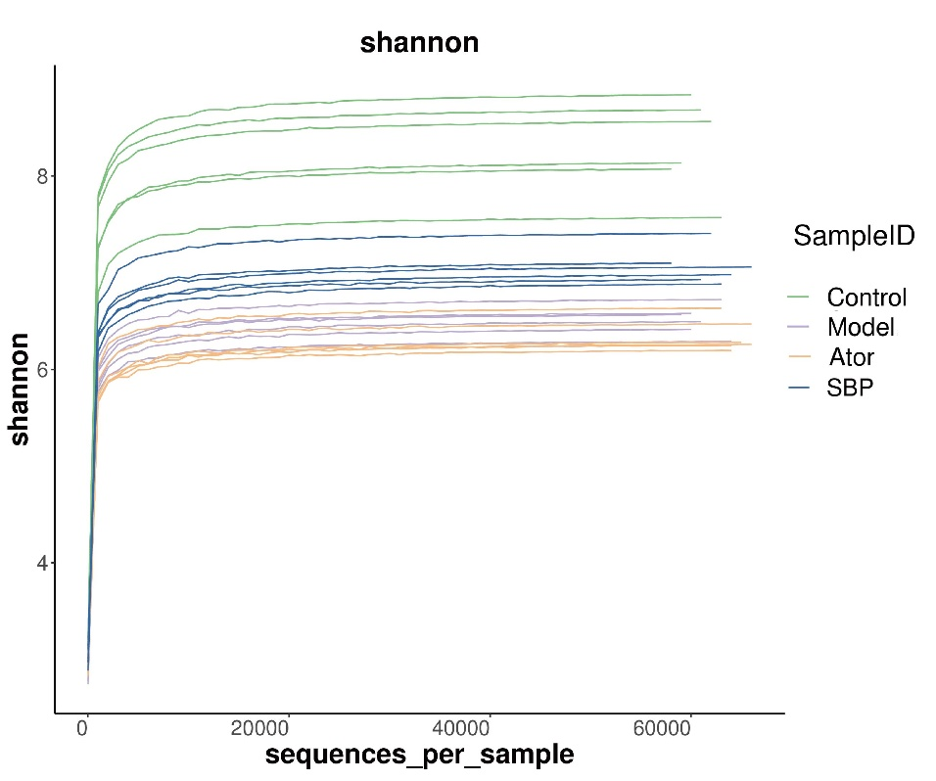
Supplementary Figure S2. Shannon rarefaction curve in individual groups. The abscissa indicates the number of sequencing tags to be retrieved randomly, and ordinates reflect the estimated value of the shannon index determined when a specific number of tags are retrieved. The curve tended to flatten as the number of sequences increased, implying the amount of sequencing data in the sample was reasonable.
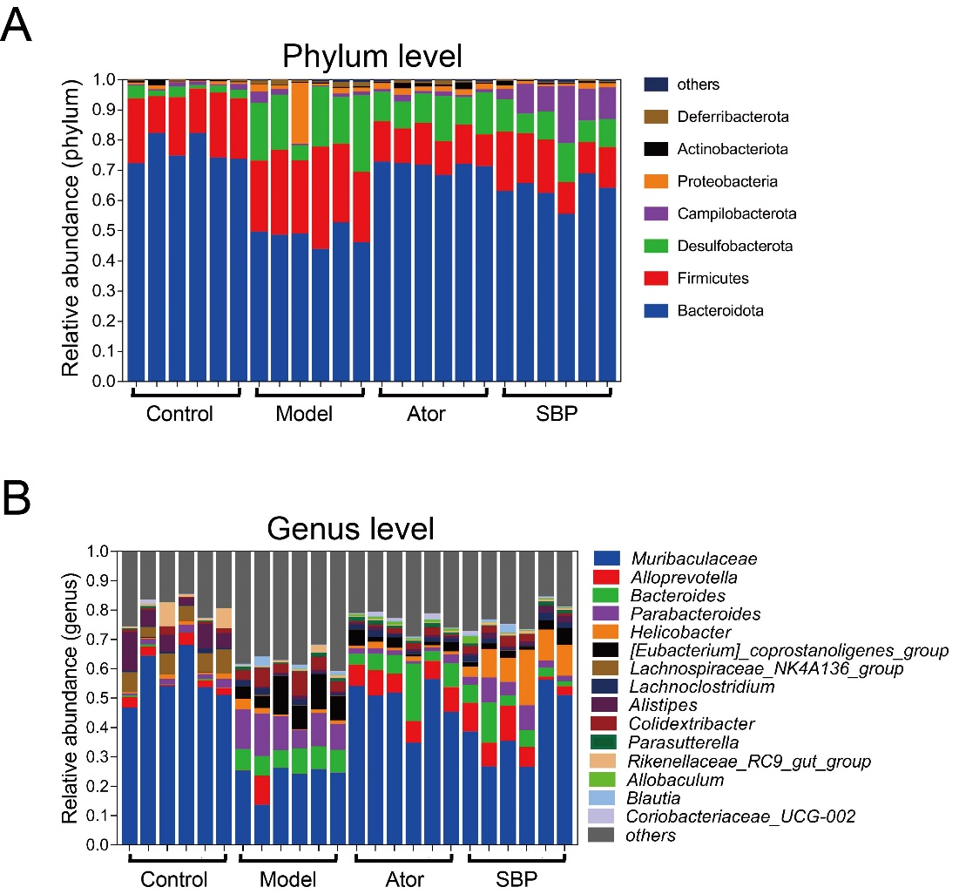

Supplementary Figure S3. The composition of gut microbiota in per sample. (A) The structure of gut microbiota in per sample at phylum level. (B) The structure of gut microbiota in per sample at genus level (Control = normal control group; Model = model group; Ator = atorvastatin group; SBP = Low dose of Shexiang Baoxin Pill group).
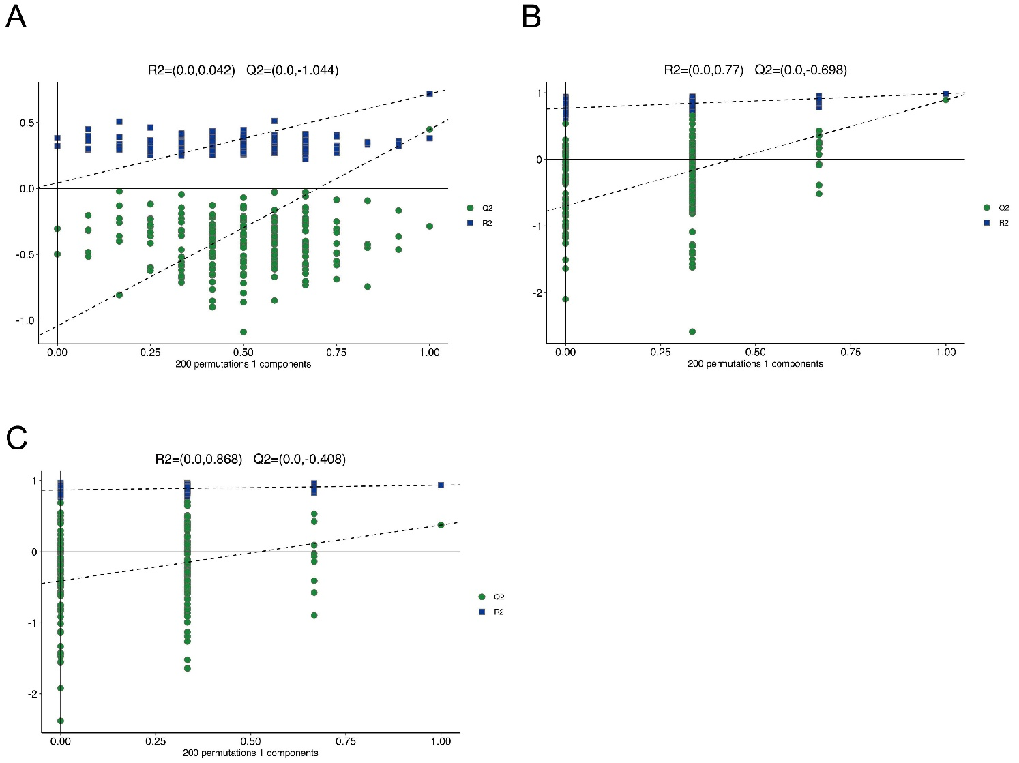
Supplementary Figure S4. Permutation test derived from the feces of mice in different group. (A) Permutation test from PLS-DA model among Control, Model, Ator and SBP groups. (B) Permutation test from OPLS-DA model between Control and Model group. (C) Permutation test from OPLS-DA model between SBP and Model group (Control = normal control group; Model = model group; Ator = atorvastatin group; SBP = Low dose of Shexiang Baoxin Pill group).
.

Supplementary Tables
Table S1 Other indexes to reflect the diversity of gut microbiota
Samples | Goods coverage | Observed species | Simpson
Control 1 | 0.961744662 | 2078.4 | 0.981118287
Control 2 | 0.964975011 | 1796.6 | 0.972085815
Control 3 | 0.96835075 | 1855.4 | 0.980980989
Control 4 | 0.967655611 | 1692.1 | 0.973952096
Control 5 | 0.955542935 | 2411.6 | 0.988998048
Control 6 | 0.960690595 | 2216.2 | 0.990001078
Model 1 | 0.975188551 | 1299.8 | 0.951237854
Model 2 | 0.973421172 | 1284.1 | 0.946453787
Model 3 | 0.972099046 | 1461.9 | 0.93765835
Model 4 | 0.973289414 | 1403.7 | 0.94426733
Model 5 | 0.97025443 | 1629.6 | 0.956922703
Model 6 | 0.969618355 | 1551.8 | 0.925351103
Ator 1 | 0.970940482 | 1410.8 | 0.94815045
Ator 2 | 0.967419355 | 1527.8 | 0.949894022
Ator 3 | 0.967655611 | 1536 | 0.949657688
Ator 4 | 0.969127669 | 1416.6 | 0.93516597
Ator 5 | 0.967174012 | 1603.6 | 0.956248152
Ator 6 | 0.971653794 | 1349.2 | 0.943415444
SBP 1 | 0.963639255 | 1758.8 | 0.958989895
SBP 2 | 0.965124943 | 1781.4 | 0.972536968
SBP 3 | 0.962939573 | 1737.4 | 0.953146522
SBP 4 | 0.962099046 | 1810.3 | 0.940516323
SBP 5 | 0.969686506 | 1508.6 | 0.96095401
SBP 6 | 0.968496138 | 1625.6 | 0.963516633

Table S2 The overlapped pathways between Model/Control and SBP/Model
NO. |  | KEGG pathway | Model/Control |  | SBP/Model
 |  |  | Rich Factor | p value |  | Rich Factor | p value
1 | Alanine, aspartate and glutamate metabolism |  | 0.1786 | 0.003646 |  | 0.1786 | 0.000352
2 | Long-term depression |  | 0.2222 | 0.043759 |  | 0.3333 | 0.000867
3 | Gap junction |  | 0.4545 | 0.000029 |  | 0.2727 | 0.001649
4 | Regulation of lipolysis in adipocytes |  | 0.2143 | 0.014570 |  | 0.2143 | 0.003462
5 | HIF-1 signaling pathway |  | 0.2000 | 0.017712 |  | 0.2000 | 0.004257
6 | beta-Alanine metabolism |  | 0.1250 | 0.031956 |  | 0.1250 | 0.005532
7 | Long-term potentiation |  | 0.2857 | 0.026834 |  | 0.2857 | 0.010011
8 | Spinocerebellar ataxia |  | 0.2857 | 0.026834 |  | 0.2857 | 0.010011
9 | Neuroactive ligand-receptor interaction |  | 0.2000 | 0.000100 |  | 0.1000 | 0.012258
10 | Porphyrin and chlorophyll metabolism |  | 0.0797 | 0.015128 |  | 0.0580 | 0.012286
11 | Taurine and hypotaurine metabolism |  | 0.1364 | 0.049406 |  | 0.1364 | 0.012852
12 | Glutamatergic synapse |  | 0.3750 | 0.002652 |  | 0.2500 | 0.013152
13 | Cocaine addiction |  | 0.5000 | 0.000126 |  | 0.2500 | 0.013152
14 | Endocrine and other factor-regulated calcium reabsorption |  | 0.2500 | 0.034894 |  | 0.2500 | 0.013152
15 | Circadian entrainment |  | 0.2222 | 0.043759 |  | 0.2222 | 0.016661
16 | GABAergic synapse |  | 0.4444 | 0.000221 |  | 0.2222 | 0.016661
17 | Amphetamine addiction |  | 0.4000 | 0.000357 |  | 0.2000 | 0.020522
18 | Alcoholism |  | 0.4000 | 0.000357 |  | 0.2000 | 0.020522
19 | Adrenergic signaling in cardiomyocytes |  | 0.3000 | 0.005372 |  | 0.2000 | 0.020522
20 | Dopaminergic synapse |  | 0.3333 | 0.000793 |  | 0.1667 | 0.029227
21 | Central carbon metabolism in cancer |  | 0.3000 | 0.000001 |  | 0.1000 | 0.029760
22 | Arginine and proline metabolism |  | 0.1154 | 0.002552 |  | 0.0641 | 0.031284
23 | Tyrosine metabolism |  | 0.1154 | 0.002552 |  | 0.0641 | 0.031284
24 | D-Glutamine and D-glutamate metabolism |  | 0.2308 | 0.011772 |  | 0.1538 | 0.034038

