Supplement Figure Legents

Suppl. 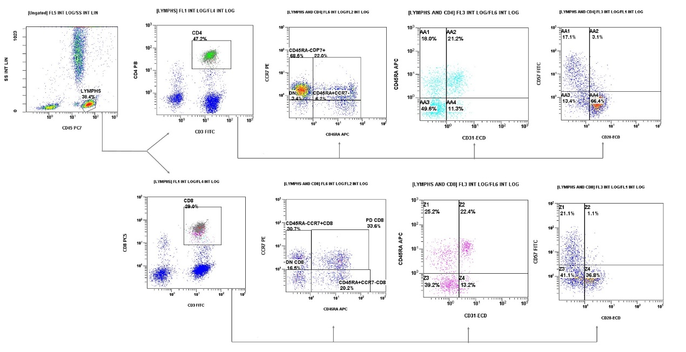Figure 1. Gating strategy for CD4 and CD8 cells, and their subsets, based on the presence of CD45RA, CCR7, CD31, CD57 and CD28
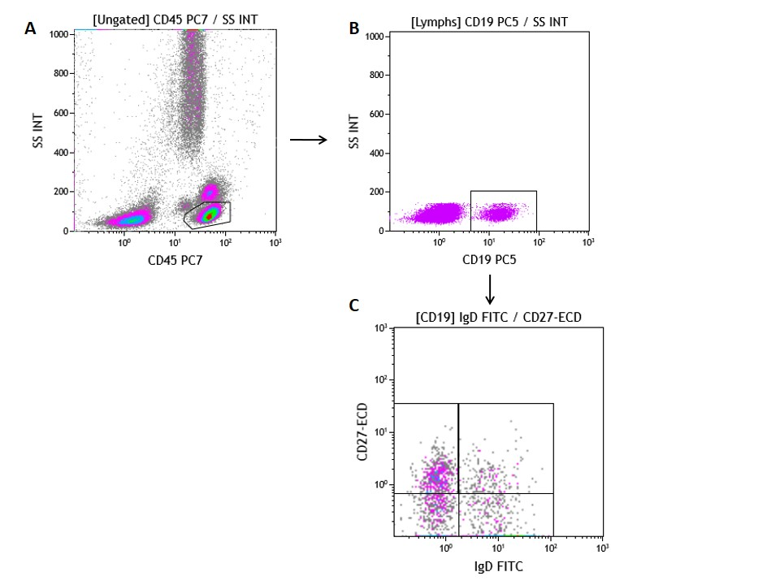

Suppl. Figure 2. Gating strategy for CD19+ cells, and their subsets based on the presence of IgD and CD27

