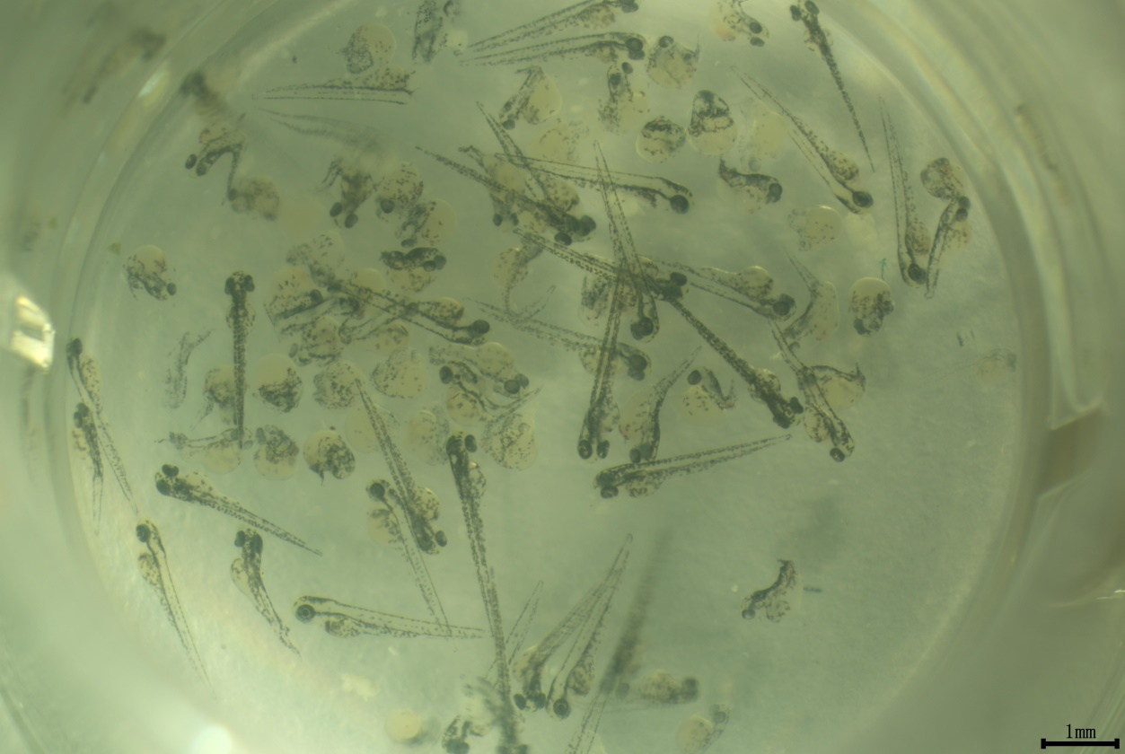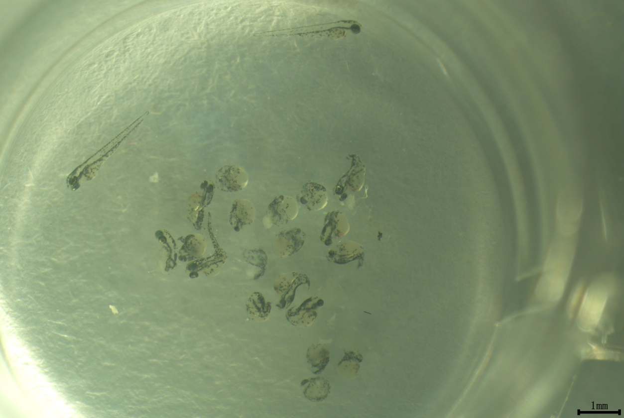
B
A

Figure S1.A, Rescue Phenotype of zebrafish embryos (48 hpf) by co-injection with Cas13d mRNA, gRNAs and flounder shisa-2 mRNA (Normal: abnormal= ); B, Control, Knockdown Phenotype of zebrafish embryos (48 hpf) after shisa-2 knockdown by co-injection with Cas13d mRNA and gRNAs(Normal: abnormal= ).

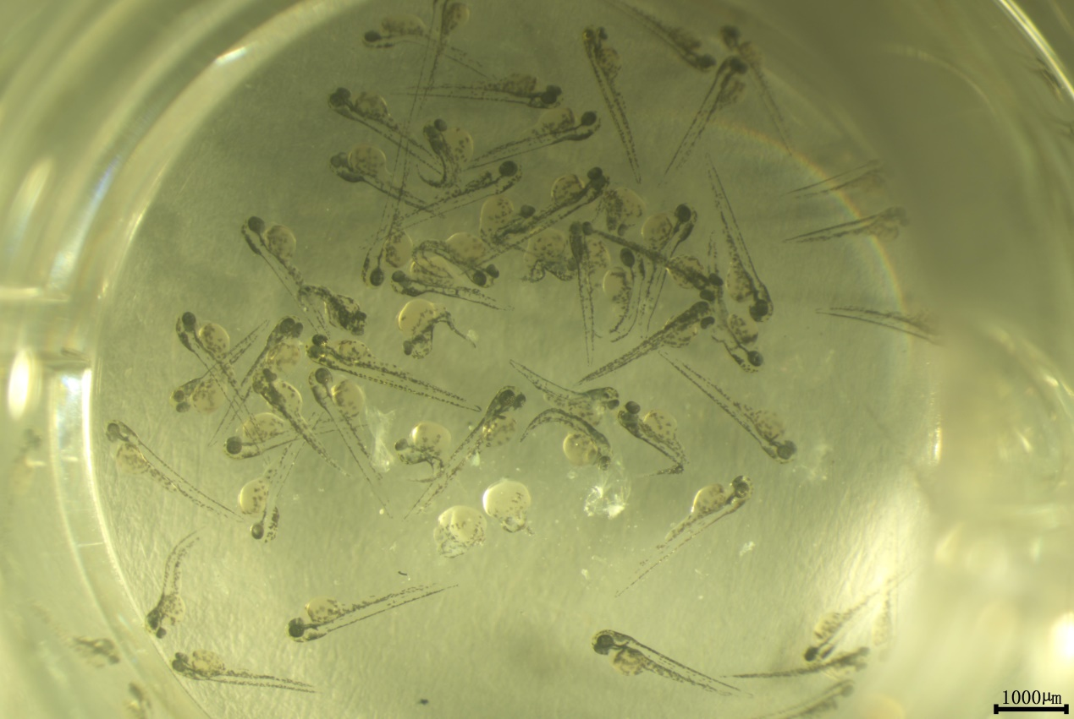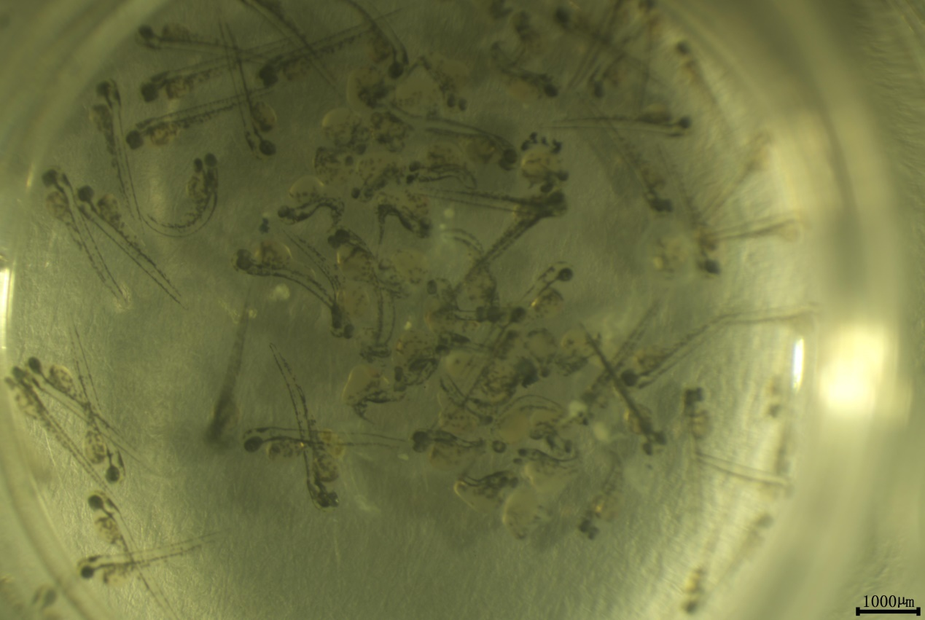
B
A
Figure S2. A, Rescue Phenotype of zebrafish embryos (48 hpf) by co-injection with Cas13d mRA, gRNAs and flounder shisa-2 mRNA, (Normal: abnormal= ); B, Control, Phenotype of zebrafish embryos (48 hpf) after shisa-2 knockdown by co-injection with Cas13d mRNA and gRNAs, (Normal: abnormal= ).

