New Janus Tricyclic Laddersiloxanes: Synthesis, Characterization and Reactivity

Yujia Liuª*, Midori Tokudaª, Nobuhiro Takedaª, Armelle Ouali^{b}* and Masafumi Unnoª*
- Gunma University, Department of Chemistry and Chemical Biology, 1-5-1 Tenjin-cho, Kiryu 376-8515, Japan
- ICGM, Univ. Montpellier, CNRS, ENSCM, 1919 route de Mende, Montpellier 34293 Cedex 05, France

Supplementary Materials

Table of contents | Pages
1. Characterization data for synthetic compounds 6-14 | S2
2. ¹H, ¹³C and ²⁹Si-NMR spectra for synthetic compounds 6-15 | S6
3. MALDI-TOF MS Spectra for synthetic compounds 6-15 | S21
4. Thermogravimetry/Differential Thermal Analysis (TG/DTA) for compounds 6-14 | S26

1. Characterization data for synthetic compounds 6-14
6-8-6 tricyclic laddersiloxane (6)
¹H NMR (600.17 MHz, CDCl₃): δ = 5.95-6.16 (m, 24H) ppm.
²⁹Si NMR (119.24 MHz, CDCl₃): δ = –35.21, –69.15 ppm.
¹³C NMR (150.91 MHz, CDCl₃): δ = 128.65, 132.64, 133.07, 136.44, 137.39, 137.85 ppm.
MALDI-TOF MS (m/z): 514.96 ([M+H]⁺, calcd 514.02).
Elemental analysis: Calcd for C₁₆H₂₄O₈Si₆: C, 37.47; H, 4.72. Found: C, 37.15; H, 4.79.

6-8-6 tricyclic laddersiloxane (7)
¹H NMR (600.17 MHz, CDCl₃): δ = 1.74 (d, J = 7.90 Hz, 4H), 1.80 (d, J = 7.90 Hz, 4H), 4.93-5.04 (m, 8H), 5.74-5.86 (m, 4H), 5.95 (dd, J = 20.62, 14.43 Hz, 4H), 6.07 (dd, J = 20.62, 4.12 Hz, 4H), 6.14 (dd, J = 14.43, 4.12 Hz, 4H) ppm.
²⁹Si NMR (119.24 MHz, CDCl₃): δ = –15.78, –69.17 ppm.
¹³C NMR (150.91 MHz, CDCl₃): δ = 22.23, 23.25, 115.99, 116.06, 128.60, 131.45, 131.58, 137.83 ppm.
MALDI-TOF MS (m/z): 570.76 ([M+H]⁺, calcd 570.08).
Elemental analysis: Calcd for C₂₀H₃₂O₈Si₆⋅H₂O: C, 40.92; H, 5.84. Found: C, 40.77; H, 5.85.

6-8-6 tricyclic laddersiloxane (8)
¹H NMR (600 .17 MHz, CDCl₃): δ = 0.31-0.38 (m, 6H), 5.94-6.13 (m, 18H) ppm.
²⁹Si NMR (119.24 MHz, CDCl₃): δ = –19.29, –19.39, –19.64, –19.77, –69.19, –69.25 ppm.
¹³C NMR (150.91 MHz, CDCl₃): δ = –1.09, –0.82, –0.79, –0.73, 128.68, 128.76, 128.85, 128.89, 134.16, 134.40, 134.85, 134.93, 135.03, 135.10, 135.90, 136.16, 137.63, 137.66, 137.73, 137.79 ppm.
MALDI-TOF MS (m/z): 486.89 ([M+H]⁺, calcd 486.02).
Elemental analysis: Calcd for C₁₄H₂₄O₈Si₆⋅0.5H₂O: C, 33.78, H, 5.06. Found: C, 33.75; H, 5.03.

6-8-6 tricyclic laddersiloxane (9)
¹H NMR (600.17 MHz, CDCl₃): δ = 5.33 (dd, J = 19.59, 15.12 Hz, 0.33H), 5.39 (dd, J = 14.78, 4.47 Hz, 0.33H), 5.52 (dd, J = 19.59, 4.47 Hz, 0.33H), 5.89-6.24 (m, 16.68H), 6.29 (dd, J = 19.93, 14.78 Hz, 0.33H), 6.99 (t, J = 7.90 Hz, 1H), 7.22-7.24 (m, 0.5H), 7.35-7.47 (m, 6H), 7.56 (dd, J = 7.90, 1.37 Hz, 1H), 7.66 (dd, J = 7.90, 1.37 Hz, 0.5H), 7.76 (dd, J = 7.90, 1.37 Hz, 1H) ppm.
²⁹Si NMR (119.24 MHz, CDCl₃): δ = –33.86, –33.96, –34.02, –34.38, –68.40, –68.86, –69.00, –69.17 ppm.
¹³C NMR (150.91 MHz, CDCl₃): δ = 127.84, 127.94, 128.04, 128.08, 128.52, 128.74, 130.57, 130.63, 130.67, 130.73, 131.62, 132.14, 132.57, 132.80, 133.48, 133.65, 133.89, 133.94, 133.99, 134.01, 134.22, 134.40, 136.37, 136.54, 137.16, 137.46, 137.96, 138.02 ppm.
MALDI-TOF MS (m/z): 634.78 ([M+Na]⁺, calcd 635.03), 650.71 ([M+K]⁺, calcd 651.00).

6-8-6 tricyclic laddersiloxane (10):
¹H NMR (600.17 MHz, CDCl₃): δ = 0.19-0.28 (m, 48H), 0.52-0.99 (m, 32H), 7.27-7.37 (m, 24H), 7.44-7.49 (m, 16H) ppm.
²⁹Si NMR (119.24 MHz, CDCl₃): δ = –1.12, –1.18, –1.31, –7.94, –55.06 ppm.
¹³C NMR (150.91 MHz, CDCl₃): δ = –3.50, –3.47, –3.25, 5.08, 6.46, 6.60, 6.68, 6.92, 6.96, 127.69, 127.81, 127.91, 128.85, 129.03, 133.71, 133.84, 133.94, 134.04, 138.99, 139.07, 139.39 ppm.
MALDI-TOF MS (m/z): 1623.16 ([M+Na]⁺, calcd 1623.56).
Elemental analysis: Calcd for C₈₀H₁₂₀O₈Si₁₄⋅0.5H₂O: C, 59.28; H, 7.59. Found: C, 59.00; H, 7.61.

6-8-6 tricyclic laddersiloxane (11):
¹H NMR (600.17 MHz, CDCl₃): δ = 0.22 (s, 12H), 0.24 (s, 12H), 0.25 (s, 24H), 0.55-0.82 (m, 32H), 1.40- 1.43 (m, 8H), 7.31-7.36 (m, 24H), 7.47-7.49 (m, 16H) ppm.
²⁹Si NMR (119.24 MHz, CDCl₃): δ = –1.16, –3.80, –3.91, –8.46, –55.41 ppm.
¹³C NMR (150.91 MHz, CDCl₃): δ = –3.48, –3.46, –2.85, –2.81, 5.04, 6.89,17.27, 17.38, 19.86, 20.02, 20.38, 20.52, 127.85, 127.87, 127.91, 128.88, 128.95, 129.02, 133.60, 133.65, 133.71, 138.98, 139.54, 139.60 ppm.
MALDI-TOF MS (m/z): 1680.35 ([M+Na]⁺, calcd 1680.63)
Elemental analysis: Calcd for C₈₄H₁₂₈O₈Si₁₄: C, 60.81; H, 7.78. Found: C, 60.47; H, 7.91.

6-8-6 tricyclic laddersiloxane (12):
¹H NMR (600.17 MHz, CDCl₃): δ = 0.10-0.26 (m, 42H), 0.54-0.78 (m, 24H), 7.31-7.34 (m, 18H), 7.46-7.49 (m, 12H) ppm.
²⁹Si NMR (119.24 MHz, CDCl₃): δ = –1.10, –1.14, –6.19, –6.36, –6.82, –54.95, –54.99, –55.31, –55.39 ppm.
¹³C NMR (150.91 MHz, CDCl₃): δ = –3.51, –3.48, –3.26, –1.64, –1.49, –1.08, 4.93, 4.99, 6.56, 6.68, 6.81, 6.95, 7.27, 8.83, 9.01, 9.41, 127.70, 127.84, 127.90, 128.87, 128.92, 128.96, 129.01, 133.70, 133.78, 133.86, 133.96, 138.96, 139.02, 139.08, 139.24, 139.44 ppm.
MALDI-TOF MS (m/z): 1327.16 ([M+Na]⁺, calcd 1327.42), 1345.17 ([M+K]⁺, calcd 1345.40).
Elemental analysis: Calcd for C₆₂H₉₆O₈Si₁₂⋅2H₂O: C, 55.47; H, 7.51. Found: C, 55.49; H, 7.51.

6-8-6 tricyclic laddersiloxane (13):
¹H NMR (600.17 MHz, CDCl₃): δ = 0.095-0.11 (m, 48H), 0.60-0.79 (m, 32H), 1.43-1.49 (m, 8H), 2.770 (s, 4H), 2.774 (s, 4H), 2.79 (s, 8H) ppm.
²⁹Si NMR (119.24 MHz, CDCl₃): δ = 5.37, 2.99, 2.93, –8.58, –55.58 ppm.
¹³C NMR (150.91 MHz, CDCl₃): δ = –4.96, –4.39, –4.32, 4.76, 4.94, 17.06, 17.18, 17.96, 18.12, 20.39, 20.49, 29.94, 30.44 ppm.
MALDI-TOF MS (m/z): 1460.86 ([M+Na]⁺, calcd 1460.18).
Elemental analysis: Calcd for C₄₄H₁₀₄Cl₈O₈Si₁₄⋅H₂O: C, 36.29; H, 7.34. Found: C, 34.94; H, 7.30.

6-8-6 tricyclic laddersiloxane (14):
¹H NMR (600.17 MHz, CDCl₃): δ = 0.10-0.25 (m, 42H), 0.59-0.70 (m, 24H), 2.78-2.79 (m, 12H) ppm.
²⁹Si NMR (119.24 MHz, CDCl₃): δ = 5.61, 5.40, 5.20, –6.17, –6.57, –6.92, –55.12, –55.22, –55.58 ppm.
¹³C NMR (150.91 MHz, CDCl₃): δ = –5.00, –4.80, –4.30, –1.67, –1.55, –1.29, –0.98, 4.58, 4.63, 4.69, 4.75, 4.83, 4.86, 4.92, 8.17, 8.69, 9.07, 9.25, 29.92, 30.02, 30.10 ppm
MALDI-TOF MS (m/z): 1162.79 ([M+Na]⁺, calcd 1162.09).
Elemental analysis: Calcd for C₃₂H₇₈Cl₆O₈Si₁₂⋅2H₂O: C, 32.66; H, 7.02. Found: C, 32.49; H, 6.98.

2. ¹H, ¹³C and ²⁹Si-NMR Spectra for synthetic compounds 6-15
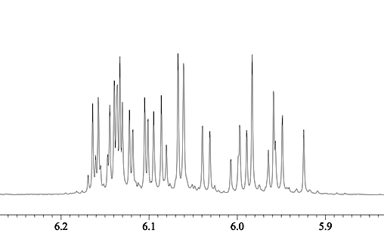
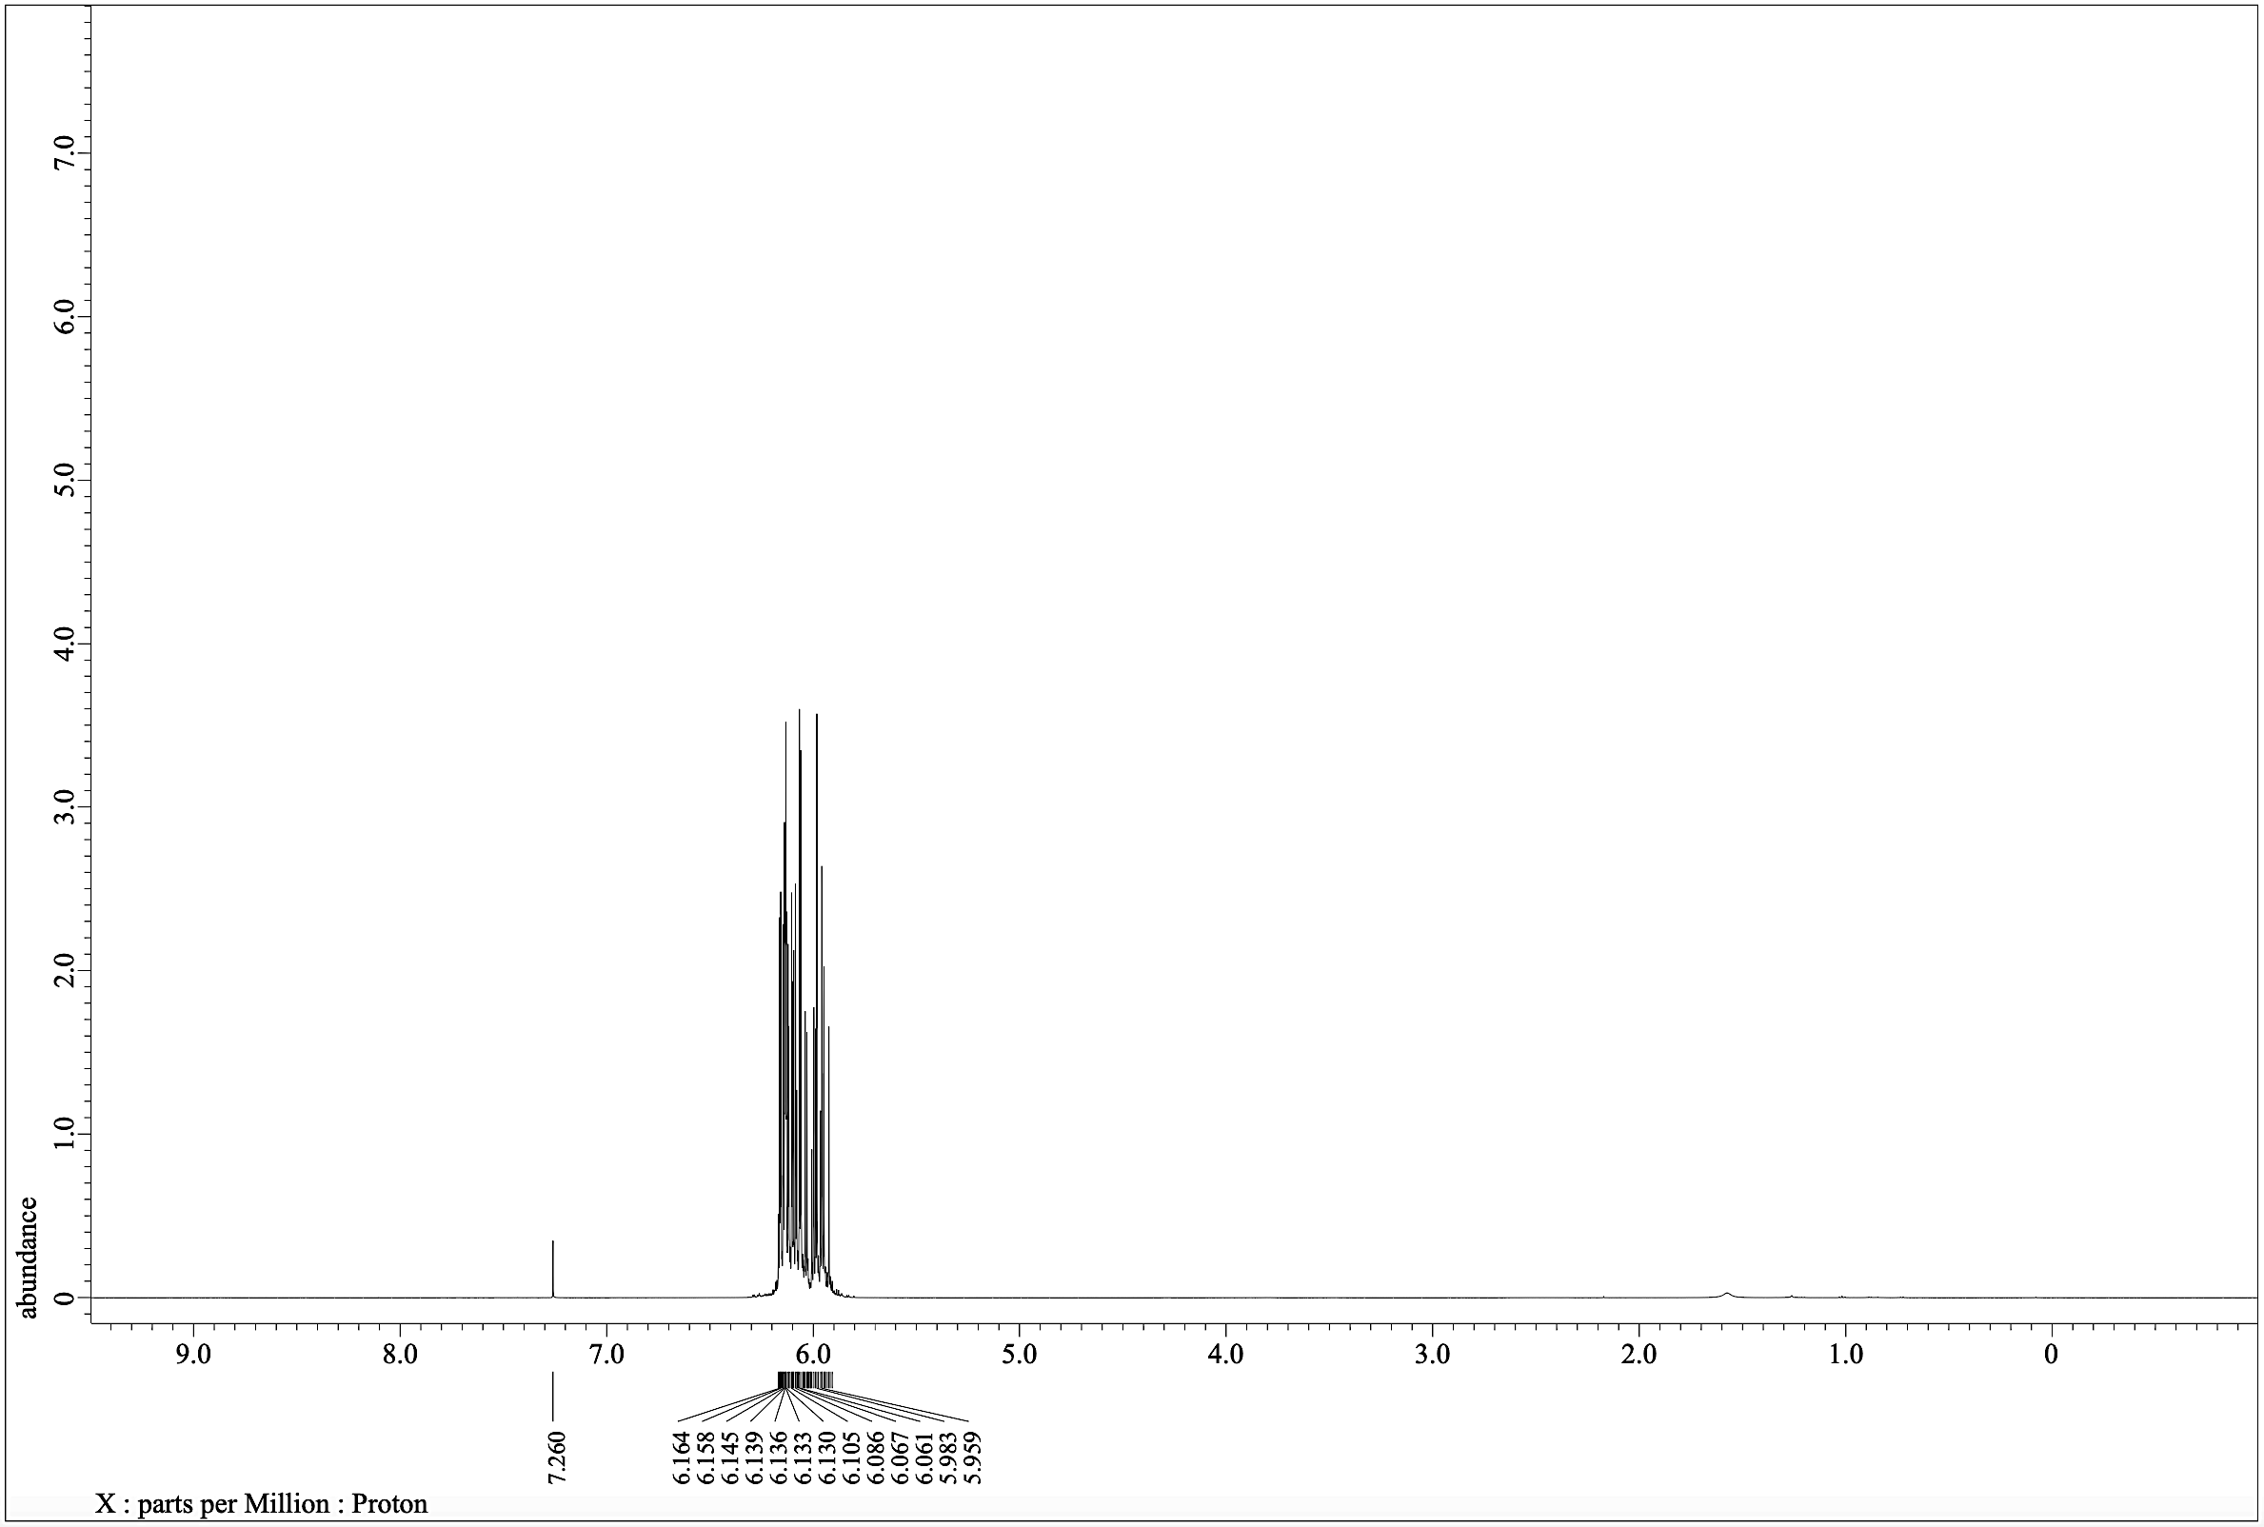
6
¹H NMR (600.17 MHz, CDCl₃)
Figure S1: ¹H NMR spectrum for 6.
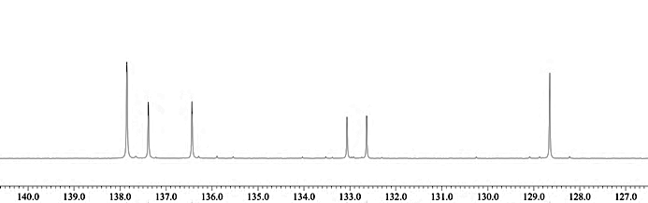
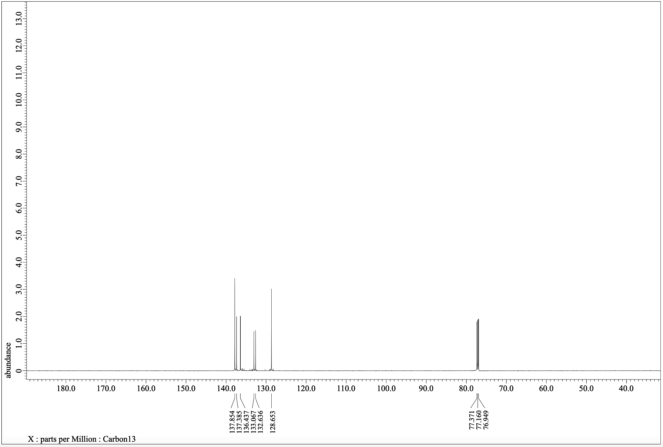
6
¹³C NMR (150.91 MHz, CDCl₃)
Figure S2: ¹³C NMR spectrum for 6.
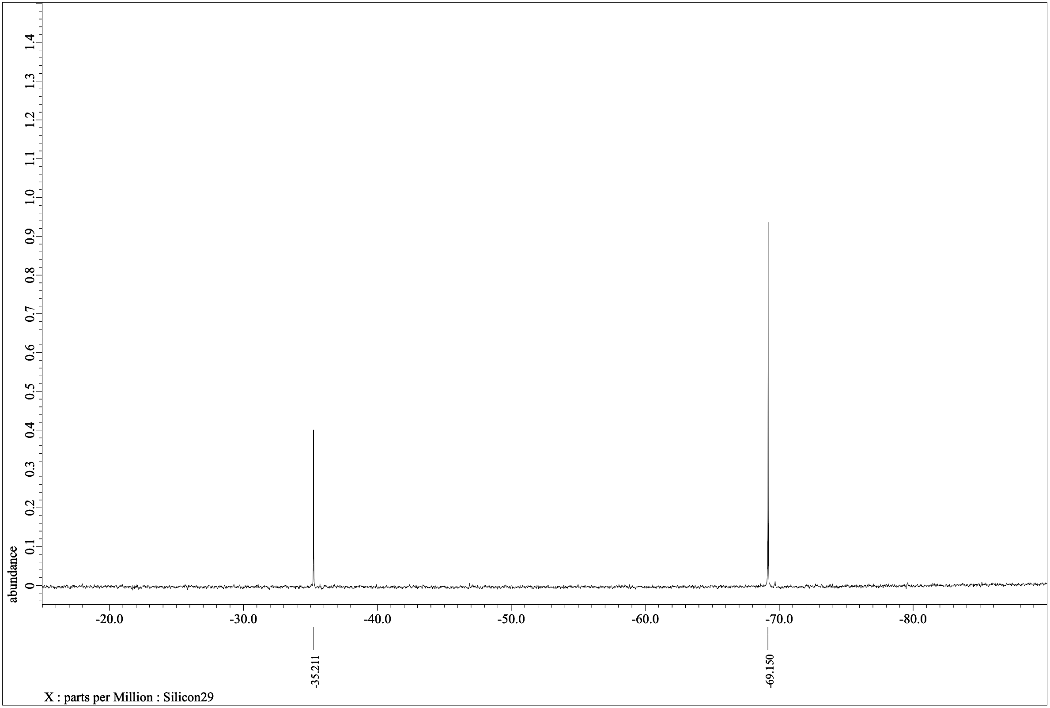
-Si-
-Si-
6
²⁹Si NMR (119.24 MHz, CDCl₃)
Figure S3: ²⁹Si NMR spectrum for 6.
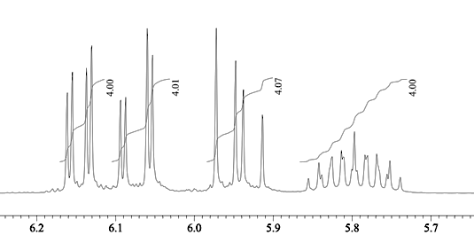
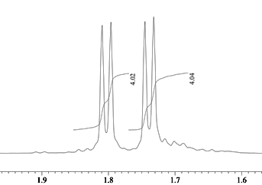
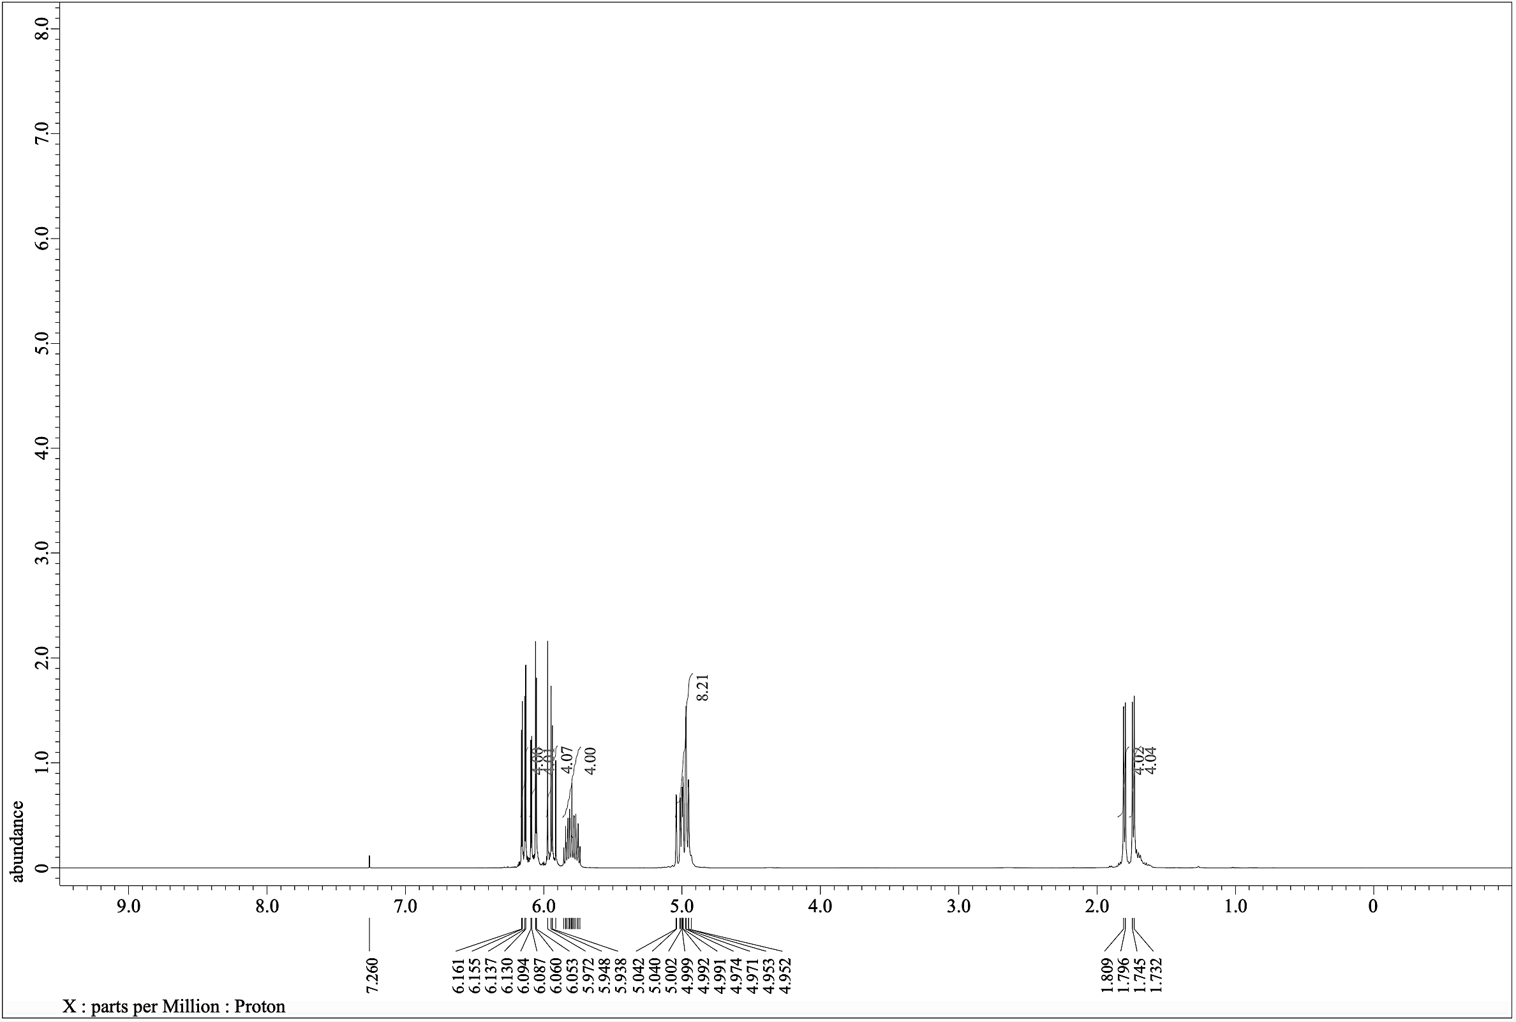
¹H NMR (600.17 MHz, CDCl₃)
7
Figure S4: ¹H NMR spectrum for 7.
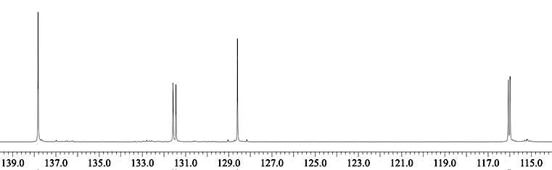
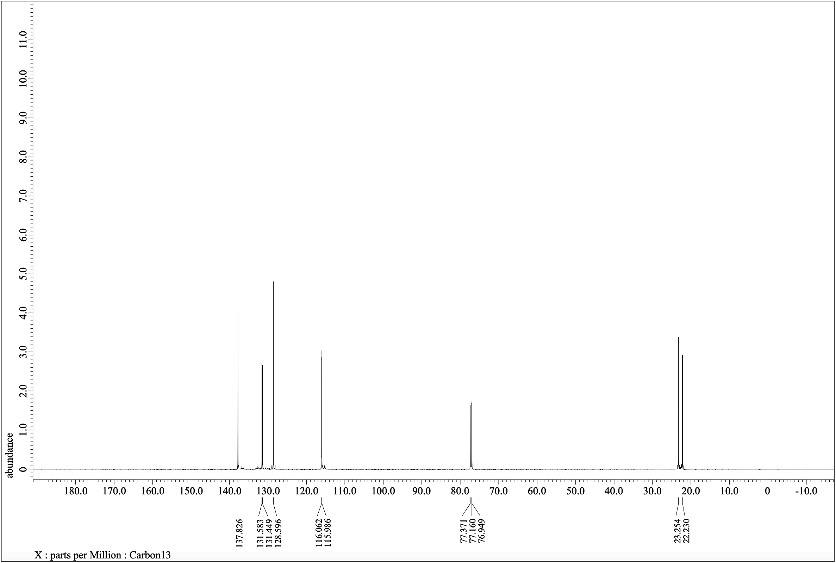
7
¹³C NMR (150.91 MHz, CDCl₃)
Figure S5: ¹³C NMR spectrum for 7.
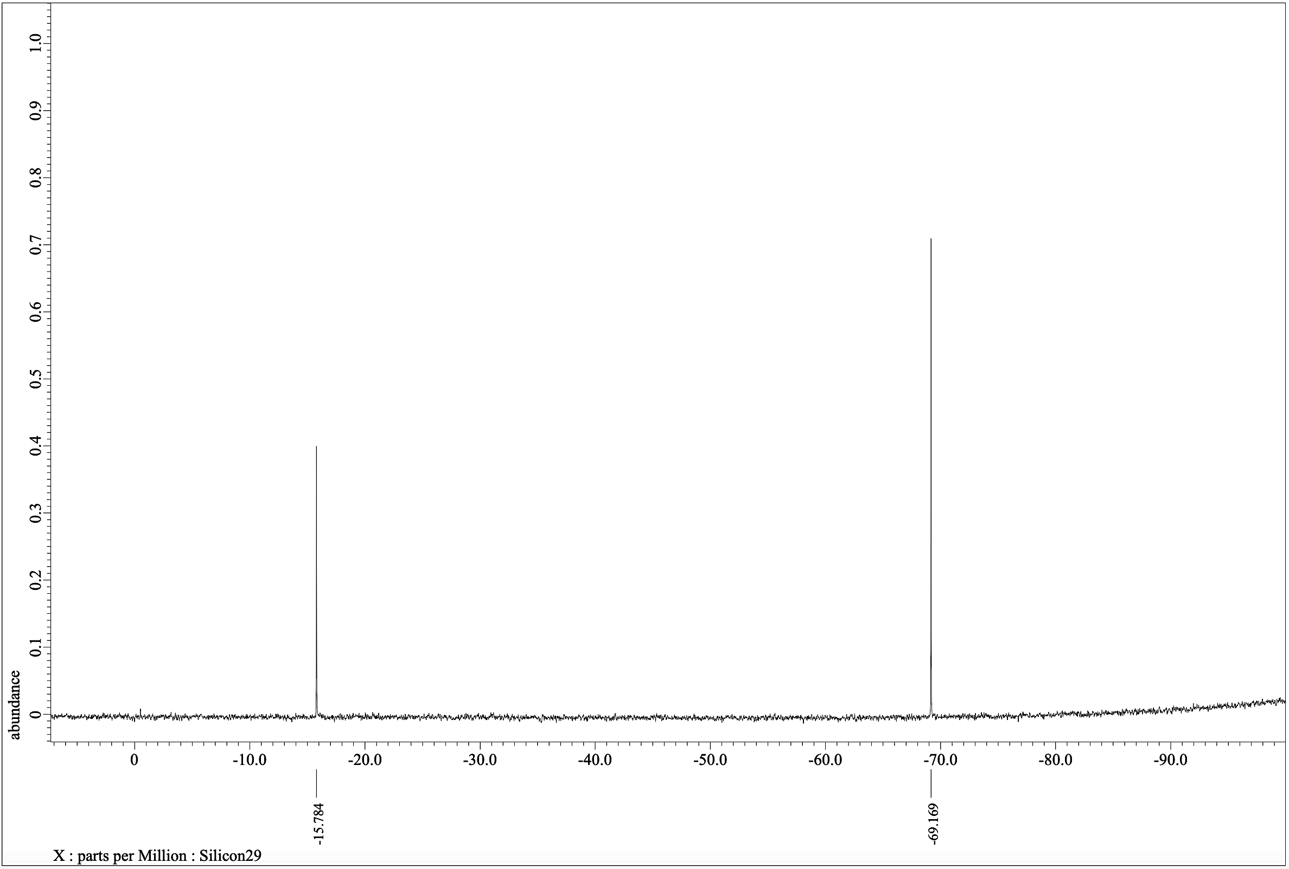
7
-Si-
-Si-
²⁹Si NMR (119.24 MHz, CDCl₃)
Figure S6: ²⁹Si NMR spectrum for 7.

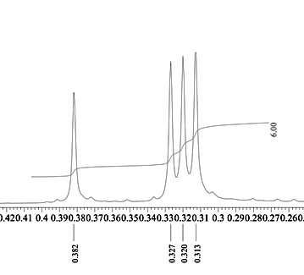
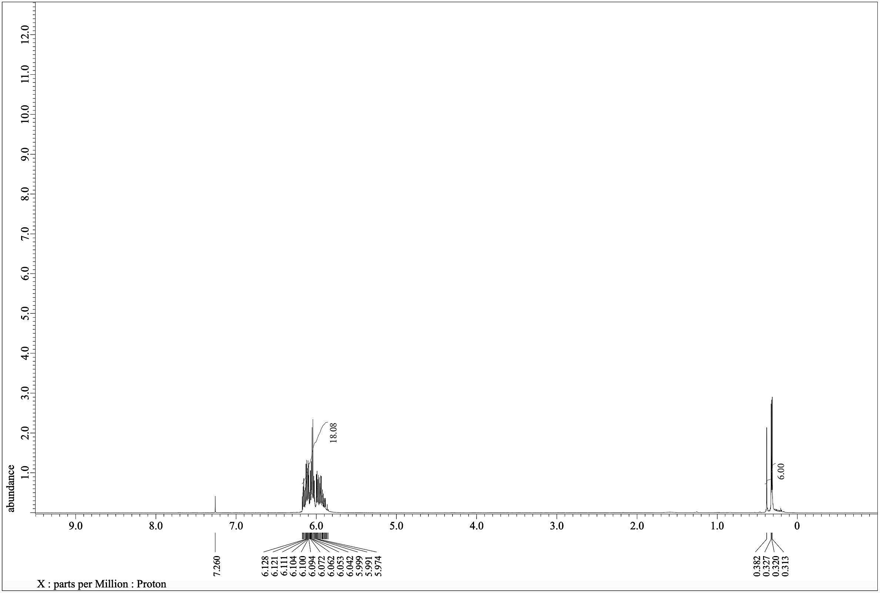
8
¹H NMR (600.17 MHz, CDCl₃)
Figure S7: ¹H NMR spectrum for 8.
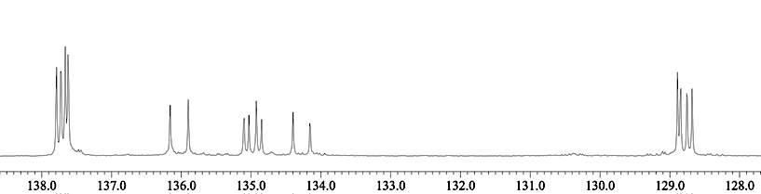
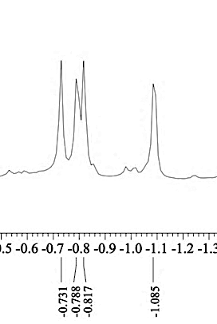
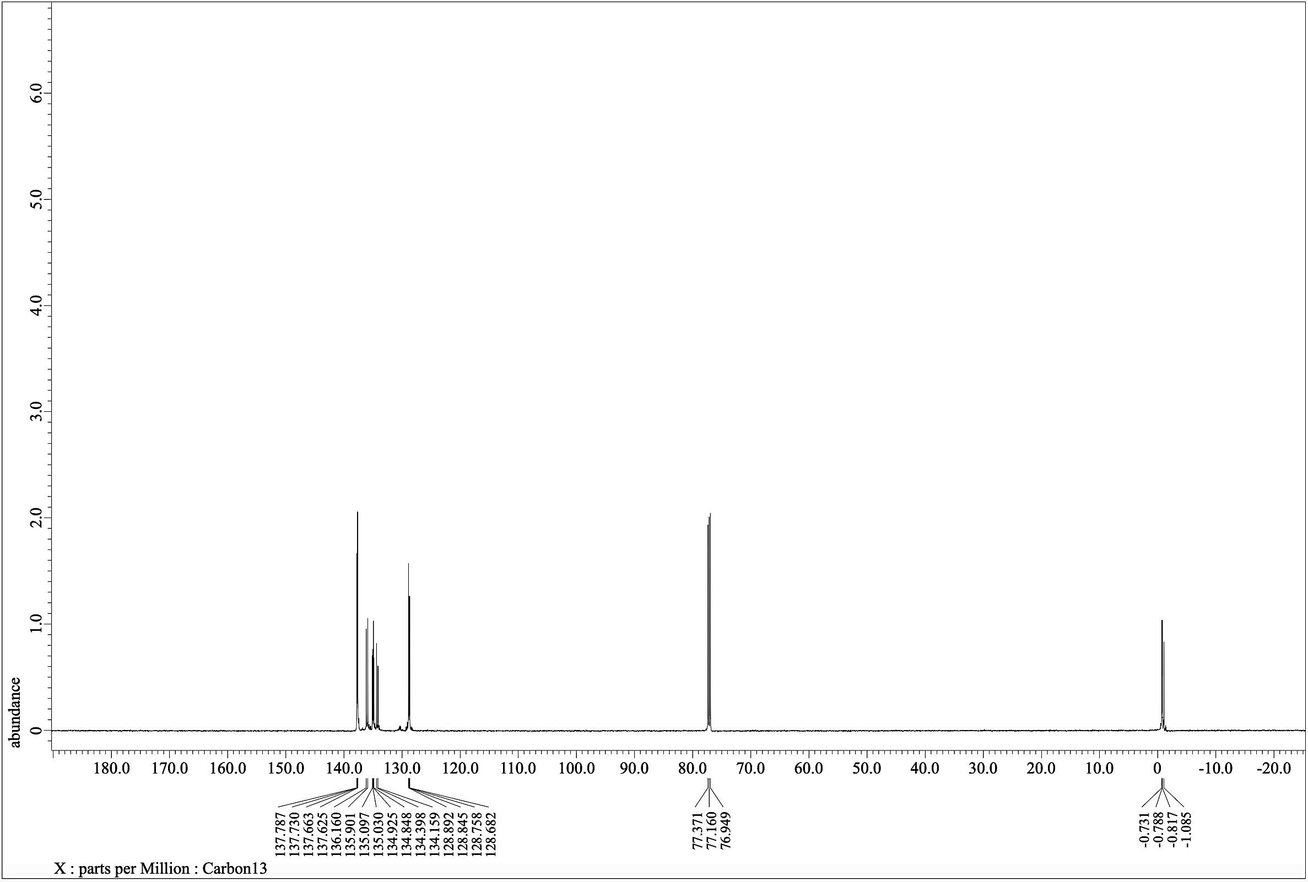
¹³C NMR (150.91 MHz, CDCl₃)
8

Figure S8: ¹³C NMR spectrum for 8.
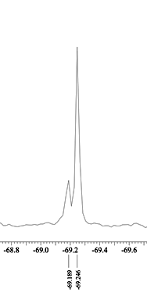
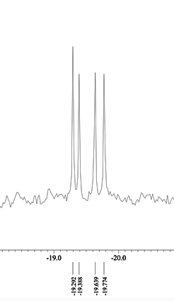
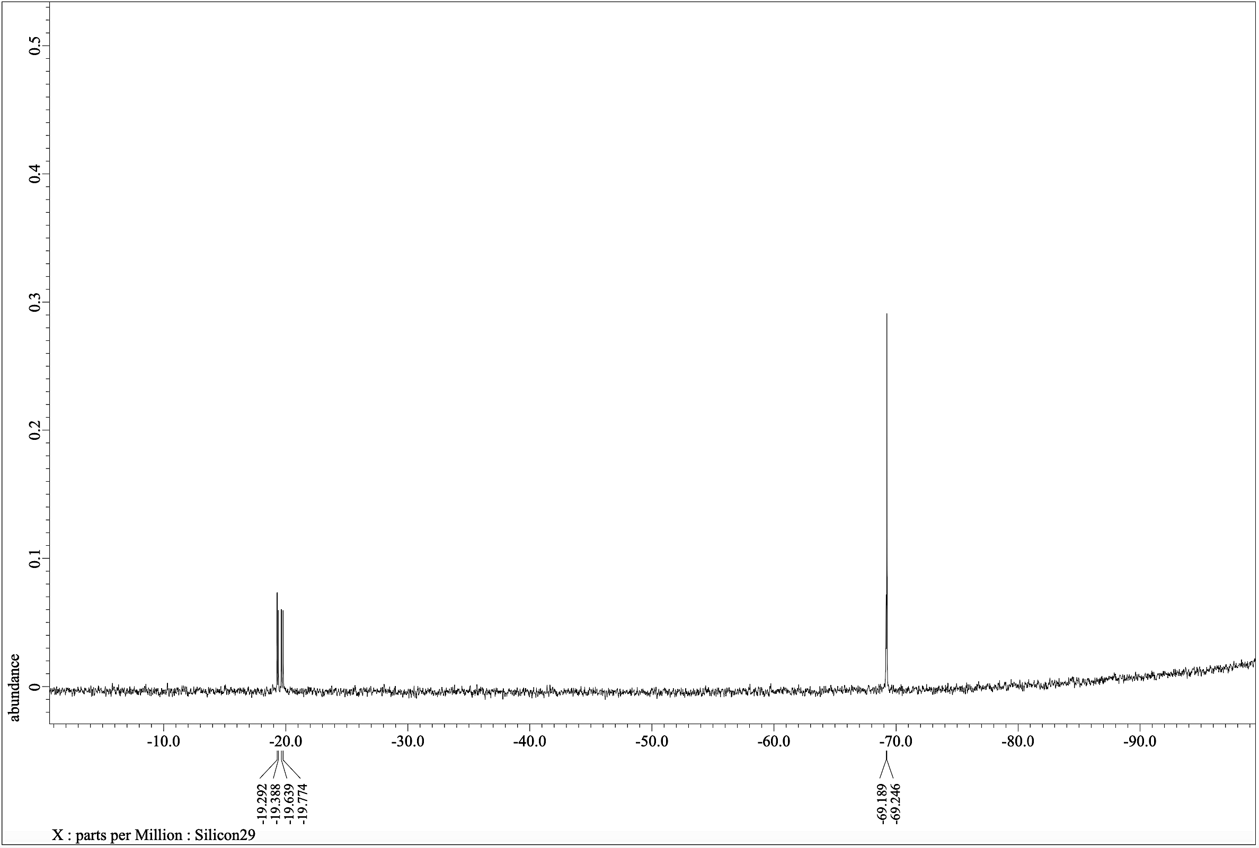
8
-Si-

-Si-

²⁹Si NMR (119.24 MHz, CDCl₃)
Figure S9: ²⁹Si NMR spectrum for 8.
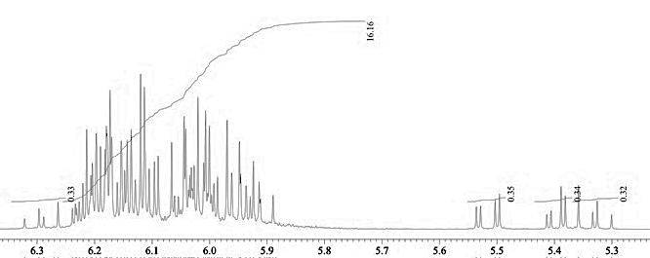
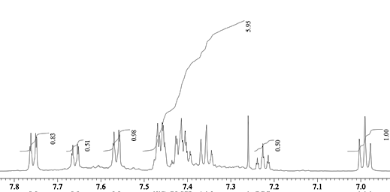
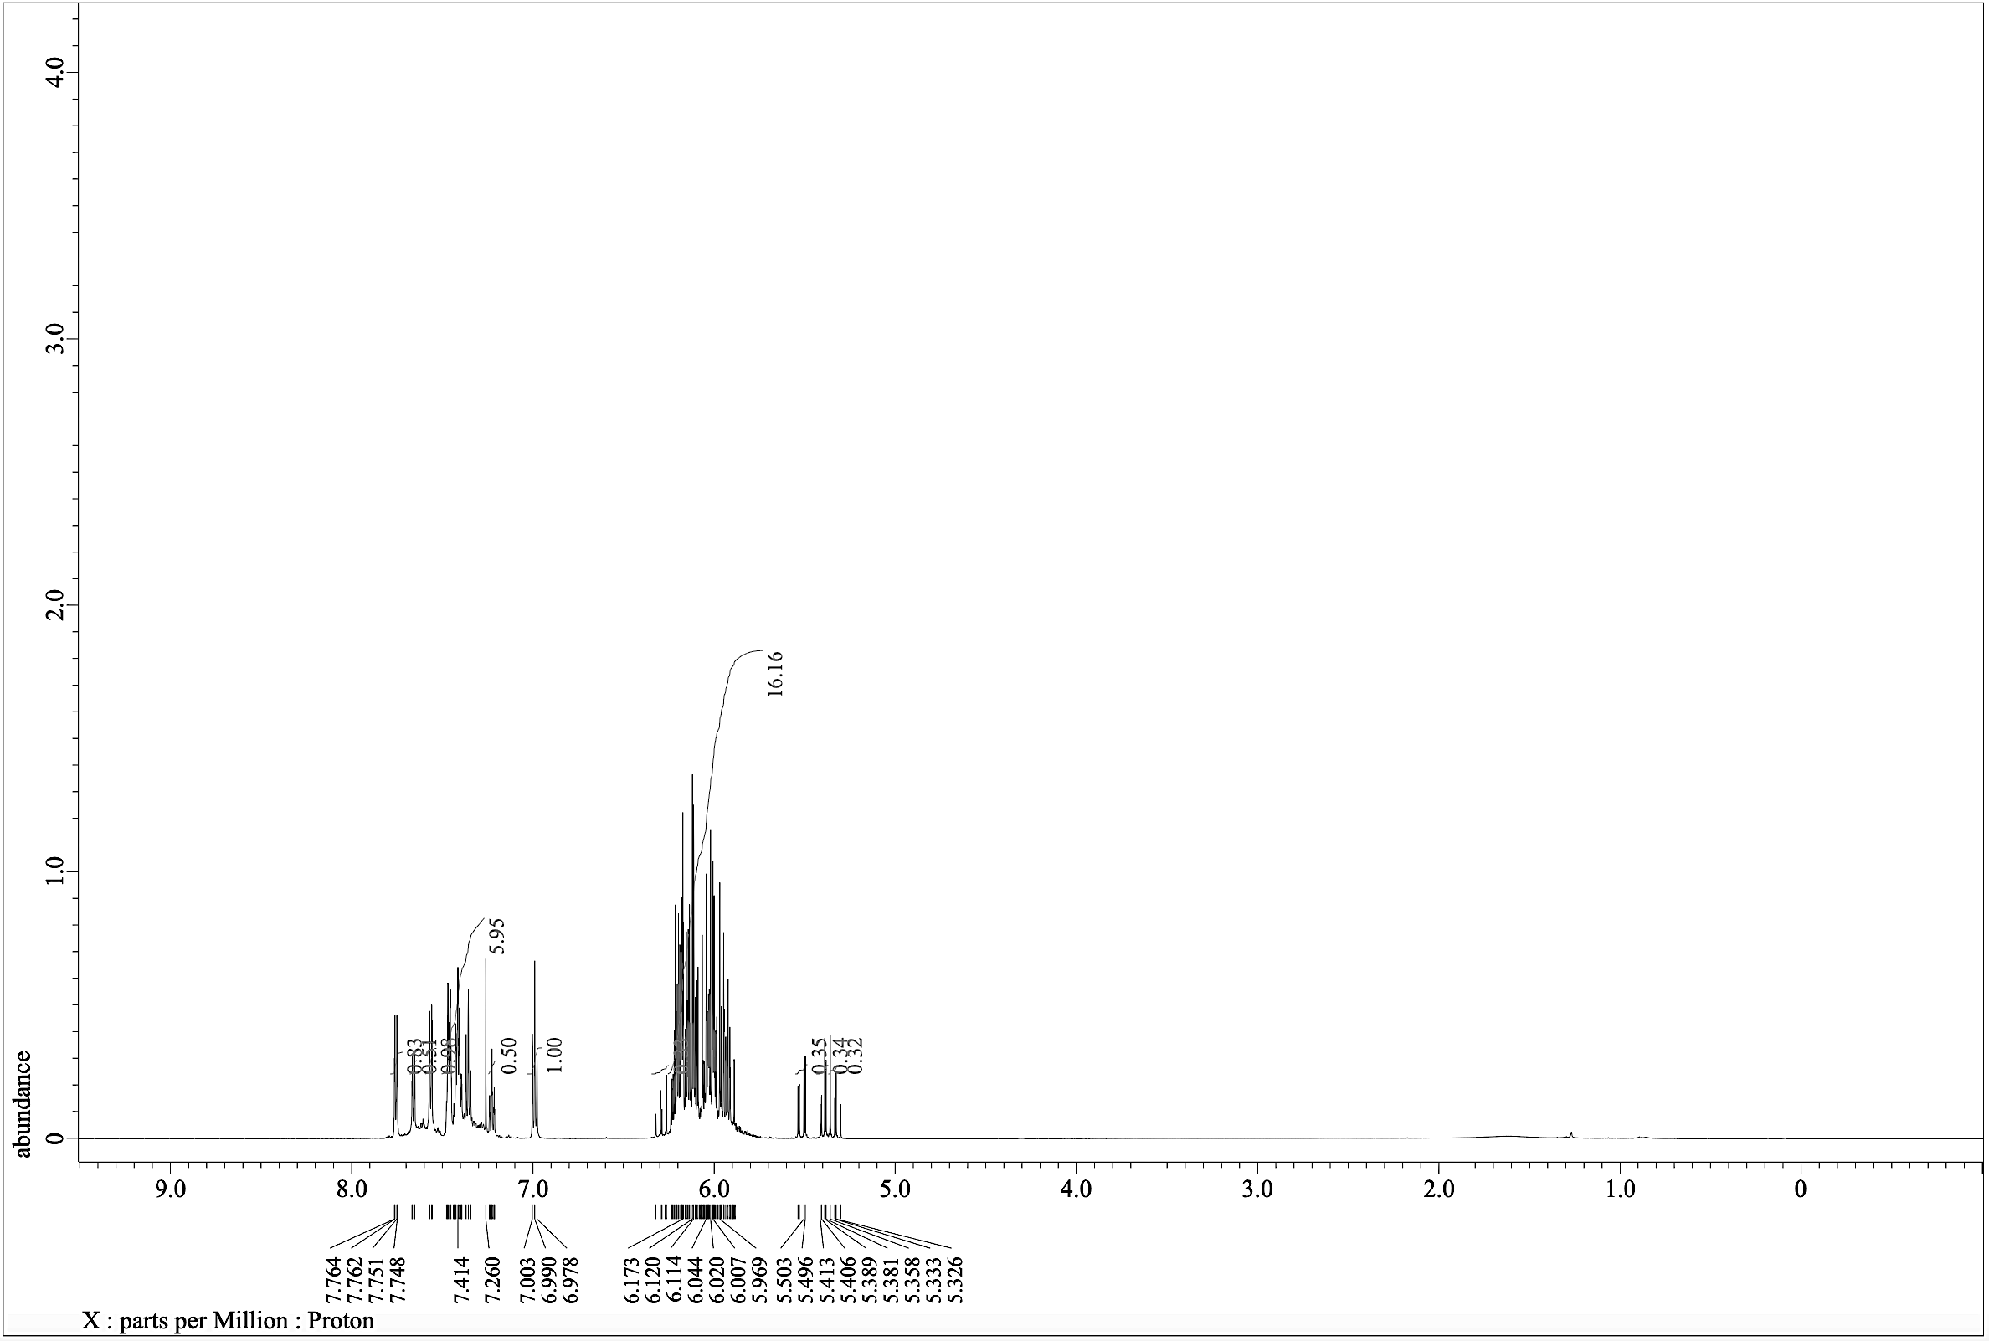

9
¹H NMR (600.17 MHz, CDCl₃)
Figure S10: ¹H NMR spectrum for 9.

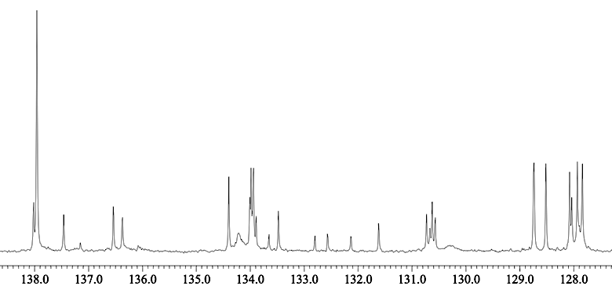
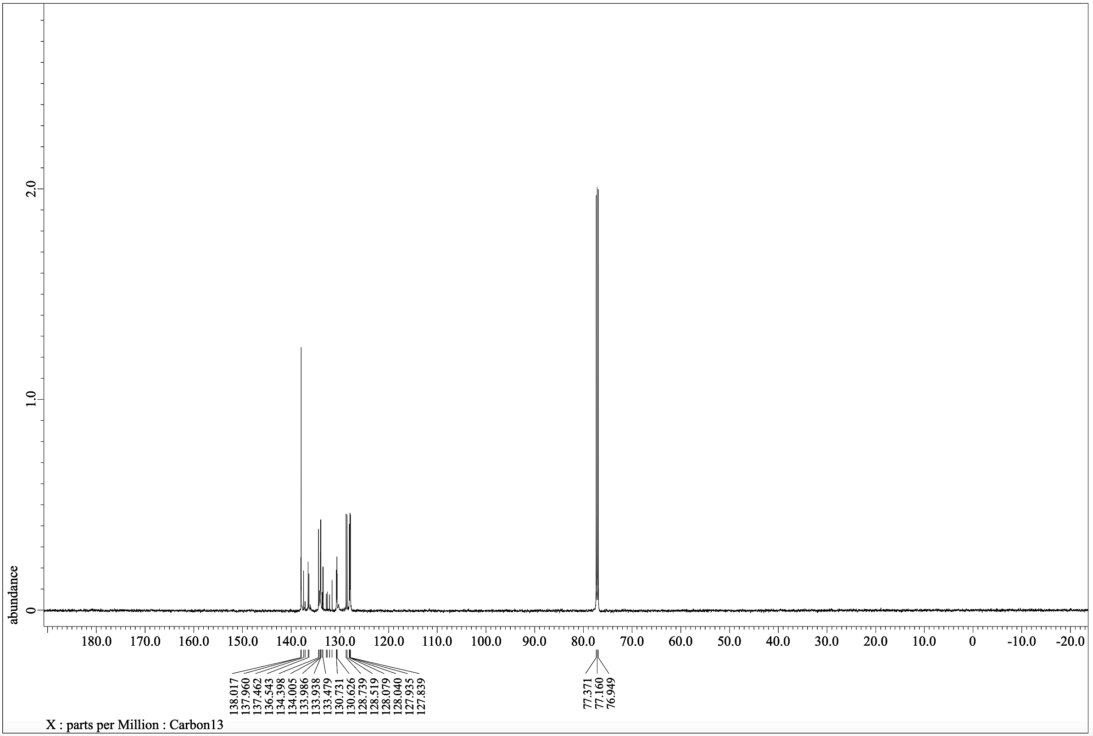

9
¹³C NMR (150.91 MHz, CDCl₃)
Figure S11: ¹³C NMR spectrum for 9.
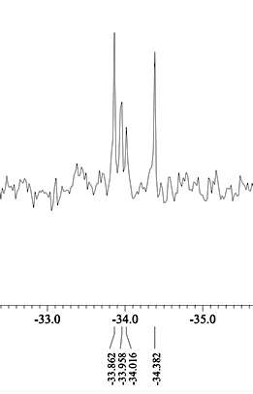
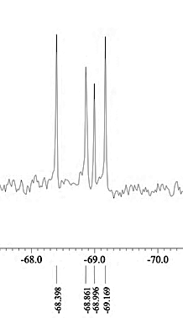
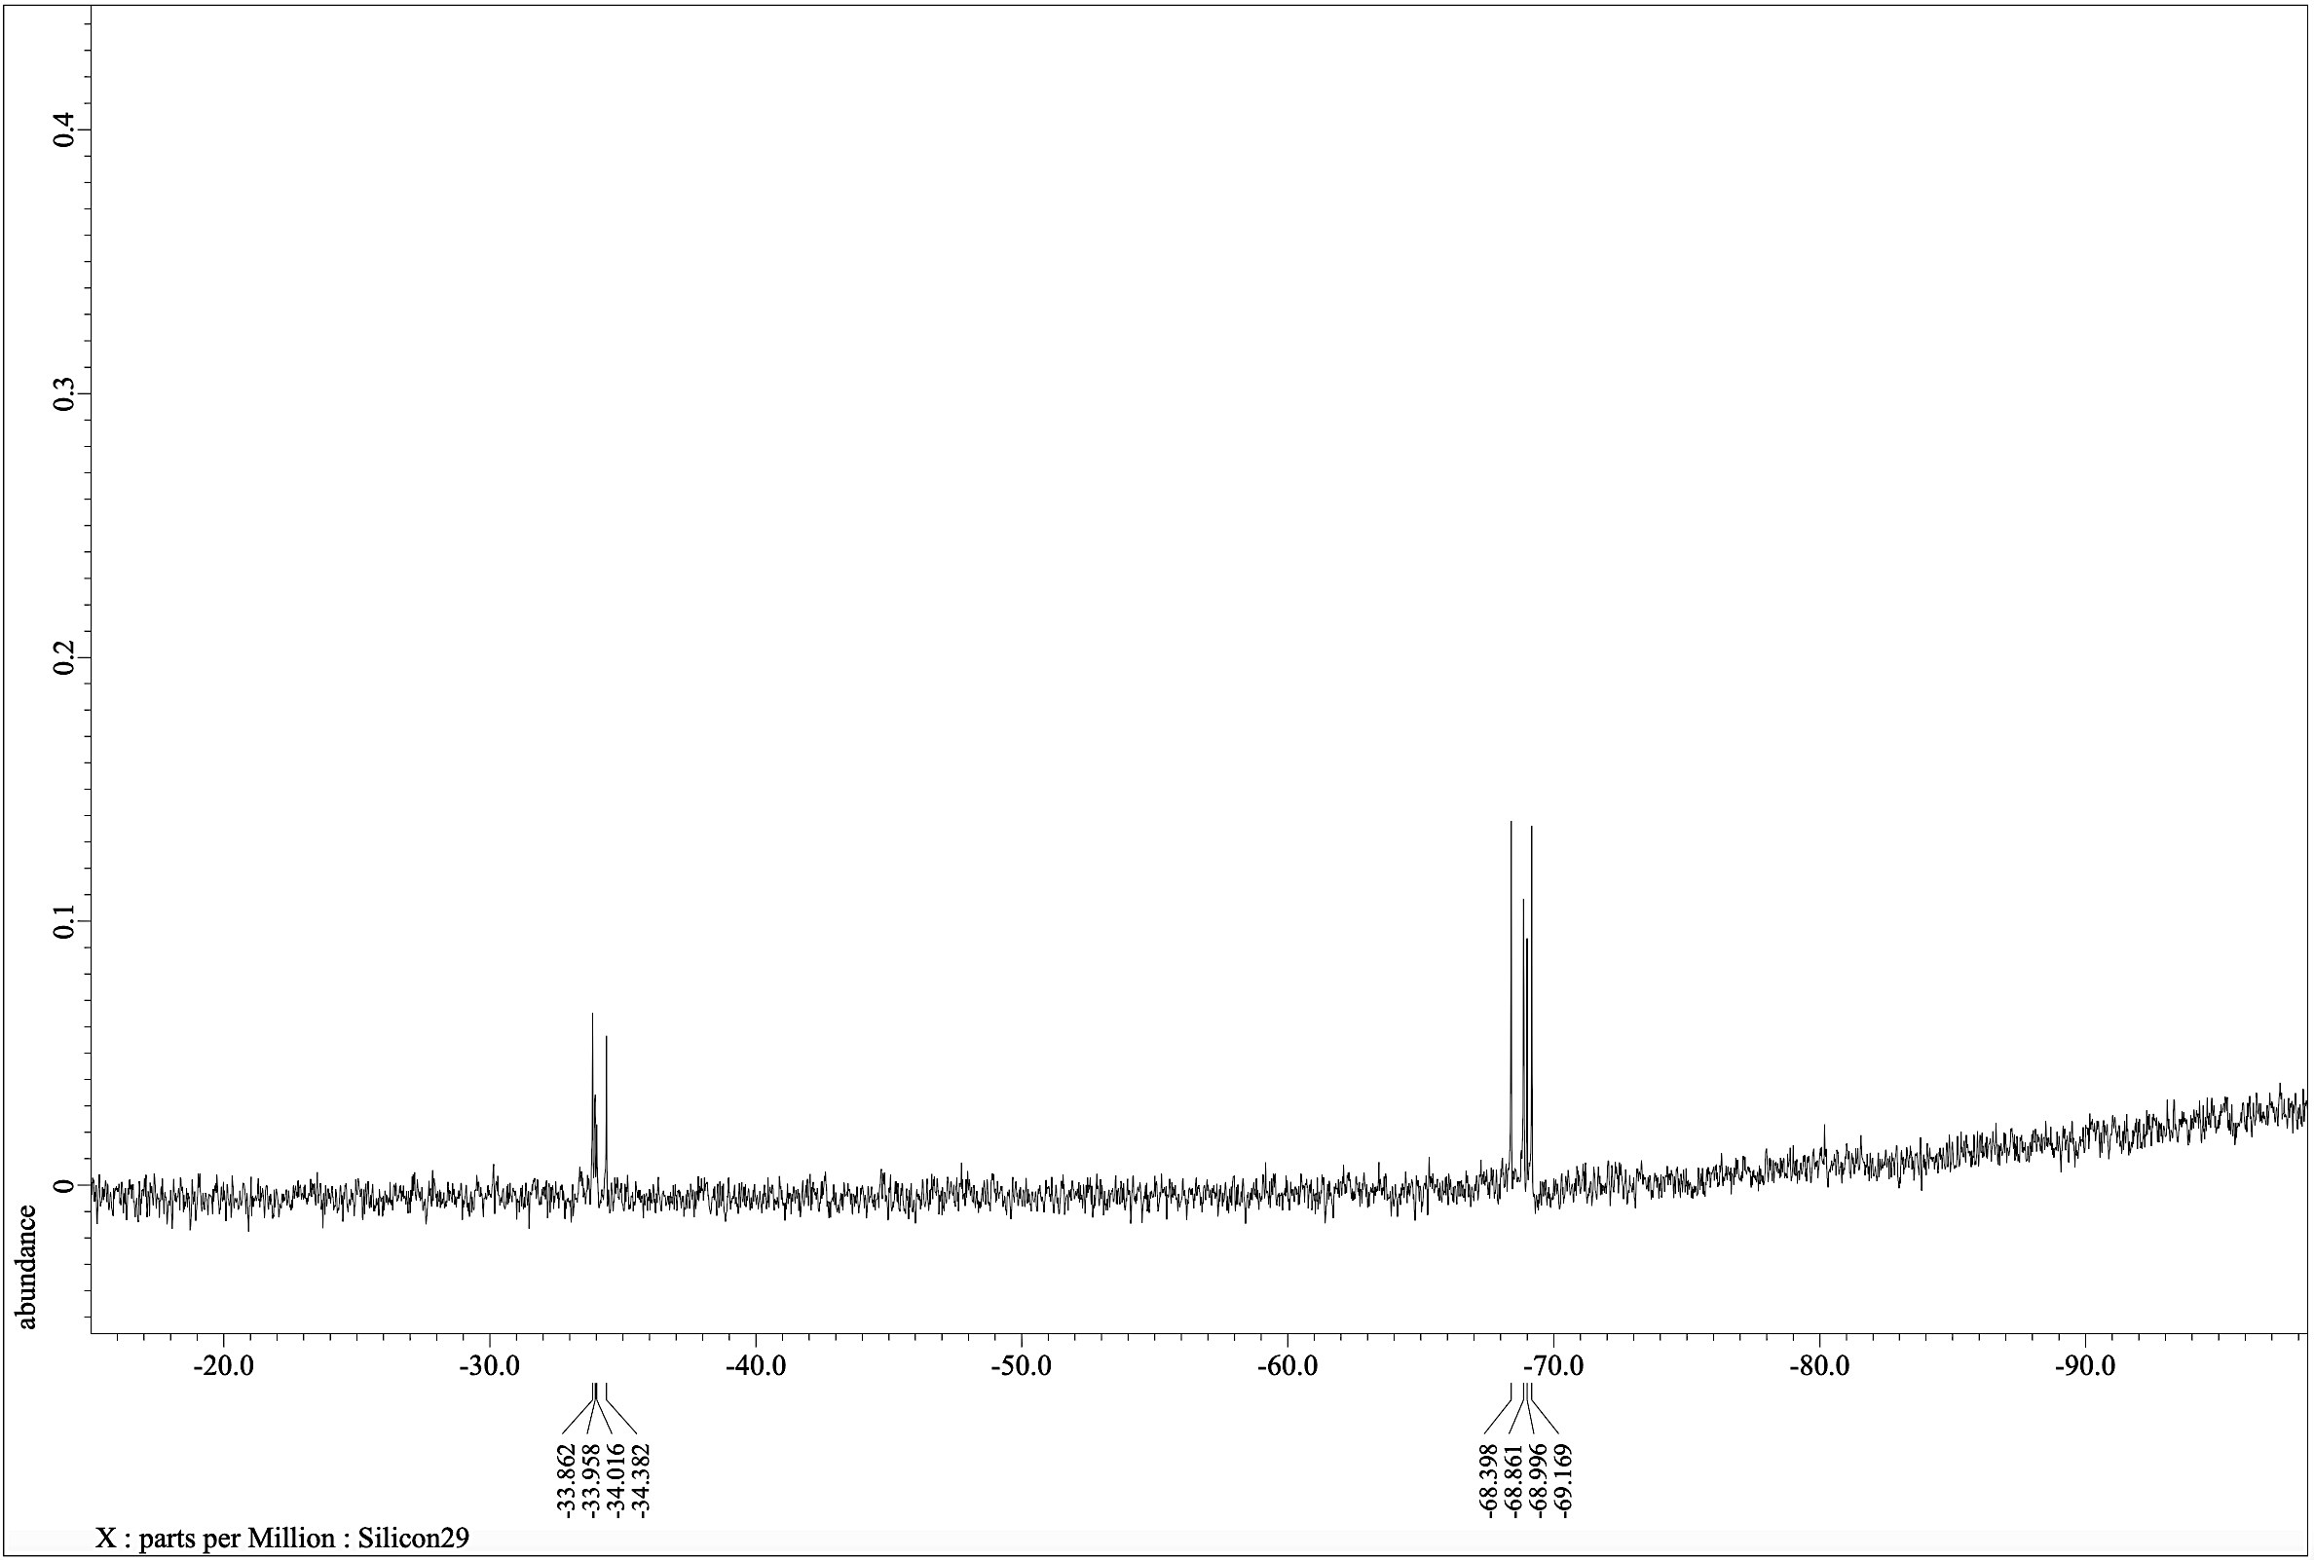
²⁹Si NMR (119.24 MHz, CDCl₃)
-Si-
-Si-

9
Figure S12: ²⁹Si NMR spectrum for 9.
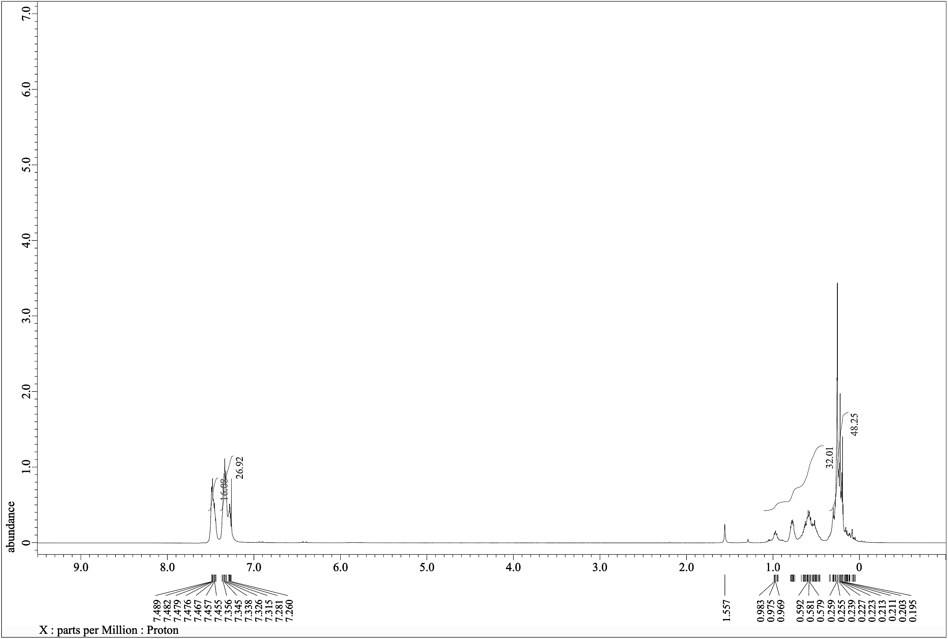
10
¹H NMR (600.17 MHz, CDCl₃)
Figure S13: ¹H NMR spectrum for 10.
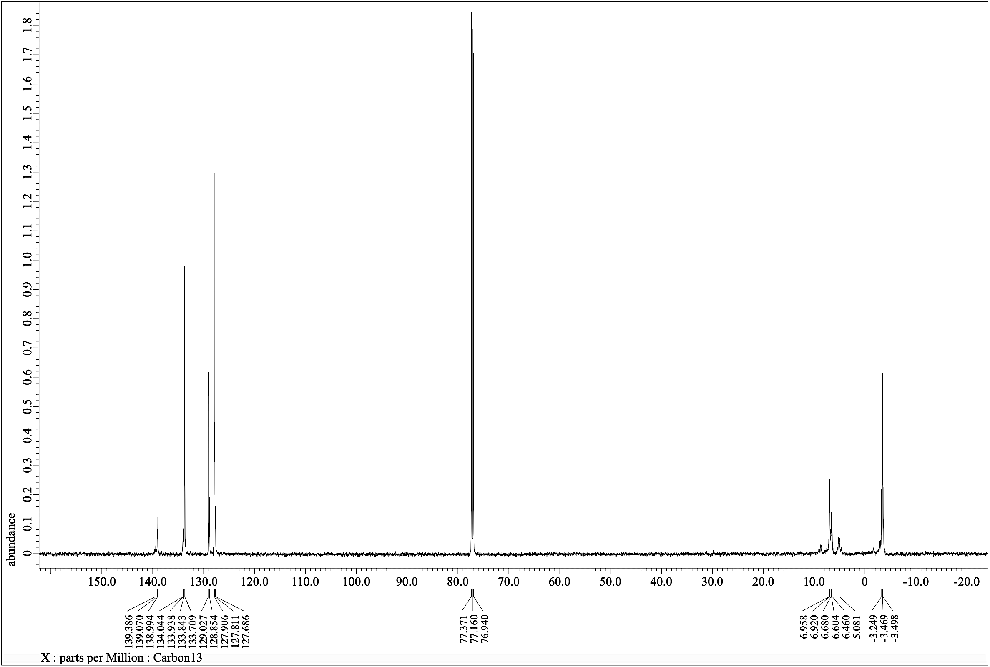
¹³C NMR (150.91 MHz, CDCl₃)
10
Figure S14: ¹³C NMR spectrum for 10.
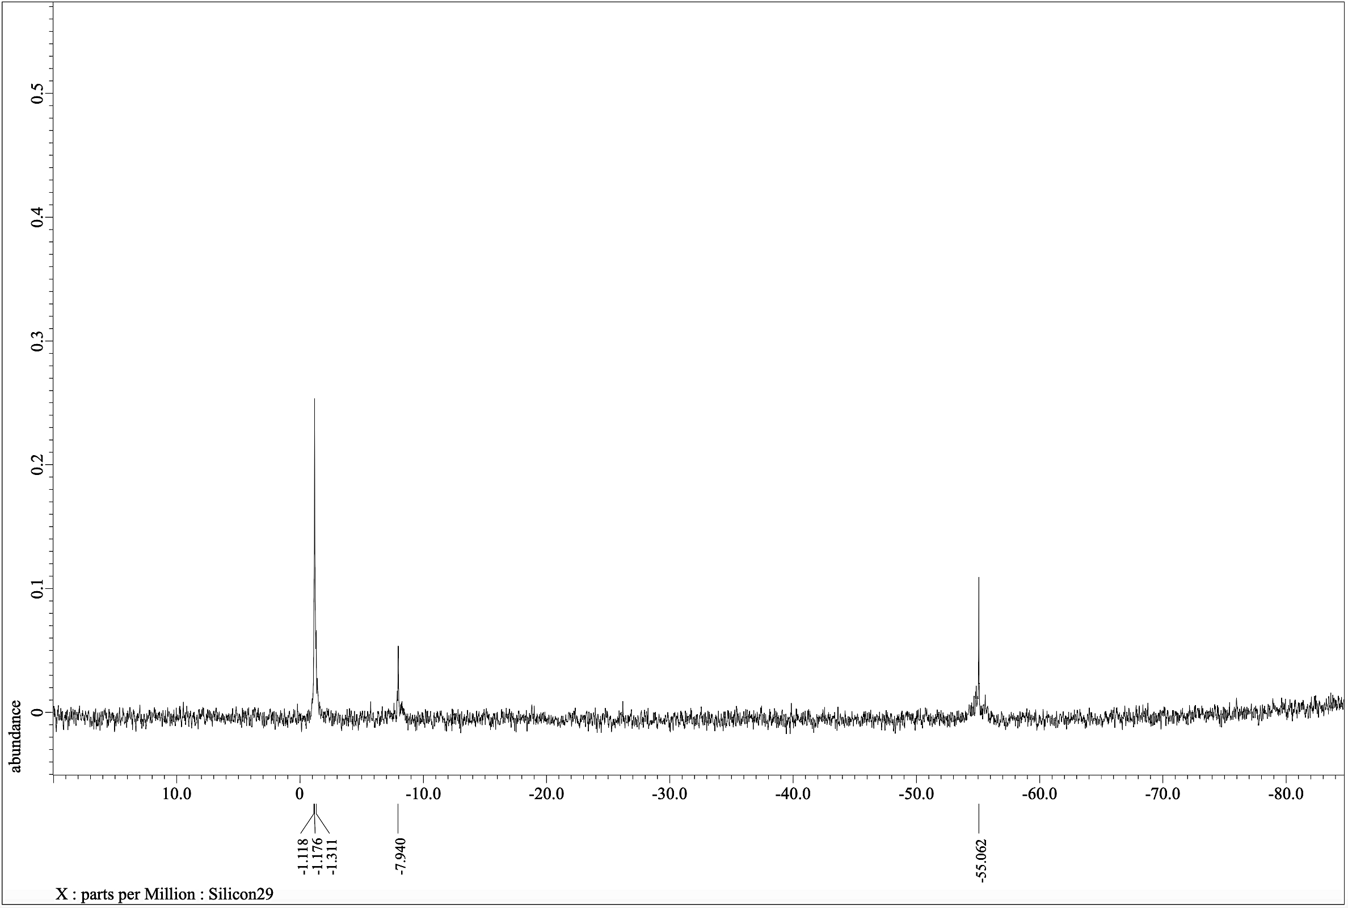
10
-Si-
-Si-
-Si-
²⁹Si NMR (119.24 MHz, CDCl₃)
Figure S15: ²⁹Si NMR spectrum for 10.
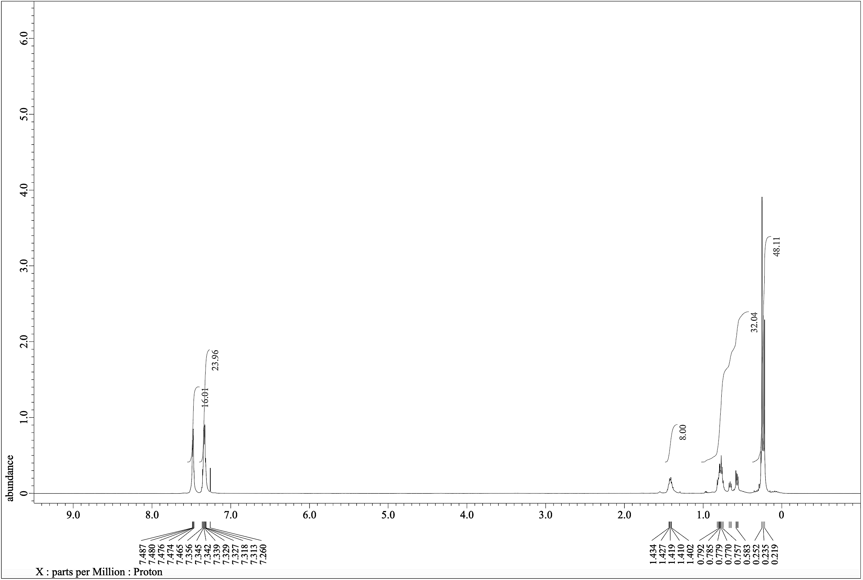
11
¹H NMR (600.17 MHz, CDCl₃)
Figure S16: ¹H NMR spectrum for 11.
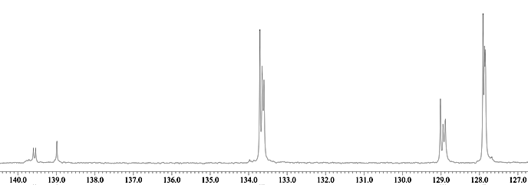
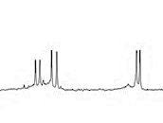
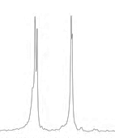
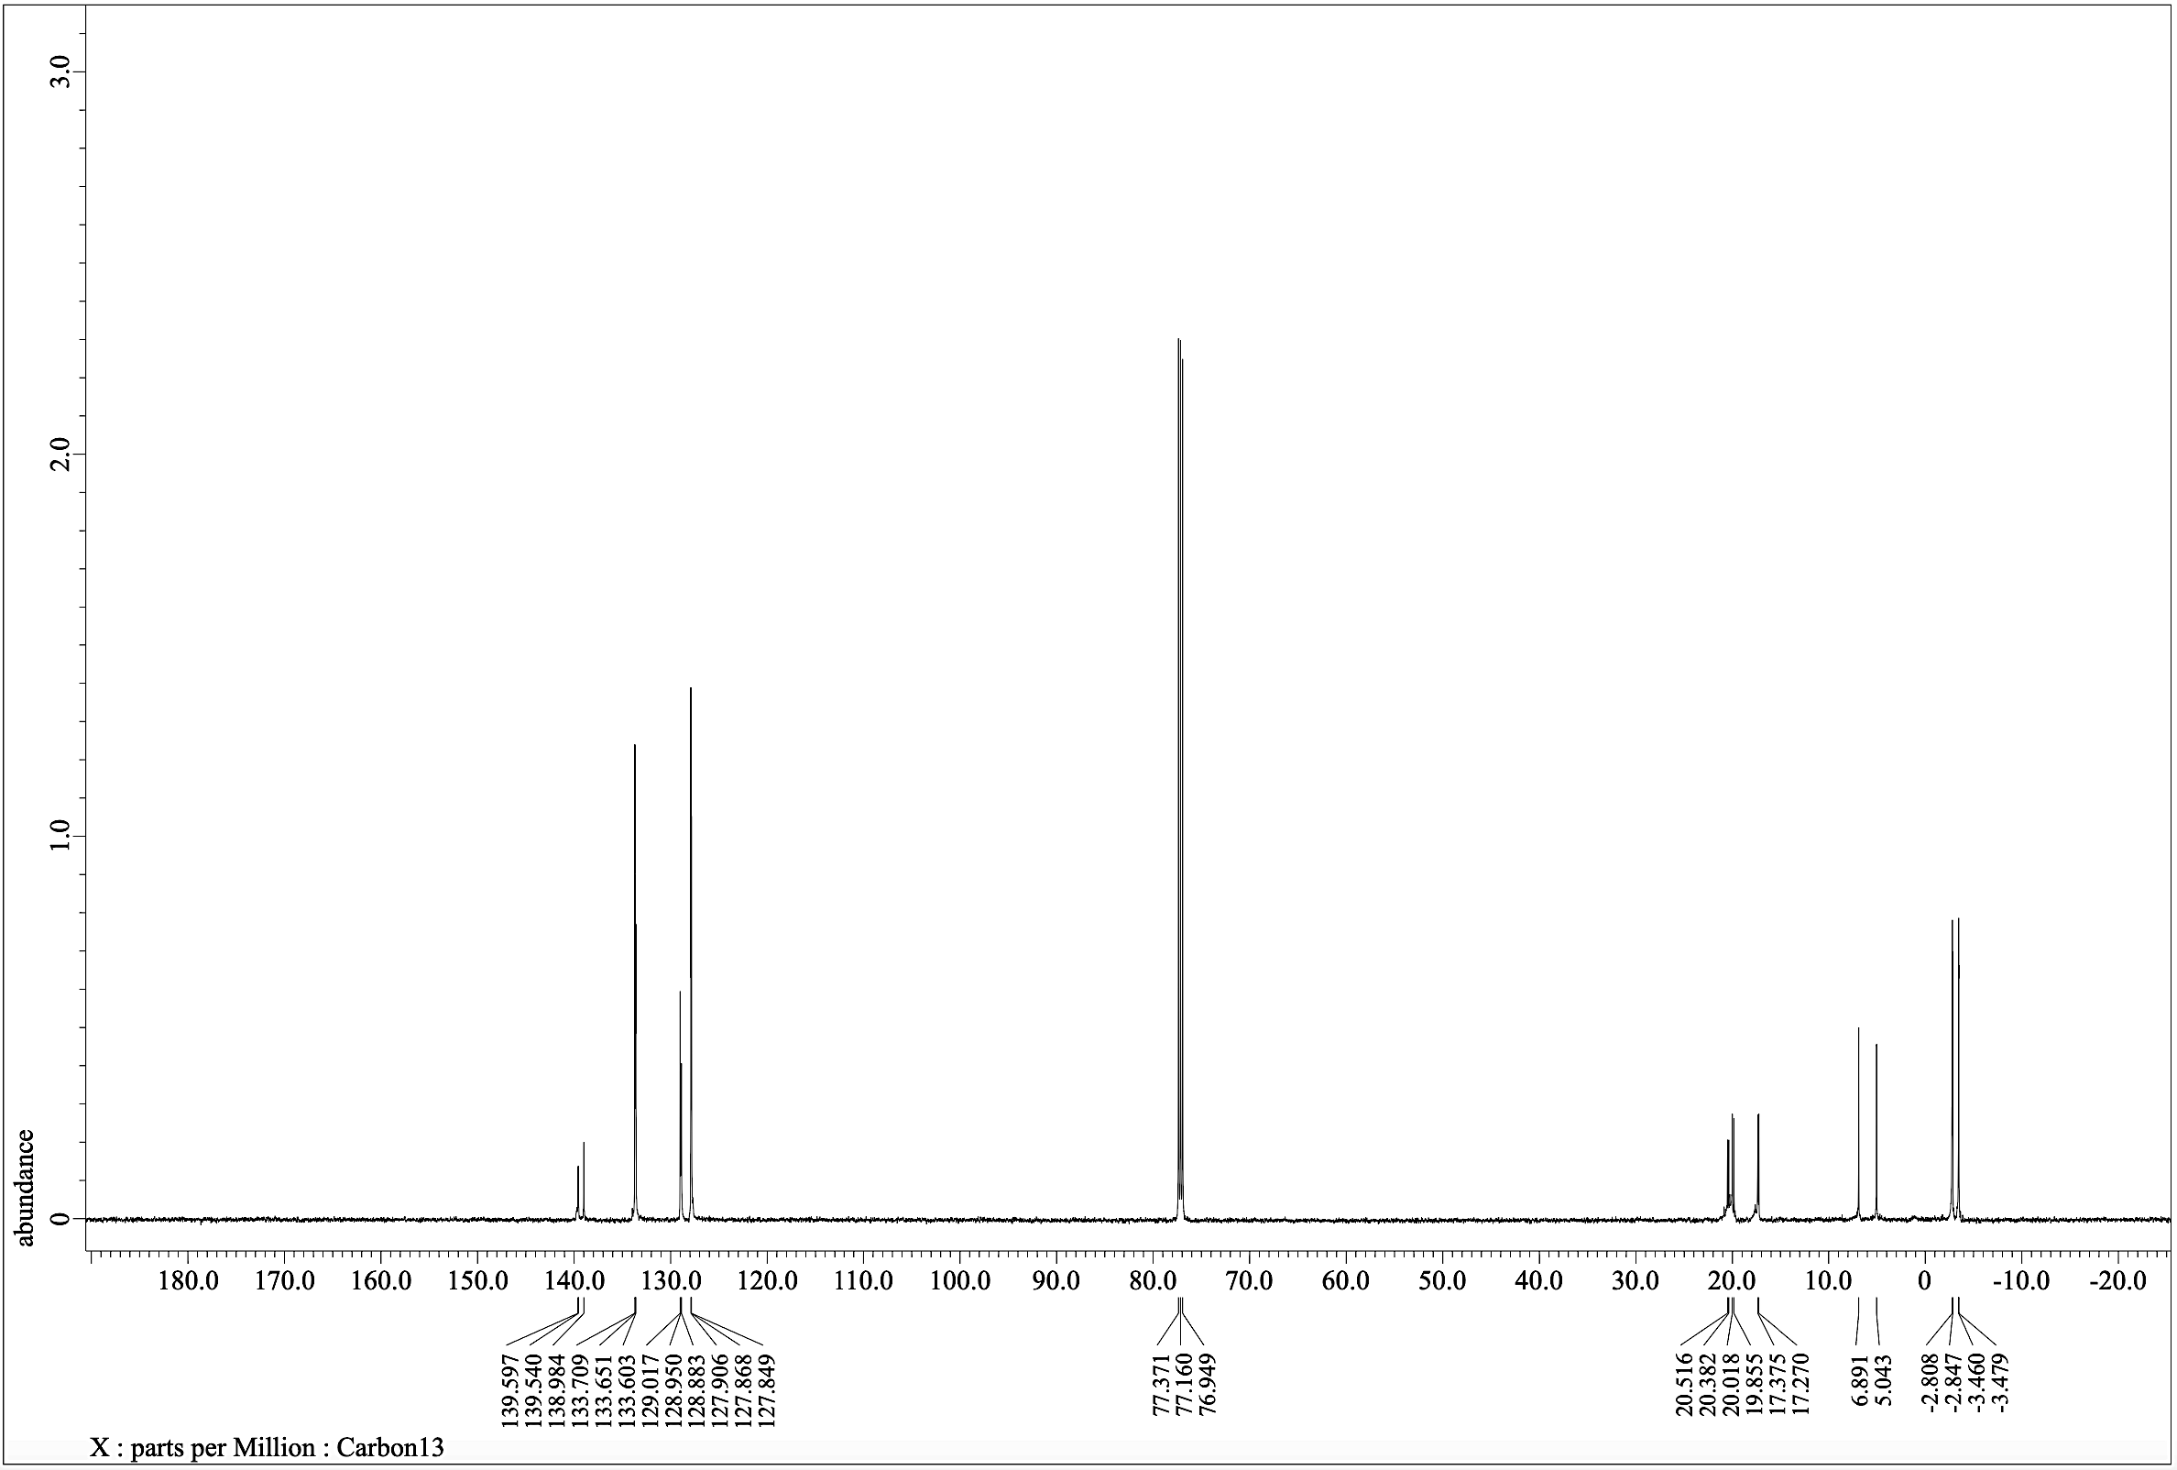

11
¹³C NMR (150.91 MHz, CDCl₃)
Figure S17: ¹³C NMR spectrum for 11.
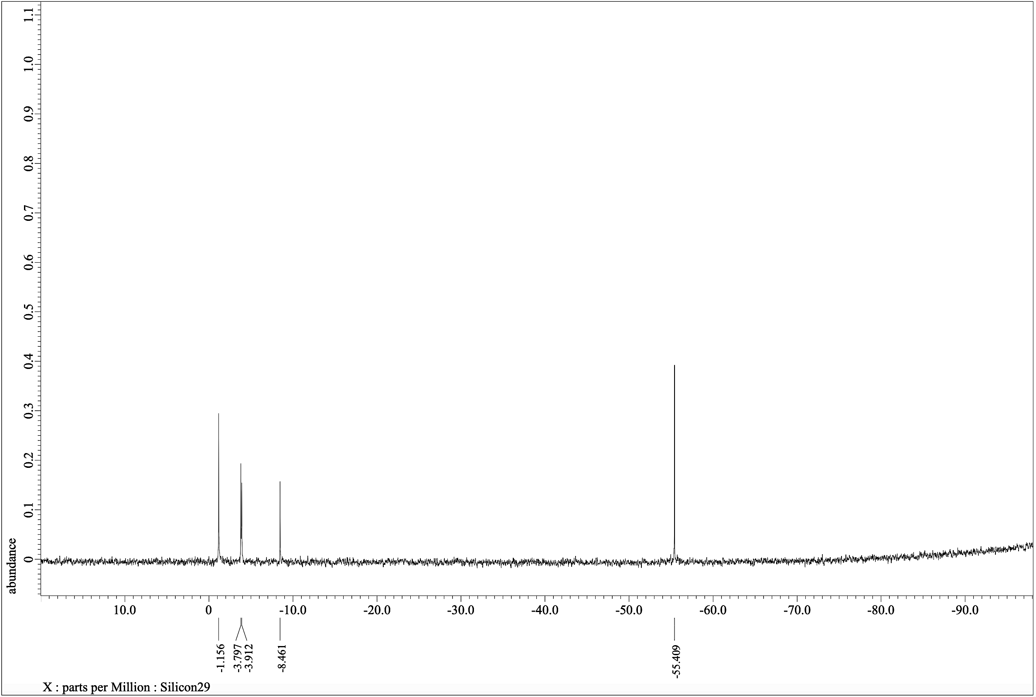
-Si-
-Si-
-Si-
-Si-
11
²⁹Si NMR (119.24 MHz, CDCl₃)
Figure S18: ²⁹Si NMR spectrum for 11.
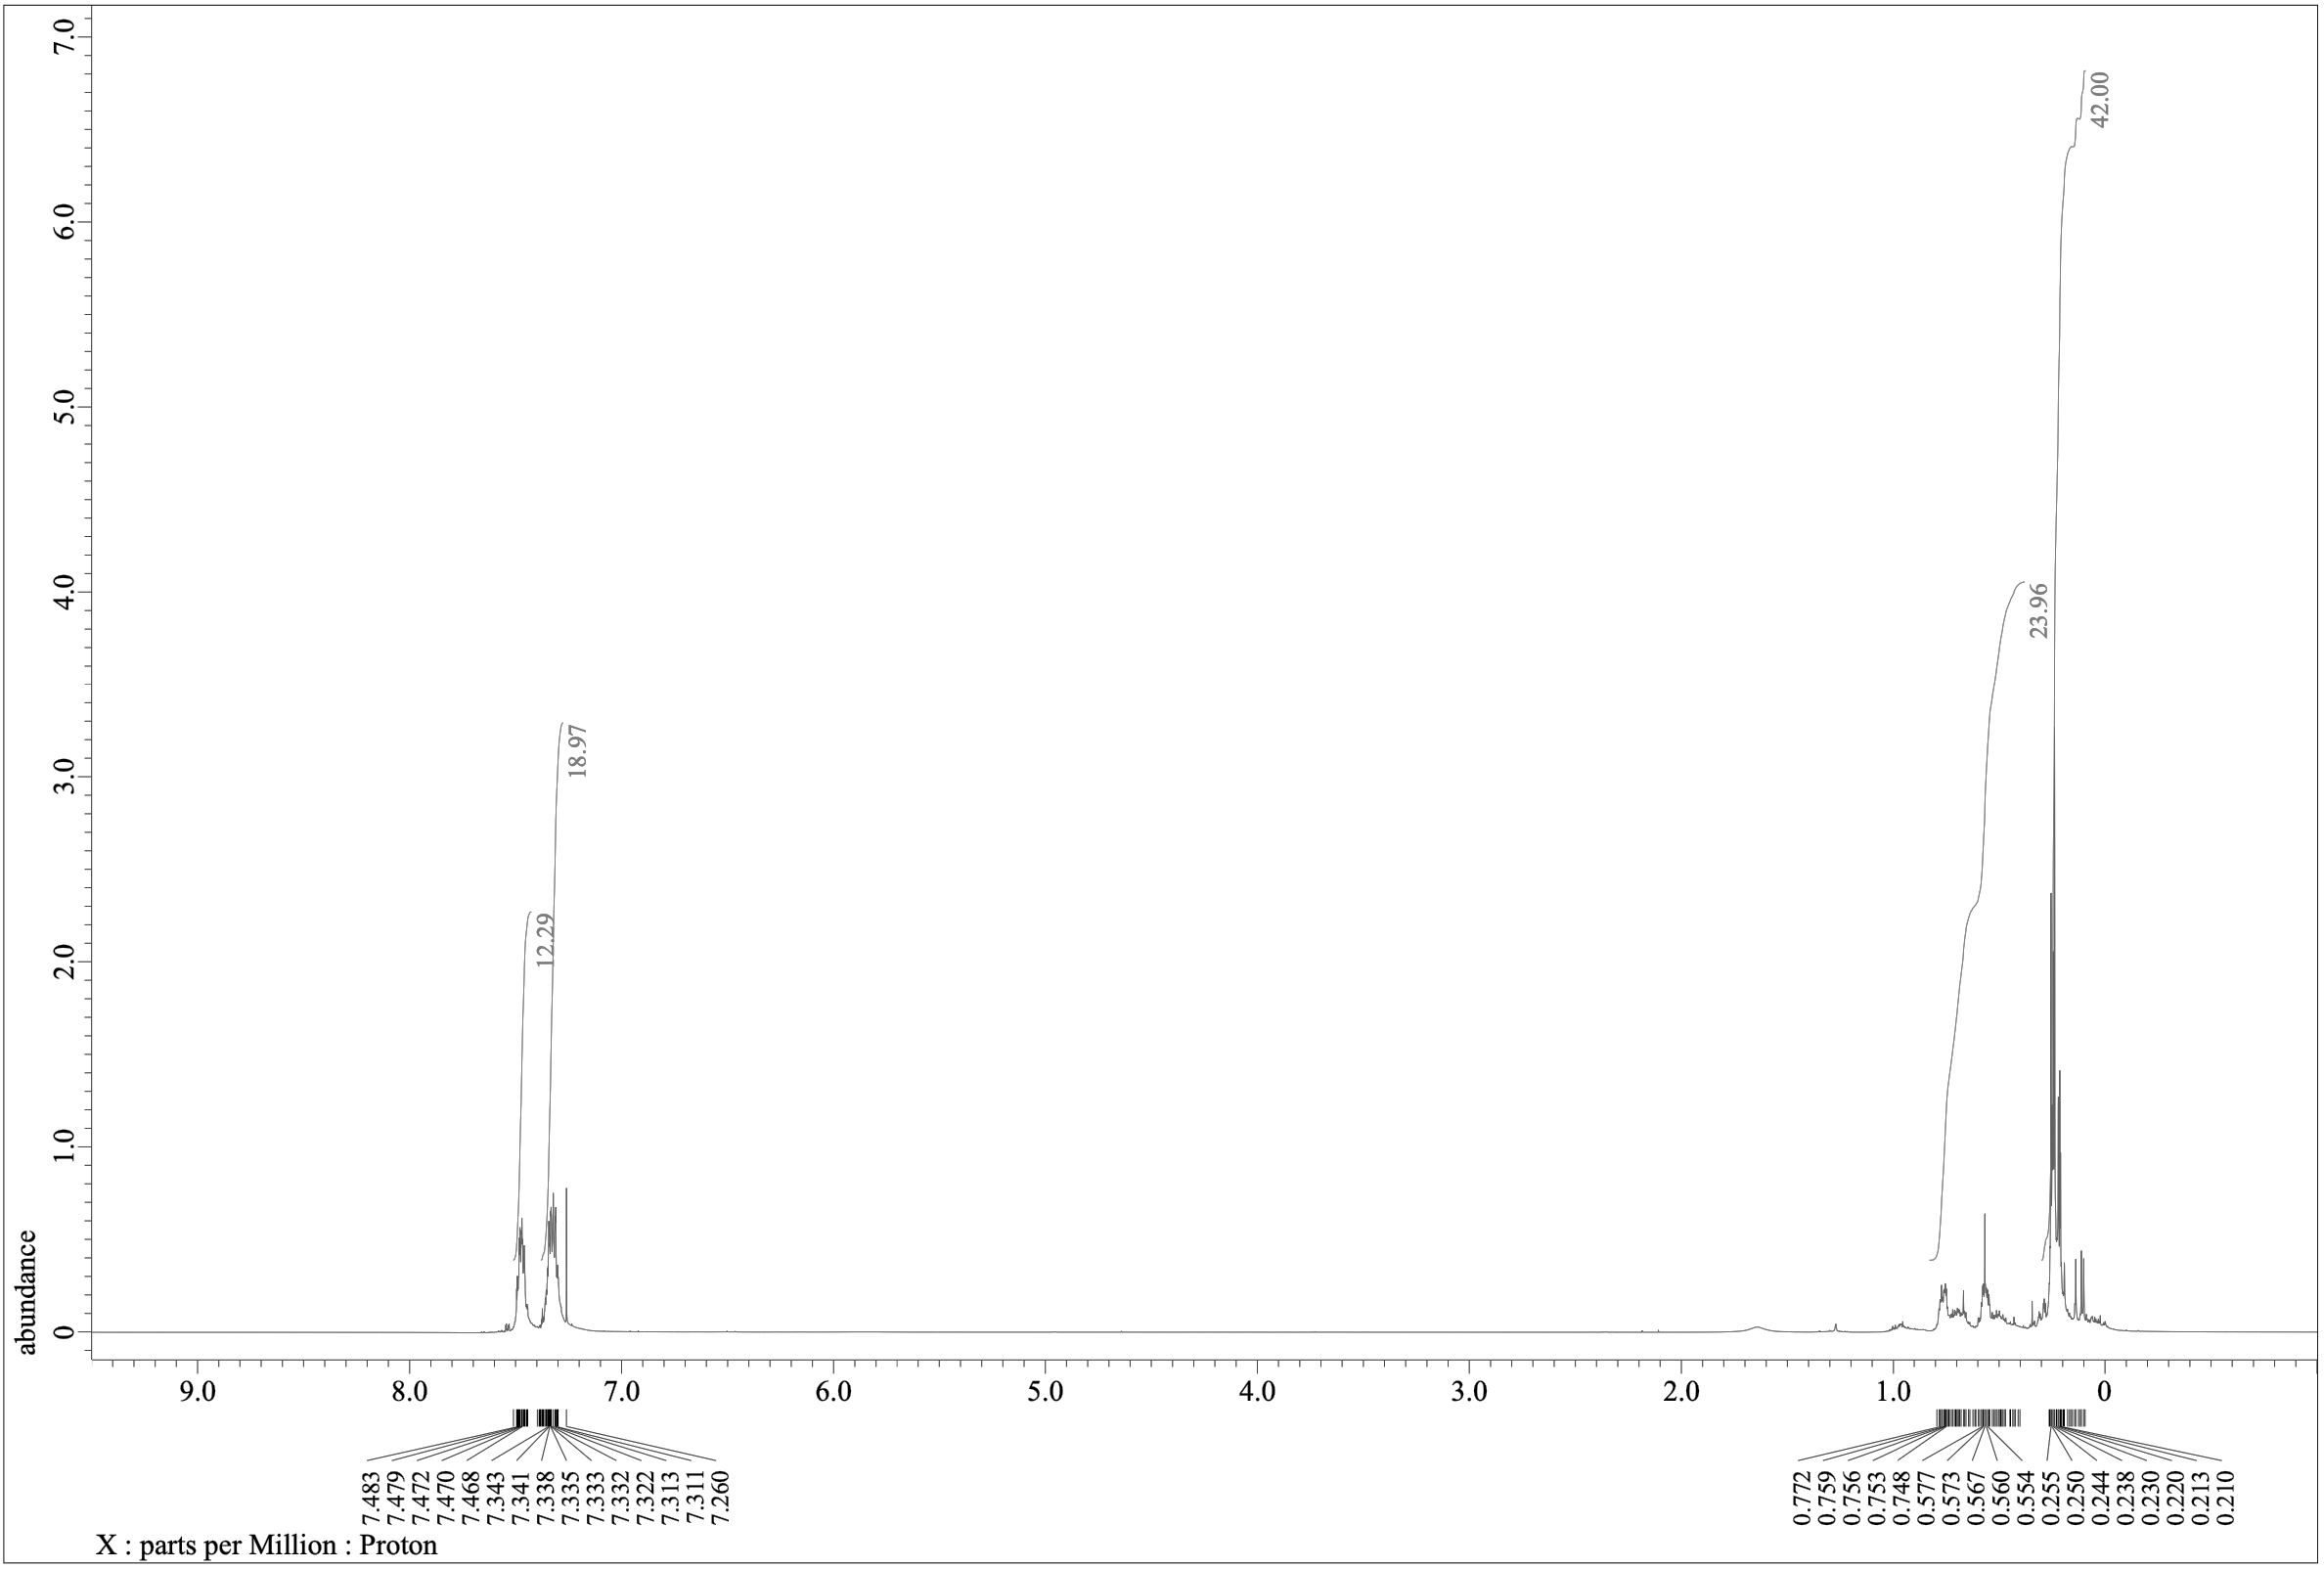
12
¹H NMR (600.17 MHz, CDCl₃)
Figure S19: ¹H NMR spectrum for 12.
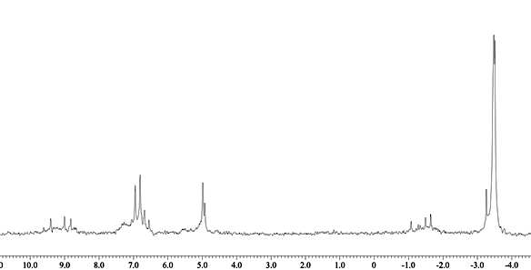
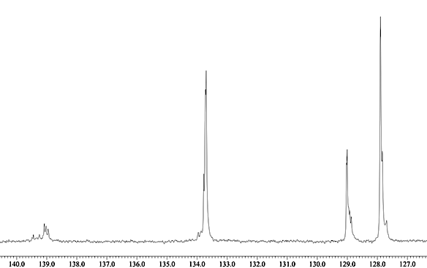
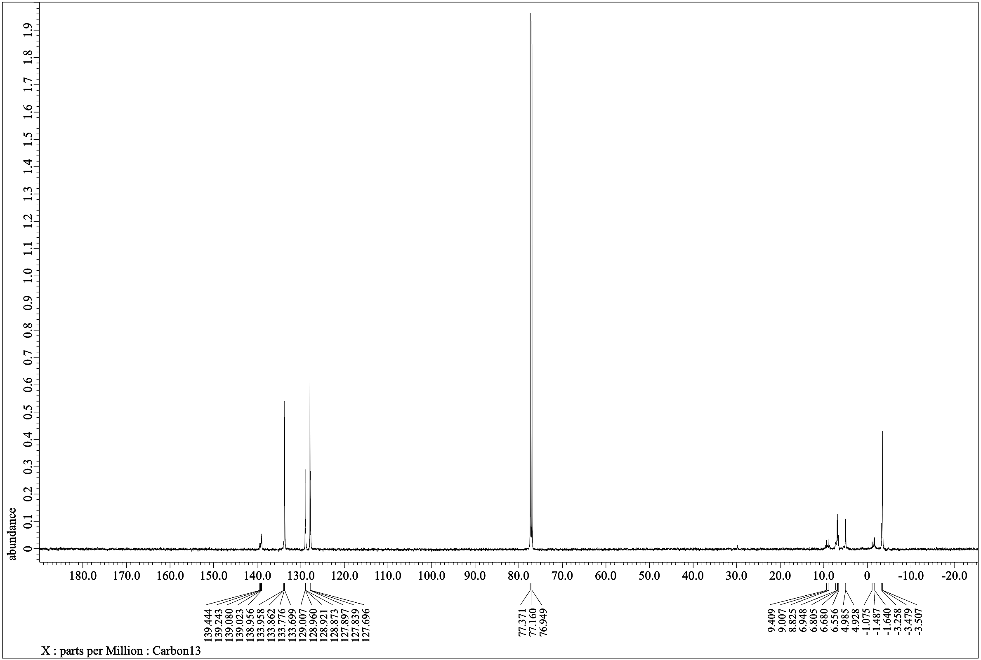
12

¹³C NMR (150.91 MHz, CDCl₃)
Figure S20: ¹³C NMR spectrum for 12.
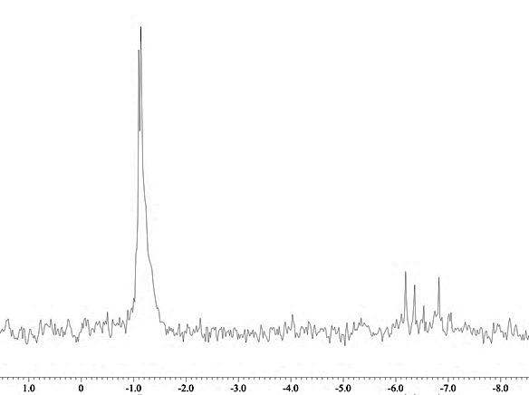
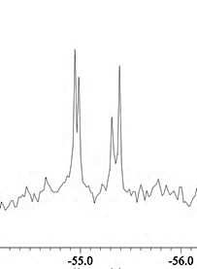
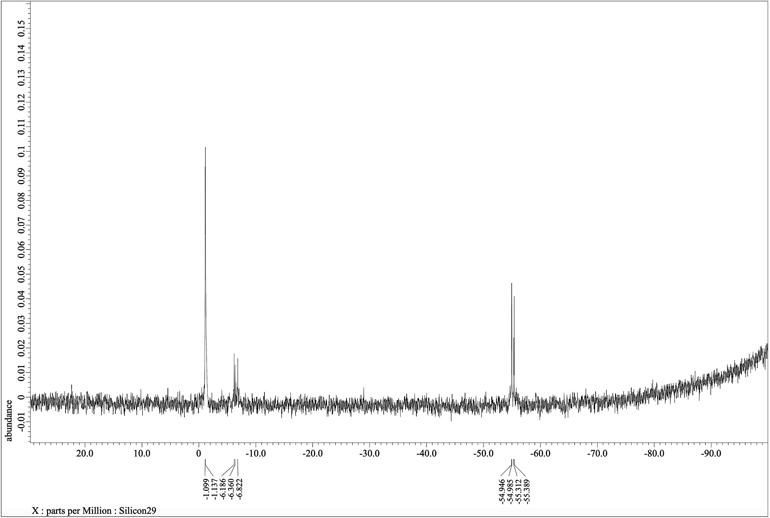
-Si-
-Si-

12

-Si-
²⁹Si NMR (119.24 MHz, CDCl₃)
Figure S21: ²⁹Si NMR spectrum for 12.
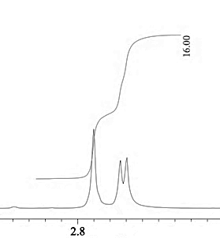
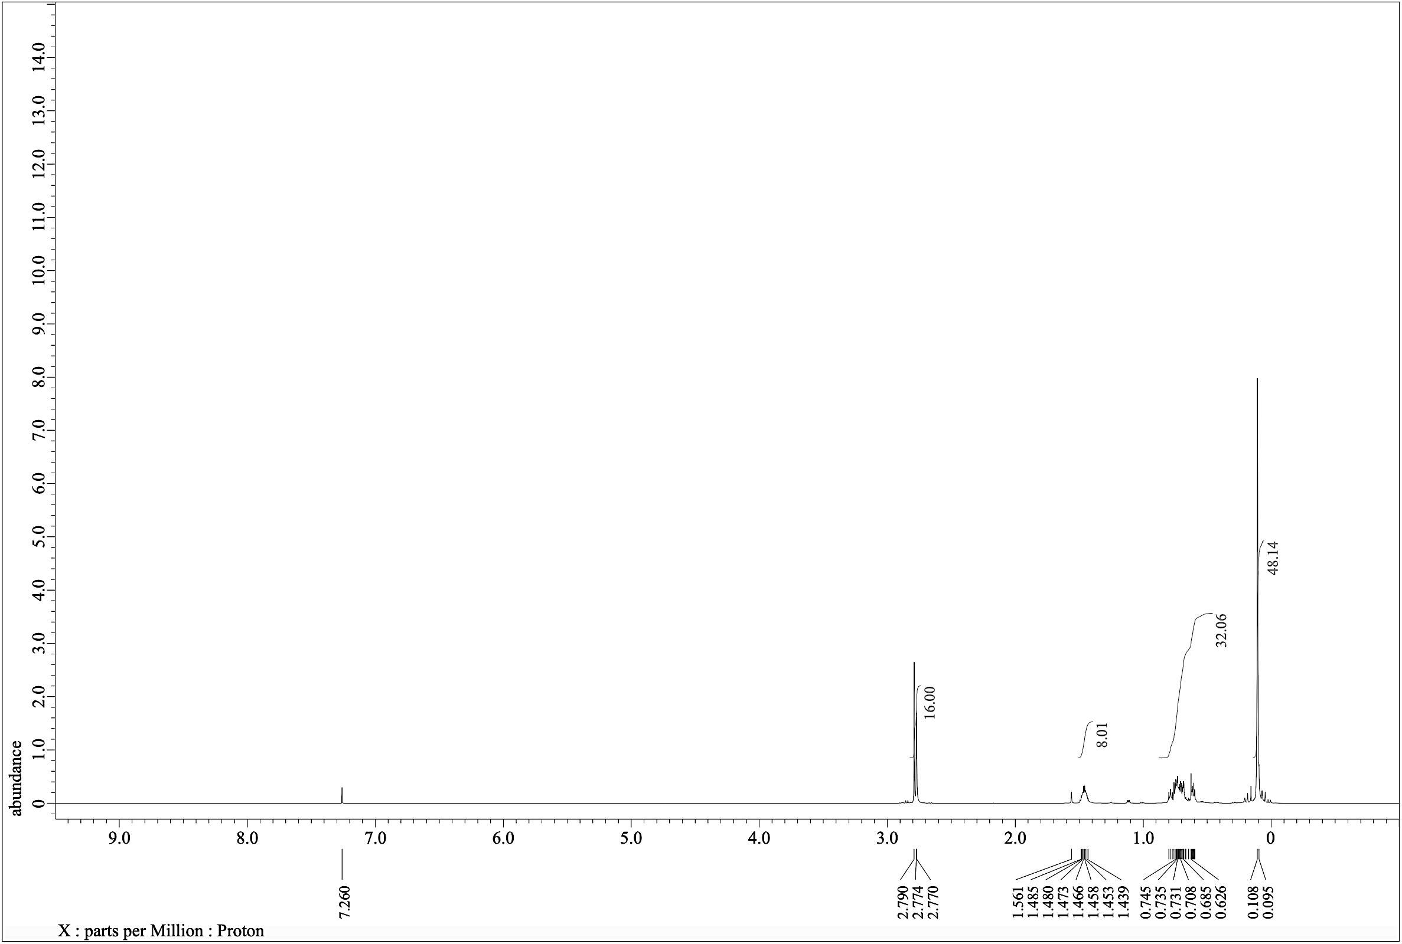
13

¹H NMR (600.17 MHz, CDCl₃)
Figure S22: ¹H NMR spectrum for 13.
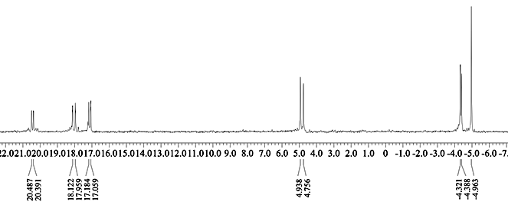
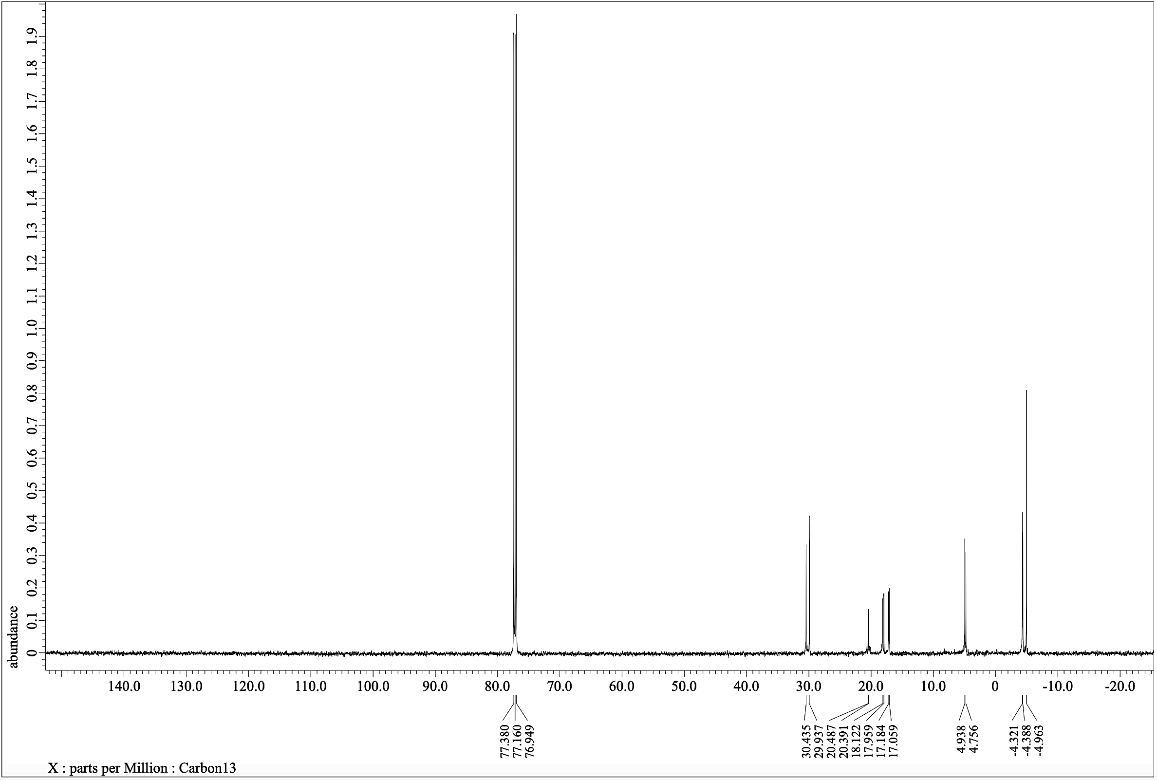
13

¹³C NMR (150.91 MHz, CDCl₃)
Figure S23: ¹³C NMR spectrum for 13.
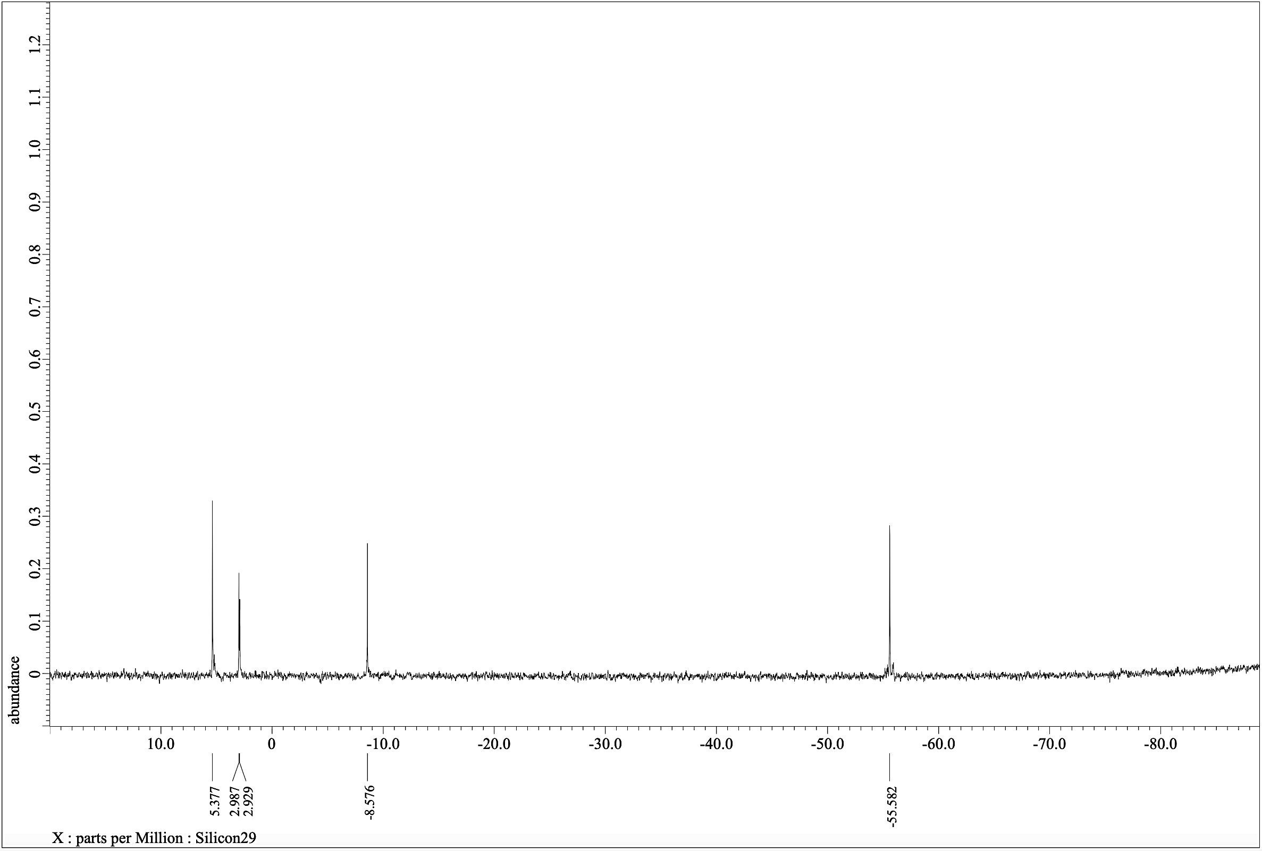
13
-Si-
-Si-
-Si-
-Si-
²⁹Si NMR (119.24 MHz, CDCl₃)
Figure S24: ²⁹Si NMR spectrum for 13.

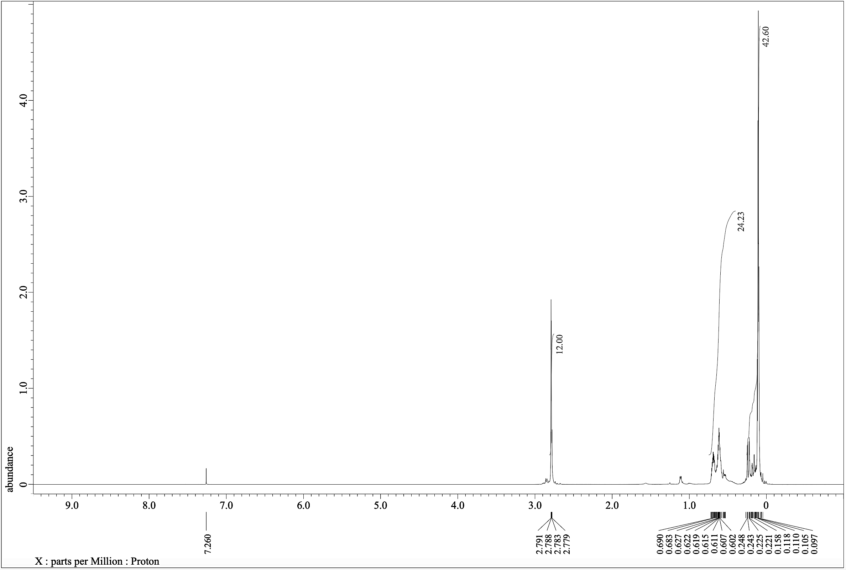
¹H NMR (600.17 MHz, CDCl₃)
14
Figure S25: ¹H NMR spectrum for 14.
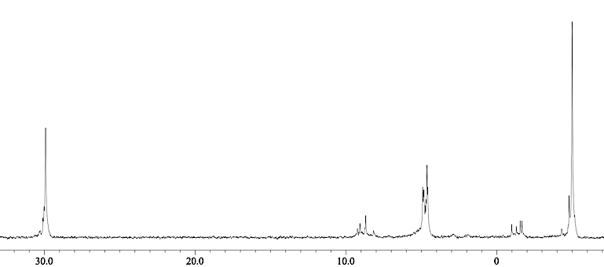
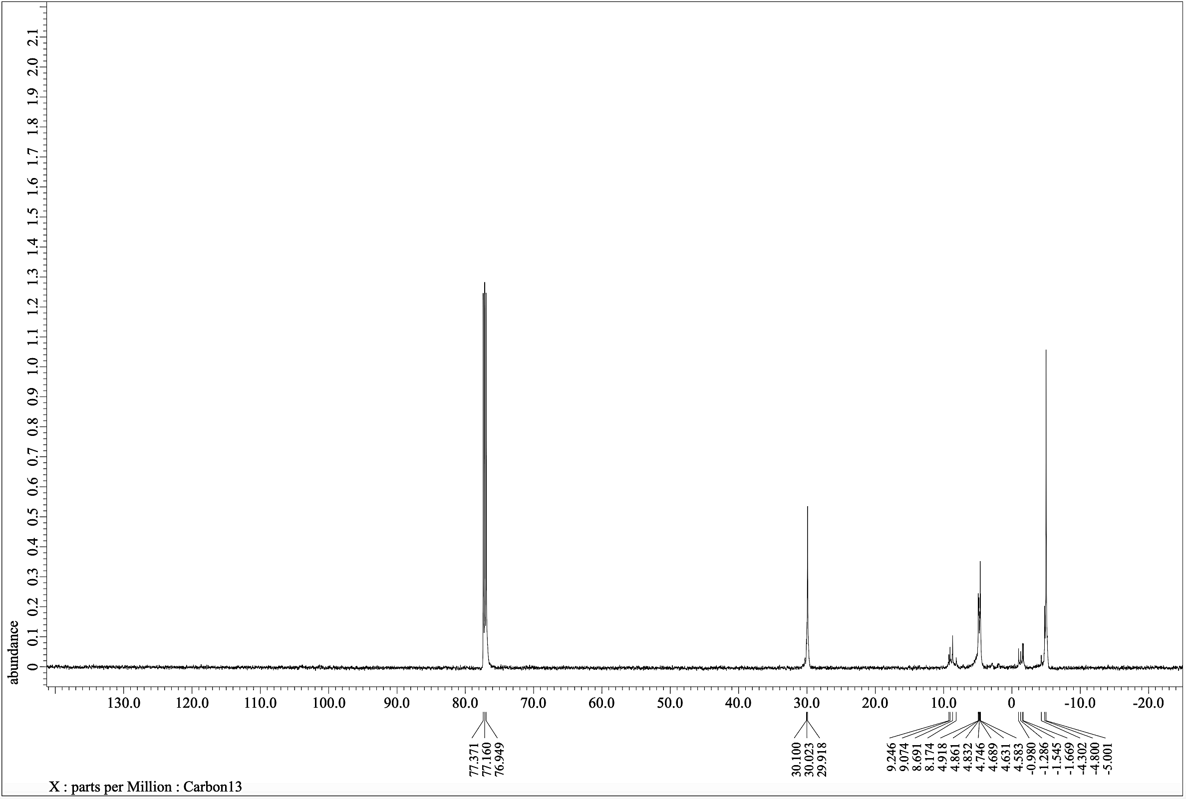
14

¹³C NMR (150.91 MHz, CDCl₃)
Figure S26: ¹³C NMR spectrum for 14.
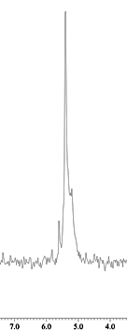
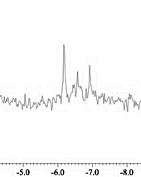
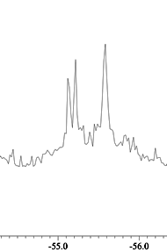
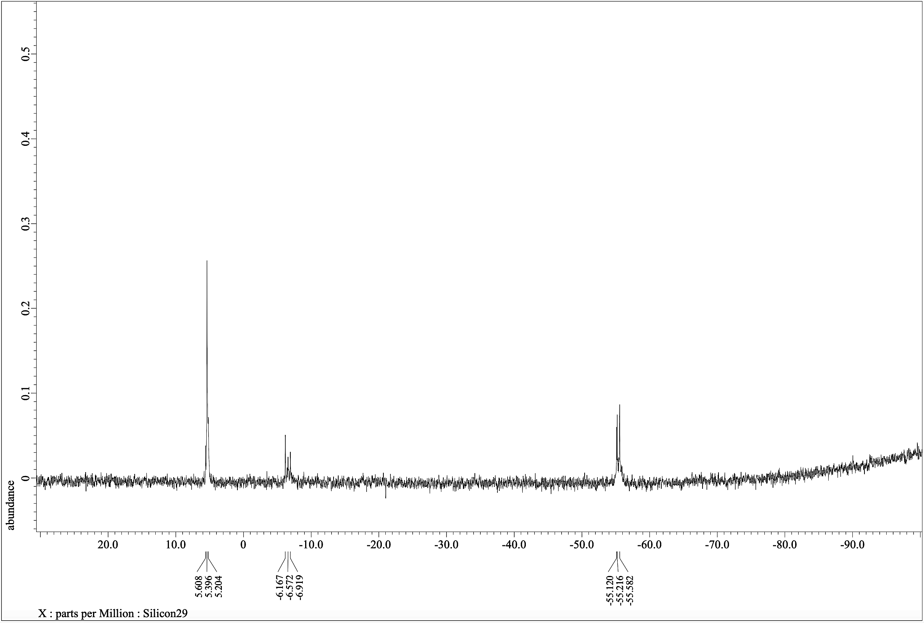
²⁹Si NMR (119.24 MHz, CDCl₃)
-Si-

-Si-

-Si-
14
Figure S27: ²⁹Si NMR spectrum for 14.
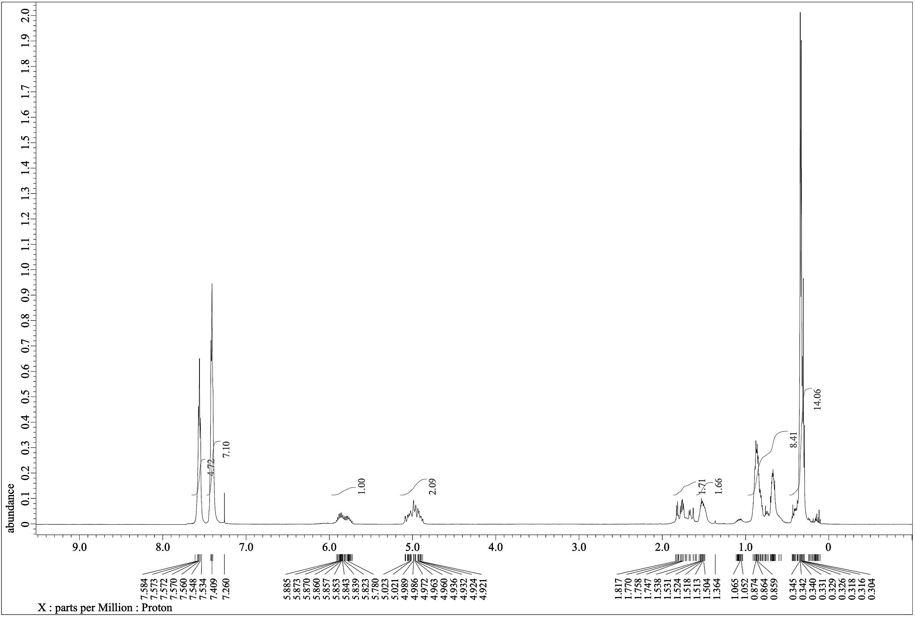
¹H NMR (600.17 MHz, CDCl₃)
Figure S28: ¹H NMR spectrum for 15.
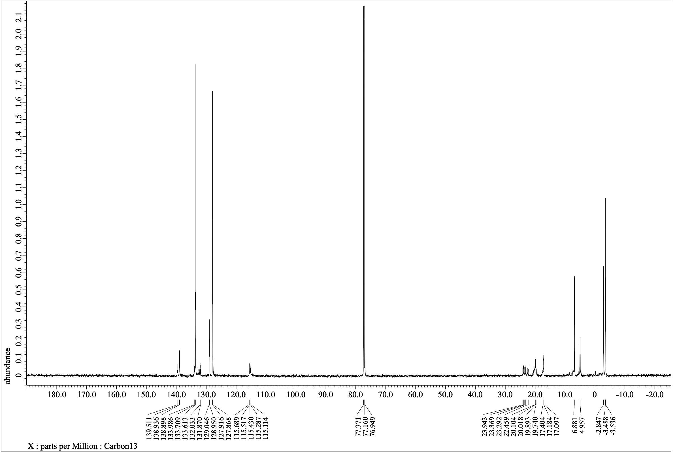
¹³C NMR (150.91 MHz, CDCl₃)
Figure S29: ¹³C NMR spectrum for 15.
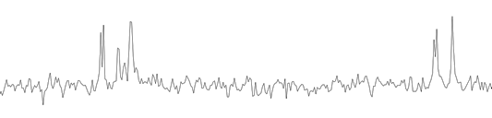
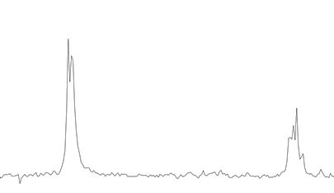
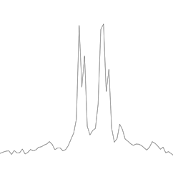
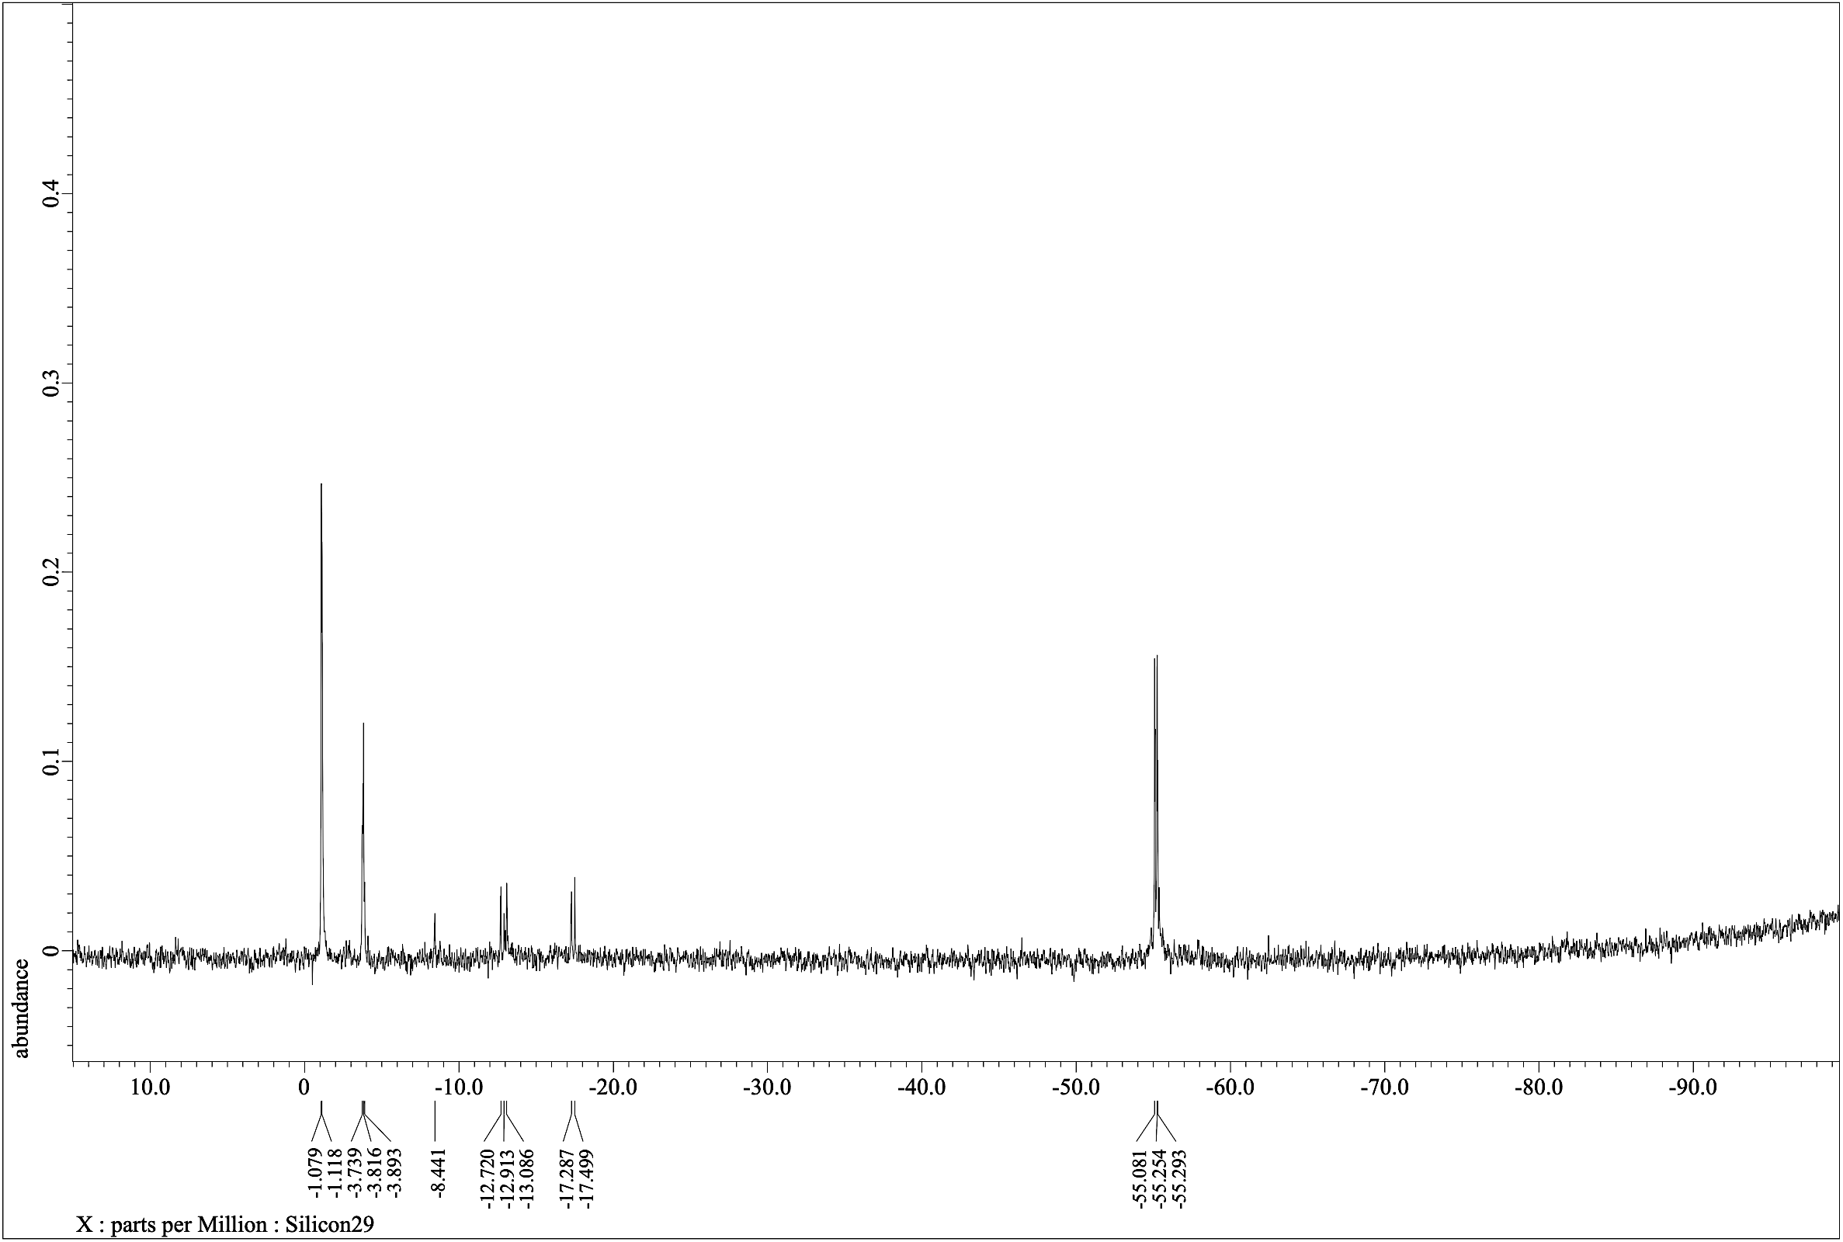
-Si-

-Si-

-Si-

²⁹Si NMR (119.24 MHz, CDCl₃)
Figure S30: ²⁹Si NMR spectrum for 15.
3. MALDI-TOF MS Spectra for synthetic compounds 6-15
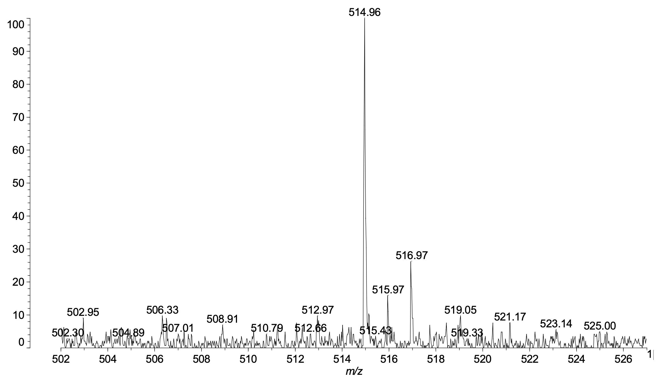
6
Figure S31: MALDI-TOF MS spectrum for 6.
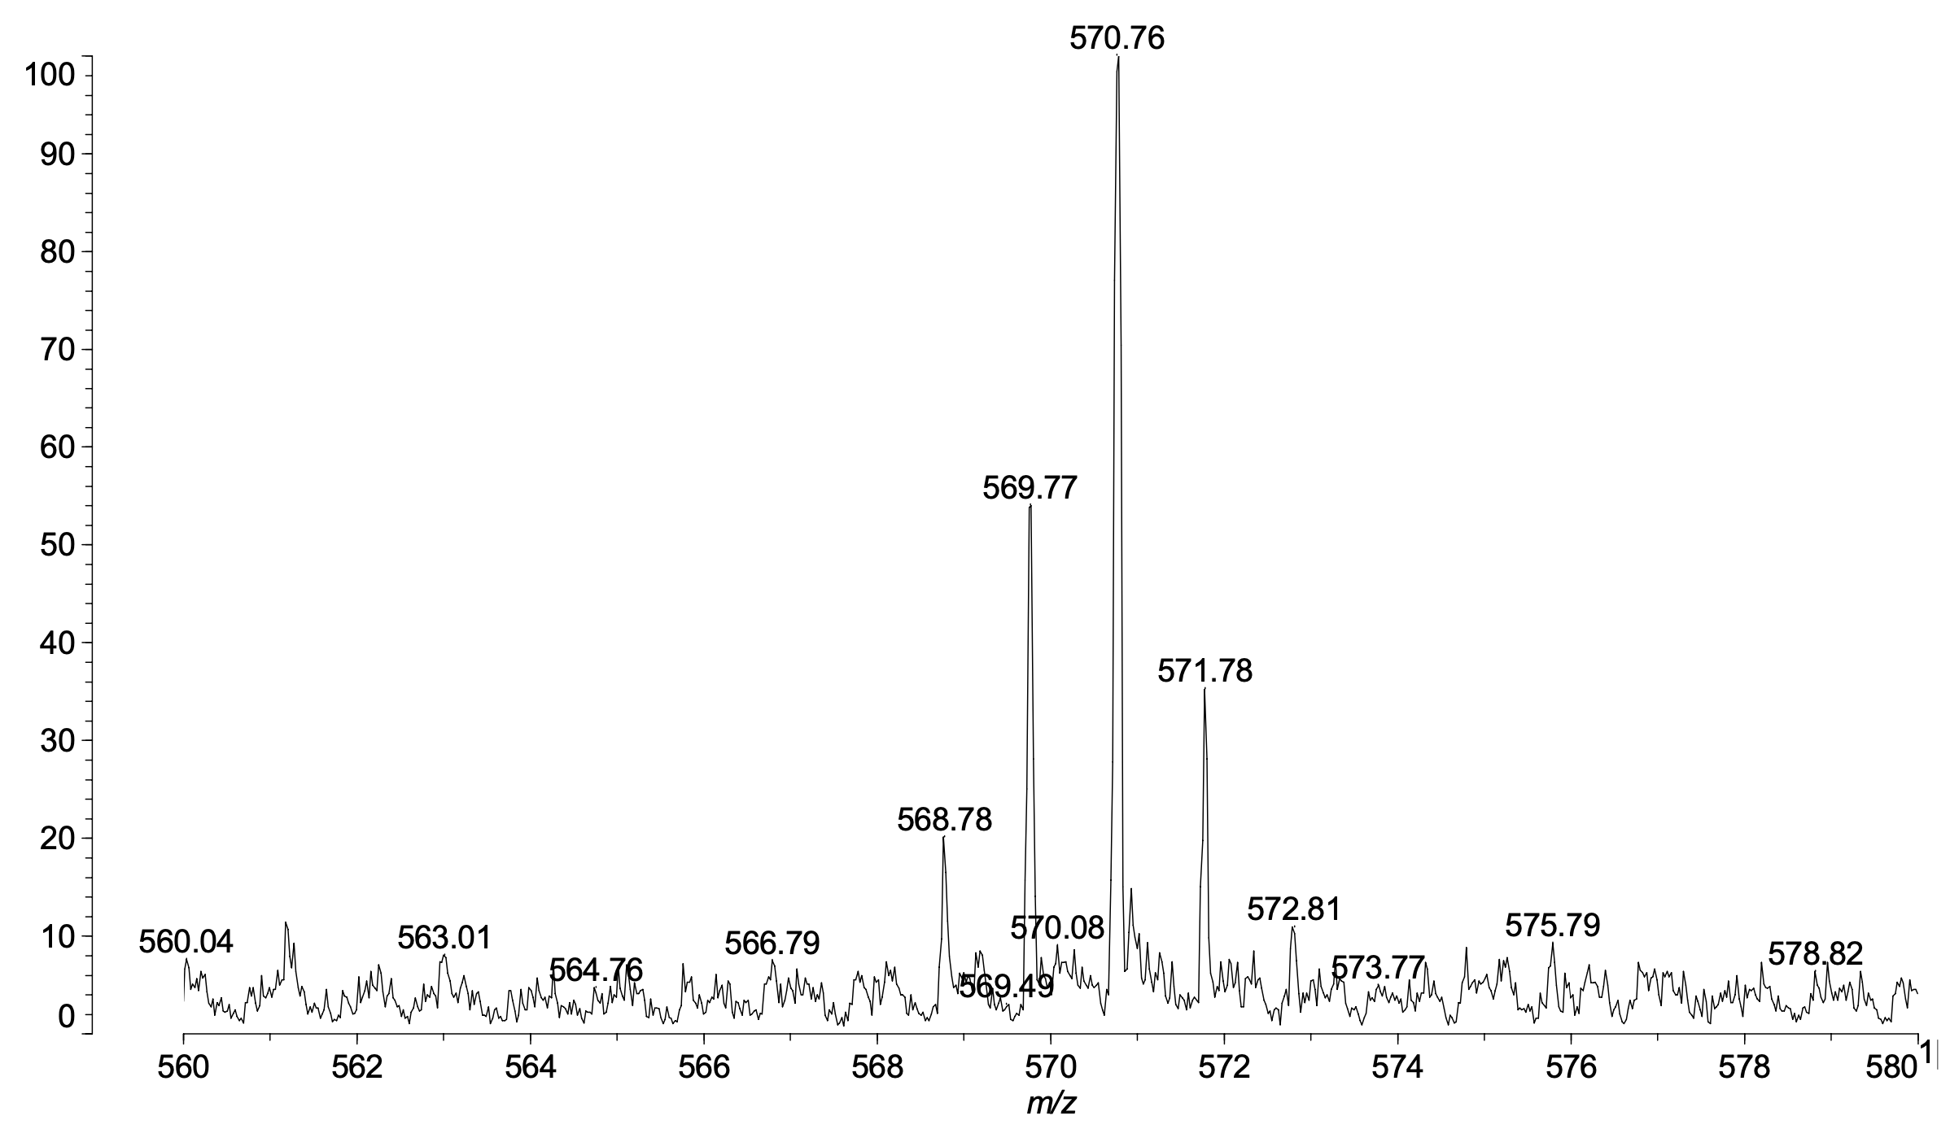
7
Figure S32: MALDI-TOF MS spectrum for 7.
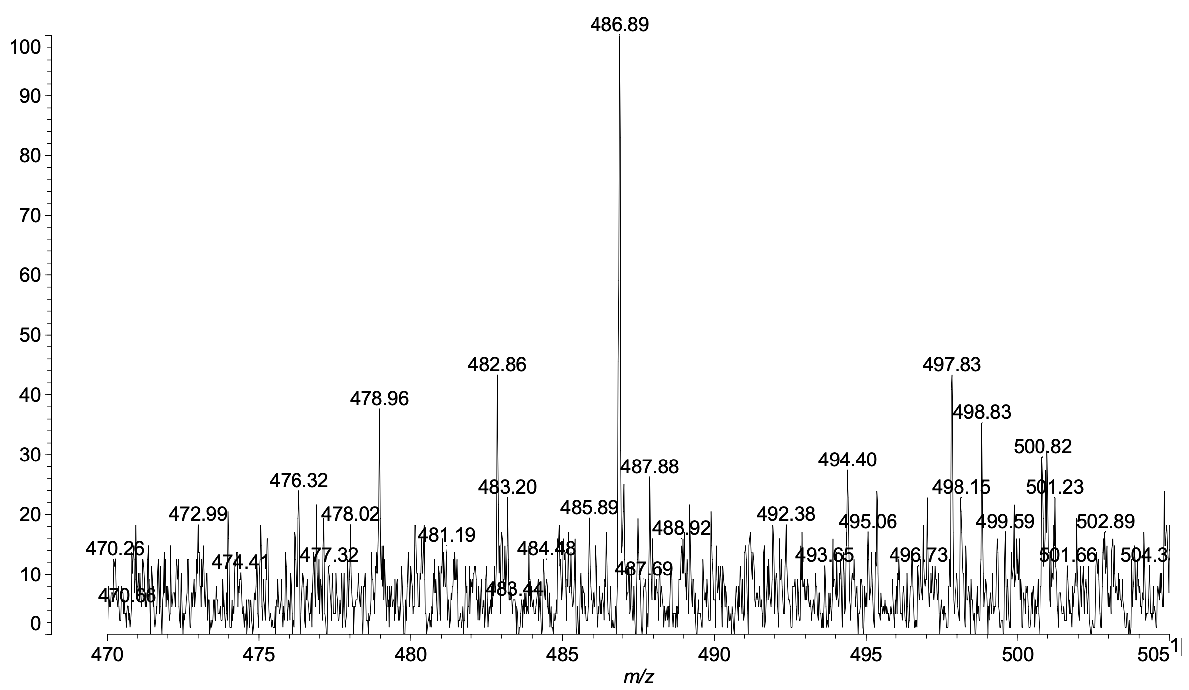
8
Figure S33: MALDI-TOF MS spectrum for 8.
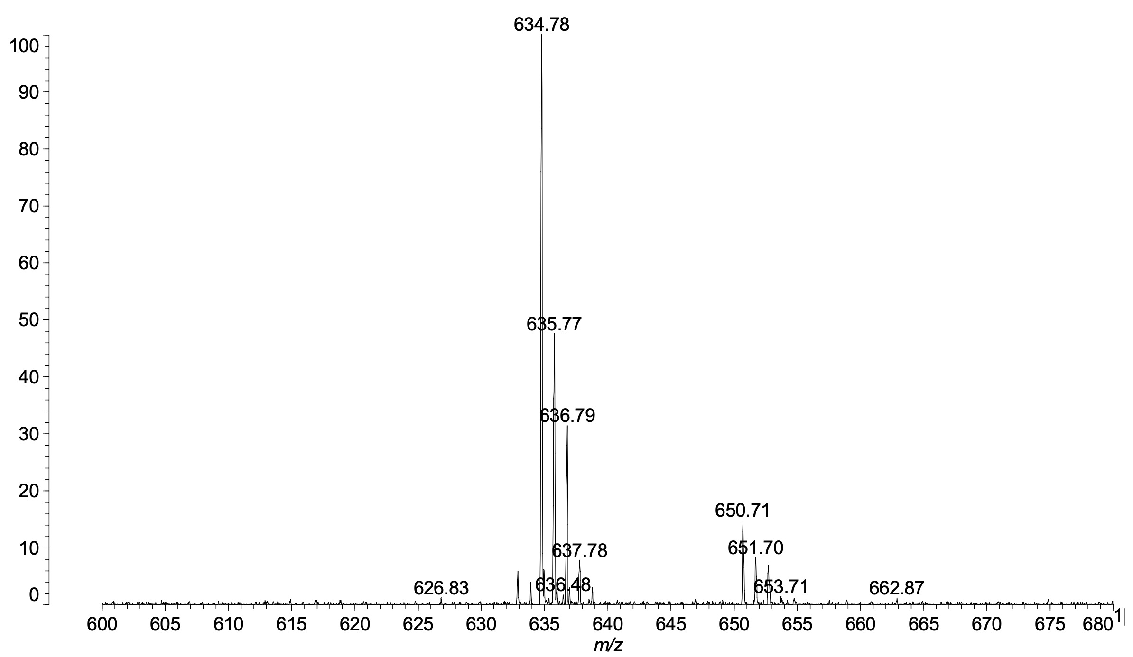
9
Figure S34: MALDI-TOF MS spectrum for 9.
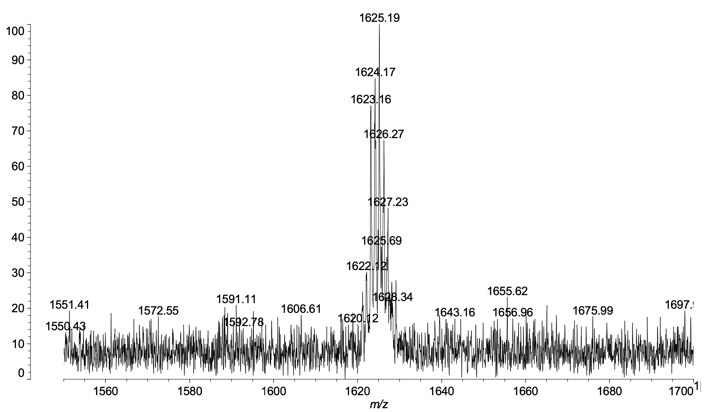
10
Figure S35: MALDI-TOF MS spectrum for 10.

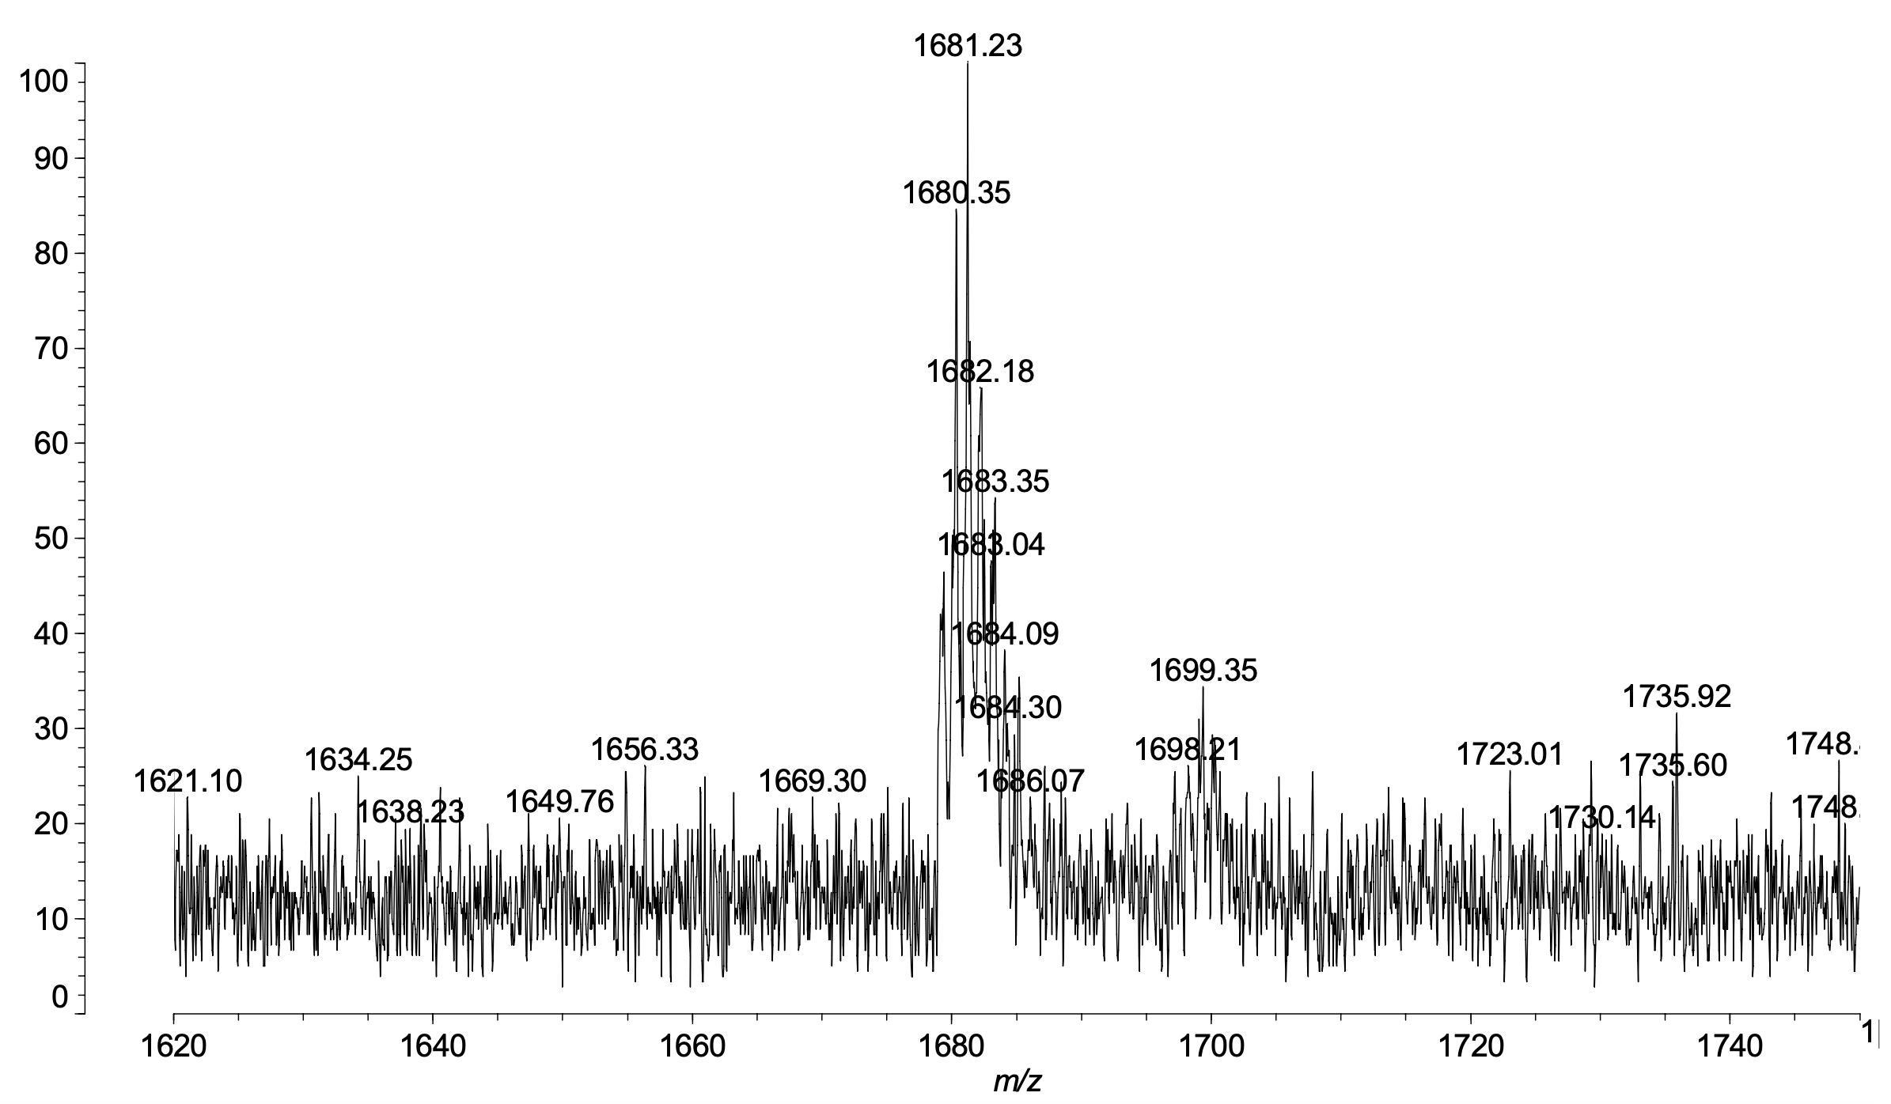
11
Figure S36: MALDI-TOF MS spectrum for 11.
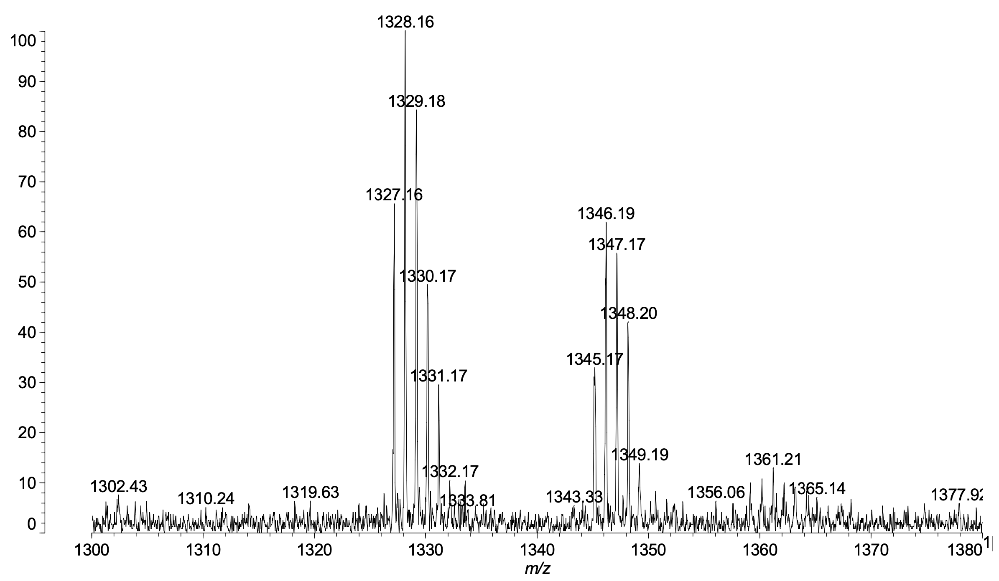
12
Figure S37: MALDI-TOF MS spectrum for 12.
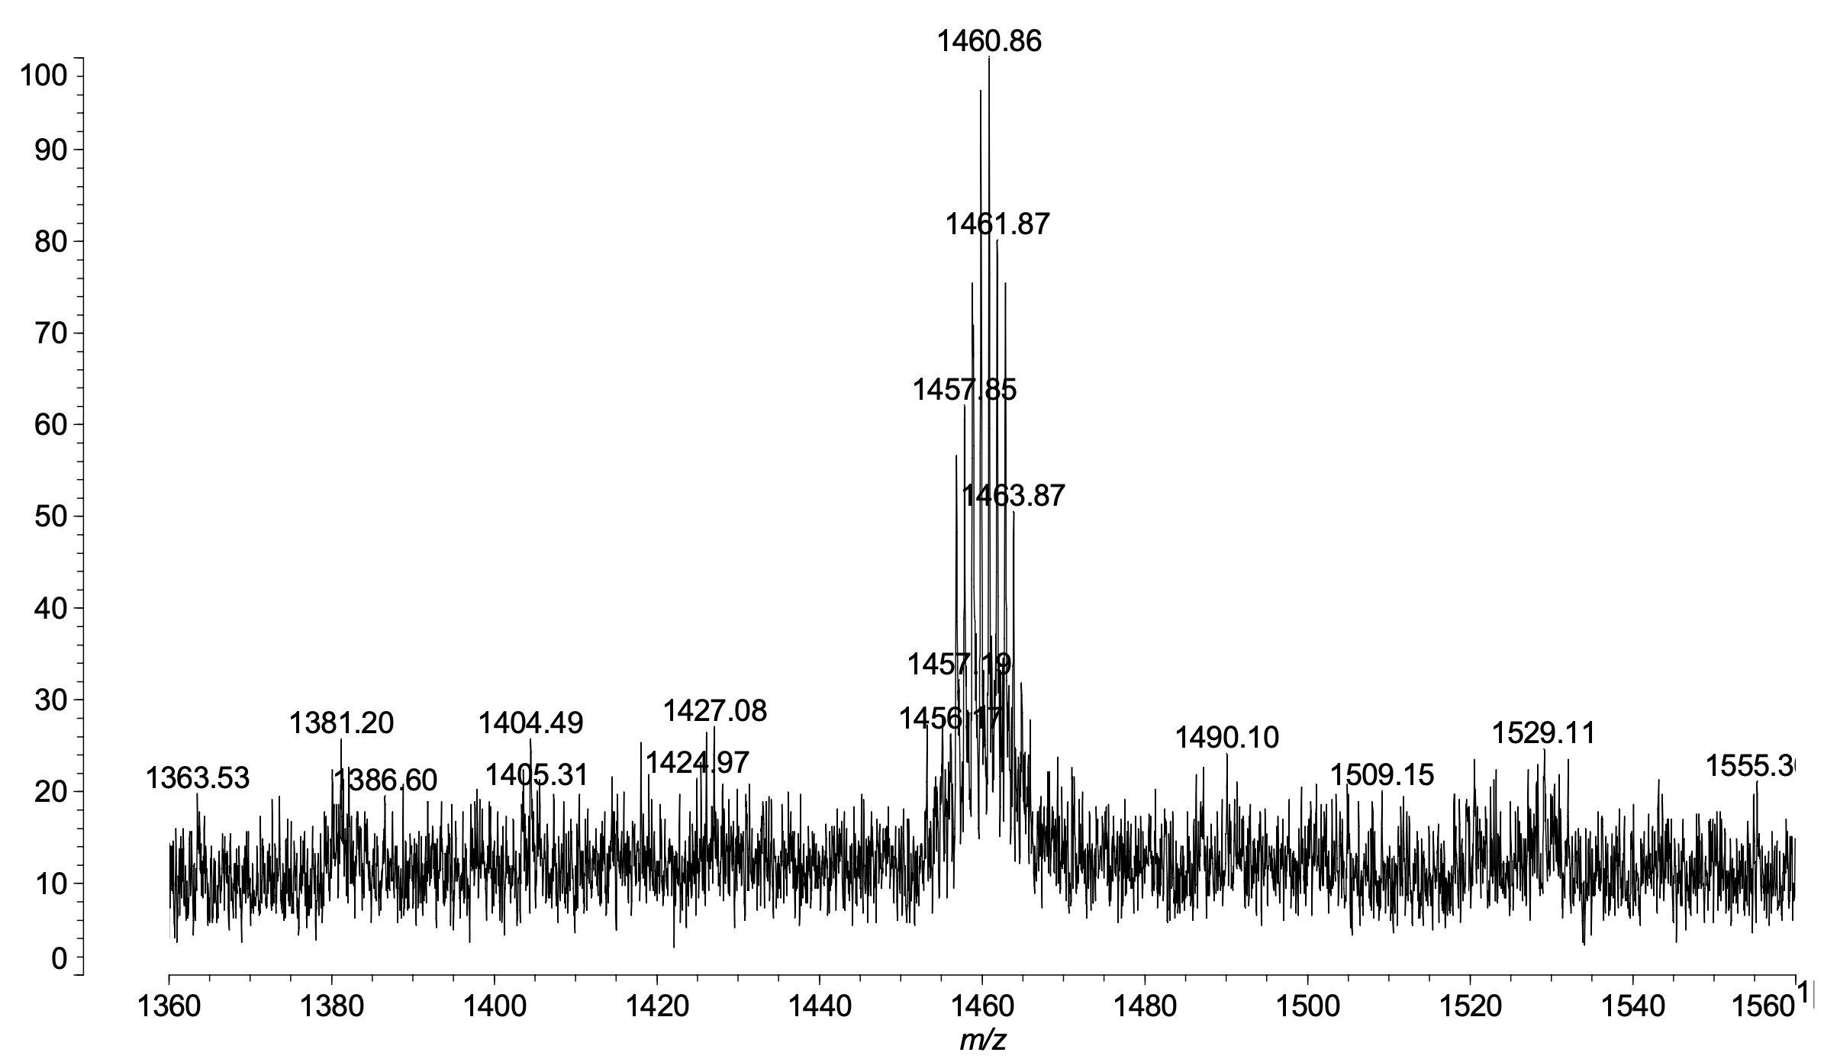
13
Figure S38: MALDI-TOF MS spectrum for 13.

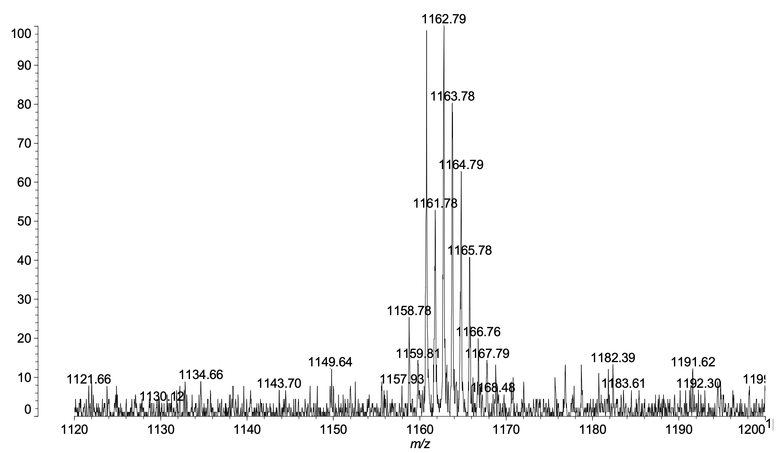
14
Figure S39: MALDI-TOF MS spectrum for 14.

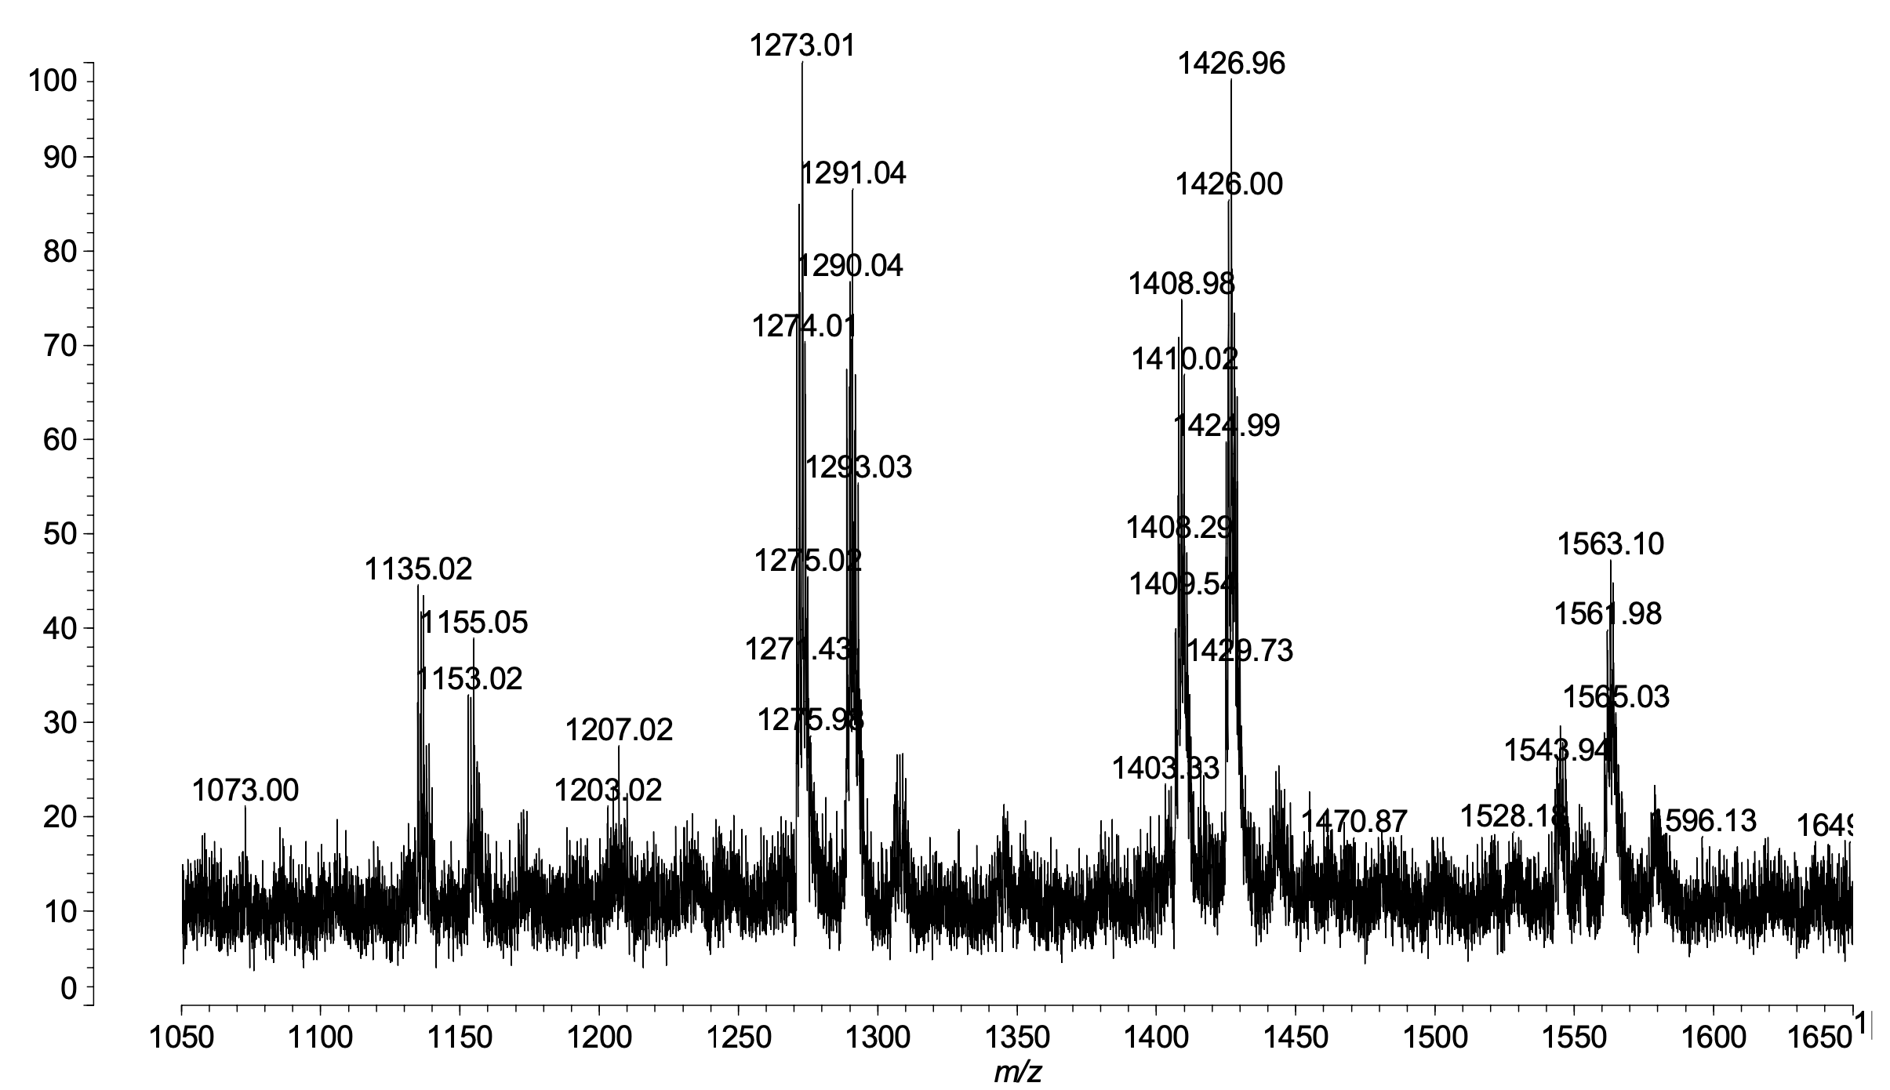
[15a+Na]⁺
[15a+K]⁺
[15d+Na]⁺
[15d+K]⁺
[15c+Na]⁺
[15c+K]⁺
[15b+K]⁺
[15b+Na]⁺
Figure S40: MALDI-TOF MS spectrum for 15.

4. Thermogravimetry/Differential Thermal Analysis (TG/DTA) for compounds 6-14
Figure S41: TG/DTA spectrum for 6 under N₂.
Figure S42: TG/DTA spectrum for 7 under N₂.

Figure S43: TG/DTA spectrum for 8 under N₂.
Figure S44: TG/DTA spectrum for 9 under N₂.
Figure S45: TG/DTA spectrum for 10 under N₂.
Figure S46: TG/DTA spectrum for 11 under N₂.
Figure S47: TG/DTA spectrum for 12 under N₂.
Figure S48: TG/DTA spectrum for 13 under N₂.
Figure S49: TG/DTA spectrum for 14 under N₂.

Table S1. Thermal properties for compounds 6-14 under N₂
Compounds | Td₅ (˚C) | Residue at 1000 ˚C (%)
6 | 172 | 80
7 | 196 | 55
8 | 148 | 24
9 | 198 | 60
10 | 340 | 18
11 | 422 | 20
12 | 348 | 33
13 | 333 | 10
14 | 323 | 17

