Supplemental Information

Mechanistic Elucidation of Activation or Deactivation Signal Transduction within Neurotensin Receptor 1 (NTSR1) Triggered by ‘Driver Chemical Group’: A Comparative Molecular Dynamics Simulation

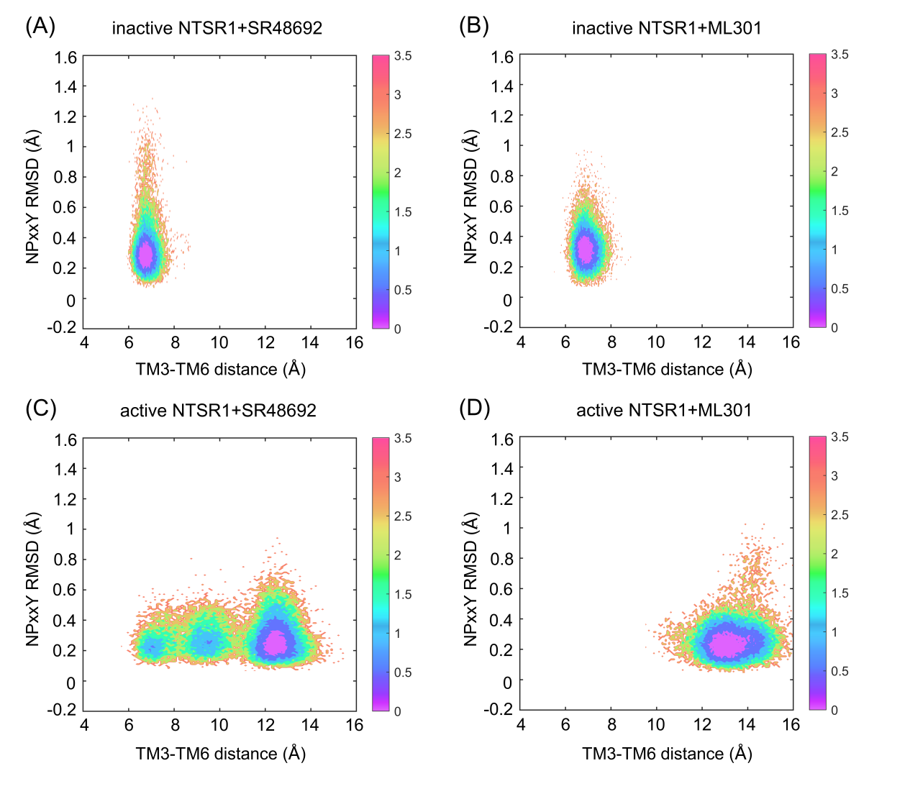
Figure S1. The analogical free energy landscape of the inactive NTSR1+SR48692 system (A), the inactive NTSR1+ML301 system (B), the active NTSR1+SR48692 system (C) and the active NTSR1+ML301 system (D) are shown by simulation trajectory projection. CV1: TM3-TM6 distance (evaluated by the distance between the center of mass of R166^{3.50} in TM3 and V302^{6.34} in TM6), CV2: NPxxY RMSD (evaluated by RMSD of non-symmetric side-chain atoms of residues N360^{7.49} to Y364^{7.53}). Color scale on the right is evaluated through density.

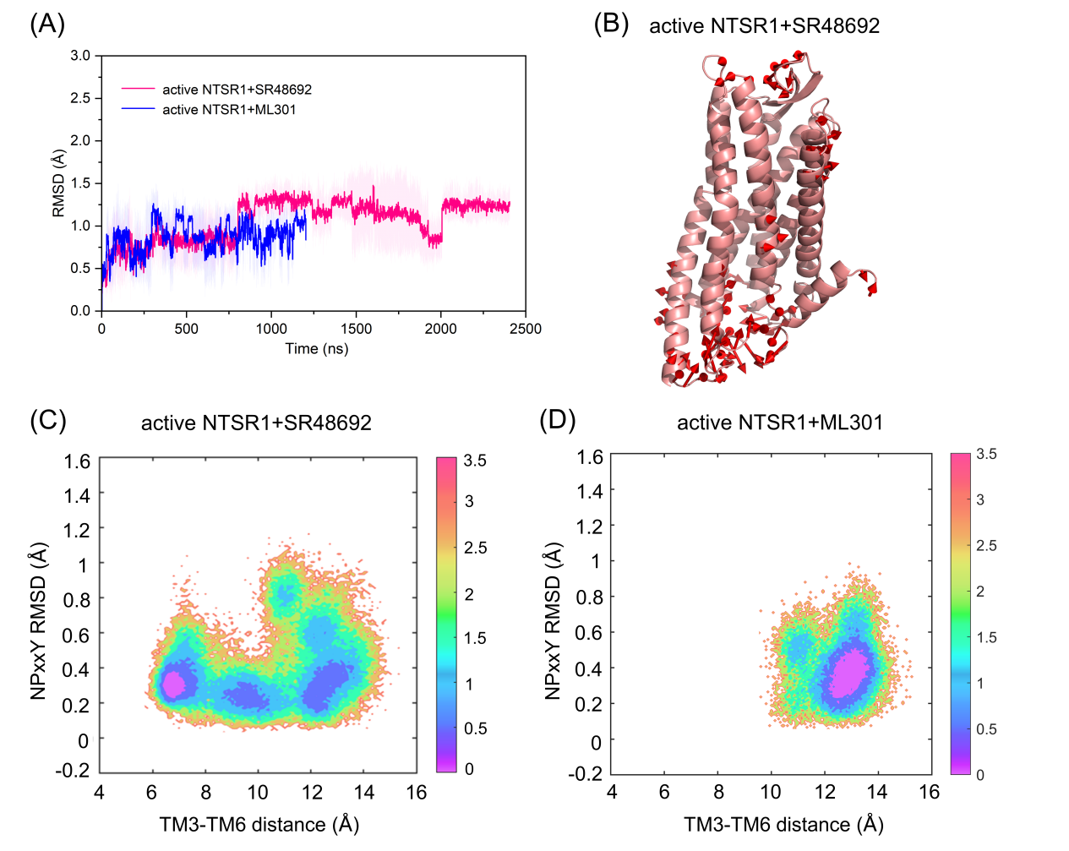
Figure S2. (A) The RMSD value of ligands in all simulations in the active NTSR1+SR48692 system (pink curve) and the active NTSR1+ML301 system (blue curve). (B) The principal pattern of motion of the active NTSR1+SR48692 system. The sizes and lengths of the red arrows are proportional to the amplitude of motions. The free energy landscapes of the active NTSR1+SR48692 system (C) and the active NTSR1+ML301 system (D) in cMD simulation. Collective variable 1 (CV1): TM3-TM6 distance (evaluated by the distance between the center of mass of R166^{3.50} in TM3 and V302^{6.34} in TM6), CV2: NPxxY RMSD (evaluated by RMSD of non-symmetric side-chain atoms of residues N360^{7.49} to Y364^{7.53}). The unit of free energy values is kcal/mol. Color scale on the right is evaluated through free energy.

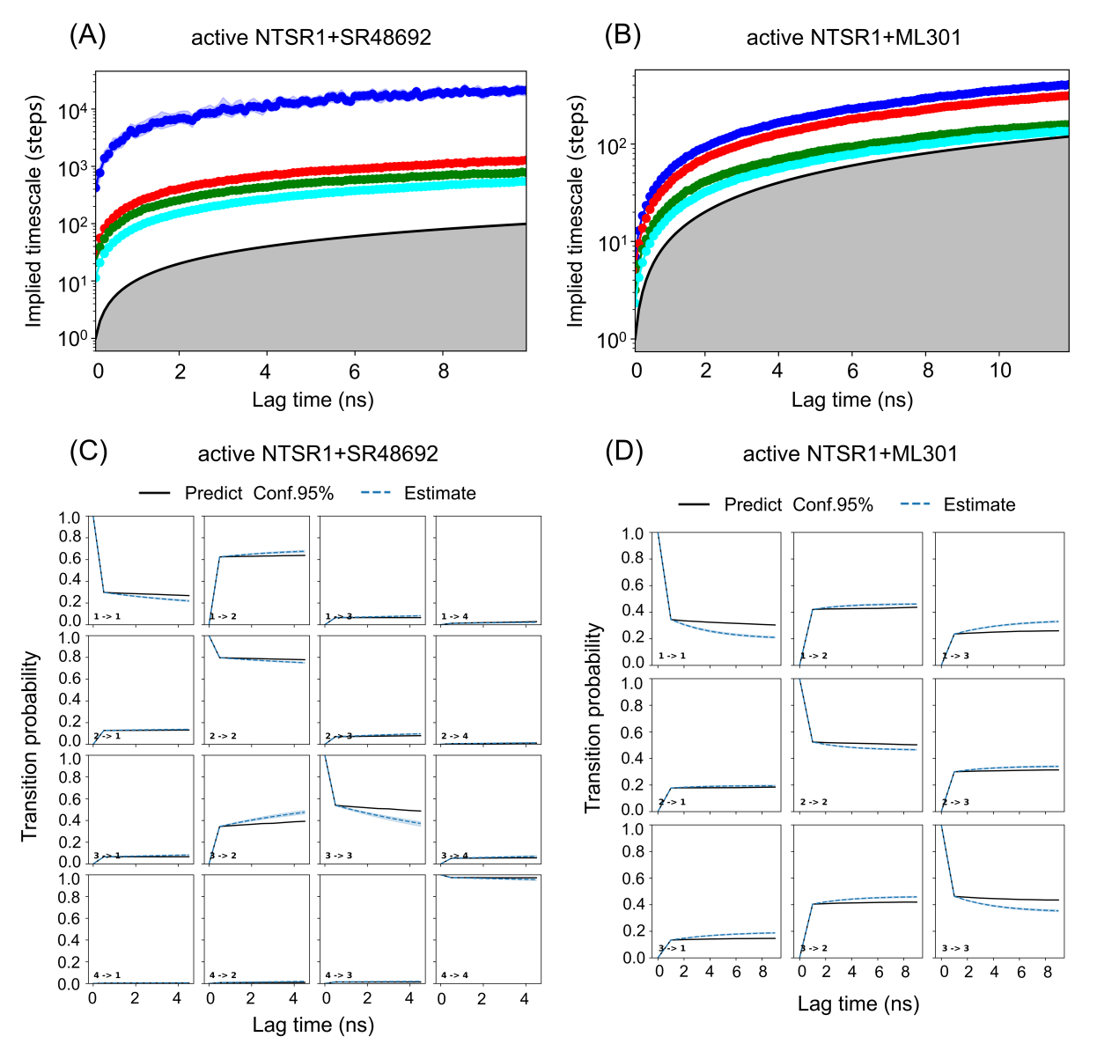
Figure S3. Implied timescale test for MSMs in the active NTSR1+SR48692 system (A) and the active NTSR1+ML301 system (B) at different lag times. Blue, red, green, and cyan lines show the timescale τ1, τ2, τ3 and τ4. Black line represents x=y in logarithmic coordinates, which separates the area where the dynamics of the processes is resolvable (white) from the non-resolvable area (grey). Chapman-Kolmogorov test of metastable states for the active NTSR1+SR48692 system (C) and the active NTSR1+ML301 system (D). The black solid estimate lines are the transition probability predicted by MSMs, while the blue dotted predict lines are practical transition probability observed in trajectories.

Table S1. Frequency of Y319^{6.51}-F353^{7.42} and F353^{7.42}-R148^{3.32} interaction in the representative trajectories in the active NTSR1+SR48692 system and the active NTSR1+ML301 system.

