Supplementary File to:
Selection for transcatheter versus surgical aortic valve replacement and long-term survival: 10-year results of the AUTHEARTVISIT Study

- Definitions of primary and secondary outcomes
For each patient, billing information (based on MEL codes) and diagnoses (based on ICD codes) were available from one year before the index operation (index-op) to the study cut-off date. Furthermore, death dates were available at the time of study cut-off. To evaluate outcomes for each patient, data were scanned from index-op to the study cut-off date for the corresponding outcome codes, shown in Supplementary Tables 1 and 2.

Supplementary Table 1. Definitions of primary and secondary outcomes
Definitions for Primary and Secondary Outcomes
Outcome | Definition
All-cause Mortality | all-cause mortality based on death date (primary outcome)
Reoperation | based on billing information (MEL-Code): first event after index-op with MEL code defined as in Table 2 (secondary outcome)
Heart Attack | Based on ICD-Codes: first event after index-op with one of the following ICD-codes: I21.0, I21.1, I21.2, I21.3, I21.4, I21.9 (secondary outcome)
Heart Failure | Based on ICD-Codes: first event after index-op with one of the following ICD-codes: I11.0, I13.0, I13.2, I50.0, I50.1, I50.9, I50.11, I50.12, I50.13, I50.14, I50.19 (secondary outcome)
Stroke | Based on ICD-Codes: first event after index-op with one of the following ICD-codes: I63.0, I63.1, I63.2, I63.3, I63.4, I63.5, I63.6, I63.8, I63.9, G45.9, G45.0, G45.1, G45.2, G45.3, G45.4, G45.8, I61.0, I61.1, I61.2, I61.3, I61.4, I61.5, I61.6, I61.8, I61.9, I64 (secondary outcome)
Supplementary Table 2. Definition of outcome “reoperation”
Coding for Outcome Reoperation
MEL Code | Description
DB020 | percutaneous implantation of a pulmonary valve
DB025 | Aortic valve replacement – catheter directed, transapical, TAVR
DB026 | Aortic valve replacement – catheter directed, transvalvular, TAVR
DB030 | Reconstruction of the aortic valve
DB040 | Reconstruction of the mitral valve
DB050 | Reconstruction of the tricuspid valve
DB055 | Reconstruction of the pulmonary valve
DB060 | Replacement of aortic valve with pulmonary autograft
DB070 | Replacement of aortic valve with stentless valve
DB080 | Replacement of aortic valve with stented valve
DB082 | Replacement of aortic valve with artificial mechanical valve
DB090 | Replacement of mitral valve with stentless valve
DB100 | Replacement of mitral valve with stented valve
DB102 | Replacement of mitral valve with artificial mechanical valve
DB110 | Replacement of tricuspid valve with stentless valve
DB120 | Replacement of tricuspid valve with stented valve
DB122 | Replacement of tricuspid valve with artificial mechanical valve
DB130 | Replacement of pulmonary valve with stentless valve
DB140 | Replacement of pulmonary valve with stented valve
DB142 | Replacement of pulmonary valve with artificial mechanical valve
DB021 | Aortic valve replacement – percutaneous, interventional, TAVR
XN010 | Aortic valve replacement – percutaneous, interventional, TAVR

- Definitions of confounders and comorbidities
The index-op group was defined using billing information (based on MEL codes); see Supplementary Table 3.

Supplementary Table 3. Definition of grouping variable (TAVR, sB-AVR)
Coding for Group Bio, TAVR
MEL Code | Description | Group Analysis
DB025 | Aortic valve replacement – catheter directed, transapikal, TAVR | TAVR
DB026 | Aortic valve replacement – catheter directed, transvalvular, TAVR | TAVR
DB060 | Replacement of aortic valve with pulmonary autograft | Biological Valve
DB070 | Replacement of aortic valve with stentless valve | Biological Valve
DB080 | Replacement of aortic valve with stented valve | Biological Valve
DB021 | Aortic valve replacement – percutaneous, interventional, TAVR | TAVR
XN010 | Aortic valve replacement – percutaneous, interventional, TAVR | TAVR

For an additional sensitivity analyses, patients were further divided by receiving or not receiving a pacemaker one month after the index-op. Supplementary Table 4 shows the MEL codes for pacemaker receipt.

Supplementary Table 4. Definitions for pacemaker receipt
Coding for Pacemaker
MEL Code | Description
DE080 | Pacemaker implantation, one chamber system (per session)  pacemaker implantation with one electrode (lead implantation not included)
DE081 | Pacemaker implantation, one chamber system, MRI conditional (per session)  pacemaker implantation with one electrode, MRI conditional (lead implantation not included)
DE090 | Pacemaker implantation, two chamber system (per session)  pacemaker implantation with atrial and ventricular electrode (lead implantation not included)
DE091 | Pacemaker implantation, two chamber system, MRI conditional (per session)  pacemaker implantation with atrial and ventricular electrode, MRI conditional (lead implantation not included)
DE100 | Implantation of a cardiac resynchronisation device (per session)  pacemaker implantation with atrial electrode (reatrial), ventricular electrode (reventricular) and left ventricular electrode for av-synchronous biventricular stimulation (artrio-biventricular pacemaker) (probe implantation not included)
DE130 | Cardiac pacemaker lead change (per session)  Change of one or multiple leads
DE140 | Pacemaker generator change, one chamber system (per session)  Pacemaker generator change without lead change (one lead system)
DE141 | Pacemaker generator change, one chamber system, MRI conditional (per session)  Pacemaker generator change without lead change, MRI conditional (one lead system)
DE150 | Pacemaker generator change, two chamber system (per session)  Pacemaker generator change without lead change (two lead system)
DE151 | Pacemaker generator change, two chamber system, MRI conditional (per session)  Pacemaker generator change without lead change, MRI conditional (two lead system)

Comorbidities were defined using ICD codes available for each patient up to one year before the index-op. Data available before the index-op were scanned for each patient based on ICD codes categorized for different comorbidities (Supplementary Table 5). If at least one time in the year before the index-op an ICD code for a comorbidity was observed as a main or secondary diagnosis, the patient was assumed to have the comorbidity.

Supplementary Table 5. ICD codes for comorbidities
Co-Morbidities | ICD-Codes
Diabetes mellitus | E10.0, E10.1, E10.2, E10.3, E10.4, E10.5, E10.6, E10.7, E10.8, E10.9, E11.0, E11.1, E11.2, E11.3, E11.4, E11.5, E11.6, E11.7, E11.8, E11.9, E12.0, E12.1, E12.2, E12.3, E12.4, E12.5, E12.6, E12.7, E12.8, E12.9, E13.0, E13.1, E13.2, E13.3, E13.4, E13.5, E13.6, E13.7, E13.8, E13.9, E14.0, E14.1, E14.2, E14.3, E14.4, E14.5, E14.6, E14.7, E14.8, E14.9
Adiposity | E65, E66.0, E66.1, E66.2, E66.8, E66.9
Hyperlipidemia | E78.0, E78.1, E78.2, E78.3, E78.4, E78.5, E78.6, E78.8, E78.9
Hyperuricemia/Gout | E79.0, E79.8, M10.0, M10.00, M10.01, M10.02, M10.03, M10.04, M10.05, M10.06, M10.07, M10.08, M10.09
Valvular, rhythmological and other CMPs | I01.0, I01.1, I01.2, I01.8, I01.9, I02.0, I02.9, I05.0, I05.1, I05.2, I05.8, I05.9, I06.0, I06.1, I06.2, I06.8, I06.9, I07.0, I07.1, I07.2, I07.8, I07.9, I08.0, I08.1, I08.2, I08.3, I08.8, I08.9, I09.0, I09.1, I09.2, I09.8, I09.9, I10, I11.0, I11.9, I12.0, I12.9, I13.0, I13.1, I13.2, I13.9, I15.0, I15.1, I15.2, I15.8, I15.9, I26.0, I26.9, I27.0, I27.1, I27.2, I27.8, I27.9, I28.0, I28.1, I28.8, I28.9, I30.0, I30.1, I30.8, I30.9, I31.0, I31.1, I31.2, I31.3, I31.8, I31.9, I32.0, I32.1, I32.8, I33.0, I33.9, I34.0, I34.1, I34.2, I34.8, I34.9, I35.0, I35.1, I35.2, I35.8, I35.9, I36.0, I36.1, I36.2, I36.8, I36.9, I37.0, I37.1, I37.2, I37.8, I37.9, I38, I39.0, I39.1, I39.2, I39.3, I39.4, I39.8, I40.0, I40.1, I40.8, I40.9, I41.0, I41.1, I41.2, I41.8, I42.0, I42.1, I42.2, I42.3, I42.4, I42.5, I42.6, I42.7, I42.8, I42.9, I43.0, I43.1, I43.2, I43.8, I44.0, I44.1, I44.2, I44.3, I44.4, I44.5, I44.6, I44.7, I45.0, I45.1, I45.2, I45.3, I45.4, I45.5, I45.6, I45.8, I45.9, I46.0, I46.1, I46.9, I470., I47.1, I47.2, I47.9, I48.0, I48.1, I48.2, I48.3, I48.4, I48.9, I49.0, I49.1, I49.2, I49.3, I49.4, I49.5, I49.8, I49.9, I50.0, I50.11, I50.12, I50.13, I50.14, I50.19, I50.9, I51.0, I51.1, I51.2, I51.3, I51.4, I51.5, I51.6, I51.7, I51.8, I51.9, I52.0, I52.1, I52.8, Q20.0, Q20.1, Q20.2, Q20.3, Q20.4, Q20.5, Q20.6, Q20.8, Q20.9, Q21.0, Q21.1, Q21.2, Q21.3, Q21.4, Q21.8, Q21.9, Q22.0, Q22.1, Q22.2, Q22.3, Q22.4, Q22.5, Q22.6, Q22.8, Q22.9, Q23.0, Q23.1, Q23.2, Q23.3, Q23.4, Q23.8, Q23.9, Q24.0, Q24.1, Q24.2, Q24.3, Q24.4, Q24.5, Q24.6, Q24.8, Q24.9, Q25.0, Q25.1, Q25.2, Q25.3, Q25.4, Q25.5, Q25.6, Q25.7, Q25.8, Q25.9
Atheriosclerosis | I69.8, I70.0, I70.1, I70.2, I70.8, I70.9
Pulmunary Disease | J43.1, J43.2, J43.8, J43.9, J44.00, J44.01, J44.02, J44.03, J44.09, J44.10, J44.11, J44.12, J44.13, J44.19, J44.80, J44.81, J44.82, J44.83, J44.89, J44.90, J44.91, J44.92, J44.93, J44.99, J45.0, J45.1, J45.8, J45.9
Kidney disease | N00,0, N00.1, N00.2, N00.3, N00.4, N00.5, N00.6, N00.7, N00.8, N00.9, N01.0, N01.1, N01.2, N01.3, N01.4, N01.5, N01.6, N01.7, N01.8, N01.9, N02.0, N02.1, N02.2, N02.3, N02.4, N02.5, N02.6, N02.7, N02.8, N02.9, N03.0, N03.1, N03.2, N03.3, N03.4, N03.5, N03.6, N03.7, N03.8, N03.9, N04.0, N04.1, N04.2, N04.3, N04.4, N04.5, N04.6, N04.7, N04.8, N04.9, N05.0, N05.1, N05.2, N05.3, N05.4, N05.5, N05.6, N05.7, N05.8, N05.9, N06.0, N06.1, N06.2, N06.3, N06.4, N06.5, N06.6, N06.7, N06.8, N06.9, N07.0, N07.1, N07.2, N07.3, N07.4, N07.5, N07.6, N07.7, N07.8, N07.9, N08.0, N08.1, N08.2, N08.3, N08.4, N08.5, N08.8, N10, N11.0, N11.1, N11.8, N11.9, N12, N13.0, N13.1, N13.2, N13.3, N13.4, N13.5, N13.6, N13.7, N13.8, N13.9, N14.0, N14.1, N14.2, N14.3, N14.4, N15.0, N15.1, N15.8, N15.9, N16.0, N16.1, N16.2, N16.3, N16.4, N16.5, N16.8, N17.0, N17.1, N17.2, N17.8, N17.9, N18.1, N18.2, N18.3, N18.4, N18.5, N18.9, N19, N20.0
Ischemic CMP | I20.0, I20.1, I20.8, I20.9, I21.0, I21.1, I21.2, I21.3, I21.4, I21.9, I22.0, I22.1, I22.8, I22.9, I23.0, I23.1, I23.2, I23.3, I23.4, I23.5, I23.6, I23.8, I24.0, I24.1, I24.8, I24.9, I25.0, I25.1, I25.2, I25.3, I25.4, I25.5, I25.6, I25.8, I25.9
Malignant diseases | C00.0, C00.1, C00.2, C00.3, C00.4, C00.5, C00.6, C00.8, C00.9, C01, C02.0, C02.1, C02.2, C02.3, C02.4, C02.8, C02.9, C03.0, C03.1, C03.9, C04.0, C04.1, C04.8, C04.9, C05.0, C05.1, C05.2, C05.8, C05.9, C06.0, C06.1, C06.2, C06.8, C06.9, C07 , C08.0, C08.1, C08.8, C08.9, C09.0, C09.1, C09.8, C09.9, C10.0, C10.1, C102., C10.3, C10.4, C10.8, C10.9, C11.0, C11.1, C11.2, C11.3, C11.8, C11.9, C12, C13.0, C13.1, C13.2, C13.8, C13.9, C14.0, C14.2, C14.8, C15.0, C15.1, C15.2, C15.3, C15.4, C15.5, C15.8, C15.9, C16.0, C16.1, C16.2, C16.3, C16.4, C16.5, C16.6, C16.8, C16.9, C17.0, C17.1, C17.2, C17.3, C17.8, C17.9, C18.0, C180.1,  C18.02, C180.3, C18.04, C18.1, C18.11, C18.12, C18.13, C18.14, C182., C18.21, C18.22, C18.23, C18.24, C18.3, C18.31, C18.32, C18.33, C18.34, C18.4, C18.41, C18.42, C18.43, C18.44, C18.5, C18.51, C18.52, C18.53, C18.54, C18.6, C18.61, C18.62, C18.63, C18.64, C18.7, C18.71, C18.72, C18.73, C18.74, C18.8, C18.81, C18.82, C18.83, C18.84, C18.9, C18.91, C18.92, C18.93, C18.94, C19, C19.1, C19.2, C19.3, C19.4, C20, C20.1, C20.2, C20.3, C20.4, C21.0, C21.1, C21.2, C21.8, C22.0, C22.1, C22.2, C22.3, C22.4, C22.7, C22.9, C23, C24.0, C24.1, C24.8, C24.9, C25.0, C25.1, C25.2, C25.3, C25.4, C25.7, C25.8, C25.9, C26.0, C26.1, C26.8, C26.9, C30.0, C30.1, C31.0, C31.1, C31.2, C31.3, C31.8, C31.9, C32.0, C32.1, C32.2, C32.3, C32.8, C32.9, C33, C34.0, C34.1, C34.2, C34.3, C34.8, C34.9, C37, C38.0, C38.1, C38.2, C38.3, C38.4, C38.8, C39.0, C39.8, C39.9, C40.0, C40.1, C40.2, C40.3, C40.8, C40.9, C41.0, C41.1, C41.2, C41.3, C41.4, C41.8, C41.9, C43.0, C43.1, C43.2, C43.3, C43.4, C43.5, C43.6, C43.7, C43.8, C43.9, C44.0, C44.1, C44.2, C44.3, C44.4, C44.5, C44.6, C44.7, C44.8, C44.9, C45.0, C45.1, C45.2, C45.7, C45.9, C46.0, C46.1, C46.2, C46.3, C46.7, C46.8, C46.9, C47.0, C47.1, C47.2, C47.3, C47.4, C47.5, C47.6, C47.8, C47.9, C48.0, C48.1, C48.2, C48.8, C49.0, C49.1, C49.2, C49.3, C49.4, C49.5, C49.6, C49.8, C49.9, C50.0, C50.1, C50.2, C50.3, C50.4, C50.5, C50.6, C50.8, C50.9, C51.0, C51.1, C51.2, C51.8, C51.9, C52, C53.0, C53.1, C53.8, C53.9, C54.0, C54.1, C54.2, C54.3, C54.8, C54.9, C55, C56, C57.0, C57.1, C57.2, C57.3, C57.4, C57.7, C57.8, C57.9, C58, C60.0, C60.1, C60.2, C60.8, C609., C61, C62.0, C62.1, C62.9, C63.0, C63.1, C63.2, C63.7, C63.8, C63.9, C64, C65, C66, C67.0, C67.1, C67.2, C67.3, C67.4, C67.5, C67.6, C67.7, C67.8, C67.9, C68.0, C68.1, C68.8, C68.9, C69.0, C69.1, C69.2, C69.3, C69.4, C69.5, C69.6, C69.8, C69.9, C70.0, C70.1, C70.9, C71.0, C71.1, C71.2, C71.3, C71.4, C71.5, C71.6, C71.7, C71.8, C71.9, C72.0, C72.1, C72.2, C72.3, C72.4, C72.5, C72.8, C72.9, C73, C740., C74.1, C749., C75.0, C75.1, C752., C75.3, C75.4, C75.5, C75.8, C75.9, C76.0, C76.1, C76.2, C76.3, C76.4, C76.5, C76.7, C76.8, C77.0, C77.1, C77.2, C77.3, C77.4, C77.5, C77.8, C77.9, C78.0, C78.1, C78.2, C78.3, C78.4, C78.5, C78.6, C78.7, C78.8, C79.0, C79.1, C79.2, C79.3, C79.4, C79.5, C79.6, C79.7, C79.8, C79.9, C80.0, C80.9, C81.0, C81.1, C81.2, C81.3, C81.4, C81.7, C81.9, C82.0, C82.1, C82.2, C82.3, C82.4, C82.5, C82.6, C82.7, C82.9, C83.0, C83.1, C83.3, C83.5, C83.7, C83.8, C83.9, C840., C84.1, C84.4, C845., C84.6, C84.7, C84.8, C84.9, C85.1, C85.2, C85.7, C85.9, C86.0, C86.1, C86.2, C86.3, C86.4, C86.5, C86.6, C88.0, C88.2, C88.3, C88.4, C887., C88.9, C90.0, C90.1, C90.2, C90.3, C91.0, C91.1, C91.3, C91.4, C91.5, C91.6, C91.7, C91.8, C91.9, C92.0, C92.1, C92.2, C92.3, C92.4, C92.5, C92.6, C92.7, C92.8, C92.9, C93.0, C93.1, C93.3, C93.7, C93.9, C94.0, C94.2, C94.3, C94.4, C94.6, C94.7, C95.0, C95.1, C95.7, C95.9, C96.0, C96.2, C96.4, C96.5, C96.6, C96.7, C96.8, C96.9, C97
Stroke before OP | ICD-Codes as in Table 1
Heart failure before OP | ICD-Codes as in Table 1
Heart attack before OP | ICD-Codes as in Table 1

- Sensitivity analyses by different age groups (65–75 years and >75 years)

Supplementary Table 6. Hazard ratios (HRs) and corresponding 95% confidence intervals (CIs) from Cox regressions for all-cause mortality in all patients as well as in propensity score–matched subgroups of patients ages 65–75 years, separately for the standard and time-dependent models
Subgroup: Patients between 65 and 75 years
 | Standard Model |  |  |  | Time dependent Analyses
 | All patients of subgroup |  | Propensity Score Matched |  | All patients of subgroup |  | Propensity Score Matched
 | HR (95% CI) | p-value | HR (95% CI) | p-value | HR (95% CI) | p-value | HR (95% CI) | p-value
Heart valve (sB-AVR vs. TAVR) : | 2.455  (2.209 - 2.728) | <0.001 | 2.368  (2.019 - 2.779) | <0.001
Year 1 |  |  |  |  | 1.889  (1.572 - 2.269) | <0.001 | 1.794  (1.324 - 2.430) | <0.001
Year 2 |  |  |  |  | 3.001  (2.307 - 3.904) | <0.001 | 3.201  (1.965 - 5.214) | <0.001
Year 3 |  |  |  |  | 2.602  (1.971 - 3.435) | <0.001 | 2.093  (1.365 - 3.210) | <0.001
Year 4 |  |  |  |  | 3.082  (2.310 - 4.110) | <0.001 | 2.941  (1.901 - 4.550) | <0.001
Year >4 |  |  |  |  | 2.659  (2.197 - 3.217) | <0.001 | 2.551  (1.955 - 3.327) | <0.001
age (per one year increase) | 1.029  (1.015 - 1.043) | <0.001 | 0.982  (0.954 - 1.010) | 0.204 | 1.029  (1.015 - 1.043) | <0.001 | 0.982  (0.954 - 1.010) | 0.201
sex (male vs. female) | 0.871  (0.800 - 0.948) | 0.001 | 0.889  (0.757 - 1.043) | 0.149 | 0.869  (0.798 - 0.946) | 0.001 | 0.889  (0.758 - 1.043) | 0.15
heart failure* | 1.529  (1.378 - 1.698) | <0.001 | 1.574  (1.312 - 1.888) | <0.001 | 1.536  (1.384 - 1.705) | <0.001 | 1.579  (1.316 - 1.895) | <0.001
heart attack* | 1.183  (0.960 - 1.458) | 0.116 | 0.825  (0.466 - 1.463) | 0.511 | 1.173  (0.952 - 1.446) | 0.134 | 0.819  (0.462 - 1.452) | 0.495
stroke* | 1.213  (0.924 - 1.591) | 0.164 | 1.122  (0.550 - 2.292) | 0.752 | 1.205  (0.918 - 1.581) | 0.178 | 1.131  (0.553 - 2.310) | 0.736
diabetes mellitus* | 1.461  (1.326 - 1.609) | <0.001 | 1.337  (1.118 - 1.600) | 0.001 | 1.464  (1.329 - 1.613) | <0.001 | 1.342  (1.122 - 1.606) | 0.001
adiposity* | 1.033  (0.899 - 1.186) | 0.65 | 1.010  (0.767 - 1.329) | 0.945 | 1.030  (0.897 - 1.182) | 0.679 | 1.008  (0.766 - 1.327) | 0.954
hyperlipidemia* | 0.834  (0.758 - 0.918) | <0.001 | 0.723  (0.593 - 0.880) | 0.001 | 0.832  (0.756 - 0.916) | <0.001 | 0.719  (0.590 - 0.877) | 0.001
hyperuricemia/gout* | 1.159  (0.957 - 1.404) | 0.131 | 1.273  (0.832 - 1.947) | 0.267 | 1.160  (0.957 - 1.405) | 0.13 | 1.281  (0.837 - 1.960) | 0.254
valvular, rhythmological and other CMPs* | 0.906  (0.797 - 1.031) | 0.135 | 1.015  (0.757 - 1.362) | 0.92 | 0.907  (0.797 - 1.032) | 0.137 | 1.017  (0.758 - 1.364) | 0.911
iCMP* | 1.093  (1.003 - 1.192) | 0.043 | 1.135  (0.963 - 1.337) | 0.132 | 1.094  (1.003 - 1.193) | 0.042 | 1.134  (0.963 - 1.337) | 0.132
atherosclerosis* | 1.220  (1.046 - 1.423) | 0.011 | 1.149  (0.827 - 1.596) | 0.408 | 1.218  (1.044 - 1.421) | 0.012 | 1.150  (0.828 - 1.597) | 0.405
pulmonary diseases* | 1.141  0.934 - 1.394) | 0.196 | 1.119  (0.745 - 1.681) | 0.588 | 1.155  (0.945 - 1.411) | 0.159 | 1.126  (0.749 - 1.692) | 0.568
kidney diseases* | 1.565  (1.391 - 1.760) | <0.001 | 1.583  (1.296 - 1.934) | <0.001 | 1.564  (1.391 - 1.759) | <0.001 | 1.584  (1.296 - 1.935) | <0.001
malignant diseases* | 1.592  (1.372 - 1.847) | <0.001 | 1.709  (1.283 - 2.276) | <0.001 | 1.598  (1.377 - 1.853) | <0.001 | 1.717  (1.289 - 2.288) | <0.001

Supplementary Table 7. Baseline characteristics between groups before and after propensity score matching for the subgroup of patients ages 65 to 75 years
Subgroup: Patients between 65 and 75 years
 | All Data |  |  | After PSM
 | Bio  (n = 6483) | TAVR  (n = 1092) | p-value | Bio  (n = 869) | TAVR  (n = 869) | p-value
Age  (median, | 71 (68 - 73) | 73 (70 - 74) | <0.001 | 73 (70 - 74) | 73 (70 - 74) | 0.766
Sex
M | 4090 (63.09%) | 638 (58.42%) |  | 519 (59.72%) | 521 (59.95%)
F | 2393 (36.91%) | 454 (41.58%) | 0.004 | 350 (40.28%) | 348 (40.05%) | 0.961
Heart failure
No | 5703 (87.97%) | 809 (74.08%) |  | 712 (81.93%) | 699 (80.44%)
Yes | 780 (12.03%) | 283 (25.92%) | <0.001 | 157 (18.07%) | 170 (19.56%) | 0.461
Heart attack
No | 6274 (96.78%) | 1064 (97.44%) |  | 855 (98.39%) | 851 (97.93%)
Yes | 209 (3.22%) | 28 (2.56%) | 0.287 | 14 (1.61%) | 18 (2.07%) | 0.592
Stroke
No | 6368 (98.23%) | 1069 (97.89%) |  | 861 (99.08%) | 858 (98.73%)
Yes | 115 (1.77%) | 23 (2.11%) | 0.524 | 8 (0.92%) | 11 (1.27%) | 0.645
Diabetes mellitus
No | 5229 (80.66%) | 759 (69.51%) |  | 663 (76.29%) | 652 (75.03%)
Yes | 1254 (19.34%) | 333 (30.49%) | <0.001 | 206 (23.71%) | 217 (24.97%) | 0.576
Adiposity
No | 5953 (91.82%) | 965 (88.37%) |  | 805 (92.64%) | 789 (90.79%)
Yes | 530 (8.18%) | 127 (11.63%) | <0.001 | 64 (7.36%) | 80 (9.21%) | 0.192
Hyperlipidemia
No | 4685 (72.27%) | 798 (73.08%) |  | 670 (77.1%) | 662 (76.18%)
Yes | 1798 (27.73%) | 294 (26.92%) | 0.604 | 199 (22.9%) | 207 (23.82%) | 0.691
Hyperuricemia/gout
No | 6255 (96.48%) | 1039 (95.15%) |  | 848 (97.58%) | 844 (97.12%)
Yes | 228 (3.52%) | 53 (4.85%) | 0.038 | 21 (2.42%) | 25 (2.88%) | 0.654
Valvular, rhythmological and other CMPs
No | 958 (14.78%) | 82 (7.51%) |  | 71 (8.17%) | 77 (8.86%)
Yes | 5525 (85.22%) | 1010 (92.49%) | <0.001 | 798 (91.83%) | 792 (91.14%) | 0.667
Ischemic CMP
No | 3041 (46.91%) | 464 (42.49%) |  | 388 (44.65%) | 388 (44.65%)
Yes | 3442 (53.09%) | 628 (57.51%) | 0.007 | 481 (55.35%) | 481 (55.35%) | 1
Atherosclerosis
No | 6142 (94.74%) | 995 (91.12%) |  | 833 (95.86%) | 822 (94.59%)
Yes | 341 (5.26%) | 97 (8.88%) | <0.001 | 36 (4.14%) | 47 (5.41%) | 0.261
Pulmonary diseases
No | 6259 (96.54%) | 984 (90.11%) |  | 826 (95.05%) | 832 (95.74%)
Yes | 224 (3.46%) | 108 (9.89%) | <0.001 | 43 (4.95%) | 37 (4.26%) | 0.567
Kidney diseases
0: No | 5906 (91.1%) | 851 (77.93%) |  | 747 (85.96%) | 745 (85.73%)
Yes | 577 (8.9%) | 241 (22.07%) | <0.001 | 122 (14.04%) | 124 (14.27%) | 0.945
Malignant diseases
No | 6180 (95.33%) | 1007 (92.22%) |  | 821 (94.48%) | 822 (94.59%)
Yes | 303 (4.67%) | 85 (7.78%) | <0.001 | 48 (5.52%) | 47 (5.41%) | 1

Supplementary Table 8. Hazard ratios (HRs) and corresponding 95% confidence intervals (CIs) from Cox regressions for all-cause mortality in all patients as well as in propensity score–matched subgroups of patients older than 75 years, separately for the standard and time-dependent models
Subgroup: Patients older than 75 years
 | Standard Model |  |  |  | Time dependent Analyses
 | All patients of subgroup |  | Propensity Score Matched |  | All patients of subgroup |  | Propensity Score Matched
 | HR (95% CI) | p-value | HR (95% CI) | p-value | HR (95% CI) | p-value | HR (95% CI) | p-value
Heart valve (sB-AVR vs. TAVR) : | 1.354  (1.272 - 1.442) | <0.001 | 1.368  (1.259 - 1.485) | <0.001
Year 1 |  |  |  |  | 0.919  (0.821 - 1.028) | 0.138 | 0.888  (0.755 - 1.044) | 0.149
Year 2 |  |  |  |  | 1.699  (1.439 - 2.006) | <0.001 | 1.852  (1.446 - 2.372) | <0.001
Year 3 |  |  |  |  | 1.655  (1.394 - 1.966) | <0.001 | 1.793  (1.404 - 2.29) | <0.001
Year 4 |  |  |  |  | 1.542  (1.306 - 1.821) | <0.001 | 1.538  (1.225 - 1.931) | <0.001
Year >4 |  |  |  |  | 1.473  (1.342 - 1.616) | <0.001 | 1.478  (1.295 - 1.686) | <0.001
age (per one year increase) | 1.064  (1.056 - 1.072) | <0.001 | 1.054  (1.041 - 1.068) | <0.001 | 1.065  (1.057 - 1.073) | <0.001 | 1.055  (1.041 - 1.068) | <0.001
sex (male vs. female) | 0.863  (0.817 - 0.912) | <0.001 | 0.889  (0.820 - 0.964) | 0.004 | 0.862  (0.816 - 0.911) | <0.001 | 0.889  (0.820 - 0.963) | 0.004
heart failure* | 1.377  (1.289 - 1.472) | <0.001 | 1.338  (1.197 - 1.496) | <0.001 | 1.380  (1.291 - 1.475) | <0.001 | 1.339  (1.198 - 1.497) | <0.001
heart attack* | 1.149  (0.988 - 1.336) | 0.071 | 1.364  (0.962 - 1.933) | 0.081 | 1.144  (0.984 - 1.330) | 0.08 | 1.365  (0.963 - 1.935) | 0.081
stroke* | 1.175  (0.958 - 1.440) | 0.122 | 1.391  (0.802 - 2.410) | 0.24 | 1.172  (0.956 - 1.437 | 0.126 | 1.389  (0.801 - 2.408) | 0.242
diabetes mellitus* | 1.330  1.239 - 1.427) | <0.001 | 1.391  (1.238 - 1.563) | <0.001 | 1.331  (1.240 - 1.428) | <0.001 | 1.390  (1.237 - 1.562) | <0.001
adiposity* | 1.128  (0.998 - 1.276) | 0.054 | 1.036  (0.787 - 1.364) | 0.8 | 1.127  (0.996 - 1.274) | 0.057 | 1.038  (0.788 - 1.367) | 0.791
hyperlipidemia* | 0.822  (0.769 - 0.879) | <0.001 | 0.808  (0.729 - 0.895) | <0.001 | 0.823  (0.770 - 0.880) | <0.001 | 0.808  (0.729 - 0.895) | <0.001
hyperuricemia/gout* | 1.067  (0.927 - 1.228) | 0.366 | 1.340  (0.978 - 1.836) | 0.068 | 1.068  (0.928 - 1.229) | 0.361 | 1.341  (0.979 - 1.837) | 0.067
valvular, rhythmological and other CMPs* | 0.840  (0.768 - 0.919) | <0.001 | 0.821  (0.726 - 0.929) | 0.002 | 0.841  (0.769 - 0.920) | <0.001 | 0.822  (0.726 - 0.929) | 0.002
iCMP* | 1.069  (1.010 - 1.133) | 0.022 | 1.105  (1.016 - 1.202) | 0.02 | 1.070  (1.010 - 1.133) | 0.022 | 1.105  (1.016 - 1.202) | 0.02
atherosclerosis* | 1.183  (1.073 - 1.305) | <0.001 | 1.261  (1.035 - 1.537) | 0.021 | 1.183  (1.072 - 1.304) | <0.001 | 1.259  (1.033 - 1.534) | 0.023
pulmonary diseases* | 1.364  (1.184 - 1.571) | <0.001 | 1.294  (0.945 - 1.772) | 0.108 | 1.384  (1.201 - 1.595) | <0.001 | 1.300  (0.949 - 1.780) | 0.102
kidney diseases* | 1.344  (1.249 - 1.447) | <0.001 | 1.448  (1.275 - 1.644) | <0.001 | 1.347  (1.252 - 1.449) | <0.001 | 1.448  (1.275 - 1.645) | <0.001
malignant diseases* | 1.355  (1.217 - 1.507) | <0.001 | 1.307  (1.063 - 1.607) | 0.011 | 1.358  (1.221 - 1.512) | <0.001 | 1.309  (1.064 - 1.609) | 0.011

Supplementary Table 9. Baseline characteristics between groups before and after propensity score matching for the subgroup of patients older than 75 years
Subgroup: Patients older than 75 years
 | All Data |  |  | After PSM
 | Bio  (n = 5266) | TAVI  (n = 6041) | p-value | Bio  (n = 2764) | TAVR  (n = 2764) | p-value
Age  (median, | 79 (77 - 81) | 83 (80 - 86) | <0.001 | 80 (78 - 83) | 80 (78 - 83) | 0.878
Sex
M | 2796 (53.1%) | 2539 (42.03%) |  | 1252 (45.3%) | 1243 (44.97%)
F | 2470 (46.9%) | 3502 (57.97%) | <0.001 | 1512 (54.7%) | 1521 (55.03%) | 0.829
Heart failure
No | 4512 (85.68%) | 4628 (76.61%) |  | 2401 (86.87%) | 2413 (87.3%)
Yes | 754 (14.32%) | 1413 (23.39%) | <0.001 | 363 (13.13%) | 351 (12.7%) | 0.659
Heart attack
No | 5058 (96.05%) | 5925 (98.08%) |  | 2737 (99.02%) | 2736 (98.99%)
Yes | 208 (3.95%) | 116 (1.92%) | <0.001 | 27 (0.98%) | 28 (1.01%) | 1
Stroke
No | 5189 (98.54%) | 5928 (98.13%) |  | 2755 (99.67%) | 2750 (99.49%)
Yes | 77 (1.46%) | 113 (1.87%) | 0.107 | 9 (0.33%) | 14 (0.51%) | 0.403
Diabetes mellitus
No | 4403 (83.61%) | 4959 (82.09%) |  | 2420 (87.55%) | 2423 (87.66%)
Yes | 863 (16.39%) | 1082 (17.91%) | 0.034 | 344 (12.45%) | 341 (12.34%) | 0.935
Adiposity
No | 5012 (95.18%) | 5753 (95.23%) |  | 2709 (98.01%) | 2706 (97.9%)
Yes | 254 (4.82%) | 288 (4.77%) | 0.924 | 55 (1.99%) | 58 (2.1%) | 0.849
Hyperlipidemia
No | 3864 (73.38%) | 4568 (75.62%) |  | 2157 (78.04%) | 2135 (77.24%)
Yes | 1402 (26.62%) | 1473 (24.38%) | 0.007 | 607 (21.96%) | 629 (22.76%) | 0.498
Hyperuricemia/gout
No | 5070 (96.28%) | 5812 (96.21%) |  | 2729 (98.73%) | 2717 (98.3%)
Yes | 196 (3.72%) | 229 (3.79%) | 0.887 | 35 (1.27%) | 47 (1.7%) | 0.221
Valvular, rhythmological and other CMPs
No | 736 (13.98%) | 524 (8.67%) |  | 342 (12.37%) | 339 (12.26%)
Yes | 4530 (86.02%) | 5517 (91.33%) | <0.001 | 2422 (87.63%) | 2425 (87.74%) | 0.935
Ischemic CMP
No | 2344 (44.51%) | 2915 (48.25%) |  | 1336 (48.34%) | 1337 (48.37%)
Yes | 2922 (55.49%) | 3126 (51.75%) | <0.001 | 1428 (51.66%) | 1427 (51.63%) | 1
Atherosclerosis
No | 4913 (93.3%) | 5536 (91.64%) |  | 2657 (96.13%) | 2656 (96.09%)
Yes | 353 (6.7%) | 505 (8.36%) | 0.001 | 107 (3.87%) | 108 (3.91%) | 1
Pulmonary diseases
No | 5139 (97.59%) | 5694 (94.26%) |  | 2723 (98.52%) | 2712 (98.12%)
Yes | 127 (2.41%) | 347 (5.74%) | <0.001 | 41 (1.48%) | 52 (1.88%) | 0.296
Kidney diseases
0: No | 4640 (88.11%) | 4804 (79.52%) |  | 2491 (90.12%) | 2489 (90.05%)
Yes | 626 (11.89%) | 1237 (20.48%) | <0.001 | 273 (9.88%) | 275 (9.95%) | 0.964
Malignant diseases
No | 5014 (95.21%) | 5675 (93.94%) |  | 2682 (97.03%) | 2678 (96.89%)
Yes | 252 (4.79%) | 366 (6.06%) | 0.003 | 82 (2.97%) | 86 (3.11%) | 0.814

4.) Sensitivity analyses: by different years of the index procedure

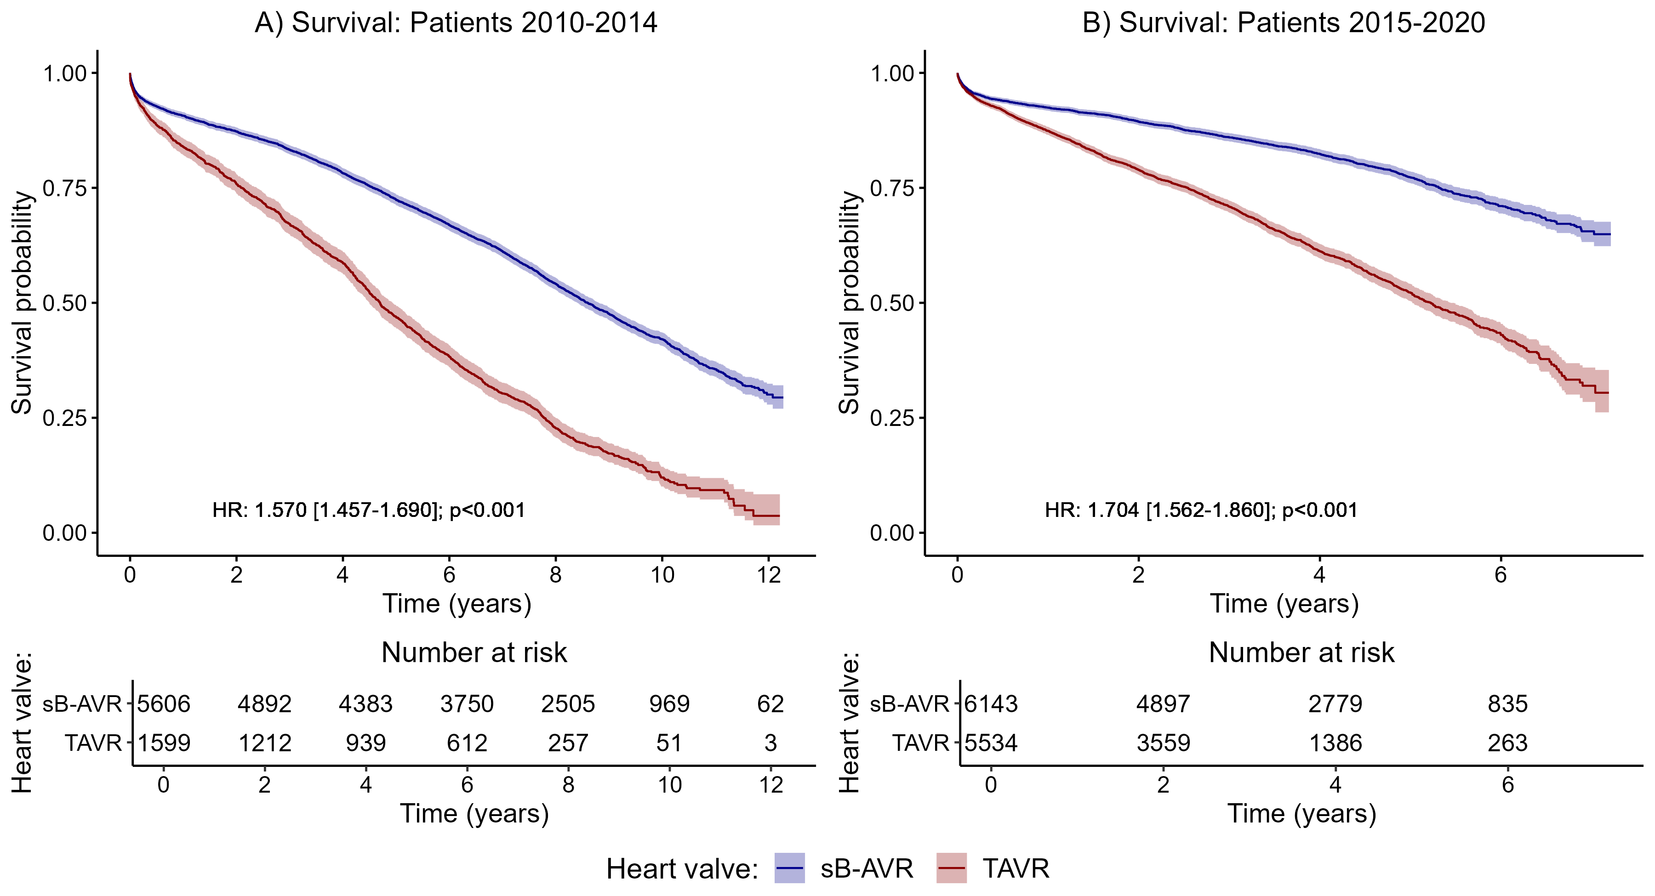
Supplementary Figure 1. Survival probabilities and corresponding 95% confidence intervals, separately for the two investigated groups (red: TAVR; blue: sB-AVR) within different subgroups of patients: A) with index procedure before 2015 and B) with index procedure during or after 2015.

Supplementary Table 10. Hazard ratios (HRs) with corresponding 95% confidence intervals from Cox regressions for all-cause mortality in the subgroup of patients with index-op before 2015 and during/after 2015
 | Patients 2010 - 2014 |  | Patients 2015 - 2020
 | HR (95% CI) | p-value | HR (95% CI) | p-value
Heart valve (sB-AVR vs. TAVR) | 1.570 (1.457 - 1.690) | <0.001 | 1.704 (1.562 - 1.860) | <0.001
age (per one year increase) | 1.059 (1.053 - 1.065) | <0.001 | 1.042 (1.035 - 1.049) | <0.001
sex (male vs. female) | 0.891 (0.839 - 0.947) | <0.001 | 0.808 (0.752 - 0.869) | <0.001
heart failure before OP | 1.344 (1.247 - 1.449) | <0.001 | 1.487 (1.366 - 1.619) | <0.001
heart attack before OP | 1.114 (0.955 - 1.301) | 0.171 | 1.227 (1.005 - 1.498) | 0.044
stroke before OP | 1.063 (0.846 - 1.335) | 0.601 | 1.409 (1.116 - 1.779) | 0.004
diabetes mellitus* | 1.387 (1.288 - 1.494) | <0.001 | 1.351 (1.237 - 1.476) | <0.001
adiposity* | 1.133 (1.007 - 1.273) | 0.037 | 1.082 (0.935 - 1.252) | 0.29
hyperlipidemia* | 0.851 (0.793 - 0.913) | <0.001 | 0.782 (0.717 - 0.853) | <0.001
hyperuricemia/gout* | 1.181 (1.014 - 1.376) | 0.033 | 1.001 (0.846 - 1.185) | 0.988
valvular, rhythmological and other CMPs* | 0.910 (0.827 - 1.001) | 0.052 | 0.793 (0.706 - 0.891) | <0.001
iCMP* | 1.117 (1.049 - 1.190) | <0.001 | 1.022 (0.950 - 1.099) | 0.567
atherosclerosis* | 1.182 (1.050 - 1.330) | 0.006 | 1.222 (1.089 - 1.372) | <0.001
pulmonary diseases* | 1.295 (1.024 - 1.639) | 0.031 | 1.371 (1.199 - 1.569) | <0.001
kidney diseases* | 1.376 (1.259 - 1.504) | <0.001 | 1.481 (1.357 - 1.618) | <0.001
malignant diseases* | 1.330 (1.180 - 1.498) | <0.001 | 1.534 (1.352 - 1.741) | <0.001

- Sensitivity analyses: by comorbid diseases

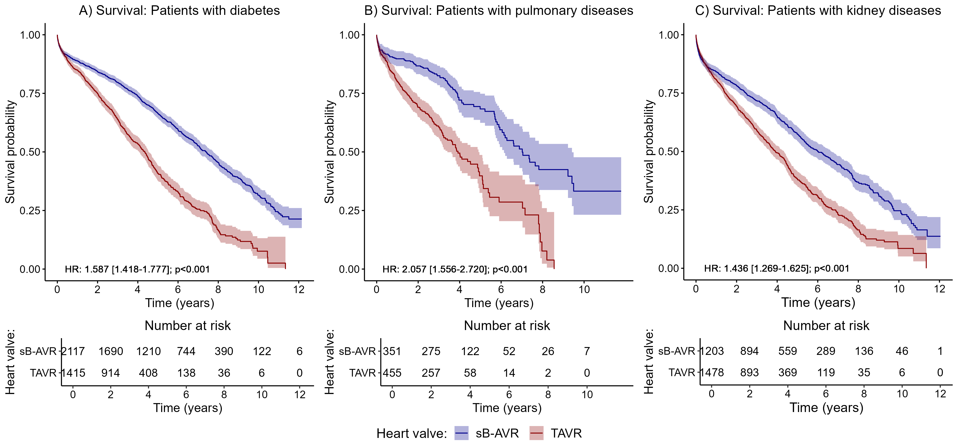
Supplementary Figure 2. Survival probabilities and corresponding 95% confidence intervals, separately for the two investigated groups (red: TAVR; blue: sB-AVR) within different subgroups of patients: A) with diabetes, B) with pulmonary diseases, and C) with kidney diseases.

Supplementary Table 11. Hazard ratios (HRs) and corresponding 95% confidence intervals (CIs) from Cox regressions for all-cause mortality in subgroups of patients with diabetes, pulmonary diseases, and kidney diseases
 | Patients with diabetes |  | Patients with pulmonary diseases |  | Patients with kidney diseases
 | HR (95% CI) | p-value | HR (95% CI) | p-value | HR (95% CI) | p-value
Heart valve (sB-AVR vs. TAVR) | 1.587 (1.418 - 1.777) | <0.001 | 2.057 (1.556 - 2.72) | <0.001 | 1.436 (1.269 - 1.625) | <0.001
age (per one year increase) | 1.038 (1.028 - 1.048) | <0.001 | 1.029 (1.008 - 1.051 | 0.008 | 1.025 (1.015 - 1.036) | <0.001
sex (male vs. female) | 0.849 (0.769 - 0.938) | 0.001 | 0.812 (0.643 - 1.026) | 0.08 | 0.853 (0.765 - 0.952) | 0.004
heart failure before OP | 1.565 (1.412 - 1.735) | <0.001 | 1.381 (1.086 - 1.756) | 0.008 | 1.43 (1.285 - 1.592) | <0.001
heart attack before OP | 1.114 (0.901 - 1.377) | 0.32 | 1.186 (0.672 - 2.094) | 0.557 | 0.989 (0.769 - 1.272) | 0.931
stroke before OP | 1.333 (1.01 - 1.76) | 0.042 | 0.869 (0.376 - 2.008) | 0.742 | 1.144 (0.823 - 1.591) | 0.422
diabetes mellitus* |  |  | 1.32 (1.019 - 1.711) | 0.036 | 1.243 (1.109 - 1.393) | <0.001
adiposity* | 1.089 (0.956 - 1.24) | 0.199 | 0.952 (0.656 - 1.381) | 0.794 | 1.036 (0.878 - 1.223) | 0.676
hyperlipidemia* | 0.926 (0.839 - 1.022) | 0.127 | 0.88 (0.695 - 1.114) | 0.289 | 0.829 (0.739 - 0.93) | 0.001
hyperuricemia/gout* | 1.157 (0.962 - 1.391) | 0.122 | 1.027 (0.686 - 1.537) | 0.898 | 1.127 (0.957 - 1.328) | 0.152
valvular, rhythmological and other CMPs* | 0.731 (0.431 - 1.24) | 0.244 | 1.122 (0.277 - 4.552) | 0.872 | 0.916 (0.548 - 1.531) | 0.737
iCMP* | 1.088 (0.98 - 1.208) | 0.115 | 0.949 (0.743 - 1.212) | 0.674 | 1.107 (0.987 - 1.241) | 0.084
atherosclerosis* | 1.217 (1.05 - 1.409) | 0.009 | 1.441 (1.06 - 1.959) | 0.02 | 1.193 (1.026 - 1.388) | 0.022
pulmonary diseases* | 1.23 (0.995 - 1.52) | 0.056 |  |  | 1.108 (0.903 - 1.359) | 0.328
kidney diseases* | 1.349 (1.208 - 1.507) | <0.001 | 1.236 (0.954 - 1.6) | 0.109
malignant diseases* | 1.236 (1.042 - 1.467) | 0.015 | 1.348 (0.935 - 1.945) | 0.11 | 1.268 (1.071 - 1.502) | 0.006

- Sensitivity analyses: by patients with and without a pacemaker implantation at 1 month after index procedure
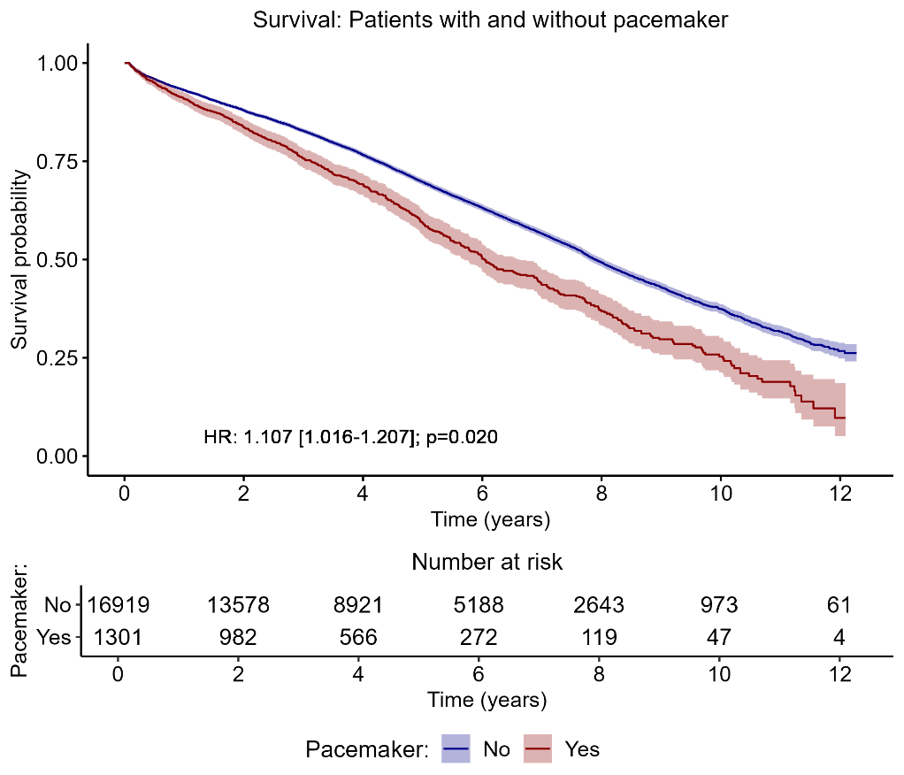
Supplementary Figure 3. Survival probabilities and corresponding 95% confidence intervals, separately for patients receiving and not receiving a pacemaker 1 month after index procedure.

Supplementary Table 12. Hazard ratios (HRs) with corresponding 95% confidence intervals from Cox regressions for all-cause mortality for the sensitivity analysis for patients receiving and not receiving a pacemaker 1 month after the index procedure
 | All-Cause Mortality
 | HR (95% CI) | p-value
Heart valve (sB-AVR vs. TAVI) | 1.667 (1.573 – 1.767) | <0.001
age (per one year increase) | 1.053 (1.048 – 1.058) | <0.001
sex (male vs. female) | 0.845 (0.805 – 0.887) | <0.001
heart failure before OP | 1.408 (1.328 – 1.493) | <0.001
heart attack before OP | 1.146 (1.007 – 1.303) | 0.038
Stroke before OP | 1.195 (1.006 – 1.418) | 0.042
diabetes mellitus | 1.393 (1.313 – 1.478) | <0.001
Adiposity | 1.103 (1.002 – 1.214) | 0.044
Hyperlipidemia | 0.825 (0.779 – 0.873) | <0.001
hyperuricemia/gout | 1.038 (0.920 – 1.172) | 0.546
valvular, rhythmological and other CMPs | 0.909 (0.840 – 0.982) | 0.016
iCMP | 1.092 (1.038 – 1.147) | <0.001
Atherosclerosis | 1.208 (1.108 – 1.316) | <0.001
pulmonary diseases | 1.333 (1.180 – 1.507) | <0.001
kidney diseases | 1.416 (1.327 – 1.512) | <0.001
malignant diseases | 1.470 (1.344 – 1.607) | <0.001
Pacemaker 1 month after OP | 1.107 (1.016 – 1.207) | 0.020

- Secondary outcomes

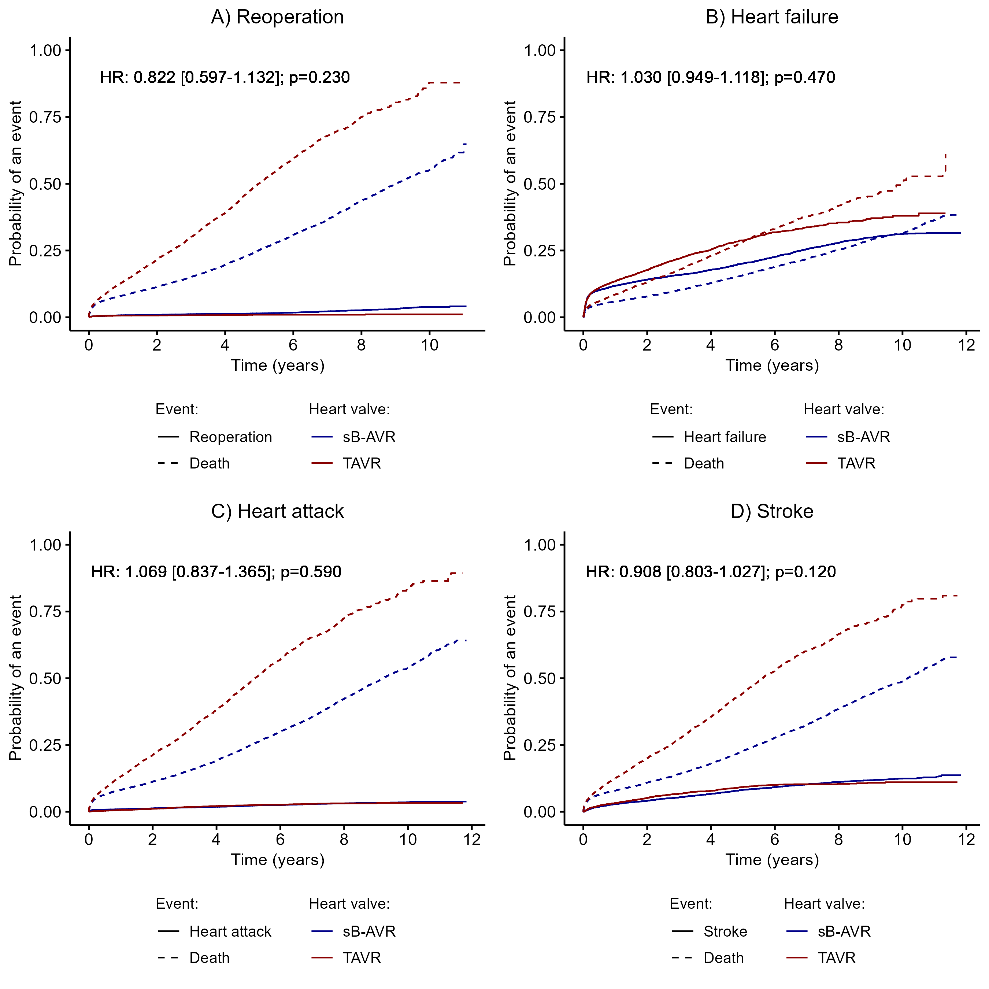
Supplementary Figure 4. Cumulative incidence curves for (A) reoperation, (B) heart failure, (C) myocardial infarcion, and (D) stroke, with death as the competing event.
Supplementary Table 13. Hazard ratios (HRs) with corresponding 95% confidence intervals (CIs) for the secondary outcome parameters of reoperation, heart failure, myocardial infarction, and stroke (competing risk analyses)
 | reoperation |  | heart failure |  | Myocardial infarction |  | stroke
 | HR (95% CI) | p-value | HR (95% CI) | p-value | HR (95% CI) | p-value | HR (95% CI) | p-value
Heart valve (sB-AVR vs. TAVR) | 0.822  (0.597 – 1.132 | 0.230 | 1.030  (0.949 – 1.118) | 0.470 | 1.069  (0.837 – 1.365) | 0.590 | 0.908  (0.803 – 1.027) | 0.120
age (per one year increase) | 0.920  (0.900 – 0.940 | < 0.001 | 1.030  (1.024 – 1.036) | < 0.001 | 0.989  (0.971 – 1.006) | 0.210 | 1.015  (1.006 – 1.024) | 0.001
sex (male vs. female) | 1.317  (1.036 – 1.675) | 0.025 | 1.082  (1.012 – 1.157) | 0.021 | 1.079  (0.890 – 1.307) | 0.440 | 1.024  (0.926 – 1.131) | 0.650
heart failure* | 0.875  (0.608 – 1.262) | 0.480 | - | - | 0.925  (0.703 – 1.218) | 0.580 | 1.005  (0.877 – 1.151) | 0.950
heart attack* | 0.980  (0.457 – 2.099) | 0.960 | 1.369  (1.140 – 1.644) | 0.001 | 4.282  (3.165.- 5.795) | < 0.001 | 0.889  (0.658 – 1.201) | 0.440
stroke* | 1.381  (0.650 – 2.933) | 0.400 | 1.126  (0.882 – 1.437) | 0.340 | 0.811  (0.365 – 1.801 | 0.610 | 2.490  (1.922 – 3.225) | < 0.001
diabetes mellitus* | 0.719  (0.511 – 1.012) | 0.058 | 1.324  (1.215 – 1.443) | < 0.001 | 1.177  (0.928 – 1.493) | 0.180 | 1.043  (0.916 – 1.188) | 0.520
adiposity* | 1.204  (0.776 – 1.869) | 0.410 | 1.136  (0.992 – 1.301) | 0.065 | 0.930  (0.636 – 1.360) | 0.710 | 0.960  (0.778 – 1.184) | 0.700
hyperlipidemia* | 1.262  (0.953 – 1.671) | 0.100 | 0.818  (0.754 – 0.886) | < 0.001 | 0.932  (0.745 – 1.166) | 0.540 | 1.129  (1.008 – 1.264) | 0.036
hyperuricemia/gout* | 1.159  (0.624 – 2.153) | 0.640 | 1.183  (0.990 – 1.413) | 0.064 | 0.917  (0.545 – 1.542) | 0.740 | 0.885  (0.672 – 1.165) | 0.380
valvular, rhythmological and other CMPs* | 0.823  (0.592 – 1.144) | 0.250 | 0.914  (0.829 – 1.008) | 0.071 | 0.553  (0.426 – 0.718) | < 0.001 | 1.094  (0.926 – 1.291) | 0.290
iCMP* | 0.651  (0.508 – 0.835) | 0.001 | 1.048  (0.978 – 1.122) | 0.180 | 1.575  (1.272 – 1.948) | < 0.001 | 1.058  (0.953 – 1.173) | 0.290
atherosclerosis* | 1.246  (0.770 – 2.019) | 0.370 | 1.269  (1.117 – 1.441) | < 0.001 | 1.436  (1.044 – 1.975) | 0.026 | 1.051  (0.866 – 1.274 | 0.620
pulmonary diseases* | 0.692  (0.305 – 1.573) | 0.380 | 1.176  (0.987 – 1.402) | 0.069 | 0.978  (0.577 – 1.659) | 0.930 | 0.732  (0.537 – 0.997) | 0.047
kidney diseases* | 1.195  (0.817 – 1.748) | 0.360 | 1.329  (1.202 – 1.470) | < 0.001 | 0.978  (727 -– 1.316) | 0.880 | 1.005  (0.864 – 1.170) | 0.950
malignant diseases* | 1.328  (0.813 – 2.171) | 0.260 | 1.010  (0.872 – 1.168 | 0.900 | 0.408  (0.219 – 0.763) | 0.005 | 0.991  (0.796 – 1.235) | 0.904

- Probability of events

Supplementary Table 14. The 2-, 5-, 7-, and 10-year event probabilities and corresponding 95% confidence intervals (CIs) for all-cause mortality, reoperation, myocardial infarction, stroke, and heart failure
 |  |  | Years
Event | Group |  | 2 | 5 | 7 | 10
All-cause Mortality | sB-ARV | Number at Risk | 9789 | 5810 | 3551 | 969
 |  | Event Probability | 0.147 | 0.319 | 0.458 | 0.695
 |  | 95% CI | 0.136 - 0.157 | 0.303- 0.334 | 0.440 - 0.475 | 0.673 - 0.716
 | TAVR | Number at Risk | 2829 | 878 | 315 | 37
 |  | Event Probability | 0.194 | 0.459 | 0.631 | 0.842
 |  | 95% CI | 0.181 - 0.206 | 0.440 - 0.478 | 0.606 - 0.655 | 0.807- 0.871
Reoperation | sB-ARV | Number at Risk | 8738 | 4780 | 2639 | 423
 |  | Event Probability | 0.010 | 0.0145 | 0.022 | 0.039
 |  | 95% CI | 0.008 - 0.011 | 0.012 - 0.017 | 0.019 - 0.026 | 0.033 - 0.045
 | TAVR | Number at Risk | 3608 | 1005 | 319 | 16
 |  | Event Probability | 0.007 | 0.010 | 0.010 | 0.011
 |  | 95% CI | 0.005 - 0.009 | 0.007 - 0.013 | 0.007 - 0.013 | 0.008 - 0.016
Myocardial Infarction | sB-ARV | Number at Risk | 9327 | 5304 | 3208 | 750
 |  | Event Probability | 0.013 | 0.022 | 0.029 | 0.036
 |  | 95% CI | 0.011 - 0.015 | 0.020 - 0.025 | 0.025 - 0.032 | 0.031 - 0.040
 | TAVR | Number at Risk | 4252 | 1250 | 415 | 34
 |  | Event Probability | 0.011 | 0.024 | 0.030 | 0.033
 |  | 95% CI | 0.009 - 0.014 | 0.020 - 0.029 | 0.024 - 0.036 | 0.027 - 0.041
Stroke | sB-ARV | Number at Risk | 9059 | 4984 | 2968 | 681
 |  | Event Probability | 0.041 | 0.082 | 0.102 | 0.125
 |  | 95% CI | 0.038 - 0.045 | 0.077 - 0.088 | 0.096 - 0.108 | 0.117 - 0.133
 | TAVR | Number at Risk | 4097 | 1165 | 388 | 31
 |  | Event Probability | 0.052 | 0.093 | 0.103 | 0.111
 |  | 95% CI | 0.046 - 0.057 | 0.085 - 0.101 | 0.094 - 0.112 | 0.100 - 0.122
Heart failure | sB-ARV | Number at Risk | 7208 | 3925 | 2262 | 555
 |  | Event Probability | 0.141 | 0.202 | 0.255 | 0.312
 |  | 95% CI | 0.134 - 0.148 | 0.193 - 0.210 | 0.245 - 0.264 | 0.300 - 0.324
 | TAVR | Number at Risk | 2815 | 759 | 244 | 18
 |  | Event Probability | 0.177 | 0.288 | 0.337 | 0.380
 |  | 95% CI | 0.167 - 0.188 | 0.273 - 0.303 | 0.319 - 0.355 | 0.355 - 0.405
Supplementary Table 15. The 2-, 5-, 7-, and 10-year all-cause mortality probabilities and corresponding 95% confidence intervals (CIs) within the different subgroups; NA (“not available”) indicates that the corresponding all-cause mortality probability could not be calculated because of a too-short follow-up
All-cause Mortality
 |  |  | Years
Subgroup | Group |  | 2 | 5 | 7 | 10
Patients 2010 - 2015 | sB-ARV | Number at Risk | 4892 | 4057 | 3431 | 969
 |  | Event Probability | 0.127 | 0.276 | 0.388 | 0.579
 |  | 95% CI | 0.119 - 0.136 | 0.265 - 0.288 | 0.375 - 0.401 | 0.564 - 0.594
 | TAVR | Number at Risk | 1212 | 750 | 484 | 51
 |  | Event Probability | 0.242 | 0.531 | 0.697 | 0.880
 |  | 95% CI | 0.221 - 0.263 | 0.506 - 0.555 | 0.674 - 0.719 | 0.856 - 0.899
Patients 2015 - 2020 | sB-ARV | Number at Risk | 4897 | 1753 | 120 | NA
 |  | Event Probability | 0.106 | 0.227 | 0.345 | NA
 |  | 95% CI | 0.098 - 0.114 | 0.214 - 0.240 | 0.320 - 0.368 | NA
 | TAVR | Number at Risk | 3559 | 722 | 30 | NA
 |  | Event Probability | 0.211 | 0.478 | 0.680 | NA
 |  | 95% CI | 0.200 - 0.222 | 0.459 - 0.496 | 0.641 - 0.716 | NA
Patients with Diabetes | sB-ARV | Number at Risk | 1690 | 941 | 564 | 122
 |  | Event Probability | 0.157 | 0.336 | 0.474 | 0.685
 |  | 95% CI | 0.141 - 0.172 | 0.314 - 0.357 | 0.448 - 0.499 | 0.651 - 0.715
 | TAVR | Number at Risk | 914 | 238 | 84 | 6
 |  | Event Probability | 0.251 | 0.591 | 0.744 | 0.924
 |  | 95% CI | 0.228 - 0.274 | 0.556 - 0.622 | 0.706 - 0.778 | 0.868 - 0.956
Patients with pulmonary disease | sB-ARV | Number at Risk | 275 | 66 | 38 | NA
 |  | Event Probability | 0.133 | 0.317 | 0.488 | NA
 |  | 95% CI | 0.096 - 0.168 | 0.252 - 0.376 | 0.391 - 0.569 | NA
 | TAVR | Number at Risk | 257 | 23 | 11 | NA
 |  | Event Probability | 0.309 | 0.602 | 0.714 | NA
 |  | 95% CI | 0.265 - 0.351 | 0.513 - 0.675 | 0.600 - 0.795 | NA
Patients with kidney diseases | sB-ARV | Number at Risk | 894 | 390 | 218 | 46
 |  | Event Probability | 0.217 | 0.426 | 0.556 | 0.754
 |  | 95% CI | 0.193 - 0.240 | 0.394 - 0.456 | 0.519 - 0.590 | 0.706 - 0.793
 | TAVR | Number at Risk | 893 | 222 | 67 | 6
 |  | Event Probability | 0.306 | 0.618 | 0.770 | 0.915
 |  | 95% CI | 0.282 - 0.330 | 0.585 - 0.649 | 0.731 - 0.804 | 0.857 - 0.949

