Supplementary material for:
Goldilocks dilemma: LPS works both as the initial target and a barrier for the antimicrobial action cationic AMPs on E. coli
Martin Jakubec^{1,} *, Fredrik G. Rylandsholm¹, Philip Rainsford¹, Mitchell Silk¹, Maxim Bril'kov², Tone Kristoffersen¹, Eric Juskewitz³, Johanna U. Ericson³, Johan M. Isaksson^{1,2,†}, John Sigurd M. Svendsen^{1,†}
¹ Department of Chemistry, Faculty of Science and Technology, UiT the Arctic University of Norway, 9019 Tromsø, Norway
² Department of Pharmacy, Faculty of Health Sciences, UiT the Arctic University of Norway, 9019 Tromsø, Norway
³ Department of Medical Biology, Faculty of Health Sciences, UiT the Arctic University of Norway, 9019 Tromsø, Norway
† Shared authorship
* Correspondence: martin.jakubec@uit.no

Peptide chemical analysis
The crude cyclic peptides were purified by preparative reverse phase-HPLC using gradients from 15 to 40 % buffer B (buffer A: water/0.1% TFA, buffer B: acetonitrile/0.1% TFA) over 50 minutes (11 ml/min flow rate). c(LWwNKr) was isolated as a white fluffy solid. HRMS (ESI): Calculated for: C₄₄H₆₂N₁₃O₇⁺ [M+H]⁺ 884.4890; found; 884.4885. c(WWWRRR) was isolated as a white solid. HRMS (ESI): Calculated for: C₅₁H₆₈N₁₈O₆²⁺ [M+H]²⁺ 514.2779; found; 514.2775. c(WRWRWR) was isolated as a white solid. HRMS (ESI): Calculated for: C₅₁H₆₈N₁₈O₆²⁺ [M+H]²⁺ 514.2779; found; 514.2773. c(WWWKKK) was isolated as a white solid. HRMS (ESI): Calculated for: C₅₁H₆₈N₁₂O₆²⁺ [M+H]²⁺ 472.2687; found; 472.2682. c(WKWKWK) was isolated as a white solid. HRMS (ESI): Calculated for: C₅₁H₆₈N₁₂O₆²⁺ [M+H]²⁺ 472.2687; found; 472.2681.
Table S1: K_{P} and k_{off} from Figure 1
AMP | K_{P} |  |  | k_{off} (s⁻¹)
 | DMPC | DMPC:PG | DMPC:LPS | DMPC | DMPC:PG | DMPC:LPS
LWwNKr | 278 ± 8 | 401 ± 19 | 1145 ± 99 | 1.76 ± 0.12 | 1.75 ± 0.16 | 1.01 ± 0.18
WKWKWK | 531 ± 10 | 630 ± 33 | 1191 ± 166 | 0.90 ± 0.24 | 1.32 ± 0.05 | 0.95 ± 0.12
WRWRWR | 1299 ± 94 | 3160 ± 15 | 4520 ± 215 | 0.87 ± 0.19 | 0.48 ± 0.05 | 0.70 ± 0.16
WWWKKK | 2534 ± 80 | 5156 ± 34 | 3943 ± 218 | 0.48 ± 0.07 | 0.32 ± 0.05 | 0.60 ± 0.15
WWWRRR | 6649 ± 80 | 12705 ± 16 | 17040 ± 1150 | 0.22 ± 0.02 | 0.19 ± 0.01 | 0.25 ± 0.03

Table S2: γB/γF ratios.
AMP |  |  | γB/γF
 | DMPC | DMPC:LPS |  | E. coli  ATCC 25922 lysate | E. coli  ATCC 25922 | E. coli  CCUG 70662- | E. coli  CCUG 70662+ | E. coli  NR 698
LWwNKr | 7.830 | 2.620 |  | 0.035 | 0.106 | 5.202 | 4.990 | 0.186
WKWKWK | 7.127 | 3.915 |  | 0.044 | 0.083 | 0.170 | 0.295 | 0.180
WRWRWR | 2.900 | 3.475 |  | 0.275 | 0.143 | 0.549 | 1.062 | 3.059
WWWKKK | 0.297 | 0.402 |  | 0.225 | 0.289 | 0.317 | 0.197 | 0.370
WWWRRR | 0.247 | 0.199 |  | 0.216 | 0.239 | 0.473 | 0.238 | 0.819

Figure S1: K_{D} extracted from steady state SPR analysis
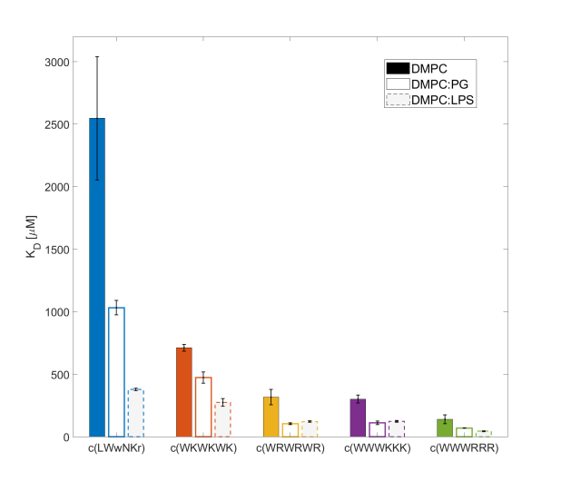

Figure S2: The five peptides with numbered amino acids for structure elucidation.
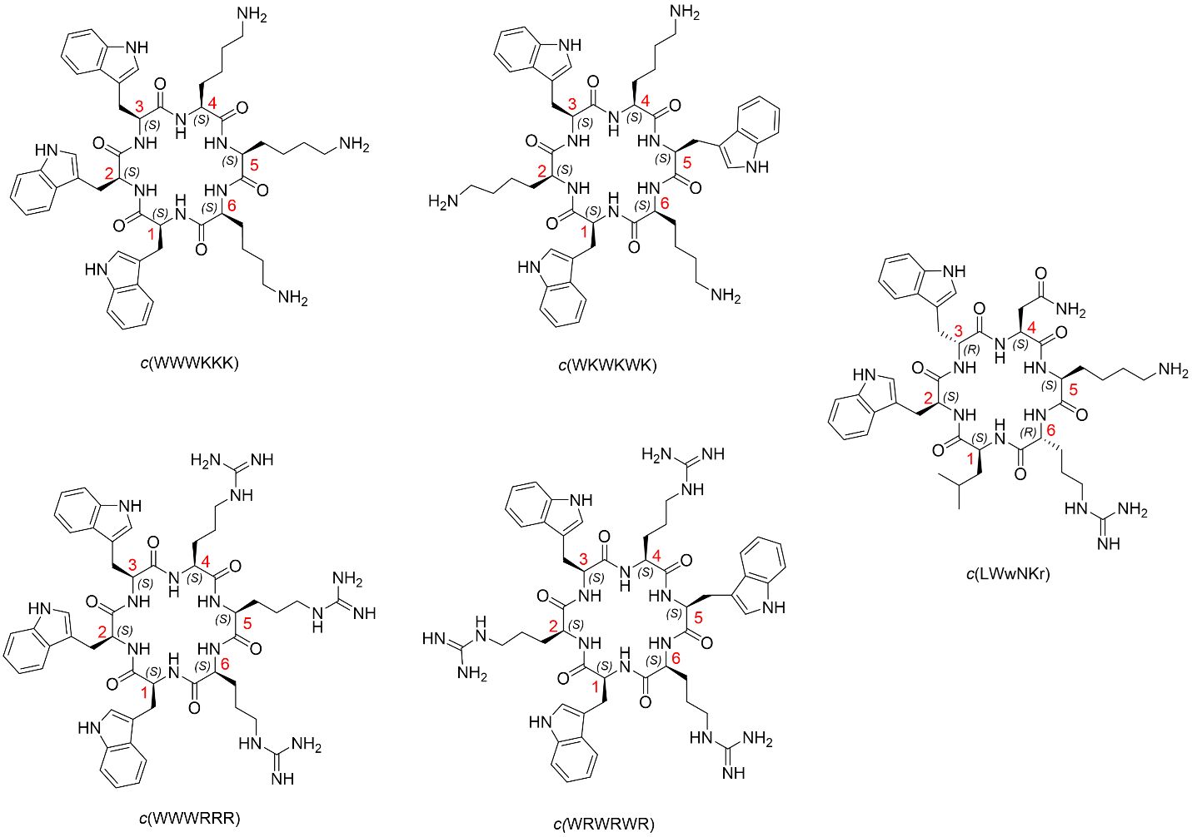
Figure S3: Labelled amino acids.

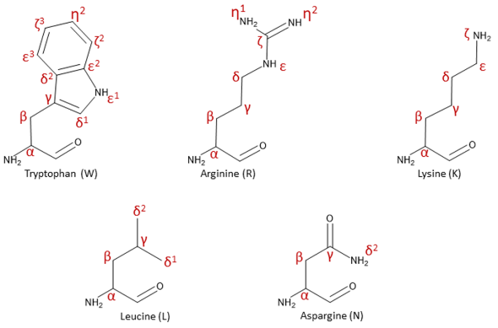

.
c(WWWKKK)
Residue # | Amino acid | Chemical shift (δ)
1 | W - Tryptophan | NHα | CO | α | β | ε1 | δ1 | γ | δ2 | ε3 | ζ3 | η2 | ζ2 | ε2
 | ¹H | 7.85 | - | 4.48 | 2.99/2.86 | 10.10 | 7.06 | - | - | 7.46 | 7.09 | 7.17 | 7.41 | -
 | ¹³C/¹⁵N | 118.01 | 173.41 | 54.70 | 26.00 | 129.28 | 124.45 | 108.96 | 127.01 | 118.48 | 119.41 | 122.04 | 111.98 | 136.34
2 | W - Tryptophan | NHα | CO | α | β | ε1 | δ1 | γ | δ2 | ε3 | ζ3 | η2 | ζ2 | ε2
 | ¹H | 7.33 | - | 4.51 | 3.11/2.87 | 10.05 | 6.95 | - | - | 7.30 | 7.05 | 7.15 | 7.39 | -
 | ¹³C/¹⁵N | 119.00 | 172.67 | 54.55 | 26.36 | 130.00 | 124.76 | 108.30 | 127.06 | 118.30 | 119.59 | 122.16 | 112.04 | 136.20
3 | W - Tryptophan | NHα | CO | α | β | ε1 | δ1 | γ | δ2 | ε3 | ζ3 | η2 | ζ2 | ε2
 | ¹H | 7.55 | - | 4.45 | 3.06/2.76 | 10.07 | 6.92 | - | - | 7.30 | 7.02 | 7.11 | 7.33 | -
 | ¹³C/¹⁵N | 121.25 | 172.67 | 55.19 | 26.06 | 129.56 | 124.19 | 108.54 | 126.86 | 118.30 | 119.44 | 122.05 | 111.94 | 136.24
4 | K -Lysine | NHα | CO | α | β | γ | δ | ε | ζ
 | ¹H | 7.84 | - | 3.75 | 1.49/1.67 | 0.66 | 1.30/1.58 | 2.26 | 7.41 | - | - | - | - | -
 | ¹³C/¹⁵N | 120.75 | 173.08 | 54.90 | 30.07 | 21.86 | 26.19 | 39.24 | 96.51 | - | - | - | - | -
5 | K -Lysine | NHα | CO | α | β | γ | δ | ε | ζ
 | ¹H | 8.03 | - | 4.10 | 1.51 | 1.68/1.50 | 1.32/1.24 | 2.88 | 7.46 | - | - | - | - | -
 | ¹³C/¹⁵N | 119.47 | 173.29 | 53.60 | 28.83 | 30.06 | 22.34 | 39.43 | 96.73 | - | - | - | - | -
6 | K -Lysine | NHα | CO | α | β | γ | δ | ε | ζ
 | ¹H | 7.77 | - | 3.88 | 1.22 | 0.85/0.74 | 1.33 | 2.61 | 7.37 | - | - | - | - | -
 | ¹³C/¹⁵N | 119.35 | 173.76 | 54.55 | 29.43 | 21.86 | X | 39.24 | 96.52 | - | - | - | - | -
Table S3: Full assignment of c(WWWKKK) according to Figure S2

Table S4: Full assignment of c(WKWKWK) according to Figure S2.
c(WKWKWK)
Residue # | Amino acid | Chemical shift (δ)
1 | W - Tryptophan | NHα | CO | α | β | ε1 | δ1 | γ | δ2 | ε3 | ζ3 | η2 | ζ2 | ε2
 | ¹H | 7.99 | - | 4.54 | 3.09 | 10.17 | 7.16 | - | - | 7.52 | 7.10 | 7.17 | 7.37 | -
 | ¹³C/¹⁵N | 119.292 | 173.01 | 54.66 | 25.99 | 129.67 | 124.35 | 108.77 | 127.06 | 118.37 | 119.46 | 122.03 | 112.04 | 136.21
2 | K -Lysine | NHα | CO | α | β | γ | δ | ε | ζ | - | - | - | - | -
 | ¹H | 7.62 | - | 3.89 | 1.42 | 0.67 | 1.28 | 2.55 | 7.35 | - | - | - | - | -
 | ¹³C/¹⁵N | 120.24 | 172.91 | 54.55 | 29.59 | 21.59 | 26.21 | 39.25 | 134.12/95.83 | - | - | - | - | -

Table S5: Full assignment of c(WRWRWR) according to Figure S2.
c(WRWRWR)
Residue # | Amino acid | Chemical shift (δ)
1 | W - Tryptophan | NHα | CO | α | β | ε1 | δ1 | γ | δ2 | ε3 | ζ3 | η2 | ζ2 | ε2
 | ¹H | 8.07 | - | 4.54 | 3.13 | 10.13 | 7.16 | - | - | 7.53 | 7.10 | 7.16 | 7.37 | -
 | ¹³C/¹⁵N | 119.43 | 172.84 | 54.84 | 26.04 | 129.65 | 124.44 | 108.78 | 126.96 | 118.23 | 119.39 | 122.07 | 111.97 | 136.23
2 | R - Arginine | NHα | CO | α | β | γ | δ | ε | ζ | η1 | η2 | - | - | -
 | ¹H | 7.65 | - | 3.90 | 1.41 | 0.82 | 2.71 | 6.77 | - | X | X | - | - | -
 | ¹³C/¹⁵N | 119.96 | 172.88 | 54.39 | 27.28 | 23.71 | 40.44 | 84.78 | 153.71 | X | X | - | - | -

Table S6: Full assignment of c(WWWRRR) according to Figure S2.
c(WWWRRR)
Residue # | Amino acid | Chemical shift (δ)
1 | W - Tryptophan | NHα | CO | α | β | ε1 | δ1 | γ | δ2 | ε3 | ζ3 | η2 | ζ2 | ε2
 | ¹H | 7.88 | - | 4.52 | 2.85/3.04 | 10.03 | 7.04 | - | - | 7.46 | 7.07 | 7.15 | 7.38 | -
 | ¹³C/¹⁵N | 118.00 | 173.20 | 54.68 | 26.04 | 129.05 | 124.44 | 109.20 | 126.79 | 118.31 | 119.29 | 122.02 | 111.89 | 136.27
2 | W - Tryptophan | NHα | CO | α | β | ε1 | δ1 | γ | δ2 | ε3 | ζ3 | η2 | ζ2 | ε2
 | ¹H | 7.42 | - | 4.54 | 2.98/3.03 | 10.05 | 7.02 | - | - | 7.38 | 7.08 | 7.16 | 7.40 | -
 | ¹³C/¹⁵N | 119.05 | 172.55 | 54.36 | 26.68 | 130.00 | 124.76 | 108.40 | 127.37 | 118.30 | 119.44 | 122.03 | 112.02 | 136.22
3 | W - Tryptophan | NHα | CO | α | β | ε1 | δ1 | γ | δ2 | ε3 | ζ3 | η2 | ζ2 | ε2
 | ¹H | 7.64 | - | 4.43 | 2.85/3.05 | 10.03 | 6.94 | - | - | 7.36 | 7.04 | 7.12 | 7.33 | -
 | ¹³C/¹⁵N | 121.23 | 173.10 | 55.49 | 26.04 | 129.50 | 124.27 | 108.40 | 126.82 | 118.17 | 119.34 | 122.03 | 111.87 | 136.23
4 | R - Arginine | NHα | CO | α | β | γ | δ | ε | ζ | η1 | η2 | - | - | -
 | ¹H | 7.94 | - | 3.72 | 1.58/1.50 | 0.74/0.87 | 2.75/2.73 | 6.77 | - | X | X | - | - | -
 | ¹³C/¹⁵N | 120.23 | 172.89 | 54.85 | 26.37 | 24.11 | 40.38 | 85.03 | 156.63 | X | X | - | - | -
5 | R - Arginine | NHα | CO | α | β | γ | δ | ε | ζ | η1 | η2 | - | - | -
 | ¹H | 8.15 | - | 4.18 | 1.48/1.75 | 1.49 | 3.11 | 7.12 | - | X | X | - | - | -
 | ¹³C/¹⁵N | 119.02 | 172.78 | 53.24 | 27.98 | 24.43 | 40.54 | 84.97 | 156.89 | X | X | - | - | -
6 | R - Arginine | NHα | CO | α | β | γ | δ | ε | ζ | η1 | η2 | - | - | -
 | ¹H | 7.87 | - | 3.85 | 1.29/1.24 | 0.85/0.93 | 2.78/2.72 | 6.80 | - | X | X | - | - | -
 | ¹³C/¹⁵N | 119.50 | 173.54 | 54.83 | 27.01 | 23.76 | 40.21 | 84.97 | 156.57 | X | X | - | - | -

Table S7: Full assignment of c(LWwNKr) according to Figure S2.
c(LWwNKr)
Residue # | Amino acid | Chemical shift (δ)
1 | L - Leucine | NHα | CO | α | β | γ | δ
 | 1H | 8.597 | - | 4.01 | 1.32 | 1.43 | 0.80/0.72 | - | - | - | - | - | - | -
 | 13C/15N | 126.00 | 173.54 | 53.33 | 39.17 | 24.35 | 22.25/19.98 | - | - | - | - | - | - | -
2 | W - Tryptophan | NHα | CO | α | β | ε1 | δ1 | γ | δ2 | ε3 | ζ3 | η2 | ζ2 | ε2
 | 1H | 7.45 | - | 4.70 | 3.09/3.13 | 10.01 | 7.10 | - | - | 7.49 | 7.07 | 7.19 | 7.43 | -
 | 13C/15N | 117.50 | 172.00 | 53.34 | 28.21 | 129.07 | 124.68 | 108.88 | 127.14 | 118.34 | 119.17 | 121.87 | 113.01 | 136.17
3 | w - (R)-Tryptophan | NHα | CO | α | β | ε1 | δ1 | γ | δ2 | ε3 | ζ3 | η2 | ζ2 | ε2
 | 1H | 8.35 | - | 3.90 | 2.82/2.91 | 10.00 | 7.00 | - | - | 7.36 | 7.08 | 7.16 | 7.40 | -
 | 13C/15N | 126.00 | 174.22 | 56.72 | 25.70 | 129.48 | 124.58 | 108.26 | 126.50 | 118.15 | 119.35 | 122.01 | 112.05 | 136.25
4 | N - Aspargine | NHα | CO | α | β | γ | δ2
 | 1H | 7.68 | - | 4.28 | 1.70/2.36 | - | 6.39/7.03 | - | - | - | - | - | - | -
 | 13C/15N | 124.00 | 172.41 | 49.63 | 34.71 | 174.06 | 110.50 | - | - | - | - | - | - | -
5 | K - Lysine | NHα | CO | α | β | γ | δ | ε | ζ
 | 1H | 7.67 | - | 4.33 | 1.52/1.72 | 1.24/1.15 | 1.52 | 2.86 | X |  | - | - | - | -
 | 13C/15N | 119.00 | 172.23 | 52.56 | 31.03 | 21.62 | 26.24 | 39.49 | X |  | - | - | - | -
6 | r - (R)-Arginine | NHα | CO | α | β | γ | δ | ε | ζ | η1 | η2
 | 1H | 8.11 | - | 4.21 | 1.60 | 1.36/1.49 | 3.08 | 7.11 | - | X | X | - | - | -
 | 13C/15N | 124.00 | 174.05 | 53.66 | 27.34 | 24.51 | 40.61 | 84.49 | 156.81 | X | X | - | - | -

