Bioresponsive gelatin-hyaluronic acid hydrogels for 3D bioprinting

Mst Rita Khatun¹, Amitava Bhattacharyya^{1,2,3}, Maral Gunbayar¹, Minsik Jung¹, Insup Noh^{1,3*}

¹Department of Chemical and Biomolecular Engineering, Seoul National University of Science and Technology, Seoul 01811, Republic of Korea
²Functional, Innovative and Smart Textiles, PSG Institute of Advanced Studies, Coimbatore 641004, India
³Convergence Institute of Biomedical Engineering and Biomaterials, Seoul National University of Science and Technology, Seoul 01811, Republic of Korea
*Correspondence: insup@seoultech.ac.kr
Scheduled to be submitted to gels.
June 2023
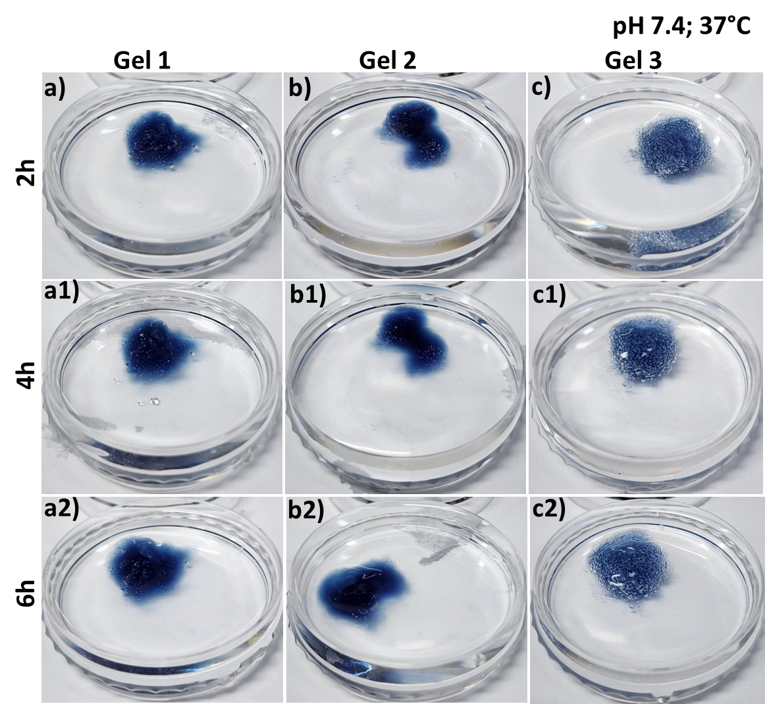
Supporting Figure 1. Swelling of different gelatin-HA hydrogel at 37°C in pH 7.4 phosphate buffer solution (PBS).
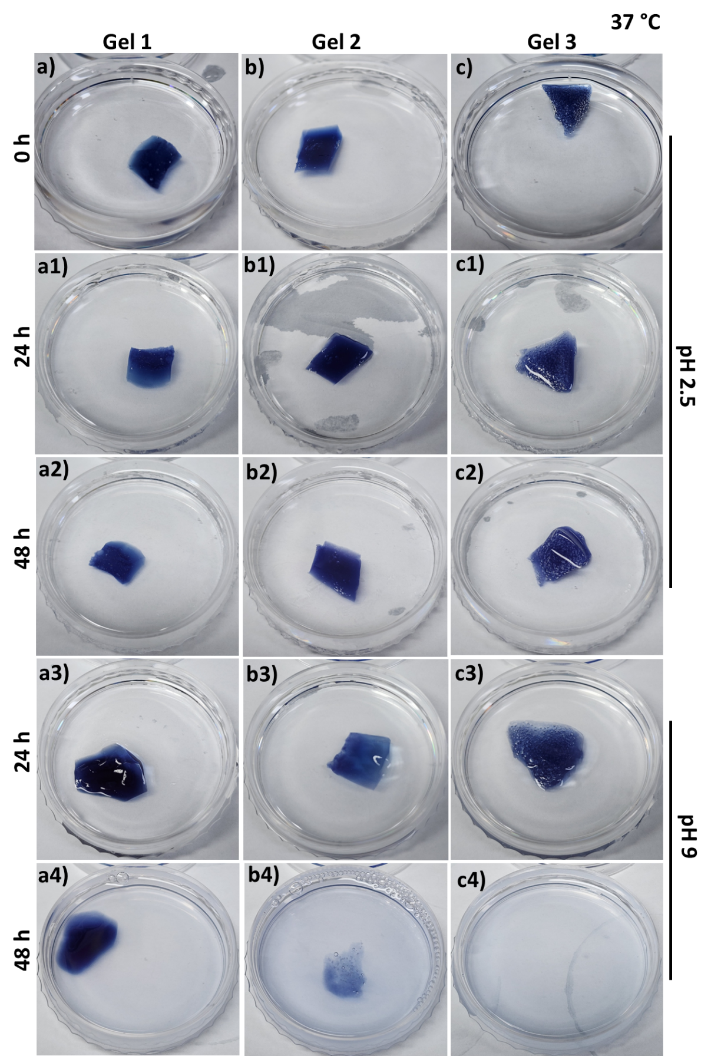
Supporting Figure 2. Degradation study of different gelatin-HA hydrogels at pH 2.5 and pH 9 PBS in 37°C for 48 hours.

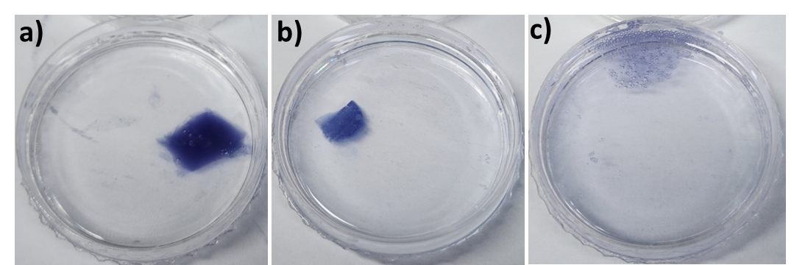
Supporting Figure 3. Degradation study of different gelatin-HA hydrogels at 37°C and pH 2.5 in PBS after 5 days, where (a) Gel 1; (b) Gel 2; (c) Gel 3.

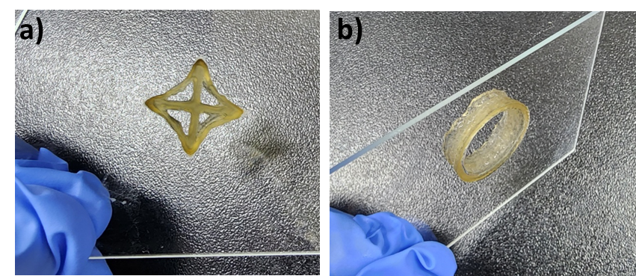
Supporting Figure 4. Adhesiveness test of the printed gelatin-HA gel scaffolds by inverting the glass substrate, where (a) star, (b) tube.

