Supplementary Materials
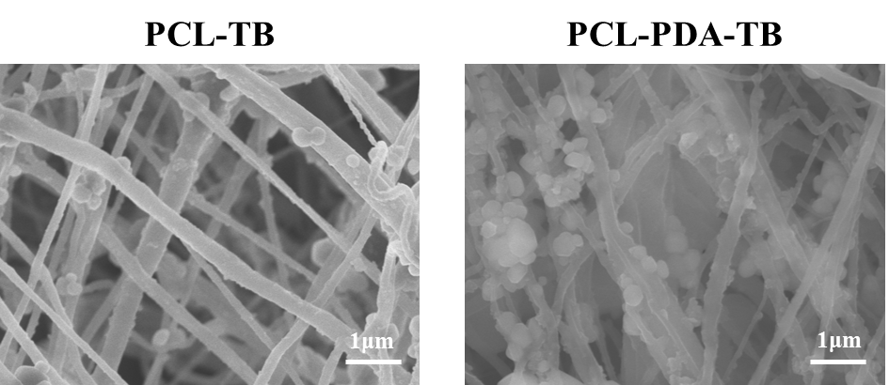
Figure S1. SEM images of Thrombin loaded onto PCL and PCL-PDA fibrous membranes.
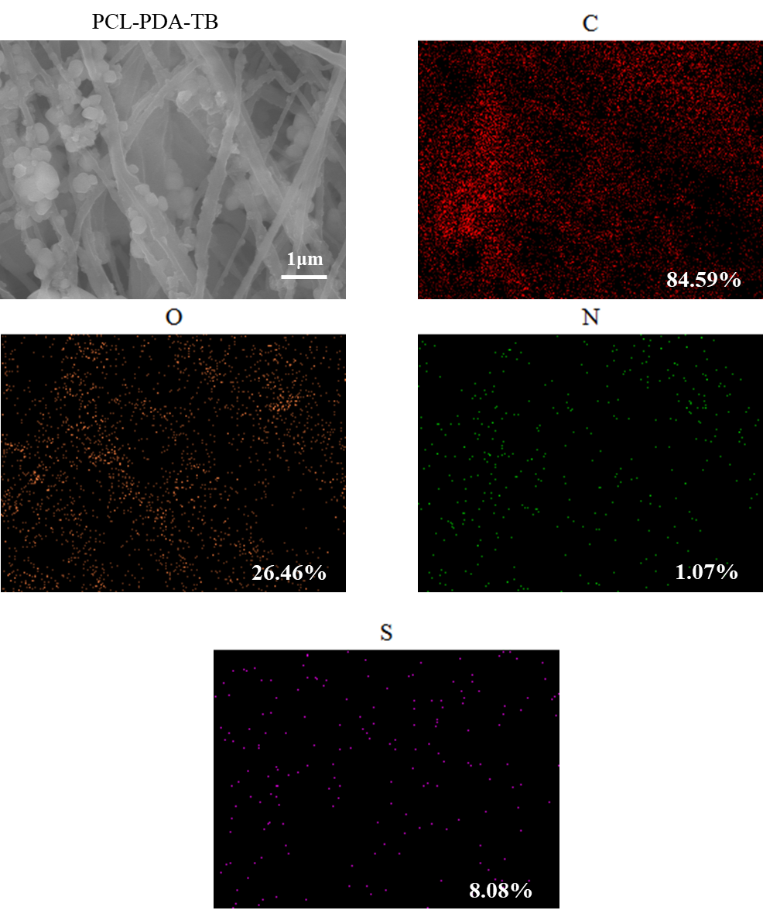
Figure S2. SEM and EDS elemental mapping images of PCL-PDA-TB fibrous membranes.

