Supplementary Material: Steam explosion of eucalypt sawdust for ethanol production within a biorefinery approach
Mairan Guigou ^{1,}*, Juan Guarino ², Luana M. Chiarello ³, María N. Cabrera ², Mauricio Vique ¹, Claudia Lareo ¹, Mario D. Ferrari ¹ and Luiz P. Ramos ^{3,}*
¹ Departamento de Bioingeniería, Instituto de Ingeniería Química, Facultad de Ingeniería, Universidad de la República, J. Herrera y Reissig 565, CP 11300 Montevideo, Uruguay; mguigou@fing.edu.uy (M.G); mauriciovique@live.com (M.V.); clareo@fing.edu.uy (C.L.), dferrari@fing.edu.uy (M.D.F.)
² Grupo de Ingeniería de Procesos Forestales, Instituto de Ingeniería Química, Facultad de Ingeniería, Universidad de la República, J. Herrera y Reissig 565, CP 11300 Montevideo, Uruguay.); jguarinoamado@gmail.com (J.G.); ncabrera@fing.edu.uy (M.N.C);
³ Graduate Program in Chemical Engineering, Federal University of Paraná, P.O. Box 19032, Curitiba, PR, 81531-980, Brazil; lchiarello@furb.br (L.M.C.); luiz.ramos@ufpr.br (L.P.R.)
* Correspondence: M.G. mguigou@fing.edu.uy; Tel.: +59827142714; L.P.R. luiz.ramos@ufpr.br; Tel.: +5541999636084

1. Steam explosion pretreatment.

Regarding the recovery of xylosaccharides in the liquid fraction, significant differences were observed among treatments considering the reaction time and the t-T interaction for confidence level of 95% (p < 0.05). By increasing the time and decreasing the T-t interaction, an increase in xylose recovery was observed in the liquid stream. According to the effects of reaction time, an increase from 5 to 10 min increased XS recovery by 24%. By contrast, XS decreased by 13% when the temperature was increased from 185 to 205°C. Also, the T-MC interaction positively affected xylose recovery. Figure S1 shows the response surface plots that were derived from the proposed experimental design.
Hemicellulose solubilization did not present significant differences for the different temperatures applied in this study and a correlation with pretreatment severity was not found. This behavior could be explained by the extensive solubilization (partial hydrolysis) of hemicelluloses at lower pretreatment temperatures (130-140°C).
None of the variables studied (T, t and MC) was statistically significant for the recovery of acetyl groups, nor for furfural or HMF in the liquid fraction for a confidence level of 95% (p < 0.05). So, a model could not be established for these response factors.

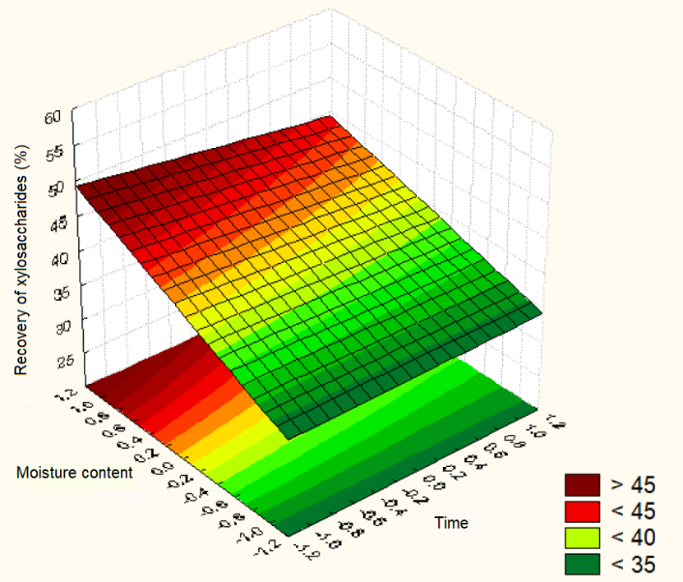  A | 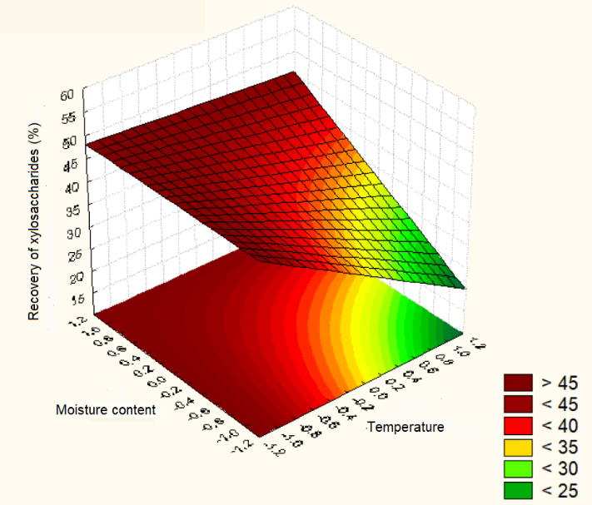  B
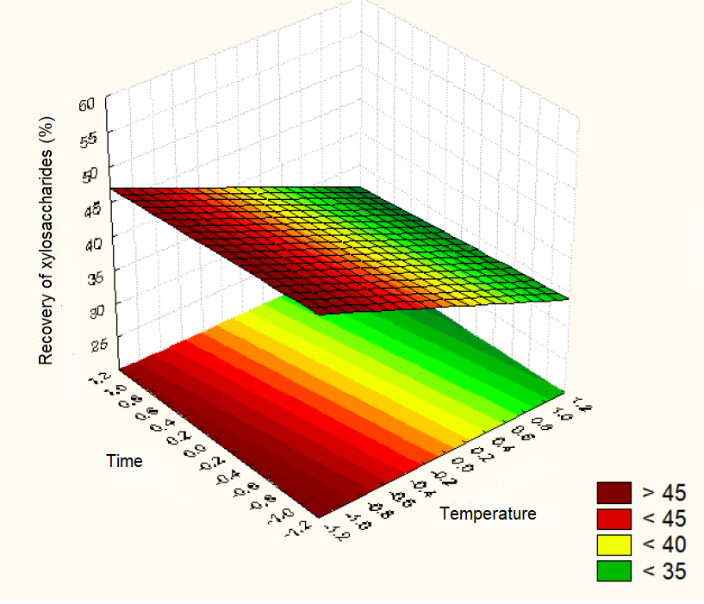
C
Figure S1. Response surface plots for the recovery of xylosaccharides as a function of (a) sawdust moisture content and reaction time, (b) sawdust moisture content and reaction temperature, and (c) reaction time and reaction temperature.

2. Enzymatic hydrolysis
When the sawdust initial moisture content (MC) was high, glucan conversion efficiency was more sensitive to pretreatment temperature. An increase of 20°C from 185 to 205°C for a residence time of 5 min in reactor vessel increased hydrolysis efficiency by 178% for sawdust with 8% MC (EV1A and EV6A) and by 93% for 50% initial MC (EV3A and EV8A). For a residence time of 10 min at 185°C using 8% MC sawdust (EV2A), the efficiency increased by 185% compared to a residence time of 5 min (EV1A), which remained the same when sawdust with 50% MC was used (EV9A and EV3A). Working at 205°C, the improvement in hydrolysis efficiency was less (49% and 14%) for 8% (EV6A and EV7A) and 50% (EV8A and EV9A) MC sawdust, respectively. Therefore, changes in reaction time had a greater influence on enzyme performance when pretreatment was carried out with low MC sawdust, suggesting that higher severities were achieved under these experimental conditions.
The hydrolysis efficiency was significantly (p < 0.05) affected by all process variables, as well as by T-t and T-MC interactions, being temperature the most influential followed by time. Figure S2 shows the surface plot of hydrolysis efficiency and glucan conversion, respectively, considering temperature, time, or sawdust MC as process variables.
A | B
C | D
E | F
Figure S2. Surface plots for hydrolysis efficiency and glucan conversion depending on the different process variables: (a) moisture content and time, (b) moisture content and temperature, and (c) time and temperature for hydrolysis efficiency, (d) moisture content and time, (e) moisture content and temperature, and (f) time and temperature for glucan conversion.
Glucose produced during enzymatic hydrolysis had a quasi linear relationship with the extent of hemicellulose removal as a result of pretreatment (Figure S3).
Figure S3. Variation of hydrolyzed glucose produced from 100 g sawdust with respect to xylan removal after steam explosion.

Figure S4 shows solids recovery, final glucose concentration, hydrolysis efficiency and glucan conversion efficiency as a function of S₀
A | B
C | D
Figure S4. (a) Solids recovery, (b) final glucose concentration, (c) hydrolysis efficiency and (d) glucan conversion efficiency vs. pretreatment severity (S₀).

There was an inverse relationship between the mass recovery of pretreated solids and pretreatment severity. More drastic pretreatment conditions improved the final glucose concentration, the enzymatic hydrolysis efficiency, and the glucan conversion efficiency. No linear trend was observed for XS and xylose release with respect to pretreatment severity.
In Table S1, the mathematic equations obtained for different response functions (recovered solids, final glucose concentration, hydrolysis efficiency, and glucan conversion efficiency) are given. In all cases, the lack-of-fit of the model was not statistically significant.
Table S1. Standardized models obtained for solid recovered, final glucose concentration, hydrolysis efficiency and glucan conversion efficiency.
C
Fitted model equation | R²
$$SR \left(\%\right)=80.2-0.59T$$ | 0.992
$$G \left(g/L\right)=8.9+3.6T++1.0t-0.8MCt$$ | 0.997
$$HE \left(\%\right)=43.0+16.8 T+5.2t+3.1MC+2.4tT-3.62tMC$$ | 0.999
$$E_{GC} \left(\%\right)=42.5+15.6 T+5.7t+3.8MC+2.5T.t-3.4tMC$$ | 0.999
SR: solid recovered, G: final ethanol concentration, HE: hydrolysis efficiency, E_{GC}: glucan conversion efficiency

A | B
Figure S5. Pareto chart of standardized effects for (a) xylosaccharides recovery, (b) hydrolysis efficiency, and (c) and glucan conversion efficiency.
Figure S6 shows the perfect linear correlation between experimental and theoretical values for glucan conversion efficiency.
Figure S6. Experimental glucan efficiency conversion of exploded solids vs. model predicted values (Equation 2).

